Document Control
- System Name: Application

Executive Summary
- This document defines the business requirements for the Application system, focusing on ingesting customer and order CSV data into Delta tables, performing data cleansing, calculating order totals, handling Slowly Changing Dimension (SCD) Type 2 for customer updates, and generating daily spend aggregates, all orchestrated via Delta Live Tables.

Business Objectives
- Load customer and order data from source CSV files into managed Delta tables.
- Cleanse ingested data by removing null literals and duplicates.
- Enrich order data with a computed TotalAmount as PricePerUnit × Qty.
- Join customer and order datasets to create an ordersummary Delta table.
- Apply SCD Type 2 methodology to maintain historical accuracy of customer data.
- Aggregate customer spend daily into the customeraggregatespend table.
- Coordinate all steps using Delta Live Tables as the implementation engine.

In-Scope
- Ingestion from defined customer and order source paths into Delta tables.
- Schema mapping and creation of Delta tables: customer, order, ordersummary, customeraggregatespend.
- Data cleansing (null and duplicate removal).
- Calculation and population of derived columns.
- SCD Type 2 historical tracking for customers in ordersummary.
- Aggregation of order data for daily spend tracking.
- Process flow driven by Delta Live Tables.

Out-of-Scope
- Data sources, elements, or tables not specified in the requirements.
- Security, access control, or data governance policies.
- Performance engineering, monitoring, alerting, and SLAs.
- Workflow scheduling, orchestration, and DevOps/infrastructure steps beyond Delta Live Tables instructions.
- User interfaces or analytical reporting layers.

Stakeholders
- Information not present in provided requirements.

Business Requirements

BR-BI-001 — Source Data Ingestion
- Description: Load customer and order CSV files from specified file paths into respective Delta tables.
- Business Value: Ensures accurate, repeatable ingestion of raw data for downstream processing.
- Priority: High

BR-BI-002 — Schema Enforcement
- Description: Maintain the predefined schema for both customer and order Delta tables.
- Business Value: Drives data quality and structural consistency.
- Priority: High

BR-BI-003 — Computed Field Enhancement
- Description: Compute TotalAmount in the order table using PricePerUnit × Qty.
- Business Value: Enables meaningful financial aggregations.
- Priority: High

BR-BI-004 — Data Cleansing
- Description: Remove "Null"/Null literals and duplicate records from both customer and order tables.
- Business Value: Improves data integrity and reliability of subsequent analysis.
- Priority: High

BR-BI-005 — Join Operations and Table Creation
- Description: Join customer and order on CustId to create the ordersummary table with SCD Type 2 handling.
- Business Value: Correlates transactional and reference data with historical accuracy.
- Priority: High

BR-BI-006 — SCD Type 2 Historical Accuracy
- Description: Apply SCD Type 2 logic in ordersummary, setting prior records as Inactive and updating StartDate/EndDate as customers change.
- Business Value: Maintains a historical trail of customer data for audit and business intelligence.
- Priority: High

BR-BI-007 — Aggregate Spend Tracking
- Description: Aggregate ordersummary data by Name and Date to create the customeraggregatespend table.
- Business Value: Supports daily customer-level financial insights.
- Priority: High

BR-BI-008 — Orchestrated Execution
- Description: Implement all processing steps using Delta Live Tables in specified sequence.
- Business Value: Ensures maintainable, scalable, and operationalized data pipelines.
- Priority: High

Assumptions & Constraints
- No requirements are assumed beyond provided content.
- Delta Live Tables is mandated for orchestration and pipeline execution.
- Auxiliary attributes for SCD (such as StartDate, EndDate, Active) are referenced but not explicitly defined.
- All transformations must maintain exact naming as provided.

Success Metrics
- Successful, lossless data ingestion and cleansing according to rules.
- Accurate computation of TotalAmount for all order records.
- 100% join rate between customer and order on CustId where keys match.
- Full historical preservation of customer changes using SCD Type 2.
- Complete population of daily spend in customeraggregatespend with no aggregation errors.
- All steps run end-to-end under Delta Live Tables without failure.

Risks & Mitigations
- Ambiguity around explicit schema data types for SCD fields — Mitigation: confirm with data architects.
- Potential gaps in monitoring, alerting, or error handling — Mitigation: escalate to engineering for definition.
- Volume/performance limits not specified — Mitigation: validate during initial pipeline runs.
- Governance, security, and scheduling not addressed — Mitigation: highlight in project scope review.

Approval
- Required parties, sign-off roles, and approval steps are not defined in current requirements; to be determined at project governance stage.

Appendix
Appendix A: Source Definitions
Source Name | Type | Location | Format | Notes
Customer source | CSV | /Volumes/gen_ai_poc_databrickscoe/sdlc_wizard/customerdata | Not present in source JSON | Loaded into Delta table customer
Order source | CSV | /Volumes/gen_ai_poc_databrickscoe/sdlc_wizard/orderdata | Not present in source JSON | Loaded into Delta table order
Appendix B: Target Definitions
Target Name | Layer | Table | Columns | Notes
customer | Base | customer | CustId, Name, EmailId, Region | Ingested from customer CSV
order | Base | order | OrderId, ItemName, PricePerUnit, Qty, Date, CustId | Ingested from order CSV
ordersummary | Silver | ordersummary | CustId, Name, EmailId, Region, OrderId, ItemName, PricePerUnit, Qty, Date | Joined and SCD Type 2 processed
customeraggregatespend | Gold | customeraggregatespend | Name, TotalAmount, Date | Aggregated from ordersummary
Appendix C: Transformations
Step | Transformation | Input | Output | Logic
1 | Load | customerdata CSV | customer | Create Delta table if not exists
2 | Load | orderdata CSV | order | Create Delta table if not exists
3 | Computed column | order | order (with TotalAmount) | TotalAmount = PricePerUnit × Qty
4 | Cleansing | customer/order | customer/order | Remove "Null"/Null literals and duplicates
5 | Join | customer + order | ordersummary | Join on CustId
6 | SCD Type 2 | ordersummary | ordersummary | Set prev to Inactive, new to Active; track dates
7 | Aggregate | ordersummary | customeraggregatespend | Sum(TotalAmount) grouped by Name and Date
Appendix D: Business Rules
Rule ID | Area | Description | Source
BR-1 | Calculation | TotalAmount = PricePerUnit × Qty | Requirements
BR-2 | Cleansing | Remove "Null"/Null literals, duplicates | Requirements
BR-3 | Join | customer to order on CustId | Requirements
BR-4 | SCD | SCD Type 2 with history for customer changes | Requirements
BR-5 | Aggregation | Sum TotalAmount by Name, Date | Requirements
Appendix E: Process Flow
Step | Description | Dependency
1 | Ingest customer and order source CSVs into Delta tables | Source files
2 | Cleanse data for nulls and duplicates | Ingestion
3 | Compute TotalAmount on order | Cleansed data
4 | Join customer and order to create ordersummary with SCD Type 2 | Cleansed data
5 | Aggregate ordersummary to customeraggregatespend | ordersummary
Appendix F: ERD
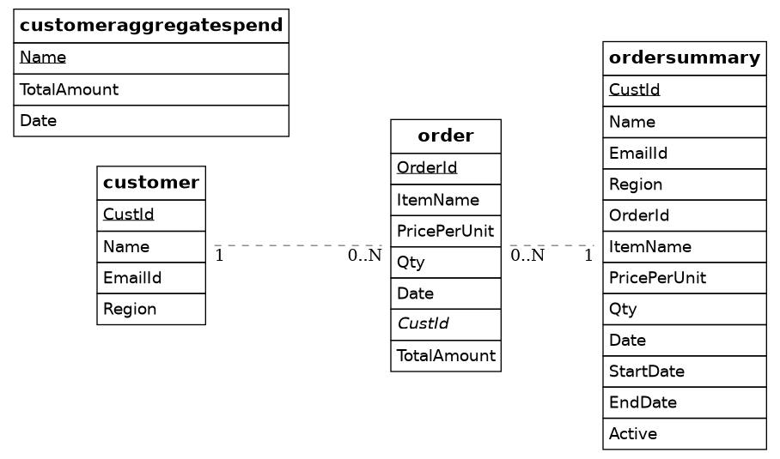

customer 1--* ordersummary
ordersummary *--1 customeraggregatespend
- The ERD describes:
- `customer` entity with CustId as primary key, related to both `order` and `ordersummary`
- `order` entity with OrderId as primary key and foreign key CustId, related to `ordersummary`
- `ordersummary` as historical join entity with SCD markers and relationships to both `customer` and `customeraggregatespend`
- `customeraggregatespend` as aggregate table related to `ordersummary`

End of Document

