Document Control
- Document Title: Business Requirements Document (BRD)
- System Name: Application

Executive Summary
- The BRD outlines business requirements for ingesting customer and order CSV data into Delta tables, performing cleansing, computing TotalAmount, SCD Type 2 joins, producing summary and aggregate tables, and operationalizing the pipeline using Delta Live Tables for the Application system.

Business Objectives
- Load source CSVs for customer and order data into Delta tables
- Cleanse data by removing null values and duplicates
- Enrich orders with computed TotalAmount (PricePerUnit × Qty)
- Join customer and order for an ordersummary table with SCD Type 2 history
- Create daily customer spend aggregates in customeraggregatespend
- Leverage Delta Live Tables for implementation

In-Scope
- Ingestion from defined file system locations
- Delta table creation: customer, order, ordersummary, customeraggregatespend
- Data cleansing per requirements
- TotalAmount computation in orders
- SCD Type 2 join logic in ordersummary
- Aggregation for customeraggregatespend
- Implementation via Delta Live Tables

Out-of-Scope
- Data sources or fields not specified in requirements
- Security, access controls, SLAs, monitoring, alerting
- Performance tuning, scheduling, orchestration, DevOps details
- Data quality metrics beyond listed cleansing
- User interfaces, reporting, analytics layers

Stakeholders
- Information not present in requirements input

Business Requirements

BR-APP-001 — Source CSV Ingestion
- Description: Load customer and order CSV files into respective Delta tables from specified paths
- Business Value: Enables downstream data processing and analytics
- Priority: High

BR-APP-002 — Schema Enforcement
- Description: Enforce defined schema for customer (CustId, Name, EmailId, Region) and order (OrderId, ItemName, PricePerUnit, Qty, Date, CustId) tables
- Business Value: Ensures data consistency and quality
- Priority: High

BR-APP-003 — Data Cleansing
- Description: Remove "Null"/Null literals and duplicate records from customer and order tables
- Business Value: Improves data accuracy and trustworthiness
- Priority: High

BR-APP-004 — Computed Column TotalAmount
- Description: Add computed column TotalAmount in order table as (PricePerUnit × Qty)
- Business Value: Supports financial calculations and reporting
- Priority: Medium

BR-APP-005 — Ordersummary Table Creation
- Description: Create ordersummary table by joining customer and order on CustId, maintaining SCD Type 2 change history for customer
- Business Value: Provides historical customer-order relationship tracking
- Priority: High

BR-APP-006 — SCD Type 2 Handling
- Description: Apply SCD Type 2 logic to customer dimension—set previous records inactive, update StartDate/EndDate, maintain history
- Business Value: Preserves change audit trail for compliance and analytics
- Priority: High

BR-APP-007 — Aggregate Spend Processing
- Description: Create customeraggregatespend table with daily TotalAmount sums grouped by Name and Date
- Business Value: Enables spend analysis and customer behavior insights
- Priority: Medium

BR-APP-008 — Delta Live Tables Implementation
- Description: Execute all pipeline requirements using Delta Live Tables
- Business Value: Standardizes pipeline management and scalability
- Priority: Medium

Assumptions & Constraints
- Only information from requirements input used
- Delta Live Tables is the mandated implementation tool
- Fields like StartDate, EndDate, Active referenced but not defined explicitly

Success Metrics
- All tables created with defined schemas
- Cleansed, enriched, and history-preserved data
- Accurate daily spend aggregations
- End-to-end flow operational using Delta Live Tables

Risks & Mitigations
- Ambiguity around certain SCD Type 2 attribute definitions
- Mitigation: Raise clarification with stakeholders
- Data quality coverage limited to cleansing steps
- Mitigation: Extend rules if required per future input
- Monitoring, error handling, and performance out of current scope
- Mitigation: Document gaps and address post-MVP

Approval
- Name:
- Title:
- Signature:
- Date:

Appendix
Appendix A: Source Definitions
Source Name | Type | Location | Format | Notes
Customer source | CSV | /Volumes/gen_ai_poc_databrickscoe/sdlc_wizard/customerdata | CSV | Loaded into Delta table customer
Order source | CSV | /Volumes/gen_ai_poc_databrickscoe/sdlc_wizard/orderdata | CSV | Loaded into Delta table order
Appendix B: Target Definitions
Target Name | Layer | Table | Columns | Notes
customer | Raw | customer | CustId, Name, EmailId, Region | Source ingest
order | Raw | order | OrderId, ItemName, PricePerUnit, Qty, Date, CustId | Source ingest
ordersummary | Curated | ordersummary | CustId, Name, EmailId, Region, OrderId, ItemName, PricePerUnit, Qty, Date | SCD Type 2 join
customeraggregatespend | Gold | customeraggregatespend | Name, TotalAmount, Date | Daily spend aggregation
Appendix C: Transformations
Step | Transformation | Input | Output | Logic
1 | Load customer CSV to Delta table | Customer source path | customer | Read and write as Delta
2 | Load order CSV to Delta table | Order source path | order | Read and write as Delta
3 | Remove Nulls and duplicates from customer and order | customer, order | cleansed tables | Filter and deduplicate
4 | Compute TotalAmount | order | order | TotalAmount = PricePerUnit × Qty
5 | Create ordersummary table (SCD Type 2 join) | customer, order | ordersummary | Join on CustId, SCD2 logic
6 | Aggregate spend | ordersummary | customeraggregatespend | sum of TotalAmount grouped by Name, Date
Appendix D: Business Rules
Rule ID | Area | Description | Source
BR-1 | Computation | TotalAmount = PricePerUnit × Qty | Requirements input
BR-2 | Cleansing | Remove "Null"/Null literals and duplicates from input tables | Requirements input
BR-3 | Join | Join customer and order on CustId | Requirements input
BR-4 | SCD Type 2 | Inactivate previous, activate new, update Start/End dates | Requirements input
BR-5 | Aggregation | Group by Name, Date, aggregate sum(TotalAmount) | Requirements input
Appendix E: Process Flow
Step | Description | Dependency
1 | Ingest customer and order CSV to Delta tables | None
2 | Clean customer and order tables | Step 1
3 | Compute TotalAmount in order | Step 1, 2
4 | Join customer and order, apply SCD Type 2, create ordersummary | Step 2, 3
5 | Aggregate spend, output to customeraggregatespend | Step 4
Appendix F: Entity Relationship Diagram (ERD) Description
- The following ERD captures the key tables and their relationships for the Application:
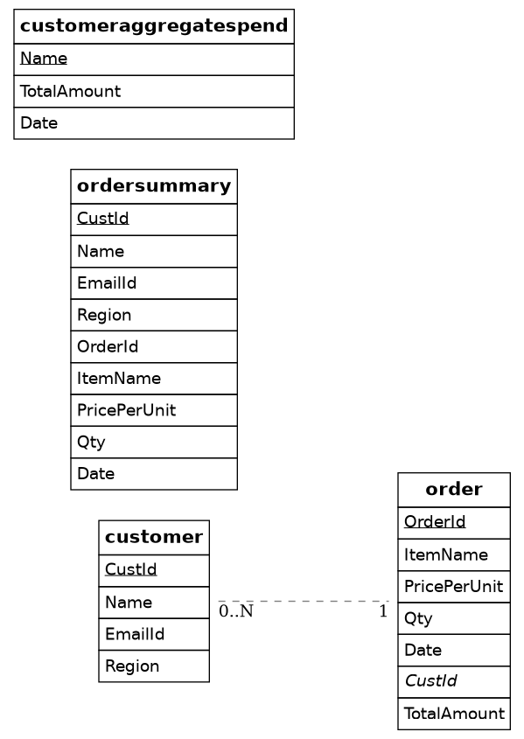

customer *--1 ordersummary
ordersummary *--1 customeraggregatespend

