TR-APP-001
- Related Functional Requirement: FR-1 Source Ingestion
- Objective: Implement automated data ingestion from structured CSV sources into Delta tables using Delta Live Tables.
- Target Cluster Configuration:
- Cluster Name: dlt-customer-order-ingest
- Runtime Version: Databricks Runtime 11.3 LTS or higher
- Node Type: Standard_DS3_v2 (or equivalent)
- Driver Node: 1 node
- Worker Nodes: 2–4 nodes (autoscaling enabled)
- Autoscaling: Enabled (2–4)
- Auto Termination: 30 minutes
- Libraries: PySpark, Delta Lake, DLT libraries
- Source Data Details:
- Source Type: CSV
- Location: /Volumes/gen_ai_poc_databrickscoe/sdlc_wizard/customerdata and /Volumes/gen_ai_poc_databrickscoe/sdlc_wizard/orderdata
- Schema: customer(CustId, Name, EmailId, Region); order(OrderId, ItemName, PricePerUnit, Qty, Date, CustId)
- Target Data Details:
- Table Name: customer, order
- Storage Format: Delta
- Partitioning Strategy: None specified
- Job Flow:
- Read customer and order CSVs from defined locations
- Write raw data to Delta tables
- Register Delta tables in metastore
- Transformations & Logic:
- Schema enforcement as defined
- No explicit transformations
- Error Handling & Logging:
- Log ingestion status per file
- Validate schema on load
- Fail job on unrecoverable errors

TR-APP-002
- Related Functional Requirement: FR-2 Schemas
- Objective: Enforce explicit schemas on ingested data for type safety and data quality.
- Target Cluster Configuration:
- Cluster Name: dlt-schema-enforcement
- Runtime Version: Databricks Runtime 11.3 LTS or higher
- Node Type: Standard_DS3_v2
- Driver Node: 1 node
- Worker Nodes: 2 nodes
- Autoscaling: Disabled
- Auto Termination: 20 minutes
- Libraries: PySpark, Delta Lake
- Source Data Details:
- Source Type: Delta (from prior ingestion)
- Location: customer, order Delta tables
- Schema: as specified
- Target Data Details:
- Table Name: customer, order
- Storage Format: Delta
- Partitioning Strategy: None
- Job Flow:
- Apply schema during read of raw data
- Validate and enforce column data types
- Log invalid records and move to quarantine set
- Transformations & Logic:
- Data type conversion as necessary
- Error Handling & Logging:
- Record failed schema matches
- Move invalid records to quarantine

TR-APP-003
- Related Functional Requirement: FR-3 Computed Column
- Objective: Implement computation of TotalAmount column in order table (PricePerUnit × Qty).
- Target Cluster Configuration:
- Cluster Name: dlt-compute-totalamount
- Runtime Version: Databricks Runtime 11.3 LTS
- Node Type: Standard_DS3_v2
- Driver Node: 1 node
- Worker Nodes: 2 nodes
- Autoscaling: Disabled
- Auto Termination: 20 minutes
- Libraries: PySpark, Delta Lake
- Source Data Details:
- Source Type: Delta
- Location: order Delta table
- Schema: OrderId, ItemName, PricePerUnit, Qty, Date, CustId
- Target Data Details:
- Table Name: order (with TotalAmount)
- Storage Format: Delta
- Partitioning Strategy: None
- Job Flow:
- Read order Delta table
- Compute TotalAmount = PricePerUnit * Qty per record
- Write enriched data to same or new Delta table
- Transformations & Logic:
- Expression: order.withColumn("TotalAmount", col("PricePerUnit") * col("Qty"))
- Error Handling & Logging:
- Validate numeric values for computation
- Log any issues with data types

TR-APP-004
- Related Functional Requirement: FR-4 Data Cleansing
- Objective: Remove explicit "Null"/Null literals and duplicate records from all source and staging tables.
- Target Cluster Configuration:
- Cluster Name: dlt-cleansing
- Runtime Version: Databricks Runtime 11.3 LTS
- Node Type: Standard_DS3_v2
- Driver Node: 1 node
- Worker Nodes: 2 nodes
- Autoscaling: Disabled
- Auto Termination: 20 minutes
- Libraries: PySpark, Delta Lake
- Source Data Details:
- Source Type: Delta
- Location: customer, order tables
- Schema: as previously defined
- Target Data Details:
- Table Name: customer_clean, order_clean
- Storage Format: Delta
- Partitioning Strategy: None
- Job Flow:
- Read source tables (customer, order)
- Filter out rows with "Null" literal values or system nulls
- Drop duplicate records using all columns
- Store cleansed data to new Delta tables
- Transformations & Logic:
- .filter(), .dropDuplicates() in PySpark
- Error Handling & Logging:
- Log count of removed records for audit
- Raise error if all records are dropped

TR-APP-005
- Related Functional Requirement: FR-5 Create Target Table ordersummary
- Objective: Create ordersummary table with proper catalog and schema if not exists.
- Target Cluster Configuration:
- Cluster Name: dlt-ordersummary
- Runtime Version: Databricks Runtime 11.3 LTS
- Node Type: Standard_DS3_v2
- Driver Node: 1 node
- Worker Nodes: 2 nodes
- Autoscaling: Disabled
- Auto Termination: 15 minutes
- Libraries: PySpark, Delta Lake
- Source Data Details:
- Source Type: DataFrame (post cleansing)
- Location: customer_clean, order_clean
- Target Data Details:
- Table Name: gen_ai_poc_databrickscoe.sdlc_wizard.ordersummary
- Storage Format: Delta
- Partitioning Strategy: None specified
- Job Flow:
- Verify if target table exists in catalog
- Create table with defined schema if not exist
- Transformations & Logic:
- None beyond schema definition
- Error Handling & Logging:
- Log table creation status

TR-APP-006
- Related Functional Requirement: FR-6 Join and Load with SCD Type 2
- Objective: Join customer/order on CustId to load into ordersummary with SCD Type 2 logic.
- Target Cluster Configuration:
- Cluster Name: dlt-scd2-processing
- Runtime Version: Databricks Runtime 11.3 LTS
- Node Type: Standard_DS3_v2
- Driver Node: 1 node
- Worker Nodes: 2 nodes
- Autoscaling: Disabled
- Auto Termination: 25 minutes
- Libraries: PySpark, Delta Lake
- Source Data Details:
- Source Type: Delta
- Location: customer_clean, order_clean
- Schema: customer(CustId, Name, EmailId, Region); order(OrderId, ItemName, PricePerUnit, Qty, Date, CustId, TotalAmount)
- Target Data Details:
- Table Name: gen_ai_poc_databrickscoe.sdlc_wizard.ordersummary
- Storage Format: Delta
- Partitioning Strategy: None specified
- Job Flow:
- Join customer_clean and order_clean on CustId
- Apply SCD Type 2 operations on customer attributes in ordersummary
- Write resulting records (history-tracked) to target Delta table
- Transformations & Logic:
- SCD 2 implementation: flag active/inactive, update StartDate/EndDate, use Merge or window functions
- Error Handling & Logging:
- Log number of inserted/updated records
- Handle overlapping histories, raise conflicts

TR-APP-007
- Related Functional Requirement: FR-7 ordersummary Schema
- Objective: Enforce and manage schema for ordersummary as per requirement.
- Target Cluster Configuration:
- Cluster Name: dlt-ordersummary-schema
- Runtime Version: Databricks Runtime 11.3 LTS
- Node Type: Standard_DS3_v2
- Driver Node: 1 node
- Worker Nodes: 2 nodes
- Autoscaling: Disabled
- Auto Termination: 15 minutes
- Libraries: PySpark, Delta Lake
- Source Data Details:
- Source Type: DataFrame join output
- Location: ordersummary stream
- Target Data Details:
- Table Name: ordersummary
- Storage Format: Delta
- Partitioning Strategy: None
- Job Flow:
- Cast and enforce fields as: CustId, Name, EmailId, Region, OrderId, ItemName, PricePerUnit, Qty, Date
- Transformations & Logic:
- Data type enforcement/assertion
- Error Handling & Logging:
- Log schema enforcement status

TR-APP-008
- Related Functional Requirement: FR-8 SCD Type 2 Change Handling Rules (customer dimension)
- Objective: Maintain historical changes in customer data within ordersummary using SCD Type 2.
- Target Cluster Configuration:
- Cluster Name: dlt-scd2-rules
- Runtime Version: Databricks Runtime 11.3 LTS
- Node Type: Standard_DS3_v2
- Driver Node: 1 node
- Worker Nodes: 2 nodes
- Autoscaling: Disabled
- Auto Termination: 30 minutes
- Libraries: PySpark, Delta Lake
- Source Data Details:
- Source Type: Delta
- Location: ordersummary Delta table
- Target Data Details:
- Table Name: ordersummary
- Storage Format: Delta
- Partitioning Strategy: None
- Job Flow:
- Detect changes in customer attributes per CustId
- Mark previous records as Inactive
- Insert new version as Active, with updated StartDate/EndDate
- Transformations & Logic:
- Use window functions and Merge statement for SCD 2
- Error Handling & Logging:
- Log change history events
- Audit field-level changes

TR-APP-009
- Related Functional Requirement: FR-9 Create Aggregate Table customeraggregatespend
- Objective: Create customeraggregatespend table in catalog/schema with correct structure.
- Target Cluster Configuration:
- Cluster Name: dlt-customeraggregatespend
- Runtime Version: Databricks Runtime 11.3 LTS
- Node Type: Standard_DS3_v2
- Driver Node: 1 node
- Worker Nodes: 2 nodes
- Autoscaling: Disabled
- Auto Termination: 10 minutes
- Libraries: PySpark, Delta Lake
- Source Data Details:
- Source Type: ordersummary
- Location: gen_ai_poc_databrickscoe.sdlc_wizard.ordersummary
- Target Data Details:
- Table Name: gen_ai_poc_databrickscoe.sdlc_wizard.customeraggregatespend
- Storage Format: Delta
- Partitioning Strategy: None
- Job Flow:
- Create table if it does not exist
- Register in metastore
- Transformations & Logic:
- None (DDL only)
- Error Handling & Logging:
- Log table creation and registration

TR-APP-010
- Related Functional Requirement: FR-10 Aggregate Loading
- Objective: Compute and load daily spend sum per Name into customeraggregatespend.
- Target Cluster Configuration:
- Cluster Name: dlt-aggregate-load
- Runtime Version: Databricks Runtime 11.3 LTS
- Node Type: Standard_DS3_v2
- Driver Node: 1 node
- Worker Nodes: 2 nodes
- Autoscaling: Disabled
- Auto Termination: 15 minutes
- Libraries: PySpark, Delta Lake
- Source Data Details:
- Source Type: ordersummary Delta
- Location: gen_ai_poc_databrickscoe.sdlc_wizard.ordersummary
- Target Data Details:
- Table Name: gen_ai_poc_databrickscoe.sdlc_wizard.customeraggregatespend
- Storage Format: Delta
- Partitioning Strategy: None
- Job Flow:
- Group ordersummary by Name and Date
- Aggregate sum(TotalAmount) for each group
- Load results into customeraggregatespend
- Transformations & Logic:
- Spark .groupBy("Name", "Date").agg(sum("TotalAmount"))
- Error Handling & Logging:
- Log aggregation completion
- Flag groups with missing values

TR-APP-011
- Related Functional Requirement: FR-11 Implementation Modality
- Objective: Ensure all transformations, cleansing, aggregation, joins, and writing to targets are orchestrated within Delta Live Tables framework.
- Target Cluster Configuration:
- Cluster Name: dlt-main-pipeline
- Runtime Version: Databricks Runtime 11.3 LTS or higher
- Node Type: Standard_DS3_v2
- Driver Node: 1 node
- Worker Nodes: 2–4 nodes
- Autoscaling: Enabled (2–4)
- Auto Termination: 60 minutes
- Libraries: PySpark, Delta Lake, DLT libraries
- Source Data Details:
- Source Type: As per above jobs
- Location: As per above jobs
- Target Data Details:
- Table Name: All targets as per requirements
- Storage Format: Delta
- Job Flow:
- Orchestrate end-to-end job dependencies in Delta Live Tables pipeline
- Validate each step with exception handling and logging
- Ensure data lineage and monitoring within pipeline
- Transformations & Logic:
- Modularize notebook/scripts for each major transformation
- Reuse code-reuse patterns for reliability
- Error Handling & Logging:
- Pipeline-level error catching
- Write logs to Databricks workspace or external storage
Figure 1: End-to-End Data Pipeline Flow
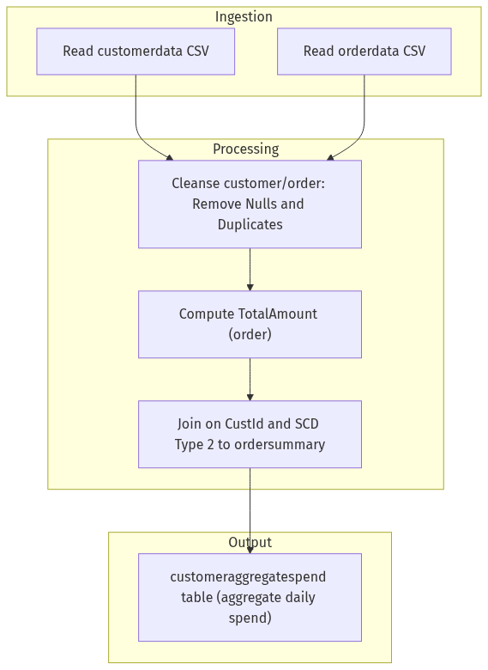

[Mermaid render failed: Kroki render failed: 400]

