Functional Requirements Document (FRD)

Project Title: Data Integration and Aggregation for Customer and Order Data

Document Version: 1.0

Prepared by: [Your Name], Senior Business Analyst

Date: [Current Date]

1. Introduction

This Functional Requirements Document (FRD) outlines the functional requirements for the data integration and aggregation project involving customer and order data.

2. Functional Requirements

The following functional requirements have been identified:

- Load customer data from CSV file `/Volumes/gen_ai_poc_databrickscoe/sdlc_wizard/customerdata` into `customer` delta table.
- Load order data from CSV file `/Volumes/gen_ai_poc_databrickscoe/sdlc_wizard/orderdata` into `order` delta table.
- Remove null records from `customer` and `order` tables.
- Remove duplicate records from `customer` and `order` tables.
- Join `customer` and `order` tables using `CustId` field.
- Create `ordersummary` table with schema: `CustId`, `Name`, `EmailId`, `Region`, `OrderId`, `ItemName`, `PricePerUnit`, `Qty`, `Date`.
- Implement SCD type 2 logic on `ordersummary` table.
- Update `StartDate` and `EndDate` columns accordingly.
- Aggregate data from `ordersummary` table.
- Create `customeraggregatespend` table with schema: `Name`, `TotalAmount`, `Date`.
- **Data Loading**:
- **Data Cleansing**:
- **Data Transformation**:
- **SCD Type 2 Implementation**:
- **Data Aggregation**:

3. System Flow Diagram

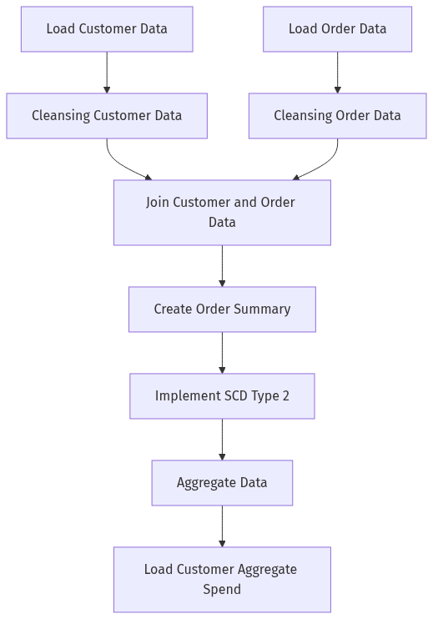

4. Process Flow / Flowchart

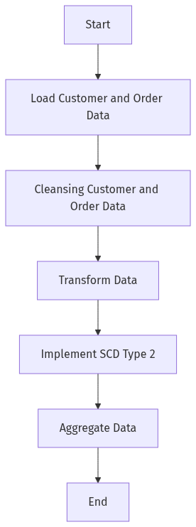

5. Data Flow Diagram (DFD)

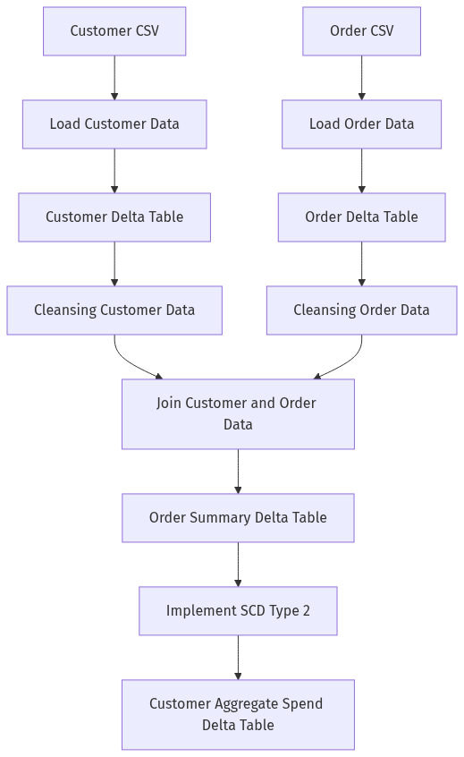

6. High-Level Architecture Diagram

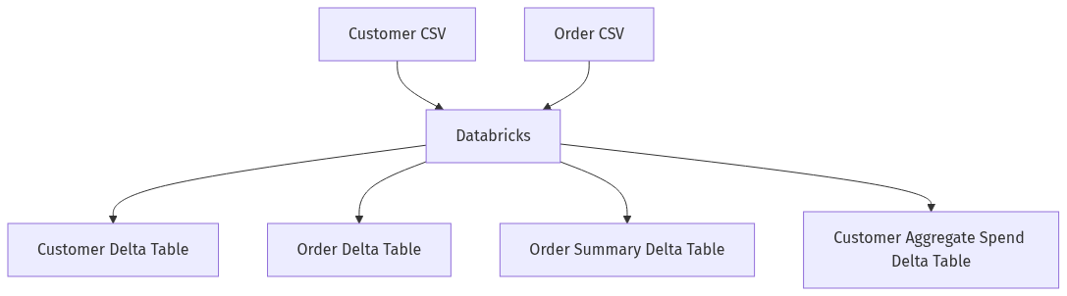

The above FRD provides a concise overview of the functional requirements for the data integration and aggregation project. The included diagrams illustrate the system flow, process flow, data flow, and high-level architecture of the proposed solution.

