Concise Functional Requirements Document (FRD) for the "Application"

Introduction:
The Application is designed to integrate customer and order data from CSV files into Delta tables, perform data cleansing and transformation, and create aggregated reports.

Functional Requirements:

- Read CSV data from specified volumes: `/Volumes/gen_ai_poc_databrickscoe/sdlc_wizard/customerdata` and `/Volumes/gen_ai_poc_databrickscoe/sdlc_wizard/orderdata`.
- Load data into Delta tables `customer` and `order`.
- **Data Ingestion Module**

- Remove "Null"/Null and duplicate records from `customer` and `order` tables.
- **Data Cleansing Module**

- Create `ordersummary` table if it does not exist with the specified schema.
- Join `customer` and `order` data using "CustId" and load into SCD Type 2 table `ordersummary`.
- Update SCD Type 2 table `ordersummary` on changes in `customer` table.
- **Data Transformation and Loading Module**

- Create `customeraggregatespend` table if it does not exist with the specified schema.
- Aggregate "TotalAmount" from `ordersummary` and load into `customeraggregatespend`.
- **Aggregated Reporting Module**

Detailed Functional Requirements:

- The system shall read CSV data from the specified volumes and load it into Delta tables `customer` and `order`.
- The system shall remove "Null"/Null and duplicate records from both `customer` and `order` tables.
- The system shall create the `ordersummary` table if it does not exist and load the joined data into an SCD Type 2 table.
- The system shall update the SCD Type 2 table `ordersummary` whenever there is a change in the `customer` table.
- The system shall create the `customeraggregatespend` table if it does not exist and load aggregated data into it.

Diagrams:

System Flow Diagram
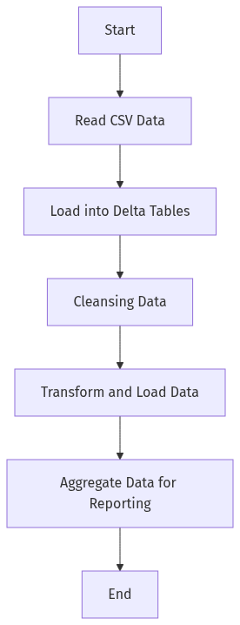

Process Flow / Flowchart
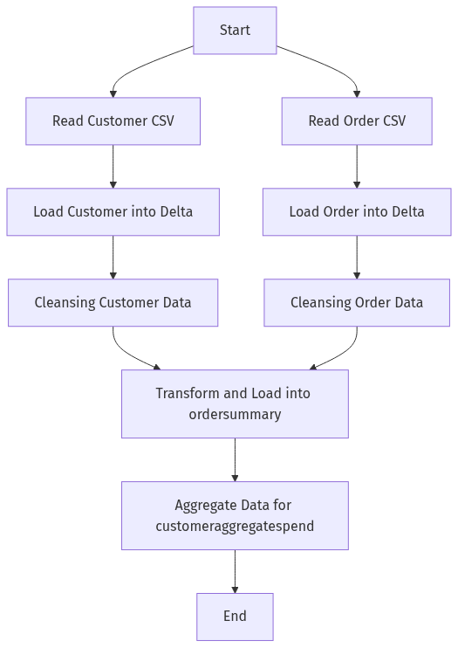

Data Flow Diagram (DFD)
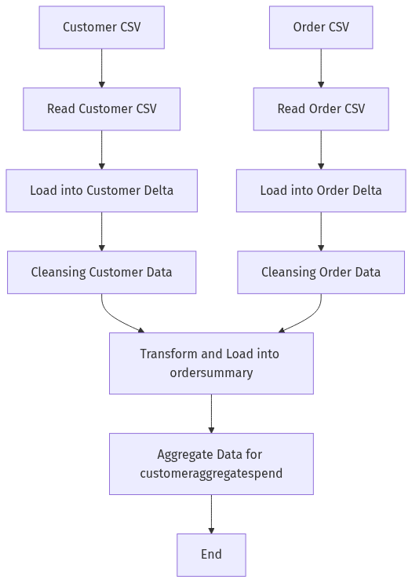

Sequence Diagram
[Diagram failed: Kroki render failed (HTTP 400): Error 400: SyntaxError: Parse error on line 2:
...aph TD;participant CSV_Customer as &quot;Cus
----------------------^
Expecting &#x27;SEMI&#x27;, &#x27;NEWLINE&#x27;, &#x27;EOF&#x27;, &#x27;AMP&#x27;, &#x27;START_LINK&#x27;, &#x27;LINK&#x27;, &#x27;LINK_ID&#x27;, got &#x27;NODE_STRING&#x27;
Error: Syntax error in graph
at Worker.convert (file:///usr/local/kroki/src/worker.js:44:15)
at async file:///usr/local/kroki/src/index.js:31:28]

High-Level Architecture Diagram
