Functional Requirements Document (FRD) for Data Platform Pipeline

Introduction:
The Data Platform Pipeline is designed to integrate customer order data from CSV files into a structured database, enabling efficient data analysis and reporting. This FRD outlines the functional requirements for the pipeline.

Functional Requirements:

- Read CSV data from specified locations (`/Volumes/gen_ai_poc_databrickscoe/sdlc_wizard/customerdata` and `/Volumes/gen_ai_poc_databrickscoe/sdlc_wizard/orderdata`) and load it into Delta tables "customer" and "order".
- Validate data ingestion for correctness and completeness.
- **Data Ingestion**

- Remove "Null"/null and duplicate records from "customer" and "order" tables.
- Validate data transformation for correctness and completeness.
- **Data Transformation**

- Create "ordersummary" table if it does not exist in the catalog "gen_ai_poc_databrickscoe" and schema "sdlc_wizard".
- Join "customer" and "order" data using "CustId" and load into SCD Type 2 "ordersummary" table.
- Validate data integration for correctness and completeness.
- **Data Integration**

- Update SCD Type 2 "ordersummary" table whenever there is a change in the "customer" table.
- Make old records inactive and new records active.
- Update `StartDate` and `EndDate` accordingly.
- Validate SCD Type 2 implementation for correctness and completeness.
- **SCD Type 2 Implementation**

- Create "customeraggregatespend" table if it does not exist in the catalog "gen_ai_poc_databrickscoe" and schema "sdlc_wizard".
- Aggregate "TotalAmount" from "ordersummary" table and group by "Name" and "Date".
- Load aggregated data into "customeraggregatespend" table.
- Validate data aggregation for correctness and completeness.
- **Data Aggregation**

System Flow Diagram
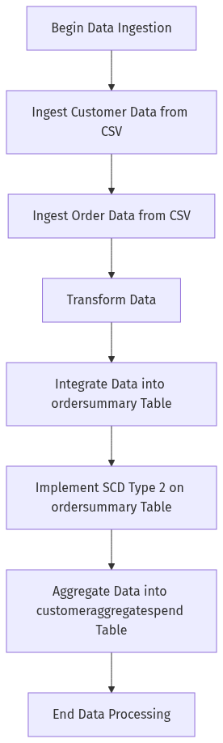

Process Flow / Flowchart
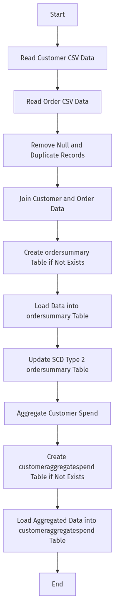

Data Flow Diagram (DFD)
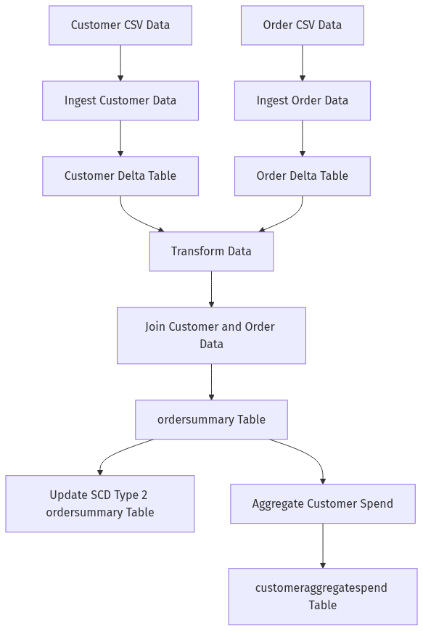

Sequence Diagram
[Diagram failed: Kroki render failed (HTTP 400): Error 400: SyntaxError: Parse error on line 2:
...aph TD;participant CSVData as &quot;CSV Data
----------------------^
Expecting &#x27;SEMI&#x27;, &#x27;NEWLINE&#x27;, &#x27;EOF&#x27;, &#x27;AMP&#x27;, &#x27;START_LINK&#x27;, &#x27;LINK&#x27;, &#x27;LINK_ID&#x27;, got &#x27;NODE_STRING&#x27;
Error: Syntax error in graph
at Worker.convert (file:///usr/local/kroki/src/worker.js:44:15)
at async file:///usr/local/kroki/src/index.js:31:28]

High-Level Architecture Diagram
