Before unplugging
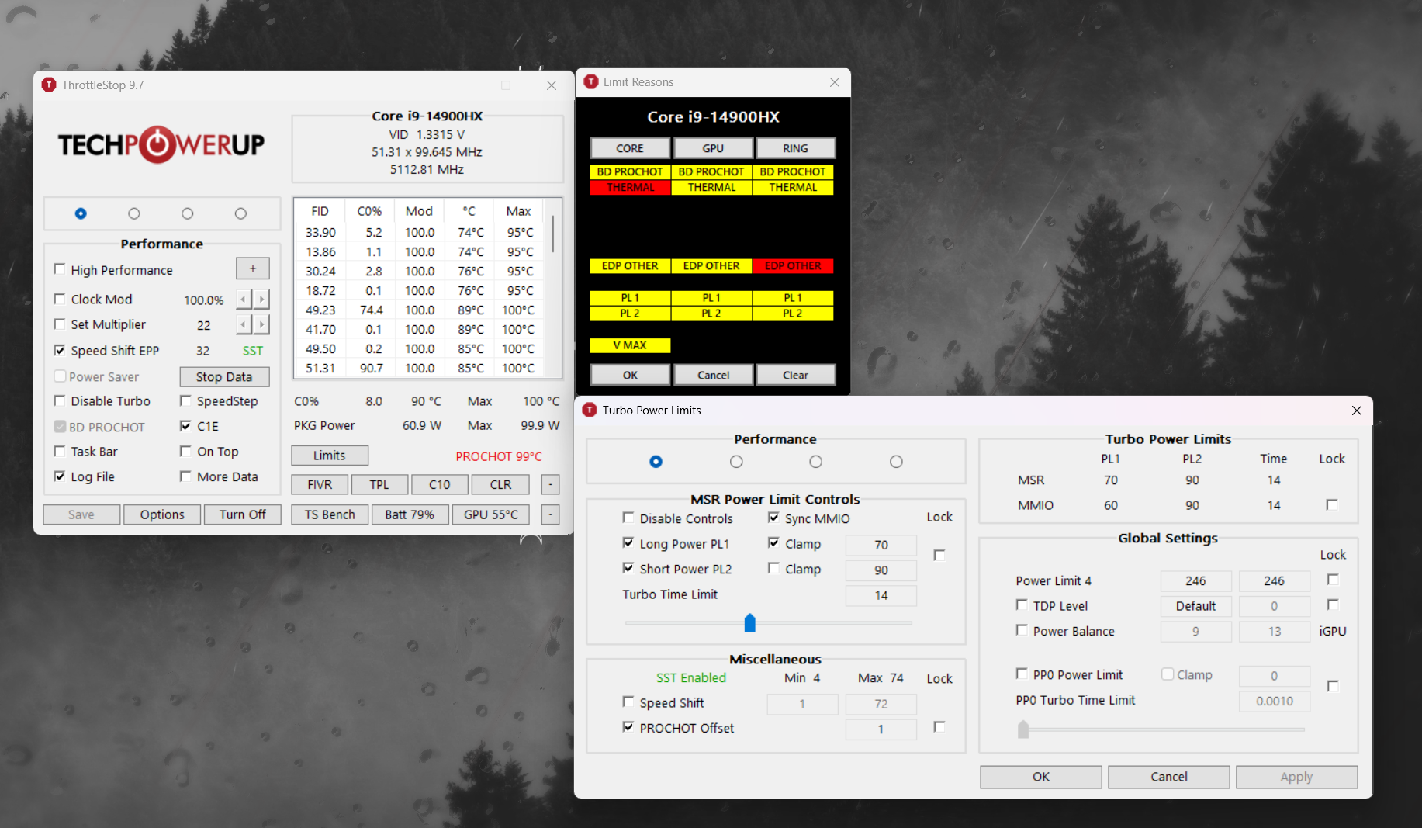

Unplugged
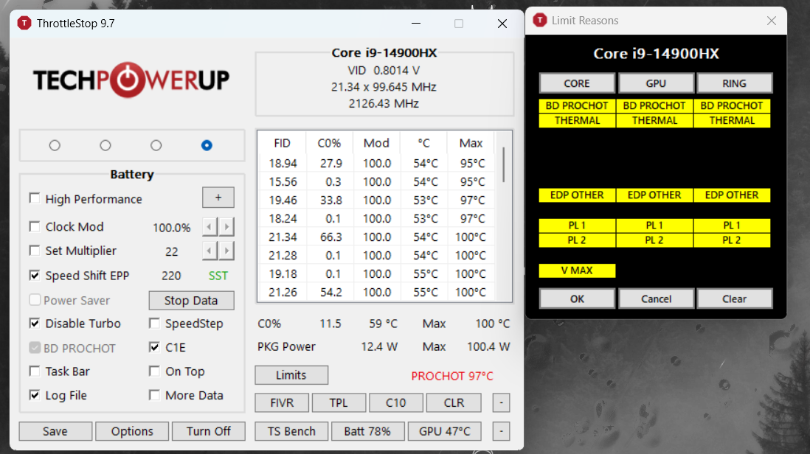
(note, TPL screen always defaults to showing the performance tab)
started HWinfo logging at this point, while unplugged (around 10:56)

At 10:57 I am plugging it back in and grabbing a screen shot 20sec or so later:
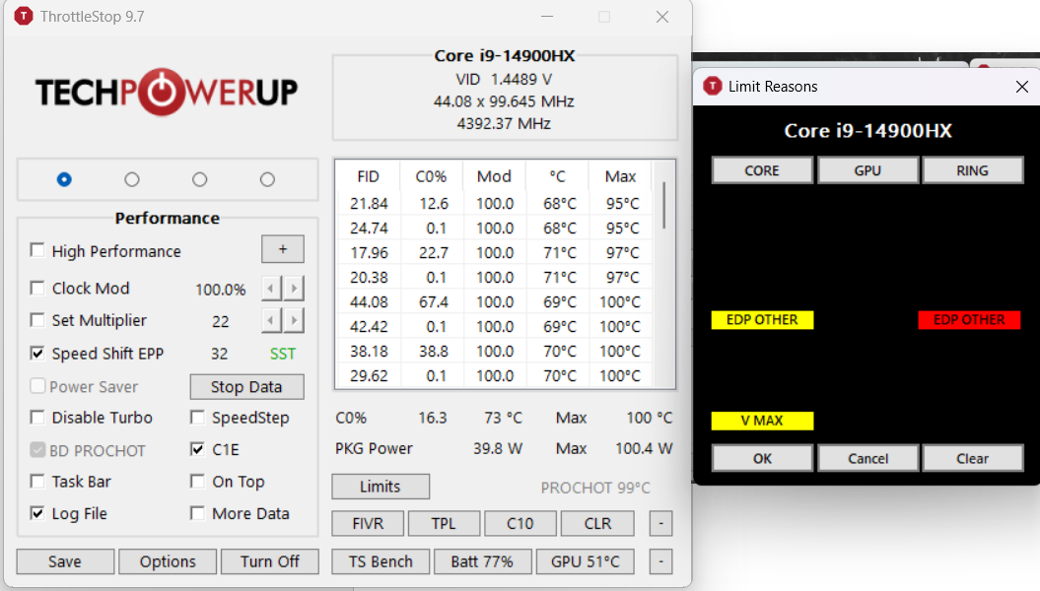

At 10:58 I start launching some normal programs to test some load.

