ZipSolution 5.9
Program documentation
Manual describes usage of ZipSolution
21.8.2011

Contents
Purpose 3
Release, Backup Sources under SVN 3
Release Binaries of Software 3
Prepare Update Packets, Differential Backups 3
Thanks & Regards 3
Cheeso 3
Igor Pavlov 3
Eugene Sichcar 4
Nicaloai Stoy 4
Software Requirements 4
Getting Started 4
Prepare Sources Release Scripts 4
Prepare Binaries Release Scripts 5
Prepare Backup Scripts 5
ZipSolution and MS-Build 6
Post-Build Event 6
Task of MS Build 6
Shortcuts on Desktop (with associated shortcuts) 7
Command Line and MS-Build Parameters 7
Guide 9
Open Documentation 9
Execute Zipping 9
Add Solution 9
Edit Solution 9
Delete Solution 9
Edit Template for New Solutions 9
Change Language 9
Add/Editing Solution Window 10
Filter Solution 10
Archive Designer 11
Common 11
Support 11
Logs 11
System Information 11
Errors 12
Known Issues 12
TortoiseSVN 12
Designed Archive 12
Autoreplace Parameter $TORTOISE_SVN_REVISION 12
Files with Russian Names and Unpacking of Archives 12
Empty Folders in Archive Designer Missing in Output Archives 12
Microsoft Visual Studio 2010 and Access of Files 12
Program Fails to Start Each Time 12
BAT, CMD Scripts and Solution Names 13
Other 13
Setup Settings Folder 13
Configuration Files 13
Application Specific Settings 13
License 13
Sources 13
Compilation Requirements 13
Libraries 14

Purpose

Release, Backup Sources under SVN
Software is intended for developers who release sources of their applications in an archive. It automates zipping of software source codes for contributing them to sourceforge.net, codeproject.com and codeplex.com by setting custom filters.
svn update
ZipSolution.Console.exe –SolutionFile=Deploy_ProjectSrc.xml

Alternative 1 (keep somewhere sources untouched, not compiled):
svn update
7z.exe [special switches for .svn folders exclusion]

Alternative 2 (export and zip):
[create target dir]
svn export [repository or file URL] [target dir] [some other settings]
zip [target dir] [target archive]
[delete target dir]

Release Binaries of Software
Program may be used when creating binary software zipped packages with use of 'archive design mode' feature: you can bind any folder or file to any place in archive you want.

Prepare Update Packets, Differential Backups
Software automates creating of so called 'update packets': you can select folder and it will pack all modified and created files starting from specified date. It saves original folder structure.
Purpose: to create update packets for small sites (consisting from html pages and powered by hands)

Thanks & Regards
This tool became possible with the following guys work:

Cheeso
This greatest guy is an author of the famous and most coolest implementation of zip for .net. This implementation is Ms-PL, that's mean completely free. This library helped lots of people around the world to add zipping to their applications. Also he created wonderfull browse for folder dialog.

Igor Pavlov
The high speed and the coolest compression, support of different applications and compressions method. This is 7-zip. http://7-zip.org. License is in Docs\7z License.txt.

Eugene Sichcar
The wrapper around 7-zip, that made available direct usage of 7-zip from .net. This is http://SevenZipSharp.codeplex.com. License is in Docs\SevenZipSharp LGPL License.txt.

Nicaloai Stoy
He translated the program to Deutch for German users [yots@gmx.net].

Software Requirements
Windows: XP, 7.
Platform: x32, x64.
Microsoft .Net Framework 4. You can download it from here.

Getting Started

Prepare Sources Release Scripts
I’ll show that process on ZipSolution project sample.
- Create folder trunk\Setup\Output;
- Create zip sources task trunk\Setup\SelfDeploy-Sources.xml
<?xml version="1.0" encoding="utf-16"?>
<XML>
<Solution name="ZipSolution-SelfDeploy-Sources">
<OutArchiveFormat>SevenZip</OutArchiveFormat>
<CompressionMethod>Default</CompressionMethod>
<CompressionLevel>Ultra</CompressionLevel>
<PreviousVersion>5.8.0.0</PreviousVersion>
<Increment>0</Increment>
<ZipFileNameTemplateStrings>
<InternalPurpose>ZipSolution-DotNet4-$VERSION-$DATE-src.7z</InternalPurpose>
<Release>ZipSolution-DotNet4-$VERSION-$DATE-src.7z</Release>
</ZipFileNameTemplateStrings>
<TargetFolders>
<TargetFolder>Output</TargetFolder>
</TargetFolders>
<DataSource Type="FolderAndFiltersDataSource" SolutionFolder="..\..">
<Filters>
<Filter Action="ExcludeByMask" Affected="Folder" Parameter="bin" />
<Filter Action="ExcludeByMask" Affected="Folder" Parameter=".svn" />
<Filter Action="ExcludeByMask" Affected="Folder" Parameter="BIN" />
<Filter Action="ExcludeByMask" Affected="Folder" Parameter="_ReSharper.*" />
<Filter Action="ExcludeByMask" Affected="Folder" Parameter="obj" />
<Filter Action="ExcludeByMask" Affected="File" Parameter="*.tmp" />
<Filter Action="ExcludeByMask" Affected="File" Parameter="*.TMP" />
<Filter Action="ExcludeByMask" Affected="File" Parameter="*.suo" />
<Filter Action="ExcludeByMask" Affected="File" Parameter="*resharper*" />
<Filter Action="ExcludeByMask" Affected="File" Parameter="*.user" />
<Filter Action="ExcludeByMask" Affected="File" Parameter="Ankh.*" />
<Filter Action="ExcludeByMask" Affected="File" Parameter="Thumbs.db" />
<Filter Action="ExcludeByMask" Affected="Folder" Parameter="Output" />
<Filter Action="ExcludeByMask" Affected="Folder" Parameter="Deployment" />
</Filters>
</DataSource>
</Solution>
</XML>
- Add zipping task to deploy script trunk\Setup\Deploy.cmd with getting version from built binaries of project
“...\ZipSolution.Console.exe” "SolutionFile=SelfDeploy-Sources.xml" "ExtractVersionFromAssemblyFile=..\Output\ZipSolution.exe"
- Done!

Prepare Binaries Release Scripts
I’ll show that process on ZipSolution project.
- Create folder trunk\Setup\output;
- Create zip binaries task trunk\Setup\SelfDeploy-Binaries.xml
<?xml version="1.0" encoding="utf-16"?>
<XML>
<Solution name="ZipSolution-SelfDeploy-Binaries">
<OutArchiveFormat>SevenZip</OutArchiveFormat>
<CompressionMethod>Default</CompressionMethod>
<CompressionLevel>Ultra</CompressionLevel>
<PreviousVersion>5.8.0.0</PreviousVersion>
<Increment>0</Increment>
<ZipFileNameTemplateStrings>
<InternalPurpose>ZipSolution-DotNet4-$VERSION-$DATE-binaries.7z</InternalPurpose>
<Release>ZipSolution-DotNet4-$VERSION-$DATE-binaries.7z</Release>
</ZipFileNameTemplateStrings>
<TargetFolders>
<TargetFolder>Output</TargetFolder>
</TargetFolders>
<DataSource Type="ManualArchiveDesignDataSource">
<Contents>
<Element Target="..\Output" LocationInArchive="" />
</Contents>
</DataSource>
</Solution>
</XML>
- Add zipping task to deploy script trunk\Setup\Deploy.cmd with getting version from for example AssemblyInfo.cs
“...\ZipSolution.Console.exe” "SolutionFile=SelfDeploy-Binaries.xml" "ExtractVersionFromAssemblyInfoCsFile=..\src\ZipSolution.UI\AssemblyInfo.cs"
- Done!

Prepare Backup Scripts
I’ll show that process on ZipSolution project (full backup with AES-256 password protection).
- Create backup project
Folder | Content
Output\ZipSolution | Here zipsolution will store results of work
ZipSolution | Folder with copy of zipsolution program files
Tasks | Here backup tasks will lay

File | File Content
Tasks\ZipSolution.codeplex.com.xml | <?xml version="1.0" encoding="utf-16"?>  <XML>  <Solution name="zipsolution.codeplex.com">  <OutArchiveFormat>SevenZip</OutArchiveFormat>  <CompressionMethod>Default</CompressionMethod>  <CompressionLevel>Ultra</CompressionLevel>  <PreviousVersion />  <Increment>0</Increment>  <ZipFileNameTemplateStrings>  <InternalPurpose>ZipSolution.codeplex.com-FullBackup.7z</InternalPurpose>  <Release>ZipSolution.codeplex.com-FullBackup.7z</Release>  </ZipFileNameTemplateStrings>  <TargetFolders>  <TargetFolder>..\Output\ZipSolution</TargetFolder>  <TargetFolder>K:\Backup-Security</TargetFolder>  </TargetFolders>  <DataSource Type="FolderAndFiltersDataSource" SolutionFolder="..\..\zipsolution.codeplex.com">  <Filters>  <Filter Action="ExcludeByMask" Affected="Folder" Parameter=".svn" />  <Filter Action="ExcludeByMask" Affected="Folder" Parameter="_ReSharper.*" />  <Filter Action="ExcludeByMask" Affected="File" Parameter="*.tmp" />  <Filter Action="ExcludeByMask" Affected="File" Parameter="*.TMP" />  <Filter Action="ExcludeByMask" Affected="File" Parameter="*.suo" />  <Filter Action="ExcludeByMask" Affected="File" Parameter="*resharper*" />  <Filter Action="ExcludeByMask" Affected="File" Parameter="*.user" />  <Filter Action="ExcludeByMask" Affected="File" Parameter="Ankh.*" />  <Filter Action="ExcludeByMask" Affected="File" Parameter="Thumbs.db" />  </Filters>  </DataSource>  </Solution>  </XML>
Backup_ZipSolution.bat | "zipsolution\ZipSolution.Console.exe" "SolutionFile=tasks\ZipSolution.codeplex.com.xml" "Password=24charPassword"
Backup_All.bat | backup_zipsolution.bat
- Mark Backup_ZipSolution.bat as encrypted (because you specified password in it).
- Done!

ZipSolution and MS-Build
Suppose you need to prepare zip archives after building of something. You can do this either by adding post-build event or adding task in your proj file.

Post-Build Event
- Perform extra configuring as it described here;
- Open properties of desired project:
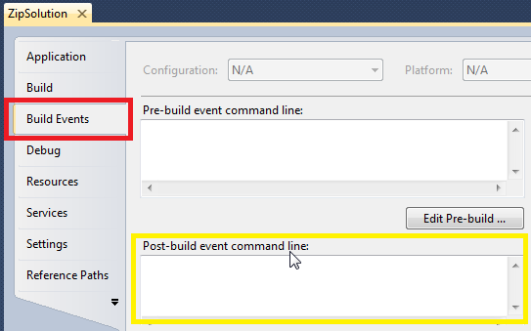
- Add something like in examples below:
"…\ZipSolution.Console.exe" "SolutionFile=$(ProjectDir)SelfDeploy-Binaries.xml" "ExtractVersionFromAssemblyInfoCsFile=$(ProjectDir)AssemblyInfo.cs" UseReleaseConfiguration
- Done!

Task of MS Build
Sample below illustrates adding ZipSolution as MS-Build task.
Adding ZipSolution as MS Build task requires some extra configuration. Suppose you’ve installed ZipSolution to C:\Program Files\ZipSolution. Suppose you’ve created project TEST PROJECT.
Configuring MS-Build:
- Perform extra configuring as it described here;
- Create Test.proj file with the following contents
<Project xmlns="http://schemas.microsoft.com/developer/msbuild/2003">
<UsingTask TaskName="ZipSolutionTask" AssemblyFile="C:\Program Files\ZipSolution\ZipSolution.Console.exe" />
<Target Name="MyTarget">
<ZipSolutionTask AnswerForFilterByDateStartTimeRequestDialogIsWeekAgo="False" Password="" UseReleaseConfiguration="False" Project="TEST PROJECT" SolutionFile="" Version="MS Build" LastChangeTime="" WaitMsec="0" ExtractVersionFromAssemblyInfoCsFile="" ExtractVersionFromAssemblyFile=""/>
</Target>
</Project>
- Done!

Shortcuts on Desktop (with associated shortcuts)
You may configure shortcuts for some tasks on your desktop.
- Copy ZipSolution shortcut or create new for ZipSolution and place it on desktop;
- Open shortcut properties and go to Shortcut tab;
- Modify target field according to the following example:
"c:\Program Files\ZipSolution\ZipSolution.exe" "Project=My zipSolution Project"
- Add key shortcuts if operation is performed often;
- Done!

Command Line and MS-Build Parameters
Parameters are case sensitive. Use them as it shown in samples. Parameters will work for ZipSolution.exe and ZipSolution.Console.exe.
Argument | Description and Sample
AnswerForFilterByDateStartTimeRequestDialogIsWeekAgo | This parameter will skip 'start time request dialog' with answer on it (current date - 7 days)
  "C:\Program Files\ZipSolution\ZipSolution.Console.exe" "Project=My zipSolution Project" AnswerForFilterByDateStartTimeRequestDialogIsWeekAgo
"Password=<my 24 or more char password goes here>" | This argument will cause encryption for any produced zip archives. Algorithm encryption is 7-Zip AES 256. Password length must be more 23 characters for high secure backups.  Files with this scripts with password must be marked as Encrypted.
  "C:\Program Files\ZipSolution\ZipSolution.Console.exe" "Project=My zipSolution Project" "Password=my top secret password"
UseReleaseConfiguration | Uses the release configuration by default. Its useful when you're packing something from command line.
  "C:\Program Files\ZipSolution\ZipSolution.Console.exe" "Project=My zipSolution Project" UseReleaseConfiguration
"SolutionFile=full file name"  "SolutionFile=relative file name " | Specifies the file with saved solution.
  "C:\Program Files\ZipSolution\ZipSolution.Console.exe" "SolutionFile=c:\application deployment\projectA\task file.xml"
  "C:\Program Files\ZipSolution\ZipSolution.Console.exe" "SolutionFile=..\task file.xml"
“Version=someVersion” | Setups the target version. When this setting is specified input version dialog is not shown and specified version is used.
  "C:\Program Files\ZipSolution\ZipSolution.Console.exe" "SolutionFile=..\task file.xml" "Version=2.3 RC1"
"ExtractVersionFromAssemblyInfoCsFile=relative path to AssemblyInfo.cs"  "ExtractVersionFromAssemblyInfoCsFile= full path to AssemblyInfo.cs” | Extracts version from specified AssemblyInfo.cs file and suppresses input version dialog. Relative path in name of AssemblyInfo.cs file is resolved relatively to current path. Stars in version such as 5.8.*.* are replaced with 'x' : 5.8.x.x. If you desire to know what is the exact version use other option.
  BAT: "C:\Program Files\ZipSolution\ZipSolution.Console.exe" "SolutionFile=..\task file.xml" "ExtractVersionFromAssemblyInfoCsFile=.\AssemblyInfo.cs"
  MS BUILD POST BUILD EVENT: "C:\Program Files\ZipSolution\ZipSolution.Console.exe" "SolutionFile=$(ProjectDir)SelfDeploy-Binaries.xml" "ExtractVersionFromAssemblyInfoCsFile=$(ProjectDir)AssemblyInfo.cs"
"ExtractVersionFromAssemblyFile=relative path to assembly dll or exe"  "ExtractVersionFromAssemblyFile=full path to exe dll" | Extracts version from compiled exe or dll or other file where version presents and suppresses input version dialog. File can be any file (including ordinary non-framework file) where version information presents.  Setting name is for legacy support. Relative path in name of Assembly file is resolved relatively to current path.
  CMD: “C:\Program Files\ZipSolution\ZipSolution.Console.exe" "SolutionFile=..\task file.xml" "ExtractVersionFromAssemblyFile=.\bin\debug\xApp.exe"
  MS BUILD POST BUILD EVENT: "C:\Program Files\ZipSolution\ZipSolution.Console.exe" "SolutionFile=$(ProjectDir)SelfDeploy-Binaries.xml" "ExtractVersionFromAssemblyFile=$(TargetPath)"
"Project=<My Project Name>" | Specified the project from user settings to use. By default internal configuration is used. For 'release' configuration please use special switch UseReleaseConfiguration described above.
  "C:\Program Files\ZipSolution\ZipSolution.Console.exe" "Project=My zipSolution Project"
"WaitMsec=<Amount of msecs>" | Before zipping the project tool will wait for specified amount of time. This setting is for visual studio issue with access to file support.
  MS BUILD POST BUILD EVENT: "C:\Program Files\ZipSolution\ZipSolution.Console.exe" "SolutionFile=$(ProjectDir)SelfDeploy-Binaries.xml" "ExtractVersionFromAssemblyFile=$(TargetPath)" "WaitMsec=1000"
"LastChangeTime=11/30/2011 12:57:12" | Predefined last write time will be used as an answer to filter by last write time filter.  Time format: MM/DD/YYYY hh:mm:ss.
  "C:\Program Files\ZipSolution\ZipSolution.Console.exe" "Project=My zipSolution Project" "LastChangeTime=11/30/2011 12:57:12"

Guide
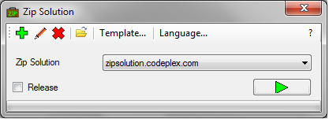

Open Documentation
To open documentation you can either click on tool bar button ? or press F1.

Execute Zipping
To execute zipping of selected solution you can either click on button or press Enter or F5.

Add Solution
To add solution you can press the corresponding tool bar button or press Ctrl+A or Ctrl+N or + (Plus).
Adding of exclude by filter solution can be done by dropping solution folder to main form.
To create portable solution in separate file with relative paths you can click special tool bar button Save to File with Relative Paths in Create / Edit Solution form. Otherwise ordinary solution will be created that will be stored in user options.

Edit Solution
To edit solution stored in your settings you can select it in combo box and click corresponding tool bar button or double click on window.
To edit solution stored in separate file (portable solution with relative paths) you must open it with Load solution from file tool bar button (Ctrl+O or F3). Then manually from Edit solution window save back to that file via Save to File with Relative Paths.

Delete Solution
To delete solution you can select it in combo box and click corresponding tool bar button.

Edit Template for New Solutions
When default settings for compression type, method, level, target folders, filters, file name strings does not suit you can change them by editing template. To do this you can click on corresponding button of main window.

Change Language
Changing language is performed on first UI start. Also you can change it with Language… tool bar button.

Add/Editing Solution Window

Filter Solution
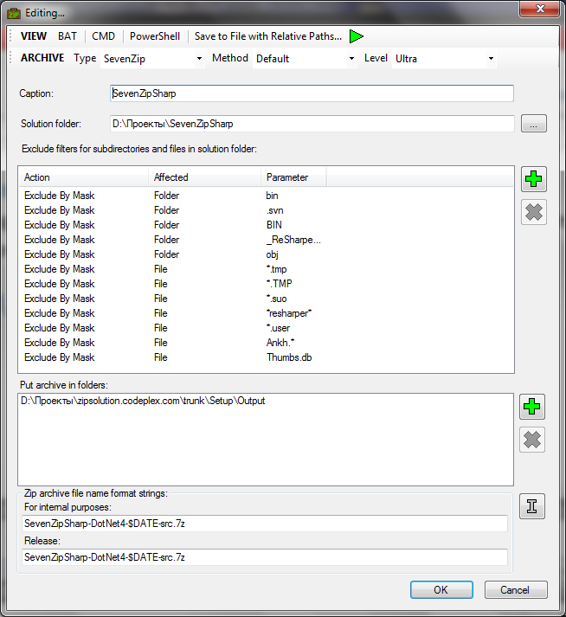
Filter list can be managed by context menu, buttons and 'Delete' key. Selection of several filters is allowed.

Archive Designer
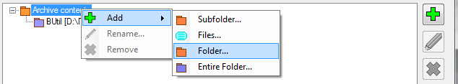
'Design of archive' data source does not support TortoiseSvn revision as autoreplacement parameter. It should replace it on empty string.
Entire Folder stands for putting all files from specified folder without subfolders.
Renaming node can be done with context menu, tool bar button, F2.

Common
Deleting element can be done via context menu, tool bar button, pressing Delete button.
Testing the solution is available with F5.
Saving solution to separate path with relative paths is supported via according tool bar button.
Generating of CMD, BAT, PS1 scripts is supported via according tool bar buttons. Those scripts are copied to clipboard. Then you can paste them to notepad, change in a way you want and save.
When you’re editing separate solution files, you must manually save them. Also you have to change generated scripts for them so scripts will use SolutionFile parameter pointing to this file.

Support
Releases, news, issues, feature requests | http://www.codeplex.com/ZipSolution
E-mail | mailto:Cuchuk.Sergey@gmail.com

Logs
ZipSolution.exe | - Press Win+R;  - Enter %temp%\HDE\ZipSolution
ZipSolution.Console.exe | - Press Win+R;  - Enter %temp%\HDE\ZipSolution
MS Build Integration | Logs are redirected to MS Build Output
Logs are in html format, errors are marked with red color.

System Information
To get system information saved in the file you can do the following:
  - Press Win+R, enter cmd;
  - Execute the following:
Systeminfo >> c:\mySystemInfo.txt

Errors
If there was no errors during packing program will terminate itself. In all other cases it will show form with errors or print them to console. In case of ms build error should break the build. Errors are logged.

Known Issues

TortoiseSVN

Designed Archive
If you chose 'design of archive' data source type this replacement parameter will be replaced on empty string

Autoreplace Parameter $TORTOISE_SVN_REVISION
It is expected that you perform some operations before zipping solution:
a) commit changes,
b) perform svn update on root folder
svn update

Files with Russian Names and Unpacking of Archives
To extract archives without any problems please use 7-zip (http://www.7-zip.org) or WinRar.

Empty Folders in Archive Designer Missing in Output Archives
Packing of empty folders in archive designer is not supported via Ionic and wrapper of 7-zip, so they are excluded.

Microsoft Visual Studio 2010 and Access of Files
Using the visual studio sometimes a problem occurrs with accessing files in post-build event. If this happens in your project you can use WaitMsec arguments
"C:\Program Files\ZipSolution-…\ZipSolution.exe" "WaitMsec=1000" […]
or create MS-Build task add such parameter in it.

Program Fails to Start Each Time
- Try to reinstall software with fresh version(which is not Beta);
- If it didn't solved problem, remove folder %appdata%\hde\ZipSolution;
- If this doesn't helped, write a support request. Include logs (from %temp%\HDE\ZipSolution) and system info:

BAT, CMD Scripts and Solution Names
You should use English characters for solution names. Russian characters are not supported in scripts.

Other

Setup Settings Folder
This is required when using software with MS Build.
- Press Win+R,
- Enter %AppData%\HDE\ZipSolution,
- Copy full path from Explorer to clipboard
For example you have copied: C:\Users\drweb86\AppData\Roaming\HDE\ZipSolution.
- Open the ZipSolution.config file from application folder in notepad,
- Replace here string
<add key="SettingsFolder" value="" />
on
<add key="SettingsFolder" value="C:\Users\drweb86\AppData\Roaming\HDE\ZipSolution" />

- Done!

Configuration Files
File | Location
ZipSolution.config | Folder with ZipSolution executables
Settings.xml | %AppData%\HDE\ZipSolution

Application Specific Settings
Those settings (such as time replace strings, culture) are located in ZipSolution.config file. Each settings is described in this file.

License
This is a public domain open source software, a gift for people with similar needs. No warranties, guaranties and responsibilities.

Sources

Compilation Requirements
To compile everything you must have:
- Microsoft Visual Studio 2010;
- Inno Setup (http://sourceforge.net/projects/innosetup).

Libraries
7-zip | http://7-zip.org (under LGPL with UnRar restriction, linked with SevenZipSharp)
SevenZipSharp | http://SevenZipSharp.codeplex.com (under LGPL, linked with project)
Ionic.Utils.Zip | http://dotnetzip.codeplex.com (under MSPL, sources are included in HDE.Platform)
BULocalization | http://sourceforge.net/projects/bulocalization (Public Domain, included in HDE.Platform, ver. 1.4)

