**SCOPE DOCUMENT**

**Project: Develop Library Management System for**

**Hanoi University**

*Development Company: ABC Company*

*Client: Hanoi University*

# Scope statements

A service agreement was established between ABC Development Company (as the service provider) and Hanoi University (as the client) in September 2022.

Both service provider and client aim to develop and deliver a software system, a Library Management System to be deployed for use as an online library service of Hanoi University. The system included 3 modules:

1. ***Sub-system 1***: Building a Central Database for the Library. A Central Database is [a database that is located, stored, and maintained in a single location.](https://en.wikipedia.org/wiki/Centralized_database)
2. ***Sub-system 2***: Develop a Search and Reserve service for all university students and lecturers/staffs. This service enables people to rent or borrow books, and manage all of them easily.
3. ***Sub-system 3***: Develop a Book Management sub-system, that helps managers now can track, obsever statistics visually, and process requests more quickly
4. Overall objectives:

* O1: Understand how the library system works
* O2: Optimize main features of library to improve using experience
* O3: Complete and deliver the product (manage library system)
* O4: Train library managers to use the software

1. Justifications:

* B1: We have many years of experience in software development in the field of education
* B2: We have developed many similar management systems for many other units across the country
* B3: We have the best blueprints for educational systems like library management
* B4: We are always appreciated for the quality of our products and our ability to support them in the future

Example:

**Patient’s Document Management System**

1. Overall objectives

* O1: Understand the process of patient’s treatment
* O2: Understand the government regulations on patient’s documents
* O3: Complete and deliver the product (manage patient documents)
* O4: Train client staffs to use the software

# Deliverables

|  |  |  |  |
| --- | --- | --- | --- |
| No | Deliverables | Detail characteristics | Date of delivery |
| 1 | *Sub-system 1*: Building a central Database for the Library | The database contains data of books, users, roles, actions: rent/pay,... for the purpose of getting data to return to API for front-end. | 2nd Nov 2022 |
| 2 | *Sub-system 2*: Develop a Search and Reserve service for all university students and staffs | All university students and staff can search for books by keywords, view results with filters, and book them in real time. | 15th Nov 2022 |
| 3 | *Sub-system 3*: Develop a Book Management subsystem | Librarians can add books, view book listings, edit information, and delete books from the book database on the admin page. | 21th Nov 2022 |

Example:

|  |  |  |  |
| --- | --- | --- | --- |
| No | Deliverables | Detail characteristics | Date of delivery |
| 1 | * 1. *Reception SubSystem*   2. *Receivable SubSystem*   3. *Medical Treatment Sub-System* | The system must conform  to government regulations  regarding medical  treatment process.  1.1 Reception can view,  check the patient to verify  information (not medical  records)  1.2 Receivable (Accounting  department) can view  patient’s information and  the amount patient should  pay.  1.3 Medical Treatment  department can view,  search all medical records | 2nd Nov 2022 |

# Work Breakdown Structure

Examples:

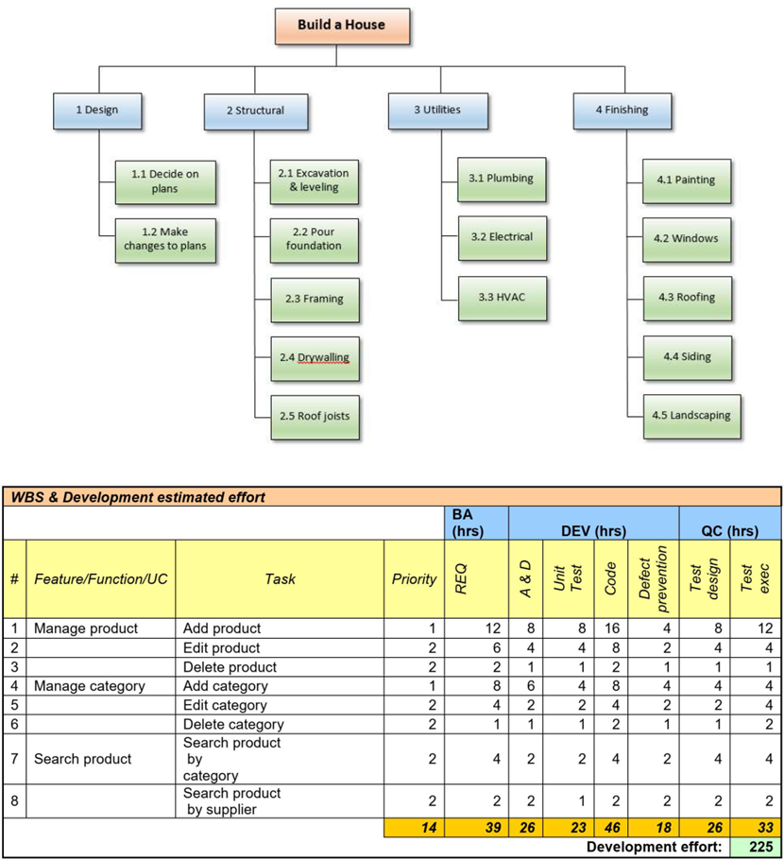

# Controlling the scope

Controlling of the scope is made following agreed steps and mechanisms between ABC company and Hanoi University:

* 1. Scope definition: [The stage of project planning that entails making a list of the precise project objectives, deliverables, tasks, expenses, and deadlines and documenting them. A scope statement or terms of reference is a document that details the parameters of a project.](https://www.techtarget.com/searchcio/definition/project-scope#:~:text=Project%20scope%20is%20the%20part,statement%20or%20terms%20of%20reference.)
  2. Scope review and baseline:
* [Scoping review is a preliminary assessment of prospective size and scope of extant research literature. aims to define the type and scope of research evidence, which typically includes active research.](https://touromed.libguides.com/c.php?g=927240&p=6680715)
* [Scope baseline which is outlined in the scope statement, work breakdown structure (WBS), and WBS lexicon, is an accepted version of the project scope. Project progress is tracked and results between real and planned are compared using the scope baseline as a reference.](https://www.projectmanager.com/training/baseline-project-scope#:~:text=What%20Is%20a%20Scope%20Baseline,compare%20actual%20versus%20planned%20results.)

Note: Scope baseline includes scope statement, WBS and WBS dictionary

Example:

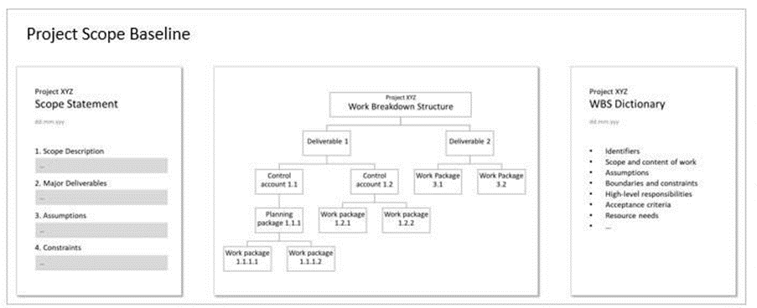

* 1. Scope change: [Alterations to a project's functionality, design, quality, spending plan, schedule, responsibilities, or other elements are known as scope changes.](https://www.lucidchart.com/blog/scope-change-management#:~:text=Scope%20changes%20are%20deviations%20in,a%20project%20manager%20or%20stakeholder.)

Example:

