Exe 1

a)

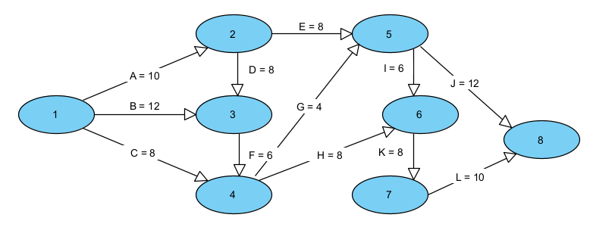

b)

|  |  |  |
| --- | --- | --- |
| Path | Point | Length |
| 1 | A – E – J | 20 |
| 2 | A – E – I – K – L | 42 |
| 3 | A – D – F – G – J | 40 |
| 4 | A – D – F – G – I – K – L | 52 |
| 5 | A – D – F – H – K – L | 50 |
| 6 | B – F – G – J | 34 |
| 7 | B – F – G – I – K – L | 46 |
| 8 | B – F – H – K – L | 44 |
| 9 | C – G – J | 24 |
| 10 | C – G – I – K – L | 36 |
| 11 | C – H – K – L | 34 |

c) The critical path for this project is 4 with length = 52.

d)

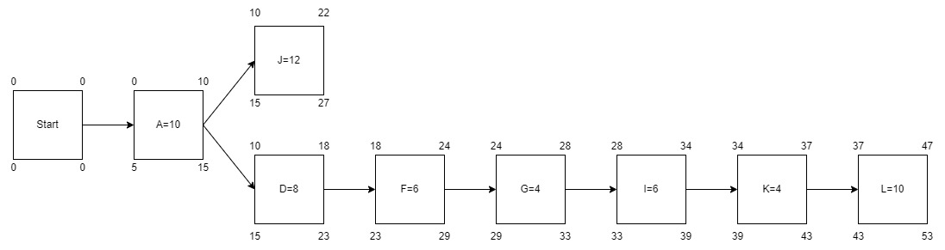

e)

