# COMP1752 Object-Oriented Programming: Jukebox Simulation Report

## Title Page

* Course Title: COMP1752 Object-Oriented Programming
* Assignment: Jukebox Simulation
* Student Name & ID
* Submission Date

## Table of Contents

## 1. Introduction

* Overview of the project
* Aims and objectives of the Jukebox simulation
* Brief summary of the system functionality
* Structure of the report

## 2. Design and Development

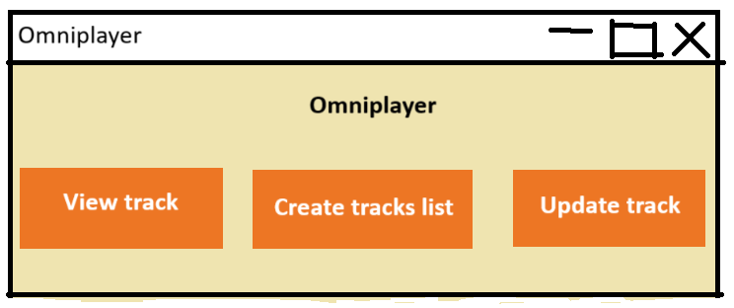

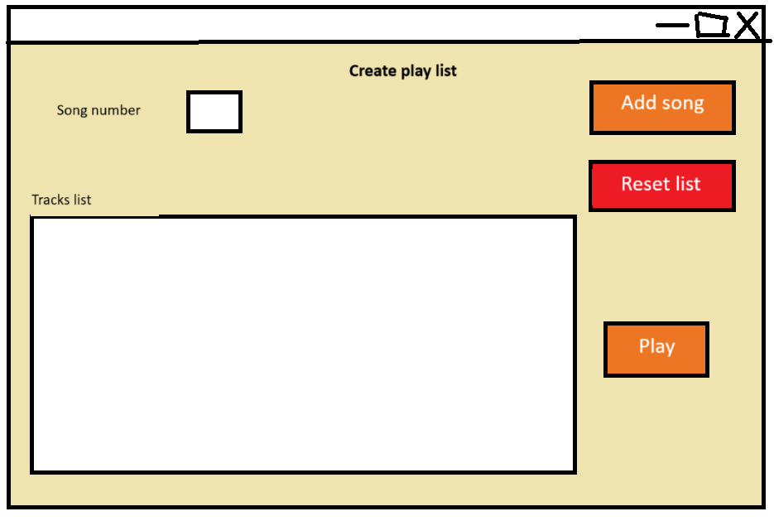

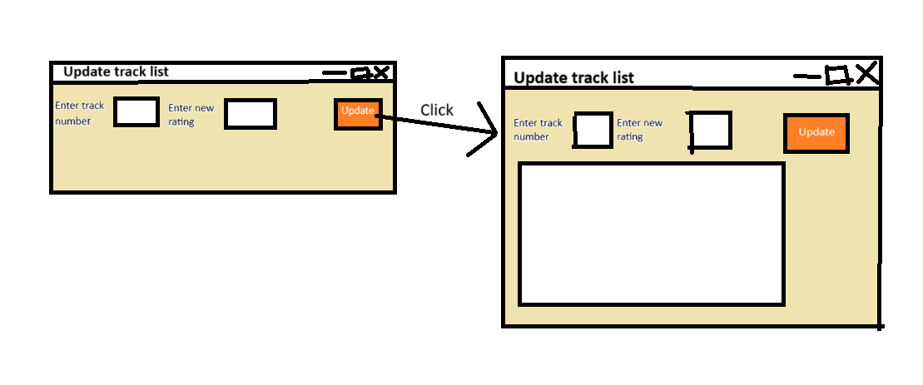

* Initial system analysis
* GUI design decisions and rationale
* Class structure and relationships
* Implementation approach
  + Development of create_track_list.py
  + Development of update_tracks.py
  + Integration with existing components
* Screenshots of program in operation

## 3. Testing and Faults

* Testing methodology
* Summary of test results
* Discussion of encountered issues
  + Resolved faults and corrections made
  + Unresolved issues and limitations
  + Validation implementation
* Unit testing approach and results

## 4. Conclusions, Further Development, and Reflection

* Summary of the program achievements
* Evaluation against original requirements
* Further development possibilities (what you would do with additional time)
* Reflection (choose one):
  + Option A: Achievements, difficulties faced and why, straightforward aspects and why
  + Option B: Personal development, knowledge and skills gained, long-term value

## 5. Innovations

* Innovation 1: [Name of innovation]
  + Description and rationale
  + Implementation details
  + Benefits and limitations
* Innovation 2: [Name of innovation]
  + Description and rationale
  + Implementation details
  + Benefits and limitations

## Appendices

### Appendix A: Commented Code (Stage 1)

* Complete commented version of view_tracks.py

### Appendix B: Test Table and Results

* Input values
* Actions performed
* Expected outputs
* Actual outputs
* Pass/fail status

### Appendix C: Full Source Code

* All Python files with brief descriptions