**Perspective Projections Project**

Background

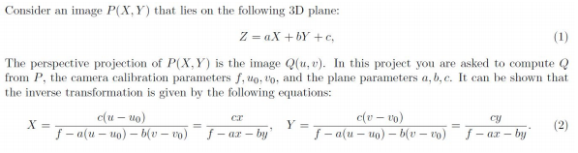

**Part I**

Write a program (OpenCV, python) that gets as input P, f; u0; v0, and a; b; c from the command line and displays Q. It should be executed as follows:

python3 mynetid1.py image f u0 v0 a b c

First, we want to get the Q. We have **two** ways.

1. Given X, Y, and calculate u, v from (2), and create 4 pair points and use cv2.getPerspectiveTransform to get transformation matrix.

But u, v is hard to calculate. And another way is Given u,v and calculate the X, Y, and create the 4 pairs point and use cv2.getPerspectiveTransform to get transformation matrix and get the inverse of the transformation matrix. Once we have transformation matrix, we can use cv2.warpPerspective to project the image

1. Simply, set the value in map_matrix below, and project it with cv2.warpPerspective

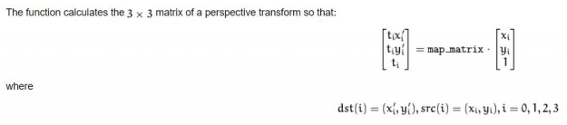

In this formula, x' = u, y' = v in Q(u,v) x = X, y = Y in P(X,Y) t = Z in (1)

map_matrix

[[c1,c2,c3],

[c4,c5,c6],

[c7,c8,c9]]

u = x' = (c1x+c2y+c3)/t

v = y' = (c4x+c5y+c6)/t

Z = t = (c7x+c8y+c9)

c1~c6: camera parameter c1

c5: focus parameter

c3,c6: u0,v0

c7 = a, c8 = b, c9 = c

The map_matrix will be set as

[[f,0,u0],

[0,f,-v0],

[a,b,c]]

**Part II**

Write a program (OpenCV, python) that gets as input the image P and c from the command line.

(All other arguments are hardcoded.)

python3 mynetid2.py image c

The two images to be displayed are defined as follows:

**Z = aX+bY+c**

**1. The left side of the image has a smaller Z value than the right side.**

We need to create a plan that slop is positive along the axis x.

Set a = 0.001

map_matrix

[[1,0,0],

[0,1,0],

[0.001,0,c]]

**2. The bottom side of the image has a smaller Z value than the top side.**

We need to create a plan that slop is negative along the axis y.

Set b = -0.001

map_matrix

[[1,0,0],

[0,1,0],

[0,-0.001,c]]