Libo

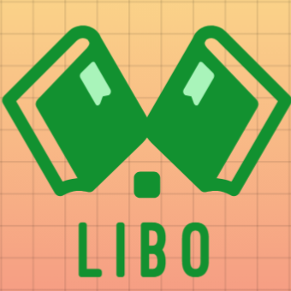

Table of Contents

Contents

About me 2

Stages 2

Coming up with idea 2

Software I used 3

Completed Tasks 4

# About me

|  |  |  |
| --- | --- | --- |
| Names | Role | Grade |
| Gabriel Dimitrov | Full-stack Developer | 10V |

# Stages

1. Come up with an idea
2. Distribute the tasks across the given time limit
3. Write the code

# Coming up with idea

1. Think of an interesting idea with educational purposes for children.
2. Make a plain design with good functionality.

# Software I used



Microsoft Teams – communication with teacher and mentor



GitHub – project storage



Microsoft Word – creating the documentation



Microsoft PowerPoint – creating the presentation



Visual Studio 2022 – writing the code

# Completed Tasks

|  |  |  |
| --- | --- | --- |
| № | Task | Status |
|  | Develop an idea | ✓ |
|  | Make a plan | ✓ |
|  | Start writing the code | ✓ |
|  | Debug | ✓ |
|  | Start working on the documentation and presentation | ✓ |
|  | Push all files to GitHub | ✓ |