Initial Setup
Open the challenge GUI. Open the correct database file if not already selected. Select the appropriate event from the pull down list of events. Initially, there will not be any challenges to select.

From the Challenge Menu, select New Challenge (Open, Ladies or Bonus). You will be asked to select the size of the bracket. This will always be a power of 2 (4, 8, 16, 32). If the number of drivers is not a power of 2, you can select the next largest size for the bracket.

Once the new challenge has been created, go to the challenge menu again and select Auto Load. This will bring up a dialog letting you select the drivers to add. For an open challenges, this will be all drivers in open classes, for a ladies challenges, this will be all drivers in a L* class and for a bonus challenge, it will simply be all drivers.

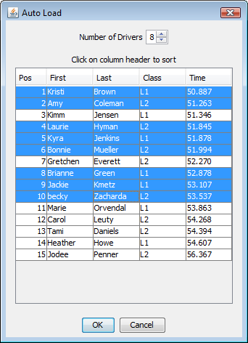
Set the number of drivers for the challenge in the top number selection. For most instances, this will be the size of the bracket but it could be a few drivers less in other situations. This setting will verify that you select the correct number of drivers.

Selecting drivers is done by holding the Ctl key and clicking or dragging across drivers. If you wish to order the list by name or class, click on the column header to do so. Once you have selected enough drivers, click OK. The bracket will be filled with the drivers selected and bracketed based on their net times. You may also drag and drop drivers from the tree on the left of the main window to enter them into a challenge but this is much more cumbersome.

Once, the challenge is ready, it may look something like so:

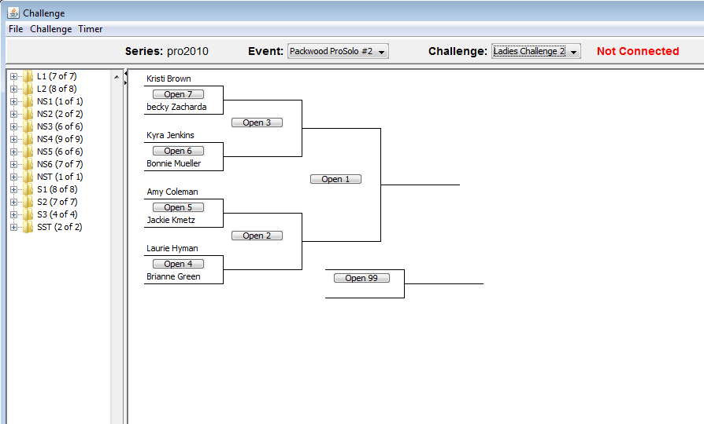
You will notice that there is a large red label in the top right indicating that the Challenge GUI is not connected to the Timer. When this occurs, the GUI can't set dial in times and the results won't make it back to the GUI. To remedy this, select Connect from the Timer menu.

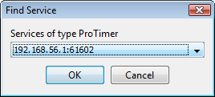
The connect dialog will pop up with all of the ProTimer services it can find on the network. There should be only 1. If nothing appears, you must verify that the firewall on either computer isn't interfering. Once selected, click OK and a connection will be made and the red label will disappear.

Running a Challenge
To run a challenge, you open up each round as the entrants pull up to the line by clicking the Open button for the corresponding round in the challenge tree.
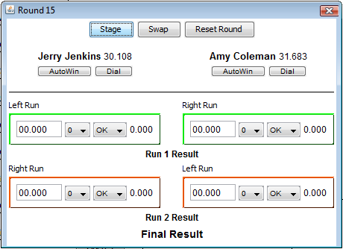
In this case, it expects Jerry to be starting on the left side and Amy to be starting on the right side. If they come up in different lanes, click the Swap button and they will be swapped in the window. Before the start can start the round, you must click Stage. This will send the dial in commands to the Pro Timer laptop. If the hardware approves, the dialins will appear at the top of the Pro Timer window. If not, you can try clicking stage again to resend them.

Once staged, the runs will have highlighted edges. Green indicates where the next set of run data to be received will be put. Red indicates the next location after that. Once a run is entered, you will see the green box return to black and the red box turn to green. If there were cones or a DNF called, the operators must manually enter those by selecting the appropriate value. Not Staged and Red Light errors will automatically be entered once the drivers passes through the finish lights. Once a round is over, the winner is automatically moved to the next round along. If the driver broke out, their new dialin is calculated and used in the next round.

In special cases, there are some other options you can use:
- The Dial button under each driver can be used to override the dialin for the driver in that round. This must be done before clicking stage.
- The Reset Round button can be used to remove all run data from the round if something went wrong and it has to be restarted.
- If a driver doesn't show up for the round, clicking AutoWin under the driver that did show up will move them to the next round.
- Entering a raw time into one of the run time boxes lets you overwrite the time that came from the hardware or if no time arrived due to a network error.

Understanding the Display
For the announcer, they are most concerned with the active round window. The main window will contain the entire challenge tree but the results appear in each round window. Initially, the only useful data will be the orange box. As the first half of the round ends, the top half of the results become available. After the second round ends, all the results will be available.
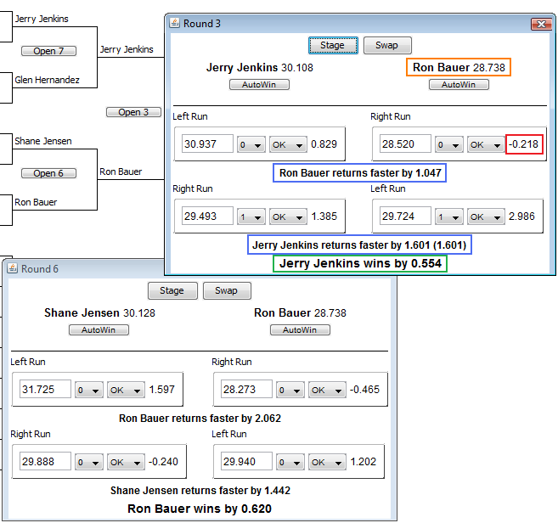
- Orange box is the drivers name and dialin
- Red box is the difference from their dialin for the individual run, includes cone penalty
- Blue boxes are the results of one half of a round, value in parenthesis is without cones
- Green box is the final result of the entire round, this field will also indicate a breakout and new dialin

