Evaluation area and the limits of cross-region transfer of wildfire susceptibility models in five Mediterranean fires
Emrehan Metin¹, Yunus Emre Cogurcu^{1*}
¹ Department of Computer Engineering, Faculty of Engineering, Çukurova University, 01330 Sarıçam, Adana, Türkiye
* Corresponding author Yunus Emre Cogurcu (ycogurcu@cu.edu.tr)
Yunus Emre Cogurcu (ORCID 0000-0002-9229-9657)
The main text (Sections 1 to 5, without tables, figure captions, equations, references and declarations) has 8,716 words, and the abstract has 247 words.

Acknowledgements
The authors thank the Department of Computer Engineering at Çukurova University for the laboratory environment in which this work was carried out.

Abstract
Wildfire susceptibility maps support prevention planning, yet are usually trained and evaluated in one region, and after a first large fire a model trained elsewhere may be the only one available. We tested such transfer in five Mediterranean regions, each with one large fire season in 2021 or 2022, namely Manavgat and Muğla (Türkiye), Bejís (Spain), North Evia (Greece) and Montiferru (Italy). Random forests used a terrain, land-cover and greenness baseline with and without six pre-fire land surface temperature (LST) and dryness predictors. Skill was the spatially blocked area under the receiver operating characteristic curve (ROC-AUC) against Moderate Resolution Imaging Spectroradiometer (MODIS) burned areas. Three results bear on hazard assessment. First, the evaluation area alone changed skill. Scored on the burn scar and a 2 km collar instead of region-wide, the same models lost 0.160 ROC-AUC on average (95% interval [0.090, 0.230]). Second, thermal predictors added +0.045 to +0.148 within regions at 5 km blocking, but only +0.007 [−0.020, +0.038] across twenty directions and +0.024 [−0.004, +0.049] on comparable areas. Third, none of twenty similarity measures was shown to predict transfer, and at point estimates the most similar pair of regions failed in both directions. Hotter surfaces burned less in four of five regions (two with interval support), consistent with LST describing land surface more than fuel dryness. Region and event effects are confounded. A model trained elsewhere should be tested against local burned areas before guiding prevention planning, and every score should name its evaluation area.
Keywords wildfire susceptibility · Mediterranean · model transferability · evaluation area · land surface temperature · spatial cross-validation

1 Introduction
Wildfire is a major disturbance in Mediterranean landscapes, and climate change is altering fire regimes (Pausas and Keeley 2021). Mediterranean fire policy needs to shift from suppression towards prevention and landscape management (Moreira et al. 2020), with susceptibility maps supporting this planning, as they already support spatial planning for landslides (Petschko et al. 2014). In the common workflow that most maps follow (Jain et al. 2020; Noroozi et al. 2024; Thies 2025; Zakari et al. 2025; Jodhani et al. 2026; Vibhandik et al. 2026), predictors and burned-area records train a classifier, most commonly a random forest (Breiman 2001; Oliveira et al. 2012; Tonini et al. 2020), which is then evaluated in the same region. Agencies with few local fire records may have to use a model trained elsewhere.

1.1 Transfer is rarely measured
Test folds usually come from the training area, season or fire. Random folds can inflate performance through spatial autocorrelation (Roberts et al. 2017; Ploton et al. 2020), while spatial blocking reduces this optimism (Meyer et al. 2018; Valavi et al. 2019), although its suitability for map accuracy assessment remains debated (Wadoux et al. 2021; Bruin et al. 2022; Milà et al. 2022). The area of applicability identifies locations where predictor values are sufficiently dissimilar from the training data, based on their distance in predictor space (Meyer and Pebesma 2021, 2022; Ludwig et al. 2023). However, neither approach establishes performance on an unseen fire. Transferability requires testing on spatially or temporally independent data (Wenger and Olden 2012) and is still an open problem in ecological modelling (Yates et al. 2018). In hazard modelling, error rates outside the training area have been estimated for landslides (Brenning 2005), and transfer between areas or countries has been tested for gully erosion (Mohebzadeh et al. 2024) and seismic damage (Ghimire and Guéguen 2024).
Few studies directly assess the transferability of fire models. Weather-driven fire-danger indices transferred poorly between fire environments in Peru (Podschwit et al. 2022). European operational fire-danger systems, including the European Forest Fire Information System, also rely on weather-based indices such as the Canadian Fire Weather Index (Vitolo et al. 2020), while major Mediterranean fires are driven by heat, wind and drought (Ruffault et al. 2020; Ghasemiazma et al. 2026). Regional fire-occurrence models transferred well across the Alps and Mediterranean Basin only under similar conditions, and a pooled model was more robust (Bekar et al. 2020). WildfireGenome (Liu and Mostafavi 2025) likewise found better transfer between similar US counties than dissimilar ones, but its response was a set of composite hazard indicators, and observed burned areas were not used. The closest Mediterranean study (Dimarco et al. 2026) evaluated a full transfer matrix across four countries using 500 m predictors, and all transfers achieved an AUC of at least 0.80, with higher scores between similar countries. However, its predictors described static place characteristics, and its response was human-caused ignition. A random forest susceptibility model covering thirteen eastern Mediterranean and southern Black Sea countries was trained on a decade of fire records (Trucchia et al. 2023), but fitting all regions jointly does not test transfer to a region without a fire record. More broadly, conclusions about wildfire models depend on how performance is evaluated (Xu et al. 2026).
When a model is transferred to a new region, its predictor distribution may change (covariate shift). Methods such as covariance alignment (CORAL) (Sun et al. 2016) are designed to reduce this shift without target labels. Domain adaptation more broadly is well established in remote sensing (Persello and Bruzzone 2012; Tuia et al. 2016), including approaches that decompose different sources of shift (Huang et al. 2026). However, the predictor-response relationship may also change (concept shift) (Moreno-Torres et al. 2012), and detecting a reversal in association requires target labels. We found no previous application of covariance alignment to fire susceptibility or burned-area prediction.

1.2 Pre-fire thermal state as a test case
Satellite measurements of the land surface before a fire are a third kind of predictor. They change from season to season like weather, but they describe each location like a map. Static predictors change little between years, so they cannot explain why one summer burned and another did not. Satellite thermal data can be used to estimate fuel moisture (Yebra et al. 2013), because land surface temperature (LST) rises as vegetation dries. LST combined with a vegetation index was used by Chuvieco et al. (2004) to estimate live fuel moisture for fire-danger rating, and the Temperature-Vegetation Dryness Index (TVDI) (Sandholt et al. 2002) is an internally normalised form of this approach, so one would expect it to transfer better than raw temperature. Pre-fire LST anomalies are related to the burned area and duration of later fires (Maffei et al. 2018, 2021), pre-fire optical moisture indices carry similar information (Maffei and Menenti 2019), and dead fuel moisture was the strongest predictor of human-caused ignition across Europe in a pooled model (Gelabert et al. 2025). Pre-fire evaporative stress from spaceborne thermal data has been used to predict unseen fires within one region (Pascolini-Campbell et al. 2025), and within-region susceptibility models exist for Turkish Mediterranean landscapes (Iban and Sekertekin 2022; Akıncı and Akıncı 2023). Satellite fuel-moisture models are, however, usually site-specific, and their transfer is rarely tested (Marino et al. 2024). To our knowledge, the transfer of a classifier that uses pre-fire thermal state to another region, without target labels, has not been tested. Large datacubes now support deep-learning fire-danger models (Kondylatos et al. 2023), whereas we used a simple fixed classifier so that only the evaluation changes. Surface predictors of this kind are meant to be used together with weather-driven danger ratings.

1.3 Evaluation area and similarity
In species distribution modelling, the evaluation area is known to affect the area under the receiver operating characteristic curve (ROC-AUC). Lobo et al. (2008) list it among the main reasons for caution when AUC values are compared, because a larger area adds more easy absences and raises the score. Related effects were shown for spatial sorting bias between training and test sites (Hijmans 2012), in a general analysis of AUC (Jiménez-Valverde 2012) and for calibration (VanDerWal et al. 2009), and the effect was described in general terms as the accessible area (Barve et al. 2011). In landslide susceptibility, including a large share of easily classified terrain changed the fitted relationships and raised the AUC (Steger and Glade 2017), and spatial-block validation with terrain-representative absences lowered the AUC from 0.941–0.954 under random partitioning to 0.728–0.747 (Dasarwar and Hindayar 2026), although in both studies the models were refitted for each design. We found no wildfire study that keeps the model fixed and changes only the evaluation cells, although region-wide scores are often read as if they described performance next to the fire.
If transfer cannot be assumed, it might still be predicted from the similarity of two regions. Species distribution studies disagree on this. Vesk et al. (2021) found that trait-based models did not predict worse with increasing geographic or environmental distance, whereas Rousseau and Betts (Rousseau and Betts 2022) found that transferability decreased with geographic distance and with extrapolation. Niche overlap can be measured with Schoener’s D and Warren’s I (Schoener 1968; Warren et al. 2008).

1.4 Objectives
We measured how far the skill of pre-fire thermal predictors transfers between five Mediterranean regions, each with one large fire season, and asked three questions.
- How much does the evaluation area change the score of one fixed model?
- Does within-region thermal skill transfer to another region without target labels? If the link between moisture stress and burning is general, thermal predictors should keep at least part of their value in a new region, and normalised channels such as the TVDI should transfer best, because they should be less affected by temperature differences between regions.
- Can the similarity of two regions predict transfer, so that a source region could be chosen before a fire?
We also tested two label-free adaptation methods (Sun et al. 2016), pooled training and the removal of predictors whose association reversed between regions. The analysis code, configuration and frozen outputs are public, so all results can be checked and re-run (Data availability).

2 Methods
We use the following terms throughout. A study area is the rectangle drawn around one fire. An evaluation frame is the set of cells on which a score is computed. The scar frame is a burned area together with a 2 km collar of unburned cells around it, and a distance collar keeps all cells within 5 or 10 km of any burned cell. We call a result supported when its 95 % interval excludes the null value (0.5 for an AUC, 0 for a difference). Label-free methods use target features but never target labels.
The within-region comparison, the transfer matrix, the two adaptation methods, the gap decomposition and the reversal test follow the fixed protocols of the processing pipeline. We recorded the twenty similarity measures on 8 August 2026, before the label correction of Section 2.2. We added the frame test (Section 2.12), the distance collars, the equivalence tests, the additional resampling units and the checks of Section S1 after the first results. They are exploratory, and we report them as such. Sections, figures and tables numbered with S (for example Section S1.2, Fig. S1 and Table S1) are in Online Resource 1.

2.1 Study regions and temporal windows
The five Mediterranean wildfire regions we analysed are Manavgat 2021 and Muğla 2021 in Türkiye, Bejís 2022 in Spain, North Evia 2021 in Greece and Montiferru 2021 in Sardinia (Fig. 1 and Table 1). Each region contributed one fire season, and each season was dominated by one large fire, although in Muğla several separate burned areas occurred in the same weeks. The events were not sampled from a defined population of fires, so the results describe large single-season events. Unlike susceptibility maps trained on multi-year fire inventories (Tonini et al. 2020; Trucchia et al. 2022), each model here was trained on the footprint of one fire season, so the task is closer to predicting which fuel burned during one large event. Each study area is a rectangle in EPSG:4326 around the fire. We did not clip it to the fire perimeter, so the unburned cells around each fire form the negative class.
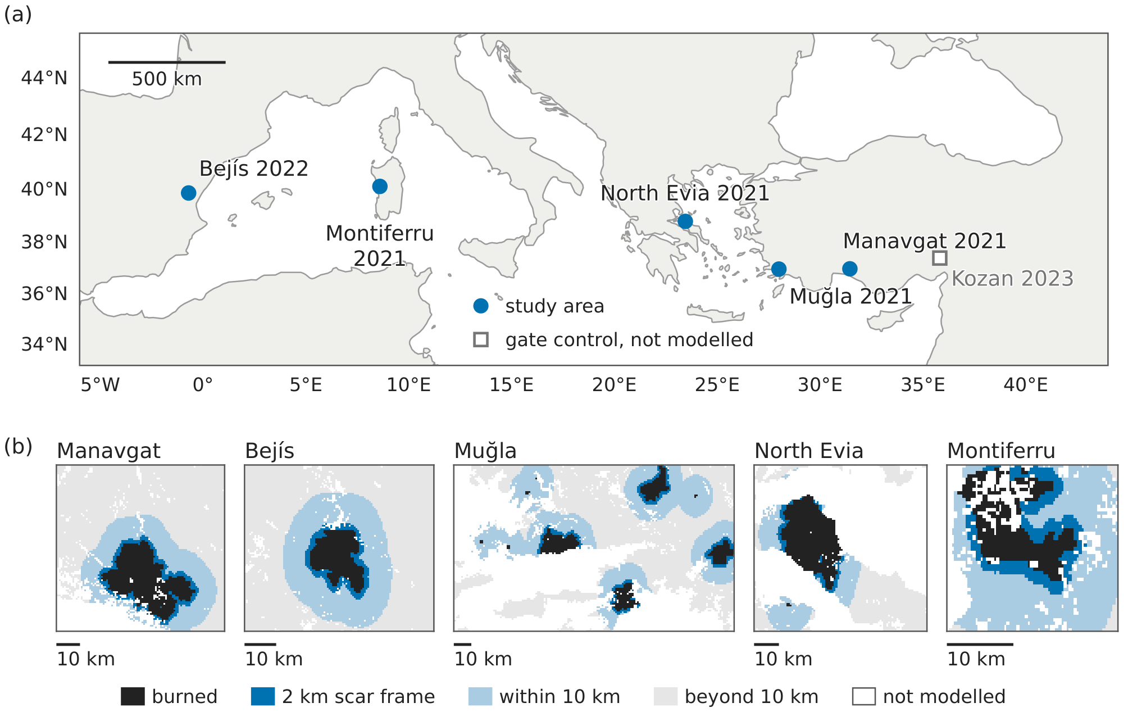
Fig. 1 Study regions and study areas. (a) Centres of the five study areas, which are Manavgat 2021 and Muğla 2021 (Türkiye), Bejís 2022 (Spain), North Evia 2021 (Greece, extended area) and Montiferru 2021 (Sardinia, Italy). Kozan 2023 is the negative control of the burned-landcover gate and is not used in any model. Mercator projection, with coastlines from Natural Earth 1:50 m. Country borders are not shown. The scale bar is exact at 38°N. (b) Each study area on the $∼$500 m analysis grid, at its own scale, with the cells of the evaluation frames of Section 2.12. Distances are to the nearest burned cell, and the scar frames surround scars of at least 50 burned cells. Not modelled are cells outside the natural-vegetation population. In Muğla one burned area reaches the eastern edge of the study area, so its collar is cut there. Bounding boxes are given in Table S13, and the share of distant cells in Table 1
Table 1 Study regions, time windows and modelled cells
Region | Predictor window | Label window | Cells | Burned | Prevalence | Gate fraction | Beyond 10 km
Manavgat 2021 (Türkiye) | 1 Jun to 27 Jul 2021 | 28 Jul to 31 Aug 2021 | 20,511 | 2,935 | 0.143 | 0.955 | 58.5 %
Bejís 2022 (Spain) | 15 Jun to 14 Aug 2022 | 15 Aug to 30 Sep 2022 | 15,190 | 1,100 | 0.072 | 0.991 | 63.1 %
Muğla 2021 (Türkiye) | 1 Jun to 28 Jul 2021 | 29 Jul to 15 Sep 2021 | 41,730 | 2,911 | 0.070 | 0.958 | 55.3 %
North Evia 2021 (Greece) | 5 Jun to 2 Aug 2021 | 3 Aug to 30 Sep 2021 | 9,298 | 2,664 | 0.287 | 0.945 | 43.7 %
Montiferru 2021 (Italy) | 25 May to 23 Jul 2021 | 24 Jul to 31 Aug 2021 | 2,544 | 539 | 0.212 | 0.723 | 2.1 %
Natural-vegetation (primary) population on the ~500 m grid. Both window ends are included, and the predictor window ends the day before the label window starts. Prevalence is the burned share of the modelled cells. Gate fraction is the share of burned cells dominated by natural vegetation (Section 2.3). Beyond 10 km is the share of modelled cells more than 10 km from any burned cell (Section 2.12). Bounding boxes and baseline years are given in Table S13.
The Manavgat fire burned 58,798 ha, 64 % of it in pure Turkish pine (Pinus brutia) stands. The Muğla study area contains all or part of several fires of the same weeks, among them those near Milas (17,164 ha), Marmaris (12,158 ha) and Köyceğiz–Dalaman (11,074 ha), each burning mainly Turkish pine (Eker et al. 2024). The North Evia fire burned 51,245 ha of pine and oak forest and of rural and urban land (Almeida et al. 2023). The Bejís fire burned 18,058 ha of Aleppo pine (Pinus halepensis) forest, holm oak (Quercus ilex) woodland and shrubland (Fernández-Guisuraga and Calvo 2023). The Montiferru fire burned about 13,200 ha, mostly herbaceous vegetation (39.5 %) and low shrubs (24.2 %), while holm oak woodland is the main forest type there (Almeida et al. 2023).
We did not fix all rectangles before any outcome was seen. Only the Montiferru rectangle follows a stated rule, and we extended the North Evia rectangle after the first one showed a very high burned fraction (Section S5.2, Table S13). We kept the first Evia rectangle as a sensitivity analysis (Section S1.2). A sixth region, Kozan 2023, was a negative control for the gate of Section 2.3, which excluded it.
Each region has two windows that do not overlap. The predictor window ends the day before the label window starts, so no predictor observation is later than the first labelled burning. Predictor windows were 57 to 61 days long and label windows 35 to 59 days. The baseline for the anomaly channels was the composites of the same calendar window in four earlier years. Fig. 2 shows the processing chain.
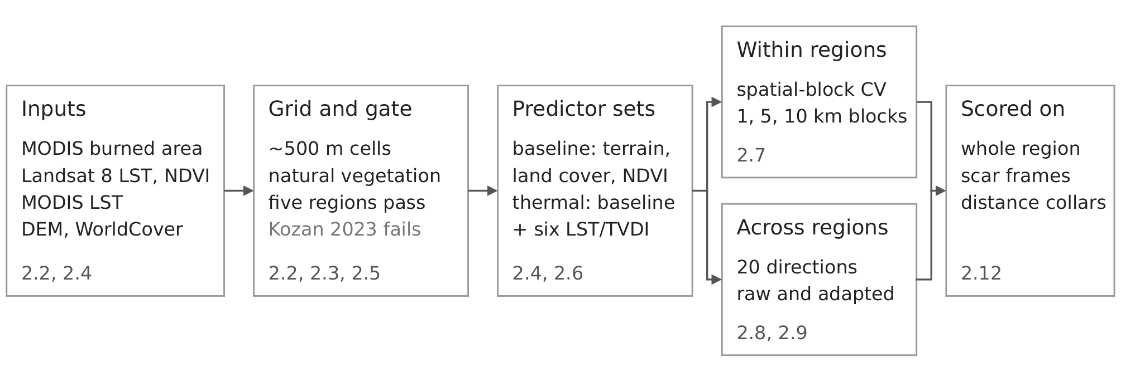
Fig. 2 Processing chain and evaluation design. Five source products are combined on the $∼$500 m analysis grid, and only regions that pass the burned-landcover gate are modelled. Kozan 2023 fails it, because 98% of its burned area is cropland. The baseline and thermal predictor sets are evaluated within regions by spatially blocked cross-validation and across regions in 20 directions, without and with label-free adaptation, and the scores are computed on the whole region, on scar frames and on distance collars. The small grey numbers give the Methods section. Leakage control, seed 42 and the spatial-block bootstrap (Section 2.13) apply throughout

2.2 Burned-area label and the ~500 m analysis grid
We took labels from the Moderate Resolution Imaging Spectroradiometer (MODIS) MCD64A1 burned-area product, Collection 6.1 (Giglio et al. 2018, 2021), through Google Earth Engine (Gorelick et al. 2017). Its errors (Boschetti et al. 2019) limit every model in this study. As a check, we repeated the within-region and transfer analyses with the Visible Infrared Imaging Radiometer Suite (VIIRS) VNP64A1 product (Giglio 2024) (Figs. S1 and S2). We sampled the MCD64A1 monthly burn-date layer onto the 30 m reference grid of the processing pipeline by nearest neighbour, so each ~500 m observation is repeated over the 30 m pixels below it, and built the analysis grid from this grid in blocks of 17 × 17 pixels. A cell is therefore about 510 m from north to south and 390 to 407 m from east to west, with an area of 0.199 to 0.208 km² (a MODIS cell is 0.215 km²). We labelled a cell burned when any of its pixels had a burn date in the label window, so a scar can grow by up to one cell at its edge. The population filter of Section 2.5 removes water cells.
Earlier burning. We removed cells that burned in the predictor window in Muğla (49 cells), North Evia (16) and Montiferru (61), while Manavgat had no burning in that window. Reports place the start of the Montiferru fire in the late afternoon of 23 July (Almeida et al. 2023) or on 24 July. Landsat 8 and Terra pass over in the morning, so no predictor observation shows the fire, and any cell that MCD64A1 dates to 23 July is among the 61 removed. In Bejís this removal was not applied, so 48 cells that burned before the label window were kept. We did not screen burning in the five previous years in any region. When we excluded those cells, the mean transfer gain fell from +0.007 to +0.003, while the within-region gain stayed positive in all regions (Table S12, Figs. S1 and S2).
Corrected Manavgat label. The label first used for Manavgat missed the first four days of the fire, 28 to 31 July. The corrected label only adds burned cells, and it raises the number of burned cells in the primary population from 784 to 2,935. In this paper, “original label” means the label before this correction, and Section S5.1 describes the correction and its control run.

2.3 Burned-landcover admissibility gate
Before modelling, each region had to pass a gate on the fraction of burned cells covered mainly by natural vegetation, using European Space Agency (ESA) WorldCover classes (Zanaga et al. 2022). We admitted a region if this fraction was at least 0.50 and at least 30 cells burned, and we rejected it as a cropland control if the cropland fraction was at least 0.50 (Section S5.1).

2.4 Predictor variables
We used ten predictors (Table S14). The baseline set contains elevation and slope from the Copernicus DEM GLO-30 (European Space Agency 2022), dominant land cover from ESA WorldCover v200 (Zanaga et al. 2022), and the median normalised difference vegetation index (NDVI) of the predictor window from Landsat 8 Collection 2 Level-2 (U.S. Geological Survey Earth Resources Observation and Science (EROS) Center 2020). These change little over one fire season. The thermal set adds six channels derived from Landsat 8 surface temperature, screened for quality and composited as the median of the predictor window. The six channels are current LST, its anomaly against the four baseline years, the TVDI (Sandholt et al. 2002), its difference from the baseline years, a downscaled LST and a fused LST. The last two use MODIS MOD11A1 v061 daytime LST (Terra, about 10:30 local time) (Wan et al. 2021) and a random-forest downscaling model to fill gaps in Landsat (0.11 % to 9.70 % of pixels, depending on the region). Because TVDI edges are fitted inside each study area and window, a TVDI value does not mean the same moisture state in two regions (Section S5.3). The median pixel had three to six clear Landsat observations in the predictor window, and one to seven in each baseline year (Table S15). We did not use Landsat 9.
To test whether normalised channels transfer better (Section 1.4), we also fitted the baseline with only the two anomaly channels, which are normalised against each region’s own baseline years, and with only the four channels of absolute surface state (Section S1.2). These four are current LST, current TVDI, downscaled LST and fused LST. The current TVDI is normalised within each scene but not against the baseline, so it belongs to the second set. As a descriptive weather reference, we compared the regional mean LST anomaly and TVDI difference with the ERA5-Land (Muñoz-Sabater et al. 2021) anomalies of air temperature and relative humidity in the predictor window (Table S1).
The six thermal channels carry about two signals. Current, fused and downscaled LST are correlated at 0.97 to 1.00 in every region, current LST and TVDI at 0.88 to 0.98, and the two anomaly channels at 0.71 to 0.94. Two principal components explain 92 % to 98 % of their variance (Section S5.3), so we read counts over the nine numeric predictors with care.
Land cover. WorldCover v200 is built from 2021 images, which is after the fire for the four 2021 events, so we repeated all analyses with the 2020 map (WorldCover v100 (Zanaga et al. 2021)). It changed the population by at most 43 burned cells in four regions, but added 142 burned cells in Montiferru, and no conclusion changed (Section S1.1).

2.5 Cell aggregation, validity and analysis populations
Cell values are means over the valid 30 m pixels of the cell. A cell is valid for modelling when NDVI, elevation and slope are available for at least 30 % of the cell and at least one land-cover pixel is valid, but thermal completeness is not required. The primary population contains the valid cells in which tree, shrub and grass cover together reach 0.50, so cropland and water are excluded. In this population, 0.1 % to 6.5 % of cells have at least one missing thermal value, depending on the region. We filled these values inside the model pipeline (Section 2.6), and missingness was not related to burning (AUC 0.49 to 0.51 in every region, Table S1). We used a secondary population of all valid cells only as a within-region sensitivity analysis in two regions (Section S1.1).

2.6 Classifier
We one-hot encoded land cover and replaced missing numeric values by the median and missing land cover by the most frequent class. We fitted these values inside each training fold, and on the source region only in transfer, so no test data were used in fitting (the adapted models of Section 2.9 are the only exception). The classifier is a random forest (Breiman 2001) with 300 trees, unlimited depth, min_samples_leaf = 3, balanced class weights and random_state = 42. We fixed these settings in advance, did not tune them, and used the same settings in every analysis.

2.7 Spatial-block cross-validation and bootstrap uncertainty
We blocked the cross-validation spatially. Cell $i$ at grid position $(r_{i},c_{i})$ is assigned to the block
$$b_{k}(i)=\left(⌊r_{i}/k⌋, ⌊c_{i}/k⌋\right). (1)$$
We drew five folds over whole blocks, stratified by label, so a block is never split between training and test. We report block sizes of $k$ = 2, 10 and 20 cells and write them as 1 km, 5 km and 10 km blocking.
Every score is a ROC-AUC on a named set of cells $F$, its evaluation frame. With $F^{+}$ the burned and $F^{−}$ the unburned cells of $F$, and $s_{i}$ the predicted score,
AUC(s;F)=1|F+| |F−|i∈F+​j∈F−​1(si>sj)+12 1(si=sj). (2)
This is the probability that a burned cell in $F$ is ranked above an unburned one, so the metric can change when the frame changes, even when no score changes (Section 2.12). We also report precision-recall AUC, because it reflects how a susceptibility map is used when burned cells are rare (Sofaer et al. 2019). The out-of-fold residuals stay spatially correlated beyond 5 km, in North Evia up to 20 to 40 km (Table S1), so intervals at 5 km blocking may be too narrow, and we give the 10 km results as a check.
We estimated uncertainty with a spatial-block bootstrap. We resampled blocks with replacement, 1000 times, with seed 42, and took the 2.5 and 97.5 percentiles as the interval. Differences are paired within each replicate, and the block size is given with every result. We resampled quantities with one value per transfer direction over the ten region pairs, and this pair-cluster bootstrap is the primary resampling unit for direction-level intervals. The five further units we compare in Section S1.3 are the naive bootstrap over directions, clustering by target region and by source region, a pigeonhole bootstrap that resamples sources and targets independently, and a leave-one-region-out jackknife. Quantities with one value per scar or per target region get a Student t interval, and a change with one value per region pair gets a pair-t interval, a Student t interval over the ten pairs. The effective sample is therefore ten pairs or five regions for direction-level intervals, and at most seven scars from three regions for scar-level intervals. Because scars are nested in regions, the region-level estimates are the primary ones for the frame test.

2.8 Cross-region transfer protocol
For each ordered pair of regions, we fitted the model on the source region and applied it to the target region. We used no target label (no refitting, threshold selection or calibration on the target). We transferred both feature sets, so the gain from the thermal block is a paired difference within each direction, and we computed all twenty ordered directions.
To ask whether the similarity of two regions predicts transfer, we used twenty similarity measures in five families (Table S11 and Section S4.5). The marginal family compares the predictor distributions. Its measures are dissimilarity in predictor space and the share of target cells inside the source’s area of applicability (Meyer and Pebesma 2021), climatic distance, and the accuracy of a domain classifier that separates source from target cells. The other families are geographic distance, niche overlap of the burned cells (Schoener’s D and Warren’s I (Schoener 1968; Warren et al. 2008)), the burned-patch regime, and the agreement of the signed associations of Section 2.10 between the two regions. We rank-correlated each measure with the raw thermal transfer AUC over the directions on which it is defined (Spearman’s ρ), with one pair-cluster bootstrap for all measures (2000 replicates, seed 42) and a permutation test over the 120 orderings of the five regions. Only the marginal measures and geographic distance can be computed before a fire.

2.9 Label-free domain adaptation
We tested two label-free methods on every direction and in both feature sets. Region-wise z-score standardises the numeric features of each region with its own statistics. CORAL after region-wise z-score then aligns the source covariance with the target covariance (Sun et al. 2016), with λ = 10⁻⁵. Both methods use target feature statistics, which are available before a fire, but never target labels. We did not choose λ by performance. We report its effect in Section S1.2 and give details in Section S5.6.

2.10 Transfer-gap decomposition and the reversal criterion
For a direction into a target, let $A_{w}$ be the within-region thermal AUC of the target, $A_{raw}$ the raw transfer AUC and $A_{ad}$ the transfer AUC after adaptation method $m$, all on the same target cells. We split the gap as
$$G=A_{w}−A_{raw}, R_{m}=A_{ad}−A_{raw}, U_{m}=A_{w}−A_{ad}, f_{m}=R_{m}/G, (3)$$
so that $R_{m}+U_{m}=G$. The recovered fraction $f_{m}$ is signed and is not clipped, so when adaptation lowers AUC, the recovery is negative and we report it as negative. Intervals come from the paired bootstrap of Section 2.7 (Section S5.5).
We measured the direction of each predictor with a signed univariate association, which is the ROC-AUC of each numeric predictor against burned, computed in each region and never folded to max(AUC, 1 − AUC). A value below 0.5 therefore shows a direction (the predictor is lower on burned cells). We call a reversal between two regions supported only when the two values are on opposite sides of 0.5 and each region’s own interval excludes 0.5. This is a per-comparison criterion, and we also report a Holm correction over each family of feature-by-pair comparisons (Section S3.2). A marginal reversal can also arise when the predictors are distributed differently in two regions, so it is not a direct test of a change in the predictor-burning relationship.

2.11 Interventions
Pooled training. In leave-one-region-out training, we trained a model on the other four regions together and tested it on the held-out region. We compared it with the mean of the four single-source models, because choosing the best single source would require target labels.
Removal of reversing features. We removed the two predictors whose reversal was supported under the original label, elevation_mean and lst_anomaly_mean, refitted all models, and also removed each predictor alone. We did not repeat the selection under the corrected label (Table S3). Because the two features were chosen from the same data, both results are post-selection estimates.

2.12 Evaluation frames and controls on the transfer path
Let $V_{R}$ be the primary population of region $R$ and $P_{R}⊂V_{R}$ its burned cells. The region-wide frame is $V_{R}$, the rectangle as drawn.
Scar frames. A scar is an 8-connected group $K$ of at least 50 burned cells. Its scar frame is
$$H_{K}=\left\{i∈V_{R}:\min_{j∈K}\left(|r_{i}−r_{j}|+|c_{i}−c_{j}|\right)≤m\right\}, (4)$$
with $m=4$ grid steps. On this grid the collar is therefore about 1.6 to 2.0 km wide along the axes and about 1.3 km along the diagonals, and all its unburned cells are next to the fire. We used four evaluations (Section 3.3). A scores the out-of-fold predictions of 5-fold blocked cross-validation ($k=10$) on $V_{R}$, and B scores the same predictions on $H_{K}$, so B is the same model scored on a different set of cells. C is leave-one-scar-out, in which a model fitted on $V_{R}\backslash H_{K}$ is scored on $H_{K}$. D averages, over the four other regions, a model fitted on that region and scored on $H_{K}$. Three controls reuse the predictions of A, namely a prevalence-matched sample, a negative-pool swap and a positive-pool swap (Section S2.1).
The two frames answer different questions. The region-wide frame asks where in a landscape a fire burned, which is the question behind prevention planning. The scar frame asks which cells next to the fire burned. This second question is harder, because spread, wind and suppression matter more there and label errors of the burned-area product are concentrated at scar edges. Two controls address the edge errors. The first excludes up to two cells at the scar edge, and the second is a placebo collar of the same shape placed away from any burned cell (Table S1).
Distance collars. The distance to the nearest burned cell and the collar of radius $r$ (5 or 10 km) are
$$d_{i}=0.45\min_{j∈P_{R}}∥(r_{i},c_{i})−(r_{j},c_{j})∥_{2}, F_{R}(r)=\{i∈V_{R}:d_{i}≤r\}. (5)$$
The 0.45 km step is a single value for both axes, so collar radii are nominal to within about 15 %. Every burned cell has $d_{i}=0$ and is kept, so only distant unburned cells are removed. In transfer, we fitted the model on $F_{s}(r_{s})$ and scored it on $F_{t}(r_{t})$. Fig. 1b shows the study areas, burned cells, scar frames and 10 km collars.
Distance within a region. To see how skill falls with distance inside one region, we fitted a model on one half of a region and scored the cells of the other half, grouped by their distance from the training cells (Section S2.2).
Every scar frame and distance collar is defined from burned cells. These frames therefore show how the evaluation area changes the metric, but they cannot be drawn before a fire.

2.13 Leakage control and reproducibility
We checked a list of forbidden columns at every model fit (coordinates, all burn-date and label-provenance columns, and the agreement fraction). The vegetation mask defines the population and is never used as a predictor. All randomness uses seed 42. Because the random-forest seed is fixed, direction-level intervals are conditional on one fitted source model. Refitting with ten seeds changed mean transfer by at most 0.003, but single directions by up to 0.049 (seed-to-seed standard deviation at most 0.015, Table S1), and this variation is not part of the direction-level intervals. Across five bootstrap seeds, every transfer verdict at 1 km blocking is stable, whereas at 5 km three verdicts change (Section S4.1).
Refitting every within-region model and all twenty CORAL transfers reproduced the frozen pipeline outputs exactly within regions and to within 1.3×10⁻⁸ in transfer (Section S5.7). Under scikit-learn 1.5.2 instead of 1.9.0, single-direction AUCs moved by up to 0.047 (Section S5.7), so exact reproduction needs the archived environment. Every input dataset is identified by its SHA-256 hash, and the reported numbers are checked automatically against the tracked outputs.
Claude (Anthropic; Opus-family models, July to October 2026) was used to write code, including the code that draws the figures, to check reported numbers, and to check grammar and improve sentence clarity. The authors reviewed all of its output, made every scientific decision and take full responsibility for the content of the publication.

3 Results

3.1 Study regions and the admissibility gate
All five regions passed the burned-landcover gate, and the negative control failed it. Kozan 2023 had a natural-vegetation fraction of 0.017 against the threshold of 0.50 and was excluded, whereas the five admitted regions had fractions of 0.723 to 0.991. The gate therefore separated the cases clearly, although one negative control cannot show that it always works. The extended North Evia rectangle kept the burned scar almost unchanged and gave a burned prevalence of 0.287 in the primary population (Section S1.2).

3.2 The thermal gain within regions
Adding the thermal predictors to the baseline raised the spatially blocked out-of-fold ROC-AUC in every region (Fig. 3 and Table 2). The interval of the gain excluded zero in all five regions at 1 km and at 5 km blocking. At 10 km blocking the point estimates stayed positive, from +0.047 to +0.154, but they rested on only 6 to 33 blocks that contain burned cells, so they are indicative. The gain also stayed positive, with interval support in all five regions, when the predictor window was closed up to two weeks earlier (Fig. S1), and at the point estimates in all five regions with labels from VIIRS VNP64A1 instead of MCD64A1. When terrain aspect was added to both feature sets, the gain stayed supported in four regions (+0.044 to +0.139) but fell to +0.020 [−0.025, +0.066] in Montiferru (Fig. S1).
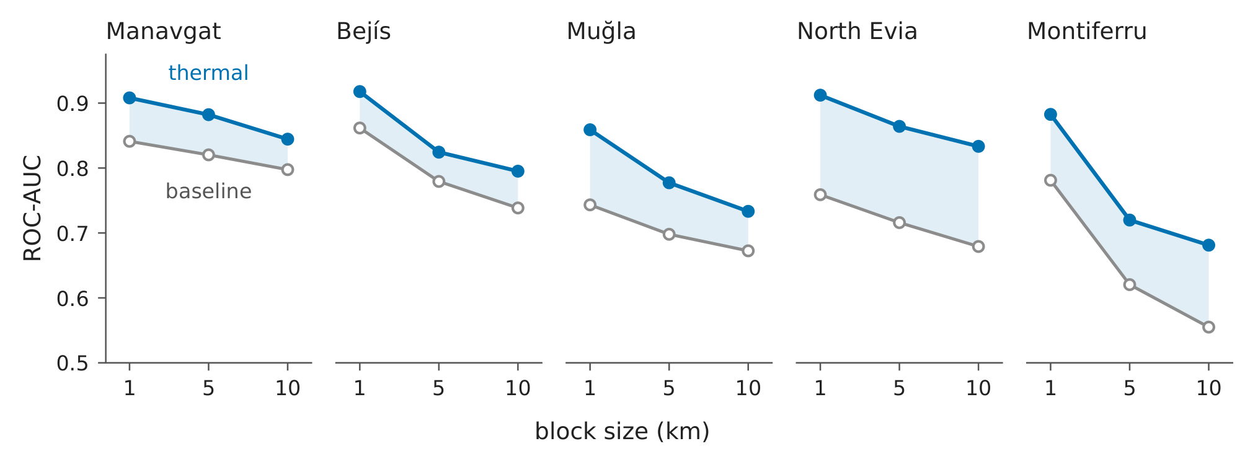
Fig. 3 The within-region thermal gain in all five regions, by block size. Natural-vegetation population, random forest and spatially blocked five-fold cross-validation. Each panel shows, for one region, the area under the receiver operating characteristic curve (ROC-AUC) of the baseline and thermal sets with blocks of 2, 10 and 20 cells ($≈$1, 5 and 10 km). The shaded band is the thermal gain. Skill falls as the blocks become larger, and the thermal set stays above the baseline at every block size. The 95% spatial-block bootstrap interval of the gain (1000 replicates, seed 42) excludes zero in all regions at 2 and 10 cells. At 20 cells only 6 to 33 blocks contain burned cells, so these values are indicative (Table 2, note)
Table 2 Within-region baseline versus thermal performance and block-size robustness
Region | Block | Baseline | Thermal | ΔAUC | 95% CI
Manavgat 2021 | 2 | 0.841 | 0.908 | +0.067 | [+0.060, +0.073]
 | 10 | 0.820 | 0.882 | +0.062 | [+0.040, +0.082]
 | 20 | 0.798 | 0.845 | +0.047 | [+0.016, +0.081]
Bejís 2022 | 2 | 0.862 | 0.918 | +0.056 | [+0.048, +0.065]
 | 10 | 0.779 | 0.824 | +0.045 | [+0.018, +0.069]
 | 20 | 0.739 | 0.795 | +0.057 | [+0.031, +0.090]
Muğla 2021 | 2 | 0.743 | 0.859 | +0.116 | [+0.106, +0.125]
 | 10 | 0.698 | 0.777 | +0.079 | [+0.050, +0.105]
 | 20 | 0.673 | 0.733 | +0.061 | [+0.030, +0.094]
North Evia 2021 (ext.) | 2 | 0.759 | 0.912 | +0.153 | [+0.142, +0.166]
 | 10 | 0.716 | 0.864 | +0.148 | [+0.119, +0.182]
 | 20 | 0.679 | 0.833 | +0.154 | [+0.124, +0.189]
Montiferru 2021 | 2 | 0.781 | 0.883 | +0.101 | [+0.080, +0.125]
 | 10 | 0.620 | 0.720 | +0.099 | [+0.017, +0.186]
 | 20 | 0.555 | 0.681 | +0.126 | [+0.053, +0.228]
Primary (natural-vegetation) population, spatially blocked 5-fold cross-validation (Section 2.7) and a paired spatial-block bootstrap with 1000 replicates. Block sizes of 2, 10 and 20 cells correspond to about 1, 5 and 10 km. The Baseline and Thermal columns are ROC-AUC, and the 95 % confidence interval (CI) belongs to ΔAUC. Source files are listed in Online Resource 1. At 10 cells (about 5 km), every region has 16 to 70 blocks with burned cells, so this is the coarsest blocking that the design supports. The 20-cell rows are indicative. Block counts are given in Section S5.4.

3.3 The effect of the evaluation frame within one region
Within one region, we compared four evaluations (Table 3). The last three were scored on the same cells and differed only in their training data.
Table 3 The four evaluations of the frame test
Evaluation | Model trained on | Scored on | Mean AUC | 95 % CI
A. Blocked cross-validation | the region, scar included | the whole region | 0.773 | [0.729, 0.818]
B. Same blocked model, restricted | the region, scar included | the scar area | 0.640 | [0.544, 0.736]
C. Leave-one-scar-out | the region, scar withheld | the scar area | 0.546 | [0.488, 0.604]
D. Foreign region | another region, 306 to 2,802 km away | the scar area | 0.553 | [0.495, 0.611]
Primary population, 5 km blocking. Rows B, C and D are scored on the scar frame. Row A is the whole region and is shown to make the difference visible. Means and Student t intervals are over the seven scars that allow row C (four in Muğla, two in Montiferru and one in Evia). The t intervals treat scars as independent, and region-level estimates are given in the text. Cell counts per scar are in Fig. S4.
The same model scored lower on the scar frame, although rows A and B used the same predictions. Over the seven scars of Table 3, A minus B was 0.133 [+0.060, +0.207]. The primary estimate uses all nine scars, including the single scars of Manavgat and Bejís, which have no row C (Fig. S4). With the region as the unit, the change then cost +0.160 [+0.090, +0.230] over five regions, and +0.137 [+0.048, +0.226] over the three regions of Table 3. The seven-scar interval is too narrow, because row A is repeated for each scar of a region. With the region as the unit, the fall from A to C was +0.266 [−0.022, +0.553], so only the frame cost is established at the region level. The two frames answer different questions (Section 2.12), so the region-wide score is not a biased version of the scar score, although it was the more optimistic of the two in all nine scars.
The cost came from the unburned cells next to the fire. Over nine scars, scoring the predictions on a random sample with the same burned fraction as the scar frame changed nothing (−0.002 [−0.005, +0.001]), as expected, because ROC-AUC does not depend on class balance. Scoring them on the scar frame cost +0.149 [+0.087, +0.211]. Replacing only the unburned cells explained 0.139 [0.098, 0.181] of this, and replacing only the burned cells −0.002 [−0.055, +0.051] (Section S2.1). A placebo collar of the same shape, placed away from any burned cell, reproduced the region-wide score, and excluding up to two cells at the scar edge left the cost at 0.145 or more with the region as the unit (Table S1). Across regions, the cost showed no relation to the share of distant cells in the study area (slope 0.005 [−0.41, +0.42], n = 5), although this test has little power.
Withholding the fire or moving the model had no measurable cost, but the test was weak. B minus C, the effect of withholding the scar, was +0.094 [−0.012, +0.200]. C minus D, the effect of using a model from 306 to 2,802 km away, was −0.007 [−0.070, +0.057]. Both intervals included zero, and both evaluations were close to chance. In Evia, however, withholding the scar left only 11 burned cells for training. In Muğla alone, where every held-out case kept a well-trained model, C and D were 0.579 and 0.586. With region-level clustering the intervals widened strongly (for example, the difference in thermal gain between rows C and D widened from [−0.061, +0.094] to [−0.154, +0.186]). Effects of up to about 0.2 therefore cannot be excluded.
On the scar frame, the thermal gain was not established. Averaged over the seven scars at 5 km blocking, with Muğla counted four times, the region-wide gain was +0.095. On the scar frame the same predictions gave +0.021 [−0.059, +0.100], leave-one-scar-out +0.024 [−0.040, +0.089], and a foreign model +0.008 [−0.021, +0.038]. Most of the fall therefore came with the change of scored cells. Changing the training data moved the gain little after that, but with effects of up to about 0.2 not excluded, the data do not resolve this (Section S2.1).

3.4 The frame effect between regions
The five study areas differed strongly in how many distant unburned cells they contained. The share of cells more than 10 km from any burned cell was 2.1 % in Montiferru and 63.1 % in Bejís (Fig. 1b and Table 1). In Manavgat, the median elevation of the modelled cells rose from 330 m within 5 km of the fire to 1,273 m at 20 to 50 km, while the burned cells had a median of 287 m.
To make the study areas comparable, we restricted every region to cells within 10 km of any burned cell, which removes only distant unburned cells. Table 4 compares transfer on these collars with transfer on the original areas. Mean transfer rose from 0.527 to 0.589, and the number of directions below chance fell from seven to five. The thermal gain rose from +0.007 to +0.024, and the static baseline rose with it, from 0.519 to 0.565.
Table 4 Cross-region transfer on the original study areas and on the distance collars
Frame (source and target) | Mean thermal AUC | Mean baseline AUC | Δ [95 % CI] | Below 0.5 (point) | Supported above / below | W − T [95 % CI]
As drawn | 0.527 | 0.519 | +0.007 [−0.020, +0.038] | 7 | 9 / 6 | +0.079 [+0.014, +0.145]
10 km collar | 0.589 | 0.565 | +0.024 [−0.004, +0.049] | 5 | 13 / 2 | +0.059 [+0.007, +0.110]
5 km collar | 0.591 | 0.574 | +0.017 [−0.004, +0.036] | 4 | 11 / 0 | +0.026 [−0.012, +0.063]
Twenty ordered directions, primary population, thermal feature set unless stated. The below-chance count is a point count. “Supported above / below” counts directions whose interval excludes 0.5, from a 10-cell (about 5 km) target-block bootstrap. Δ is the paired thermal-minus-baseline difference with a pair-cluster bootstrap interval, 1000 replicates (with 20,000 replicates, as in Fig. S3, the collar interval is [−0.003, +0.051]). W − T is the within-region thermal gain minus the transfer gain, averaged by target region, with a Student t interval over the five targets.
The thermal gain in transfer was small on every frame. On the 10 km collar its interval included zero under the primary resampling unit. Of the five other units that can be computed, two excluded zero, namely clustering by target region and clustering by source region (Fig. S3). In an exploratory equivalence test with a margin of ±0.05, the gain was within the margin under all six units that can be computed on the original areas and under four of six on the collar (Section S1.3). The margin was set after the results and is close to the smallest within-region gain (+0.045), so the test does not show that the transfer gain is negligible relative to local gains. The difference between the within-region and transfer gains (W − T) was positive on the original areas and on the 10 km collar, but not on the 5 km collar (Table 4).
On the collar, four regions agreed in sign on elevation, LST and TVDI, and Manavgat was on the other side of 0.5 on all three. Its elevation association was 0.376 [0.300, 0.465], against 0.606 [0.525, 0.685] in Muğla and 0.648 [0.550, 0.740] in Evia (Bejís and Montiferru in Table S4). Under the per-comparison criterion of Section 2.10, two reversals were supported on the collar, both on elevation and both involving Manavgat. They were not the same pairs as on the original areas. Manavgat against Muğla was supported on both frames. Manavgat against Evia became supported on the collar, because the Evia interval excluded 0.5 only there. Manavgat against Bejís lost support narrowly (the Bejís interval, [0.496, 0.722], missed 0.5 by 0.004). Neither collar reversal survived a Holm correction over the ninety feature-by-pair comparisons (adjusted p = 0.33 and 0.79, Section S3.2).
In four of five regions, a hotter pre-fire surface was associated with less burning at the point estimates, the opposite of what the dryness idea predicts. In Manavgat the burned cells were hotter (current LST 0.665 on the original area), but they were also low-lying. When elevation was held constant through deciles, the Manavgat LST association fell to 0.403 [0.343, 0.464] on the collar, and after the linear effect of elevation was removed it was 0.409 [0.350, 0.475]. On the original area the same values were 0.455 and 0.446, with intervals that include 0.5 (Section S3.3).
The sign-agreement fraction, which is built from these signed associations, did not predict transfer on the original areas (ρ = +0.52 [−0.27, +0.87]) or on the collar (ρ = +0.38). Its cosine version predicted collar transfer at ρ = +0.57 [+0.05, +0.88]. However, this is one of about forty uncorrected tests, on a frame defined by the labels, so we report it but do not use it (Section S3.2).
The within-region gain survived the collar and stayed positive in all five regions, with a mean of +0.083 against +0.087 on the original areas.
The transfer shortfall remained on matched frames. On the 10 km collar at 5 km blocking, the within-region reference was 0.786, and transfer was +0.197 [+0.091, +0.303] below it (Student t over the five targets). Manavgat had the largest shortfall (+0.319).

3.5 Cross-region transfer on the original study areas
These results use the original study areas and should be read together with Section 3.4. Values for each direction are given in Table S8.
Transfer varied widely, and some directions were below chance. Target AUC ranged from 0.314 to 0.677 (Fig. 4). At 5 km blocking, nine of twenty directions were above chance with interval support, six were below and five were uncertain, whereas at 1 km blocking the intervals were narrower (Section S4.1). Two below-chance directions, Manavgat to Bejís and Muğla to Manavgat, kept interval support on the collar. Manavgat was the weakest target, with a mean of 0.435 against 0.494 to 0.572 for the other targets. Without the eight directions that involve Manavgat, mean transfer was 0.566, which is still far below within-region skill (Fig. S2).
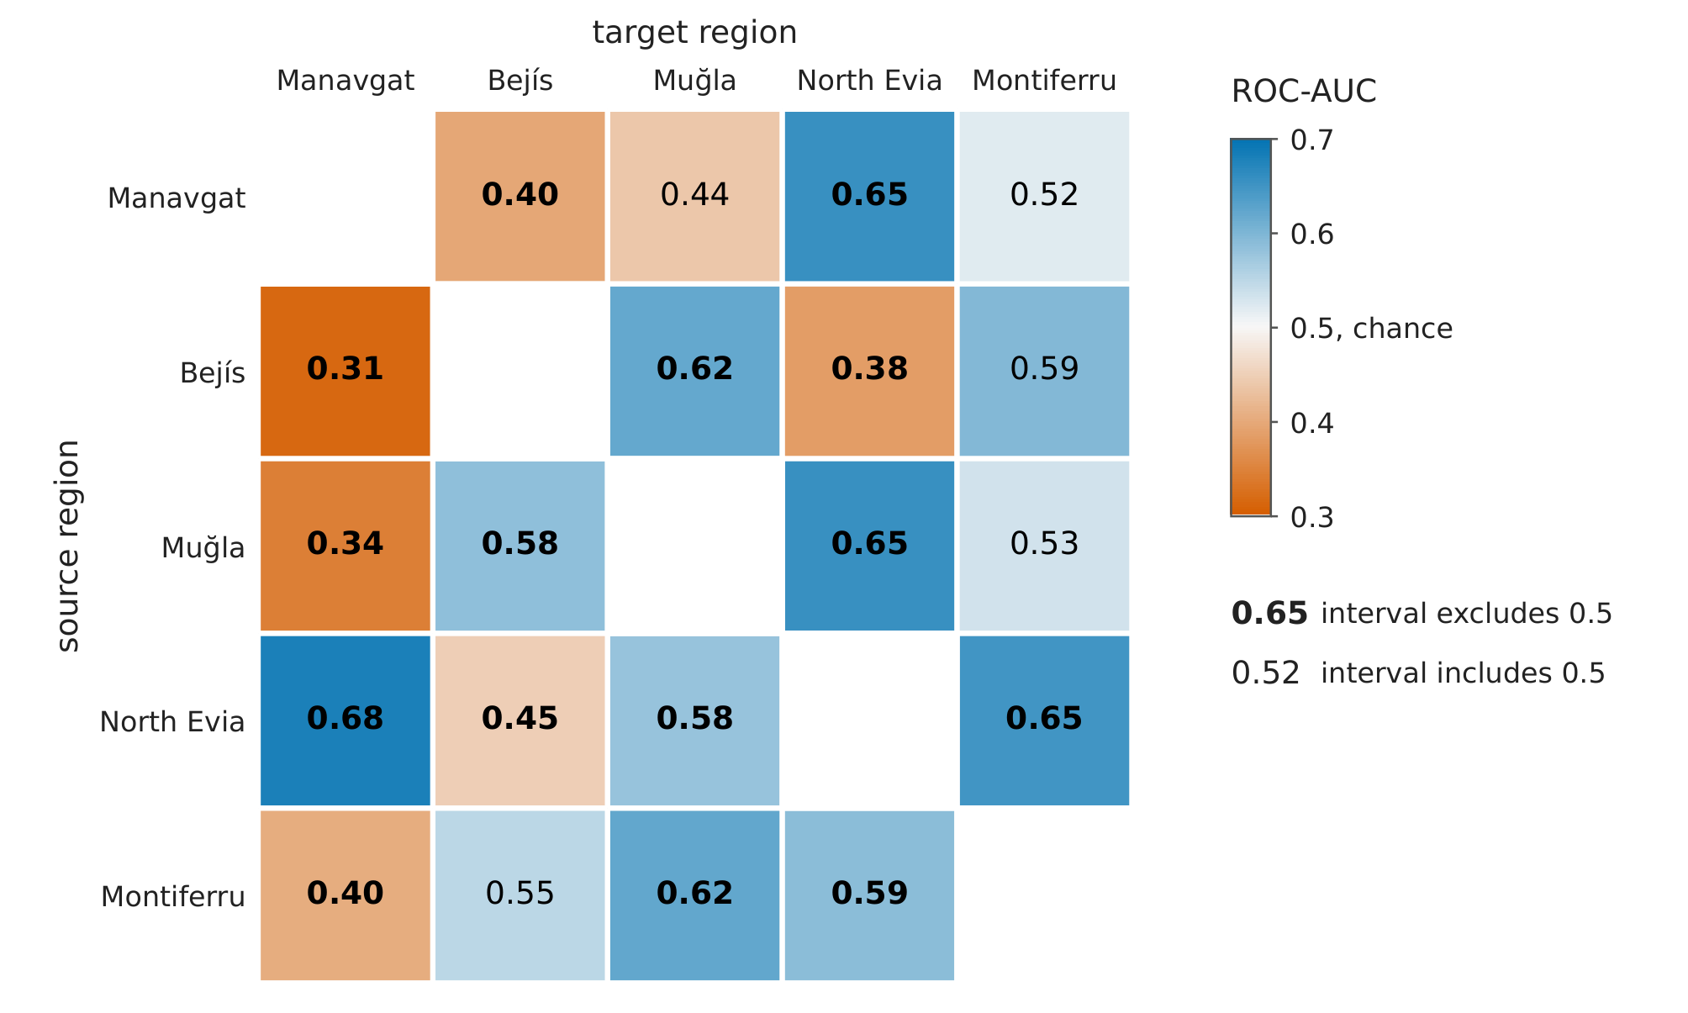
Fig. 4 Cross-region transfer without adaptation. Thermal transfer ROC-AUC for the 20 ordered directions, on the natural-vegetation population and the original study areas. Rows are source regions and columns are target regions. The diagonal is empty. Values range from 0.314 to 0.677 and are printed to two decimals. The interval in the key is the 95% spatial-block bootstrap interval with 10-cell ($≈$5 km) target blocks, which excludes 0.5 in fifteen directions, nine above and six below chance. Intervals are given in Table S8
Skill also fell with distance inside one region. A model fitted on one half of a region reached a mean target AUC of 0.709 within 5 km of its training cells, 0.570 at 5 to 10 km and 0.519 at 10 to 20 km (Fig. S5, where the distance bins have no intervals).
In precision terms, transfer was weaker still. Precision-recall AUC averaged 0.181, against a no-skill baseline of 0.157 (the baseline of each target is its burned prevalence, which ranges from 0.070 to 0.287). The median lift over the baseline was 1.18, and seven of twenty directions were below their own baseline. At 5 km blocking, two of these seven had intervals below the baseline, both into Manavgat (Table S10). In map terms, the 10 % of target cells with the highest scores contained on average 10.3 % of the burned cells, which is what a random ranking gives, and eight of twenty directions did worse. Within regions, the same share was 35.5 % (Table S1).
The static baseline did not transfer either (mean 0.519, against 0.527 for the thermal model), so the failure is not specific to the thermal predictors. Simpler models did not transfer better. A forest of depth 6 with at least 50 cells per leaf, a forest with at least 200 cells per leaf and a penalised logistic regression reached 0.527, 0.522 and 0.481, and their thermal contributions to transfer were −0.011, −0.019 and −0.021, all with pair-cluster intervals that include zero (Fig. S2).
The normalised channels did not transfer better than the absolute ones. Added to the baseline, the two anomaly channels gave a mean transfer AUC of 0.524 and the four absolute channels 0.531. Per direction the difference averaged −0.006, was positive in 11 of 20 directions and ranged from −0.099 to +0.087 (Section S1.2). Within regions the two sets were almost equal (0.862 and 0.864).
The paired thermal gains ranged from −0.148 to +0.132, with twelve positive and eight negative, and a mean of +0.007. The directions are not independent, because each region appears in eight of them. Accordingly, all six resampling units that can be computed on this frame gave intervals that include zero, from [−0.006, +0.022] (clustering by target region) to [−0.028, +0.045] (pigeonhole bootstrap, Fig. S3). A crossed random-effects model with source and target intercepts gave the widest interval, +0.007 [−0.035, +0.050]. It is a more conservative analysis of the same directions and does not confirm the result independently (Fig. S3).
The two label-free adaptation methods moved transfer toward chance (Fig. 5). Under region-wise z-scoring the twenty directions ranged from 0.302 to 0.630, and under CORAL from 0.406 to 0.624. Under CORAL, sixteen of twenty directions moved closer to chance, which helped the directions that failed and harmed those that worked, so the mean fell from 0.527 to 0.517. Choosing the better method in each direction gave 0.523, but this choice uses target labels. In the gap decomposition, which was computed before Montiferru was added and covers the twelve directions among the other four regions, seven directions showed negative recovery, five of them with intervals below zero (Section S4.2). A movement toward chance is also what any loss of information would produce. Aligning the source with the covariance of a third, unrelated region moved 15 of 20 directions toward chance as well (mean 0.507), and a stronger regularisation (λ = 1, mean 0.512) did not help (Section S1.2). These results therefore do not show that the methods removed a distribution shift.
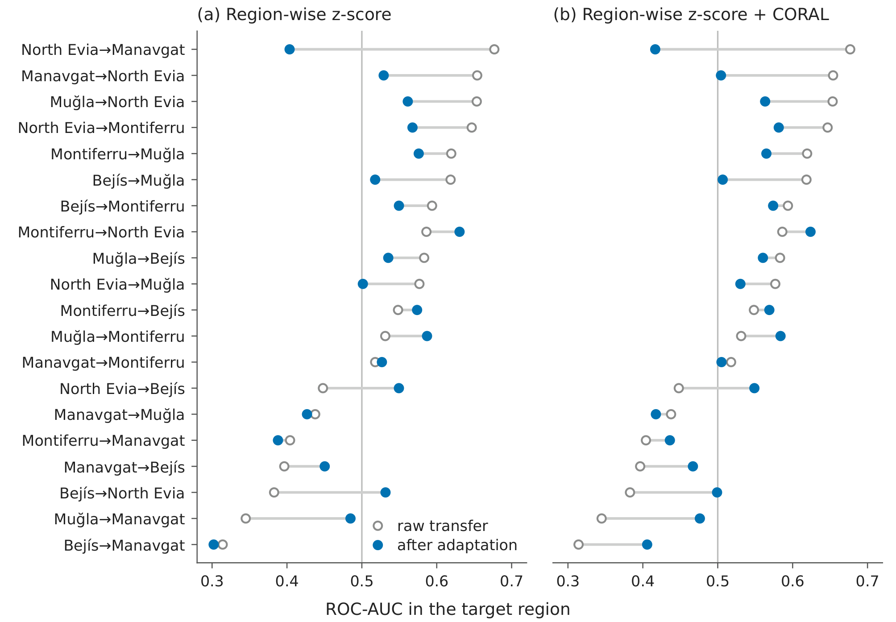
Fig. 5 Label-free adaptation moves transfer toward chance. All 20 ordered directions, sorted by raw transfer ROC-AUC, on the natural-vegetation population and the original study areas. Each row joins the raw value to the value after adaptation by (a) region-wise z-score or (b) CORAL after region-wise z-score. Neither method uses target labels. Thirteen directions move closer to chance under z-scoring and sixteen under CORAL, and the mean moves from 0.527 to 0.510 and to 0.517. The vertical line is chance. Values and intervals are given in Table S8

3.6 Further results
A model trained on the other four regions together was better than the mean single-source model for one target of five, Evia (0.715 [0.668, 0.757] against 0.569), and worse for the other four at the point estimates (Fig. 6).
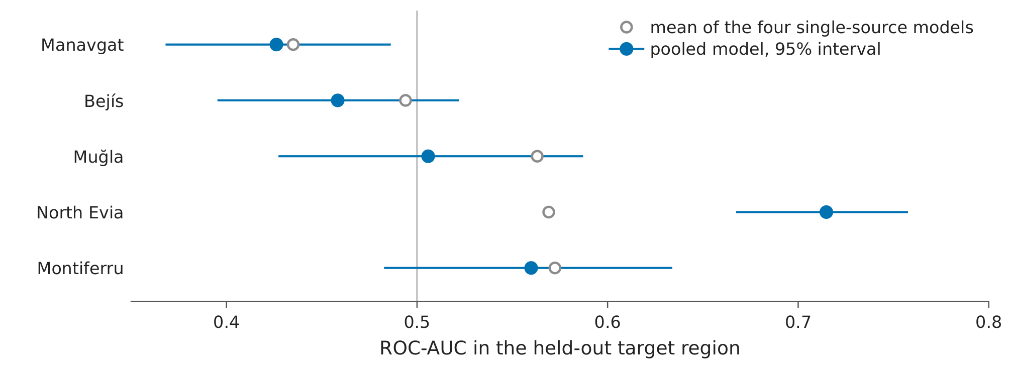
Fig. 6 Pooling the other regions helps one target of five. For each held-out target, the mean of the four single-source models and a model trained on the other four regions together, with its 95% spatial-block ($≈$5 km) bootstrap interval. Natural-vegetation population and thermal feature set, without adaptation. The pooled model is better than the mean single source only for North Evia, at 0.715 [0.668, 0.757] against 0.569. For Manavgat and Bejís it is below chance at the point estimate (0.426 and 0.458), and only the Manavgat interval lies fully below chance. The vertical line is chance
Removing the two reversing features lowered within-region AUC by 0.076 and changed transfer by +0.014 [−0.018, +0.049] under the primary pair-cluster bootstrap, which includes zero. The pair-t interval plotted in Fig. 7 is +0.014 [−0.028, +0.056] (Section S1.2).
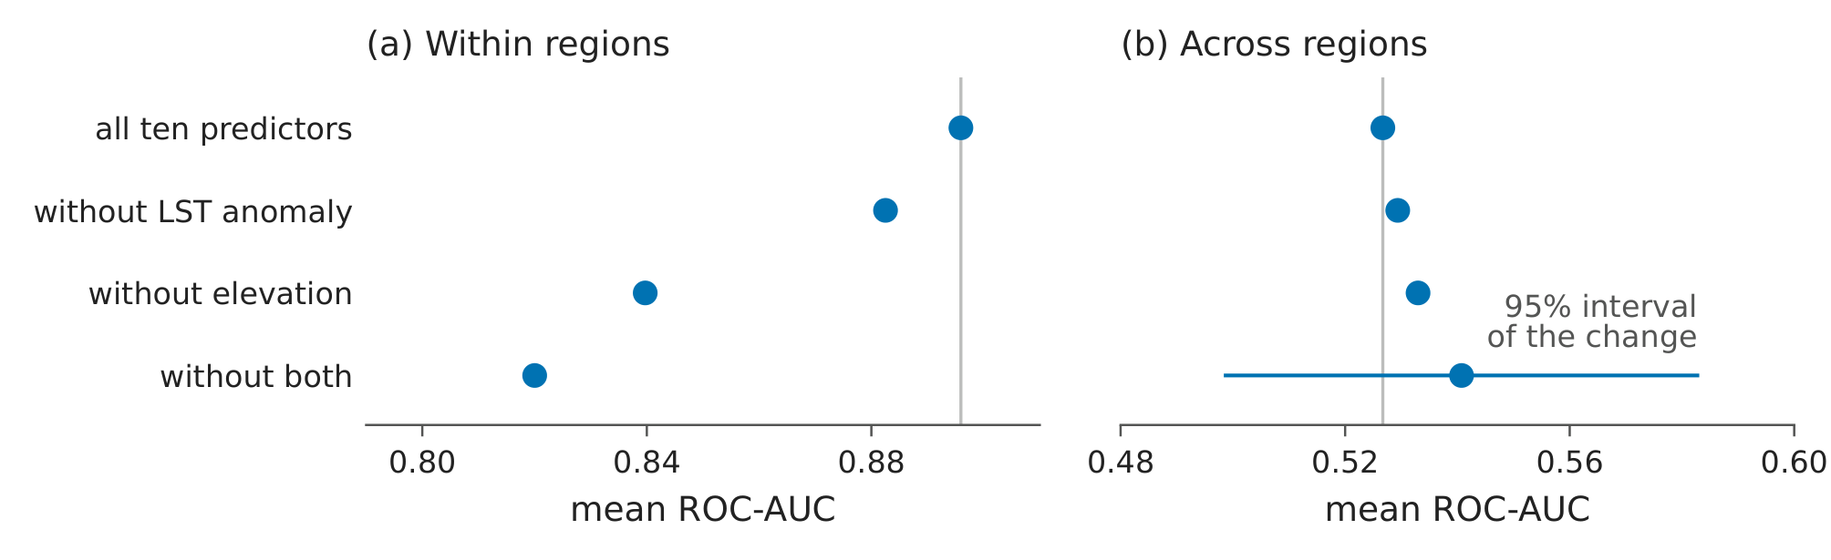
Fig. 7 Removing the reversing features costs local skill and gives no measurable transfer gain. The four feature sets are all ten predictors and the sets without the land surface temperature (LST) anomaly, without elevation and without both. (a) Mean within-region ROC-AUC over five regions at 1 km blocking. (b) Mean transfer ROC-AUC over 20 directions. Both axes span 0.12 ROC-AUC, and the vertical lines mark the full set. Within-region skill falls (0.896 $→$ 0.820), a cost of 0.076 that is supported in every region, while mean transfer rises (0.527 $→$ 0.541). The horizontal line in (b) is the full-set level plus the pair-$t$ interval of this change over ten region pairs, [$−$0.028, $+$0.056]. It crosses the vertical line, so zero change is included (the primary pair-cluster bootstrap gives [$−$0.018, $+$0.049])
The twenty similarity measures were not changed after the label correction. On the original study areas, none predicted transfer with an interval that excludes zero (Table S11), and in a permutation test over all 120 orderings of the five regions no measure reached p < 0.10 (Section S4.5). Under the original Manavgat label, the two largest conditional measures, the sign-agreement fraction and its cosine, had intervals that excluded zero (+0.84 and +0.81). After the label correction they did not, so this null result depends on the correction (Section S4.5). None of the measures that can be computed before a fire predicted transfer (Section S4.5). The contrast pairs illustrate this at the point estimates (Fig. 8). Manavgat and Muğla have the highest niche overlap in the cohort (mean one-dimensional Schoener’s D = 0.80), but transfer was below chance in both directions, at 0.438 and 0.345. Conversely, Bejís and Montiferru have the lowest overlap (D = 0.48), but transfer was above chance in both directions, at 0.594 and 0.548. At 5 km blocking only Muğla to Manavgat kept interval support (Fig. 8).
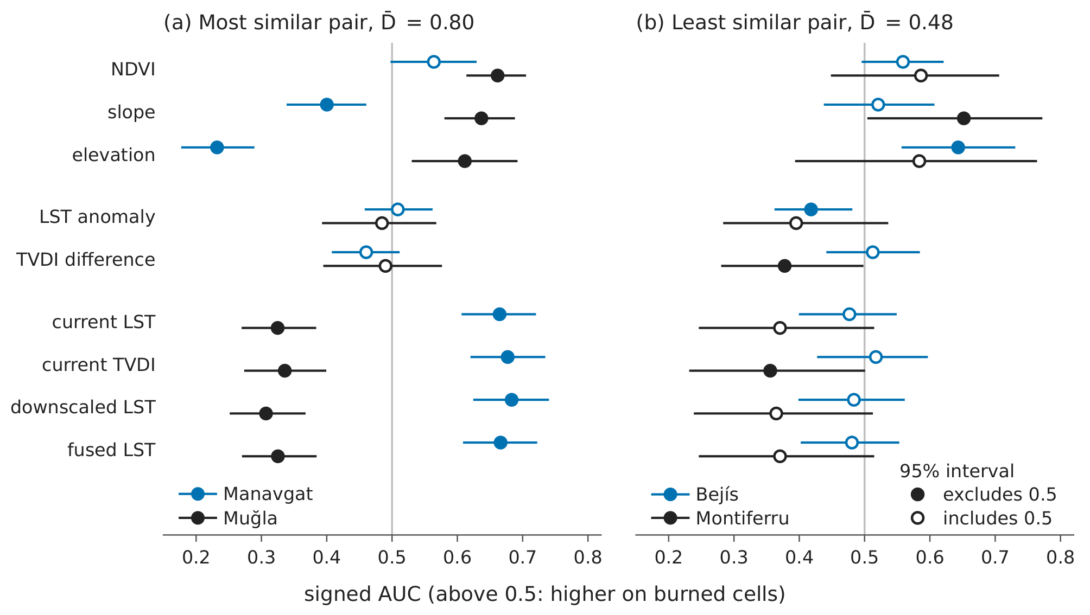
Fig. 8 The contrast pairs. (a) Manavgat and Muğla, the most similar pair (mean one-dimensional Schoener’s $D$, $\overset{‾}{D}=0.80$, and rank 1 of 10 on all five overlap measures). Transfer is below chance in both directions at the point estimates (0.438 and 0.345). (b) Bejís and Montiferru, the least similar pair ($\overset{‾}{D}=0.48$, rank 10). Transfer is above chance in both directions (0.594 and 0.548). For each of the nine numeric predictors (land cover is categorical and has no signed AUC), a dot gives its signed univariate AUC in each region with the 95% spatial-block (10-cell, $≈$5 km) bootstrap interval. A value above 0.5 means that the predictor is higher on burned cells. The rows are grouped into static, anomaly and absolute thermal predictors. In (a), six predictors are supported in both regions and all six have opposite signs (signs agree on 2 of 9). In (b), no predictor is supported in both regions, and signs agree on 7 of 9. At 1 km blocking all four directions have interval support. At 5 km only Muğla$→$Manavgat has, so the contrast is stated at the point estimates

4 Discussion

4.1 The three findings together
The first finding sets the size of the second. When the study areas were made comparable, three between-region results changed (Section 3.4), namely mean transfer, which elevation reversals have interval support, and the correlation of one similarity measure with transfer. Two results remained. Transfer stayed well below within-region skill, and the elevation association of Manavgat stayed reversed against other regions. The supported pairs, however, changed between the frames, and none survived multiplicity correction. The third finding closes an obvious way around the second, because none of the twenty similarity measures predicted transfer on the original study areas.

4.2 What the within-region score measures
The thermal gain within regions held in every check, including the removal of the coordinate-informed channels (Fig. S1), except terrain aspect in Montiferru (Section 3.2). On the scar frame it fell to +0.021 and was not established, mainly because the scored cells changed, although an effect of withholding the scar cannot be excluded (Section 3.3).
The within-region score also describes skill close to the training cells. Inside one region, skill was close to chance 10 to 20 km from the training cells (Section 3.5). The within-region reference therefore measures interpolation, how well a model fills gaps inside an observed fire season, whereas transfer is extrapolation to a new one. Part of the transfer shortfall is thus a matter of distance, and a model of this kind is best described as having short-range skill.
Each region also contributed one fire season, dominated by one large fire. The negative class therefore contains cells that could have burned but were not reached, and ignition, wind and suppression decided much of this. Burned-area patterns have different controls at different scales (Parisien and Moritz 2009), and a pre-fire surface predictor can only rank cells by their condition before the fire. The shortfall therefore cannot be split into a region effect and an event effect. A second Muğla fire was examined for this purpose, but that comparison is confounded by overlapping populations and the study area and is reported only in Section S3.5.

4.3 The two interventions
Pooling four source regions helped only Evia, and for all five targets it stayed well below the within-region ceiling (Section S4.4). Removing the two reversing predictors cost 0.076 of within-region skill, mostly from elevation and supported in every region, and changed mean transfer by +0.014 [−0.018, +0.049] (the pair-t interval in Fig. 7 gives +0.014 [−0.028, +0.056]). The change, like the thermal contribution to transfer (+0.007), includes zero, so a local cost was measured but no transfer gain in return.

4.4 What the thermal predictors measured
The thermal predictors were chosen as a measure of pre-fire dryness, but they did not behave as one. At the point estimates, hotter surfaces burned less in four of five regions, and in Manavgat once elevation was held, although the Manavgat result has interval support only on the collar (Section 3.4). In summer, land surface temperature is strongly shaped by canopy cover, exposed soil and terrain. Dense, cooler vegetation carries more fuel, so a negative association fits LST acting as a descriptor of the land surface, whereas a dryness index should show the opposite sign. In Montiferru, most of the within-region thermal gain disappeared once terrain aspect was added, which fits this reading. Descriptively, across only five regions, the mean LST anomaly also followed the ERA5-Land (Muñoz-Sabater et al. 2021) air-temperature anomaly of the predictor window, but not its relative-humidity anomaly (Table S1). The normalised channels did not transfer better than the absolute ones either (Section 3.5). In Mediterranean ecosystems, the link between fire and climate also depends on fuel and productivity (Pausas and Paula 2012), so the sign of a surface predictor may differ between landscapes. Whether a fire becomes very large depends mostly on fire weather acting on drought-stressed fuel (Ghasemiazma et al. 2026), which no surface predictor measured before the fire can carry. The surface component tested here would be added to weather-driven danger rating (Vitolo et al. 2020), as in products that combine susceptibility with pre-season weather (Bergonse et al. 2021).
Dimarco et al. (2026) found good transfer in a similar Mediterranean design, while transfer failed here. Their predictors are static attributes of a place and their response is a record of human-caused ignitions, whereas here the predictors describe the surface in one season and the response is the footprint of one fire season per region. These two differences cannot be separated in this comparison, but in this cohort the static baseline also did not transfer (mean 0.519), so predictor class alone does not explain the difference.

4.5 Implications for fire management
Region-wide susceptibility maps are used for prevention planning, and these results support four changes in practice.
First, report the evaluation frame and the question it answers (Section 2.12). On the same model, the region-wide and scar-frame scores differed by 0.160 ROC-AUC with the region as the unit, more than the thermal gain within most regions (Table 2), so both are needed to judge a model.
Second, measure transfer in the target region. A within-region score does not show how a model will work elsewhere, and no similarity measure tested here could replace the measurement. On average, a model moved to a new region did not usefully rank the burned cells there (its highest-scored 10 % of cells contained about as many burned cells as a random choice), although the best direction reached 27 % (Table S1). Where a burned-area record of earlier fires exists for the target region, it can be used to check a transferred model before use, but this option was not tested here.
Third, fix the study area by a stated rule before the predictors are computed. The study areas used here were not comparable, and this changed three between-region results (Section 3.4). An accessible-area rule (Barve et al. 2011) is one option.
Fourth, do not expect label-free adaptation to repair transfer. Both methods tested moved most directions toward chance, including those that had worked (Section 3.5). A reversed association cannot be seen without target labels, so aligning the predictor distributions cannot correct it.

4.6 Limitations
Each region contributes one fire season, so region and event effects cannot be separated. The study areas were not comparable either. They could be restricted but not extended, because they were fixed earlier in the processing pipeline (Section 3.4). All labels come from one burned-area product, MCD64A1 (Giglio et al. 2018), with known omission and commission errors (Boschetti et al. 2019; Katagis and Gitas 2022), which are concentrated at scar edges. With VIIRS VNP64A1 labels (Giglio 2024), which overlap MCD64A1 by 87 % to 98 %, no conclusion changed, but independent fire perimeters were not used (Figs. S1 and S2). The land-cover map is post-fire for four events. With the 2020 map, mean transfer was 0.513 instead of 0.527 and no conclusion changed, although in Montiferru the 2021 map left out about a fifth of the burned natural vegetation (Section 2.4, Figs. S1 and S2). No weather predictors were used, and only four estimators were compared (Fig. S2).
The frame cost rests on few scars. The full comparison is defined on seven scars in three regions, so the region-level estimates should be quoted (Section 3.3). Point estimates depend on the software version and the seed. Single directions moved by up to 0.047 under another scikit-learn version and by up to 0.049 across ten random-forest seeds, and direction-level intervals do not include this variation (Section 2.13, Table S1 and Section S5.7). Spatial dependence reaches beyond the 5 km blocks, so intervals at 5 km blocking may be too narrow, especially in North Evia (Section 2.7 and Table S1). The sign of the thermal contribution to transfer also depends on the estimator. It was +0.007 for the random forest used here but negative for the three simpler models (−0.011 to −0.021), although every interval includes zero (Section 3.5).
The similarity tests rest on ten independent region pairs, so both positive and negative results have low power, and the measures based on interval support are unstable, because five to six interval bounds lie within 0.01 of 0.5 and one changed flag moved a correlation by about 0.2 (Section S4.5). The reversal test is marginal. A reversal of a single predictor can also come from different predictor distributions, so it does not prove a change in the predictor-burning relationship (Section 2.10). Finally, the low transfer into Manavgat is located but not explained. Weather, quality screening and the study area were tested, and none explained it. Terrain was held through elevation and aspect only, and in Manavgat burn timing and elevation are confounded (Sections S1.1 and S3.3).

5 Conclusions
Three conclusions are supported for these five Mediterranean regions, each with one large fire season.
First, the evaluation area changes the score. Scoring one fixed model on the burn scar and its 2 km collar instead of the whole region lowered ROC-AUC by 0.160 with the region as the unit, and the loss came from the unburned cells next to the fire. A study should report which area its score refers to.
Second, local skill transferred at most weakly. The thermal gain held within all five regions but was not established on the scar frame. Across twenty transfer directions it was +0.007 on the original study areas and +0.024 on comparable areas, both intervals including zero, and on matched areas transfer stayed 0.197 below the within-region reference. Neither the static baseline nor the two label-free adaptation methods did better.
Third, none of twenty similarity measures was shown to predict transfer. At the point estimates the most similar pair of regions failed in both directions, and the least similar pair transferred above chance.
Before a borrowed model is used for prevention planning, its skill should be measured in the target region, and the study area should be fixed by a stated rule before the predictors are computed. Several fire seasons per region are needed to separate region effects from event effects.

References
Akıncı HA, Akıncı H (2023) Machine learning based forest fire susceptibility assessment of Manavgat district (Antalya), Turkey. Earth Science Informatics 16:397–414. https://doi.org/10.1007/s12145-023-00953-5
Almeida M, Ribeiro LM, Alves D, et al (2023) Analysis of 2021 critical wildfire events in the Mediterranean region. Publications Office of the European Union, Luxembourg
Barve N, Barve V, Jiménez-Valverde A, et al (2011) The crucial role of the accessible area in ecological niche modeling and species distribution modeling. Ecological Modelling 222:1810–1819. https://doi.org/10.1016/j.ecolmodel.2011.02.011
Bekar İ, Tavşanoğlu Ç, Pezzatti GB, et al (2020) Cross-regional modelling of fire occurrence in the Alps and the Mediterranean Basin. International Journal of Wildland Fire 29:712–722. https://doi.org/10.1071/WF19158
Bergonse R, Oliveira S, Gonçalves A, et al (2021) Predicting burnt areas during the summer season in Portugal by combining wildfire susceptibility and spring meteorological conditions. Geomatics, Natural Hazards and Risk 12:1039–1057. https://doi.org/10.1080/19475705.2021.1909664
Boschetti L, Roy DP, Giglio L, et al (2019) Global validation of the Collection 6 MODIS burned area product. Remote Sensing of Environment 235:111490. https://doi.org/10.1016/j.rse.2019.111490
Breiman L (2001) Random forests. Machine Learning 45:5–32. https://doi.org/10.1023/A:1010933404324
Brenning A (2005) Spatial prediction models for landslide hazards: Review, comparison and evaluation. Natural Hazards and Earth System Sciences 5:853–862. https://doi.org/10.5194/nhess-5-853-2005
Bruin S de, Brus DJ, Heuvelink GBM, et al (2022) Dealing with clustered samples for assessing map accuracy by cross-validation. Ecological Informatics 69:101665. https://doi.org/10.1016/j.ecoinf.2022.101665
Chuvieco E, Cocero D, Riaño D, et al (2004) Combining NDVI and surface temperature for the estimation of live fuel moisture content in forest fire danger rating. Remote Sensing of Environment 92:322–331. https://doi.org/10.1016/j.rse.2004.01.019
Dasarwar P, Hindayar JN (2026) Omission error in landslide susceptibility mapping: A cost-based decision framework for Deccan Basalt Terrain, India. Natural Hazards 122:687. https://doi.org/10.1007/s11069-026-08481-3
Dimarco NA, Faraji I, Wahbi M, et al (2026) Generalizing human-driven wildfire ignition models across Mediterranean regions using harmonized remote-sensing and machine-learning data. Geomatics 6:13. https://doi.org/10.3390/geomatics6010013
Eker R, Çınar T, Baysal İ, Aydın A (2024) Remote sensing and GIS-based inventory and analysis of the unprecedented 2021 forest fires in Türkiye’s history. Natural Hazards 120:10687–10707. https://doi.org/10.1007/s11069-024-06622-0
European Space Agency (2022) Copernicus DEM GLO-30 [dataset]. European Space Agency. https://doi.org/10.5270/ESA-c5d3d65
Fernández-Guisuraga JM, Calvo L (2023) Fuel build-up promotes an increase in fire severity of reburned areas in fire-prone ecosystems of the western Mediterranean Basin. Fire Ecology 19:72. https://doi.org/10.1186/s42408-023-00232-0
Gelabert PJ, Jiménez-Ruano A, Ochoa C, et al (2025) Assessing human-caused wildfire ignition likelihood across Europe. Natural Hazards and Earth System Sciences 25:4713–4729. https://doi.org/10.5194/nhess-25-4713-2025
Ghasemiazma F, Tonini M, Fiorucci P, Turco M (2026) Megafires in Mediterranean Europe: The compound role of fire weather and drought. npj Natural Hazards 3:33. https://doi.org/10.1038/s44304-026-00197-5
Ghimire S, Guéguen P (2024) Host-to-target region testing of machine learning models for seismic damage prediction in buildings. Natural Hazards 120:4563–4579. https://doi.org/10.1007/s11069-023-06394-z
Giglio L (2024) VIIRS/NPP burned area monthly L4 global 500m SIN grid V002 [dataset]. NASA Land Processes Distributed Active Archive Center. https://doi.org/10.5067/VIIRS/VNP64A1.002
Giglio L, Boschetti L, Roy DP, et al (2018) The Collection 6 MODIS burned area mapping algorithm and product. Remote Sensing of Environment 217:72–85. https://doi.org/10.1016/j.rse.2018.08.005
Giglio L, Justice C, Boschetti L, Roy D (2021) MODIS/Terra+Aqua burned area monthly L3 global 500m SIN grid V061 [dataset]. NASA Land Processes Distributed Active Archive Center. https://doi.org/10.5067/MODIS/MCD64A1.061
Gorelick N, Hancher M, Dixon M, et al (2017) Google Earth Engine: Planetary-scale geospatial analysis for everyone. Remote Sensing of Environment 202:18–27. https://doi.org/10.1016/j.rse.2017.06.031
Hijmans RJ (2012) Cross-validation of species distribution models: Removing spatial sorting bias and calibration with a null model. Ecology 93:679–688. https://doi.org/10.1890/11-0826.1
Huang Y, Liu N, Chen W, et al (2026) Enhancing transferability of foliar trait retrieval models: A comparative analysis of transfer learning strategies and domain shift characterization. Remote Sensing of Environment 337:115336. https://doi.org/10.1016/j.rse.2026.115336
Iban MC, Sekertekin A (2022) Machine learning based wildfire susceptibility mapping using remotely sensed fire data and GIS: A case study of Adana and Mersin provinces, Turkey. Ecological Informatics 69:101647. https://doi.org/10.1016/j.ecoinf.2022.101647
Jain P, Coogan SCP, Subramanian SG, et al (2020) A review of machine learning applications in wildfire science and management. Environmental Reviews 28:478–505. https://doi.org/10.1139/er-2020-0019
Jiménez-Valverde A (2012) Insights into the area under the receiver operating characteristic curve (AUC) as a discrimination measure in species distribution modelling. Global Ecology and Biogeography 21:498–507. https://doi.org/10.1111/j.1466-8238.2011.00683.x
Jodhani K, Bhatiya L, Sirvi L, et al (2026) Artificial intelligence and remote sensing frameworks for wildfire monitoring and risk analysis across multiple ecosystems: A review. AIMS Environmental Science 13:56–98. https://doi.org/10.3934/environsci.2026004
Katagis T, Gitas IZ (2022) Assessing the accuracy of MODIS MCD64A1 C6 and FireCCI51 burned area products in Mediterranean ecosystems. Remote Sensing 14:602. https://doi.org/10.3390/rs14030602
Kondylatos S, Prapas I, Camps-Valls G, Papoutsis I (2023) Mesogeos: A multi-purpose dataset for data-driven wildfire modeling in the Mediterranean. In: Advances in neural information processing systems 36 (NeurIPS 2023) datasets and benchmarks track. pp 50661–50676
Liu C, Mostafavi A (2025) WildfireGenome: Interpretable machine learning reveals local drivers of wildfire risk and their cross-county variation. arXiv preprint arXiv:2511.11589. https://doi.org/10.48550/arXiv.2511.11589
Lobo JM, Jiménez-Valverde A, Real R (2008) AUC: A misleading measure of the performance of predictive distribution models. Global Ecology and Biogeography 17:145–151. https://doi.org/10.1111/j.1466-8238.2007.00358.x
Ludwig M, Moreno-Martinez A, Hölzel N, et al (2023) Assessing and improving the transferability of current global spatial prediction models. Global Ecology and Biogeography 32:356–368. https://doi.org/10.1111/geb.13635
Maffei C, Alfieri SM, Menenti M (2018) Relating spatiotemporal patterns of forest fires burned area and duration to diurnal land surface temperature anomalies. Remote Sensing 10:1777. https://doi.org/10.3390/rs10111777
Maffei C, Lindenbergh R, Menenti M (2021) Combining multi-spectral and thermal remote sensing to predict forest fire characteristics. ISPRS Journal of Photogrammetry and Remote Sensing 181:400–412. https://doi.org/10.1016/j.isprsjprs.2021.09.016
Maffei C, Menenti M (2019) Predicting forest fires burned area and rate of spread from pre-fire multispectral satellite measurements. ISPRS Journal of Photogrammetry and Remote Sensing 158:263–278. https://doi.org/10.1016/j.isprsjprs.2019.10.013
Marino E, Yáñez L, Guijarro M, et al (2024) Transferability of empirical models derived from satellite imagery for live fuel moisture content estimation and fire risk prediction. Fire 7:276. https://doi.org/10.3390/fire7080276
Metin E, Cogurcu YE (2026) Evaluation area and the limits of cross-region transfer of single-season wildfire models with pre-fire thermal predictors: Analysis code, modelling datasets and frozen outputs [software], version 1.2.0. Zenodo. https://doi.org/10.5281/zenodo.23070876
Meyer H, Pebesma E (2021) Predicting into unknown space? Estimating the area of applicability of spatial prediction models. Methods in Ecology and Evolution 12:1620–1633. https://doi.org/10.1111/2041-210X.13650
Meyer H, Pebesma E (2022) Machine learning-based global maps of ecological variables and the challenge of assessing them. Nature Communications 13:2208. https://doi.org/10.1038/s41467-022-29838-9
Meyer H, Reudenbach C, Hengl T, et al (2018) Improving performance of spatio-temporal machine learning models using forward feature selection and target-oriented validation. Environmental Modelling & Software 101:1–9. https://doi.org/10.1016/j.envsoft.2017.12.001
Milà C, Mateu J, Pebesma E, Meyer H (2022) Nearest neighbour distance matching Leave-One-Out Cross-Validation for map validation. Methods in Ecology and Evolution 13:1304–1316. https://doi.org/10.1111/2041-210X.13851
Mohebzadeh H, Biswas A, DeVries B, et al (2024) Transferability of predictive models to map susceptibility of ephemeral gullies at large scale. Natural Hazards 120:4527–4561. https://doi.org/10.1007/s11069-023-06377-0
Moreira F, Ascoli D, Safford H, et al (2020) Wildfire management in Mediterranean-type regions: Paradigm change needed. Environmental Research Letters 15:011001. https://doi.org/10.1088/1748-9326/ab541e
Moreno-Torres JG, Raeder T, Alaiz-Rodríguez R, et al (2012) A unifying view on dataset shift in classification. Pattern Recognition 45:521–530. https://doi.org/10.1016/j.patcog.2011.06.019
Muñoz-Sabater J, Dutra E, Agustí-Panareda A, et al (2021) ERA5-Land: A state-of-the-art global reanalysis dataset for land applications. Earth System Science Data 13:4349–4383. https://doi.org/10.5194/essd-13-4349-2021
Noroozi F, Ghanbarian G, Safaeian R, Pourghasemi HR (2024) Forest fire mapping: A comparison between GIS-based random forest and Bayesian models. Natural Hazards 120:6569–6592. https://doi.org/10.1007/s11069-024-06457-9
Oliveira S, Oehler F, San-Miguel-Ayanz J, et al (2012) Modeling spatial patterns of fire occurrence in Mediterranean Europe using multiple regression and random forest. Forest Ecology and Management 275:117–129. https://doi.org/10.1016/j.foreco.2012.03.003
Parisien M-A, Moritz MA (2009) Environmental controls on the distribution of wildfire at multiple spatial scales. Ecological Monographs 79:127–154. https://doi.org/10.1890/07-1289.1
Pascolini-Campbell M, Fisher JB, Cawse-Nicholson K, et al (2025) Assessment of spatial autocorrelation and scalability in fine-scale wildfire random forest prediction models. Scientific Reports 15:21504. https://doi.org/10.1038/s41598-025-06814-z
Pausas JG, Keeley JE (2021) Wildfires and global change. Frontiers in Ecology and the Environment 19:387–395. https://doi.org/10.1002/fee.2359
Pausas JG, Paula S (2012) Fuel shapes the fire-climate relationship: Evidence from Mediterranean ecosystems. Global Ecology and Biogeography 21:1074–1082. https://doi.org/10.1111/j.1466-8238.2012.00769.x
Persello C, Bruzzone L (2012) Active learning for domain adaptation in the supervised classification of remote sensing images. IEEE Transactions on Geoscience and Remote Sensing 50:4468–4483. https://doi.org/10.1109/TGRS.2012.2192740
Petschko H, Brenning A, Bell R, et al (2014) Assessing the quality of landslide susceptibility maps – case study Lower Austria. Natural Hazards and Earth System Sciences 14:95–118. https://doi.org/10.5194/nhess-14-95-2014
Ploton P, Mortier F, Réjou-Méchain M, et al (2020) Spatial validation reveals poor predictive performance of large-scale ecological mapping models. Nature Communications 11:4540. https://doi.org/10.1038/s41467-020-18321-y
Podschwit H, Jolly W, Alvarado E, et al (2022) Reliability of cross-regional applications of global fire danger models: A Peruvian case study. Fire Ecology 18:25. https://doi.org/10.1186/s42408-022-00150-7
Roberts DR, Bahn V, Ciuti S, et al (2017) Cross-validation strategies for data with temporal, spatial, hierarchical, or phylogenetic structure. Ecography 40:913–929. https://doi.org/10.1111/ecog.02881
Rousseau JS, Betts MG (2022) Factors influencing transferability in species distribution models. Ecography 2022:e06060. https://doi.org/10.1111/ecog.06060
Ruffault J, Curt T, Moron V, et al (2020) Increased likelihood of heat-induced large wildfires in the Mediterranean Basin. Scientific Reports 10:13790. https://doi.org/10.1038/s41598-020-70069-z
Sandholt I, Rasmussen K, Andersen J (2002) A simple interpretation of the surface temperature/vegetation index space for assessment of surface moisture status. Remote Sensing of Environment 79:213–224. https://doi.org/10.1016/S0034-4257(01)00274-7
Schoener TW (1968) The Anolis lizards of Bimini: Resource partitioning in a complex fauna. Ecology 49:704–726. https://doi.org/10.2307/1935534
Sofaer HR, Hoeting JA, Jarnevich CS (2019) The area under the precision-recall curve as a performance metric for rare binary events. Methods in Ecology and Evolution 10:565–577. https://doi.org/10.1111/2041-210X.13140
Steger S, Glade T (2017) The challenge of ‘trivial areas’ in statistical landslide susceptibility modelling. In: Mikoš M, Tiwari B, Yin Y, Sassa K (eds) Advancing culture of living with landslides. Springer, Cham, pp 803–808
Sun B, Feng J, Saenko K (2016) Return of frustratingly easy domain adaptation. In: Proceedings of the thirtieth AAAI conference on artificial intelligence (AAAI-16). AAAI Press, Phoenix, Arizona, USA, pp 2058–2065
Thies B (2025) Machine learning wildfire susceptibility mapping for Germany. Natural Hazards 121:12517–12530. https://doi.org/10.1007/s11069-025-07292-2
Tonini M, D’Andrea M, Biondi G, et al (2020) A machine learning-based approach for wildfire susceptibility mapping. The case study of the Liguria region in Italy. Geosciences 10:105. https://doi.org/10.3390/geosciences10030105
Trucchia A, Meschi G, Fiorucci P, et al (2022) Defining wildfire susceptibility maps in Italy for understanding seasonal wildfire regimes at the national level. Fire 5:30. https://doi.org/10.3390/fire5010030
Trucchia A, Meschi G, Fiorucci P, et al (2023) Wildfire hazard mapping in the eastern Mediterranean landscape. International Journal of Wildland Fire 32:417–434. https://doi.org/10.1071/WF22138
Tuia D, Persello C, Bruzzone L (2016) Domain adaptation for the classification of remote sensing data: An overview of recent advances. IEEE Geoscience and Remote Sensing Magazine 4:41–57. https://doi.org/10.1109/MGRS.2016.2548504
U.S. Geological Survey Earth Resources Observation and Science (EROS) Center (2020) Landsat 8-9 operational land imager / thermal infrared sensor level-2, collection 2 [dataset]. US Geological Survey. https://doi.org/10.5066/P9OGBGM6
Valavi R, Elith J, Lahoz-Monfort JJ, Guillera-Arroita G (2019) blockCV: An R package for generating spatially or environmentally separated folds for k-fold cross-validation of species distribution models. Methods in Ecology and Evolution 10:225–232. https://doi.org/10.1111/2041-210X.13107
VanDerWal J, Shoo LP, Graham C, Williams SE (2009) Selecting pseudo-absence data for presence-only distribution modeling: How far should you stray from what you know? Ecological Modelling 220:589–594. https://doi.org/10.1016/j.ecolmodel.2008.11.010
Vesk PA, Morris WK, Neal WC, et al (2021) Transferability of trait-based species distribution models. Ecography 44:134–147. https://doi.org/10.1111/ecog.05179
Vibhandik P, Sawant S, Joshi A, Bidwe R (2026) A systematic literature review on forest fire susceptibility mapping using geo-spatial technology and future research directions. Discover Artificial Intelligence 6:396. https://doi.org/10.1007/s44163-026-00921-0
Vitolo C, Di Giuseppe F, Barnard C, et al (2020) ERA5-based global meteorological wildfire danger maps. Scientific Data 7:216. https://doi.org/10.1038/s41597-020-0554-z
Wadoux AMJ-C, Heuvelink GBM, Bruin S de, Brus DJ (2021) Spatial cross-validation is not the right way to evaluate map accuracy. Ecological Modelling 457:109692. https://doi.org/10.1016/j.ecolmodel.2021.109692
Wan Z, Hook S, Hulley G (2021) MODIS/Terra land surface temperature/emissivity daily L3 global 1km SIN grid V061 [dataset]. NASA Land Processes Distributed Active Archive Center. https://doi.org/10.5067/MODIS/MOD11A1.061
Warren DL, Glor RE, Turelli M (2008) Environmental niche equivalency versus conservatism: Quantitative approaches to niche evolution. Evolution 62:2868–2883. https://doi.org/10.1111/j.1558-5646.2008.00482.x
Wenger SJ, Olden JD (2012) Assessing transferability of ecological models: An underappreciated aspect of statistical validation. Methods in Ecology and Evolution 3:260–267. https://doi.org/10.1111/j.2041-210X.2011.00170.x
Xu Y, Dai Y, Chang L, et al (2026) Does your wildfire prediction model actually work, or just score well? arXiv preprint arXiv:2605.18911. https://doi.org/10.48550/arXiv.2605.18911
Yates KL, Bouchet PJ, Caley MJ, et al (2018) Outstanding challenges in the transferability of ecological models. Trends in Ecology & Evolution 33:790–802. https://doi.org/10.1016/j.tree.2018.08.001
Yebra M, Dennison PE, Chuvieco E, et al (2013) A global review of remote sensing of live fuel moisture content for fire danger assessment: Moving towards operational products. Remote Sensing of Environment 136:455–468. https://doi.org/10.1016/j.rse.2013.05.029
Zakari RY, Malik OA, Wee-Hong O (2025) Machine learning-driven wildfire susceptibility mapping in New South Wales, Australia using remote sensing and explainable artificial intelligence. Natural Hazards 121:15331–15357. https://doi.org/10.1007/s11069-025-07395-w
Zanaga D, Van De Kerchove R, Daems D, et al (2022) ESA WorldCover 10 m 2021 v200. Zenodo. https://doi.org/10.5281/zenodo.7254221
Zanaga D, Van De Kerchove R, De Keersmaecker W, et al (2021) ESA WorldCover 10 m 2020 v100. Zenodo. https://doi.org/10.5281/zenodo.5571936

Statements and Declarations

Funding
This work was supported by the Çukurova University Scientific Research Projects Coordination Unit (Bilimsel Araştırma Projeleri Koordinasyon Birimi) under its Career Starter Project scheme, project code FKB-2025-17608 (“Early detection and prevention of forest fires with a thermal digital twin-based UAV swarm system”). The funder had no role in the study design, the analysis, the interpretation of the results, the writing of the manuscript or the decision to submit it.

Competing interests
The authors have no relevant financial or non-financial interests to disclose.

Author contributions
Stated in CRediT terms. Emrehan Metin: Software, Data curation, Investigation, Validation, Writing (review and editing). Yunus Emre Cogurcu: Conceptualization, Methodology, Formal analysis, Investigation, Visualization, Writing (original draft), Writing (review and editing), Supervision, Project administration, Funding acquisition. Both authors read and approved the final manuscript.

Data availability
All satellite inputs are public and were retrieved through Google Earth Engine. Burned-area labels were taken from MODIS MCD64A1 v061 (Giglio et al. 2021), land surface temperature from MODIS MOD11A1 v061 (Wan et al. 2021), surface reflectance and surface temperature from Landsat 8 Collection 2 Level-2 (U.S. Geological Survey Earth Resources Observation and Science (EROS) Center 2020), terrain from the Copernicus DEM GLO-30 (European Space Agency 2022) and land cover from ESA WorldCover v200 (Zanaga et al. 2022). For the sensitivity analyses, burned area was also taken from VIIRS VNP64A1 v002 (Giglio 2024) and land cover from ESA WorldCover v100 (Zanaga et al. 2021), and regional weather anomalies came from ERA5-Land (Muñoz-Sabater et al. 2021) as computed by the processing pipeline. The MODIS, VIIRS and Landsat products are courtesy of NASA’s Land Processes Distributed Active Archive Center and the U.S. Geological Survey. WorldCover is distributed under a CC BY 4.0 licence (© ESA WorldCover project 2021, contains modified Copernicus Sentinel data (2021) processed by the ESA WorldCover consortium). The Copernicus DEM was produced using Copernicus WorldDEM-30 © DLR e.V. 2010 to 2014 and © Airbus Defence and Space GmbH 2014 to 2018, provided under COPERNICUS by the European Union and ESA; all rights reserved. The ERA5-Land values contain modified Copernicus Climate Change Service information. No proprietary or restricted data were used.
The five modelling datasets, one per region, and the frozen numeric outputs behind every reported number are released with the analysis code (Metin and Cogurcu 2026). Each dataset is identified by SHA-256 in paper/code/_canonical.py, and every analysis script verifies that hash on load. For Bejís, Muğla, North Evia and Montiferru the hash equals the canonical-input record of the upstream pipeline at commit 6381f4c. For Manavgat it is the corrected-label re-freeze (5a5e876c…), produced at the same commit. The two small changes needed for this are given in Section S5.7. The pipeline’s own record still names the original-label table (054a1961…), which is not used here.

Code availability
The upstream processing pipeline, satellite-thermal-digital-twin (E. Metin), is public at https://github.com/emrehann17/satellite-thermal-digital-twin under the MIT licence. The analysis code, figure scripts and checks are at https://github.com/dryuemco/thermal-twin, and version 1.2.0 is archived at Zenodo (Metin and Cogurcu 2026). Figs. 1 to 8 and Figs. S1 to S5 are drawn by the scripts in paper/figures/, which also assert Table 2 and every plotted value against the frozen outputs. Tables S2 to S4 and S7 to S11 are rebuilt row by row by paper/code/appendix_tables.py from source files whose SHA-256 values are pinned in paper/labelfix_rerun/round5/tables/SOURCES.sha256, while the other tables name their source files in their captions. paper/figures/check_all.py runs all of these checks. We used Python 3.12.10 with NumPy 2.4.4, pandas 3.0.2 and scikit-learn 1.9.0. Point estimates depend on the scikit-learn version (Section 2.13), so exact reproduction needs this environment.

Ethics approval
Not applicable. This study involved no human participants, animal subjects or personally identifiable data.

