August 2024 Z-Wave RF Range Testing

# Executive Summary

Coming once the testing is complete

# Goals

* ZRAD to ZRAD ZWLR RF range testing in various environments generating a Heat Map using Geographic Location Command Class and a GPS receiver
* ZRAD End Device Mounted on a Motorcycle to move around quickly
  + Some data may be captured using an eBike or walking especially in urban environments
* ZRAD Controller running Z-Wave JS to pull GPS locations and store in a .CSV file
* 2 videos – 1 ~3min short at WW, longer ~5 min YouTube
* Environments:
  + Wooded
    - [Bound](https://www.google.com/maps/place/BoundTree%2FLine+Hill+Parking/@43.2080352,-71.7716687,280) Tree ATV Henniker NH
    - Rockingham [trail](https://www.nhstateparks.org/find-parks-trails/recreational-rail-trails/rockingham-recreational-rail-trail,-fremont-branch) Freemont to Sandown
    - [Hopkington-Everet OHRV](https://www.google.com/maps/place/Hopkinton-Everett+OHRV+Trails+Area/@43.1239432,-71.6538497,1887) trails
  + Open agricultural field
    - Wagon Hill Durham NH (not quite big enough?)
  + Green houses?
  + Residential
    - Newton MA
    - Dover NH
  + Urban
    - Boston Silabs Office
      * Do the windows have metal tinting with poor RF?
      * Can we get on the roof? Probably not
      * Use the top floor of the NECCO parking deck?
    - Dover NH
      * Controller on top of the [Garrison Hill tower](https://www.google.com/maps/place/Garrison+Hill+Tower,+Abbey+Sawyer+Memorial+Hwy,+Dover,+NH+03820/@43.2094265,-70.8704013,333) which has line-of-sight to much of Dover below for several miles and plenty of urban streets
        + Too many trees – do not use
      * Can drive & park at the base of the tower
      * Trial on 8/10 did not go well. Too many trees surrounding the tower results in few if any pings even on the road just below the tower. Only time it connects is line-of-sight which is rare at ground level.
    - Strafford NH
      * The [Stratham Hill Tower](https://www.google.com/maps/place/Stratham+Hill+Tower/@43.0312354,-70.8911063,3178) is an alternative but doesn’t have as many streets nearby
      * Requires a hike up the hill to get to the tower
  + Water – need a boat – lakes or the ocean depending on the weather
* At some point:
* Use ZRAD to capture GPS, but also capture stats of other devices
  + Use Indicator Get? ZWInfo Get? Needs to be a secure GET to know frame made both directions clean
  + ZW mesh with ZRAD
  + Commercial products
    - Ring
    - Zooz light switch? Blink xmas lights all over the bike and night Electric Cowboy style!
      * Need a large battery and inverter – Jackery?
    - 3Labs flow meter
* Compare with Wifi, Zigbee, Matter, Lora, others?
  + 2.4 protocols in urban environments will probably suck due to all the noise
* Compare with YAGI antenna – point-to-point
* Example use-cases
  + Track skydiving jump (Homeseer)
  + Track model rocket launch
  + Track glacier movement for months at a time (need low-power)

# Journal

## 2024-08-10 – Dover Garrison Hill Tower

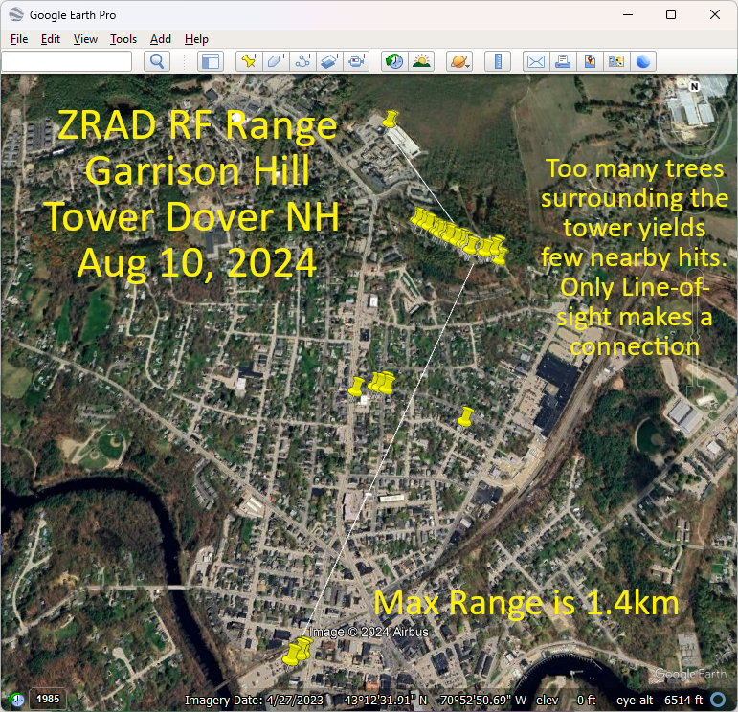Trial run at the Garrison Hill tower which has a commanding view of the city of Dover NH. The problem is the tower is surrounded with a thick forest which from the top of the tower you can just see over the tops of the trees. This means there are no connections made to the streets immediately below the tower thru all the trees. The few line-of-sight locations in the city will connect at over 1.4km but there are few of these at ground level. Lots of 3 story buildings and more trees block the LoS.

Download Google Earth Pro which can import the .csv file and display it on a map and take measurements. Note that the online version of Google Earth does NOT have the feature to import a .csv file. This does not appear to import the altitude, just 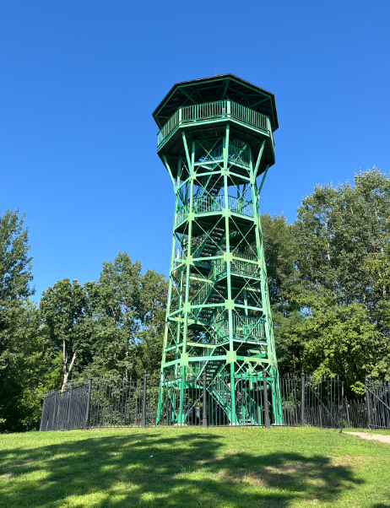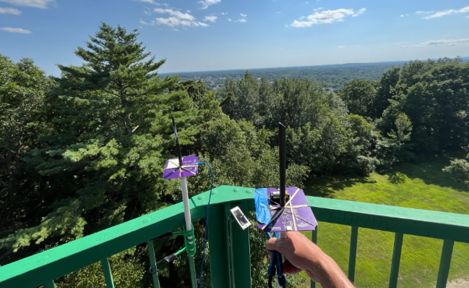Lat/Lon. Tried a few CSV to KML conversion utilities but GE still doesn’t seem to how the altitude.

Still looking for a mapping solution that will produce a 3D model for skydiving or rocketry that shows the altitude.

Raw data:

Time, Latitude, Longitude, Altitude, TxPower, RSSI, Sat Aug 10 2024 15:19:13 GMT-0400 (Eastern Daylight Time)

03:19:13 PM, 43.20914840698242, -70.8693618774414, 182.85, 0, 0

03:19:13 PM, 43.20912551879883, -70.86934661865234, 182.85, 0, 0

03:19:13 PM, 43.2091064453125, -70.86935424804688, 182.85, 0, 0

03:19:13 PM, 43.209556579589844, -70.8694076538086, 110.76, 0, 0

03:19:13 PM, 43.20950698852539, -70.86963653564453, 112.66, 0, 0

03:19:13 PM, 43.20948028564453, -70.86962127685547, 112.71, 0, 0

03:19:13 PM, 43.20952224731445, -70.86958312988281, 112.74, 0, 0

03:19:13 PM, 43.209510803222656, -70.86959075927734, 112.79, 0, 0

03:19:13 PM, 43.209510803222656, -70.86959075927734, 112.79, 0, 0

03:19:13 PM, 43.20949172973633, -70.86959075927734, 112.79, 0, 0

03:19:13 PM, 43.20949172973633, -70.86958312988281, 112.79, 0, 0

03:19:13 PM, 43.20948028564453, -70.86958312988281, 112.92, 0, 0

03:19:13 PM, 43.20948028564453, -70.86958312988281, 113.18, 0, 0

03:19:13 PM, 43.20948028564453, -70.86957550048828, 113.33, 0, 0

03:19:13 PM, 43.20948028564453, -70.86957550048828, 113.33, 0, 0

03:19:13 PM, 43.2094841003418, -70.86957550048828, 113.57, 0, 0

03:19:13 PM, 43.20949935913086, -70.86959075927734, 114.15, 0, 0

03:19:13 PM, 43.209503173828125, -70.86958312988281, 114.19, 0, 0

03:19:13 PM, 43.209495544433594, -70.86959075927734, 114.23, 0, 0

03:19:13 PM, 43.20949935913086, -70.86959075927734, 114.26, 0, 0

03:19:13 PM, 43.20949935913086, -70.86959075927734, 114.27, 0, 0

03:19:13 PM, 43.209495544433594, -70.86959838867188, 114.39, 0, 0

03:19:13 PM, 43.20949935913086, -70.86959838867188, 114.4, 0, 0

03:19:13 PM, 43.209495544433594, -70.86959838867188, 114.44, 0, 0

03:19:13 PM, 43.20949935913086, -70.86959075927734, 114.23, 0, 0

03:19:13 PM, 43.209503173828125, -70.8696060180664, 114.28, 0, 0

03:19:13 PM, 43.20951843261719, -70.86962127685547, 114.25, 0, 0

03:19:13 PM, 43.20949172973633, -70.86962890625, 114.39, 0, 0

03:19:13 PM, 43.20949172973633, -70.86962890625, 114.46, 0, 0

03:19:13 PM, 43.20948791503906, -70.86962890625, 114.72, 0, 0

03:19:13 PM, 43.20948791503906, -70.86962890625, 114.76, 0, 0

03:19:13 PM, 43.20949172973633, -70.86962890625, 114.76, 0, 0

03:19:13 PM, 43.209495544433594, -70.86962890625, 114.22, 0, 0

03:19:13 PM, 43.209495544433594, -70.86962127685547, 114.05, 0, 0

03:19:13 PM, 43.209495544433594, -70.86961364746094, 114.02, 0, 0

03:19:13 PM, 43.209495544433594, -70.8696060180664, 114.01, 0, 0

03:19:13 PM, 43.209495544433594, -70.8696060180664, 114.28, 0, 0

03:19:13 PM, 43.209495544433594, -70.8696060180664, 114.37, 0, 0

03:19:13 PM, 43.20949935913086, -70.86961364746094, 114.45, 0, 0

03:19:13 PM, 43.20950698852539, -70.86961364746094, 114.48, 0, 0

03:19:13 PM, 43.209495544433594, -70.86962890625, 113.76, 0, 0

03:19:13 PM, 43.209495544433594, -70.86963653564453, 113.7, 0, 0

03:19:13 PM, 43.20950698852539, -70.86963653564453, 113.49, 0, 0

03:19:13 PM, 43.209495544433594, -70.86964416503906, 112.86, 0, 0

03:19:13 PM, 43.209449768066406, -70.86972045898438, 113.86, 0, 0

03:19:13 PM, 43.20943069458008, -70.86981201171875, 116.74, 0, 0

03:19:13 PM, 43.20942306518555, -70.86993408203125, 118.76, 0, 0

03:19:13 PM, 43.209434509277344, -70.87007141113281, 120.62, 0, 0

03:19:13 PM, 43.20954895019531, -70.87053680419922, 118.04, 0, 0

03:19:13 PM, 43.20954895019531, -70.87054443359375, 117.98, 0, 0

03:19:13 PM, 43.20954895019531, -70.87054443359375, 118.11, 0, 0

03:19:13 PM, 43.20954513549805, -70.87055206298828, 117.93, 0, 0

03:19:13 PM, 43.20953369140625, -70.87055969238281, 117.61, 0, 0

03:19:13 PM, 43.209537506103516, -70.87055206298828, 117.55, 0, 0

03:19:13 PM, 43.20953369140625, -70.87055206298828, 117.59, 0, 0

03:19:13 PM, 43.20953369140625, -70.87055206298828, 117.62, 0, 0

03:19:13 PM, 43.20953369140625, -70.87055206298828, 117.63, 0, 0

03:19:13 PM, 43.20953369140625, -70.87055206298828, 116.77, 0, 0

03:19:13 PM, 43.209529876708984, -70.87055969238281, 116.38, 0, 0

03:19:13 PM, 43.20952606201172, -70.87056732177734, 115.39, 0, 0

03:19:13 PM, 43.20953369140625, -70.87055969238281, 115.86, 0, 0

03:19:13 PM, 43.209529876708984, -70.87055969238281, 115.28, 0, 0

03:19:13 PM, 43.209529876708984, -70.87055969238281, 115.12, 0, 0

03:19:13 PM, 43.209529876708984, -70.87055969238281, 115.1, 0, 0

03:19:13 PM, 43.209529876708984, -70.87055206298828, 115.16, 0, 0

03:19:13 PM, 43.209529876708984, -70.87055206298828, 115.16, 0, 0

03:19:13 PM, 43.209529876708984, -70.87055206298828, 114.67, 0, 0

03:19:13 PM, 43.209529876708984, -70.87055206298828, 114.61, 0, 0

03:19:13 PM, 43.209529876708984, -70.87054443359375, 114.56, 0, 0

03:19:13 PM, 43.209529876708984, -70.87054443359375, 114.37, 0, 0

03:19:13 PM, 43.20952606201172, -70.87054443359375, 112.99, 0, 0

03:19:13 PM, 43.20952606201172, -70.87054443359375, 113.14, 0, 0

03:19:13 PM, 43.209537506103516, -70.87054443359375, 113.21, 0, 0

03:19:13 PM, 43.20954513549805, -70.87054443359375, 113.26, 0, 0

03:19:13 PM, 43.20954513549805, -70.87055206298828, 113.24, 0, 0

03:19:13 PM, 43.2096061706543, -70.87062072753906, 113.13, 0, 0

03:19:13 PM, 43.209716796875, -70.870849609375, 109.28, 0, 0

03:19:13 PM, 43.209815979003906, -70.87113952636719, 102.61, 0, 0

03:19:13 PM, 43.20994186401367, -70.87145233154297, 96.4, 0, 0

03:19:13 PM, 43.204952239990234, -70.87549591064453, 39.67, 0, 0

03:19:13 PM, 43.197731018066406, -70.87783813476562, 28.76, 0, 0

03:19:13 PM, 43.19785690307617, -70.87754821777344, 29.44, 0, 0

03:19:13 PM, 43.19789505004883, -70.8774185180664, 29.73, 0, 0

03:19:13 PM, 43.204017639160156, -70.87120819091797, 38.08, 0, 0

03:19:13 PM, 43.20500564575195, -70.87425994873047, 52.11, 0, 0

03:19:13 PM, 43.20512008666992, -70.87433624267578, 52.22, 0, 0

03:19:13 PM, 43.20505905151367, -70.87454986572266, 52.2, 0, 0

03:19:13 PM, 43.20509338378906, -70.87472534179688, 51.47, 0, 0

03:19:13 PM, 43.214290618896484, -70.87380981445312, 71.92, 0, 0

03:19:13 PM, 43.21426010131836, -70.87390899658203, 72, 0, 0

03:19:13 PM, 43.214263916015625, -70.87390899658203, 71.91, 0, 0

03:19:13 PM, 43.214263916015625, -70.8739013671875, 71.94, 0, 0

03:19:13 PM, 43.2105827331543, -70.87279510498047, 80.26, 0, 0

03:19:13 PM, 43.21054458618164, -70.87272644042969, 81.1, 0, 0

03:19:13 PM, 43.21044921875, -70.87248992919922, 85.54, 0, 0

03:19:13 PM, 43.210365295410156, -70.87230682373047, 89.83, 0, 0

03:19:13 PM, 43.2101936340332, -70.87200164794922, 100.19, 0, 0

03:19:13 PM, 43.21015930175781, -70.87191772460938, 102.55, 0, 0

03:19:13 PM, 43.210086822509766, -70.87181854248047, 103.75, 0, 0

03:19:13 PM, 43.210086822509766, -70.87167358398438, 105.19, 0, 0

03:19:13 PM, 43.21006774902344, -70.87158203125, 105.62, 0, 0

03:19:13 PM, 43.210025787353516, -70.8714828491211, 106.06, 0, 0

03:19:13 PM, 43.210018157958984, -70.87147521972656, 106.04, 0, 0

03:19:13 PM, 43.20982360839844, -70.87091064453125, 103.57, 0, 0

03:19:13 PM, 43.20981216430664, -70.87089538574219, 103.56, 0, 0

03:19:13 PM, 43.209693908691406, -70.87068176269531, 104.28, 0, 0

03:19:13 PM, 43.2095947265625, -70.87054443359375, 103.38, 0, 0

03:19:13 PM, 43.2095947265625, -70.87053680419922, 103.17, 0, 0

03:19:13 PM, 43.2095947265625, -70.87052917480469, 103.28, 0, 0

03:19:13 PM, 43.209590911865234, -70.87052917480469, 103.39, 0, 0

## 2024-08-09 – Call With Sam & Mark

Sam showed the script for the marketing video. Data is totally secondary but the real data is important to Mark and I. The production team is arriving Monday! Thursday Boston, Friday is NH.

## 2024-08-08 – Initial discussions with Mark Umina

Introduced Sam Ponedal who is Silabs marketing