# RF Range Testing Executive Summary

April 2024

A series of field tests were performed measuring the Line-Of-Sight (LoS) RF Range of Z-Wave in various modes. The threshold for the range is 100% error-free communication, fully encrypted. The absolute maximum range where we can occasionally get a message thru would be much further. However, Z-Wave demands reliable communication so the threshold is set at the point before significant degradation of the channel. The focus of these tests is on the Z-Wave Alliance Reference Application Design (ZRAD) kit. The results are:

* ZRAD to ZRAD in ZWLR maximum LoS range = 2.08 miles
* ZRAD to ZRAD in US Z-Wave Mesh maximum LoS range = 1.17mi
* ZRAD to ZRAD in EU Z-Wave Mesh maximum LoS range = 1.17mi

Details are below.

The desire is to do more testing when Eric can get Geographic Location CC working. GeoLoc will enable Heat Maps to be created easily and make testing much quicker and quantitative.

Plan for RF testing April 2024:

* Location – Merrimack River in Haverhill MA – 1+mi LOS down river with adjacent sidewalk but there are trees between the road and the river
  + Head west toward bridge for 250m or less
    - Can go around bridge to go as far as 800m
  + Head east down river for up to 1.5mi
    - Note buildings in the way at the beginning for the first 500m
  + Turns out there are too many trees and not long enough LOS for full range of ZWLR
  + This location will not be used in future testing
* Method – ERTT sending Basic Set On/Off every 300ms S2Auth
  + ED has blinking LEDs when connection is OK, stops when its not
  + When LED stops blinking and does not restart within 5s, then that is the edge
  + Can adjust orientation during the 5s but remain standing still (not moving)
  + Fully secure = DUT joined with S2 Auth so ZERO bits dropped to blink LED
* Goal:
  + Prove the ZRAD has best-in-class RF range for ZWLR and EU
* Devices to test:
  + Controllers:
    - Mounted on a PVC pipe with rubber bands about 5’ above ground
    - ZRAD – different antennas
  + End Devices
    - Mounted on a PVC pipe with rubber bands and held at ~5’ above ground
    - ZRAD Battery powered with CR123A – SwitchOnOff which will blink LED
    - Homeseer PS100 PCB antenna battery powered but with special firmware
    - DK2603 Thunderboard with Antenna #1
    - ~~XG28-EK2705A Explorer Kit with chip antenna~~
      * ZG28 is not working nor supported in SSv5
    - EU Devices:
      * Mark has a few

Future testing: Use Geographic Location CC to capture numerous data points with full 2D heat maps. A boat would also enable much wider range. Ideally offshore at Isle of Shoals but Great Bay or a large lake would work OK.

* Geographic Location CC loaded into a SwOnOff ZRAD
  + Read out the exact GPS location while the DUT is moving
  + Controller will GET the GPS location and store it with Tx power and stats
    - S2 Security encrypted = zero bits corrupted
    - SDK Retries are OK – no application retries
    - Quantitative threshold for communication vs. subjective (led blinking)
    - Store .csv file which can then be plotted on a map in excel
  + GPS sensor is the SparkFun XA1110 with a small antenna
    - Ensure the Blue LED is blinking indicating it has satellite lock
    - Should not be a problem since testing is outdoors in open space
* All trials are joined with S2 Authenticated requiring 100% perfect data or frame cannot be decrypted
* Planned Trials:
  + **ZWLR testing:**
  + ZRAD Controller ZWLR antenna #2 + ZRAD SwOnOff antenna #2
  + ZRAD Controller antenna #2 + ZRAD SwOnOff antenna #2 – classic ZW instead of ZWLR
  + Same as above but with poor antenna on ZRAD SwOnOff
  + TBZ Controller ZWLR + ZRAD SwOnOff antenna #2
  + ZG28 devkit ZWLR (chip antenna) + ZRAD SwOnOff antenna #2
  + UZB + ZRAD SwOnOff antenna #2
  + **EU Testing:**
  + ZRAD Controller EU +14dBm + ZRAD SwOnOff antenna #2 EU +14dBm
  + ZRAD Controller EU antenna #1 + off-the-shelf EU device
  + ZRAD Controller ZWLR antenna #1 + off-the-shelf ZWLR device (homeseer PS100) PCB antenna
  + ZRAD Controller ZWLR antenna #1 + other ZWLR device

Alternate locations:

* Pease Airfield in Portsmouth NH – doesn’t work
  + 1.5mi flat mostly open range from the end of the runway along the golf course
  + the airfield is 10+’ higher than much of the surrounding path which would block the RF signal
  + No LOS plus a 6’ chain link fence around it
* Merrimack river in Lowell MA – limited 1km range across the river
  + Clear view across the river for 1km to a sidewalk on the far side
* Plum Island Beach – 7mi flat straight no obstructions
  + Sand and sun make this location difficult
* Scammell bridge dover NH – 700m down river – then a jump to 2mi across the Little Bay Bridge
  + Nearby to Erics home
  + South side parking lot is base – there are some trees along shore
  + 700m to other side of the bridge – pretty much LOS at certain points but not continuous
  + Can go down dover point Rd to Newicks dock for 1.2mi open range but not intermediate points
  + 1.6mi to Little Bay Bridge & Hilton Park but the old bridge is closed – must use the walkway on the far side

# Testing Data 2024-04-25

* 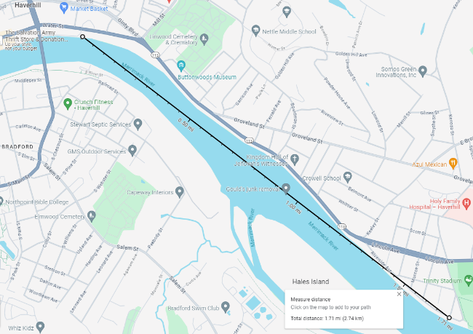**Location:** Haverhill MA along Merrimack River
  + Controller at River Rest Park patio on the edge of river
  + End Devices can go West along river for 250m LOS to bridge
  + ED with less than 800m of range can continue W around the end of the bridge LOS
  + ED with more than 800m of range must go East along Water Street
  + Water street has a row of trees between the street and the river
  + Maximum range is 1.7mi
  + This location is not optimal because there are too many trees along the river that end up blocking the signal so it is far from LOS. If the range is less than 800m the west sidewalk is pretty much LOS but many devices are well over that distance. I don’t expect to use this location in the future.
* **Setup:**
  + 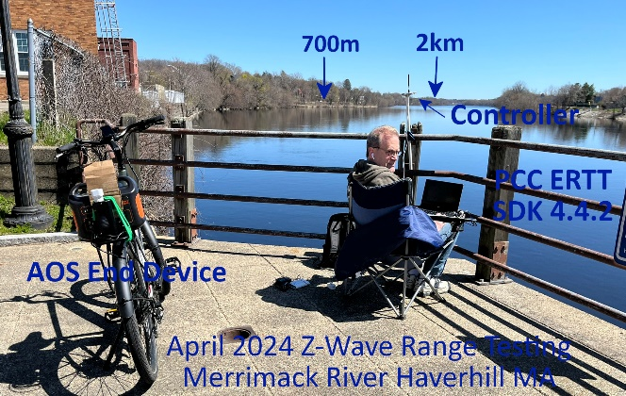All devices have GSDK 4.4.2 unless otherwise noted
  + Joined using S2 Authenticated unless otherwise noted
  + PCC running ERTT sending Basic On/Off every 300ms blinking LED in ED
    - ED must be blinking regularly to still be in range
    - Zero lost frames with no data loss
    - Security encryption means even 1 bit of corruption is not decryptable
    - Watching the traffic on the Zniffer and the ERTT shows more frames failed to be ACKed but the LED was still blinking regularly
  + Controller is mounted on a PVC pole and strapped to the fence
  + Controllers:
    - ZRAD Controller board #2 – SerialAPI -PCC can change from EU/US
  + End Devices
    - ZRAD US Pin:16512 board #4 – CR123A powered – Customized SwOnOff
    - ZRAD EU Pin54817 board #5– CR123A powered – Customized SwOnOff
    - TBZ US Pin:23063 Powered with USB brick – antenna #3
  + Antennas:
    - #1 – [TI.92.2113](https://www.taoglas.com/datasheets/TI.92.2113.pdf) 915MHz Good antenna
    - #2 - [**DELTA12C/X/SMAM/S/S/17**](https://www.digikey.com/en/products/detail/siretta-ltd/DELTA12C-X-SMAM-S-S-17/6096292) – 915MHz poor antenna
    - #3 - [**JCG402LR-2**](https://www.digikey.com/en/products/detail/jc-antenna/JCG402LR-2/15814458) – 915MHz low cost but good
    - #4 - [**ANT-868-CW-HW-SMA**](https://www.digikey.com/en/products/detail/te-connectivity-linx/ANT-868-CW-HW-SMA/5592340) – 868 good
    - #5 - [**FW.86.B.SMA.M**](https://www.digikey.com/en/products/detail/taoglas-limited/FW-86-B-SMA-M/6362785) – 868 good
    - #6 - [**FLEXI-SMA-868**](https://www.digikey.com/en/products/detail/rf-solutions/FLEXI-SMA-868/5845738) – 868 poor
* 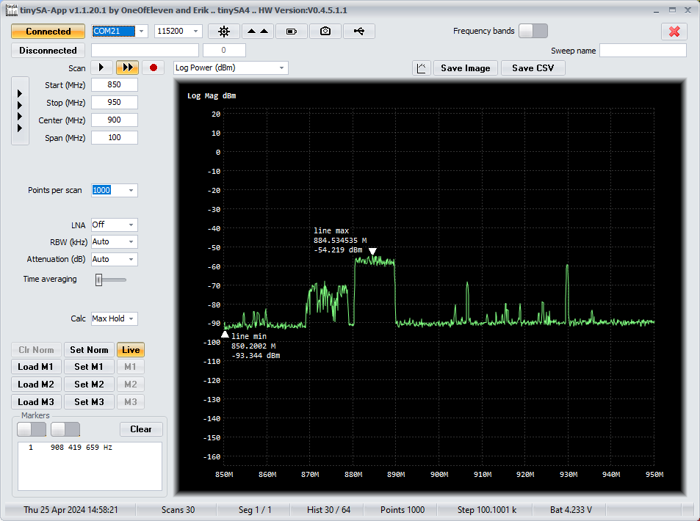RF background shows typical noise in the 824-846Mhz and 859-879MHz ([mobile](https://specmap.sequence-omega.net/) phone) and an intermittent radio at 929MHz
* **ZWLR Trials:**
  + ZRAD to ZRAD with #3 antennas
    - RF Range: 2160m not LOS
    - 12 Riverside Av solid connection
  + ZRAD with Antenna #3 to ZWLR Zooz wall switch ZEN04 – incorrectly returns a report when a basic report is sent – or is that because I haven’t set the lifeline? Nope. Lifeline is set to 1.
    - RF Range: 900m
    - Intersection of groveland street is solid with a few retries
    - ZRAD with Antenna #3 to ZWLR
  + ZRAD with Antenna #3 to Zooz Outdoor dual
    - RF Range: 2000m
    - 524 water street
  + ZRAD with Antenna #3 to Ecolink garage door – also returns a report with a basic set
    - RF Range: 2060m
    - Water & Keeley
* **ZW EU Trials:**
  + ZRAD to Aeotec SmartSwitch 7 type F – Incorrectly returns a switch report inside supervision
    - RF Range: 528m
    - Barely makes buttonwood museum which is the start of the opening in the trees
    - Can get a few frames thru on the far side of the park but not reliably
    - In the other direction it reaches the bridge no problem 250m

# Testing Data 2024-04-22 & 25

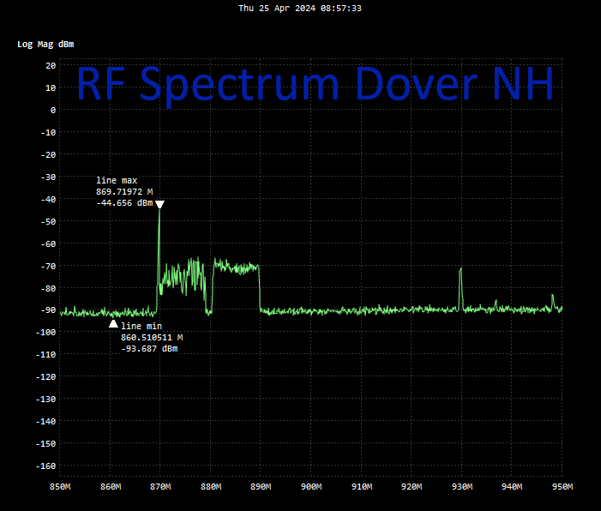Some of the tests were run on the morning of the 25th.

This location shows quiet RF spectrum except for the two bands of mobile phone traffic on either side of 868MHz and an intermittent radio at 929MHz.

* 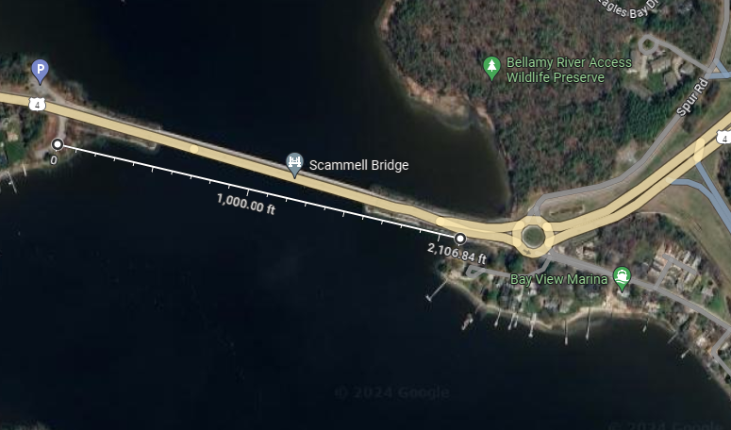**Location:** Scammell bridge Dover NH
  + Controller in parking lot on South side of West end of bridge
  + End Device is then moved across bridge to the SE
  + Distance is 650m to end of the bridge
  + Limited points are available down Dover Point Road
* **Setup:** 
  + DUTs joined S2Auth
  + SDK 4.4.2
  + PCC running ERTT at West end of bridge
  + 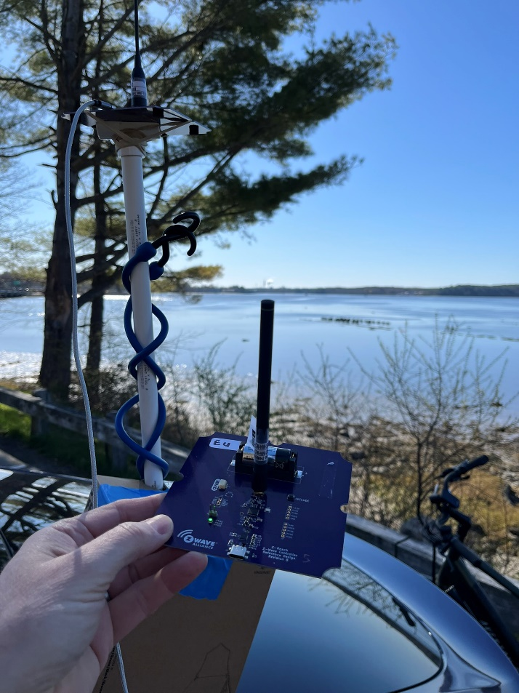DUTs mounted on a PVC pipe with rubber bands ~5’ off ground
  + ZRAD Controller firmware is standard SerialAPI
  + ZRAD ED is a customized SwOnOff to control the LEDs properly (.s37 checked into the ZRAD repo)
    - 16512-58082-50459-58629-17292-55749-28421-30309 – board #4 USLR
    - 25505-27362-51698-45921-34444-22344-50624-15346 – Board #5 EU
  + 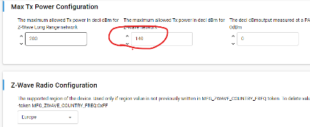EU firmware sets Max Tx to 140:
  + DK2603 Thunderboard
    - 23063-31288-04510-25690-52479-49105-31800-52055
  + Firmware for other devices are SDK 4.4.2 Demo projects
  + UZB7 firmware is version 7.11 which is old and does not support ZWLR
  + ZW Alliance MFG ID is 0x31D
* **ZWLR Trials:**
* 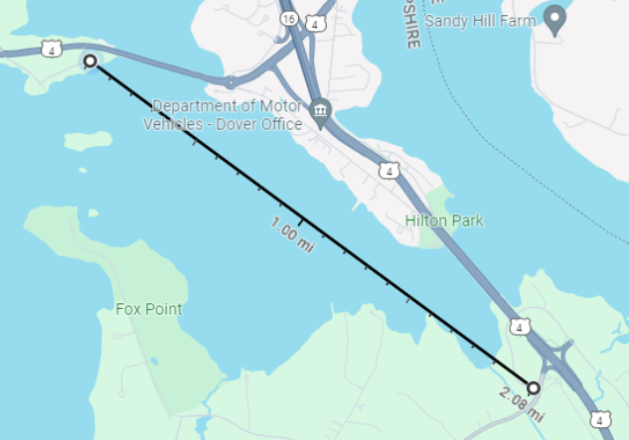#1: ZRAD at both ends – Antenna TI.92.2112 (recommended antenna) - +20dBm
  + RF RANGE: 2.08 miles – to the intersection of Nimble Hill Rd and Shattuck way thru quite a few trees!
  + At various points along Dover Point Rd there was no connection but it would start again as soon as a little closer to the bay.
  + Only the top of the little bay bridge was blinking – the sidewalk is on the N side of the bridge (far side)
  + But once on S side of bridge near Trickys cove it was blinking solid to the end of Shattuck way
* #2: ZRAD at both ends – ED Antenna is DELTA12C/X/SMA (poor antenna)
  + RF RANGE:
* 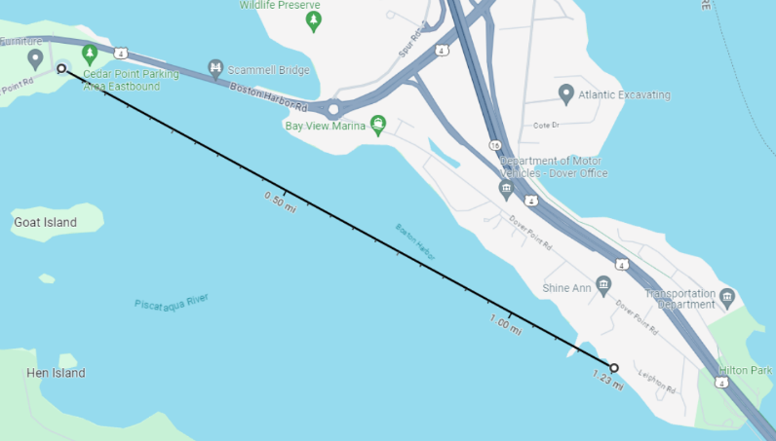#3: ZRAD Controller
  + ED DK2603 with TI.92.2112 antenna – ZGM230 +14dBm
  + RF RANGE: 1.23mi
  + Got to Newicks solid
  + Marginal at Hilton park at 1.4mi
  + Probably goes a bit further than 1.23 but no access between Newicks and Hilton Park
* **ZW Mesh Trials:**
* #1: ZRAD both ends with TI.21.2112 antennas
  + RF RANGE: 1880m (1.17mi) Got to Newicks!
* #2: ZRAD both ends with JCH4 antennas at both ends
  + RF Range: got to Newicks but did not reach from Hilton Park
* **ZW EU Trials: (Mesh)**
* ED EU is set to +14dBm in firmware
* Controller is set to EU and +14dBm using the PCC: 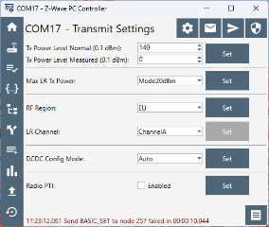
* #1: ZRAD both ends with – C=FM86 antenna, ED=ANT868 antenna
  + RF Range: 1880m (1.17mi)
    - I would have expected further given EU is at higher power
  + RF RANGE: 68m – barely makes the end of the parking lot
  + When no ACK is received, the PCC or SerialAPI waits 2min before retrying
  + PCC is version 5.54.103 which is the vesion in GDSK 4.4.2 (latest)
  + This makes testing impossible as waiting 2min each time 1 packet is lost will take too long
  + At the end of the parking lot, after 2 min, blinking would resume for about 10s before it would stop again.
  + With the FW.86.B antenna I could not join a US device at all! So maybe this antenna is super specific to the 868 band? Or is this antenna bad? YES! The antenna is apparently BAD!
  + Tried with the JCH4 antenna on the controller and the ANT868 on ED was able to join easily.
  + RF Range: Newicks but not Hilton
* #2: ZRAD both ends with – C=FM86 antenna, ED=FLEXI antenna (poor antenna)
  + RF RANGE:
* #3: ZRAD both ends with – FM86 antenna on both – PCC set to 0dBm
  + RF RANGE: