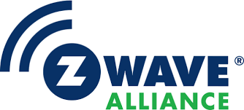Z-Reach Z-Wave Controller Reference Design

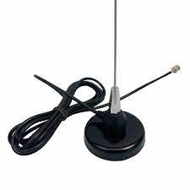

Figure 1 To be replaced with the real product when ready

Z-Reach is a Best-in-Class RF Range Z-Wave controller reference design intended to accelerate Z-Wave product development. Z-Reach is an ideal platform for a host controller interface or to prototype Z-Wave end devices.

## Features

* Public GitHub repository
  + Open-Source repository
  + MIT License
* KiCAD schematic & PCB layout
  + Easy import into Altium
  + Gerbers for immediate production
  + 4-layer PCB – 5” square
* Z-Wave Long Range ?.?km RF range
* Z-Wave EU ?.?km RF range
  + Open field 100% connectivity
* Silicon Labs EFR32ZG23 +20dBm
  + 32-bit ARM CM33 CPU 39Mhz
  + 512K Flash 64K RAM
  + SubGHz Radio +20dBm Tx
  + Robust peripherals
  + Tag-Connect debug connector
* Silicon Labs CP2102N USB to UART
  + USB-C interface
* Standard Z-Wave SerialAPI firmware
* White Paper on Antenna Best Practices
* Theory of Operation documentation
* BOM cost under $10 @10K

The Z-Reach is a *reference design* available in the GitHub open-source repository for free. The design may be copied and used in commercial products subject to the terms of the standard MIT License agreement. Finished products based on Z-Reach will be available from partners but not directly from the Z-Wave Alliance.

Z-Reach differs from the Silicon Labs development kits in that the primary focus is on best-in-class RF range at an affordable cost. The design can be copied and customized to meet your exact needs with minimal effort.

Z-Reach is not a finished product. FCC/CE testing, Z-Wave Certification, enclosure design and packaging would be needed to ship finished product based on this reference design.

Z-Wave end products can be prototyped using Z-Reach. Various populate options enable interfaces to QWIIC sensors, color LED, and GPIOs to connect to any external device. A battery connector enables development of low-power sleeping or FLiRs devices.

## Revision History

Rev 0.9 Feb 2024 – Initial draft