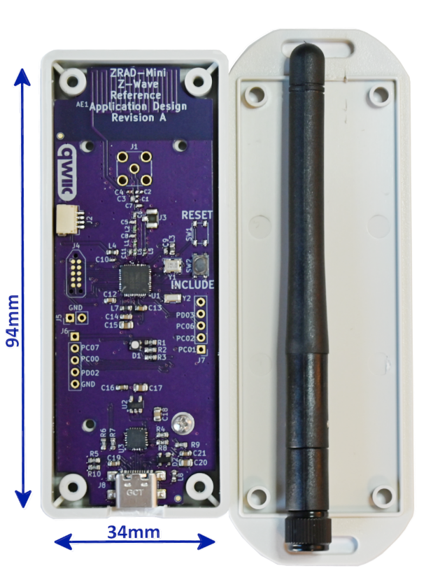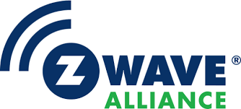ZRADmini is a Best-in-Class RF Range Z-Wave reference design intended to accelerate Z-Wave product development. ZRAD is an ideal platform for a host controller interface or to prototype Z-Wave end devices. ZRADmini is a smaller, lower cost version of the original ZRAD.

## **Features**

* Public GitHub repository
  + Open-Source repository MIT License
  + <https://github.com/drzwave/ZRAD>
* KiCAD schematic & PCB layout
  + Easy import into Altium
  + Gerbers for immediate production
  + 2-layer PCB – 34x94mm
* Z-Wave US Long Range 2+mi RF range
  + Open field 100% connectivity 100kbps fully secure & encrypted
  + PCB or SMA antenna
* Silicon Labs EFR32ZG23 +20dBm
  + 32-bit ARM CM33 CPU 39Mhz
  + 512K Flash 64K RAM
  + SubGHz Radio +20dBm Tx
  + Tag-Connect debug connector
* Silicon Labs CP2102N USB to UART
  + USB-C connector
* Standard Z-Wave SerialAPI firmware
* QWIIC I2C connector
* Color LED
* GPIO Expansion Header
* Theory of Operation documentation
* BOM cost under $15 @10K

The ZRADmini is a ***reference design*** available at the GitHub open-source repository for free. The design may be copied and used in commercial products subject to the terms of the standard MIT License agreement. Finished products based on Z-Reach will be available from partners but not directly from the Z-Wave Alliance.

ZRAD differs from the Silicon Labs development kits in that the primary focus is on best-in-class RF range at an affordable cost. The design can be copied and customized to meet your exact needs with minimal effort.

ZRAD is not a finished product. FCC/CE testing, Z-Wave Certification, enclosure design and packaging are needed to ship finished product based on this reference design.

Z-Wave end products can be prototyped using ZRAD. Various populate options enable interfaces to QWIIC sensors, color LED, and GPIOs to connect to any external device. A battery holder enables development of low-power sleeping or FLiRs devices.

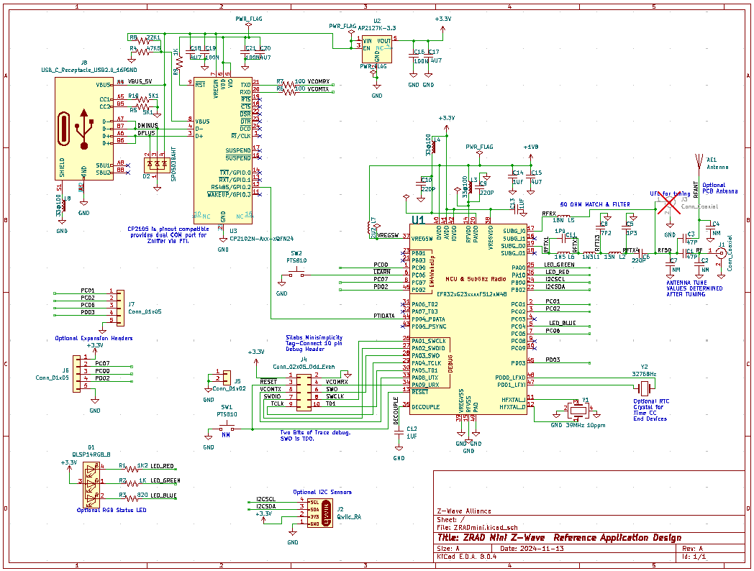

## Revision History

Rev 1.0 Nov 2024 – First Publish

Rev 1.1 Jan 2025 – Add Photo