ZRAD Z-Wave Reference Application Design

# Introduction

The Z-Wave Alliance Z-Wave Reference Application Design (ZRAD) is a simple to copy, easy to modify, Open-Source *Reference* design of a Z-Wave best-in-class RF range device. ZRAD is not a product you can purchase, but anyone is welcome to manufacture and sell a product based on ZRAD. The objective is to accelerate Time-To-Market for Z-Wave products thru a simple to follow example with detailed step-by-step instructions.

See the [README.md](https://github.com/drzwave/ZRAD/blob/main/README.md) file in the repo for the latest information on building and using ZRAD.

## Features

* Public GitHub repository
  + Open-Source Repository
  + MIT License
* KiCAD schematic & PCB layout
  + Easily imported into other tools like Altium
  + Gerbers for immediate production
* EFR32ZG23 based +20dBm
  + 512K FLASH, 64K RAM
  + ARM CM33 CPU 39MHz
  + UARTs, Timers, I2C, ADC, DAC
* CP2102N USB->UART host interface
* Standard SerialAPI Firmware
* Documentation with full details for customization and replication
* Battery powered End Device option
* Target Assembled/tested kit cost less than $50@10K (not including enclosure)
* Target BOM cost under $15@10K
* White Paper on Z-Wave Antenna Best Practices and RF range field test results

# Theory of Operation

## Z-Wave MCU

Naturally the heart of ZRAD is the Silicon Labs EFR32ZG23 SoC. The ZG23 has an ARM CM33 CPU, a long list of standard peripherals and the Z-Wave radio. The ZGM230 module is limited to +14dBm (or half the RF range) compared to the SoC at +20dBm. The SoC requires tuning the 39MHz crystal on every unit produced but this is easily done in a few seconds on the production line. The procedure for tuning is described below and scripts are available in the Repo.

The UART Rx/Tx pins are connected to the CP2102 thru 100 ohm resistors to allow the Tag-Connect debug cable to drive the pins during manufacturing. RailTest is needed to send/receive UART commands during crystal calibration. While this does not provide complete isolation between the CP2102 and the debug connector, the debug connector is typically only connected for a few seconds during final test making this a viable low-cost solution.

A Tag-Connect 10 pin header with alignment pins is used for programming and test during production and debug. Two Trace pins are wired to the header to enable Trace debugging using the adaptor board in the [etm_zwave](https://github.com/drzwave/etm_zwave) repo. The PTI pins are not wired as Z-Wave typically uses a separate standalone Zniffer. The 2 ground pins are often needed for Trace debugging to improve signal integrity across the 10 pin ribbon cable.

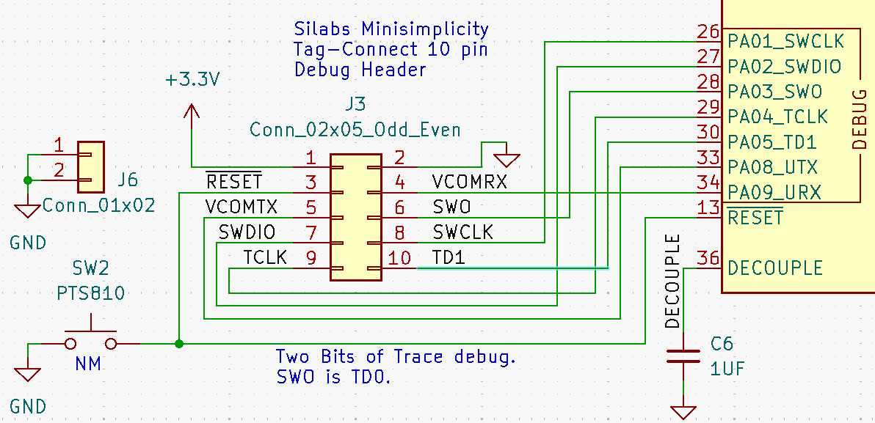

The ZG23 DCDC switching power supply is utilized to convert the 3.3V to 1.8V for the VDD power supply. The USB 5.0VDC is passed thru a linear LDO to drop the supply voltage to 3.3V. Power spikes of about 130mA occur when the radio transmits at +20dBm. The LDO and USB handle that sudden change in supply current ensuring good RF range. The PAVDD is powered with 3.3V to power the RF amplifier to +20dBm. The analog supply and IOVDD are on the 3.3V to provide better analog voltage range and connectivity with other external devices. The internals of the ZG23 are powered with 1.8V. Sensitive power supplies have additional ferrite beads and capacitors to ensure clean supply voltages.

## Antenna Filter and Match

The RF path from the ZG23 to the RF50 signal is straight from the Silabs DevKit reference designs ([xG23-RB4210A](https://www.silabs.com/documents/public/user-guides/ug507-brd4210a-user-guide.pdf)). This path filters the RF and shifts the high impedance pins to be close to 50 ohms. Between the matching circuit and the SMA connector is a standard 3 element pi filter used to match the impedance of the antenna. The values for these 3 elements are typically tuned to a specific antenna and RF region. A U.FL footprint is in this path to make tuning easier via a U.FL cable to a network analyzer. The U.FL is only mounted to bare PCBs to help with tuning. Thus, it is listed as “NM” in the schematic and is why there is a red X thru it. The SubGx1 pins are not used.

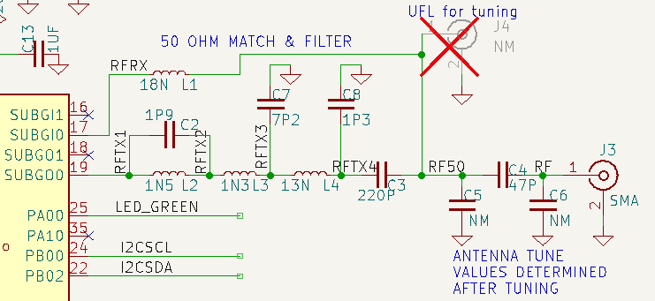

## USB-C Interface

A Silicon Labs CP2102N USB to UART chip is used to connect the SerialAPI to the host computer. A USB-C connector is used but only USB 2.0 is supported. USB3 is not supported or needed as the data rate of the UART is 115200 baud. The design follows the reference example in the CP2012 datasheet. This [article](https://hackaday.com/2023/08/07/all-about-usb-c-example-circuits/) was used as a guide. A CP2105 dual UART is pinout compatible and might be used in a future release to include support for Zniffer via PTI. Pin 12 of the CP2105 is wired to the PD04 pin of the ZG23 which can be used for 9-bit data mode of the PTI component.

## Power Supplies

USB-C provides +5V power in the typical application of a controller. The +5V is reduced to 3.3V via an LDO to power the on-chip switching regulator on the ZG23. The radio is powered from +3.3V to achieve a transmit power of +20dBm to the PAVDD pin.

When prototyping a low-power end device, the battery holder can be populated and connected to a CR123A or similar 3V battery. No reverse battery protection is provided so the battery holder must ensure the polarization. The LDO and USB devices are not populated when developing a battery powered device.

## PCB Ground Plane

A very important part of an IoT radio is the ground plane. Ideally the ground plane is perpendicular to the antenna and is half-wavelength. At 868MHz the wavelength is 34.5cm and 920Mhz is 32.6cm. The exact dimension isn’t that critical as long as it’s close. The ½ wavelength is 17cm but a square is more cost effective than a disk, thus divide by the diagonal (1.41) to get a 12cm on a side or roughly 5” square PCB. The ground plane fills the entire bottom side of the PCB to ensure there are no eddy currents or blockages. The next layer is used to distribute power. The upper two layers are used for interconnection of the ICs. All layers are flood-filled with ground as much of the area is open to provide a large ground plane for ideal RF performance. A smaller PCB size can be easily prototyped by simply making the PCB smaller with the potential of a loss in RF performance.

A related calculation is the width of the infeed trace. The width of the infeed trace is calculated using one of the many coplanar waveguide calculators such as: <https://chemandy.com/calculators/coplanar-waveguide-with-ground-calculator.htm>.

For [OSHPark](https://docs.oshpark.com/services/four-layer/), the relative dielectric constant is 3.61. The thickness of the prepreg is .2021mm. Usually the gap is set to .3mm then try various widths until the calculator comes up with close to 50 ohms. For ZRAD using OSHPark for PCBs, the calculated width is .44mm. Most of the infeed trace is 0.44mm except where it needs to narrow to reach the pins of the ZG23.

## RGB Color LED

An RGB Color LED can be used to provide visual status of any sort. Utilizing this LED requires customizing the SerialAPI. The LED can be used when ZRAD is used as an end-device for Indicator CC support. The LED is Active Low meaning the LED is ON when the pin is a zero (0V). The LEDs are driven directly from the GPIOs without extra FETs to keep costs low. This limits the brightness of the LEDs but they are sufficiently bright for most applications.

* Red = PC04 (LED3_GPIO)
* Green = PA00 (LED1_GPIO)
* Blue = PA10 (LED2_GPIO)

The pins can be assigned using the Z-Wave Target Boards component in Simplicity Studio. Open the .SLCP file and select the Software Components tab. Scroll down to the Z-Wave Target Boards component and click on the gear icon. Assign the pin as shown above. The standard Switch On Off sample app will then control the green LED as the state of the switch and the blue LED will blink when in Learn mode or via Indicator CC. If SSv5 is not properly setting the configuration, see the README.MD file for the latest workaround.

## Learn Mode Switch

PC05 is connected to a SPST momentary pushbutton switch. This pin is an EM4WU pin so it can wake the chip from EM4. End Devices use this pin to enter Classic Inclusion/exclusion mode. Press and hold for more than 5 seconds to factory reset ZRAD. Controller applications do not populate this switch.

## I2C via QWIIC connector

Tons of handy and cheap I2C devices from Sparkfun use the tiny 4 pin QWIIC connector. There are sensors of every type, various displays, and GPS receivers. To add I2C to the ZRAD, install the Platform->Driver->I2C->I2CSPM component. Configure it with: Leave the Reference clock frequency at 0, Speed Mode=Fast Mode (400kbits/s), Selected Module=I2C0 (or I2C1), SCL=PB00, SDA=PB02. Reference clock frequency of 0 sets the reference frequency to the same as the I2C peripheral clock which is usually the HF clock (39MHz) (based on following the code). Once configured, the pins should show up in the PinTool. sl_system_init() calls sl_driver_init() calls sl_i2cspm_init_instances() which then configures the I2C block on startup. The only function is the [I2CSPM_Transfer](https://docs.silabs.com/mcu/5.9/efr32mg13/group-I2CSPM)(). The Z-Wave Multilevel Sensor sample app uses the I2CSPM which can be used as an example to see how it works.

## DEBUGPRINT

DEBUGPRINT can be defined and used to print messages via the MiniSimplicity headers VCOM pins. Typically, the USART is used for this purpose. First install the Services->IO Stream: USART component. Configure for 115200 baud, USART0, RTS/CTS=none, Rx=PA09, Tx=PA08. Then install Z-Wave-> Debug Print and uncomment the #define DEBUGPRINT in app.c or as a compiler symbol which will enable all printfs in every file.

## Optional Connections

Extra connections are incorporated in the design to allow prototyping of many other types of Z-Wave devices. These connectors and devices are normally NOT mounted for SerialAPI applications.

* 32KHz crystal supports Time CC. The on-chip low-speed oscillator drifts by a few minutes per day making it not usable for schedules or other time-of-day uses. The crystal reduces drift to a few seconds per day.
* Two 5 pin GPIO headers provide generic connections to other devices
* SW2 is an optional switch connected to RESET which is handy when debugging End Devices

## Crystal Calibration

See the README.md file and scroll down to the Crystal Calibration section for the procedure to calibrate the 39MHz crystal. Calibration is unique to each unit and must be performed during final test. Calibration is required for maximum RF range across environmental conditions and aging.

# Programming and Testing

The Test folder has Python scripts for programming, calibrating, and testing ZRADMini using the jig in the 3D folder, a Silabs WSTK ProKit, TinySA spectrum analyzer and a PC or raspberry pi. See the Test/ReadMe.md file for more details.

# Fabrication

ZRAD is a reference design and not a commercial product though it is intended to be copied and possibly sold as one. The procedure below documents the process to build prototype quantities. This is an example process and each manufacturer may have slightly different requirements. The process below is for ZRADmini. Open KiCAD and ensure the schematic is ERC clean and the PCB is DRC clean. ZRADmini has a few Exclusions to the ERC/DRC which can be ignored.

## PCB Files – Gerber Generation from KiCAD

1. Open the Schematic and PCB in KiCAD (version 8.0.4 or later)
2. Print the Schematic as a PDF and save as ZRADminiSchematic.pdf
3. Make ONLY the following layers visible: F.Silkscreen, User.Comments (contains all the PCB fabrication details), Edge.Cuts, F.Paste
   1. Turn off VIAs in the Objects tab
   2. Print, black and white, fit-to-page, save to ZRADminiFabrication.pdf
4. 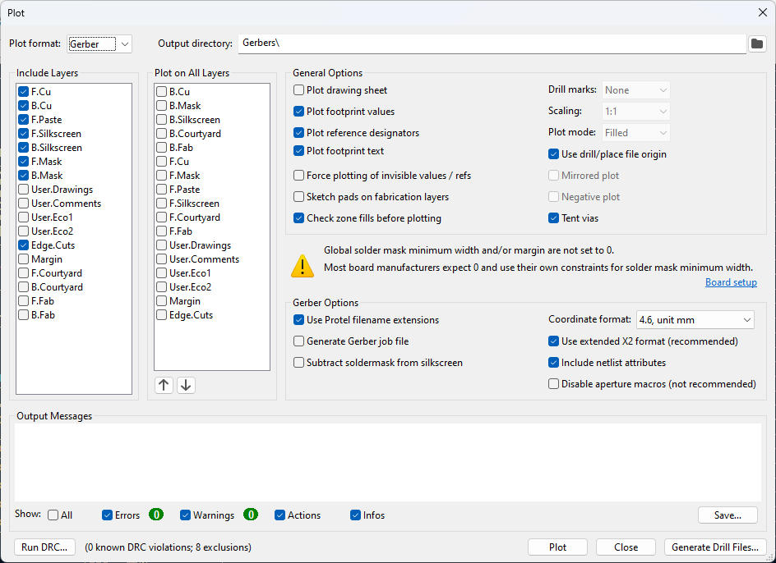File->Fabrication Outputs->Gerbers
5. Click on “Plot” as shown here
6. Then click on Generate Drill Files and then Generate Drill File (use defaults). This will create the *.drl file.
7. Generate the Positions file for pick-and place assembly (*.pos): File->Fabrication Outputs->Generate Placement Files->Generate Positions file
8. Delete the delete the *-bottom.pos file as there are no components on the bottom of the ZRADmini.
9. ZIP up the 10 files (*.drl, *.gbl, *.gbs, *.gbo, *.gm1, *.gtl, *.gts, *.gtp, *.gto, *.pos). The files are described in the notes on the Fabrication drawing.
10. Delete all the files except for the ZIP file
11. Open the ZIP file in gerber viewer (a tool inside KiCAD) and verify everything looks OK
    1. Check for any odd looking traces or anything that might be a problem in manufacturing
    2. Look closely at the .GTS (top solder mask) and ensure the ZG23 pads have solder mask between them and that it is NOT exactly the same size as the pad. Some PCB manufactures treat mask=pad (zero) to be “use default clearance” which can be as much as 3mm which would cause all the pads to short together. Set 0.0508mm as the Solder mask expansion in KiCAD. Make sure are no isolated ground pours and plenty of GND vias between layers
12. To purchase prototype PCBs:
13. Upload the gerbers zip file to OSHpark.com or other prototype PCB shop. Select the desired number of boards. Purchase the stencil which is a 3mil mylar (5mil is too thick – maybe the 5 mil is better?). Consider ordering the steel stencil as it likely will result in less chances for solder shorts but is twice the cost. Do NOT use the kicad files with OSHpark as they will regenerate the solder mask tolerances making the pads for the ZG23 short together.
14. Order components from the BOM. Export as a .csv file and Digikey can input the file to create a complete kit of components.
15. When everything arrives, place the stencil over the PCB, swipe a THIN layer of solder paste over the pads, Place the components using a microscope, bake the board in an IR oven, inspect the board looking for shorts/opens and repair them then you are ready to test your new ZRADmini!

# Regulatory Preparation

Z-Wave products typically require regulatory approval thru appropriate test facilities. The regulatory bodies are FCC in the US, ISED in Canada, CE for Europe and others. Typically test houses want a device that will simply power up and turn the radio on in various modes. More details are in [UG523](https://www.silabs.com/documents/public/user-guides/ug523-bring-up_test-hw-development.pdf) and [UG409](https://www.silabs.com/documents/public/user-guides/ug409-railtest-users-guide.pdf). For Silicon Labs devices, the firmware required is called RailTest. Simplicity Studio has a project called RAIL – SoC RAILtest which must be customized for ZRAD. Follow the steps below to create a usable railtest firmware. Note that railtest is a standalone program that does not need a bootloader and overwrites NVM so the DSK is typically lost when railtest is flashed into a device.

1. Plug in a Silabs devkit or select one in the My Products pane of the Launcher perspective (xG23-RB4210)
   1. This will automatically set the pinouts to match ZRAD – primarily for the UART
2. Create the RAILtest project – RAIL-SoC RAILtest
3. Double click on the .slcp file
4. Click on the Software Components tab
5. Enter NVM3 in the Search window
6. Scroll down to: Services->Command Line Interface->Extensions->CLI:Storage in NVM3
7. Install it and be certain to name the component “inst0”
8. Build the project and flash it to the DUT
9. Open a serial port to the USB port
   1. or using SSv5 right click on the WSTK and select Launch Console
   2. Then click on the Serial 2 tab, then press ENTER in the window at the bottom
10. getversion will return the current version of railtest
11. Can also enter HELP for a list of all railtest commands

Below are specific details on the important railtest commands for Z-Wave.

|  |  |  |
| --- | --- | --- |
| Railtest command | Results | Comments |
| rx 0 | {{(rx)}{Rx:Disabled}{Idle:Enabled}{Time:240676874}} | Turns off the radio – required before changing radio configuration |
| setzwavemode 1 3 | {{(setzwavemode)}{ZWAVE:Enabled} {Promiscuous:Enabled}{BeamDetect:Enabled}{PromiscuousBeam:Disabled}} | Configures Railtest for Z-Wave mode |
| setzwaveregion 1 | {{(setzwaveregion)}{ZWaveRegion:US-United States} {ZWaveRegionIndex:1}} | US mesh  Ch0=916.0 100kbps GFSK  Ch1=908.40 40kbps FSK  Ch2=908.42 9.6kbps FSK |
| setzwaveregion 11 | {{(setzwaveregion)} {ZWaveRegion:USLR1-United States, Long Range 1}{ZWaveRegionIndex:11}} | US Long Range Channel A (DSSS)  Ch 3=912.0 100kbps OQPSK |
| setzwaveregion 12 | {{(setzwaveregion)} {ZWaveRegion:USLR2-United States, Long Range 2}{ZWaveRegionIndex:12}} | US Long Range Channel B (DSSS)  Ch3=920.0 100kbps OQPSK |
| Setchannel 0-3 | {{(setchannel)}{channel:3}} | Set the frequency based on region |
| Setpower xxx [raw] | {{(setpower)}{powerLevel:240}{power:210}} | Set transmit power  XXX = deci-dBm (140=14.0dBm)  RAW changes to “raw power level” instead of deci-dBm |
| settxtone 0 or 1 | {(settxtone)}{Stream:Enabled}{None:Disabled} {StreamMode:Tone}{Time:1251689899}} | Carrier On (1) or Off (0) |
| settxstream 0 or 1 | {{(settxstream)}{Stream:Enabled}{None:Disabled} {StreamMode:PN9}{Time:3481955496}} | PN9 modulated On (1) or Off (0) |
|  |  |  |
| clearscript 1 |  | Removes the script in FLASH |
| enterscript 1 |  | Begin capturing script commands and store to FLASH  The script is automatically run on powerup |
| Endscript |  | End of the script |
| Printscript |  | Print the script |
| Runscript |  | Runs the script for testing purposes |

Sample commands to for a 908.40 MHz carrier that turns on when powered up:

clearscript 1

enterscript 1

rx 0

setzwavemode 1 3

setzwaveregion 1

setchannel 0

settxtone 1

endscript

For Z-Wave Mesh the maximum transmit power must be determined using the procedure in the [Z-Wave 700: Tx Power Calibration](https://community.silabs.com/s/article/z-wave-700-tx-power-calibration-adjustment-in-railtest-and-application-fw-x) or in this [KBA](https://community.silabs.com/s/article/z-wave-700-how-to-adjust-tx-power-on-slave-devices?language=en_US). Z-Wave Long Range uses dynamic power and the regulations allow up to +30dBm of transmit power but the Z-Wave chips can transmit at a maximum of +20dBm. Thus, ZWLR max power typically does not need to be set and can remain at the default of 200 (+20dBm).

# Board Status:

Rev A: 2 boards scrapped – USB chip difficult to solder due to pads under the IC.

Rev B:

* 1: ZG23A, SE=2.2.4, CTune=0x87
  + 13013-20757-03685-13998-02429-19075-02920-54669
* 2: ZG23A, SE=2.2.4, CTune=0x89, SerialAPI (no DSK)
* 3: ZG23B, SE=2.2.4, Ctune=0x98 – **shipped to David Zima** 4/19/2024 with Railtest
* 4: ZG23B, SE=2.2.4, Ctune=0x95 – works ok as an ED – Has a CR123A battery holder & reset button
  + 16512-58082-50459-58629-17292-55749-28421-30309
  + CP2102 isn’t connecting via USB
  + Suspect a short under the USB connector on one of the data pins
* 5: ZG23B, SE=2.2.4, Ctune=0x99
  + 54817-13409-17164-25837-27750-16443-46416-26908
* 6-12: bare boards

Rev C:

* 1: ZG23B, SE 2.2.4, CTune=0x94
  + 12041-60201-44764-43614-63900-49745-32509-52297
* 2: ZG23B, SE 2.2.4, Ctune=0x98
  + 31350-48981-20595-45123-33910-07500-29843-63102
* 3: Bare

ZRADMini Rev A:

|  |  |  |  |  |  |  |
| --- | --- | --- | --- | --- | --- | --- |
| **#** | **MCU** | **Antenna** | **CTUNE** | **Status** | **PIN** | **Comments** |
| 1 | ZG23B020 | PCB untuned C3=47pF | No | Working |  |  |
| 2 | ZG23B020 | SMA top side (wrong) | No | Working |  | Zniffer |
| 3 | ZG23B020 | SMA | Y 140 | End Device Only | 19084 | CP2102 not working so no USB data  3.2KHz buzzer in series with 150 ohm to PD02 drive low. |
| 4 | ZG23B020 | PCB US tuned | Yes | Working |  |  |
| 5 | ZG23B020 | PCB EU tuned | Yes | Working |  | Gave to somebody |
| 6 | ZG23B020 | SMA | Yes | Working |  | SerialAPI |
| 7-9 |  |  |  | Bare boards, 1 used for tuning |  |  |

ZRADTri Rev A: Trident PCB

|  |  |  |  |  |  |  |
| --- | --- | --- | --- | --- | --- | --- |
| **#** | **MCU** | **Antenna** | **CTUNE** | **Status** | **PIN** | **Comments** |
| 1 | CZ20 | SMA | No | Program, no RF |  |  |
| 2 | CZ20 | SMA | No | Program, no RF |  | Questionable CZ20 solder |
| 3 |  |  |  |  |  |  |
| 4 |  |  |  |  |  |  |
| 5 |  |  |  |  |  |  |
| 6 |  |  |  |  |  |  |
| 7-9 |  |  |  | Bare boards |  |  |

# Reference Documents

1. EFR32ZG23 Datasheet
2. EFR32xG23 reference manual – details of all peripherals & registers
3. ZRAD Github repository
   1. See docs directory for this document and the Z-Reach datasheet
4. [CP2102N](https://www.silabs.com/documents/public/data-sheets/cp2102n-datasheet.pdf) Datasheet

# Issues/Learning:

1. Place the Tag-Connect on a 1mm grid and if possible 5mm in from the edge of the PCB
   1. Easier to match the location on a test jig if its on a broad grid
2. Screw in Antennas RF quality is not consistent with price
   1. Cheap antennas can be better than expensive ones

# Document History

|  |  |  |
| --- | --- | --- |
| DATE | Who | Description |
| 6/12/2024 | ER | Initial release |
| 12/28/2024 | ER | Project officially complete per SOW with Z-Wave Alliance but as an open source project efforts continue |
|  |  |  |
|  |  |  |

# Journal

Details of the development and timeline are described here in reverse chronological order.

## 2025-05-09 – Trident board build

Minor errors: 120pF in BOM is 0603 but footprint is 0402 – change BOM, C16 footprint is 0603 but BOM is 0805 (should be 0805).C1,2&3 are NM unless PCB antenna. Need to order enclosures.

Main problem is that board #2 CZ20 didn’t solder very well at all. Seems to have lifted slightly especially on one side. Many of the pins had no solder on the pad – where did it go? Did the EP suck it all in. The vias are not filled with solder so maybe they are all sucking it in? I was hoping the vias would suck the chip tight. I hand soldered the CZ20 but are there opens/shorts? Board #1 was fine. The metal stencil is definitely better than a mylar one. Both boards had a few shorts on the USB connector. Is there a different one with better pads? Also want to swap to a slightly different size LED that is a more common size. Both boards program fine but are not producing NodeInfo or any RF. The HF crystal is 32MHz, not 39MHz so I had to order some 32MHz which will be a few more days before I can get into RF testing.

## 2025-04-30 – Adding a buzzer to GeoLocCC

One problem with GeoLocCC is that when in the field it is difficult to see an LED in bright sunlight to know if the DUT is beyond range or not. An easier solution would be for it to beep audibly every time a REPORT is sent. I have a Piezo 3.8khz buzzer ([AT-1438-TWT-R](https://www.digikey.com/en/products/detail/pui-audio-inc/at-1438-twt-r/1464840)) I can try to drive with a PWM on a ZRAD. Supposed to be 5V but I can probably drive it with 3.3V and the GPIO will ground the other pin via a GPIO connected to the PWM then tristate the GPIO when not buzzing. Supposed to be 1mA and produce 80db but it’ll be inside the enclosure so it’ll be less and 3.3V. I need to add a 3.3K ohm resistor to limit the current to 1mA though maybe a bit less will also be OK as the buzzer also has internal resistance. Cheaper alternatives: [**AT-1224-TWT-5V-2-R**](https://www.digikey.com/en/products/detail/pui-audio-inc/AT-1224-TWT-5V-2-R/5011404), [**GT-11PS**](https://www.digikey.com/en/products/detail/soberton-inc/GT-11PS/479668), [**PS1720P02**](https://www.digikey.com/en/products/detail/tdk-corporation/PS1720P02/935932). J6 on ZRADmini has +3.3V and 3 GPIOs. The buzzer is 13.8mm and overhangs the PCB by about 3.5mm and is too tall at 7.3mm. The GT is much lower in height and slightly smaller but would still overhang. I’m working with board #3. Surface mount buzzers are generally very low height. [**AT-1127-ST-2-R**](https://www.digikey.com/en/products/detail/pui-audio-inc/AT-1127-ST-2-R/5011397) would work better as it has a port out the side and might just barely fit in the case. Or use [**PT-1704**](https://www.digikey.com/en/products/detail/soberton-inc/PT-1704/1245316) which has wire leads. I also have [GT-0950RP3](https://www.digikey.com/en/products/detail/soberton-inc/GT-0950RP3/479660?s=N4IgTCBcDaICwGYEFoCMAGVcQF0C%2BQA) which is much smaller and fits in the case so I’ll use that – 3.2KHz, 30 ohms, rated for 30mA so a 330 ohm resistor would be OK. The pins are 4mm spacing (0.157in) which doesn’t line up with my holes but the leads will bend OK. It will connect to PC00 directly but I’ll have a 300 ohm resistor to **PD02** which is what I’ll plan on using.

1. Upgraded the project from 2024120 to 2024122 – build it ensure it still works
   1. Had to edit the SDK ZW_cmdclass.h file again since the SDK updated from .1 to .2
   2. FLASH is overflowing by 92 bytes!
   3. See my [blog](https://drzwave.blog/2025/05/01/dreaded-flash-memory-overflow-solutions/) for how to get around it while debugging
2. In SSv5 in the SwOnOff_2024120_ZG23B_geoCC project, add Platform->Driver->PWM->PWM component
   1. Name the instance “beep”
   2. Configure it with: PWM Freq=3200, Selected Module=TIMER0, CC0=PD02, Output Channel=0
   3. The SL_PWM_BEEP configuration has a bunch of things to choose but NO DOCUMENTATION on what they do or why I would want to use it. I clicked on the Documentation button and it brings me to the PWM Driver on docs.silabs.com. But nothing explains what CCx is or does. I happen to know these are documented in the reference manual but I don’t want to have to chase this down – it should be right here in SSv5!
   4. Code compiles and it seems the PWM is initialized but no sound.
   5. The SSv5 debugger doesn’t display any data in the peripherals window. Appears to have all of them but when you click on them you get nothing. The console says it read a lot of registers. Aha – register contents are in the Memory window. Timer0_NS is running and enabled. Mode is PWM. COFOA is 0 but should be 1 to toggle the output? Change that in the debugger but still no sound. Tried various other registers in the timer and GPIO but no sound. Looking on the scope, nothing is coming out.
   6. I added sl_pwm_start(&sl_pwm_Beep); in sl_pwm_init.c to see if I just needed to “start” it but that didn’t do anything either.
   7. No documentation says how to enable Toggle mode.
   8. It’s easier to just directly write the registers than try to figure this out!
   9. Once again, there is no thought as to how the average user would want to use a timer and then provide a simple API to do the most common basic operations. The timers have a ton of features, few people ever use. In this case, the API barely does anything and it would seem it doesn’t even do it correctly. Plus the documentation is of very little help. Ugh.
   10. After several hours of debug in Ozone and randomly setting various registers to various values I’ve come up with what appears to work. The driver does not setup the timer properly. For some reason Ozone is unable to alter the timer CTL register as I cannot change the HALT bit so the timer runs while debugging. The Status register says the timer is not locked but it will not let me change the values.
   11. Registers that need additional setup:
       1. TOP is set to 0x2F9A which is computed by the driver
       2. Timer0.CC0_CTRL.CMOA=b’11 – set the output on compare match
       3. Timer0.CC0_CTRL.COFOA=b’10 – clear the output on timer overflow
       4. Timer0.CC0_OCB=Timer0.TOP/2 – set the compare to ½ TOP = 17CD
       5. TIMER0->CC[0].CTRL |= (0b11<<8) | (0b10<<10); // Set on compare, clear on overflow
       6. TIMER0->CC[0].OCB = TIMER0->TOP/2; // set CC0 compare to be 1/2 of TOP for 50% duty cycle.
   12. The buzzer isn’t that loud and the voltage is just a fraction of a volt with a lot of over/undershoot at the edge. Using PC00 (directly drive the buzzer without a resistor) also works and is much louder but will that impact the RF or overall current thru the chip? And it’s not that much louder. I’ll just drop the resistor from 300 to 150 ohms. 3.2K is pretty high pitched.
   13. Next step is to figure out how to set a timer to run the timer for X amount of time. Might be easier to install an ISR and have the timer itself self-time? The easy software timers from the 500 series appear to be gone. Incomprehensible Silabs timer API is totally useless.
   14. To add the ISR, in the same sl_pwm_init.c just add:

**#include** <em_core.h> // Interrupt numbers

**void** **TIMER0_IRQHandler**(**void**) { // Run the timer for ~1/2 sec then shut it down - Audible beep lasts for 1/2 sec.

**static** **int** count;

**if** (count<=0) {

count = TIMER0->TOP/4;

TIMER0->CMD = 0x02; //STOP

} **else** {

count--;

}

TIMER0->IF_CLR = TIMER0->IF; // clear interrupts

}

* 1. And just below the REPORT in CC_GeographicLoc.c is the one line to start the timer each time it sends a GeoLoc Report: TIMER0->CMD = 0x01; // start BEEP timer

Check files in. Time for more range testing! Maybe switch the GPIO to be Open Drain and invert the polarity so the pin floats high in idle and only draws power when beeping.

## 2025-04-15 – Trident PCB release to fabrication

The mounting holes and fudicials were dropped when I updated the PCB from the schematic it appears. Had to add those back in. There are 8 DRC error exclusions. The 2 Fudicial marks, 4 vias with one connection on the USB SMD mounting pads, the U.FL connector doesn’t match the one in the library which has several DRC errors in it, CZ20 footprint in the library has .2mm vias in the EP but the minimum allowed is .254 so I had to manually increase those. Ordered 9 PCBs and a metal stencil.

## 2025-04-14 – Trident PCB layout

I am experimenting with the CZ20 footprint with thermal holes in the ground pad. I normally don’t like holes as they sometimes are not as flat and might result in the pins not making good contact. I also made the paste holes a little smaller as too much paste does cause the chip to rise up though the holes might help with that by sucking some of the solder down into the holes. This required some modifications to the footprint to pass DRC and exclude a few errors.

## 2025-04-11 – Trident Schematic

Completed the schematic capture. The CZ20 KiCAD symbol is still being worked out but the PR has been created.

## 2025-04-09 – Begin TridentIoT version

Trident is providing a little funding to cover the costs for developing a ZRAD version with the CZ20 chip on it. Work begins today. The first step is to upgrade to KiCAD 9.0.1.

## 2025-02-13 – GeoLocCC adding non-gps support

Wanting to finish up the implementation of GeoLocCCv2 I need to add support for storing the GPS location in NVM. So, first step is to google “silicon labs NVM token file storage” and see what I can find for documentation:

1. AN1154 – is an out of date document for NVM with EmberZNet PRO
2. AN1135 – Is an NVM3 document that is still valid and specifically mentions Z-Wave support
   1. Just points to INS14259 section 7.2.
   2. INS14259 gives a pretty succinct description of how to use NVM
3. [NVM Api](https://docs.silabs.com/z-wave/latest/zwave-api/nvm) – docs.silabs.com NVM API specifically in Z-Wave which is autogenerated from the code
   1. The functions are described but again, it’s like reading the dictionary when I want a short story
   2. Too much information and no guide as to what’s important
4. [Zpal-nvm](https://docs.silabs.com/z-wave/latest/zwave-api/zpal-nvm) – Slightly more documentation on docs.silabs.com which points out the _init, _write, _read functions which are in fact the 3 ones I’m interested in
   1. Low level routines called by the NVM api in INS14259
5. UG103.7 – NVM storage fundamentals – generic document on NVM3

The immediate problem isn’t lack of documentation; it’s sifting thru the docs trying to find something useful.

Next, I used the Silabs “Ask AI” search tool “How to use NVM3 in Z-Wave?” which did pretty well at summarizing what needs to be done! But it is apparently unaware that NVM3 is already instanced and initialized by the Z-Wave stack so AI has way too much detail on initialization. AI did provide sample code calling ZAF_nvm_* functions. It did not suggest using the NVM API or Zpal-nvm described above.

Next, I searched thru the sample apps looking for an example and found that they all initialize NVM. The PowerStrip app specifically uses NVM to store configuration data and other stuff. See ZAF_nvm.c which stores the zaf_handle and provides a basic set of commands. See ZAF_file_ids.h for the file ID #s which are simply sequential number in parenthesis. File IDs are 20 bit numbers. What are the numbers used by the Z-Wave protocol? I assume fairly large numbers? INS14259 says the app must only use 16-bit FileIDs as the upper 4 bits are used for Z-Wave. 12K is available to the application. Just do a ZAF_nvm_app_write() to initialize a new file. Must also write a default value into zaf_nvm_app_set_default_configuration() which is called on exclusion or factory reset.

## 2025-01-27 – EMEA Prep – GeoLoc testing

Worked with Dominic to get the index.js working using the latest ZWJS and working on my laptop. Building more EULR devices to test with. I need to see if the ZRADMini has similar RF range to ZRAD to avoid bringing the large ZRAD to Barcelona. Spent most of the day but have 1 ZRM with an SMA antenna and GeoLoc, 1 with SwOnOff PCB antenna, a TBZ with SwOnOff connected thru a USB hub powered by my Anker brick.

Dominic updated index.js to capture up to 3 other devices and seems to work. But it puts the GeoLoc data into separate files. I need them all in the same file with the NodeID then Excel 3D maps will color code the nodes. I fixed the script and now it puts the nodeID as a column which 3D maps can then color code. Field testing tomorrow!

## 2025-01-24 – EMEA Prep – GeoLoc build

Trying to install I2CSPM into my project with keys so I can OTA. But installing I2CSPM says it need IO Stream but then fails. The docs say there are no dependencies but clearly there are. Installing I2CSPM is not configurable so clearly something isn’t working. Uninstalling then gives a Validation Error. Previously I had always enabled DEBUGPRINT so let’s try that. Nope that doesn’t work. DebugPrint doesn’t install the IO Stream. I reverted back to my older project that has geoloc in it but no keys. Not sure what the difference is but as usual SSv5 makes it impossible to move forward so instead I move backward. I need to get the javascript program pulling more than 1 DUT today. Unfortunately, I have no idea how to write JS. How does one figure out what calls to make? Scheduled a call with Dominic on Monday

In the meantime, let me try to get ZWJS running on my laptop so I don’t have to lug 2 of them all around Spain. I have Z-Wave-JS-UI installed using npm install zwave-js-ui. This gives me the ability to add/remove nodes and test them using chrome on my laptop. Browse to: <http://localhost:8091/#/control-panel> after starting ZWJS by starting a powershell and typing “zwave-js-ui”. But it won’t talk to Node? – node gives a MODULE_NOT_FOUND.

## 2025-01-23 – EMEA Prep – Document OTA & key generation

Updated the ReadMe.md for 2024.12.0 and added the key generation information. I built the bootloader, generated Keys, created the app and configured the minimum needed for the sample app and documented all that and checked it in.

## 2025-01-22 – EMEA Prep – Build EU End Device with GeoLoc

Got a controller and Zniffer for EU. Next is the End Device with GeoLoc using 2024.12.0.

Tried following the new CLI code in the sample app SwOnOff. It is massive, bloated, barely documented, impossible to follow and not at all needed by customer code. Typically, you’d want to rip all that out. I can’t figure out how to just send some chars out the uart (or even which uart is configured for it – pintool says it EUSART0). I use the same pinout as the TBZ so the blue and green LEDs and learn button are the same and the UART. For now I’ll try to make minimal changes to the sample app. First step is just to join the EU controller and see they talk. That much is working – joined and Basic Set will turn the blue LED on/off. Indicator SET will blink the green LED. Now to add GeoLoc. Followed the instructions with a few minor updates to a couple of files and it compiles. Plugged the M8Q in and it worked first time. I need to update the code to remove the valid bits which are no longer needed. I ordered 2 more M8Qs just to have a spare in Spain.

I tried to get ZWJS to run but it wants to use USLR so I emailed Dominic to ask how to get it into EULR.

All devices must support Firmware Update Get/Report which is a good command to test range with as the report is fairly long. Or use Association grouping get for a very short command?

## 2025-01-21 – EMEA prep

Building and testing EU devices for use at the EMEA summit.

Board 3 travelled to CES and the little M2 screws inside the case fell out and rolled around. It seems #3 no longer works over the UART via USB. It will talk over the tag-connect cable but USB is not recognized when it is plugged into a PC. Nope, I has incorrectly listed #2 as the one with the bad USB but it is #3. Working to get #2 with the Zniffer in it – follow the README.md. Board #2 seems to work when also powered via the tag connect but not via USB only? #2 Zniffer works when connected thru the WSTK to COM4 but not straight thru the USB. Doesn’t work with the PC Controller either. Maybe the USB doesn’t work on board 2 and board 3? AHA! The first via on board 2 from R7 (VCOMRX) was open. Looked OK but was not making contact thru the PCB. I stuffed a wire thru the via and soldered it in place and now it’s a Zniffer via USB. Perhaps board 3 has the same problem? That via is a standard via on .1mm center so it’s just a manufacturing defect. Maybe I will make this via a little larger if board 3 has the same problem. No, board 3 has a different problem – the CP2102 doesn’t seem to respond at all.

Trying to install the SerialAPI into board #6. Won’t connect to the WSTK but the board is programmed and has the SwitchOnOff app in it. I had to use Commander to Recover Bricked Device as I believe it was just locked. Doesn’t seem to talk via USB but PCC does work via WSTK. The RX and TX seem to be connected – no opens. Power cycled my PC and now its working fine. Seems the EULR max power is 14dBm? PCC gives an error when trying to set it to +20. Seems that is the regulatory maximum.

## 2025-01-03 – Test program development

Started building the Test program for ZRADMini. Testing boards 1-6 in preparation for the EU summit where I’ll need reliable ZRADs with GeoLocCC.

For whatever reason, programming is failing to boot via the python program. But if I program the exact same file using commander it works just fine. The python program first flashes railtest to calibrate the crystal. The python program is not programming the bootloader whereas commander does. The .s37 file has the bootloader merged along with the keys. That’s because I had the unmerged filename in the python script! That fixed that problem. Now I’ve got problems with the QR code generation. Something must have changed in the environment as I needed to assign the type of img to get it to work. Board 4-6 appear to be working. Haven’t tested everything but they programed fine.

## 2024-12-30 – Build ZRADMini boards 4-6

Wiped off ½ of the solder paste from the USB connector which resulted in few solder shorts and still made good connections. Still seems to be too much solder on most components. Looking closely at the stencil the holes are slightly larger than previous versions of the stencils. The price of the stainless steel stencils has come down significantly (used to be $100+, now $30) and might be worth it to minimize rework clearing shorts. I changed the paste size to be -5% and maybe next time I’ll order a 5mil instead of 3mil as maybe the 3 mil is so thin it’s letting paste squeeze under it? Or just pay the extra for steel?

## 2024-12-28 – ZRADMini Test Jig

Designed a ZRADMini Test jig which uses a Tag-Connect pogo post cable to press against the test points on the PCB and a clamp to hold the PCB in place. I had the Rev A jig 3D printed but realized I measured the connector position from the wrong end of the PCB so this one is not usable. It is handy to check the overall dimensions. I have too much play in the PCB with 1mm on all 4 side. Better to be 0.5mm I think. Still want some play as the key feature is the Tag-connect which has alignment pins in it. The PCB does not have the footprint on an even 1mm grid which makes it a pain to properly line up. It does need to be about 5mm in from the edge of the PCB and not right on the edge without some tricky 3D printing of the jig. From the ANTENNA end of the PCB to the center of the tag-connect it 44.5mm and 4.365mm from the edge. I incorrectly measured from the USB end instead of the antenna end.

## 2024-12-11 – ZRADMini PCB antenna tuning

On a bare PCB with just the series cap with a 47pF cap and the UFL with the RX path cut off installed in a case with screws and then connected to my Agilent N9912A spectrum analyzer I get:

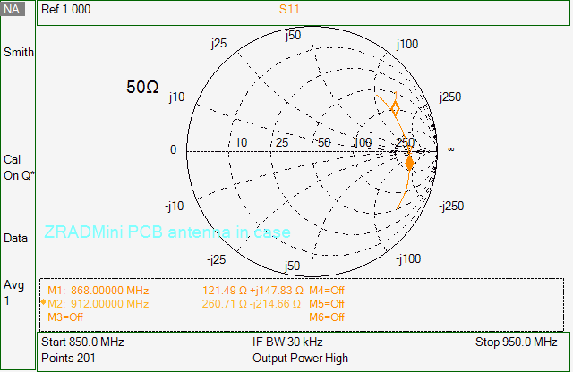

The antenna needs to be optimized for the EU for the unplugfest in Feb. But I’ll start with US at 912MHz.

This is not a particularly ideal starting point. If the antenna is closer to 50 ohms to start with would be better. Plus the antenna design is stuffed into the end of the PCB with long edges next to each other which I have heard will tend to cancel each other out resulting in a less than optimal antenna design.

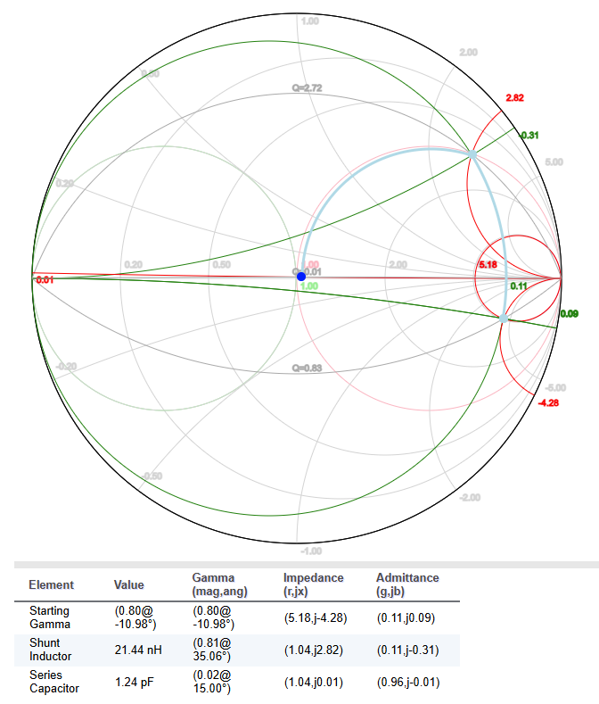Use the [RFMentor](https://www.rfmentor.com/content/smith-chart-matching-app) smith chart tool to calculate the matching network. Usually 2 components, sometimes 3. The tool only approximates the match as real components have many other parasitic effects. But it is a good start. Divide the real and imaginary parts by 50 (ohms) to get the normalized values needed for the RFMentor tool to get 5.21,-j4.29, Click in the circle to set the first point as close as possible. One option is to add a shunt inductor to swing up then a series cap to bring it back down to 50 ohms as shown here.

But the series cap is too small to be practical.

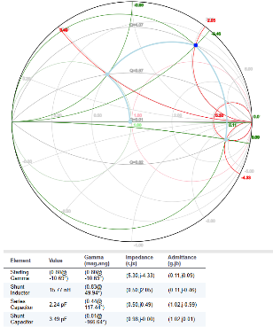Using all 3 elements looks better. From the antenna inwards is a 15nH shunt inductor to a 2.25pF series cap into a 3.49 shunt cap. The next step is to try some real components and see where we land after installing them one at a time.

The 868 frequency (2.43+j2.96) would be something like a 2.12pF shunt into a 20nH series inductor.

Start trying various real components to see where we go. The BOM already has a 13 and 18nH inductors so we’ll start with those. Solder a 13nH inductor into C2 we get:

|  |  |
| --- | --- |
|  |  |
| Initial setup.  C7=nm - shunt  C3=47pF - series  C4=nm – shunt closest to antenna  Case is on with screws installed  Placing a piece of wood next to the case shifts down slightly – similar to mounting the case to a rafter. Drywall is a bit more of a shift but still not much. |  |
| Remove the 2 screws holding the back on.  Slight shift but not enough to eliminate the metal screws but they do have to be part of the matching effort. |  |
| Remove the entire case shows the case does make a significant impact. The case is quite thin and only a few mm from the PCB.  Measurements from here will include the case since it makes such an impact.  Once challenge is that the UFL has to be unplugged each time a value is updated. This might result in the UFL failing as it is not intended for this many plug/unplug cycles. |  |
| C7=13nH - shunt  C3=47pF - series  C4=nm  Case on  As expected this moved the point up. Using RFMentor a 2pF series cap should bring it back down.  0.508+j2.33  A 2.0pF series then 3.5pF shunt would get this right to 50 ohms |  |
| C7=13nH - shunt  C3=2.2pF - series  C4=nm  There is a 1.9pF already in the BOM but maybe we can use 2 of these to get very close.  2.2pF is too low of a value. Try a larger one. |  |
| C7=13nH - shunt  C3=3.3pF - series  C4=nm  Looking better, now a 3.3pF shunt should bring us down to 50 ohms. |  |
| C7=13nH - shunt  C3=3.3pF - series  C4=3.3pF – shunt  Not enough. But will a larger inductor for C7 bend us down where we need to be? I have 18nH already in the BOM.  Experimenting with RFMentor looks like it might work. |  |
| C7=18nH - shunt  C3=3.3pF - series  C4=3.3pF – shunt  Close! VSWR is below 2 but still above 1. Need a slightly smaller C3 should get us right in there. We are close to the original values predicted by RFMentor. |  |
| C7=18nH - shunt  C3=3.0pF - series  C4=3.3pF – shunt  Shifted to the left but didn’t reduce the imaginary part which is what we really need. Need to increase the inductor a little more. |  |
| C7=22nH - shunt  C3=3.0pF - series  C4=3.3pF – shunt  This is about as good as you can get. The inductor is a Johansen instead of murata so that could throw some variability in but that’s the only value I had. Could C3 be a little smaller? It’s already smaller than I would like to push all the RF power thru it. |  |
| VSWR is below 2 and very wide. 1.2 is about as good as you can get but 4 is not so good.  So stick with these for US. I’ll check EU some other time.  EU will need different matching values.  The PCB vendor can also result in changes in matching so any time the boards are ordered in volume a quick match check should be done. |  |

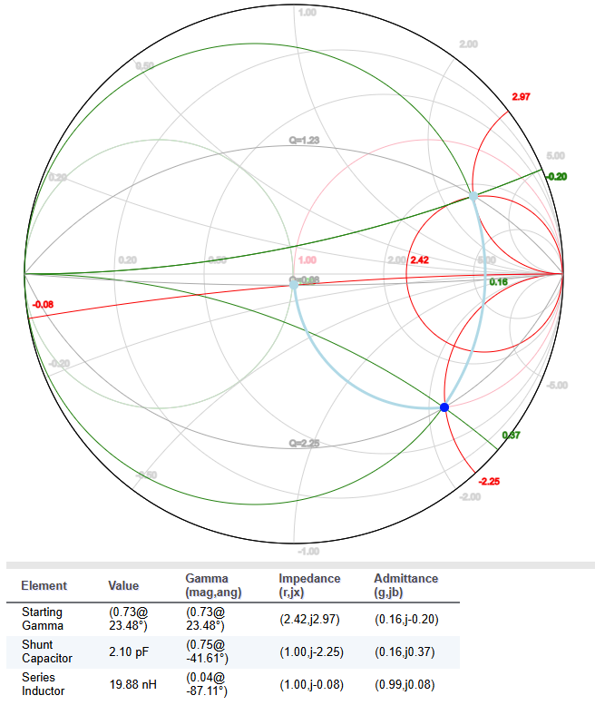EULR frequencies are 864 and 866MHZ but that’s close enough to 868 for matching purposes. Checking the EU match values – start at 2.43+j2.96:

Looks like a 2pF shunt then a 19nH series inductor should do the trick. Do I need a DC blocking cap? I don’t have a footprint for that. C4=2pF, C7=18nH yields 247-j130 (4.9-j2.6) which isn’t much better and not what we need. A larger cap should push it down further and a larger inductor will bring it back up. Maybe the cap was damaged when I soldered it on – didn’t look that good when I took it off. Switched C4=3.3pF yields 107.4-j9.6 (2.14-j0.19) which isn’t terrible but need to move left somehow. Increase C4=3.9pF yields 74.9+j35 which is really odd as it should go more negative. Other parasitics must be impacting more than the actual cap value (blobs of solder, traces etc). The other option is a large shunt inductor into a small series then a shunt cap similar to US.

Try a 27nH shunt into a 3.3pF series and 3.3pF shunt yields 19.4+j9.3 which is too far to the left. Use larger caps – 4.7pf for both. That works!

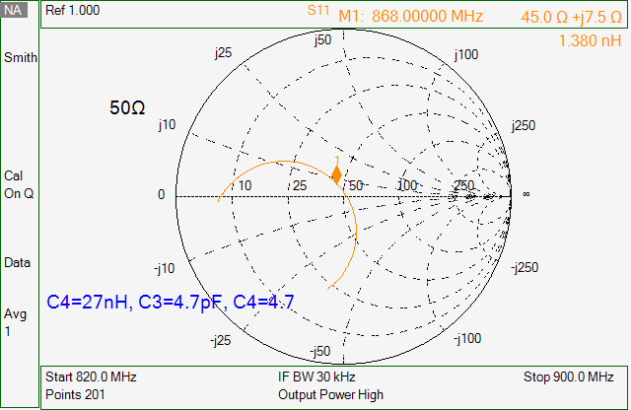EU Tuned antenna: C7=27nH, C3=4.7pF, C4=4.7pF yields 45+j7.5 and VSWR=1.2. Fortunately, neither required changing the length of the antenna itself so the PCB does not need to be redone. Now the question is what the range will be of the PCB antenna vs. the SMA external one? Need to test that but first need to build a PCB tuned for EU and US. The optimal frequency is 872MHz.

Updated the schematic and BOM with this info.

## 2024-11-17 – ZRADmini build

Built 3 boards. All had numerous solder shorts. I used a brand-new tube of solder paste and must’ve put it on too thick. I did swipe it thin with a 2nd pass but apparently the new solder squeezes under the stencil. The USB connector is tough to clear the solder shorts.

The SMA antenna should be soldered to the bottom of the PCB. The PCB fits in the case fine. The USB connector is recessed too much but not sure I can bring it closer to the edge (might need a different connector). The case must be cut to have a hole for the USB connector. The first 2 boards I built have the SMA on the wrong side but it is possible to put the PCB in backwards but the USB connector is hard to reach. Tried to desolder it but the SMA will not come out. Clearing the solder shorts under the USB on board 1 and 2 required several tries.

Board Status:

1. PCB antenna – OK – Runs SerialAPI
2. SMA antenna (wrong side) – runs SerialAPI but does not talk over USB, CP2102 does not pass data.
   1. Limited to an End Device
3. SMA antenna – runs SwitchOnOff & SerialAPI

Tried to load the XG23-RB4210A serialAPI but it goes into a reset loop for some reason. Use commander to Recover Bricked Device to bring it back. I built the bootloader and SerialAPI to debug them based on the 4210 devkit and not a custom PCB which has worked fine in the past. The bootloader runs fine. The SerialAPI gets to sl_stack_init() and jumps to 0xdeadbeee somewhere and then is stuck in the reset loop. Following the code in more detail into sl_zwave_protocol_startup() which is library code which then crashes. The code runs fine on a DevKit so something in the library code is checking for something and branching to 0xDeadBeef. Tried Ozone but it didn’t give any more details. The challenge is that the chip goes into a reset loop which the debugger disconnects so you can’t track backwards to figure out the cause. Ozone doesn’t catch the failure either. I did track the code further thru system_startup_core into sl_dcdc_vmon_init(0x0802A2C8 which is in sl_dcdc.c line 136). Sl_dcdc_power_mode_select(0x0802A23C line 56). EMU_DCDCModeSet(which is source code). Fails at line 3506 which writes DCDC_CTRL_MODE(0x01) to DCDC->CTRL_SET. This bit switches from BYPASS mode to enabling the DCDC switcher which apparently doesn’t work on ZRADmini? The power supply then crashes until the chip resets and the debugger disconnect.

The Devkit does this on powerup:

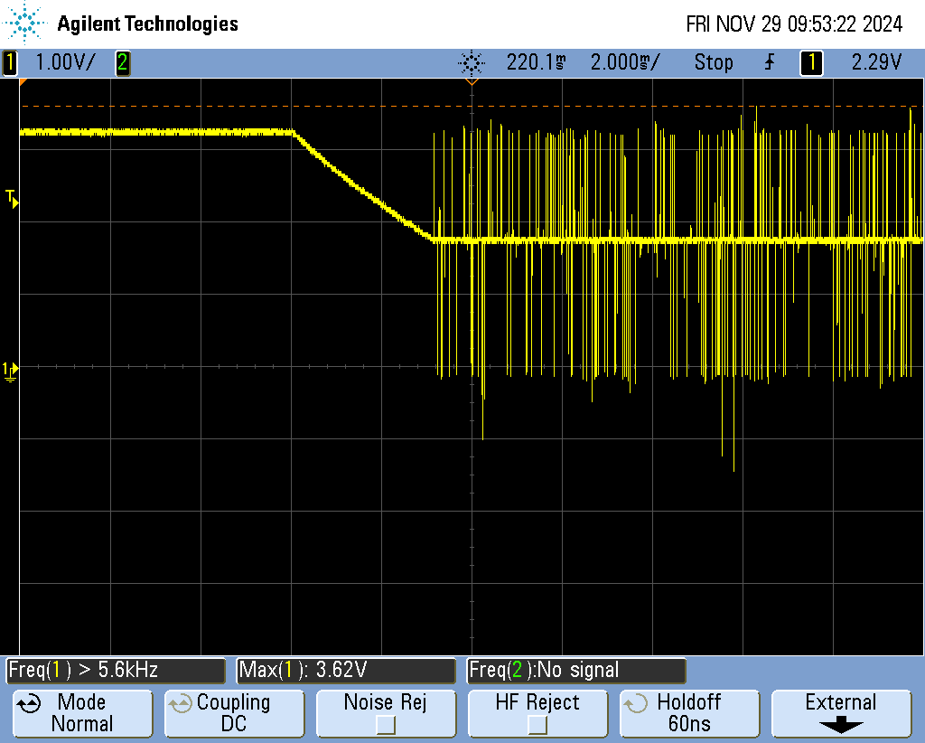The DCDC is in bypass with Dvdd at 3.3v which then ramps to 1.8v then the DCDC starts kicking the inductor so that the voltage remains at 1.8V.

The 2.2uH power inductor on the devkit uses a 1008 package with 1.9A and 101mOhm resistance. Which seems like massive overkill since the digital logic will only be drawing a fraction of an amp (probably just trying to minimize losses at great expense). ZRAD uses a 2.2uH in an 0603 package with 750mA and 375mOhm resistance which isn’t bad (also only 6 cents compared to 31). There are 0805’s that are only 14 cents with 1.3A and 156mA which is closer to the one on the devkit.

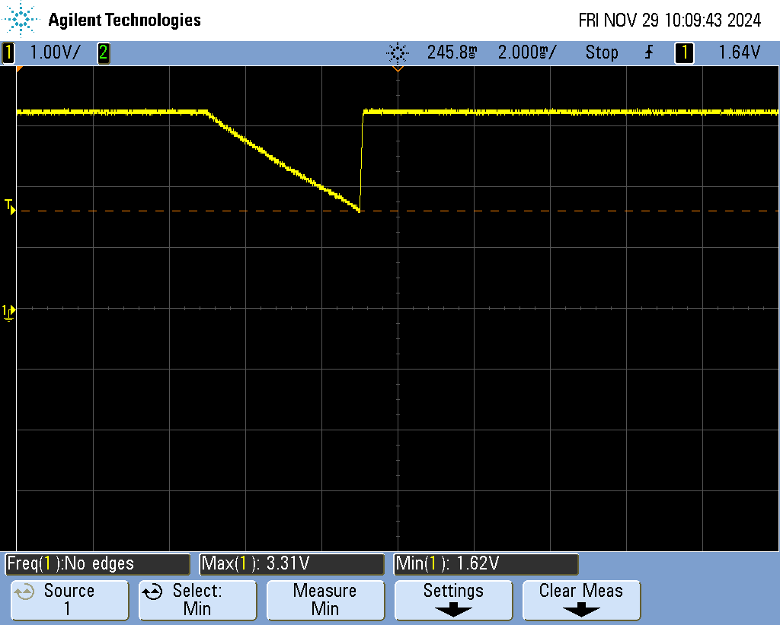The ZRADmini however drops to 1.6v and then obviously the voltage monitor kicks the reset line and the chip is then stuck in a reboot loop.

Reversed the SMA connector on Board 3. The DCDC runs fine on that board with SwOnOff and the SerialAPI.

Thus, Board 1 and 2 appear to have a problem with the DCDC switching and will not run code that enables it. Board #1 has an open on the VREGSW pin which is a corner pin. Soldered that pin again and now it is working. Board 2 appeared to have a bad 2.2uH inductor so I replaced it. It runs the serialAPI code but the PCC does not recognize it. Connections to the ZG23 look good. Touch soldered the pins on the CP2102 which were fat but still doesn’t talk.

Board #2 USB pins are not shorted but the CP2102 does not send any data out the Tx lines. Something about the CP2102 has failed but nothing obvious. I touch soldered most of the pins. The USB pins toggle and look OK. Dminus is normally low but also on a good board. Board #2 will be limited to ED only – powered via USB but can’t talk over it.

## 2024-11-26 – GPS examples

The AWG reviewers of Geoloc CC V2 want several examples of the GPS coordinates and the hex values stored in the ZG23. This also brought into focus the need to also have some Test code to make sure it all works.

Tried to find a map that would also output NMEA sentences with altitude and then I could put those into the code and make sure they generated good numbers. Couldn’t find that in one tool but combining a few you can cobble together some examples. GPS tools: [NMEA Checksum](https://www.meme.au/nmea-checksum.html) calculator, Google Earth will give the decimal coordinates and altitude from the map by dropping a pin, [GPS Visualizer](https://www.gpsvisualizer.com/calculators) can convert between formats, Generate a NMEA file from a map [nmeagen.org](https://nmeagen.org/). The process to generate sample NMEA sentences: Use NMEAGEN.ORG, search for a location, click on a specific spot, Generate NMEA File (which downloads a file), copy the GPGGA line (has 0.0 for the altitude), paste that into the NMEA Checksum calculator (delete the checksum and the leading $), find the altitude via Google Earth, plug the altitude into the 10th field (0.0,M), recalculate the checksum, then plug the compete NMEA sentence into the test code.

1. Eiffel Tower: $GPGGA,220333.093,4851.542,N,00217.669,E,1,12,1.0,37.0,M,0.0,M,,*55
2. Death Valley: $GPGGA,220333.093,3613.846,N,11647.047,W,1,12,1.0,-86,M,0.0,M,,*73
3. Sydney Opera House: $GPGGA,221800.175,3351.398,S,15112.920,E,1,12,1.0,4.2,M,0.0,M,,*74
4. Christ Redeemer Statue: $GPGGA,221800.175,2257.114,S,04312.624,W,1,12,1.0,703,M,0.0,M,,*73
5. McMurdo Station: $GPGGA,221800.175,7750.807777,S,16640.261234,E,1,12,1.0,118,M,0.0,M,,*67

These landmarks were chosen because one is in each quadrant of the earth, Death Valley is below sea level (negative altitude) and McMurdo Station is close to the ends of the valid values.

## 2024-11-14 – Release Rev A of ZRADmini

ZRADmini PCB was released to fabrication – should get 9 PCBs next week. Ordered components to populate them with.

## 2024-11-13 – Create ZRADmini

Requested an account on Altair for their FEKO antenna simulator. TO use the 1551 enclosure the 900MHz meander antenna I’ve used before doesn’t fit. The TI antenna uses 28 folds of 6+1mm = 19.6cm which is much less than the 33cm which is the wavelength of 913MHz but also longer than ½ wavelength. [RayPCB.com](https://www.raypcb.com/how-to-design-pcb-antenna/) has an antenna tutorial. Had to create a new shape for the PCB antenna. Most cases the SMA will be used but the PCB is there mostly to compare RF range.

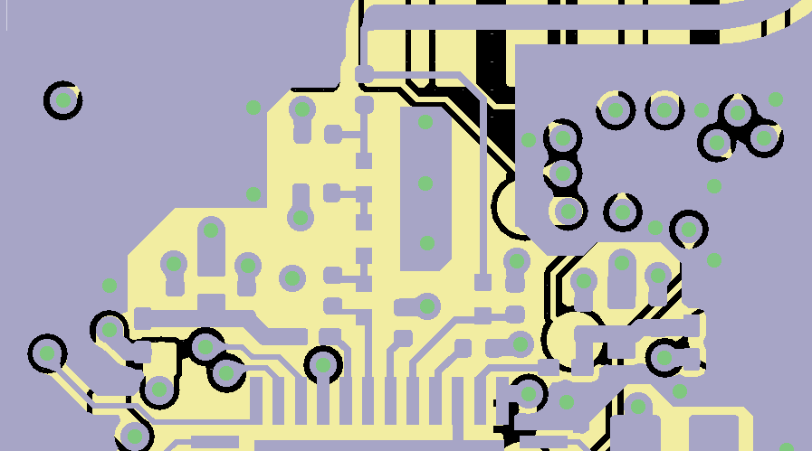The RF match from the ZG23 to 50 ohms is copied from the BRD4210A +20dBm Radio Board UG507 from silabs. However, the RF components are 0201 which are basically the size of a grain of sand and really hard to manage for prototyping purposes so 0402s were used instead. Technically the RF match should be redone but Silabs does not provide a guide on how to do this.

Had to remove the battery holder as there just isn’t room on the PCB (even on the bottom) and it wouldn’t fit in the case.

The assumption is the controller version is the typical use-case for ZRADmini and not as an End Device though it can be. As an ED, it probably won’t fit in the case without more extensive drilling. The USB connector will have to be drilled out but this is easily done using an inexpensive “maker” CNC machine. If the SMA connector is desired for an antenna that would also have to be drilled out but the hope is the PCB antenna will be nearly as good.

## 2024-11-12 – ZRAD-mini concept

After range tested yesterday with TBZ boards with varying ground rod length which didn’t make a difference, the desire is to also create a ZRAD-mini PCB design that fits in an off the shelf case, PCB antenna and SMA, 2 layer PCB and is much smaller and thus cheaper.

To determine the PCB size, the main constraint is the enclosure.

* Enclosures:
  + Requirements are ~2x4x1”, PCB mounting posts, end for USB-C, tab for all mounting is a plus
  + [HP-3653B](https://www.digikey.com/en/products/detail/bud-industries/HP-3653-B/2057368) – 1.023x4.165 PCB, $2.70@100 – A bit narrow but inexpensive
  + [1551UUFLGY](https://www.digikey.com/en/products/detail/hammond-manufacturing/1551UUFLGY/14556091) – 1.34x3.7 PCB, $1.88@100 – thin and has mounting tabs
  + [HP-3651-B](https://www.digikey.com/en/products/detail/bud-industries/HP-3651-B/2057366) – 2.23x3.243 PCB, $2.40 – 2 flat ends easily machined for USB connector

## 2024-10-22 – GeoLocCC debug

Actually the XA1110 GPS module is buggy. It works ok as long as it remains locked to satellites after a cold start. But if it loses lock (like getting into a skydiving airplane) then it gets all confused and is unable to correct itself for some reason. It also seems to have really terrible altitude measurements. Thus, today I am trying to use the ZOE-M8Q module which uses a different GPS chip. The M8Q works so much better!

## 2024-08-06 – GeoLoc CC

GeoLoc is working well. I added an Indicator CC so the LEDs will blink on the DUT to know if it is out-of-range.

See this [SparkFun](https://docs.sparkfun.com/SparkFun_RTK_Everywhere_Firmware/) page for various GPS mapping software solutions. Downloaded [QGIS](https://www.qgis.org) to see if that works.

## 2024-08-05 – GeoLoc CC

See the Ubuntu laptop for more details. One interesting point is that making the temporary floating point variables on the ZG23 to be Double instead of just float didn’t seem to make any difference. I keep getting a power of 2 off somewhere. The longitude should be 70 but I keep getting 140. AHA! The problem is I was shifting the MSB by 23 instead of 24! I am now getting Longitude correctly into Z-WaveJS! Got the first Heat Map! 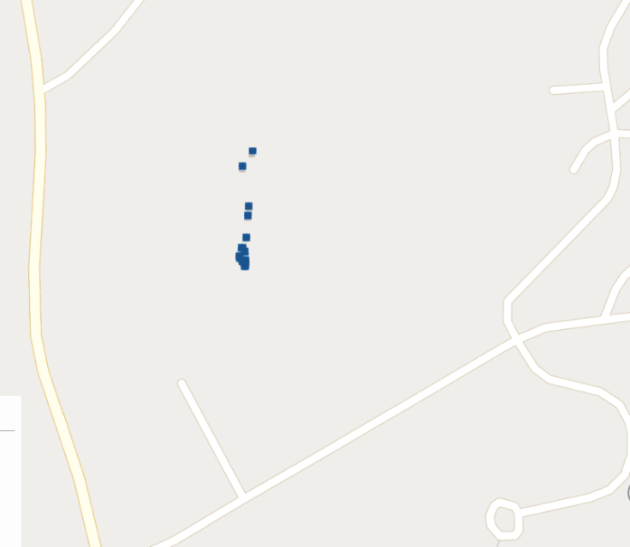ZwaveJS throws and unhandled error as soon as there is no ACK so I asked Dominic how to ignore those.

## 2024-07-30 – GeoLoc CC

Sidetracked on a personal project for the last several weeks but back to GeoLoc now. Sent Dominic more questions and hopefully have a call with him as I cannot figure out how/where to run the script to send GeoLoc commands.

The other option is if the SerialAPI can handle encryption for me. I’d much rather write a few lines of Python to talk to the SerialAPI and use the PCC to join devices. But I need something to handle encryption. SerialAPI can do encryption but ONLY for the end-device libraries, not as a controller. Bummer.

## 2024-07-15 – GeoLoc CC debug

Back to debugging GeoLoc CC to generate heat maps of the RF range. We also have plans to do range testing via skydiving, rocketry, and motorcycles in addition to just general neighborhood testing.

Domenic emailed me some basic instructions on setting up Z-Wave JS-UI for testing GeoLocCC. I would use the raw SerialAPI but we need to test using ZWLR which always uses Authenticated Security which is good because then we are only testing with 100% clean packets (1 corrupted bit and you cannot decrypt the message). But the SerialAPI doesn’t handle security S2 for me and it would be easier in general to use Z-Wave JS (I think). Initially I tried to get it working on my laptop but so much of Z-Wave JS relies on Linux commands (specifically in talking to the hardware) that I felt it would be easier to build a Linux laptop and use it for debug. I had an old Dell laptop just waiting for this purpose. See the ReadMe.txt file on the laptop for details on installing various software to get the system working.

I was able to have Z-Wave JS UI running in a docker, able to connect to the Controller, add a node via SmartStart. But it doesn’t retain the settings. See the ReadMe.txt for more details.

## 2024-06-11 – Trace Debug

Retesting Rev B using trace works perfectly. A 9.514MHz square wave comes out the TRACECLK pin. The only other option is that the JT2Mini board has a short on it? I don’t measure a short using a DMM. I only have 2 JT2MINIs and one has been modified for rev B. With the rev B Jt2Mini I do get the traceclk out on the wrong pins. So it’s looking like it’s the JT2Mini board. Yup – the 10 pin header on the JT2Mini had 2 pins that didn’t quite make connection down to the pads. Touch soldered and now the TRACECLK shows up on the test point and the scope but J-Trace still doesn’t see the it. So is the 20 pin connector not soldered well? Yes – that board for whatever reason must’ve had some oil or dirt on the pads and as a result didn’t make good solder joints. Fixed the solder joints. Trace is working well on Board C2. Thus, I can close out that issue. Trace complains the buffer is overflowing. See this [CASE](https://community.silabs.com/s/question/0D58Y0000AWmBmUSQV/trace-overflow-detected-using-segger-jtrace-on-zg23?language=en_US) for a discussion of the STALLENA bit. Setting STALLENA in MAIN works fine. Not sure why setting is via the Ozone script doesn’t stick. I filed this [case](https://forum.segger.com/index.php/Thread/9495-J-Trace-unable-to-set-STALLENA-on-ARMCM33-from-Silabs-EFR32ZG23-in-JLinkScript-b/) on Segger.

Back to GeoLocCC debug and documentation. GeoLoc is replying to a GET with a REPORT. But I need a script to pull the data out and dump a .csv which can then be plotted on a map. Updated the BOM by adding individual TABs for each build type. Released ZRAD as a public repo since the hardware is done!

## 2024-06-10 – Trace debug

Checking trace debug has been fixed. Unfortunately, my first go at it with board 2 doesn’t have the trace clock coming out. The project Ozone was using was in a tight reset loop. I need to rebuild it using the current project. Still not getting anything on traceclk or TD1. TD2 is toggling. GPIO.TRACEROUTEPEN is set to 0x0E which enables the traceclk, TD0 and TD1. PA3,4,5 and Pushpull. Thought maybe the pins where shorted on board #2 so I switch to #1 but get the same result. Traceclk is low, TD1 is high, TD2 is toggling. Wiring looks fine in KiCAD. Not shorted to GND. When I use Ozone in the debugger to set traceenb to 1 the debugger fails to read 4 bytes and then has to be restarted which is why I suspected the pin might be shorted.

The TCLK and TD1 labels on J3 are backwards. The wires were corrected but the silkscreen labels were not.

## 2024-06-07 – Documentation and testing of Rev C

Updated documentation in preparation for release. Tested the 2 new Rev C PCBs.

* Board 1: Ctune=0x6a=908.4434, 0x98=908.418, 0x94=908.420
* Board 2: Ctune=0x6a=908.448, 0x98=908.420

## 2024-06-06 – Rev C PCB assembly

Built 2 Rev C boards but I’ll need to order more components to build more as I’m out of a number of things.

## 2024-05-28 – GeoLocCC

Debugging converting the NMEA sentence into binary numbers to return via the GeoLocCC. Printf does not normally support %f and has to be enabled via settings->C/C++ Build->GNU ARM C Linker-> C Library-> check the box Printf float.

Ram usage : 53056 / 65536 B ( 80.96 %)

Flash usage : 479264 / 491520 B ( 97.51 %)

With the printf float disabled:

Ram usage : 53056 / 65536 B ( 80.96 %)

Flash usage : 474128 / 491520 B ( 96.46 %)

Which is 5K just to be able to print floats! But it’s not needed except to print so leave it off except when debugging.

Seem to have it basically working. Needs more testing and some trials!

## 2024-05-23 – GeoLocCC

Tried a few random ideas – commented out the INT32_t in ZW_classcmd.h and binary switch starts working again! WTF! There are no int32s at all in ZW_classcmd.h file. Why would int32_t make the code crash? The entire file only has UINT8_T. Geo GET also returns a report so for whatever reason you can only have UINT8_T in ZW_classcmd.h! CO had no idea why but figures something must parse it and assumes everything is bytes.

## 2024-05-22 – GeoLocCC and I2C

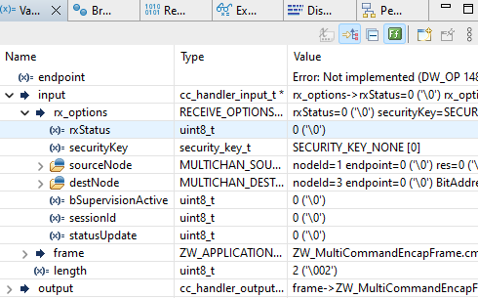The suspicion is that I2CSPM is what is blowing up Z-Wave probably because it is blocking instead of being interrupt driven which means the CPU is stuck in polling loops for long periods of time. There are several ways to go about checking this: 1) setup trace and see how long it’s sitting in poll loops (already know it’s a LONG time), 2) remove I2CSPM from one of the existing projects and get the code to compile and run, 3) make a fresh install without GeoLoc, add I2CSPM and see if Basic Set crashes, 4) rewrite the I2C interface to be interrupt driven instead of polled (I suspect I’ll eventually have do this), 5) wire up the UART instead of I2C (hand soldered unreliable connection – disadvantage of not having a standardized connector). #2 is easiest to start with – just comment out the code that runs the I2C. Basic works but geoloc get has a 0xD5 in RxStatus which is bogus. Try #3: Created SwOnOff_ZG23B_ZRAD_GeoNoI2C- This project gets the 0xD5 in RxStatus so it is something in GeoLocCC. Must be an incorrect pointer to a type of some sort. Have to compare this with other CCs. Both basic and binary switch CC use REGISTER_CC_V5. Binary switch is also getting 0xD5 and thus is not responding to a Binary Switch GET. Let’s try the generic project. The generic project gets an rxStatus of 0 which is what is expected and thus returns a binary switch report. 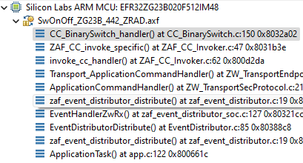 This is the good project when a breakpoint is set right at the start of CC_Binary Switch Handler.

Net result is that the problem is in the creation of the GeoLocCC and not the I2C driver. What the problem is though is a mystery. Clearly the rx_options is filled with garbage in the broken version. But why would that break it? Is there a hardcoded limit somewhere we are exceeding? The input structure is in the AppStackBuffer (0x900 bytes) according to the MAP file.

I set a watchpoint on the address and it breaks in Transport_ApplicationCommandHandler while pulled the value from rxOpt so I set another watchpoint there. Seems that portasm.c modifies address 2000BCDx which is where the data is coming from?

## 2024-05-20 – GeoLocCC

Ongoing effort to get Geographic Location CC to work. Working in the SwOnOff_ZG23B_442_GeoCC project on Board B4. I keep getting RADIO_BOARD_EFR32ZG23=1 in the compiler preprocessor settings. I don’t see where SSv5 keeps pulling it from. I can’t factory reset the board because pressing the learn button immediately goes into the default handler. This is because PB1 is not defined. I had to use the source file (radio_no_board.c) to fix it and arbitrarily assign it to PC03. If it’s not assigned, then we get an Assert and go to the default handler. Confusing because the PB starts from 1 but the pin numbers start from 0. That got the push button to work and able to Factory Reset the board, join the network and PCC is able to control the green LED via basic on/off.

Commented out the code for zaf_event_distributor_app_zw_rx which was a hack anyway. Need to find the source of the corruption thru the proper handler. Send a GeoLoc GET and I get this out of the UART:

BuildTxAckHeader: pFrame->frame.headerLength = 0D

BuildTxSingleHeader: pFrame->frame.headerLength = 0C

BuildTxAckHeader: pFrame->frame.headerLength = 0D

But nothing relative to getting into the GeoLoc code. Note the above is for the 1st time it’s sent which it has to resync the S2 Nonce. Once synced, only get one line with the 0x0D length. No idea where this DPRINT comes from as searching for the strings doesn’t find anything. The call to DPRINTF is from ReceiveHandler() in ZW_transport.c in the library – set a breakpoint inside the library code for DebugPrintf to find it. If that’s in the library code, isn’t it always going to be executed and thus slow the code down? Can the compiler remove the library code if DEBUGPRINT is not defined?

Basic Set and Indicator CC also don’t work at all once GeoCC is added. Commenting out the GeoLoc registration doesn’t fix anything. Something else is breaking the code. So, it’s a binary search to add things 1 at a time to figure out what’s causing the SDK to go into the weeds. Could it be that one of the other interrupts is causing the failure?

Create a new SwOnOff_442_GeoCC_dbg where I’ll incrementally add things to find the cause. Followed the readme.md for ZRAD to setup the board with SwOnOff which is working non-secure. I can send a basic set to turn the LED on/off. Press the button to send Learn and DEBUGPRINTs are coming out uart.

Next step is to install GeoLocCC but I’m going to do it with GPS_ENABLED not defined and then comment out almost everything except a few printfs. No changes to ZW_classcmd.h. That works. I can send a GeoLoc GET and I get a printout from the DPRINT. So the next step would be to get it to respond by adding more stuff in. I’ll add the I2C last as maybe that’s what’s blowing it all up? I2C is blocking so maybe the CPU loses data or queues overflow? Trace might also help there.

## 2024-05-16 – Rev C PCB

Sergue at zwave.me confirmed that his zniffer is able to decode the 9 bit UART mode of the PTI module. Wired that to the CP2012 using the RX pin for the CP2015. This is just an option and at the moment is not supported but gives future possibilities. I ordered 3 Rev C PCBs.

Rev C schematic is ERC clean. The PCB has 2 excluded warnings due to footprint modifications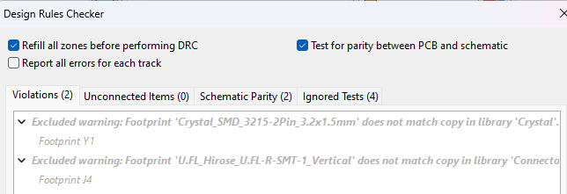 which are OK. The footprints were slightly modified to fix other minor DRC warnings.

I want to build a small, cheap version of the board – 2 layer with PCB antenna 4”x2” which Zima says he’s had good luck with. Call it ZRAD-S for “small”. Prove out if the PCB ground plane makes a huge difference or not. Same schematic, different PCB.

## 2024-05-13 – Rev C PCB

Fixing a few errors in the Rev B PCB and adding a 2nd UART port via USB with a CP2105 as an option. Andrew Hayden mentioned they had gotten this to work. This would enable a zniffer at the same time as the SerialAPI which would provide super handy remote debugging capabilities. See Issue #5 on the repo for more details. Battery holder is backwards, the TCLK and TD1 pins are reversed and rename things to be ZRAD. Added more documentation.

Filled out a project via Screaming Circuits to see how much they would charge for a turnkey project of 25 boards - $185 per board with a 1 week turnaround without the EFR32ZG23 or the LDO (they could quote them – or we could choose another LDO). With a longer 31 day turnaround the price is down to $152 per board. They use Sunstone for PCBs which are quite expensive though even thru OSHPark the 4 layer PCB is expensive - $80 for 15 day turn or $112 for 5 days. SC Custom process has prices under $50 each. This is a complete turnkey production but doing any significant numbers are cheaper in volume (1K or more). Typically, there is a big price break at the 10K/yr production levels.

## 2024-04-26 – Railtest

David Zima is doing some RF chamber testing to determine if ZRAD can meet FCC at +20dBm TX power. He needs the Railtest commands to do it which were added to the Regulatory section above.

## 2024-04-23 – RF Range Testing

Today I will be testing mesh Z-Wave in US and EU regions at the Scammell Bridge in Dover NH. The first problem is checking that the devices are in EU region. The firmware tends to write the MFG_ZWAVE_COUNTRY_FREQ and then gets stuck there even though the firmware is set to some other region. Downloading the firmware doesn’t seem to set it unless you first erase it via commander then overwrite it. The EU Zniffer firmware in 4.4.1. and 4.4.2 doesn’t appear to work on a thunderboard. Try a DevKit?

Using my N9912 SA I confirmed that board #5 is using EU frequencies. The zniffer on a TBZ however does not appear to be. However board #5 is always blasting out at 868! Even the standard SwOnOff 442 binary file turns on the TX 100%. Interesting. Board #5 was joined to the PCC with a ZWLR NodeID. So I completely wiped the DUT and started again initially with the standard SW On Off binary. OK, now it is working normally. The key is a full wipe including the _REGION. The full wipe removes the CTUNE which is in the UD page? So it has to be reprogrammed along with the DSK.

I plugged in a devkit 548 and eventually go it into EU frequencies. Unlocked debug was not enough to clear the _REGION! I had to use the command below! Taking hours to just get devkits into EU working order. Ugh. Very difficult to tell what’s going on with the Agilent SA.

The PCC is able to switch from US_LR to EU via the SerialAPI (and back to US_LR). I built an EU zniffer and programmed a DK with a ZGM230 on it with it as a dedicated EU Zniffer. My TBZ zniffer is back to a US_LR zniffer. DK 548 has an EU SwitchOnOff demo in it.

Too late to take the equipment to the bridge for long range testing. But a quick walk thru my neighborhood and it works everywhere even around a hill. 160m thru several buildings or maybe around them?

## 2024-04-22 – RF Range Testing

The effort to add GeoLocCC has failed – see below. Using the ERTT to determine range. See the RFRangeTest.docx in the Test folder for details. Planning and some preliminary testing at the bridge in Dover NH.

Was hoping to be able to use the EK2705 chip antenna as a test but it seems it is no longer supported in SSv5.

Built an EU ZRAD but it does not talk EU because the MFG_ZWAVE_COUNTRY_FREQ is set to 9. To fix it: commander flash --tokengroup znet --token MFG_ZWAVE_COUNTRY_FREQ:0xFF

## 2024-04-20 – GeoLocCC

Transport_ApplicaitonCommandHandler in ZW_TransportEndpoint.c receives the rxStatus of 229 (0xE5). This comes from EventHandlerZwRx in zaf_event_distributor_soc.c which is where the FreeRTOS queue data is pulled from.

I was hoping that with a ZG23B the code would not still have this bug. I have no idea how to get around this now as the bug is somewhere in the SDK it would seem. Has something overflowed a stack? Obviously, something is corrupt. Need to hack something to be able to do range testing next week so for now I’ll just use the zaf_event_distributor_app_zw_rx() and put that in app.c. I can queue the REPORT but the ZAF doesn’t end up sending it I suspect because other bits in the TxOptions have invalid values and as a result the frame is not sent. Looks like the type for TxOptions_t is not the right one. This code is so squirrely – everything is renamed, repackaged, copied, swizzled, its nearly impossible to follow. The main problem is there is no API!

The ZAF_Transmit() function is the one that posts into the transmit queue QueueNotifyingSendToBack. Right now after queuing the REPORT the chip reboots obviously because an invalid pointer is passed thru the queue.

I have no idea how to fix this or even debug it. I emailed CO to see if he had any ideas.

The alternative is to code a simple app that sends a command to the hub and if it replies then record the GPS coordinates at that point. Then I don’t need to add a new command class. But time is short to make that happen. Might be easy enough to just light the green LED when a secure frame is exchanged, the blue LED when the secure frame fails but a NOP works, and red when nothing is getting thru. This is more obvious than the ERTT blinking an LED.

We’ll have to rely on the plain old ERTT for the summit unless CO can find a solution.

Oops – the battery holder footprint has + and – reversed. Added this to the Issue for Rev B.

## 2024-04-19 – GeoLocCC

Back to GeoLocCC since the ZG23B boards will require customized firmware just for B boards. I only have maybe 1 or 2 more ZG23A parts. I might have to order some. The other option is to rebuild GeoLoc for B boards since I’m unable to go any further with the current project since the SDK is giving me garbage.

1. Start with the wizard again with SwOnOff but with the ZG23B connected via Wstk2 mini simplicity header and board #5
2. Configure RF Region for ZWLR
3. SwOnOff project fails to build due to APP_BUTTON_A and LED not being defined. This is caused by the compiler setting the Preprocessor symbol RADIO_BOARD_EFR32ZG23=1. Note that RADIO_NO_BOARD is also set. Delete the RADIO_BOARD_EFR32ZG23 symbol and the project builds and runs (sitting in the WFI instruction).
4. Install DebugPrint as described in the ZRAD ReadMe.md
5. Configure LEDs/Buttons
6. Join the DUT to a controller – basic On/Off toggles the green LED
7. Install I2CSPM for QWIIC interface
   1. Basic set still works
   2. I had to remove the RADIO_BOARD_EFR32ZG23 again
8. Follow the instructions in the Geographic Location ReadMe.md
   1. Edit ZW_ClassCmd.h file and soft link the files
   2. Had to remove RADIO_BOARD_EFR32ZG23 again
9. The SDK is still giving me garbage – the rxStatus has an 0xE5 in it which the code then thinks it is a multicast frame so it’s dropped.

I ordered 2 more GPS boards – 1 XA1110 and a slightly more expensive one to see if it has more accuracy. Sparkfun has a board that’s $179.95 that they claim is accurate to within 24mm! I also ordered 2 more Tag-Connect debug cables as they seem to disappear! I also ordered more antennas to have pairs of the same one. Unfortunately, the 868 recommended antenna is backordered and not expected until July! Must do EU with the less expensive antenna which were in stock.

Tested and CTUNEd board #3. Shipped it and a bare board to David Zima for testing.

## 2024-04-18 – ZG23B debug

The 3 new boards I built yesterday don’t run the firmware but get stuck in some sort of reset loop. I rewired an ETM_ZWAVE adaptor board to fix the Trace debugging wiring mistake on the ZRAD (easier to rewire a 2 layer PCB than the 4 layer ZRAD board). Trace is working fine but it’s not easy to find the failure as the trace overflows. The task switch goes to a RAILINT which then unpacks a long list of stacked functions so I suspect there is a stack overflow somewhere. Single stepping with Trace tends to cause a hardfault accessing peripherals for some reason.

I get:

OnTraceStart() end - Took 5.22ms

LTRACE (Time since start: 0.112 578, Thread=ETM4): Trace overflow detected. Trace packets may have been lost.

For more information on how to avoid overflows see the following article: https://wiki.segger.com/J-Trace_overflow_error

Debug.Halt();

From Ozone with Trace enabled. Seems like the CPU might not have STALLENA enabled? I went thru this before with Segger and tried to get an answer from the Silabs CPU group but they had no idea. The Wiki page suggests: TRACE_SetEnableStalling = 1 but it’s not a command. I recall that when Trace is enabled this is set by default (maybe?).

This [Community](https://community.silabs.com/s/question/0D58Y0000AWmBmUSQV/trace-overflow-detected-using-segger-jtrace-on-zg23?language=en_US) page asks the question is the STALLENA feature available in HW? The only other option is to prescale the CPU clock by 2 to slow it down to reduce the amount of trace data. Another option is to lower the CPU clock. The xG23 RM shows that the ETM is from SYSCLK but the CPU is based on HCLK so it should be possible to lower the clock speed by powers of 2.

Reduce the CPU clock speed and then trace does not overflow. But the clock speed isn’t sticky as the CPU overwrites the clock register on occasion. Add these lines to the JLINK script:

U32 CMU_SYSCLKCTRL;

CMU_SYSCLKCTRL = CMU_BASE + 0x070;

JLINK_MEM_WriteU32(CMU_SYSCLKCTRL, 0x03001);

JLINK_SYS_Report1("CMU_SYSCLKCTRL: ", JLINK_MEM_ReadU32(CMU_SYSCLKCTRL));

But it does seem to prevent overrunning trace.

The problem remains that it seems like the stack is overflowing somewhere.

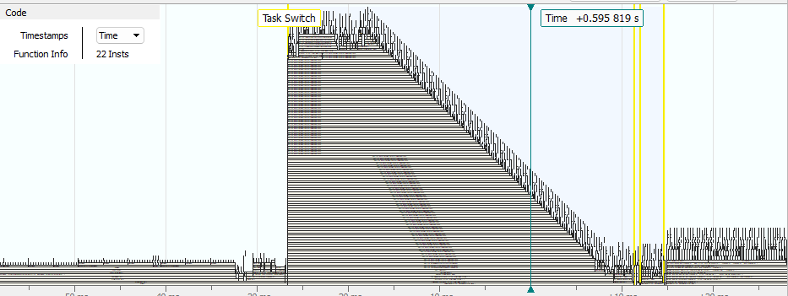

The task switches to a huge stack of RAIL interrupts it seems. .text.RAILINT_6433f1eb5ac17efd72f74a695e677e55 which all return but you would think that would cause stack overflows. This function is executed during startup inside of ZW_RadioPhyInit(). When I break at function e55 I get different trace results:

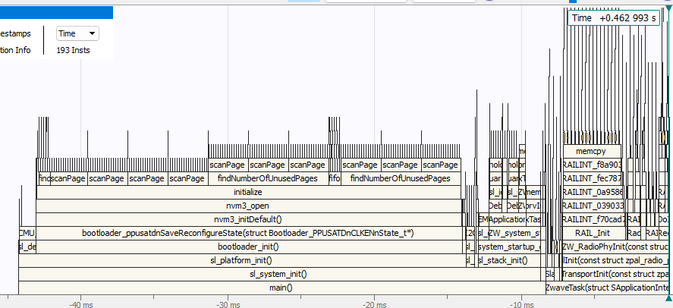

Note we are inside ZW_RadioPhyInit and everything is OK. No task switch and crazy stack. Trying to step thru the code from here ends up getting back thru reset at 0x0800170 which is the bootloader first instruction after the vector table. I suspect we’re actually underflowing the stack which is why Ozone thinks the stack is so deep.

Unfortunately, Trace isn’t providing me much help here as something is completely messed up. Well the good thing is that running the A code on a B devkit does exactly the same thing! So it seems code compiled for an A part will NOT run on a B part! I need to make a copy of the project and change the target to a B part. This also means I can use a devkit with trace with all 4 pins. Maybe that will give me more info? I also don’t have time to debug this!

I built SwOnOff using a B devkit. Then changed the target board to Custom Board and the part to an EFR32ZG23A and that project runs on a B part just fine. So, it’s not the fact that it’s an A build on a B part at least for the off-the-shelf SwOnOff. I enabled debugprint and set to US_LR were the only customizations. The same code runs OK on my new boards so it’s not something special about the board it would seem. Nope, it works because the B is still listed as a symbol. So, switching the “target” in the Properties isn’t a valid way of switching the target as it doesn’t change the target (which is also a SSv5 bug). I used the .SLCP file to change the target. Then the project doesn’t compile because all the GPIOs and EUSART settings were lost. Ugh.

One more try of running A firmware on a B part. Start with a RB4202D in a WSTK (ZG23B). In My Products of the Launcher perspective select an EFR32ZG23A010F512IM48 part. Select the GSDK 4.4.2 SDK. New->NewProjectWizard, Next, Select Z-Wave then the SwitchOnOff project and CREATE it and name it SwOnOff_ZG23A_441_runsonB. Click on Build – it should build OK. Click on the bug icon to download it and run it. It will run to main, but it then gets stuck in a reset loop forever. Click on Pause and the code should be sitting at the WFI instruction in EM1 waiting for something to do. Instead the code is often in a RAILINT doing a RequestIRCalibration() or waiting for the BURTC to sync or one of the other longer startup routines. If you then enable DEBUGPRINT (which requires some effort to enable the USART and assign the Ios) you will see it prints out just a few lines and then resets over and over again. I entered this [case](https://community.silabs.com/s/question/0D5Vm000008YhPxKAK/code-compiled-for-zg23a-does-not-run-on-a-zg23b). Seems when you create a project it loads a RADIO_BOARD_EFR32ZG21=1 as a Setting in Project Properties which might be what is blocking LED/Buttons.

## 2024-04-17 – GeoLocCC & 3 more boards

Call with Christian Salmony-Olsen to get Geographic Location CC V2 installed in a sample project.

* [How to implement a new command class](https://docs.silabs.com/z-wave/7.21.1/zwave-api/md-content-how-to-implement-a-new-command-class) on docs.silabs.com
  + Is a bit light on details but is a good start
* Linker Magic is the trick for adding CC to the NIF. Linux does this sort of thing which is where the concept came from
* All CO could suggest is look at what is coming in from the queue and there might be a bug in the SDK
* I did share GeoCC with CO and he will try implementing in the Trident stack

Join the GeoCC version classic without any keys. Still doesn’t turn the LED on via Basic. But the DPRINTs do say the command is supported. Sending a GeoLoc works! So at least I can get the GeoLoc debugged then figure out what the problem is with security later. ZWLR requires security so it will have to work eventually. But it doesn’t return the report. CO stated I just had to make the length non-zero and ZAF would send it. The reason it doesn’t send is because the rxStatus is 0xE5 which fails the is_multicast function RECEIVE_STATUS_TYPE_BROAD (0x04) so my code drops the frame. Obviously the rxStatus has garbage in it as E5 is an invalid value. Tracing that back to the xQueueZwRx and it is giving me 0xE5 so garbage coming from the SDK. I emailed CO asking what I do next.

Meanwhile I built 3 more boards. Board #5 removed about ½ the solder under the ZG23 EP so it would be less likely to lift seemed to help. But board 3 and 4 have the ZG23 down tight to the PCB even with all the solder paste. On all 3 boards I scraped off the excess paste to have just the thickness of the mylar and pressed the ZG23 down firmly. Much less solder shorts in general. None on the CP2102. Boards 3-5 cycle thru eResetReason 7 quickly – a few hundred ms so its not the watchdog. They do print out messages. Board #3-5 have ZG23**B**. They have SE firmware 2.1.7 – Updated to 2.2.4 but that made no difference.

I tried to single step to find what’s causing the reset but it’s something after the init routines when FreeRTOS starts up. So I tried to setup trace but the J-Trace is not showing any target power. Loose connection. Now have power but trace isn’t capturing. The TRACECLK is only 2.3MHz which is way lower than it should be. That’s because D2 is the traceclk since it’s at 10mhz. The board has the tracelk and D2 backwards. So, no trace until Rev C. I entered an Issue to fix that. The PCB is hard to rework since the trace layer is on an inner layer and not the bottom. I could rework an ETM adapter board but even that is pretty hard to do. I may go there if nothing else works.

## 2024-04-16 – GeoLocCC

After installing the Geographic Location CC, a Basic SET no longer works nor does the binary switch set! This is likely due to the NULLs used in declaring GeoLocCC support for Basic CC. But that shouldn’t impact the binary switch set but it does. Seems like the geoloc handler isn’t being called at all.

Apparently by adding GeoLocCC I need to add a function called zaf_event_distributor_zw_rx(SZwaveReceivePackage RxPkg) which there is a weak version that does nothing. This function is here as an extra call to anything not handled by the command class handler in the next paragraph.

I expect the ZAF_CP_CommandPublish to handle the GeoLocCC since it is a subscribed CC. But it is quite difficult to step thru this code. So switch to Ozone. EventHandlerZwRx() is the main function for handling the ZW Rx queue. Made a copy of ZAF_CmdPublisher.c to enable debugprints in it. I commented out the registration of GeoLocCC and turned off the timer to get the CC to work. There are still 3 CCs registered even though GeoLoc no longer shows up in the NIF. The CC and Cmd are 00 for all 3. Basic and binary switch don’t work. Something has blown up the CC registration. But that code is super hard to follow. Had to create yet another SwOnOff to figure out what these are supposed to have in them. This involved redoing the LEDs, USART, DEBUGPRINT which takes upwards of an hour to plug back in each time. The DPRINTs in the temporary project also list the CmdClass and Cmd as 0. And yet somehow it is able to process the correct binary switch command class. Aha, the subscriber list is not for the CCs but instead Application, Security, Multicast as line 40 of ZAF_Common_helper.c describes. The key is the call to Transport_ApplicationCommandHandler() which in turn calls invoke_cc_handler() which then finally goes thru the list of command classes. The list is from ZAF_type.h using extern const CC_handler_map_latest_t. _cc_handlers_v3 are identified in the .map file so this is created at compile time. The SwOnOffTmp is able to control the LEDs via a SwOnOff or Basic so it’s CCs are working fine. So why isn’t the version that I put the GeoLocCC into? The GPIOs are still wired up it seems. Never gets to invoke_cc_handler for some reason. Gets to ApplicationCommandHandler(). Eventually gets to TransportCmdClassSupported and for some reason fails searching thru the secure list (the device is joined S2Auth). I send the command from the PCC securely but the securityKey is security_key_none? WTF. The whole RxPayload directly out of the xQueueReceive is all zeroes so something is blown up? Well the TMP version (which works) also gets all zeroes? So how does it get past the security check? It’s the 2nd time thru that is all filled in. I think the first time thru just strips off the security stuff. Sometimes it’s the 2nd pass? In the GeoLoc version the 2nd pass how various non-zero values but security is still None. The first time the EZwaveReceiveType is 128, the 2nd is 132 but iLength is 0 and key is None. The temp project gets type=128 with Key=Auth and source/dest and other fields filled in, then type=132 key=None. Type=132 is StayAwake. The StayAwake can be ignored since this is an AOS. Seems like the Geo project is broken inside the SDK as the queue is delivering garbage. My choice is to start over again but I could use the zaf_event_distributor_zw_rx to hack in the GeoCC and not try to insert it via other code? This was a solid ½ day of debugging that got me nowhere. How does Silabs expect people to add code to their sample projects?

I emailed Christian to see if he can help tomorrow. I will need to build more boards tomorrow and do some preliminary testing and cannot spend much more time on getting GeoCC working.

## 2024-04-15 – I2C & GeoLocCC

Followed the instructions for install I2CSPM which I had to manually fix the sl_i2cspm_QWIIC_config.h file but it was easy enough. Next step is to install GeoLocCC by following the instructions in the ReadMe.md.

## 2024-04-12 – GeoLocCC – rename project from ZReach to ZRAD

ZWA Marketing didn’t like the name ZReach so they came up with ZRAD for Z-Wave Reference Application Design. Thus, the Repo was renamed to ZRAD as were several files but not all yet.

One of the main purposes of ZRAD is to give an example of a best-in-class RF range device. Thus, we need to measure the range in real world locations. Start with testing at an open-field site. Open-field sites are hard to find in New England as we have lots of hills, trees and buildings. There are few sites with more than 1 mile of open space.

Plan for RF testing:

* Location – Merrimack River in Haverhill MA – 1+mi LOS down river with adjacent sidewalk but there are trees between the road and the river
  + Initially head west toward bridge – if connection remains strong
  + Head east down river – note the buildings in the way at the beginning
* Geographic Location CC loaded into a SwOnOff ZRAD
  + Read out the exact GPS location while the DUT is moving
  + Controller will GET the GPS location and store it with Tx power and stats
    - S2 Security encrypted = zero bits corrupted
    - SDK Retries are OK – no application retries
    - Quantitative threshold for communication vs. subjective (led blinking)
    - Store .csv file which can then be plotted on a map in excel
  + GPS sensor is the SparkFun XA1110 with a small antenna
    - Ensure the Blue LED is blinking indicating it has satellite lock
    - Should not be a problem since testing is outdoors in open space
* All trials are joined with S2 Authenticated requiring 100% perfect data or frame cannot be decrypted
* Devices without GeoLoc CC are done using ERTT sending Basic On/Off to blink LED
  + Location data is recorded manually and threshold is subjective
  + Seems to be a way to share via Google maps? Apple maps will not give GPS coords
  + Turn on location sharing and share with a google account then they can see it on google maps
* Trials:
  + ZRAD Controller ZWLR antenna #2 + ZRAD SwOnOff antenna #2
  + ZRAD Controller antenna #2 + ZRAD SwOnOff antenna #2 – classic ZW instead of ZWLR
  + ZRAD Controller EU +14dBm + ZRAD SwOnOff antenna #2 EU
  + Same as above but with antenna #1
  + Same as above but with poor antenna on ZRAD SwOnOff
  + TBZ Controller ZWLR + ZRAD SwOnOff antenna #2
  + ZG28 devkit ZWLR (chip antenna) + ZRAD SwOnOff antenna #2
  + UZB + ZRAD SwOnOff antenna #2
  + ZRAD Controller EU antenna #1 + off-the-shelf EU device
  + ZRAD Controller ZWLR antenna #1 + off-the-shelf ZWLR device (homeseer PS100) PCB antenna
  + ZRAD Controller ZWLR antenna #1 + other ZWLR device

Ongoing work with GeoLocCC. Adding GeoLocCC to my SwOnOff_ZG23_441_GeoCC project. The previous GeoCC project was for a ZG230B so there are a number of challenges with that though it does seem to work on the ZRAD board. Renaming projects seems to blow up SSv5. So I started a new project using 442. Struggling just getting DEBUGPRINT installed. I configure the USART pins but doesn’t seem to change the config files. Click on SOURCE then manually edit the USART pins to connect them and then it compiles OK. The LED and button pins also had to be manually edited.

## 2024-04-11 – I2C Debug – set ctune

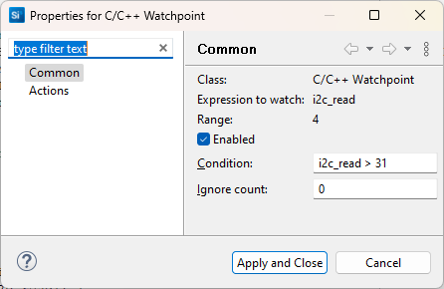The spaces in the NMEA are from i2c_read=32 which should never happen. Tried to set a [watchpoint](https://community.silabs.com/s/article/simplicity-studio-v4-watchpoints?language=en_US) on i2c_read>31 but it doesn’t work. Ozone is also not able to set a watchpoint expression. Ozone can set breakpoints on a write or a read of a variable but not on an expression so I suspect the issue is the HW debugging logic doesn’t support it.

The problem was comparing with <= instead of <. Found this by inspection. Trace probably could have found it quickly but I haven’t set that up yet. Fetching the NMEA sentence reliable now.

+....NMEA=$GNGGA,133700.000,4310.242586,N,07052.281637,W,1,9,1.11,42.117,M,-32.898,M,,*4A

+.........NMEA=$GNGGA,133701.000,4310.242974,N,07052.281336,W,1,9,1.11,42.052,M,-32.898,M,,*4E

+.........NMEA=$GNGGA,133702.000,4310.242672,N,07052.281168,W,1,9,1.11,41.993,M,-32.898,M,,*4A

+..........NMEA=$GNGGA,133703.000,4310.242547,N,07052.281174,W,1,8,1.18,41.942,M,-32.898,M,,*47

+....................NMEA=$GNGGA,133704.000,4310.241100,N,07052.280788,W,1,8,1.18,42.034,M,-32.898,M,,*4B

+.........NMEA=$GNGGA,133705.000,4310.239380,N,07052.279957,W,1,7,1.27,42.113,M,-32.898,M,,*42

+.........NMEA=$GNGGA,133706.000,4310.239013,N,07052.279833,W,1,7,1.27,42.342,M,-32.898,M,,*4D

+..........NMEA=$GNGGA,133707.000,4310.239051,N,07052.280373,W,1,6,1.34,42.311,M,-32.898,M,,*46

The + is the timer which is set to 933ms. Each . is another I2C buffer of 32 bytes. Once the NMEA is found, then the sentence is printed.

Need to set CTUNE for the 2 boards built so far.

1. Download RailTest into the DUT
2. Rx 0
3. Setzwavemode 1 3
4. Setzwaveregion 1
5. Setchannel 2
6. Settxtone 1 – turns on the radio carrier
7. Getctune – record the CTUNEXIANA value in hex
8. Use TinySA Ultra with start=908.3 stop=908.6
9. Measure the peak which the TinySA should display – goal is to be within 1ppm of 908.420MHz (1000Hz)
10. If the peak is high, set ctune to be a higher value, if low, try a lower value
11. Settxtone 0
12. Rx 0
13. Setctune XXX
14. Settxtone
15. Measure – go back to step 11 until within 1000Hz

Board 1 started at 0x6a which measured at 908.4376. 0x78=908.4289, 0x83=908.4226, 0x89=908.4192 which is close enough, 0x87=908.4202.

RailTest does NOT program the CTUNE value in the NVM. It just sets it in RAM. Execute the following command to set it permanently (in NVM) – commander ctune set –-value <ctunevalue> -d EFR32ZG23

Always do a ctune get to check the value was programmed in the Token.

Board 2: 0x6a=908.4379, 0x87=908.4212, 0x89=908.4199.

Board 3: 0x6a=908.4453, 0x99=908.4192, 0x98-908.4199.

Board 4: 0x6a=908.4433, 0x98=908.4187, 0x94=908.4209, 0x96=908.4195, 0x95=908.4202

Board 5: 0x6a=908.4459, 0x99=908.4202

SDK 4.4.2 released yesterday but does not appear to have the lockup fix in it according to the release notes.

## 2024-04-10 – I2C debug

The sparkfun XA1110 GPS interface is simply terrible. You have to read out a 255 byte buffer then parse thru it to try to find the NMEA sentence you want and piece it back together. The Arduino example code breaks up the I2C transfers into 32 byte chunks so we can do the same. Seems like you just keep reading data out like it’s a UART until you get an entire frame of 0x0A which will indicate there is no more data? I just love debugging by trial and error! After many hours I finally have the NMEA sentence capturing. I need to start a timer to fetch the GPS value every few seconds. Use the ZAF software Timers as described [here](https://community.silabs.com/s/article/z-wave-700-how-to-use-software-timers?language=en_US) and [here](https://www.silabs.com/documents/public/user-guides/INS14259.pdf). I am getting the NMEA sentence every 1.3s but sometimes there is a space in it which there should not be. I do get buffers of all 0x0a which means we are out of data. The spaces do seem to be coming from the GPS module. Do I need to remove them to match the checksum or not? The spaces are in bad places just random locations in the middle of a number. Is this a bug in the GPS module or my code?

## 2024-04-09 – I2C QWIIC debug

Back to I2C debug via QWIIC connector to a GPS module so we can use GeoLocCC to pull the exact location of the DUT and measure the range. While the ERTT is easy, determining the point where the LED stops blinking is subjective. Often the blinking will stop, the person stops walking, the LED starts again or vice versa. Is that the edge of the RF range or not? You can walk another 50 meters and the blinking can come and go. With GPS coordinates we can also capture the TX power and background RSSI.

The project I am working with is: SwOnOff_ZG23A_441. This is a temporary one to get the I2C working. As is typical with all Silabs APIs, the I2CSPM looks simple but has these enormous structures inside with little to no documentation. Thus, I have to spend a lot of time tracing thru the code to figure out what to fill out and how it works. Almost quicker to write my own! I2CSPM_Transfer sits in the While loop calling I2C_Transfer waiting for the transfer to complete. This is a blocking call and since each I2C bit is 3us this can add up to upwards of a millisecond for a large transfer. But it is easy to use and we have spare CPU cycles. Wandering thru the code for Multilevel Sensor sample app – wow! So much complexity for such a simple task. Very hard to follow. It sends a sensor report when the button is pressed which is the only event. Unclear how a sensor GET is handled. Somehow some giant structure is initialized with a function pointer I assume. That’s way more complicated than we need for now. Can I just use I2CSPM_Transfer? The I2CSPM_Transfer is always returning -1 from all addresses. But is it doing anything on the I2C bus? I’ll have to hook up my scope. SCL and SDA are toggling but it always does the same addr of 0. Because I wasn’t changing it in the code! I can probe all addresses and it finds 0x10. The I2C address of the SparkFun XA1110 GPS breakout board is supposed to be 0x10 (7 bit addr). The GTOP_NEMA_over_I2C_ software guide explains how to get the NMEA sentence over I2C. I can see the transfers on the PicoScope which probe just the address and return a 0 when the GPS ACKs the addr. The I2CSPM then sends the data byte which is zero for now. It appears you just read the NMEA sentence every 500ms and one of the 2 will be a complete sentence. The other might be partial while it is being filled out. Data of the packet will be 0x0A if the data is invalid. Either the end, the beginning, or the entire buffer will be 0x0A. Merge the packets together while discarding the 0x0A to get a complete sentence.

Enabled DEBUGPRINT. When I press the LEARN button the code goes into Board_DefaultHandler because the button handler is not defined which takes an assert. I did define PB1_GPIO=PC05 via Z-Wave Target Boards component. Board.h has settings for PB1 which is the one I am using and defined in the Z-Wave Target Boards. Set a breakpoint in Board_IsButtonAvailable. Run thru the init, then when pressed the breakpoint fires. Btn=BOARD_BUTTON_PB1[0]. This is APP_BUTTON_A but I need it to be APP_BUTTON_LEARN_RESET which is BOARD_BUTTON_PB2. I filed this [case](https://community.silabs.com/s/question/0D5Vm000007oaXmKAI/how-do-i-use-the-zwave-target-boards-component-for-my-own-pcb) to get an answer. I enabled PB2 as with PC05 and just made PC03 on the header PB1. That got the Learn button to work. Blinks the blue LED while in Learn mode.

## 2024-04-04 – Rev B PCB Debug

### Antenna Smith Charts

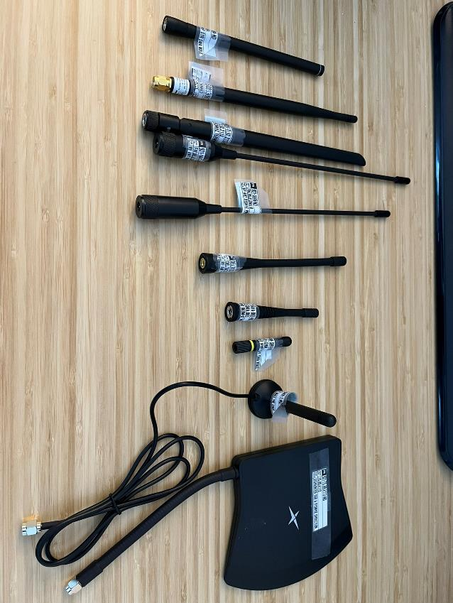David Zima mentioned that some antennas may assume a ground plane but other may not. Thus, I used one of the Rev A boards, cut the trace to the SMA, soldered another SMA to the bottom of the board which then can be screwed into my VNA to generate a Smith chart for each specific antenna below. I used my Agilent N9921A FieldFox spectrum analyzer in VNA mode. Calibrated the open connector (or the connector with the GND plane) to zero out the connector, then screwed the antenna into the N9912A and had it plot the smith chart from 850 to 950MHz. Used the Log Mag chart to find the minimum and set the marker there.

SETUP:

Eleven antennas were tested of various sizes and cost:

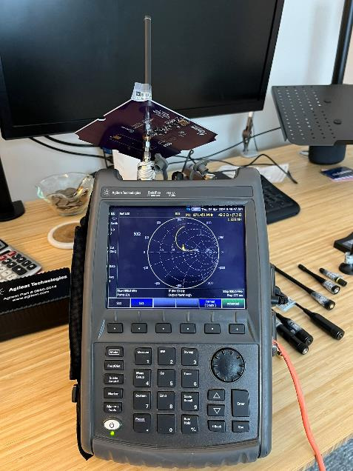The setup used an Agilent N9912A Vector Network Analyzer. Two passes were made with each antenna, one with a GND plane and one without. The GND plane used is a Rev A PCB with an SMA connector soldered to the bottom of the board and the RF trace on the PCB was cut.

The setup shown here has the GND PCB attached. The QuickCal calibration of the N9912A was used to zero out the effect of the connectors and ground plane prior to testing.

|  |  |  |
| --- | --- | --- |
| **Part Number** | **With GND Plane** | **Without GND Plane** |
| **[TI.92.2113](https://www.digikey.com/en/products/detail/taoglas-limited/TI-92-2113/11197416)**  $6.20 – gain 1.21dBi – 198mm  Comments:  Looks like the one shipped with Silabs DevKits  Relatively insensitive to hand nearby unless touching.  VSWR under 1.5 |  |  |
| [**TS.89.4113**](https://www.digikey.com/en/products/detail/taoglas-limited/TS-89-4113/15284364)  $40.56 – gain 3.5dBi  Comments:  Directional antenna with 3.5/2.7dBi gain in 1 direction – Tomahawk shaped.  Not a candidate for Z-Reach but interesting for comparison purposes.  Not sensitive to nearby hand until touching | Basically, the same since the antenna is on a short cable so the GND plane is not close enough to impact the response. | Adding the ground plane made little difference |
| [**ANT-8/9-MMG1-SMA-1**](https://www.digikey.com/en/products/detail/te-connectivity-linx/ANT-8-9-MMG1-SMA-1/16592298)  $5.66 – gain 2dBi – 83mm  Comments:  Cable to a small magnetic mount that will stick to iron.  Insensitive to hand unless almost touching the antenna.  Advantage here is the PCB could be quite small but include a metal disk to stick it to.  VSWR is under 2 (min of 1.5) for much of the range  Wide frequency range so the same antenna is OK for EU and US |  |  |
| [**ANT-916-CW-RH-SMA**](https://www.digikey.com/en/products/detail/te-connectivity-linx/ANT-916-CW-RH-SMA/1962849)  $8.89 – gain -1.3dBi – 51mm  Comments:  Very Small.  Hand closer than 1” to make a significant difference in smith chart  Price is the same for 1 or 10,000. |  |  |
| [**FW.95.B.SMA.M**](https://www.digikey.com/en/products/detail/taoglas-limited/FW-95-B-SMA-M/6362786)  $9.13 – gain 2.7 dBi – 226mm  Comments:  With GND VSWR is 1.1  Sensitive to hand 1” away  Slim and stiff but quite long |  |  |
| [**DELTA12C/X/SMAM/S/S/17**](https://www.digikey.com/en/products/detail/siretta-ltd/DELTA12C-X-SMAM-S-S-17/6096292)  $9.65 – gain 3dBi – 130mm  Comments:  Classic Rubber Ducky  Terrible VSWR barely below 3  Very little sensitivity to a hand but it’s not good in the first place |  |  |
| [**JCG402LR-2**](https://www.digikey.com/en/products/detail/jc-antenna/JCG402LR-2/15814458)  $2.42 – gain 2dBi – 110mm tiltable  Comments:  Relatively insensitive to hand nearby until touching the base. The tip was not sensitive implying there’s no wire up there. Touching close to the base brings the impedance down right to 50 ohms. Thus it should be possible to tune the antenna to the desired band.  Lowest cost antenna.  Better without the ground plane! |  |  |
| [**2600130083**](https://www.digikey.com/en/products/detail/w%C3%BCrth-elektronik/2600130083/11680415)  $14.88 – gain 0.9dBi – 179mm  Comments:  Covers 868 thru 928.  Highly impacted by a hand nearby without a GND, less so with GND.  VSWR above 2. |  |  |
| **868 antennas:** |  |  |
| [**ANT-868-CW-HW-SMA**](https://www.digikey.com/en/products/detail/te-connectivity-linx/ANT-868-CW-HW-SMA/5592340)  $8.74 – gain 0dBi – 135mm  Comments:  One of the better antennas  VSWR well below 2 for a wide frequency range  Hand has little impact more than 1” away  There is an identical antenna at 916MHz - ANT-916-CW-HW-SMA |  |  |
| [**FW.86.B.SMA.M**](https://www.digikey.com/en/products/detail/taoglas-limited/FW-86-B-SMA-M/6362785)  $9.13 – gain 2.8dBi  240mm  Comments:  Thin fixed (similar to the 915 one above)  Hand has little impact until less than 1” away  Needs the ground plane to have VSWR below 2.  One of the larger antennas |  |  |
| [**FLEXI-SMA-868**](https://www.digikey.com/en/products/detail/rf-solutions/FLEXI-SMA-868/5845738)  $5.12  Comments:  Short Rubber Ducky  One of the cheaper options, it’s also not very good based on the smith charts. Especially with a large GND plane. |  |  |

### Conclusion:

The Smith chart analysis shows that all antennas are NOT the same. Higher prices do not necessarily mean a better antenna. The cheapest antenna has some of the best results. This initial analysis will be followed up with field tests of the three recommended antennas below. After field testing, the chosen antenna will have the PCB/BOM optimized for maximum RF range while also aligning with the cost budget. This may involve making the PCB smaller and/or altering the matching and filtering components.

* 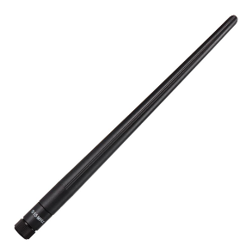Recommended antenna is the same one shipped with the Silabs DevKit

* + [TI.92.2113](https://www.taoglas.com/datasheets/TI.92.2113.pdf) - [$6.29](https://www.digikey.com/en/products/detail/taoglas-limited/TI-92-2113/11197416?s=N4IgTCBcDaICoEkB0BOMSwEZMGYAEIAugL5A) @1k – +1.21dBi – 198mm – 915MHz
  + [**TI.85.2113**](https://www.digikey.com/en/products/detail/taoglas-limited/TI-85-2113/11197203) is the 868 version
  + Reasonable cost, good response, not overly sensitive to nearby objects
  + GND plane didn’t make that much of a difference
  + The PCB size could be made smaller to lower cost
  + BOM would need to be tuned for this antenna
* 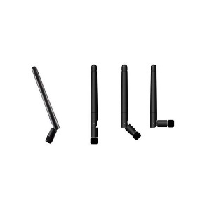Smaller low-cost alternative can be a good choice - bendable
  + [JCG402LR-2](https://www.digikey.com/en/products/detail/jc-antenna/JCG402LR-2/15814458) - [$2.54@1K](mailto:$2.54@1K) - +2dBi – 110mm – 915MHz
  + [**JCG402LR-1**](https://www.digikey.com/en/products/detail/jc-antenna/JCG402LR-1/15814463) is the 868 version
  + Without the GND plane has VSWR of 1.1 thus could make PCB smaller
* 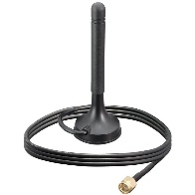Alternative option is the antenna with a cable and magnetic mount
  + [ANT-8/9-MMG1-SMA-1](https://mm.digikey.com/Volume0/opasdata/d220001/medias/docus/6146/ANT-89-MMG1-SMA-1.pdf) – $[5.66@1K](mailto:5.66@1K) - +2dBi – 82mm – both 915&868
  + Could significantly reduce the size of the PCB since the GND plane isn’t needed
    - Lower cost PCB
    - Lower cost enclosure
  + PCB would need specific tuning to achieve better results
  + Ship a metal disk for mounting and to improve RF range?

Where to test the RF Range? Testing at the beach is terrible due to sand and sun. Much better if the range can be down a river with a paved sidewalk alongside and the head end is in the shade. The River Rest Park in Haverhill MA has a 1+ mi view down the Merrimack river though there are trees in the way at various points. Follow the Buttonwoods Riverside Park. Need to bring a bike – walking is too slow to be able to test multiple antennas.

## 2024-04-03 – Rev B PCB debug

Still trying to get the SwOnOff project to work. Tried again but this time I just waited for several minutes between each step to see if it’s just SSv5 being so incredibly slow. To start off, I built just the SwOnOff and only changed the region to US_LR and it sits in all sorts of odd loops in RAILINT and BURTC. Board #1 does not have a QR code so the code hasn’t finished initialization. It does get to Main().

Using Ozone to manually set GPIOs to check out the LED. Green works, Red and blue are backwards but work. I’ll just change the documentation. PC05 the momentary switch for Learn Mode works. I’ll check out I2C later. Right now I need to connect Basic On/Off with turning on the LEDs so we can run the ERTT.

Nothing in the .SLCP to configure binary switch CC. Looking thru the code in app.c is a p_switches structure which apparently needs something to connect to. P_switches comes from cc_binary_switch_get_config(). This comes from SwitchOnOff_hw.c which again comes from p_switch. How is this then threaded to a GPIO? SWITCH_STATUS_LED is from APP_LED_A which is BOARD_LED1 which is simply an enum of 0 (in board.h). The board_getLedPort uses m_led_info[led] to get the gpioport. This in turn uses LED_INFO(LED1). But in this project m_led_info is never assigned a value. Create a project using a TBZ and see if it’s assigned somewhere. AHA! The key is the LED_INFO is a macro that expands LED1 into several other #defines with LED1 as part of the name. Talk about obfuscation! The file radio_no_board.h says to Use Configuration Wizard in Context Menu to set the various LED values. But WHERE in the Wizard? Z-Wave Target Board has the configuration of the LEDs and buttons. According to the ReadMe.md, BTN0=toggle state of the switch, BTN1=learn mode, LED0=state of switch LED1=indicator CC. Thus, set BTN1=PC05 and LED1=PA00 (green) and LED2=PA10 (blue) (active low). The LEARN button and the blue LED comes on when pressed! And sending an On/Off turns on/off the green led! So the code is much more tightly integrated into SSv5 now. However, following the code is nearly impossible! This is enough to begin some range testing using the ERTT.

Next step is to get the I2C QWIIC connector checked out and connected to a GPS to enable tracking an end device to get quantitative range measurements. There is a Peripheral Driver I2CSPM in the wizard but it is polled and blocking which is not great. Should be interrupt driven. What does the TBZ multi-level sensor do? RHT sensor is enabled in Platform/Board/Board Control. The Si70xx driver is installed. The I2CSPM is enabled and configured. The Reference Clock frequency is set to 0 (does that matter or does 0 select the HFXO?) – no documentation of course so who knows. There is a short doc on docs.silabs.com but doesn’t explain the configuration in the SLC. The GPIOs are configured. Back to the SwOnOff project – install the I2CSPM. Selected Fast Mode (400K) and assigned the SCL and SDA pins. The project compiles and the I2C pins show up in the PinTool. The I2C peripheral is initialized in sl_driver_init so it should be working. The only interface is via the I2CSPM_Transfer function in sl_i2cspm. I did verify the power and gnd connections on the connector so the PCB is a go.

## 2024-04-02 – Rev B PCB debug

Built the OTA bootloader which fortunately just builds using the defaults. Created a SwOnOff project to quickly check out the LED and QWIIC connectors. Once those are checked out, I can order more boards. First step is to get DEBUGPRINT working via a custom board. With the DevKit, the USART is used for debugprint but with a custom board the project fails to build because of “undefined reference to sl_iostream_write”. Click on the .SLCP file, search for IO STREAM, select Services/IO Stream which then opens a popup with a variety of choices – use IO Stream:USART. That didn’t work and I cannot get any other USART to configure as SSv5 says Selected Modules are “none” with no other options. So, I deleted the project and started again but this time I enabled Iostream before trying to compile.

This time, when I Installed Z-Wave Debug Print a popup asked for which IO Stream I wanted to install so I selected EUSART. But seems like nothing happened. Closed SSv5 and reopened and debug print is not enabled so something did not save. Closed SSv5 again and opened it but this time I installed IO Stream USART first then enabled debugprint. That seems to have worked. The project compiles. Not exactly sure how that worked and it’s terrible that I have to basically randomly try various things to find one that works. All because the Silabs environment is way too heavily weighted towards their devkits and NOT customer boards!

The SwOnOff project does not boot and gets stuck in BOOTLOADER_TEST_FAULT_HANDLING for some reason? I get different results each time I run. It’s not in a WFI which is where it usually is. Using Ozone I still have no idea what’s going on. The BURTC is running but seems like it’s in some sort of loop.

## 2024-04-01 – Rev B PCB debug

How to build the bootloader for Z-Wave for a custom PCB instead of a devkit? The problem with the devkits is they all use hi-security “B” parts which most users don’t need or want. The mid-security “A” parts are cheaper and firmware written for an A part will run a B part but not the reverse. Thus, it is important to compile the firmware for the A part. Downloading the devkit pre-compiled sample apps gets stuck in a loop presumably waiting for a high security feature. Using the Silabs search button didn’t find any usable articles. However, using google to search for “z-Wave 800 series build Z-Wave bootloader” bring you to: <https://community.silabs.com/s/article/Creating-OTA-bootloader-for-Z-Wave-800-series>. This KB is a bit light on the topic but at least gives some guidance. But we need an OTW version for the serial API. Add “OTW” to the google search and it pops up: <https://community.silabs.com/s/article/z-wave-700-otw-of-controller> .

This last article says to look here for the pre-compiled bootloaders: \demo-applications\protocol\z-wave\Apps\bin\

I filed a “feedback” on the website that the binary files are not in this directory.

I have a blog article in the works on how to build the bootloader. I was able to build the bootloader once I configured the Bootloader UART Driver component. The Pintool shows the Rx/Tx pins correctly.

[UG489](https://cn.silabs.com/documents/public/user-guides/ug489-gecko-bootloader-user-guide-gsdk-4.pdf) Bootloader User Guide is the main reference document but it does not explain the key requirements for Z-Wave. The document does not mention Z-Wave at all.

Next step is to build the SerialAPI in the same method – build it using a devkit and copy the necessary options into the custom board project. Built it and it chooses the standard UART pins by default so the project just builds without needing any configuration. Connect the PCC to it and it works and can join a node!

Board 1 debug: Ohm meter shows zero ohms between D2 pins 2 and 3 which are the 2 USB data lines. Short was under the USB-C connector. Touch soldered that to open the short and now the board shows up as a CP210x driver COM port.

Articles on how to implement [I2C](https://community.silabs.com/s/article/z-wave-700-how-to-implement-i2c-into-the-z-wave-embedded-framework?language=en_US) and [SPI](https://community.silabs.com/s/article/z-wave-700-how-to-implement-spi-into-the-z-wave-embedded-framework?language=en_US).

Next step is to get a SwitchOnOff into board 1 and then see how far can they reach. Need to quickly test out the LED and QWIIC connectors then order 9 more PCBs if they are all OK. Maybe quickly check the antenna tune and have to ctune both boards.

## 2024-03-29 – Rev B PCB assemble and debug

Three boards arrived today and I built 2. Still forgot to order 7.2pF caps but I had 7.5 which are close enough for now. Everything fits and the new refdes line up with the BOM.

The ZG23 soldered well but had a few shorts and both boards had 1 side slightly raised which in turn had several opens. For prototype builds I think removing some of the solder paste of the EP would make the chip not stand up. Maybe also push it down harder to make sure all 4 sides will quickly apply surface tension to hold it down. The footprint is a standard footprint so I assume for volume production the amount of paste would be more consistent and the IC would be applied with more pressure.

Board 2 connects via USB! The CP210x driver loads. Board #1 comes up as an unknown device. Touch soldered the USB connector which looks fine now – had some shorts originally and looked OK before I touched them up again. Device Manager reports the Device Descriptor Request Failed.

For now, I’ll focus on board #2 and come back to board #1 later.

The demo files are stored at: C:\SiliconLabs\SimplicityStudio\v5\offline\com.silabs.sdk.stack.super_4.4.1\protocol\z-wave\demos. I downloaded the BRD4204 version of the SerialAPI solution but PCC does not recognize it. I can’t debug it either as all I have is the binary which is in some sort of loop and not at the EM1 WFI so the firmware is stuck somewhere.

But this has an A part and there may be other special things on the PCB that don’t match my board (I did install a 32KHz crystal). I need to build a bootloader and a SAPI using the actual part which will take some time to figure out how to configure both the bootloader and SAPI.

The SE firmware is 2.1.2 but GDK 4.4.1 has 2.2.4 so I upgraded the SE. Now it gets to main but immediately ends up in HardFault_handler. I switched to Ozone and it ends up at the WFI like it’s supposed to. WTF. And now so is SSv5. WTF. And it now has a QR code. Now to enable debugprint. Select it, then wait at least 1 minute. Then install it. Wait another minute or more. Select IO Stream: EUSART(0). Wait another minute. Click on Install. Wait several minutes. Doesn’t seem to do anything. Nothing asking me for which GPIOs to use. Ask it to build an has nothing to do so nothing has changed as far as SSv5 is concerned. Uncomment DEBUGPRINT and attempt to build fails because it needs sl_iostream_write. Give up on DEBUGPRINT. I don’t really need it but it is often handy.

## 2024-03-18 – Rev A PCB debug – Rev B update

What are the possible reasons the CP2102 doesn’t connect to a PC? The most likely problem is that D- isn’t connected or is shorted to something as pin 5 is one of the recessed corner pins. First thing to view is to see if reset is being held low during power-on. Then look at the D+/D- pins during power on and see if they toggle. Not much else I can debug as the CP2102 is fully encapsulated – no oscillator or anything else coming out. Configuration is done via USB. Check that pin 13 (WAKEUP_N) is high which it should be. Should see the TX/RX uart pins toggle as well by the ZG23 sending power on commands. On power up I see the USB pins toggling probably sending a wakeup sequence. I also see the ZG23 sending the wakeup commands on the TX. Reset quickly follows powerup so I think that is fine. I posted this [question](https://community.silabs.com/s/question/0D5Vm000005tCdsKAE/cp2102-unresponsive) to the community page. I searched the community but didn’t find anything similar.

I might as well fix all the issues and release Rev B as I can’t see what else might be wrong. Either the CP2102 connects, or it doesn’t – no way to debug it if it fails.

Rev B issues are in github:

1. The refdes are not ordered relative to their position on the PCB. I forgot to run the reorder after placement so the refdeses are the random order they were placed on the schematic.
2. C11 and C12 are 220pF caps but have a 0603 footprint instead of 0402. The 0402 can be installed in the 0603.  
   Fixed in Schematic, not PCB.
3. The color LED is the wrong pinout in the schematic - the LED needs to be a common anode, not cathode. The footprint has the wrong pinout for the selected LED - QLSP14RGB_B (7 cents) which is a good LED. Might have to make a custom footprint and symbol to fix it.

* A LED I've used before is: CLV1A-FKB-CJ1M1F1BB7R4S3CT ($0.38) Though it does have 3.2V forward drop which won't work if on battery power where the voltage might be only 2.4V.

1. The infeed track width to be 50 ohms should be .44mm instead of .3. Move L1 to the right just enough to get the flood fill to fill in between L1 and L2. Ideally squeeze a via in there. The traces out of the ZG23 have to start at .2mm (same size as the pad) but should widen immediately to .44mm.
2. Switch from the CP2102N QFN20 to the QFN24 package. The QFN20 has 4 pins that are below and recessed slightly within the package. The QFN20 is a standard pin arrangement so the solder joints can be visually inspected and reworked as needed.
3. The QWIIC connector footprint has thru-holes but the part is SMT.
4. Label the signals on the Tag-Connect
5. Add an optional reset switch (normally not mounted). It's just super handy during debug to be able to reset the chip by pressing a button.

Rev B upgrades the KiCAD database to V8.0.0. This required updating a number of symbols and footprints which are much more standardized in V7 – specifically pin 1 markers are in most footprints.

Somehow pins 29 and 30 are backwards in Rev A? I corrected this in Rev B. TD1 and TCLK.

The U.FL connector for whatever reason has a DRC error in it that the solder mask bridges 2 nets. I made it a little smaller. As a result, there is an exclusion that the footprint doesn’t match the one the library.

The 32KHz crystal also has an exclusion because I edited it again as the silk screen lines are too close to the pad.

QWIIC connector – easier to just modify the one I already have to be SMT than try to import one. Well, turns out in KiCAD V8 there already is a JST connector library and it has the correct footprint!

DRC Report: The 2 symbols were slightly fixed to prevent errors. The extra footprints are the fudicials.

** Drc report for ZRAD.kicad_pcb **

** Created on 2024-03-18T15:06:45-0400 **

** Found 2 DRC violations **

[lib_footprint_mismatch]: Footprint 'Crystal_SMD_3215-2Pin_3.2x1.5mm' does not match copy in library 'Crystal'.

Local override; warning (excluded)

@(207.0000 mm, 114.0000 mm): Footprint Y1

[lib_footprint_mismatch]: Footprint 'U.FL_Hirose_U.FL-R-SMT-1_Vertical' does not match copy in library 'Connector_Coaxial'.

Local override; warning (excluded)

@(203.0000 mm, 97.2000 mm): Footprint J4

** Found 0 unconnected pads **

** Found 2 Footprint errors **

[extra_footprint]: Extra footprint

Local override; warning (excluded)

@(174.4000 mm, 74.6000 mm): Footprint Fid1

[extra_footprint]: Extra footprint

Local override; warning (excluded)

@(223.0000 mm, 145.2000 mm): Footprint Fid2

** End of Report **

Release board for fab via OSHPark and ordered a new stencil. Updated BOM with new RefDes.

## 2024-03-15 – Rev A PCB debug

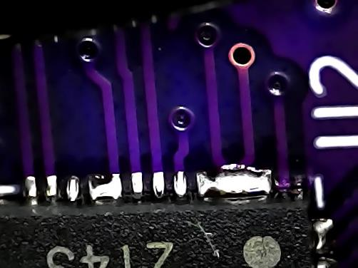Solder blobs on boards 1 & 2: Cleared them without too much trouble using soldering iron and a solder sucker. The USB connector was the most problematic but seems OK.

Plugging in the Minisimplicity header and powering the board via the WSTK SSv5 is able to detect the part and pull the info from it. Since it’s an A part, it seems none of the precompiled Demos are available so I have to create a SerialAPI and bootloader. Or is simply that this is a custom board so SSv5 doesn’t assume the GPIOs are where they are on a devkit? Naturally the bootloader project won’t compile because there’s no EUSART assigned. This is because all of Silabs projects are very centered on their devkits and if you don’t use one of those then you are 100% on your own with no help at all.

I built a BL and SAPI using the ZGM230 DK2603 board as the target. Flashed the binaries into the board and it powers up and has configured a DSK so it must be doing something. But it sits waiting for the BURTC to sync which it never will because I don’t have the 32KHz oscillator installed. But since I built the project using a devkit board it assumes it is setup. Ugh. Pintool doesn’t show anything in the SAPI project (or the BL). I can’t easily copy that to an empty SAPI project. I then create a blank SAPI project then try to figure out what else needs to be configured. The version via the devkit installs Platform->board->starter kit->BRD2603A which in turn enables a ton of stuff but not in a way I can then copy parts I need in a blank project. I created another SAPI project and this time it compiled! WTF? There are no VCOM or EUSARTs in the .slcp file? How is the UART being wired thru? How would we change it? It is in the pintool! Not sure how. It does appear to be running. I want to see if it’s coming out the UART. PC Controller does not find it thru the WSTK. Config/serial_api_config.h uses USART0 PA08 Tx and PA09 Rx.

USB is not working – the PC doesn’t detect a plugin in either orientation. Power is working. +5V VBUS comes in and the LDO makes 3.3V just fine. But nothing shows up in Device Manager on my PC. Using SSv5 Console it doesn’t connect. Not sure what that means. Is Tx/Rx backwards? The CP2102 is a QFN20 but the 4 corner pins are BELOW the package and not visible at the edge. Would be much better to use the QFN24 instead which is slightly larger but all the pins come to the edge of the package and none are recessed. 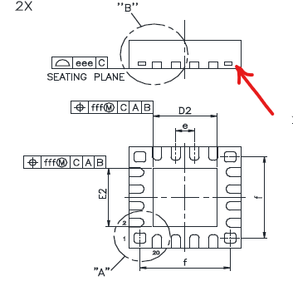They are the same price on Digikey and we have to room on the board. USB D+ pin is on the corner of the package. I would have thought the CP2102 will show up as a USB device when plugged into a computer without any interaction via the UART. I could wire an FTDI to the resistors to get something to work and check more things out. But that isn’t a good test of the RF range since so many things are hacked.

Board #1 & #2 are recognized via SWD and Commander: EFR32ZG23A020F512GM48

Ordered the missing components from the BOM. Not needed immediately. I got a bunch of antennas in the mail today.

## 2024-03-14 – Rev A PCB build

I built 3 boards. Board #3 has been cut down to roughly the minimum size to compare with the full size boards to measure the RF range difference with a smaller ground plane. Basically answering the question – does the additional cost for PCB real estate significantly improve the RF range? Overall size of the reference design isn’t that much of a concern but cost is an important factor though range is the priority.

I forgot to order 1.3nH inductors and 7.2pF caps. I had 1.2nH and 6.8pF which are close enough. I’ll order the correct ones for the next build. The QWIIC connector I ordered is SMT but the PCB is TH so need to pick a different connector. I didn’t order the 32khz crystals but those are not needed at this point. The QWIIC connectors appear to all be SMT so I’ll change the PCB and keep these components.

The solder paste seemed a bit thick and resulted in several shorts. I ordered the .003” thick mylar stencil. The only other option is a .005” so I am using the thinner one. My solder paste is a little thick as the basement is 55F so maybe warming the solder paste up will help is spread more evenly.

## 2024-03-13 – Antennas

I have a box of various antennas. However, they are not labeled and I don’t have the part numbers nor the specs. Some of them might be 2.4GHz, 868, 915. I really can’t tell. So, I ordered some and will keep the part number with the antenna so we know for sure which one is which. Digikey has 15,000 antennas! Filtering that down to SMA in the 900/868MHz bands with an SMA connector and in stock gets us down to 43. I ordered the following:

|  |  |  |  |
| --- | --- | --- | --- |
| Part Number | Price  @1k | Len mm | Comments |
| [**TI.92.2113**](https://www.digikey.com/en/products/detail/taoglas-limited/TI-92-2113/11197416) | $6.20 | 198 | Looks like the one shipped with Silabs DevKits |
| [**TS.89.4113**](https://www.digikey.com/en/products/detail/taoglas-limited/TS-89-4113/15284364) | $40.56 | 118 | Directional antenna with 3.5/2.7dBi gain in 1 direction |
| [**ANT-8/9-MMG1-SMA-1**](https://www.digikey.com/en/products/detail/te-connectivity-linx/ANT-8-9-MMG1-SMA-1/16592298) | $5.66 | 83 | Cable to a mount |
| [**FW.95.B.SMA.M**](https://www.digikey.com/en/products/detail/taoglas-limited/FW-95-B-SMA-M/6362786) | $9.13 | 226 | Thin fixed |
| [**DELTA12C/X/SMAM/S/S/17**](https://www.digikey.com/en/products/detail/siretta-ltd/DELTA12C-X-SMAM-S-S-17/6096292) | $9.65 | 130 | Classic Rubber Ducky |
| [**JCG402LR-2**](https://www.digikey.com/en/products/detail/jc-antenna/JCG402LR-2/15814458) | $2.42 | 110 | Tiltable – Low cost! |
| [**2600130083**](https://www.digikey.com/en/products/detail/w%C3%BCrth-elektronik/2600130083/11680415) | $14.88 | 179 | Covers 868 thru 928 |
| 868 antennas: |  |  |  |
| [**ANT-868-CW-HW-SMA**](https://www.digikey.com/en/products/detail/te-connectivity-linx/ANT-868-CW-HW-SMA/5592340) | $8.74 | 135 |  |
| [**FW.86.B.SMA.M**](https://www.digikey.com/en/products/detail/taoglas-limited/FW-86-B-SMA-M/6362785) | $9.13 | 240 | Thin fixed (similar to the 915 one above) |
| [**FLEXI-SMA-868**](https://www.digikey.com/en/products/detail/rf-solutions/FLEXI-SMA-868/5845738) | $5.12 | 73 | Short Rubber Ducky |

## 2024-03-03 – Component selection & ordering

Exported the BOM out of KiCAD and used it to manually create the BOM. Ordered enough components for 10+ boards. I already have 15 ZG23s from previous projects and samples. Entered an Issue on github that a couple of the caps are 0603 but should be 0402. The 0402 will still fit but better to have the proper footprint. I expect to spin the PCB at least once more.

The plan is to take one of the 3 boards coming in now and cut it to a much smaller size and compare the range. No sense in making the board bigger than it has to be but we are looking for maximum range. If the full size board is at least 3 dBm better than definitely keep the full size board.

KiCAD has been upgraded to version 8.0.0 which came out a week ago. I had to upgrade to checkin the ZG23 component as all libraries were upgraded to V8. The ZG23 will now be included in the KiCAD default libraries. My PR [4289](https://gitlab.com/kicad/libraries/kicad-symbols/-/merge_requests/4289) has already been merged in. I assume it’ll be included in the next tagged release.

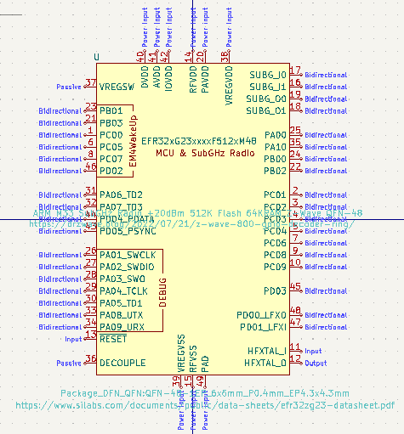

## 2024-02-23 – PCB release to fab

There are 3 excluded DRC violations:

1. The Y2 Crystal footprint was slightly modified to clear the silkscreen error in the footprint
2. The 2 Fiducial marks are not in the schematic

These “warnings” can be ignored.

The PCB is 120mm square which I am certain is overkill. But we can cut a board to be smaller and see the net impact. Might also make a different proto board with a smaller PCB. The corners have 10mm radiuses to make a clean point for the enclosure to latch onto the PCB and make it easier to separate the boards when built as arrays.

Three PCBs and a stencil ordered. Expected in about a week. These 3 boards are just for initial testing to make sure the design doesn’t have some major problem like an incorrect pinout. One board will be for tuning the antenna(s), one is a proto and I expect to cut one to be much smaller to see if the large ground plane makes a difference. Might also want to make a 2 layer PCB version which is cheaper. I’ll order components on Monday.

## 2024-02-22 – PCB layout

DRC clean but in need of cleanup and more documentation.

## 2024-02-21 – Schematic capture

Schematic capture completed and ERC is clean.

Footprints to be picked out:

* USB-C receptacle – GCT [USB4110](https://www.digikey.com/en/products/detail/gct/USB4110-GF-A/10384547)-GF-A is SMT with 2 small mounting pins less than a buck
* [39MHz](https://abracon.com/Resonators/abm8.pdf) crystal – Crystal:Crystal_SMD_3225-4Pin_3.2x2.5mm
* 32KHz crystal – Crystal:Crystal_SMD_3215-2Pin_3.2x1.5mm - SC32S-7PF20PPM
* RGB LED – LED_SMD:LED_WS2812B-2020_PLCC4_2.0x2.0mm - [QLSP14RGB_B](https://www.digikey.com/en/products/detail/quelighting-corp/QLSP14RGB-B/15848703)
  + Might need to make a custom footprint
* The RF RCs are 0402 which are cheap and still OK to hand solder. 0201s are tough to handle.
* Other RCs are 0603 and large caps are 0805 which makes them easy to handle and cheap.

PCB board created and a few components placed. Need to adjust the DRC rules to match [OSH Park](https://docs.oshpark.com/design-tools/kicad/kicad-design-rules/).

## 2024-02-20 – Schematic capture

Connected the USB UART to the same pins as the debug header but thru 100 ohm resistors. I could have put the USB UART to a different set of pins but then the firmware could NOT use the standard SerialAPI and would have to be customized with each release. Didn’t think that was a good idea. The series resistors are to provide some isolation when BOTH USB and the debugger are connected. The main issue is that during production, RailTest has to be downloaded and then commanded via the debug connector to the UART to Tx ON for crystal calibration. But since USB is also connected, it is also driving the UART pins. Simply adding some series resistors will provide sufficient isolation for the short time during production. Even during debug it’s not a big deal. During normal operation the resistors will help with EMI. UART speed is only 115.2K baud so the resistors will have no impact on that. The other option is to use a switch but that would be overkill and just 1 more place for things to fail and increase cost.

USB pins require ESD protection as described here: <https://www.digikey.com/en/articles/why-usb-type-c-circuit-protection-is-vital> but this is overkill IMHO. There are many triple TVS diodes but they do not seem to have a common pinout. Prices for these triple diodes are around 30 cents. Only need USB2 level ESD as we do not need to support USB3 which has tighter restrictions on the capacitance of the TVS diode. This [article](https://www.electronicproducts.com/how-to-protect-usb-type-c-connectors-from-esd-and-overtemperature/) has a good description of requirements. Want to have something with lots of 2nd sources and not be locked into a single part. KiCAD doesn’t have any diodes in 0402, mostly SOD-xxx. The CP2102 recommends SP0503BAHTG which is in the KiCAD library and digikey has 114K of them so it is easier to use this part.

The Tag-Connect debug header VAEM is tied directly to the 3.3V from the LDO. This is normally not a problem but could result in both the WSTK and the LDO driving the 3.3V pins. Since they are both at the same voltage it usually doesn’t matter. The WSTK should normally NOT drive the VAEM pin (slide the switch to USB or battery). The only time you would drive the VAEM pin is if you are debugging a battery powered device and want to measure the power which would be done using the AEM in SSv5. But in that case, the LDO would not be installed. The only question is during programming will the LDO short 3V3 to GND? That would require the USB to also be plugged in or powered via a test point which is acceptable but makes things more difficult. However, a functional test of the USB would require the cable being plugged in so maybe it is OK.

There is no QWIIC connector symbol or footprint in KiCad. I copied the ones from the sparkfun repo but I didn’t want to import the entire thing so I created project specific libraries which will also hold some other project specific stuff like the Z-Wave logo and things.

## 2024-02-16 – Project Start

Wrote the datasheet. Started Schematic capture and Theory of Operation (ToO) development.

Lots of LDOs to choose from. Diodes Inc [**AP2125K-3.3TRG1**](https://www.digikey.com/en/products/detail/diodes-incorporated/AP2125K-3-3TRG1/4470777) is 10 cents and will be the initial LDO to use (Digikey has 45K in stock). The TI [**TPS7A0333PDBVR**](https://www.digikey.com/en/products/detail/texas-instruments/TPS7A0333PDBVR/12165108) LDO I’ve used before is 33 cents but does have better Iq, temperature range and Vdropmax but the Diodes Inc is fine.

For the USB-C interface, I used this example: <https://hackaday.com/2023/08/07/all-about-usb-c-example-circuits/>. The classic question is what to connect the shield of the connector to? The Shield is the outside layer of the cable thus it can act as an unintentional antenna and then fail FCC. The example wires it to GND but that is likely to radiate more than leaving it unconnected. Nice discussion [here](https://electrical.codidact.com/posts/279876#:~:text=%E2%88%920-,Connect%20the%20shield%20directly%20to%20ground%20plane,to%20the%20PCB%20ground%20plane.) which mostly recommends connecting SHIELD to GND. There are 2 purposes for this connection – EMI and ESD. For ESD it makes sense to have a solid connection to have the entire board remain at the same potential which might shoot up thousands of volts in an ESD event. But I am more concerned about EMI which in an abundance of caution I put a small ferrite bead leading to the shield to reduce any EMI. Can replace this with a zero ohm resistor later, or leave it open or insert a capacitor or even just short the pads out. I’m not too worried about ESD as ZRAD is pretty much plugged in once and left there for the duration.

## 2024-02-07 – Create Repository

Created the Repo, this file and started the hardware design in KiCAD.