Financial Report on the Clorox Company (CLX)

A Project for the Computational Finance Course

Abstract

In this Project for the Computational Finance course led by prof. Alan Solomon at the Sami Shamoon College of Engineering, we aim to demonstrate basic understanding of the course material by writing a guide for the feduciary on how to provide guidance for investors using the tools of computational finance.

**On the simplified nature of analysis in this document.**

Subject of financial analysis is very information-dense and to perform such an analysis (be it an analysis of industrial sectors, fundamental, technical, etc.) in earnest is a non-trivial job that we don’t see ourselves capable of performing.

Therefore, this document aims to provide a simplified, non-rigorous analysis aiming to showcase our understanding of course material and minimal proficiency in scientific communication using tools such as web scraping and searching for financial data, DeepSeek LLM with Web Search functionality, R language [“R: The R Project for Statistical Computing” (n.d.)], its “tidyquant” package [Dancho and Vaughan (2025)] and Quarto scientific publishing system [“Quarto” (n.d.)].

## Sector Analysis

**Note**

In this section we analyze financial data on websites such as <https://finance.yahoo.com>, as well as using the [DeepSeek LLM](https://chat.deepseek.com/) to find analysis on the web and provide summaries. Some basic charting using R language [“R: The R Project for Statistical Computing” (n.d.)] is introduced.

### Financial Analysis of the Clorox Company in the Consumer Defensive Sector

#### **1. Sector Analysis**

Clorox operates in the **Consumer Defensive sector**, specifically within the Household and Personal Products sub-sector. This sector is characterized by stable demand and recession resilience.

Sector’s **Market Cap** is estimated to be $3.7 trillion. The **Market Weight (Share)** of the sector relative to the other 10 sectors is 5.45%.

Sector’s **Year-To-Date Return** is 6.17%, which outperforms S&P500 (3.54%).

#### **2. Position Relative to Competitors**

Clorox’s market share inside it’s sector is relatively small:

| COMPANY NAME | MARKET SHARE 12 Months Ending Q4 2024 | MARKET SHARE 12 Months Ending Q3 2024 | MARKET SHARE MRQ Q4 2024 | MARKET SHARE Q3 2024 |
| --- | --- | --- | --- | --- |
| **The Clorox Company** | 2.61% | 2.80% | 2.42 % | 2.66 % |
| The Campbells Company | 3.60% | 3.61% | 3.97% | 3.46% |
| Colgate palmolive Company | 7.32% | 7.54% | 7.09% | 7.59% |
| Conagra Brands Inc | 4.58% | 4.61% | 4.58% | 4.21% |
| Ecolab Inc | 5.06% | 5.07% | 5.26% | 5.40% |
| Mccormick and Company Incorporated | 2.45% | 2.50% | 2.58% | 2.53% |
| Procter and Gamble Co | 30.72% | 31.46% | 31.37% | 32.77% |
| Hormel Foods Corporation | 5.52% | 5.65% | 5.09% | 4.37% |
| Avon Products Inc | 1.15% | 1.28% | 0.95% | 1.23% |
| Horizon Kinetics Holding Corporation | 0.01% | 0.00% | 0.02% | 0.00% |
| Ingredion Incorporated | 2.75% | 2.89% | 2.68% | 2.83% |
| Lancaster Colony Corporation | 0.69% | 0.70% | 0.73% | 0.70% |
| J and j Snack Foods Corp | 0.58% | 0.59% | 0.52% | 0.64% |
| Treehouse Foods Inc | 1.19% | 1.24% | 1.20% | 1.19% |
| Dole Plc | 3.00% | 3.46% | 3.00% | 3.46% |
| Church and Dwight Co Inc | 2.22% | 2.27% | 2.27% | 2.28% |
| Coty Inc | 2.22% | 2.30% | 2.39% | 2.52% |
| Unilever Plc | 24.32% | 22.02% | 24.32% | 22.02% |
| SUBTOTAL | 100% | 100% | 100% | 100% |

CLX’s Market share relative to its competitors, as of Q4 2024 within the Consumer Non Cyclical Sector (i.e. Consumer Defensive), source: “The Clorox Market Share Relative to Its Competitors, as of Q4 2024 - CSIMarket” (n.d.)

Clorox competes with major players such as **Procter & Gamble (PG)**, **Colgate-Palmolive (CL)**, **Church & Dwight (CHD)**, and **Kimberly-Clark (KMB)**. Let’s look at their stock price relative to each other using R language.

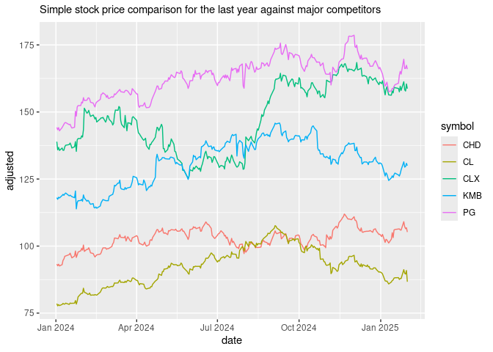

### **Conclusion**

We can use web scraping, modern LLM chatbots and R language to perform all the necessary analysis of the particular industrial sector and the corporation’s position in this sector. The analysis shows small, but strong position of the company relative to it’s sector, as well characterizes the sector itself.

## Personality of the Company

**Note**

In this section we collect and cite a variety of publicly available sources to perform an analysis of the company personality. We use use DeepSeek LLM with Web Search functionality to collect and analyze these sources.

#### **Company Purpose and Responsibility**

##### **Company Purpose**

Clorox’s stated purpose is to “champion people to be well and thrive every single day” [“Purpose & Values” (n.d.)]. As a health and wellness company, Clorox aims to make a meaningful and positive impact on the world by improving the health and safety of employees, consumers, and communities. All of this is reflected in their family-friendly and inclusive branding.

##### **Responsibility Policies**

Clorox integrates environmental, social, and governance (ESG) goals into its core business strategy [“Responsibility” (n.d.)]. Key areas of focus include:

* **Healthy Lives**: Promoting employee well-being, product stewardship, and transparency in ingredients.
* **Clean World**: Reducing greenhouse gas emissions, plastic waste, and transitioning to 100% renewable energy in U.S. and Canada operations.
* **Thriving Communities**: Ensuring pay equity, fostering diversity, and supporting community initiatives.

Clorox has set ambitious targets, such as achieving net-zero emissions by 2050.

##### **IGNITE Strategy**

The IGNITE strategy is Clorox’s long-term plan to drive what the company calls a “purpose-driven growth” [“IGNITE Strategy” (n.d.)] by aligning financial goals with ESG priorities. Key pillars include:

* **Fuel Growth**: Leveraging technology and sustainability to generate cost savings and reinvest in brands.
* **Innovate Experiences**: Building purpose-driven brands and enhancing consumer experiences through personalized and sustainable products.
* **Reimagine Work**: Creating an inclusive workplace and simplifying operations to drive efficiency.
* **Evolve Portfolio**: Expanding into consumer megatrends like sustainability and wellness.

The strategy also includes specific financial targets, such as 2-4% net sales growth and 11-13% free cash flow generation.

#### **Key Executives, Their Commitment and Performance**

| Name | Title | Pay | Year Born |
| --- | --- | --- | --- |
| Ms. Linda J. Rendle | CEO & Chairman | 3.93M | 1979 |
| Mr. Kevin B. Jacobsen | Executive VP & CFO | 1.91M | 1967 |
| Mr. Eric H. Reynolds | Executive VP and Chief Operating & Strategy Officer | 1.96M | 1970 |
| Ms. Angela C. Hilt | Executive VP, Chief Legal Officer & Corporate Secretary | 1.45M | 1972 |
| Ms. Kirsten M. Marriner | Executive VP and Chief People & Corporate Affairs Officer | 1.54M | 1973 |
| Ms. Laura E. Peck | VP, Chief Accounting Officer & Corporate Controller | – | 1977 |
| Ms. Chau Banks | Senior VP and Chief Information & Data Officer | – | 1970 |
| Ms. Lisah Burhan | Vice President of Investor Relations | – | – |
| Mr. Eric Sean Schwartz | Senior VP & Chief Marketing Officer | – | 1972 |
| Mr. Erbie L. Foster Jr. | Chief Diversity Officer | – | – |

Key Executives, source: [“The Clorox Company (CLX) Company Profile & Facts” (n.d.)]

According to [“The Clorox Company: Business Model, SWOT Analysis, and Competitors 2024 - PitchGrade” (n.d.)], CEO and Chairman Linda J. Rendle, as well as the other executives and board members have significant ownership stakes at the company, indicating high confidence in their business.

Financial analysis website Simply WallSt gives the upper management team at Clorox high marks on all 4 criteria: Compensation vs Market, Compensation vs Earnings, Experienced Management and Experienced Board [“The Clorox Company (CLX) Leadership & Management Team Analysis” (n.d.)].

#### **Company Brand and Reputation**

Clorox is a globally recognized leader in the cleaning and consumer products industry, known for its trusted brands such as **Clorox Bleach**, **Pine-Sol**, **Hidden Valley**, **Brita**, and **Burt’s Bees**.

The company has received numerous accolades, including being named one of **America’s Greenest Companies** by Newsweek, a **Safer Choice Partner of the Year** by the EPA, and a top performer in the **Human Rights Campaign Foundation’s Corporate Equality Index**. Its sustainable brands, such as **Brita**, **Burt’s Bees**, and **Green Works**, have gained significant consumer trust for their eco-friendly and socially responsible practices [“Recognitions” (n.d.)].

In August 2023, Clorox experienced a severe **cyberattack** [Mascellino (2023)] that disrupted its IT systems and operations. The attack, which was detected on August 14, forced the company to take affected systems offline, leading to significant production delays and supply chain disruptions. Clorox activated its business continuity plans, reverting to manual processes for order fulfillment and customer communications.

The cyberattack had a material financial impact, with Clorox reporting a 23-28% decline in quarterly sales and a drop in its stock price by over 25% following the incident.

Clorox’s response to the cyberattack highlighted its crisis management capabilities. The company maintained transparency by providing regular updates to stakeholders and implementing phased recovery plans to restore operations safely. Brand and reputation were not severely damaged in the process.

#### **Conclusion**

We can use modern LLM chatbots to collect publicly available sources and perform analysis of the company personality. The analysis shows strong branding, good leadership and consistent performance.

## Fundamental Analysis

**Note**

In this section we will take a look at quantitative fundamental analysis tools provided by the “tidyquant” R language package [Dancho and Vaughan (2025)] and use them to get key financial ratios of fundamental analysis for the Clorox company. This section is based on the following wonderful tutorial: “Performance Analysis with Tidyquant” (n.d.)

#### **Basic Fundamental Analysis of the Clorox Company**

First let’s retrieve 5-year period returns from the prices adjusted for stock splits, both for Clorox and S&P500 as the baseline. Next, we combine both datasets (Clorox and S&P500 returns) using “left-join” on the “date” field. Using this dataset, we can retrieve all kind of fundamental metrics, such as **Alpha** (0.0008), **Beta** (0.414).

library(tidyverse)

# A tibble: 1 × 3  
# Groups: symbol [1]  
 symbol Alpha Beta  
 <chr> <dbl> <dbl>  
1 CLX 0.0008 0.414

We can also get the **Annualized Sharpe Ratio and Returns**, **Types of Mean Return (Geometric, Arithmetic, etc.)**, **Kurtosis**, as well as **Maximum and Median Return** by following the similar steps (no need for the baseline this time).

library(tidyverse)  
library(tidyquant)  
  
Ra <- "CLX" |>  
 tq_get(get = "stock.prices",  
 from = "2020-01-01",  
 to = "2025-02-01") |>  
 group_by(symbol) |>  
 tq_transmute(select = adjusted,   
 mutate_fun = periodReturn,   
 period = "monthly",   
 col_rename = "Ra")  
  
Ra |>  
 tq_performance(Ra = Ra, Rb = NULL, performance_fun = table.AnnualizedReturns) |>  
 print()

# A tibble: 1 × 4  
# Groups: symbol [1]  
 symbol AnnualizedReturn `AnnualizedSharpe(Rf=0%)` AnnualizedStdDev  
 <chr> <dbl> <dbl> <dbl>  
1 CLX 0.0381 0.153 0.249# A tibble: 1 × 17  
# Groups: symbol [1]  
 symbol ArithmeticMean GeometricMean Kurtosis `LCLMean(0.95)` Maximum Median  
 <chr> <dbl> <dbl> <dbl> <dbl> <dbl> <dbl>  
1 CLX 0.0056 0.0031 1.20 -0.0128 0.218 0.0054  
# ℹ 10 more variables: Minimum <dbl>, NAs <dbl>, Observations <dbl>,  
# Quartile1 <dbl>, Quartile3 <dbl>, SEMean <dbl>, Skewness <dbl>,  
# Stdev <dbl>, `UCLMean(0.95)` <dbl>, Variance <dbl>

#### **Conclusion**

We can use the “tidyquant” R language package to perform fundamental analysis of the company and obtain all of the key financial ratios for such analysis. The analysis shows a company in recovery with strong fundamentals.

## Technical Analysis

**Note**

Technical analysis in this section follows the wonderful tutorial provided here: [“Financial Modeling with R” (n.d.)]

#### **Basic Technical Analysis of the Clorox Company**

We’ll start with providing a simple plot of stock price movement.

library(tidyquant)

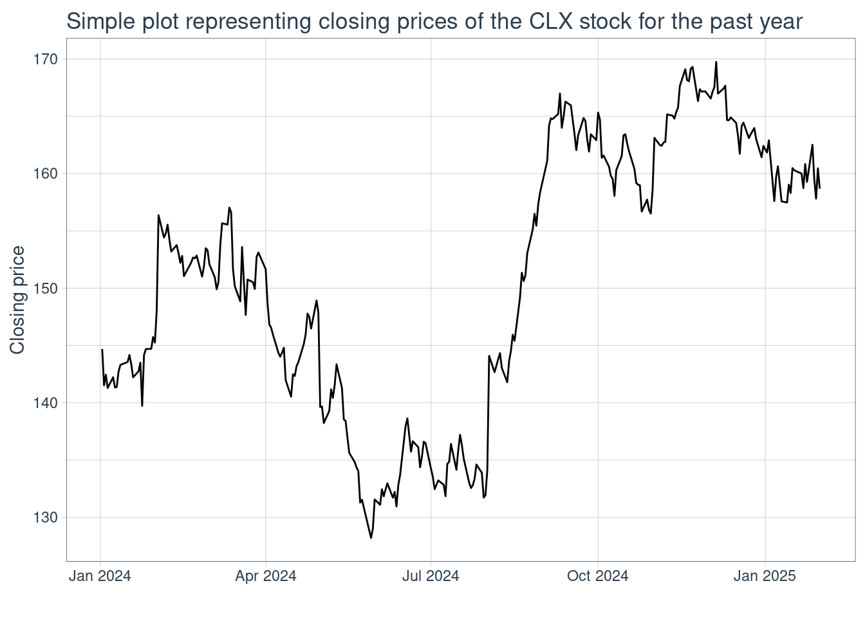

To identify basic trend in this movement, we then chart the **Simple Moving Average**.

library(tidyquant)  
library(ggplot2)  
library(dplyr)  
CLX <- tq_get("CLX", get = "stock.prices", from = "2024-01-01",   
 to = "2025-02-01")  
CLX |>  
 ggplot(aes(x = date, y = close)) +  
 geom_line() +  
 geom_ma(ma_fun = SMA, n = 25, linetype = 1, size = 1.25) +  
 labs(y = "Closing Price", x = "") +   
 theme_tq()

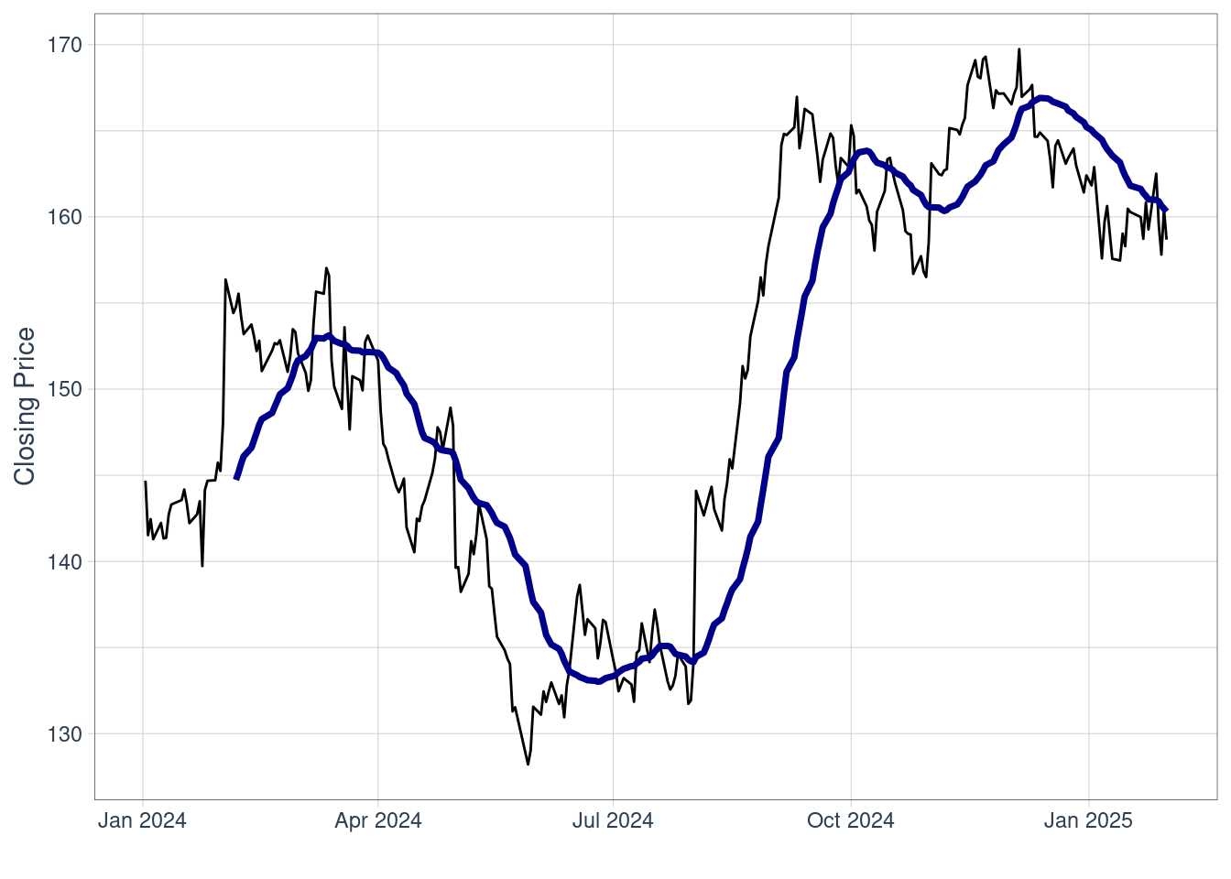

By playing with the “n” value - the average of the last n-day stock prices - we produced a line that closely resembles the price line. Since the SMA line crosses the price line from top to bottom, we’re supposed to anticipate a drop in the stock price.

**The Bollinger Bands** is another useful tool of technical analysis. These are “envelopes plotted at a standard deviation level above and below a simple moving average of the price” [“Financial Modeling with R” (n.d.)]. They supposed to show the volatility of a price of the stock and the size of expected change of the price in the future.

Let’s demonstrate.

library(tidyquant)  
library(ggplot2)  
library(dplyr)  
CLX <- tq_get("CLX", get = "stock.prices", from = "2024-01-01",   
 to = "2025-02-01")  
CLX |>  
 ggplot(aes(x = date, y = close, open = open,  
 high = high, low = low, close = close)) +  
 geom_line() +  
 geom_bbands(ma_fun = SMA, sd = 2, n = 25,  
 linetype = 2, size = 0.5, alpha = 0.2,  
 fill = palette_light()[[1]],  
 color_bands = palette_light()[[1]],  
 color_ma = palette_light()[[2]]) +  
 labs(y = "Closing Price", x = "") +  
 theme_tq()

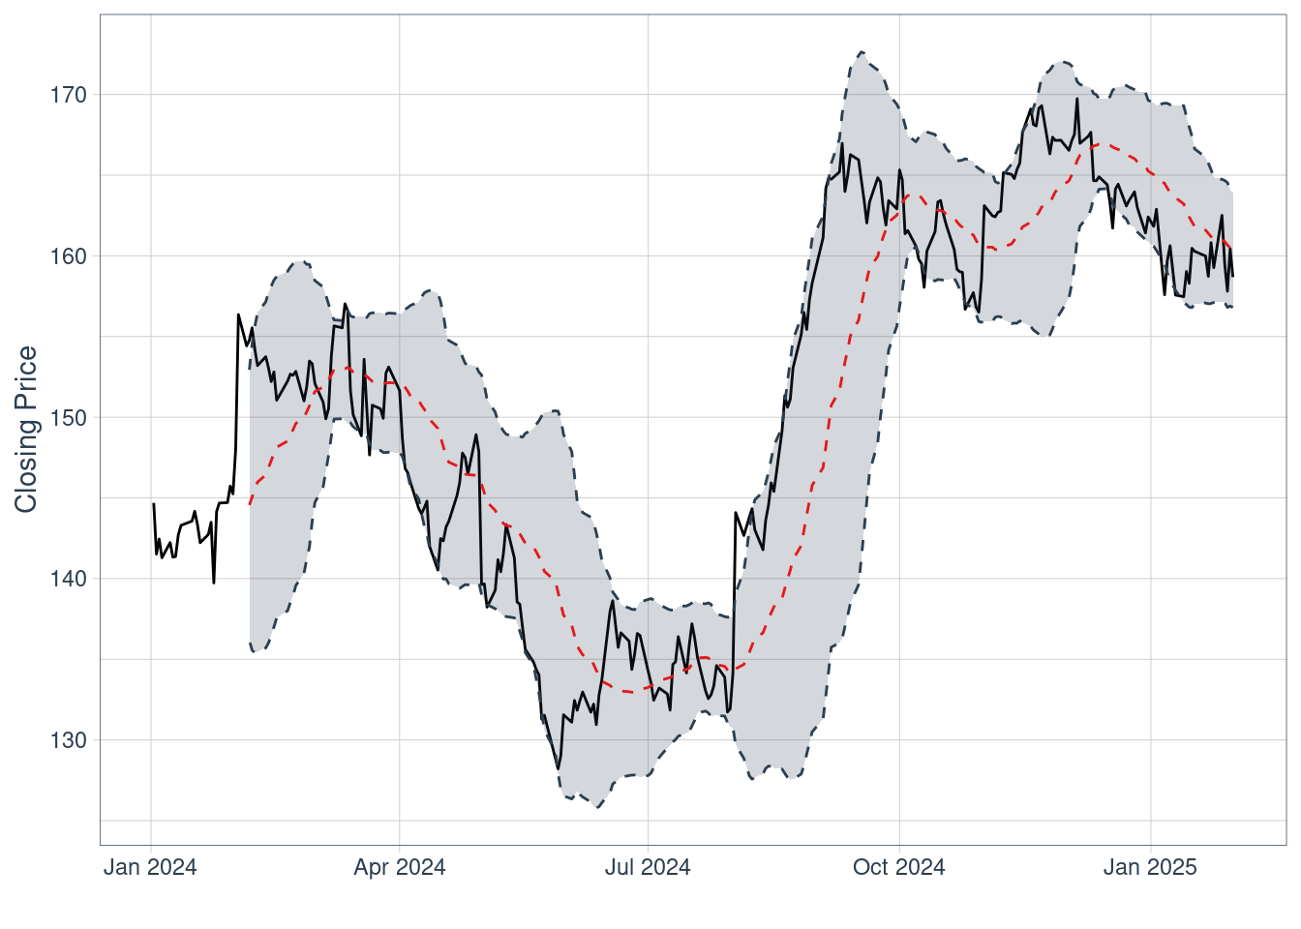

And finally let’s look at such charts for major competitors to get the feel of the market.

library(tidyquant)  
library(ggplot2)  
library(dplyr)  
prices <- tq_get(c("CLX", "CL", "PG", "CHD"), get = "stock.prices", from = "2024-01-01",   
 to = "2025-02-01")  
prices |>  
 ggplot(aes(x = date, y = close, open = open,  
 high = high, low = low, close = close)) +  
 geom_line() +  
 geom_bbands(ma_fun = SMA, sd = 2, n = 25,  
 linetype = 2, size = 0.5, alpha = 0.2,  
 fill = palette_light()[[1]],  
 color_bands = palette_light()[[1]],  
 color_ma = palette_light()[[2]]) +  
 facet_wrap(~ symbol, ncol = 2, scales = "free_y") +  
 theme_tq()

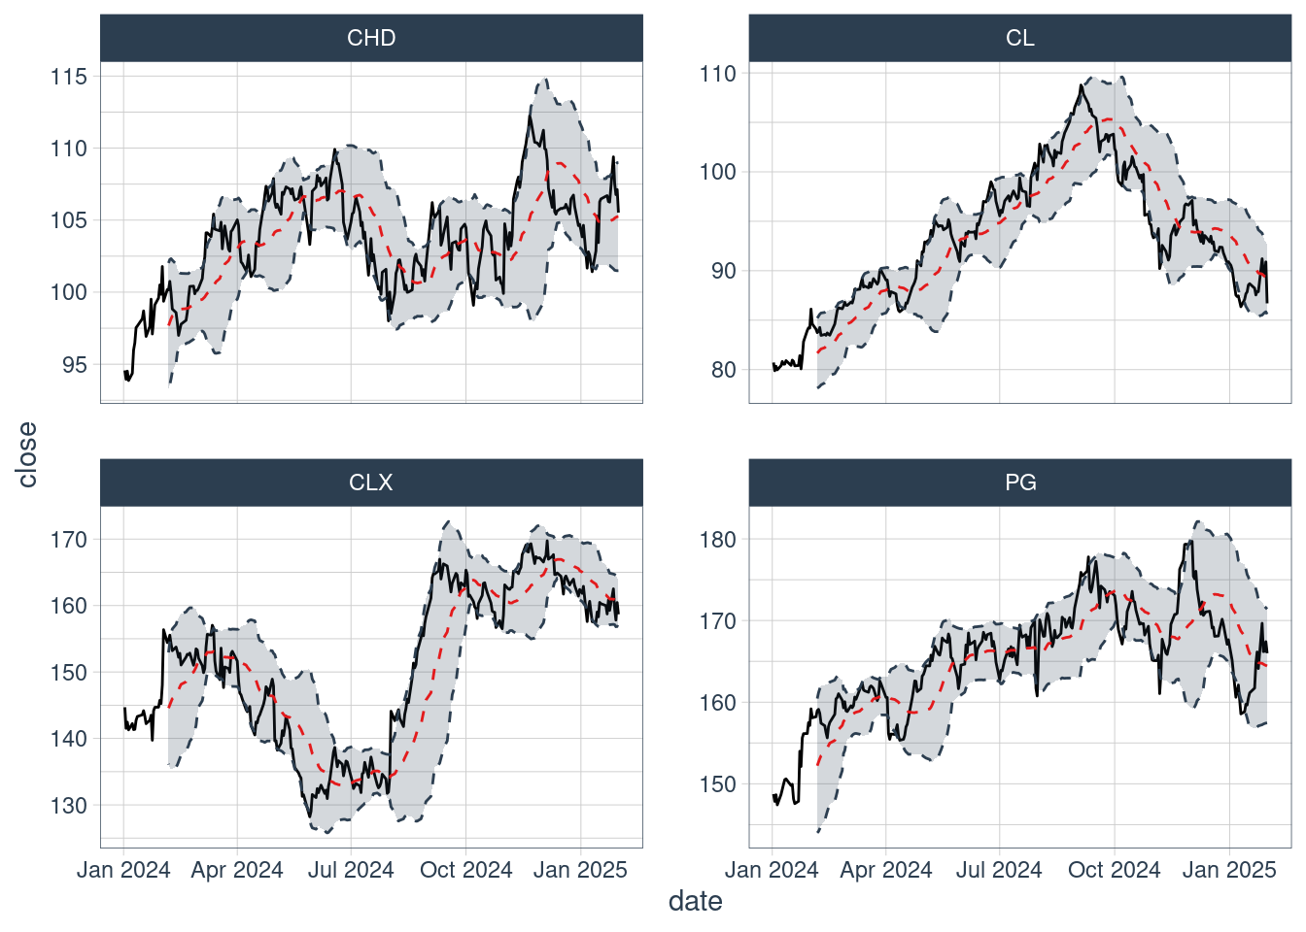

As we can see, the volatility of the stock prices shouldn’t be that great in the near future. Since technical analysis is best-suited for short-term trading, near future is all we can advise or client on based on such analysis.

### Conclusion

We can use “tidyquant” R language package along with other packages for producing charts to perform basic technical analysis of stock price. The analysis predicts stable performance in the short term.

## Company Performance 2019-2024

**Note**

In this section we provide some historic data and rudimentary analysis of the company during the 2019-2024 period.

### Historical Analysis of the Company

As we’ve identified in the previous sections, major events for the company in this peroid included the adoption of IGNITE strategy and recent cyberattack. Another major event was, of course, the global pandemic.

In terms of the corporation’s life cycle, Clorox is definitely in the **Maturity** phase: it is relatively stable, resilient to shocks and demonstrates confidence during the recovery from such shocks.

Getting historical data is very easy with R language - you just provide the time period you are interested in, and get it same as always.

library(tidyquant)

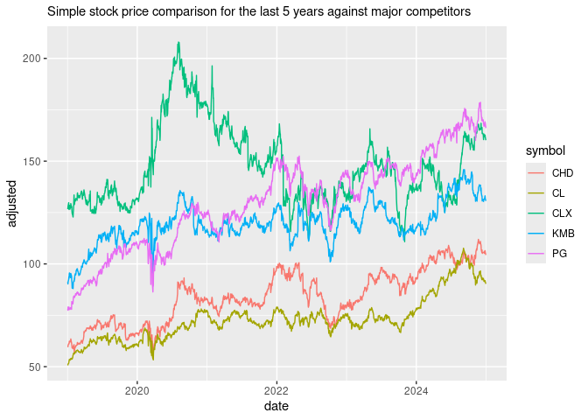

Fundamental analysis based on revenue data for the last five-year period can be found in the “Fundamental Analysis” section.

Sites like <https://stockanalysis.com> provide all kinds of historic data for the last five-year period in nice tables. All of it can be scraped - we’ll scrape and reproduce some of it here.

| Fiscal Year | Current | FY 2024 | FY 2023 | FY 2022 | FY 2021 | FY 2020 |
| --- | --- | --- | --- | --- | --- | --- |
| Period Ending | Feb ’25 Feb 14, 2025 | Jun ’24 Jun 30, 2024 | Jun ’23 Jun 30, 2023 | Jun ’22 Jun 30, 2022 | Jun ’21 Jun 30, 2021 | Jun ’20 Jun 30, 2020 |
| Market Capitalization | 18,222 | 16,948 | 19,661 | 17,352 | 22,376 | 27,626 |
| Market Cap Growth | 13.64% | -13.80% | 13.31% | -22.45% | -19.00% | 41.66% |
| Enterprise Value | 21,024 | 19,913 | 22,613 | 20,467 | 25,241 | 30,412 |
| Last Close Price | 147.92 | 133.25 | 150.09 | 128.86 | 159.95 | 190.95 |
| PE Ratio | 40.32 | 60.53 | 131.95 | 37.56 | 31.52 | 29.42 |
| Forward PE | 20.81 | 21.90 | 29.44 | 28.13 | 25.00 | 30.85 |
| PS Ratio | 2.56 | 2.39 | 2.66 | 2.44 | 3.05 | 4.11 |
| PB Ratio | 166.14 | 34.45 | 50.67 | 23.80 | 37.80 | 30.43 |

CLX’s Historical Financial Ratios, source: “The Clorox Market Share Relative to Its Competitors, as of Q4 2024 - CSIMarket” (n.d.)

### Conclusion

We can use publicly available data, as well as the R language to get historical financial data and ratios. The analysis shows strong performance during the last five-year period.

## Forecasting

**Note**

In this section we use ARIMA model to provide a long-term forecast of the company stock price.

### **Long-Term Financial Forecast for the Company Using ARIMA Model**

Long-term financial forecasting, like all social forecasting, is an incredibly fraught undertaking due to many different reasons (see, for example, [Cerqueira (2022)] and [“Forecasting and Predictive Analytics: A Critical Look at the Basic Building Blocks of a Predictive Model” (n.d.)]). Luckily, many tools are available for us to experiment with.

We’ve already done some simple short-term forecasting in our “Technical Analysis” section using **SMA** and **Bollinger Bands**. We’ve also accessed volatility by calculating **Beta** value and estimated risk/return using **Annualized Sharpe Ratio**, which might help us in medium-term forecasting. Now we will try using advanced **ARIMA** (Auto-Regressive Integrated Moving Averages) to predict stock prices for the next 6 months and for the next year.

library(tidyquant)

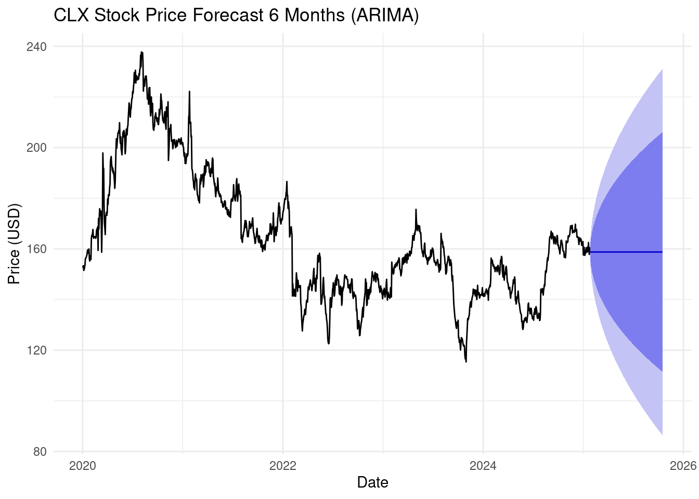

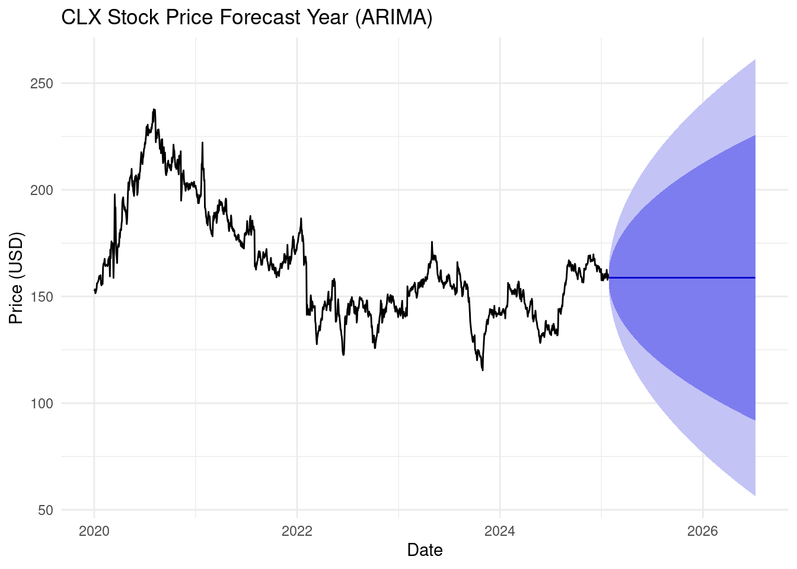

We can see the band for the future time periods representing possible price ranges and 2 confidence levels.

### **Conclusion**

We can use advanced forecasting models (such as ARIMA) available in the R language to predict the stock price. The analysis shows a wide range of possible future prices, albeit without major ups or downs.

## Summary

### **Analysis Summary and Letter Grade**

Our analysis shows mature company with stable management, good branding, strong fundamentals and good estimated prospects. We give the letter grade **B** for the company and recommend including its stock in the investment portfolio. Of course, no one single stock should be recommended individually for investment, but portfolio management is out of scope for this document.

### **Advice for the Fiduciary**

This document provides the fiduciary with basic tools for the quantitative analysis of individual corporations. These tools are indeed **basic** and should only be viewed as a starting point for serious analysis. There are many great ways to learn more about finance and investment. We would recommend to look at the following sources (which we ourselves used to prepare this document) to learn more: [“Quantitative Finance with R” (n.d.)], [Wahlen, Baginski, and Bradshaw (2022)], [*Forecasting: Principles and Practice (2nd Ed)* (n.d.)], [“R for Data Science (2e)” (n.d.)], [“Tidy Quantitative Financial Analysis” (n.d.)], [“Investopedia” (n.d.)].

Cerqueira, Vitor. 2022. “8 Reasons Why Forecasting Is Hard.” *Towards Data Science*. https://towardsdatascience.com/8-reasons-why-forecasting-is-hard-481755a05325/.

Dancho, Matt, and Davis Vaughan. 2025. “Tidyquant: Tidy Quantitative Financial Analysis.”

“Financial Modeling with R.” n.d. https://mlozanoqf.github.io/tutorial_pmf/. Accessed February 14, 2025.

“Forecasting and Predictive Analytics: A Critical Look at the Basic Building Blocks of a Predictive Model.” n.d. *Brookings*. https://www.brookings.edu/articles/forecasting-and-predictive-analytics-a-critical-look-at-the-basic-building-blocks-of-a-predictive-model/. Accessed February 15, 2025.

*Forecasting: Principles and Practice (2nd Ed)*. n.d. Accessed February 15, 2025.

“IGNITE Strategy.” n.d. *The Clorox Company*. Accessed February 14, 2025.

“Investopedia.” n.d. *Investopedia*. https://www.investopedia.com/. Accessed February 15, 2025.

Mascellino, Alessandro. 2023. “Clorox Operations Disrupted By Cyber-Attack.” *Infosecurity Magazine*. https://www.infosecurity-magazine.com/news/clorox-disrupted-cyber-attack/.

“Performance Analysis with Tidyquant.” n.d. https://business-science.github.io/tidyquant/articles/TQ05-performance-analysis-with-tidyquant.html. Accessed February 14, 2025.

“Purpose & Values.” n.d. *The Clorox Company*. Accessed February 14, 2025.

“Quantitative Finance with R.” n.d. https://mlozanoqf.github.io/. Accessed February 15, 2025.

“Quarto.” n.d. *Quarto*. https://quarto.org/. Accessed February 14, 2025.

“R for Data Science (2e).” n.d. https://r4ds.hadley.nz/. Accessed February 11, 2025.

“R: The R Project for Statistical Computing.” n.d. https://www.r-project.org/. Accessed February 14, 2025.

“Recognitions.” n.d. *The Clorox Company*. Accessed February 14, 2025.

“Responsibility.” n.d. *The Clorox Company*. Accessed February 14, 2025.

“The Clorox Company (CLX) Company Profile & Facts.” n.d. *Yahoo Finance*. https://finance.yahoo.com/quote/CLX/profile/. Accessed February 13, 2025.

“The Clorox Company (CLX) Leadership & Management Team Analysis.” n.d. *Simply Wall St*. https://simplywall.st/stocks/us/household/nyse-clx/clorox/management. Accessed February 14, 2025.

“The Clorox Company: Business Model, SWOT Analysis, and Competitors 2024 - PitchGrade.” n.d. https://pitchgrade.com/companies/the-clorox-company. Accessed February 13, 2025.

“The Clorox Market Share Relative to Its Competitors, as of Q4 2024 - CSIMarket.” n.d. https://csimarket.com/stocks/competitionSEG2.php?code=CLX. Accessed February 14, 2025.

“Tidy Quantitative Financial Analysis.” n.d. https://business-science.github.io/tidyquant/. Accessed February 13, 2025.

Wahlen, James M., Stephen P. Baginski, and Mark Bradshaw. 2022. *Financial Reporting, Financial Statement Analysis, and Valuation: A Strategic Perspective*. 10. ed. Boston, MA: Cengage.