**Assignment 1:-** Date:12/07/2022

Q:1)**What is Tangable and Intangable?**

Ans 1:)**The best way to remember tangible assets is to remember the meaning of the word “Tangible” which means *something that can be felt with the sense of touch.* Assets which have a physical existence and can be touched and felt are called** [**Tangible Assets**](https://www.accountingcapital.com/assets/what-are-tangible-assets/)**.**

**The opposite of tangible assets,**[**Intangible assets**](https://www.accountingcapital.com/assets/what-are-intangible-assets/) **don’t have a physical existence and cannot be touched or felt.The objects are real and they exist but they do not have a physical presence. For example: air or moonlight.**

**The main difference between tangible and intangible assets is where one can be touched and felt the other only exists on paper.Thus, nearly everything that exists in this world falls under one of these two categories. Things that exist and can be touched, i.e. tangible or things that cannot be touched, i.e. intangible, and that really is the only difference between the two terms.**

Q:2) **What is the correct order among linker,loader,editor?**

Ans:2) **The correct order is: 1.)Editor 2.)Linker 3.) Loader.**

**Linker:**

**A linker is an important utility program that takes the object files, produced by the assembler and compiler, and other code to join them into a single executable file.**

**Loader:**

**It loads the executable code into memory; programs and data stacks are created, registers get initialized.**

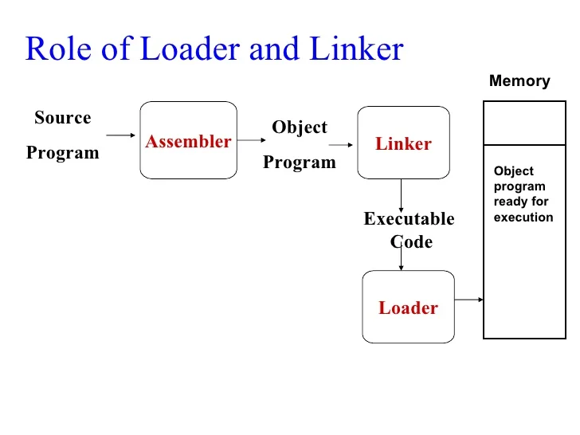

Q:3) **When linkage error occurs ?**

Ans:3) **Linkage error occurs when a class has some dependencies on another class and the latter class changes after compilation of the former class.**

**NoClassDefFoundError occurs when the class was present during compile time and the program was compiled and linked successfully but the class was not present during runtime. It is an error that is derived from LinkageError.**

Q:4) **What is Debugging and how does it work?What is a Debugger?**

Ans:4) **It is a systematic process of spotting and fixing the number of bugs, or defects, in a piece of software so that the software is behaving as expected.**

**Bugs and errors are so prone to happen in software development because it's such a conceptual and abstract activity.Debugging is a developer activity and effective debugging is very important before testing begins to increase the quality of the system.**

**A debugger is a computer program that allows you to uncover and diagnose errors in computer software.**

**A debugger essentially allows us to step through our source code and examine how the code is working. If we set a breakpoint, and run in debug mode, our code will pause at that break point and allow us to step into the code.**

Q:4) **Find the error?**

**class Hello**

**{**

**public static void main(String args[])**

**{**

**System.*out*.println("hello");**

**}**

**return 0**

**}**

Ans:4)**The program won’t execute and it will display an error message :**

**java: illegal start of type**

