**User Guide**

**For Pokémon information program**

**1007-Final Project**

Project Team Member

Yurui Mu(ym1495)

Yang Sun(ys2603)

Binqian Zeng(bz866)

1. **Introduction:**  
   This program is a local application helping ‘Pokémon Go’ players to know information about different Pokémon and catch them more easily and efficiently.   
   Information that the program can provide include  
   1) Pokemon Basic Info (pokemon id):
2. Show its overall CP ranking/percentile/mean
3. Show its overall HP ranking/percentile/mean
4. Show the same type Pokemons with it
5. Show its CP ranking/percentile/mean among the same type pokemons
6. Show its HP ranking/percentile/mean among the same type pokemons

2) Pokemon Go Info:

I. Overall Pokemon Go Info about a certain pokemon (pokemon id):

A. Show whether people have seen it in pokemon

B. Show the cities where it was often observed (histogram)

C. Show the pokemons whom it was often observed together with

D. Show distribution of its appearance time of the day in pie chart'

II. Regional Pokemon Go Info about a certain pokemon in a certain city (pokemon id, city name)

A. Show whether people have seen it in this city

B. Show the pokemons which are often observed in this city (histogram)

C. Show the pokemons often observed together with it in this city

D. Show distribution of its appearance time of the day in this city(pie chart)

1. **How to use this program:**  
   1) Make sure all data files are in the same directory as the main program. Like the image show below:

‘cleanedData.csv’: please download from our google drive link (from your NYUaccount) into the same directory as the main program. https://drive.google.com/a/nyu.edu/file/d/0BxWGUQbHQtu1b2M5Q05IQnpwdTA/view?usp=sharing

‘practiceData.csv’: it’s a clip of ‘cleanedData.csv’ used for function tests.

‘pokemonGO.csv’: it contains the basic info we need about pokemons.  
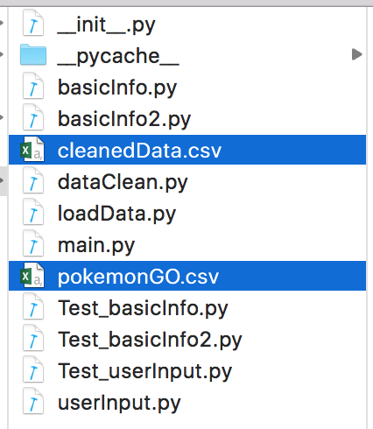  
2) Open ‘Terminal’and set the path to the folder location.   
 e.g. cd Desktop/Programming_for_DS/1007Finalproject/final_project  
3) Excute main.py to start local server.  
 e.g. python main.py  
4) Follow the instruction to obtain information you need.

5) The plots will pop up and be saved in the png file indicated on the screen. But please do close the plot manually to proceed our program.

1. **Attention:**1.Users should input following the instruction strictly. Any other input will be regarded as invalid. Mind surplus comma or space.2.Make sure all data files are in the same directory as the main program. Like the image show above.   
   3. Internet is not needed to access any results. All results come from the two data files, cleanedData.csv and pokemonGO.csv.
2. **To Grader**

The data file, cleanedData.csv, is data which has been cleaned. The data clean program is called ‘dataClean.py’. We list it with all other programs and files but it will not be executed while using the main program.