EPS130 Homework 4

EPS130 Homework on Instrumentation (Chapter 4)

The indicator equation describes the response of a single degree of freedom oscillator that is weakly coupled to the ground through a spring suspension system and mechanical damping system. Under certain conditions dictated by the parameters of the indicator equation related to the design of the instrument the mass remains fixed in space in an absolute, inertial reference frame as the ground moves beneath it. Understanding the response of this system is important to seismologists in that the desired information is not the relative motion of the instrument with respect to its internal reference frame, but the actual motion of the ground on which the instrument is resting. It is possible using filter theory to remove the response of the instrument.

To do calculations and make plots use a python notebook.

Problem 1. It is desired to have broadband recordings at high frequency that is flat in displacement above a frequency of 0.1 Hz. If the mass of the recording instrument is 10 grams, and is critically damped, what is the value of the spring elasticity coefficient, and units considering the original indicator equation?

Problem 2. If the spring coefficient remains unchanged how does the response of the instrument change if the mass is reduced to 1 gram?

Problem 3. Sketch the acceleration and displacement response of the instruments in problems 1 and 2. There is a workbook link to datahub so that you may use python to graph the acceleration and displacement instrument response functions.

Modern broadband and high dynamic range instruments use electronic feedback to maintain mass position thereby increasing dramatically the linearity of the response and through electronic control the band width of the response. Whereas it once required two or more stations on a single pier to obtain records spanning the observational range of earthquake phenomena now only one of these modern force-feed back instruments is needed. In Figure 1 the Fourier Amplitude Spectrum of the transverse component record from Parkfield for the October 31, 2007 Alum Rock Mw5.4 earthquake is compared to a spectrum of pre-event noise. Figure 2 compares the broadband ground displacement with several historic instruments such as the short- and long-period Wood-Andersons, the Galitzen, and the Press-Ewing. These instruments are obviously tuned to be sensitive to different frequency (period) passbands.

Problem 4. Follow the prompts below to examine the differences in the waveforms comparing the broadband record to the short period Wood-Anderson (WASP), the long-period Wood-Anderson, and the Galitzen instruments.

A. Qualitatively describe the difference between the earthquake and the noise spectra. What is the cause of the peaked background noise between 0.1 to 0.2 Hz?

B. Annotate Figure 2 with picks of the P-wave, S-wave and Love wave. Note that picking the first arriving S-wave can be difficult. It will be helpful to utilize the records from the different instrument types to identify the phase arrivals. Give a brief justification or explanation for the picks that you have made. Is any particular instrument more suitable for making the body wave identifications? What about for the surface wave identification?

C. For the four instrument types estimate the dominant period of the recorded signal. This can be done by making several measurements of wave period. Based on your measurements speculate on the natural period of each of the instruments.

D. It seems that the Galitzen record is noticeably noisier (the oscillatory signal before the P-wave arrival). What is the origin of the noise? Based on your period estimate is there any correlation with the noise spectrum shown in Figure 1. You may want to consult the textbook for information about what the noise might be from.

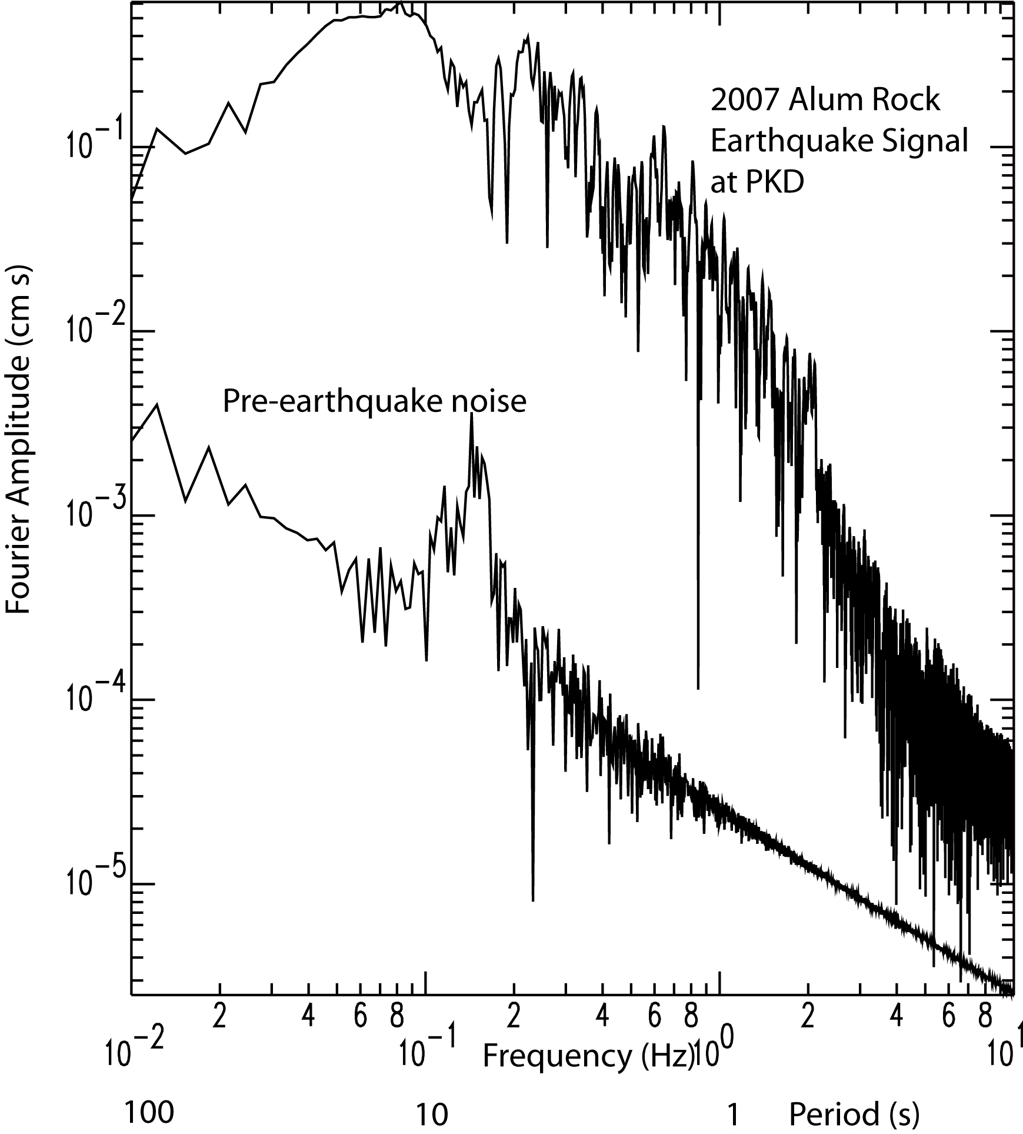

Figure 1. Fourier Amplitude spectra for the October 31, 2007 Parkfield earthquake recorded at Parkfield (PKD) is compared to the spectrum from a pre-earthquake noise sample. Note the peak in the noise between 0.1 to 0.2 Hz.

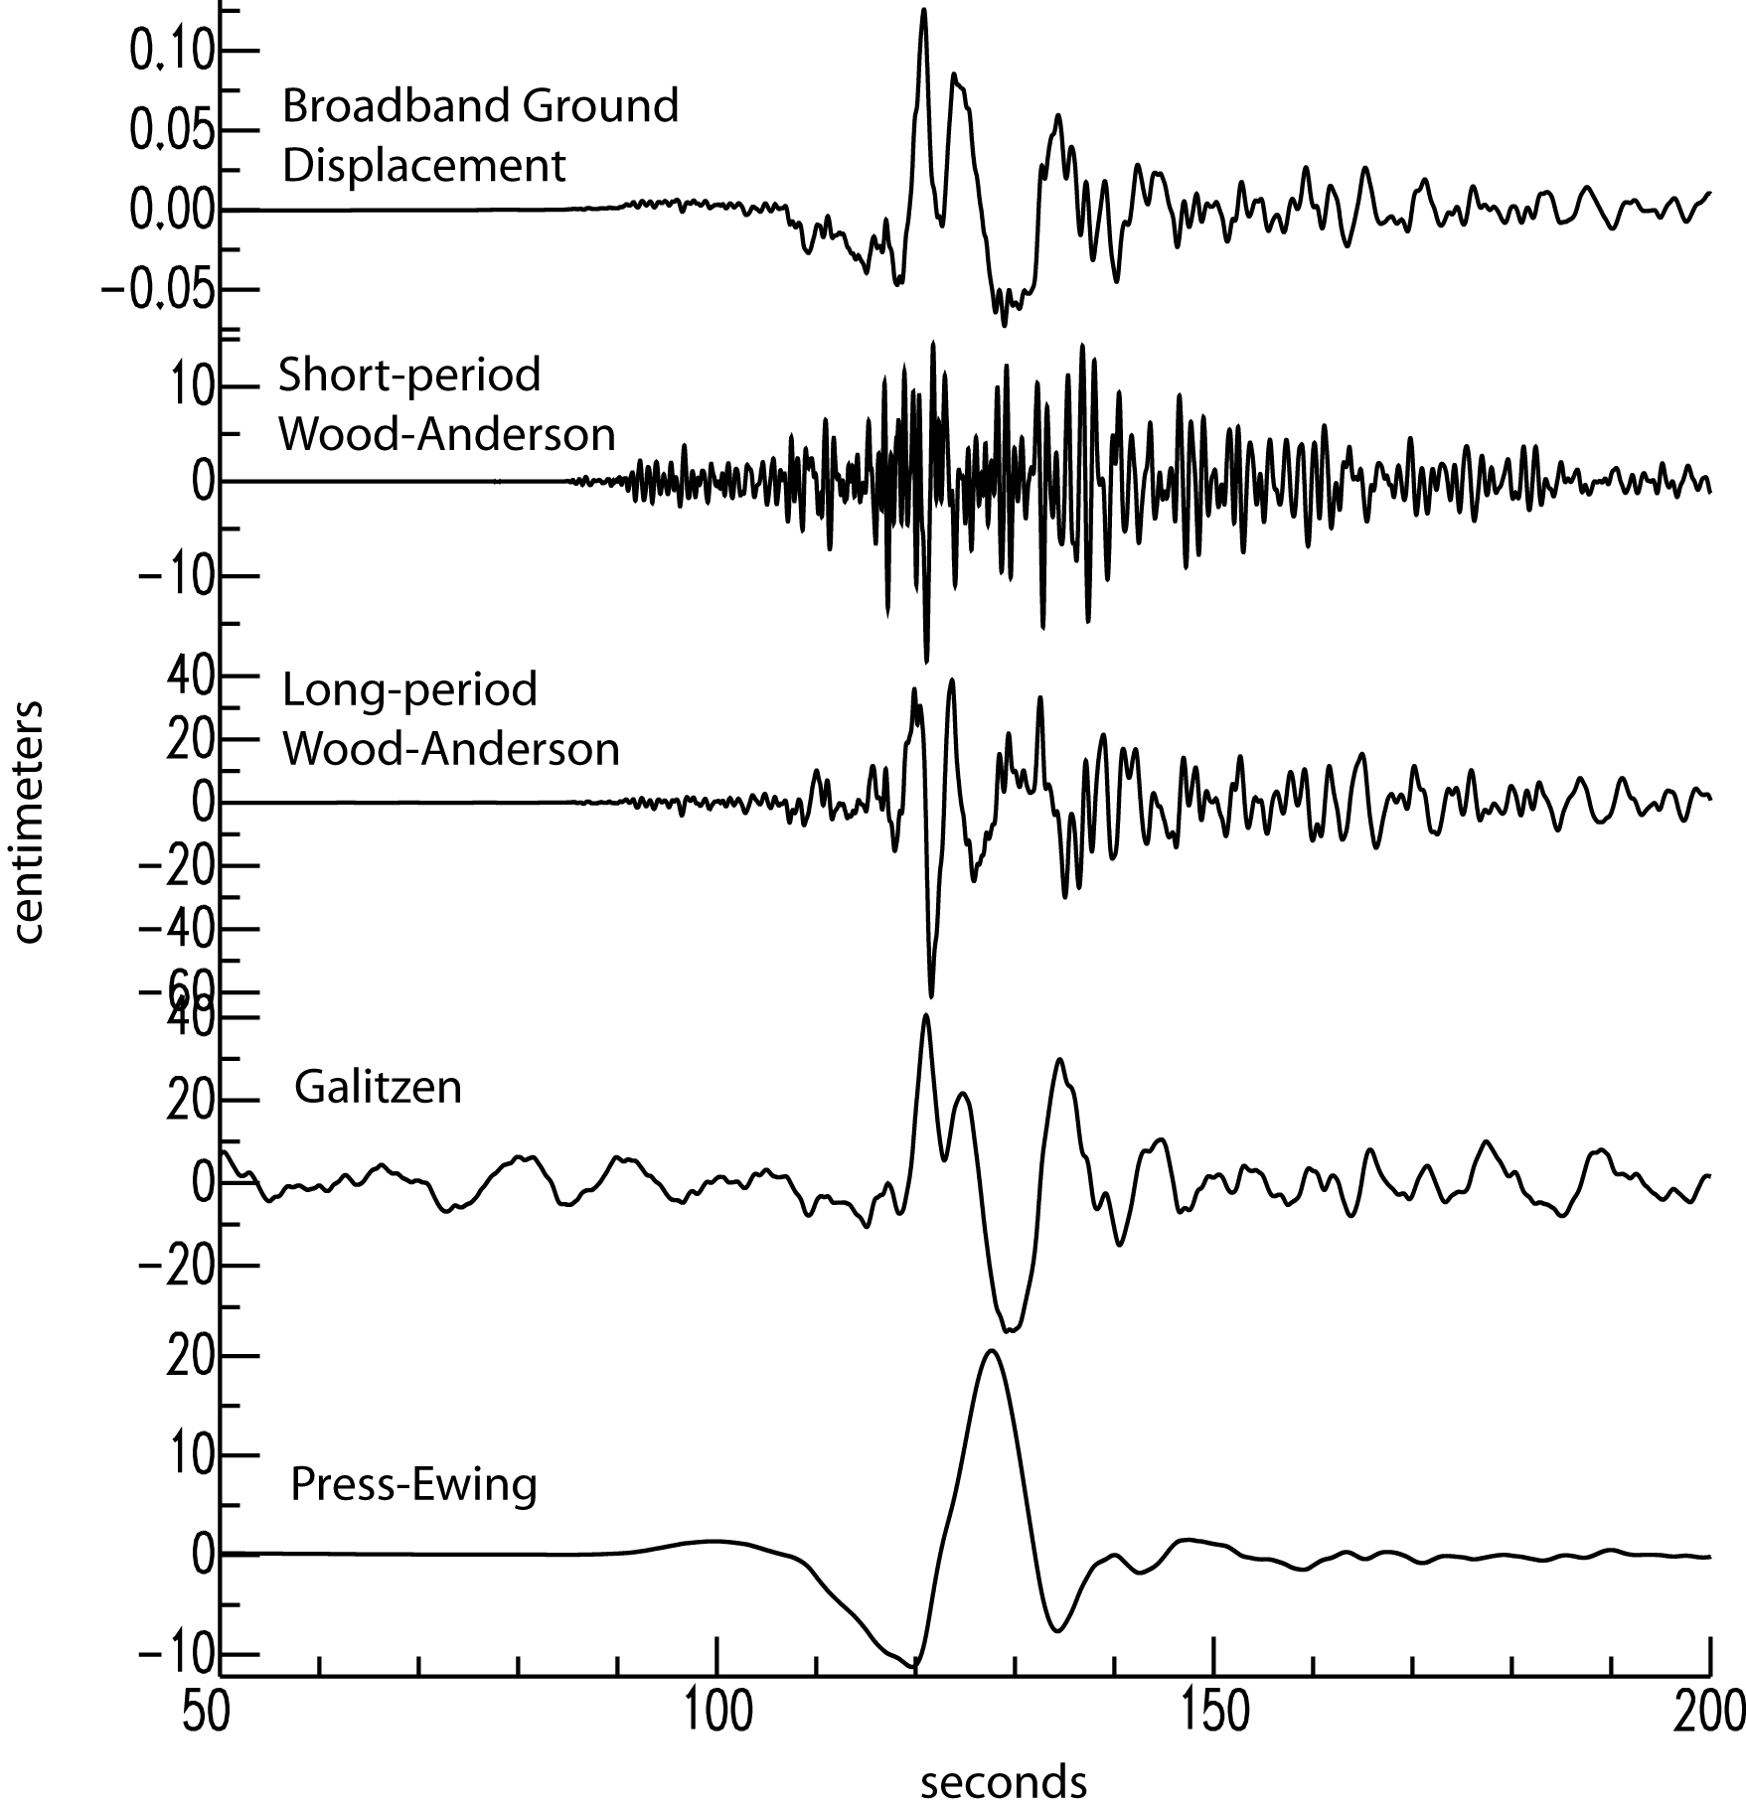

Figure 2. Broadband ground displacement is compared to seismograms from four historical instruments. The record shown is for the transverse component recorded at PKD approximately 198 km SE of the epicenter. Note that while for the first trace the amplitude is actual ground displacement in cm for the other stations it is the amplitude registered on the instrument. The amplitude of the long-period Wood-Anderson is more than 1 meter peak to peak, which is much larger than the historical instruments were capable of recording. Historically the amplitudes would have been capped at about 10 cm peak to peak.