**PH150e/CP117AC Homework #4: WORKSHEET**

**Spring 2019**

Name:______________________________________________________

Email: ____________________________________________

Section # & GSI name: __________________________

**In this assignment, you must use this form to answer all questions and you must attach a map to this file. Your map can be pasted as a jpeg or image file or as a pdf, but it MUST be attached to or embedded in his file for you to receive credit. Following directions is part of this assignment.**

**Please read and review the Assignment Instructions closely before you attempt to answer any questions below.** For more background on CHNAs please review: <https://www.cdc.gov/stltpublichealth/cha/plan.html>

**PART 1:**

Using your CHNA report for your assigned zip code, answer the following:

1. What are the racial and demographic percentages in your zip code? How do these compare to the county, California and the US as a whole? Use the table below or make your own with at least 5 major demographic groups.

|  |  |  |  |  |  |
| --- | --- | --- | --- | --- | --- |
| **Area** | % White | % Black | % Asian | % Native American / Alaska Native | % Some Other Race |
| **Zip Code** |  |  |  |  |  |
| **County** |  |  |  |  |  |
| **California** |  |  |  |  |  |
| **US** |  |  |  |  |  |

1. (a) What percent of the Latino and/or Asian population in your zip code is categorized as ‘Limited English Proficiency?’

(b)How might linguistic isolation influence community health?

1. (a) What percent of the Children in your zip code are below 100% of the poverty level?

(b) what does 100% below the poverty level mean and how might this economic status influence health? Please offer a succinct definition:

1. (a) What is the percentage of substandard housing in your zip code compared to the county, California and the US as a whole?

(b) How might substandard housing act as a determinant of health?

1. (a) What percent of the population in your zip code uses public transportation to commute to work over 60 minutes?

(b) is access to public transportation beneficial or detrimental to community health? Please briefly explain:

1. (a) How many Primary Care Physicians (PCPs) per 100,000 people are there in your zip code, and how does this compare to the rate in California and the US?

(b) does the # of PCPs in your zip code help explain the average life expectancy? Why or why not?

1. (a) What is the rate of SNAP-Authorized Retailers per 10,000 people in your zip code? How does this compare to the County, California, and the US?

(b)What is SNAP and how might access/lack of access to SNAP-Authorized Retailers promote/inhibit healthy food decisions?

**NOTE: You must create a map as defined in your Zip Code instructions before completing the questions below. Please refer to the HW#4 instructions for creating the map using engagementnetwork.org.**

**PART 2**

1. Describe the specific area and point data sets you used to create your map. For example, if you used “Adult poor physical health” as your area data, what does this mean and how was it measured? Similarly, if your point data were “SNAP Retailers,” define what this means. What is/are the sources of the data and how were they collected? Be sure the description is easy for a non-public health person to understand.

(*Click the “i” next to your data source to learn more information)*

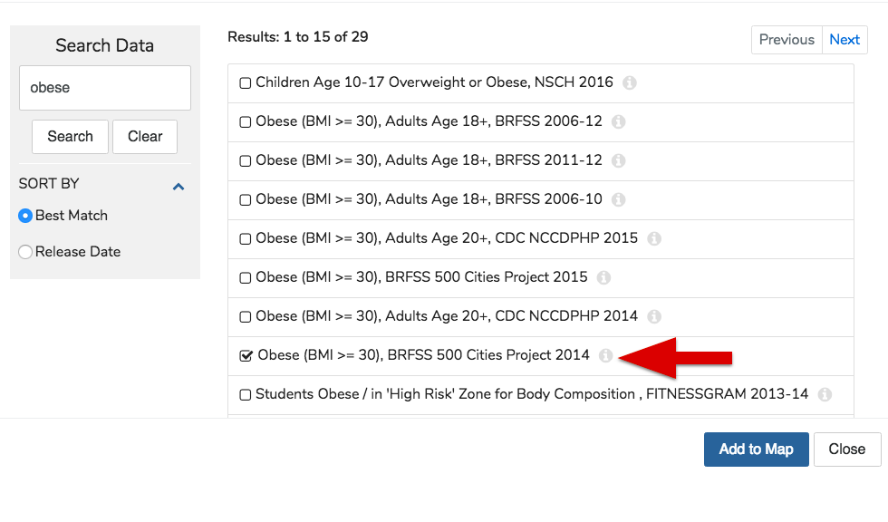

1. Area data used, Name:

Meaning:

Source and collection method:

1. Point data used. Name:

Meaning:

Source and collection method:

1. Now, interpret your map. What do you think it is showing? Please briefly describe the ‘story’ that your map might reveals about community health in this place? Do your data help reveal any correlations between a particular ‘exposure’ and health outcomes? What additional information might you want to help make sense of your map? Please briefly explain in 1 paragraph.

**PART 3: Please complete after visiting your assigned BART Station**

Homework – Required Questions

1. **Describe a public transportation asset you see from the BART station that isn’t BART (i.e., bus stops, bike share, flex car sites, vanpool).**

**2. Describe one food asset you see around the BART station area**. **If there aren’t any, please note this.**

3. **Spend a few minutes observing people coming and going. Describe one activity that you see around the BART station where people are interacting (i.e., street food vendor, someone playing music, adults helping kids cross the street, etc.).**

**4. Take a picture of one asset you see. Attach the picture either in this document or as a separate file to bcourses. In a few sentences below, answer the following: What did you take a picture of? What asset does this represent to you? What else does your picture communicate about this place?**