探索的データ分析 - EDA

p000117x, Suzuki, Hiroshi 鈴木寛

2024年2月13日

knitr::opts_chunk$set(out.extra = "```{r, font_family = 'Hiragino Sans'}")

## 課題

以下の指標の中から、二つ以上（複数）を選択して、データの概要（description）を記録し、データを WDI で取得し、以下の分析をする。

1. 各年毎のデータの数の棒グラフ
2. 経年変化を表す折れ線グラフ
   1. 日本、またはデータがある国
   2. 選択したいくつかの国
3. 複数の指標の値を一列に含む縦長の表（Long Table）を作成し
   1. 日本、またはデータがある国の、複数の指標を色分けした経年変化のグラフ
   2. 選択したいくつかの国についての経年変化のグラフを、国を色分けし、指標は線の種類を変えたグラフ
4. データが十分ある最近の年の値のヒストグラム
5. データが十分ある最近の年の値の10カ国の値の棒グラフ
   1. 値が大きい方から
   2. 値が小さい方から
6. 二つのデータの散布図- NA は取り除くこと。（log10 スケールを用いる場合は値が正のもののみに限定）
   1. （地域を除き）国のみの散布図 （近似（回帰）直線を表示）
   2. 最近の年の（地域を除き）国のみの散布図　（近似（回帰）直線を表示）
   3. b に対応する相関係数
7. カテゴリー変数（Categorical Variable: region, income, year など）と、数値変数（Numberical Variable）一組についての箱ヒゲ図（Boxplot）

それぞれについて考察（気づいたこと、疑問など）を記す

これは、課題１と課題２の合わせたものです。課題１も課題２も終わった人は、挑戦してください。

**2023.2.17.23:59** までに Moodle の課題２追加提出ボックスに提出してくださればフィードバックを書きます。。

### データ

1. Refugee population by country or territory of asylum：SM.POP.REFG [[Link](https://data.worldbank.org/indicator/SM.POP.REFG)]

Refugees are people who are recognized as refugees under the 1951 Convention Relating to the Status of Refugees or its 1967 Protocol, the 1969 Organization of African Unity Convention Governing the Specific Aspects of Refugee Problems in Africa, people recognized as refugees in accordance with the UNHCR statute, people granted refugee-like humanitarian status, and people provided temporary protection. Asylum seekers–people who have applied for asylum or refugee status and who have not yet received a decision or who are registered as asylum seekers–are excluded. Palestinian refugees are people (and their descendants) whose residence was Palestine between June 1946 and May 1948 and who lost their homes and means of livelihood as a result of the 1948 Arab-Israeli conflict. Country of asylum is the country where an asylum claim was filed and granted.

1. Refugee population by country or territory of origin：SM.POP.REFG.OR [[Link](https://data.worldbank.org/indicator/SM.POP.REFG.OR)]
2. Net ODA received (% of GNI)：DT.ODA.ODAT.GN.ZS [[Link](https://data.worldbank.org/indicator/DT.ODA.ODAT.GN.ZS)]
3. Net official development assistance and official aid received (current US$)：DT.ODA.ALLD.CD [[Link](https://data.worldbank.org/indicator/DT.ODA.ALLD.CD)]
4. Net ODA received (% of central government expense)：DT.ODA.ODAT.XP.ZS [[Link](https://data.worldbank.org/indicator/DT.ODA.ODAT.XP.ZS)]
5. Military expenditure (current USD)：MS.MIL.XPND.CD [[Link](https://data.worldbank.org/indicator/MS.MIL.XPND.CD)]
6. Military expenditure (% of general government expenditure)：MS.MIL.XPND.ZS [[Link](https://data.worldbank.org/indicator/MS.MIL.XPND.ZS)]
7. Arms imports (SIPRI trend indicator values)：MS.MIL.MPRT.KD [[Link](https://databank.worldbank.org/metadataglossary/world-development-indicators/series/MS.MIL.MPRT.KD)]
8. Arms exports (SIPRI trend indicator values)：MS.MIL.XPRT.KD [[Link](https://databank.worldbank.org/metadataglossary/world-development-indicators/series/MS.MIL.XPRT.KD)]

# 難民人口

## データ

### データ情報

1. 難民受け入れ人口：Refugee population by country or territory of asylum：SM.POP.REFG [[Link](https://data.worldbank.org/indicator/SM.POP.REFG)]
2. 難民となる人口：Refugee population by country or territory of origin：SM.POP.REFG.OR [[Link](https://data.worldbank.org/indicator/SM.POP.REFG.OR)]

* 難民の庇護国とは、庇護請求が提出され、認められた国のことである。出身国とは、一般的に請求者の国籍または市民権のある国を指す。
* **Description:** Refugees are people who are recognized as refugees under the 1951 Convention Relating to the Status of Refugees or its 1967 Protocol, the 1969 Organization of African Unity Convention Governing the Specific Aspects of Refugee Problems in Africa, people recognized as refugees in accordance with the UNHCR statute, people granted refugee-like humanitarian status, and people provided temporary protection. Asylum seekers–people who have applied for asylum or refugee status and who have not yet received a decision or who are registered as asylum seekers–are excluded. Palestinian refugees are people (and their descendants) whose residence was Palestine between June 1946 and May 1948 and who lost their homes and means of livelihood as a result of the 1948 Arab-Israeli conflict. Country of asylum is the country where an asylum claim was filed and granted. Country of origin generally refers to the nationality or country of citizenship of a claimant.
* **概要:** 難民とは、「難民の地位に関する1951年条約」またはその「1967年議定書」、「アフリカにおける難民問題の特定の側面を管理する1969年アフリカ統一機構条約」に基づき難民と認められた人、UNHCRの法令に基づき難民と認められた人、難民に準ずる人道的地位を与えられた人、一時的な保護を与えられた人を指す。庇護申請者–庇護または難民認定を申請し、まだ決定を受けていない人、または庇護申請者として登録されている人–は除外される。パレスチナ難民とは、1946年6月から1948年5月までの間に居住地がパレスチナであり、1948年のアラブ・イスラエル紛争の結果、住居と生計手段を失った人々（およびその子孫）である。庇護国とは、庇護請求が提出され、認められた国のことである。出身国とは、一般的に請求者の国籍または市民権のある国を指す。

### データの取得

#### 準備

*これまでとも同じように二つのパッケージを読み込み（load）ます。*

knitr::opts_chunk$set(cache = TRUE)

library(tidyverse)  
library(WDI)

library(tidyverse)

## ── Attaching core tidyverse packages ──────────────────────── tidyverse 2.0.0 ──  
## ✔ dplyr 1.1.4 ✔ readr 2.1.5  
## ✔ forcats 1.0.0 ✔ stringr 1.5.1  
## ✔ ggplot2 3.4.4 ✔ tibble 3.2.1  
## ✔ lubridate 1.9.3 ✔ tidyr 1.3.1  
## ✔ purrr 1.0.2   
## ── Conflicts ────────────────────────────────────────── tidyverse_conflicts() ──  
## ✖ dplyr::filter() masks stats::filter()  
## ✖ dplyr::lag() masks stats::lag()  
## ℹ Use the conflicted package (<http://conflicted.r-lib.org/>) to force all conflicts to become errors

# library(ggplot2)  
# library(dplyr)  
# library(readr)  
# library(tidyr)  
# library(forcats)  
library(WDI)

library(showtext)

## 要求されたパッケージ sysfonts をロード中です

## 要求されたパッケージ showtextdb をロード中です

# showtext_auto()   
showtext_auto(FALSE)

*変数名を指定します。ここでは、refugee_asylum と、refugee_origin としました。なるべくわかりやすい名前にします。*

*この変数名は、今後使いますから、重要です。一応、例として、わたしが使った、変数名を書いてあります。他の変数名を使っても構いません。extra = TRUE とすると、地域名（region）や、収入レベル（income）などが追加されます。*

df_unemploy <- WDI(indicator = c(female_unemploy = "SL.UEM.TOTL.FE.ZS",   
 male_unemploy = "SL.UEM.TOTL.MA.ZS"),  
 extra = TRUE)

df_refugee <- WDI(  
 indicator = c(refugee_asylum = "SM.POP.REFG",   
 refugee_origin = "SM.POP.REFG.OR"),  
 extra = TRUE)

*data ディレクトリに書き込んでおきます。*

write_csv(df_unemploy, "data/unemploy.csv")

write_csv(df_refugee, "data/refugee.csv")

*data ディレクトリから読み出します。Run All や、Run All Chunks Above をする時は、上の二つをスキップする設定にしてあります。*

df_unemploy <- read_csv("data/unemploy.csv")

df_refugee <- read_csv("data/refugee.csv")

## Rows: 16758 Columns: 14  
## ── Column specification ────────────────────────────────────────────────────────  
## Delimiter: ","  
## chr (7): country, iso2c, iso3c, region, capital, income, lending  
## dbl (5): year, refugee_asylum, refugee_origin, longitude, latitude  
## lgl (1): status  
## date (1): lastupdated  
##   
## ℹ Use `spec()` to retrieve the full column specification for this data.  
## ℹ Specify the column types or set `show_col_types = FALSE` to quiet this message.

### データの確認

df_unemploy

*データ名で、中身を表示できます。head(df_refugee) とすると、6行表示されます。*

df_refugee

## # A tibble: 16,758 × 14  
## country iso2c iso3c year status lastupdated refugee_asylum refugee_origin  
## <chr> <chr> <chr> <dbl> <lgl> <date> <dbl> <dbl>  
## 1 Afghanist… AF AFG 2014 NA 2023-12-19 300421 2596259  
## 2 Afghanist… AF AFG 1971 NA 2023-12-19 NA NA  
## 3 Afghanist… AF AFG 2006 NA 2023-12-19 34 2107510  
## 4 Afghanist… AF AFG 2013 NA 2023-12-19 16861 2556483  
## 5 Afghanist… AF AFG 1995 NA 2023-12-19 19605 2679132  
## 6 Afghanist… AF AFG 2005 NA 2023-12-19 31 2166139  
## 7 Afghanist… AF AFG 1997 NA 2023-12-19 5 2676675  
## 8 Afghanist… AF AFG 1998 NA 2023-12-19 NA 2667118  
## 9 Afghanist… AF AFG 1999 NA 2023-12-19 NA 2601690  
## 10 Afghanist… AF AFG 1996 NA 2023-12-19 18779 2674234  
## # ℹ 16,748 more rows  
## # ℹ 6 more variables: region <chr>, capital <chr>, longitude <dbl>,  
## # latitude <dbl>, income <chr>, lending <chr>

*変数の情報を得ることができます。*

str(df_unemploy)

str(df_refugee)

## spc_tbl_ [16,758 × 14] (S3: spec_tbl_df/tbl_df/tbl/data.frame)  
## $ country : chr [1:16758] "Afghanistan" "Afghanistan" "Afghanistan" "Afghanistan" ...  
## $ iso2c : chr [1:16758] "AF" "AF" "AF" "AF" ...  
## $ iso3c : chr [1:16758] "AFG" "AFG" "AFG" "AFG" ...  
## $ year : num [1:16758] 2014 1971 2006 2013 1995 ...  
## $ status : logi [1:16758] NA NA NA NA NA NA ...  
## $ lastupdated : Date[1:16758], format: "2023-12-19" "2023-12-19" ...  
## $ refugee_asylum: num [1:16758] 300421 NA 34 16861 19605 ...  
## $ refugee_origin: num [1:16758] 2596259 NA 2107510 2556483 2679132 ...  
## $ region : chr [1:16758] "South Asia" "South Asia" "South Asia" "South Asia" ...  
## $ capital : chr [1:16758] "Kabul" "Kabul" "Kabul" "Kabul" ...  
## $ longitude : num [1:16758] 69.2 69.2 69.2 69.2 69.2 ...  
## $ latitude : num [1:16758] 34.5 34.5 34.5 34.5 34.5 ...  
## $ income : chr [1:16758] "Low income" "Low income" "Low income" "Low income" ...  
## $ lending : chr [1:16758] "IDA" "IDA" "IDA" "IDA" ...  
## - attr(*, "spec")=  
## .. cols(  
## .. country = col_character(),  
## .. iso2c = col_character(),  
## .. iso3c = col_character(),  
## .. year = col_double(),  
## .. status = col_logical(),  
## .. lastupdated = col_date(format = ""),  
## .. refugee_asylum = col_double(),  
## .. refugee_origin = col_double(),  
## .. region = col_character(),  
## .. capital = col_character(),  
## .. longitude = col_double(),  
## .. latitude = col_double(),  
## .. income = col_character(),  
## .. lending = col_character()  
## .. )  
## - attr(*, "problems")=<externalptr>

### 変形

#### 変数の選択（selecting）

df_unemp <- df_unemploy |>   
 select(country, iso2c, year, female_unemploy, male_unemploy, region, income)  
df_unemp

df_ref <- df_refugee |>   
 select(country, iso2c, year, refugee_asylum, refugee_origin, region, income)  
df_ref

## # A tibble: 16,758 × 7  
## country iso2c year refugee_asylum refugee_origin region income   
## <chr> <chr> <dbl> <dbl> <dbl> <chr> <chr>   
## 1 Afghanistan AF 2014 300421 2596259 South Asia Low income  
## 2 Afghanistan AF 1971 NA NA South Asia Low income  
## 3 Afghanistan AF 2006 34 2107510 South Asia Low income  
## 4 Afghanistan AF 2013 16861 2556483 South Asia Low income  
## 5 Afghanistan AF 1995 19605 2679132 South Asia Low income  
## 6 Afghanistan AF 2005 31 2166139 South Asia Low income  
## 7 Afghanistan AF 1997 5 2676675 South Asia Low income  
## 8 Afghanistan AF 1998 NA 2667118 South Asia Low income  
## 9 Afghanistan AF 1999 NA 2601690 South Asia Low income  
## 10 Afghanistan AF 1996 18779 2674234 South Asia Low income  
## # ℹ 16,748 more rows

*データには country のところに、国だけでなく、地域も入っているので、地域のリストを、iso2c で REGION に入れておきます。*

REGION <- c("1A", "1W", "4E", "6F", "6N", "6X", "7E", "8S", "A4", "A5",   
"A9", "B1", "B2", "B3", "B4", "B6", "B7", "B8", "C4", "C5", "C6",   
"C7", "C8", "C9", "D2", "D3", "D4", "D5", "D6", "D7", "EU", "F1",   
"F6", "M1", "M2", "N6", "OE", "R6", "S1", "S2", "S3", "S4", "T2",   
"T3", "T4", "T5", "T6", "T7", "V1", "V2", "V3", "V4", "XC", "XD",   
"XE", "XF", "XG", "XH", "XI", "XJ", "XL", "XM", "XN", "XO", "XP",   
"XQ", "XT", "XU", "XY", "Z4", "Z7", "ZB", "ZF", "ZG", "ZH", "ZI",   
"ZJ", "ZQ", "ZT")

REGION <- c("1A", "1W", "4E", "6F", "6N", "6X", "7E", "8S", "A4", "A5",   
"A9", "B1", "B2", "B3", "B4", "B6", "B7", "B8", "C4", "C5", "C6",   
"C7", "C8", "C9", "D2", "D3", "D4", "D5", "D6", "D7", "EU", "F1",   
"F6", "M1", "M2", "N6", "OE", "R6", "S1", "S2", "S3", "S4", "T2",   
"T3", "T4", "T5", "T6", "T7", "V1", "V2", "V3", "V4", "XC", "XD",   
"XE", "XF", "XG", "XH", "XI", "XJ", "XL", "XM", "XN", "XO", "XP",   
"XQ", "XT", "XU", "XY", "Z4", "Z7", "ZB", "ZF", "ZG", "ZH", "ZI",   
"ZJ", "ZQ", "ZT")

*地域名にはどのようなものがあるか見ておきます。*

df_unemp |> filter(iso2c %in% REGION) |> distinct(country, iso2c)

df_ref |> filter(iso2c %in% REGION) |> distinct(country, iso2c)

## # A tibble: 49 × 2  
## country iso2c  
## <chr> <chr>  
## 1 Africa Eastern and Southern ZH   
## 2 Africa Western and Central ZI   
## 3 Arab World 1A   
## 4 Caribbean small states S3   
## 5 Central Europe and the Baltics B8   
## 6 Early-demographic dividend V2   
## 7 East Asia & Pacific Z4   
## 8 East Asia & Pacific (excluding high income) 4E   
## 9 East Asia & Pacific (IDA & IBRD countries) T4   
## 10 Euro area XC   
## # ℹ 39 more rows

*国名も、地域（region）と、所得レベル（income）と共に、表示しておきます。*

df_unemp |> filter(!(iso2c %in% REGION)) |> distinct(country, iso2c, region, income)

df_ref |> filter(!(iso2c %in% REGION)) |> distinct(country, iso2c, region, income)

## # A tibble: 217 × 4  
## country iso2c region income   
## <chr> <chr> <chr> <chr>   
## 1 Afghanistan AF South Asia Low income   
## 2 Albania AL Europe & Central Asia Upper middle income  
## 3 Algeria DZ Middle East & North Africa Lower middle income  
## 4 American Samoa AS East Asia & Pacific Upper middle income  
## 5 Andorra AD Europe & Central Asia High income   
## 6 Angola AO Sub-Saharan Africa Lower middle income  
## 7 Antigua and Barbuda AG Latin America & Caribbean High income   
## 8 Argentina AR Latin America & Caribbean Upper middle income  
## 9 Armenia AM Europe & Central Asia Upper middle income  
## 10 Aruba AW Latin America & Caribbean High income   
## # ℹ 207 more rows

### 分析する国のリスト

*自分で分析したい国のリストを作ってください。ここでは、紛争に関係がありそうな国を CONFLICTS にします。無論、変更してくだっさって構いません*

CONFLICTS <- c("Syrian Arab Republic", "Ukraine", "Afghanistan", "South Sudan", "Myanmar", "Congo, Dem. Rep.", "Turkiye", "West Bank and Gaza")

CONFLICTS <- c("Syrian Arab Republic", "Ukraine", "Afghanistan", "South Sudan", "Myanmar", "Congo, Dem. Rep.", "Turkiye", "West Bank and Gaza")

## 視覚化

### 1. 各年毎のデータの数の棒グラフ

*まずは、NA の値を削除します。そのあとで、国の情報の数を数えたいので、!(iso2c %in% REGION) で、上でおいた、地域の iso2c を選択し、! は否定でしたから、地域ではないものを選択し、その数を棒グラフにしています。*

df_unemp |> drop_na(female_unemploy, male_unemploy) |> filter(!(iso2c %in% REGION)) |>  
 ggplot(aes(year)) + geom_bar()

df_ref |> drop_na(refugee_asylum, refugee_origin) |> filter(!(iso2c %in% REGION)) |>  
 ggplot(aes(year)) + geom_bar()

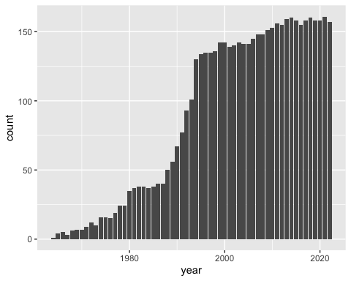

**気づいたこと・疑問**

* 1960 すぎからデータはあるが、1990年ごろからは十分ある。

### 2. 経年変化を表す折れ線グラフ

#### a. 日本、またはデータがある国

df_unemp |> filter(country == "Japan") |> drop_na(female_unemploy) |>  
 ggplot(aes(year, female_unemploy)) + geom_line() +  
 labs(title = "日本の女性労働者失業率")

df_ref |> filter(country == "Japan") |> drop_na(refugee_asylum) |>  
 ggplot(aes(year, refugee_asylum)) + geom_line() +  
 labs(title = "Refugee Population of Japan of Asylum")

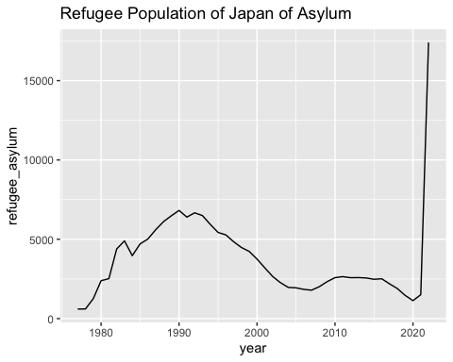

df_unemp |> filter(country == "Japan") |> drop_na(male_unemploy) |>  
 ggplot(aes(year, male_unemploy)) + geom_line() +  
 labs(title = "日本の男性労働者失業率")

df_ref |> filter(country == "Japan") |> drop_na(refugee_origin) |>  
 ggplot(aes(year, refugee_origin)) + geom_line() +  
 labs(title = "Refugee Population of Japan as Origin")

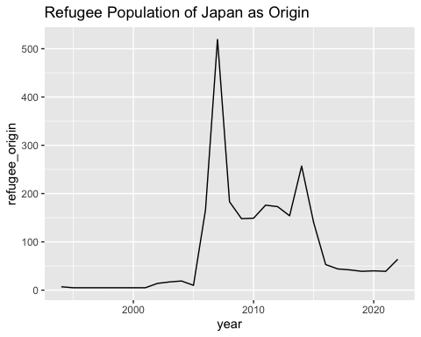

df_ref |> filter(country == "World") |> drop_na(refugee_origin) |>  
 ggplot(aes(year, refugee_origin)) + geom_line() +  
 labs(title = "Refugee Population of World as Origin")

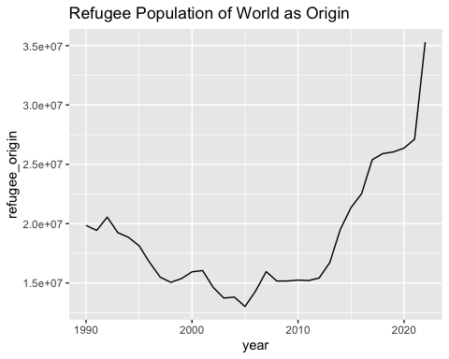

**気づいたこと・疑問**

#### b. 選択したいくつかの国

df_unemp |> filter(iso2c %in% ASEAN) |> drop_na(female_unemploy) |>  
 ggplot(aes(year, female_unemploy, col = country)) + geom_line() +  
 labs(title = "ASEAN の女性労働者失業率")

CONFLICTS は、country ですから、下のようにします。

df_ref |> filter(country %in% CONFLICTS) |> drop_na(refugee_asylum) |>  
 ggplot(aes(year, refugee_asylum, col = country)) + geom_line()

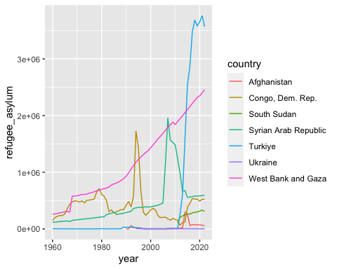

**気づいたこと・疑問**

df_unemp |> filter(country %in% asean) |> drop_na(male_unemploy) |>  
 ggplot(aes(year, male_unemploy, col = country)) + geom_line() +  
 labs(title = "ASEAN の男性労働者失業率")

df_ref |> filter(country %in% CONFLICTS) |> drop_na(refugee_origin) |>  
 ggplot(aes(year, refugee_origin, col = country)) + geom_line() +  
 labs(title = "難民となる人口")

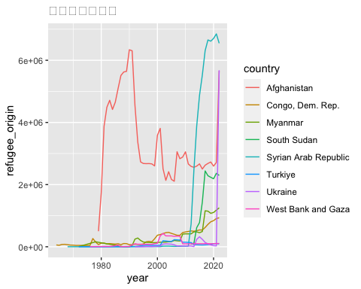

**気づいたこと・疑問**

* 変化が多いので、別々にみた方が良いかもしれない。

### 3. 縦長の表（Long Table）

*cols = c(refugee_asylum, refugee_origin) と、一つの指標にまとめるものをリストすると、name に指標名が入り、value に、その値が入る。書式は、pivot_longer(cols = ..., names_to = ..., values_to = ...) で、初期設定では、names_to = "name", values_to = "value" となっているので、指定しないと、下のようになる。Help 参照。*

df_unemp_long <- df_unemp |> pivot_longer(cols = c(female_unemploy, male_unemploy))  
df_unemp_long

df_ref_long <- df_ref |> pivot_longer(cols = c(refugee_asylum, refugee_origin))  
df_ref_long

## # A tibble: 33,516 × 7  
## country iso2c year region income name value  
## <chr> <chr> <dbl> <chr> <chr> <chr> <dbl>  
## 1 Afghanistan AF 2014 South Asia Low income refugee_asylum 300421  
## 2 Afghanistan AF 2014 South Asia Low income refugee_origin 2596259  
## 3 Afghanistan AF 1971 South Asia Low income refugee_asylum NA  
## 4 Afghanistan AF 1971 South Asia Low income refugee_origin NA  
## 5 Afghanistan AF 2006 South Asia Low income refugee_asylum 34  
## 6 Afghanistan AF 2006 South Asia Low income refugee_origin 2107510  
## 7 Afghanistan AF 2013 South Asia Low income refugee_asylum 16861  
## 8 Afghanistan AF 2013 South Asia Low income refugee_origin 2556483  
## 9 Afghanistan AF 1995 South Asia Low income refugee_asylum 19605  
## 10 Afghanistan AF 1995 South Asia Low income refugee_origin 2679132  
## # ℹ 33,506 more rows

#### a. 日本の複数の指標を色分けした経年変化のグラフ

*col = name と指定すると、色で区別して、一つのグラフに描ける*

df_unemp_long |> filter(country == "Japan") |> drop_na(value) |>  
 ggplot(aes(year, value, col = name)) + geom_line() +  
 labs(title = "日本の男女別失業率")

df_ref_long |> filter(country == "Japan") |> drop_na(value) |>  
 ggplot(aes(year, value, col = name)) + geom_line() +  
 labs(title = "日本の難民")

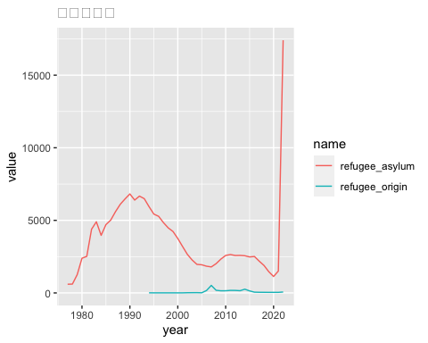

**気づいたこと・疑問**

* スケールがかなり違うので、別々にみたほうが良いかもしれない。

df_unemp_long |> filter(country == "World") |> drop_na(value) |>  
 ggplot(aes(year, value, col = name)) + geom_line() +  
 labs(title = "世界の男女別失業率")

df_ref_long |> filter(country == "World") |> drop_na(value) |>  
 ggplot(aes(year, value, col = name)) + geom_line() +  
 labs(title = "世界の難民")

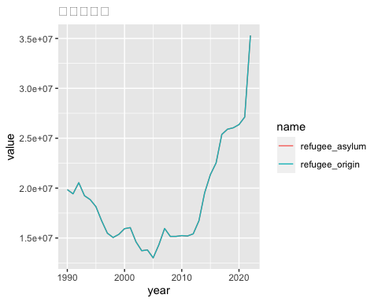

**気づいたこと・疑問**

* どちらも同じ値になっている。

#### b. 選択したいくつかの国の複数の指標を色分けした経年変化のグラフ

df_unemp_long |> filter(iso2c %in% ASEAN) |> drop_na(value) |>  
 ggplot(aes(year, value, col = country, linetype = name)) + geom_line() +  
 labs(title = "ASEAN の男女別失業率")

df_ref_long |> filter(country %in% CONFLICTS) |> drop_na(value) |>  
 ggplot(aes(year, value, col = country, linetype = name)) + geom_line() +  
 labs(title = "紛争国の難民数")

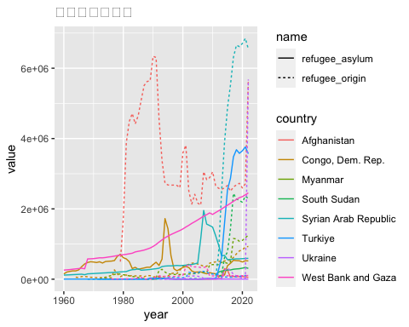

**気づいたこと・疑問**

* これだけでは、正確にはみることができないが、興味深い。

### 4. ヒストグラム

それぞれのデータが十分ある最近の年の値のヒストグラム（度数分布）

*分け方の数 bins や、幅 binwidth を適切に変更*

#### 一つ目の指標

*必要に応じて、log10 スケール（scale_x_log10()）を使う。*

df_unemp |> filter(!(iso2c %in% REGION)) |> filter(year == 2022) |> drop_na(female_unemploy) |>  
 ggplot(aes(female_unemploy, fill = region)) + geom_histogram(bins = 10, col = "black", linewidth = 0.2) + scale_x_log10()

df_ref |> filter(!(iso2c %in% REGION)) |> filter(year == 2022) |> drop_na(refugee_asylum) |>  
 ggplot(aes(refugee_asylum, fill = region)) + geom_histogram(bins = 10, col = "black", linewidth = 0.2) + scale_x_log10()

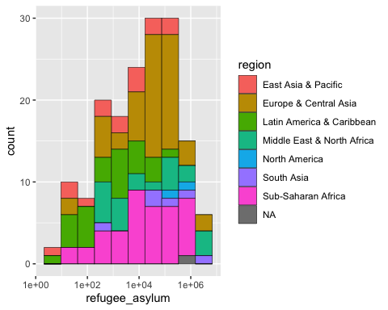

df_unemp |> filter(!(iso2c %in% REGION)) |> filter(year == 2022) |> drop_na(female_unemploy) |>  
 ggplot(aes(female_unemploy, fill = income)) + geom_histogram(bins = 10, col = "black", linewidth = 0.2)

df_ref |> filter(!(iso2c %in% REGION)) |> filter(year == 2022) |> drop_na() |>  
 ggplot(aes(refugee_asylum, fill = income)) + geom_histogram(bins = 10, col = "black", linewidth = 0.2) + scale_x_log10()

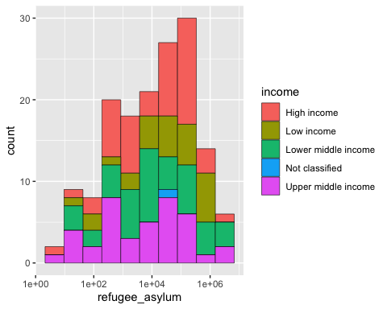

#### 二つ目の指標

df_unemp |> filter(!(iso2c %in% REGION)) |> filter(year == 2022) |> drop_na(male_unemploy) |>  
 ggplot(aes(male_unemploy, fill = region)) + geom_histogram(bins = 10, col = "black", linewidth = 0.2) + scale_x_log10()

df_ref |> filter(!(iso2c %in% REGION)) |> filter(year == 2022) |> drop_na(refugee_origin) |>  
 ggplot(aes(refugee_origin, fill = region)) + geom_histogram(bins = 10, col = "black", linewidth = 0.2) + scale_x_log10()

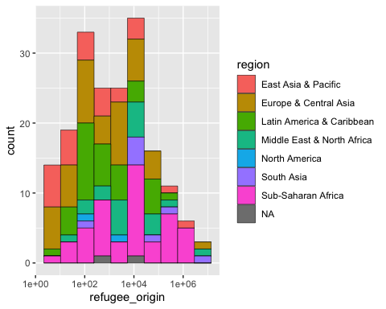

df_unemp |> filter(!(iso2c %in% REGION)) |> filter(year == 2022) |> drop_na(male_unemploy) |>  
 ggplot(aes(male_unemploy, fill = income)) + geom_histogram(bins = 10, col = "black", linewidth = 0.2)

df_ref |> filter(!(iso2c %in% REGION)) |> filter(year == 2022) |> drop_na(refugee_origin) |>  
 ggplot(aes(refugee_origin, fill = income)) + geom_histogram(bins = 10, col = "black", linewidth = 0.2) + scale_x_log10()

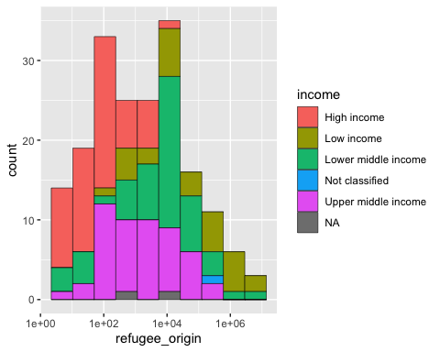

**気づいたこと・疑問点**

* スケールがかなり異なるため、log10 スケールの方が見やすい。

### 5. 棒グラフ

データが十分ある最近の年の値の10カ国の値の棒グラフ

#### a. 一つ目の指標：値が大きい方から

df_unemp |> filter(!(iso2c %in% REGION)) |> filter(year == 2022) |> drop_na(female_unemploy) |>  
 arrange(desc(female_unemploy)) |> slice_head(n = 10) |>  
 ggplot(aes(fct_rev(fct_inorder(country)), female_unemploy, fill = region)) + geom_col() + coord_flip() + labs(title = "女性失業率の高い順", x = "")

df_ref |> filter(!(iso2c %in% REGION)) |> filter(year == 2022) |> drop_na(refugee_asylum) |>  
 arrange(desc(refugee_asylum)) |> slice_head(n = 10) |>  
 ggplot(aes(fct_rev(fct_inorder(country)), refugee_asylum, fill = region)) + geom_col() + coord_flip() + labs(title = "難民受け入れ国別人数", x = "")

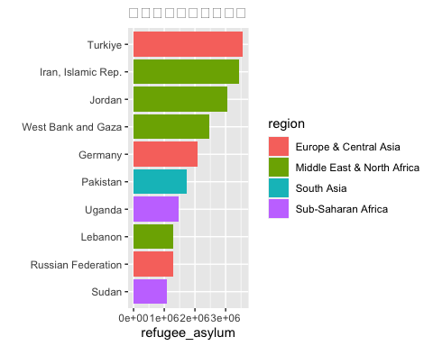

#### b. 一つ目の指標：値が小さい方から

df_unemp |> filter(!(iso2c %in% REGION)) |> filter(year == 2022) |> drop_na(female_unemploy) |>  
 arrange(female_unemploy) |> slice_head(n = 10) |>  
 ggplot(aes(fct_rev(fct_inorder(country)), female_unemploy, fill = region)) + geom_col() + coord_flip() + labs(title = "女性失業率が低い順")

df_ref |> filter(!(iso2c %in% REGION)) |> filter(year == 2022) |> drop_na(refugee_asylum) |>  
 arrange(refugee_asylum) |> slice_head(n = 10) |>  
 ggplot(aes(fct_rev(fct_inorder(country)), refugee_asylum, fill = region)) + geom_col() + coord_flip() + labs(title = "難民受け入れ数が低い国")

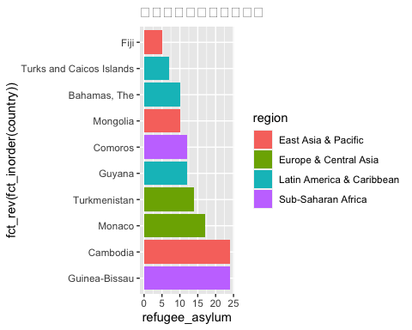

#### a. 二つ目の指標：値が大きい方から

df_unemp |> filter(!(iso2c %in% REGION)) |> filter(year == 2022) |> drop_na(male_unemploy) |>  
 arrange(desc(male_unemploy)) |> slice_head(n = 10) |>  
 ggplot(aes(fct_rev(fct_inorder(country)), male_unemploy, fill = region)) + geom_col() + coord_flip() + labs(title = "男性失業率の高い順", x = "")

df_ref |> filter(!(iso2c %in% REGION)) |> filter(year == 2022) |> drop_na(refugee_origin) |>  
 arrange(desc(refugee_origin)) |> slice_head(n = 10) |>  
 ggplot(aes(fct_rev(fct_inorder(country)), refugee_origin, fill = region)) + geom_col() + coord_flip() + labs(title = "難民の多い順", x = "")

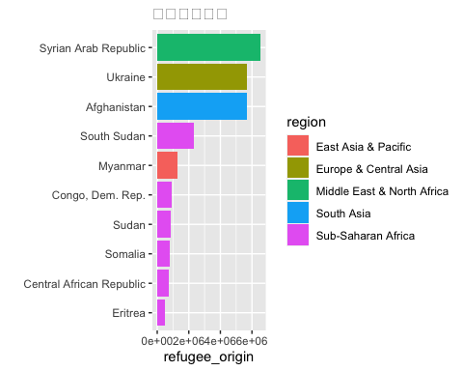

#### b. 二つ目の指標：値が小さい方から

df_unemp |> filter(!(iso2c %in% REGION)) |> filter(year == 2022) |> drop_na(male_unemploy) |>  
 arrange(male_unemploy) |> slice_head(n = 10) |>  
 ggplot(aes(fct_rev(fct_inorder(country)), male_unemploy, fill = region)) + geom_col() + coord_flip() + labs(title = "男性失業率が低い順")

df_ref |> filter(!(iso2c %in% REGION)) |> filter(year == 2022) |> drop_na(refugee_origin) |>  
 arrange(refugee_origin) |> slice_head(n = 10) |>  
 ggplot(aes(fct_rev(fct_inorder(country)), refugee_origin, fill = region)) + geom_col() + coord_flip() + labs(title = "難民の幅ない国")

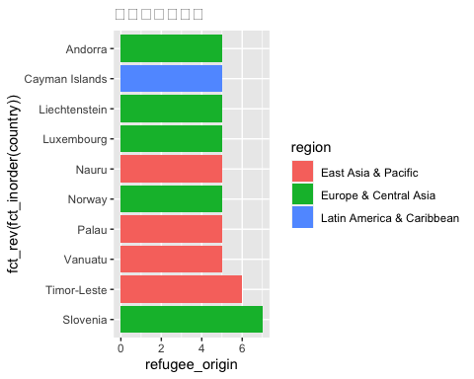

### 6. 散布図

*必要に応じて、LOG10 (scale_x_log10(), scale_y_log10()) スケールを使う。*

#### a.（地域を除き）国のみの散布図

df_unemp |> filter(!(iso2c %in% REGION)) |> drop_na(female_unemploy, male_unemploy) |>  
 ggplot(aes(female_unemploy, male_unemploy)) + geom_point() +  
 labs(title = "失業率：男女別相関")

df_ref |> filter(!(iso2c %in% REGION)) |> drop_na(refugee_asylum, refugee_origin) |>  
 ggplot(aes(refugee_asylum, refugee_origin)) + geom_point() +  
 scale_x_log10() + scale_y_log10() +  
 labs(title = "難民出国・受け入れ人数")

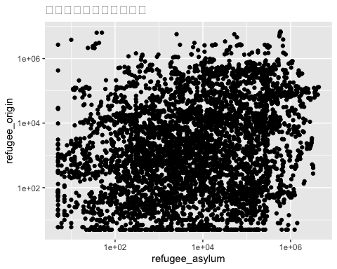

**気づいたこと・疑問**

#### 近似（回帰）直線の表示

df_unemp |> filter(!(iso2c %in% REGION)) |> drop_na(female_unemploy, male_unemploy) |>  
 ggplot(aes(female_unemploy, male_unemploy)) + geom_point() +   
 geom_smooth(formula = 'y~x', method = "lm", se = FALSE) +  
 labs(title = "失業率：男女別相関（回帰直線付）")

df_ref |> filter(!(iso2c %in% REGION)) |> drop_na(refugee_asylum, refugee_origin) |>  
 ggplot(aes(refugee_asylum, refugee_origin)) + geom_point() +   
 geom_smooth(formula = 'y~x', method = "lm", se = FALSE) +  
 scale_x_log10() + scale_y_log10() +  
 labs(title = "難民の出国・受け入れ人数（回帰直線付）")



**気づいたこと・疑問**

#### b. 最近の年の（地域を除き）国のみの散布図

df_unemp |> filter(!(iso2c %in% REGION)) |> filter(year == 2022) |>   
 drop_na(female_unemploy, male_unemploy) |>  
 ggplot(aes(female_unemploy, male_unemploy)) + geom_point() +  
 labs(title = "2022年の失業率：男女別相関")

df_ref |> filter(!(iso2c %in% REGION)) |> filter(year == 2022) |>   
 drop_na(refugee_asylum, refugee_origin) |>  
 ggplot(aes(refugee_asylum, refugee_origin)) + geom_point() +  
 labs(title = "2022年の難民相関")

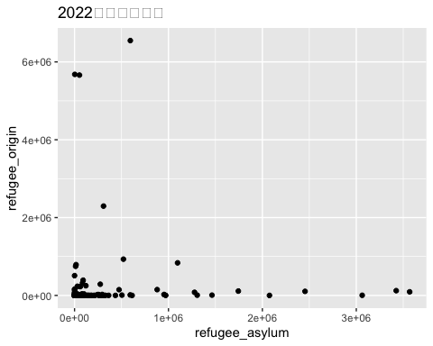

**気づいたこと・疑問**

#### 近似（回帰）直線の表示

df_unemp |> filter(!(iso2c %in% REGION)) |> filter(year == 2022) |>   
 drop_na(female_unemploy, male_unemploy) |>  
 ggplot(aes(female_unemploy, male_unemploy)) + geom_point() +   
 geom_smooth(formula = 'y~x', method = "lm", se = FALSE) +  
 labs(title = "失業率：男女別相関（回帰直線付）")

df_ref |> filter(!(iso2c %in% REGION)) |> filter(year == 2022) |>   
 drop_na(refugee_asylum, refugee_origin) |>  
 ggplot(aes(refugee_asylum, refugee_origin)) + geom_point() +   
 geom_smooth(formula = 'y~x', method = "lm", se = FALSE) +  
 labs(title = "難民相関（回帰直線付）")

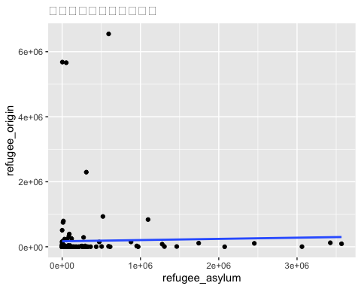

**気づいたこと・疑問**

#### c. 相関係数

df_unemp |> filter(!(iso2c %in% REGION)) |> filter(year == 2022) |>   
 drop_na(female_unemploy, male_unemploy) |> select(female_unemploy, male_unemploy) |> cor()

df_ref |> filter(!(iso2c %in% REGION)) |> filter(year == 2022) |>   
 drop_na(refugee_asylum, refugee_origin) |> select(refugee_asylum, refugee_origin) |> cor()

## refugee_asylum refugee_origin  
## refugee_asylum 1.00000000 0.02499224  
## refugee_origin 0.02499224 1.00000000

**気づいたこと・疑問**

### 7. 箱ヒゲ図（Boxplot）

必要時応じて、ログスケール（scale_y_log10()）

df_unemp_long |> filter(!(iso2c %in% REGION)) |> filter(year == 2022) |>   
 drop_na(value) |>  
 ggplot(aes(name, value)) + geom_boxplot() +  
 labs(title = "労働者失業率：男女別箱ひげ図")

df_ref_long |> filter(!(iso2c %in% REGION)) |> filter(year == 2022) |>   
 drop_na(value) |>  
 ggplot(aes(name, value)) + geom_boxplot() + scale_y_log10() +  
 labs(title = "難民箱ひげ図")

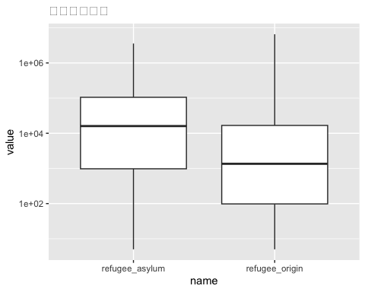

**気づいたこと・疑問**

df_unemp_long |> filter(!(iso2c %in% REGION)) |> filter(year == 2022) |>   
 drop_na(value, region) |>  
 ggplot(aes(region, value, fill = name)) + geom_boxplot() + coord_flip() +  
 labs(title = "労働者失業率：男女・地域別箱ひげ図")

df_ref_long |> filter(!(iso2c %in% REGION)) |> filter(year == 2022) |>   
 drop_na(value, region) |>  
 ggplot(aes(region, value, fill = name)) + geom_boxplot() + coord_flip() +  
 labs(title = "難民地域別箱ひげ図")

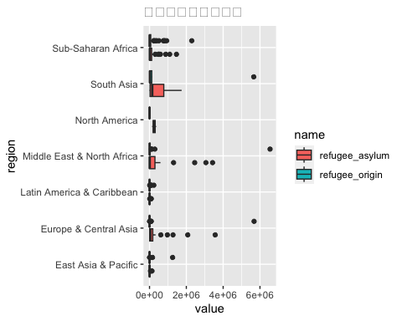

**気づいたこと・疑問**

df_unemp_long |> filter(!(iso2c %in% REGION)) |> filter(year == 2022) |>   
 drop_na(value, income) |> filter(income != "Not classified") |>  
 ggplot(aes(income, value, fill = name)) + geom_boxplot() + coord_flip() +  
 labs(title = "労働者失業率：男女・収入レベル別箱ひげ図")

df_ref_long |> filter(!(iso2c %in% REGION)) |> filter(year == 2022) |>   
 drop_na(value, income) |> filter(income != "Not classified") |>  
 ggplot(aes(income, value, fill = name)) + geom_boxplot() + coord_flip() +  
 labs(title = "難民・収入レベル別箱ひげ図")

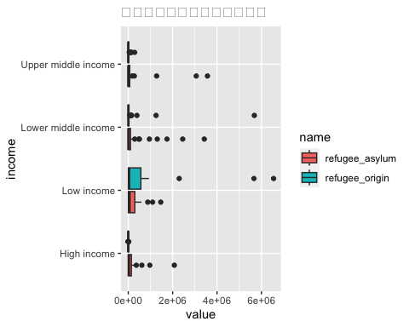

**気づいたこと・疑問**

df_unemp_long |> filter(!(iso2c %in% REGION)) |> filter(year %in% c(1991, 2001, 2011, 2021)) |>  
 drop_na(value) |>   
 ggplot(aes(factor(year), value, fill = name)) + geom_boxplot() +  
 labs(title = "労働者失業率：男女別・10年ごとの箱ひげ図")

df_ref_long |> filter(!(iso2c %in% REGION)) |> filter(year %in% c(1991, 2001, 2011, 2021)) |>  
 drop_na(value) |>   
 ggplot(aes(factor(year), value, fill = name)) + geom_boxplot() +  
 labs(title = "難民・10年ごとの箱ひげ図")

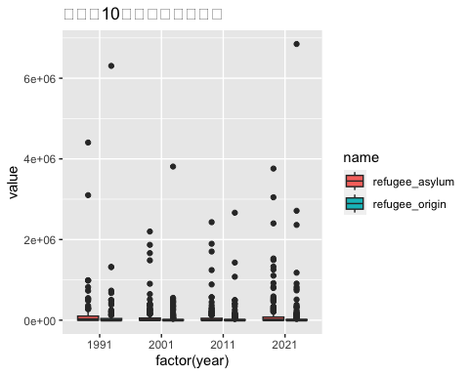

**気づいたこと・疑問**

df_unemp_long |> filter(iso2c %in% ASEAN) |> drop_na(value) |>   
 ggplot(aes(country, value, fill = name)) + geom_boxplot() + coord_flip() +  
 labs(title = "ASEAN の労働者失業率：男女別箱ひげ図")

df_ref_long |> filter(country %in% CONFLICTS) |> drop_na(value) |>   
 ggplot(aes(country, value, fill = name)) + geom_boxplot() + coord_flip() +  
 labs(title = "紛争国の難民箱ひげ図")

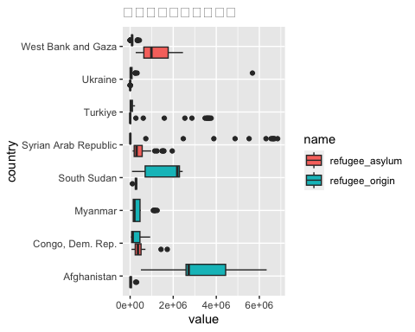

**気づいたこと・疑問**