THE DIFFERENCE BETWEEN WHO YOU ARE AND WHAT YOU WANT TO BE... IS WHAT YOU DO.

visualvm sneakpeak into jvm
apt-get install visualvm

LINKS

The Future of Data Science - Data Science @ Stanford
https://www.youtube.com/watch?v=hxXIJnjC_HI

Apache Hadoop Tutorial | Hadoop Tutorial For Beginners | Big Data Hadoop | Hadoop Training | Edureka
https://www.youtube.com/watch?v=mafw2-CVYnA

How to Become a Data Scientist in 2017? | Data Scientist Career | Data Science Future
https://www.youtube.com/watch?v=ccCblUZFM0w&t=6s

Intro to hadop: https://www.youtube.com/watch?v=OoEpfb6yga8
Intro to MapReduce- by arun: https://www.youtube.com/watch?v=ht3dNvdNDzI
Explaining MapReduce by deck of cards: https://www.youtube.com/watch?v=bcjSe0xCHbE

apache blog for hdfs developers
https://blogs.apache.org/

TERMS

1,024 Megabytes = 1 Gigabyte. 1,024 Gigabytes = 1 Terabyte. 1,024 Terabytes = 1 Petabyte. 1,024 Petabytes = 1 Exabyte (In 2000, 3 exabytes of information was created.) 1,024 Exabytes = 1 Zettabyte

loosely coupled vs tightly coupled
The Hat is "loosely coupled" to the body. This means you can easily take the hat off without making any changes to the the person/body. When you can do that then you have "loose coupling. See below for elaboration.

Think of your skin. It's stuck to your body. It fits like a glove. But what if you wanted to change your skin colour from say white to black? Can you imagine just how painful it would be to peel off your skin, dye it, and then to paste it back on etc? Changing your skin is difficult because it is tightly coupled to your body. You just can't make changes easily. You would have to fundamentally redesign a human being in order to make this possible.

Distributed data process vs parallel process

Deterministic and Stochastic modelling
In deterministic models, the output of the model is fully determined by the parameter values and the initial conditions initial conditions. Stochastic models possess some inherent randomness. The same set of parameter values and initial conditions will lead to an ensemble of different outputs.

https://stackoverflow.com/questions/3419353/what-is-the-difference-between-a-database-and-a-data-warehouse

survival analytics
which customers likely to leave telecom com/software com/any com

Database
Used for Online Transactional Processing (OLTP) but can be used for other purposes such as Data Warehousing. This records the data from the user for history.

Data Warehouse
Used for Online Analytical Processing (OLAP). This reads the historical data for the Users for business decisions

What is Functional Programming?
Functional Programming is a concept which treats functions as first class citizens. At the core of functional programming is immutability. It emphasizes on application of functions in contrast to imperative programming style which emphasizes on change in state. Functional programming has no side effects whereas programming in imperative style can result in side-effects

Distro:
Company’s version of open source technology. They give it for free, but charge for help requested.

What is Commodity Machine?
A commodity computer is a standard-issue PC that is widely available for purchase. The term usually differentiates typical consumer products from specialized or high-performance computers but is sometimes used to refer to low-cost and no-frills but functional machines.

Computer hardware that is affordable and easy to obtain. Typically it is a low-performance system that is IBM PC-compatible and is capable of running Microsoft Windows, Linux, or MS-DOS without requiring any special devices or equipment.

NOTES

Framework- Hadoop
Programming Paradigm- MapReduce

Mapreduce is great but Spark is catching and may surpass in next 5 years

Sentiment anlysis with MS Excel2013 -> odbc driver(connect excel to hadoop)

apche arrow- in memory columnar storage
Engineers from across the Apache Hadoop community are collaborating to establish Arrow as a de-facto standard for columnar in-memory processing and interchange

What is Big Data?
Big Data refers to technologies and initiatives that involve data that is too diverse, fast-changing or massive for conventional technologies, skills and infra- structure to address efficiently. Said differently, the volume, velocity or variety of data is too great.

'Big Data' describes data sets so large and complex they are impractical to manage with traditional software tools.

Big Data Technologies:

1. Apache Hadoop

Apache Hadoop is a java based free software framework that can effectively store large amount of data in a cluster. This framework runs in parallel on a cluster and has an ability to allow us to process data across all nodes. Hadoop Distributed File System (HDFS) is the storage system of Hadoop which splits big data and distribute across many nodes in a cluster. This also replicates data in a cluster thus providing high availability.

2. Microsoft HDInsight

It is a Big Data solution from Microsoft powered by Apache Hadoop which is available as a service in the cloud. HDInsight uses Windows Azure Blob storage as the default file system. This also provides high availability with low cost.

3. NoSQL

While the traditional SQL can be effectively used to handle large amount of structured data, we need NoSQL (Not Only SQL) to handle unstructured data. NoSQL databases store unstructured data with no particular schema. Each row can have its own set of column values. NoSQL gives better performance in storing massive amount of data. There are many open-source NoSQL DBs available to analyse big Data.

4. Hive

This is a distributed data management for Hadoop. This supports SQL-like query option HiveSQL (HSQL) to access big data. This can be primarily used for Data mining purpose. This runs on top of Hadoop.

5. Sqoop

This is a tool that connects Hadoop with various relational databases to transfer data. This can be effectively used to transfer structured data to Hadoop or Hive.

Top Hadoop Distros:
Cloudera
Hortonworks
MapR
IBM
Pivotal

Cloudera takes the open source Hadoop software and makes some proprietary changes to it to improve the security, high availability, governance and administration of the software, the analysts say

Everything in the Hortonworks distribution is open source, which gives customers ultimate flexibility when using the software in case they want to migrate away from it, but comes at the expense of some functionality.

Moore's law is the observation that the number of transistors in a dense integrated circuit doubles approximately every two years.

HDFS:
The Hadoop Distributed File System (HDFS) is the primary storage system used by Hadoop applications.

Example of HDFS:
Think of a file that contains the phone numbers for everyone in the United States; the people with a last name starting with A might be stored on server 1, B on server 2, and so on.

Big Data Analytic Tools:

Many analysts divide big data analytics tools into four big categories. The first, descriptive analytics, simply tells what happened. The next type, diagnostic analytics, goes a step further and provides a reason for why events occurred. The third type, predictive analytics, discussed in depth above, attempts to determine what will happen next. This is as sophisticated as most analytics tools currently on the market can get.

However, there is a fourth type of analytics that is even more sophisticated, although very few products with these capabilities are available at this time. Prescriptive analytics offers advice to companies about what they should do in order to make a desired result happen. For example, while predictive analytics might give a company a warning that the market for a particular product line is about to decrease, prescriptive analytics will analyze various courses of action in response to those market changes and forecast the most likely results.

Currently, very few enterprises have invested in prescriptive analytics, but many analysts believe this will be the next big area of investment after organizations begin experiencing the benefits of predictive analytics.

MACHINE CONFIG

docker: cloudera-quickstart-vm-5.12.0-0-beta-docker
Hadoop 2.6.0-cdh5.12.0
Apache Pig version 0.12.0-cdh5.12.0 (rexported)
Sqoop 1.4.6-cdh5.12.0
Hive 1.1.0-cdh5.12.0
HBase 1.2.0-cdh5.12.0

my_machine_ubuntu16.04:
hadoop-2.6.0-cdh5.13.0 (pseudo distributed mode)
pig-0.17.0
sqoop-1.4.6-cdh5.13.0
hive-1.1.0-cdh5.13.0
hbase-1.2.6
spark-2.2.0-bin-hadoop2.6
zookeeper-3.4.6

In /usr/bin:
lrwxrwxrwx 1 root root 22 Aug 18 2017 java -> /etc/alternatives/java

$jps

jps - Java Virtual Machine Process Status Tool. The Java Virtual Machine has a jps tool wich is a bit like the ps command. jps lists all java Processes of a user.

jps command is used to check all the Hadoop daemons like NameNode, DataNode, ResourceManager, NodeManager etc. which are running on the machine.

APACHE HADOOP

Apache Hadoop Tutorial | Hadoop Tutorial For Beginners | Big Data Hadoop | Hadoop Training | Edureka
https://www.youtube.com/watch?v=mafw2-CVYnA

Hadoop Key Features:

- distributed file system
- scalable: rather than vertical scaling, it can be scaled horizontally by adding commodity hardwares
- cost-effective
- fault tolerant: automatic failover management
- high throughput
latency- time to get 1st record. imp in interactive systems where user clicked a button n waiting for response.
throughput- no of record processed. hadoop built for this. so its not well suited fr interactive input. its latency is not high.
6.data locality optimization:
data (in PB) in usa, program in India
It will takae long time and bandwidth to transfer huge amount of data. Hadoop handles it by transfering code (probably few MBs) to usa, and running it locally
7. Hadoop supports heterogenous cluster
IBM-RHEL (IBM m/c running on RHEL), Intel-Ubuntu, HP – centos

8. Schema on read

Single node setup Vs pseudo distributed setup

Single node setup (standalone setup)
By default, Hadoop is configured to run in a non-distributed or standalone mode, as a single Java process. There are no daemons running and everything runs in a single JVM instance. HDFS is not used.

You don't have to do anything as far as configuration is concerned, except the JAVA_HOME. Just download the tarball, unzip it, and you are good to go.

Pseudo-distributed mode
The Hadoop daemons run on a local machine, thus simulating a cluster on a small scale. Different Hadoop daemons run in different JVM instances, but on a single machine. HDFS is used instead of local FS.

As far as pseudo-distributed setup is concerned, you need to set at least following 2 properties along with JAVA_HOME:

fs.default.name in core-site.xml.
mapred.job.tracker in mapred-site.xml.

You could have multiple datanodes and tasktrackers, but that doesn't make much sense on a single machine.

Check slave in hadoop conf, if ‘localhost’ is written then hadoop is in pseudo distributed mode.

Meaning of fs.defaultFS property in core-site.xml in hadoop?

<property>
<name>fs.default.name</name>
<value>hdfs://192.168.1.2:9000/</value>
</property>

Include fs.defaultFS/fs.default.name in core-site.xml to allow dfs commands without providing full site name in the command. Running hdfs dfs -ls / instead of hdfs dfs -ls hdfs://hdfs/

This is used to specify the default file system and defaults to your local file system that's why it needs be set to a HDFS address. This is important for client configuration as well so your local configuration file should include this element.

<name>fs.default.name</name>.
Here fs denotes file system and default.name denotes namenode

<value>hdfs://192.168.1.2:9000/</value>.

Here 9000 denotes port on which datanode will send heartbeat to namenode. And full address is the machine name that is converted to hostname.

Something important to note about port is that you can give any port greater than 1024 as lesser than that have to give root privileges.

In my system it is localhost instead of 192.168.1.2

UIs and Ports
Namenode webui http://localhost:50070/
All Applications http://localhost:8088/ (default)
Logs: http://localhost:8088/logs/userlogs/

$start-dfs.sh
$start-yarn.sh
Alternative(deprecated)- start-all.sh

jps is cmdline utility which comes with Java
$jps

$hdfs dfs -ls /

$stop-dfs.sh
$stop-yarn.sh
Alternative(deprecated)- stop-all.sh

How to start and stop a Hadoop datanode without affecting the cluster (start-dfs.sh start on all node)
In some circumstances, you need to start or stop a datanode without touching other nodes or whole hadoop cluster, how to do it?

Here it is

To stop
You can stop the DataNodes and TaskTrackers from NameNode's hadoop bin directory. If you have hadoop environment variables setup, then just run:

$ hadoop-daemon.sh stop tasktracker
$ hadoop-daemon.sh stop datanode
So this script checks for slaves file in conf directory of hadoop to stop the DataNodes and same with the TaskTracker.

To start
Again this script checks for slaves file in conf directory of hadoop to start the DataNodes and TaskTrackers.

$ hadoop-daemon.sh start tasktracker
$ hadoop-daemon.sh start datanode

Root location in hdfs:
hdfs dfs -ls /

Show replication status and other information
hdfs fsck /
hdfs fsck -racks

Checking disk usage:
$hdfs dfs
## list of commands
$ hdfs dfs -du /ctr
6311147778 6311147778 /ctr/train.csv
-h -> probably means human readable format
$ hdfs dfs -du -h /ctr
5.9 G 5.9 G /ctr/train.csv

$ hadoop fs -du -s /user/sks/wc
287 287 /user/sks/wc
$ hadoop fs -du /user/sks/wc
115 115 /user/sks/wc/input.txt
47 47 /user/sks/wc/input2.txt
125 125 /user/sks/wc/output

Rack and Rack Awareness
A rack is a collection of 30 or 40 nodes that are physically stored close together and are all connected to the same network switch. Network bandwidth between any two nodes in rack is greater than bandwidth between two nodes on different racks.A Hadoop Cluster is a collection of racks.

NameNode achieves this rack information by maintaining rack ids of each data node. This concept of choosing closer data nodes based on racks information is called Rack Awareness in Hadoop. A default Hadoop installation assumes all the nodes belong to the same rack.

apache blog for hdfs developers
https://blogs.apache.org/

hdfs rebalance

Whenever a new data node is added to the existing HDFS cluster or a data node is removed from the cluster then some of the data nodes in the cluster will have more/less blocks compared to other data nodes.

In this unbalanced cluster, data read/write requests become very busy on some data nodes and some data nodes are under utilized.

In such cases, to make all the data nodes space is uniformly utilized for blocks distribution, HDFS rebalance will be triggered by Hadoop Administrator.

Yes. Running balancer will start moving blocks from nodes where you have higher number of blocks to nodes which have less number of blocks. This depends on a number of factors. For example, you likely have balancing threshold set to 10% which means blocks can be distributed within the cluster within 10% of each other (one node has 10 blocks and other 9 or 11 would be acceptable - no need to balance further).

When balancer runs, it takes up network resources. You want to make sure you are not doing it when you have heavy load as those jobs will be affected. There are also checks against moving blocks as you may have current jobs using them.

A cluster is in a balanced status when, % of space used in each data node is within limits of Average % of space used on data nodes +/- Threshold size

Hadoop Architecture:

Namenode:Datanode = Master:slave
block size-128mb (data ranging from 0-128mb), then next block, so on
namenode-metadata of all files, namenode should have large memory

Hadoop Architecture Overview:
Apache Hadoop offers a scalable, flexible and reliable distributed computing big data framework for a cluster of systems with storage capacity and local computing power by leveraging commodity hardware. Hadoop follows a Master Slave architecture for the transformation and analysis of large datasets using Hadoop MapReduce paradigm. The 3 important hadoop components that play a vital role in the Hadoop architecture are -

- Hadoop Distributed File System (HDFS) – Patterned after the UNIX file system
- Hadoop MapReduce
- Yet Another Resource Negotiator (YARN)

Namespace and metadata
According to 'Hadoop The definitive guide' - "The NameNode manages the filesystem namespace. It maintains the filesystem tree and the metadata for all the files and directories in the tree."

Essentially, Namespace means a container. In this context it means the file name grouping or hierarchy structure.

Metadata contains things like the owners of files, permission bits, block location, size etc.

26 November

Scale up Vs scale out:
Vertical Scaling (Scale-up): Generally refers to adding more processors and RAM, buying a more expensive and robust server.

Horizontal Scaling (Scale-out): Generally refers to adding more servers with less processors and RAM. This is usually cheaper overall and can literally scale infinitely (although we know that there are usually limits imposed by software or other attributes of an environment’s infrastructure)

distributed- so we can scale out

using 1st time- must format namenode

1. Format namenode for first time
hdfs namenode -format
hdfs namenode -format > out.txt >> %1
*on every execution it generates a cluster ID

then recreate from ambari. If ambari is unresponsive or cleaned, then create vm machine again from vm image

2.start the dfs processes: start-dfs.sh
3.check the JPs for namenode and datanode process
4.perform hdf -dfs -mkdir /user/test
This will ensure we are able to write into HDFS

$which hadoop
/home/suyog/hadooop/hadoop-2.6.0-cdh5.13.0/bin/hadoop

Note: most jobs are for optimizing hadoop jobs, less about MapReduce writings

apche arrow- in memory columnar storage

columnar storage:
A columnar database is a database management system (DBMS) that stores data in columns instead of rows.
The goal of a columnar database is to efficiently write and read data to and from hard disk storage in order to speed up the time it takes to return a query.

Here is an example of a simple database table with 4 columns and 3 rows.

ID Last First Bonus
1 Doe John 8000
2 Smith Jane 4000
3 Beck Sam 1000

In a row-oriented database management system, the data would be stored like this: 1,Doe,John,8000;2,Smith,Jane,4000;3,Beck,Sam,1000;

In a column-oriented database management system, the data would be stored like this: 1,2,3;Doe,Smith,Beck;John,Jane,Sam;8000,4000,1000;
the column 1 values are physically together, followed by all the column 2 values, etc.

One of the main benefits of a columnar database is that data can be highly compressed. The compression permits columnar operations — like MIN, MAX, SUM, COUNT and AVG— to be performed very rapidly. Another benefit is that because a column-based DBMSs is self-indexing, it uses less disk space than a relational database management system (RDBMS) containing the same data.

As the use of in-memory analytics increases, however, the relative benefits of row-oriented vs. column oriented databases may become less important. In-memory analytics is not concerned with efficiently reading and writing data to a hard disk. Instead, it allows data to be queried in random access memory (RAM).

Enable Ambari

Increased Ram to 4 GB
Browser- http://192.168.21.128:8080
admin, admin

#If many nodes in clusters, then rather thnn making changes in all
ambari- yarn - do change - changes get passed- nodes

HDFS operations (Eclipse 4.7)

eclipse -> import -> maven -> existing maven project -> source
rclick on project(top folder) -> run as -> maven clean
rclick on project -> run as -> maven install
This will build a jar file. Check for path in console logs.

Building jar: /home/suyog/eclipse-workspace/hdfsoperations/target/hdfsoperations-0.0.1-SNAPSHOT.jar

$./bin/hadoop jar .. to be executed from location "$HADOOP_HOME"
`hadoop jar ..` works too if path is set.
$hadoop jar <YOUR_JAR_FILE_LOCATION> <YOUR_JAVA_CLASS_WITH_PACKAGE> <INPUT_FILE_LOCATION> <OUTPUT_FILE_LOCATION>

$ ./bin/hadoop jar /home/suyog/eclipse-workspace/hdfsoperations/target/hdfsoperations-0.0.1-SNAPSHOT.jar com.cdac.hadoop.hdfsoperations.App
Hello World!

$hadoop jar /home/suyog/eclipse-workspace/hdfsoperations/target/hdfsoperations-0.0.1-SNAPSHOT.jar com.cdac.hadoop.hdfsoperations.PathChecksAndListing

default ports by various hdfs services:
https://ambari.apache.org/1.2.3/installing-hadoop-using-ambari/content/reference_chap2_1.html

27 November

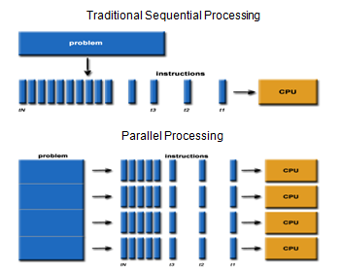

programming paradigm
A programming paradigm is a style, or “way,” of programming.Common programming paradigms include:
imperative which allows side effects,
functional which disallows side effects,
declarative which does not state the order in which operations execute,
object-oriented which groups code together with the state the code modifies,
procedural which groups code into functions,

MapReduce:

A programming paradigm that allows for massive scalability of unstructured data across hundreds or thousands of commodity clusters servers in an Apache Hadoop cluster
https://www.guru99.com/introduction-to-mapreduce.html

Shuffling in MapReduce
The process of transferring data from the mappers to reducers is known as shuffling i.e. the process by which the system performs the sort and transfers the map output to the reducer as input. So, MapReduce shuffle phase is necessary for the reducers, otherwise, they would not have any input (or input from every mapper). As shuffling can start even before the map phase has finished so this saves some time and completes the tasks in lesser time.

SHUFFLING is the process of moving Mapper outputs to the Reducer. After the first map task, the mapper nodes start exchanging their intermediate outputs from map tasks to the reducers so that similar keys from the mapper nodes reach the same reducer node.

Sorting in MapReduce
The keys generated by the mapper are automatically sorted by MapReduce Framework, i.e. Before starting of reducer, all intermediate key-value pairs in MapReduce that are generated by mapper get sorted by key and not by value. Values passed to each reducer are not sorted; they can be in any order.

SORTING is the process of automatic sorting of the intermediate keys on a single node by the MapReduce before they are presented to the Reducer.
NOTE:There is no Shuffling or Sorting in Map-only tasks.

https://developer.yahoo.com/hadoop/tutorial/module4.html#dataflow

Map -> Combiner -> Partitioner -> Sort -> Shuffle -> Sort -> Reduce

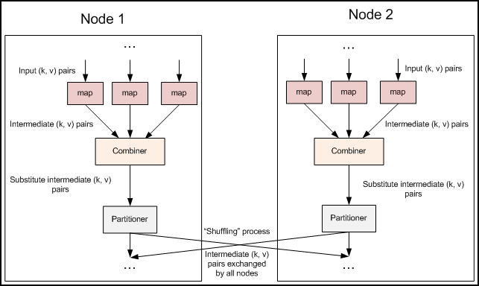

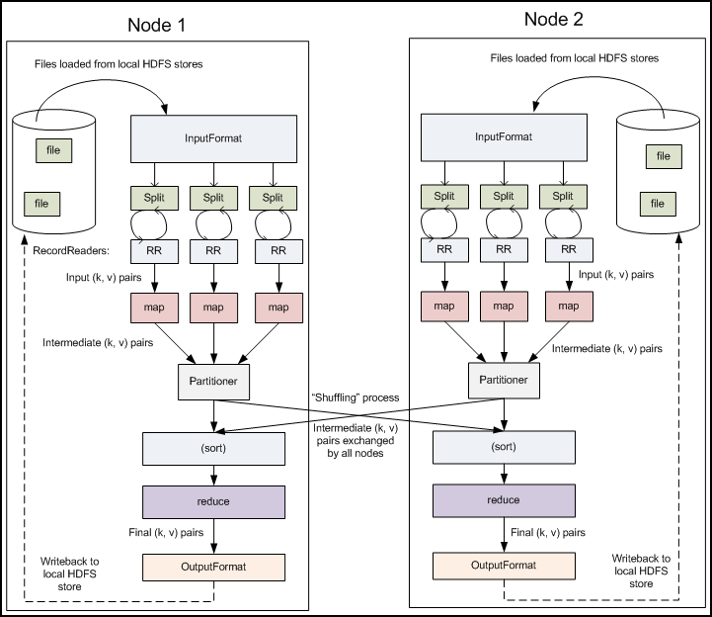

Basic Hadoop commands

Load the data:
hdfs dfs -copyFromLocal /path/to/local/file/custfile*.txt /user/hadoop/customer
can use put instead copyFromLocal

Retrieve data:
copyToLocal or get

data types in hadoop

Serialization
Serialization is the process of converting object data into byte stream data for transmission over a network across different nodes in a cluster or for persistent data storage.

Deserialization
Deserialization is the reverse process of serialization and converts byte stream data into object data for reading data from HDFS. Hadoop provides Writables for serialization and deserialization purpose.

To provide mechanisms for serialization and deserialization of data, Hadoop provided two important interfaces Writable and WritableComparable

Constraints on Key-values in Mapreduce
Hadoop data types used in Mapreduce for key or value fields must satisfy two constraints.
Any data type used for a Value field in mapper or reducer input/output must implement Writable Interface.
Any data type used for a Key field in mapper or reducer input/output must implement WritableComparable interface along with Writable interface to compare the keys of this type with each other for sorting purposes.

Hadoop provides classes that wrap the Java primitive types and implement the WritableComparable and Writable Interfaces. They are provided in the org.apache.hadoop.io package.

All the Writable wrapper classes have a get() and a set() method for retrieving and storing the wrapped value.

Primitive Writable Classes
These are Writable Wrappers for Java primitive data types and they hold a single primitive value that can be set either at construction or via a setter method.

All these primitive writable wrappers have get() and set() methods to read or write the wrapped value. Below is the list of primitive writable data types available in Hadoop.

BooleanWritable
ByteWritable
IntWritable
VIntWritable
FloatWritable
LongWritable
VLongWritable
DoubleWritable
In the above list VIntWritable and VLongWritable are used for variable length Integer types and variable length long types respectively.

Serialized sizes of the above primitive writable data types are same as the size of actual java data type. So, the size of IntWritable is 4 bytes and LongWritable is 8 bytes.

Array Writable Classes
Hadoop provided two types of array writable classes, one for single-dimensional and another for two-dimensional arrays. But the elements of these arrays must be other writable objects like IntWritable or LongWritable only but not the java native data types like int or float.

ArrayWritable
TwoDArrayWritable

Map Writable Classes
Hadoop provided below MapWritable data types which implement java.util.Map interface

AbstractMapWritable – This is abstract or base class for other MapWritable classes.
MapWritable – This is a general purpose map mapping Writable keys to Writable values.
SortedMapWritable – This is a specialization of the MapWritable class that also implements the SortedMap interface.

Other Writable Classes
NullWritable
NullWritable is a special type of Writable representing a null value. No bytes are read or written when a data type is specified as NullWritable. So, in Mapreduce, a key or a value can be declared as a NullWritable when we don’t need to use that field.

ObjectWritable
This is a general-purpose generic object wrapper which can store any objects like Java primitives, String, Enum, Writable, null, or arrays.

Text
Text can be used as the Writable equivalent of java.lang.String and It’s max size is 2 GB. Unlike java’s String data type, Text is mutable in Hadoop.

BytesWritable
BytesWritable is a wrapper for an array of binary data.

GenericWritable
It is similar to ObjectWritable but supports only a few types. User need to subclass this GenericWritable class and need to specify the types to support.

http://hadooptutorial.info/hadoop-data-types/

nov28- HADOOP STREAMING
https://hadoop.apache.org/docs/r1.2.1/streaming.html

Hadoop streaming is a utility that comes with the Hadoop distribution. The utility allows you to create and run Map/Reduce jobs with any executable or script as the mapper and/or the reducer. For example:

$HADOOP_HOME/bin/hadoop jar $HADOOP_HOME/hadoop-streaming.jar \
-input myInputDirs \
-output myOutputDir \
-mapper /bin/cat \
-reducer /bin/wc

You can supply a Java class as the mapper and/or the reducer. The above example is equivalent to:

$HADOOP_HOME/bin/hadoop jar $HADOOP_HOME/hadoop-streaming.jar \
-input myInputDirs \
-output myOutputDir \
-mapper org.apache.hadoop.mapred.lib.IdentityMapper \
-reducer /bin/wc
https://hadoop.apache.org/docs/r1.2.1/streaming.html

downloaded jar file for hadoop2.6.0:
https://mvnrepository.com/artifact/org.apache.hadoop/hadoop-streaming/2.6.0

Data warehouse
A data warehouse essentially combines information from several sources into one comprehensive database.

WHY IT MATTERS:
Companies with data warehouses can have an advantage in product development, marketing, pricing strategy, production time, historical analysis, forecasting and customer satisfaction. However, data warehouses also can be very expensive to design and implement, and sometimes their construction makes them unwieldy.

datawarehouse examples: ibm netiza, amazon redshift

Running project hdfs.filesystem
hadoop jar /home/suyog/eclipse-workspace/hadoop.filesystem/target/hadoop.filesystem-0.0.1-SNAPSHOT.jar org.daa.examples.hadoop.filesystem.FileOperations

Running project hadoop.wordcount

imported project hadoop.wordcount in Eclipse
-- general way, and 'import as maven prj' way both works.
-- Aim- I imported all maven depencies of that project. On creating maven project, I only get Maven dependency Junit.
-- Normal way I had to add maven depencies for various imports. (I will do this later)

wordcount.java -> run as configurations -> /path/to/input /path/to/output
//shows job progress/counters in Eclipse console
//creates files part-r-00000 and _SUCCESS in output folder at given path

Note: Can explore/understand/dubug working of mapper and reducer by putting System.out.println()

In run configurations
- saved 2 confs, one for wordcount, other for trainAnalytics. No need to enter program arguments everytime

Note: output dir shouldn't exist. I had file output.txt at that path, it gave error

$hadoop jar <YOUR_JAR_FILE_LOCATION> <YOUR_JAVA_CLASS_WITH_PACKAGE> <INPUT_FILE_LOCATION> <OUTPUT_FILE_LOCATION>

$hadoop jar /home/suyog/eclipse-workspace/hadoop.wordcount/target/hadoop.wordcount-0.0.1-SNAPSHOT.jar org.daa.examples.hadoop.wordcount.WordCount /user/suyog/data/input_wc.txt /user/suyog/data/output_wc

#norm
$cd $HADOOP_HOME
$./bin/hadoop jar /home/suyog/eclipse-workspace/hadoop.filesystem/target/hadoop.filesystem-0.0.1-SNAPSHOT.jar org.daa.examples.hadoop.wordcount.WordCount /user/sks/input_wc.txt /user/sks/output

or run as a script,
$ chmod +x Runner.sh
$./Runner.sh

Resolve Issue- Job counters task counters not visible in cmdline console

Not getting job counters, task counters, mapper and reducer output through hadoop jar <snapshot.jar> <package.className> <input> <output>
I can see them in Eclipse console, but not by commandline.

Probable Reason: Is it not visible because Hadoop is in Pseudo Distributed mode? Check hadoop type in Docker and virtual box, then run it.

hadoop jar /home/suyog/eclipse-workspace/hadoop.wordcount/target/hadoop.wordcount-0.0.1-SNAPSHOT.jar org.daa.examples.hadoop.wordcount.WordCount /user/suyog/data/input_wc.txt /user/suyog/data/output_wc

$HADOOP_HOME/etc/hadoop -> hadoop , hadoopMapreduce1 hadoopMapReduce1Pseudo hadoopMApReduceSecure
I made changes in core-site.xml of dir hadoop. Should i make changes in hadoopMapReduce1Pseudo. I cant see job counters, taskcounters when i run hadoop jar.... Could this be the reason?

Logs
Browser: http://sks-inspiron-15-3567:8042/logs/userlogs/ or, http://localhost:50070/logs/userlogs/

In cmdline:
$cd $HADOOP_HOME/logs/userlogs
$ls -l
//pick recent application by timestamp
//3 containers- 1st is main, 2nd is mapper, 3rd is reducer. Check sdtout for System.out.println() outputs

cloudera vm
in job progress/counter:
17/12/17 00:27:54 INFO mapreduce.Job: The url to track the job: http://quickstart.cloudera:
map/reduce -> logs -> there System.out.println() output (from mapper and reducer) is visible

Assignment

1.Create an MR job with the following features:
- word count
- How many ‘and’ (case insensitive) occured in input text
- Find following stats from job
  - io.buffers used during entire job execution
  - total mappers
  - total reducers
  - I/p and o/p formats used in job which processing

2.Create an MR job with the following features:
- You receive data from all the trains that are coming and going via a junction.
- Input data – train_data.txt
- Using the above data, answer the following:
  - Total how many train data in present in the input data.
  - How many trains are travelling from this station in each hour
  - How many trains are travelling in each direction in each hour
  - What is the avg speed of each train travelling in each direction in each hour.
  - If you receive some data that is incorrect in input file, add additional code to handle that inside your mapper/ reducer

Sample:
1000 | 1000 | 60 | E
1001 | 1010 | 80 | W
1002 | 1015 | 40 | N
1003 | 1020 | 60 | S

./bin/hadoop jar /home/suyog/eclipse-workspace/hadoop.trainAnalytics/target/hadoop.wordcount-0.0.1-SNAPSHOT.jar org.daa.examples.hadoop.trainAnalytics.trainAnalyticsDriver /home/suyog/data/train_data.txt /home/suyog/data/output_trainAnalytics

My approach:
i. key -> train number -> at reducers, sum ‘1’ values for each key, and display with key -> key – sum -> example -> 1000 - 3
ii. key -> train number -> at reducer, sum values for each key -> (static int) totalTrainRecords += sum -> display totalTrainRecords
make 1 key out of multiple keys:
[1000,1100) -> 10th hour -> replace 1010 by 1000
iii. E+“1000” -> E1000 -> East direction, 10th hour -> At reducer, sum count -> It gives total number of trains moving in East at 10th hour or per hour.
iv. E+“1000” + 1000 -> E10001000 -> East direction 10th hour train number 1000 -> sum the values (speed) -> take average -> its average speed.
v. regex -> /d didn’t work in Eclipse 4.7 (java 1.8), used //d, it worked!! ... check which java eclipse is using? SE1.5?
\d implies digit.
+ sign implies one or more occurance of previous character.
\. -> since . is a special character in regex, we have to escape it with \.
Also, \ is a special escape character in java , hence from java perspective we need to add an additional \ to escape the backslash (\)
* - 0 or more.
^ - beginning
$ - end

context.write -> writes in part-r-00000 file
System.out.println -> goes in mapper, reducer logs for pseudo distributed Hadoop, but in eclipse it shows. Use local files rather than hdfs in eclipse. For stand alone hadoop, all counters are shown on cmdline console.

Try grouping in MapReduce:
http://javarevisited.blogspot.in/2015/07/how-to-do-group-by-in-java-8.html

Java 8 now directly allows you to do GROUP BY in Java by using Collectors.groupingBy() method. GROUP BY is a very useful aggregate operation from SQL. It allows you to group records on certain criteria. How do you group by in Java? For example, suppose you have a list of Persons, How do you group persons by their city e.g. London, Paris or Tokyo? Well, we can do that by using a for loop, checking each person and putting them on a list of HashMap with the same city, but in Java 8, you don't need to hack your way like that, you have a much cleaner solution. You can use Stream and Collector which provides groupingBy() method to do this. Since its one of the most common way to aggregate data, it has a real benefit, coupled that with the various overloaded version of groupingBy() method which also allow you to perform grouping objects concurrently by using concurrent Collectors.

You can now more easily create a group of objects on arbitrary criterion than ever before. Java 8 Collectors class also provide several overloaded version of the groupingBy() function for more sophisticated grouping. You can even do a group by concurrently by using groupingByConcurrent() method from java.util.streams.Collectors class.

nov29- Hadoop Ecosystem

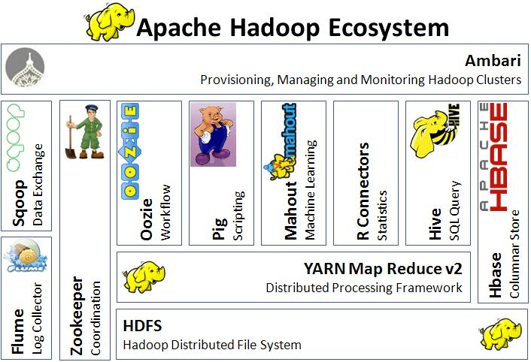

HADOOP YARN

start-yarn.sh
stop-yarn.sh

YARN (Yet Another Resource Negotiator) is a new component added in Hadoop 2.0

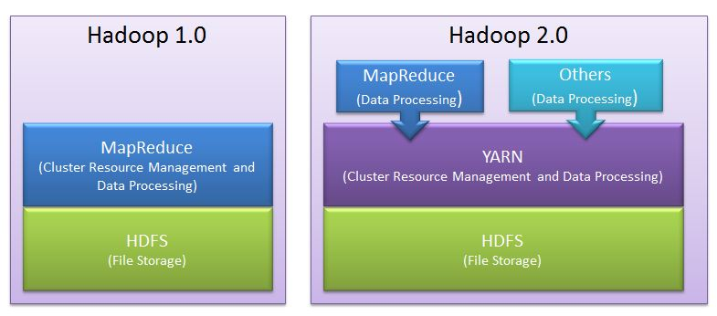

As shown, in Hadoop 2.0 a new layer has been introduced between HDFS and MapReduce.
This is YARN framework which is responsible for doing Cluster Resource Management.

Cluster Resource Management:
Cluster resource management means managing the resources of the Hadoop Clusters. And by resources we mean Memory, CPU etc.

YARN took over this task of cluster management from MapReduce and MapReduce is streamlined to perform Data Processing only in which it is best.

Cluster Resource Management in Hadoop 1.0

In Hadoop 1.0, there is tight coupling between Cluster Resource Management and MapReduce programming model.
Job Tracker, which does resource management, is part of, MapReduce Framework.

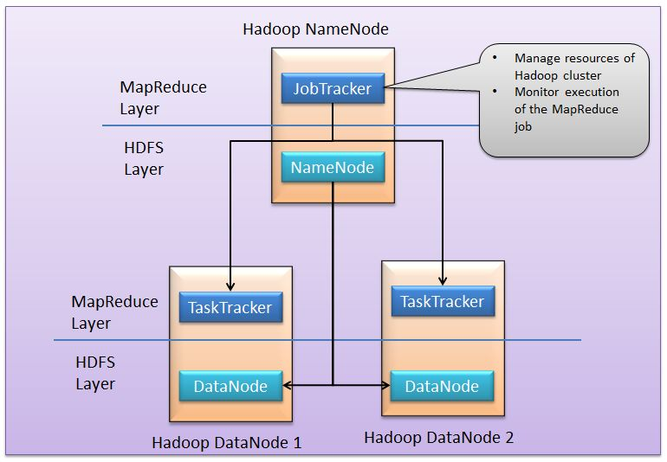

Here, JobTracker is responsible for both managing the cluster's resources and driving the execution of the MapReduce job.

Job Tracker
JobTracker process runs on a separate node and not usually on a DataNode.
JobTracker is an essential Daemon for MapReduce execution in MRv1. It is replaced by ResourceManager/ApplicationMaster in MRv2.
JobTracker receives the requests for MapReduce execution from the client.
JobTracker talks to the NameNode to determine the location of the data.
JobTracker finds the best TaskTracker nodes to execute tasks based on the data locality (proximity of the data) and the available slots to execute a task on a given node.
JobTracker monitors the individual TaskTrackers and the submits back the overall status of the job back to the client.
JobTracker process is critical to the Hadoop cluster in terms of MapReduce execution.
When the JobTracker is down, HDFS will still be functional but the MapReduce execution can not be started and the existing MapReduce jobs will be halted.

TaskTracker
TaskTracker runs on DataNode. Mostly on all DataNodes.
TaskTracker is replaced by Node Manager in MRv2.
Mapper and Reducer tasks are executed on DataNodes administered by TaskTrackers.
TaskTrackers will be assigned Mapper and Reducer tasks to execute by JobTracker.
TaskTracker will be in constant communication with the JobTracker signalling the progress of the task in execution.
TaskTracker failure is not considered fatal. When a TaskTracker becomes unresponsive, JobTracker will assign the task executed by the TaskTracker to another node.

Few Important Notes about YARN:
1. YARN is backward compatible.
This means that existing MapReduce job can run on Hadoop 2.0 without any change.
2. No more JobTracker and TaskTracker needed in Hadoop 2.0
JobTracker and TaskTracker has totally disappeared. YARN splits the two major functionalities of the JobTracker i.e. resource management and job scheduling/monitoring into 2 separate daemons (components).
1.Resource Manager
2.Node Manager(node specific)
Central Resource Manager and node specific Node Manager together constitutes YARN.

http://saphanatutorial.com/how-yarn-overcomes-mapreduce-limitations-in-hadoop-2-0/

APACHE PIG

Apache Pig is an abstraction over MapReduce. We can perform MapReduce operations using a high-level scripting language instead of developing complex codes in Java. It is a tool/platform which is used to analyze larger sets of data representing them as data flows.
Pig code = 1/20 of MapReduce code. Development time = 1/16 of MapReduce.

Pig can be used for following purposes:
- ETL data pipeline
- Research on raw data
- Iterative processing.

Features of Pig
Apache Pig comes with the below unique features:

- Rich set of operators − It provides many operators to perform operations like join, sort, filer, etc.
- Ease of programming − Pig Latin is similar to SQL and it is easy to write a Pig script if you are good at SQL.
- Optimization opportunities − The tasks in Apache Pig optimize their execution automatically, so the programmers need to focus only on semantics of the language.
- Extensibility − Using the existing operators, users can develop their own functions to read, process, and write data.
- UDF’s − If a programmer wants to write custom functions which is unavailable, Pig provides the facility to create User-defined Functions in other programming languages such as Java and invoke or embed them in Pig Scripts. This provides extensibility to Apache Pig.
- Handles all kinds of data − Apache Pig analyzes all kinds of data, i.e. structured, semi-structured or unstructured data. It stores the results in HDFS.
- Approximately, 10 lines of pig code is equal to 200 lines of MapReduce code.
- Apache Pig extracts the data, performs operations on that data and dumps the data in the required format in HDFS i.e. ETL (Extract Transform Load).
- It allows programmers and developers to concentrate upon the whole operation irrespective of creating mapper and reducer functions separately.

Why Pig is called Data Flow language?
https://community.hortonworks.com/questions/21178/why-pig-latin-has-known-has-data-flow-language.html

In a dataflow language, you have a stream of data which is passed from instruction to instruction to be processed.

Pig provides developers many operators which can be applied on data one after another to get final output. Once data is loaded, it flows through all Pig operators. This is the reason Pig is called as data flow language.

..SQL forces the pipeline to be written inside-out, with operations that need to happen first happening in the from clause sub-query. Of course this can be resolved with the use of intermediate or temporary tables. Then the pipeline becomes a disjointed set of SQL queries where ordering is only apparent by looking at a master script (written in some other language) that sews all the SQL together. Also, depending on how the database handles temporary tables, there may be cleanup issues to deal with. In contrast, Pig Latin shows users exactly the data flow, without forcing them to either think inside out or construct a set of temporary tables and manage how those tables are used between different SQL queries.

https://www.edureka.co/blog/introduction-to-pig/

What is Pig and Pig Latin?
Pig is an open-source high level data flow system. It provides a simple language called Pig Latin, for queries and data manipulation, which are then compiled in to MapReduce jobs that run on Hadoop.

Pig is important as companies like Yahoo, Google and Microsoft are collecting huge amounts of data sets in the form of click streams, search logs and web crawls. Pig is also used in some form of ad-hoc processing and analysis of all the information.

Why Do you Need Pig?
- It’s easy to learn, especially if you’re familiar with SQL.
- Pig’s multi-query approach reduces the number of times data is scanned. This means 1/20th the lines of code and 1/16th the development time when compared to writing raw MapReduce.
- Performance of Pig is in par with raw MapReduce
- Pig provides data operations like filters, joins, ordering, etc. and nested data types like tuples, bags, and maps, that are missing from MapReduce.
- Pig Latin is easy to write and read.

Why was Pig Created?
Pig was originally developed by Yahoo in 2006, for researchers to have an ad-hoc way of creating and executing MapReduce jobs on very large data sets. It was created to reduce the development time through its multi-query approach. Pig is also created for professionals from non-Java background, to make their job easier.

Where Should Pig be Used?
Pig can be used under following scenarios:
- When data loads are time sensitive.
- When processing various data sources.
- When analytical insights are required through sampling.

Apache Pig is used for analyzing and performing tasks involving ad-hoc processing. Apache Pig is used:

- Where we need to process, huge data sets like Web logs, streaming online data, etc.
- Where we need Data processing for search platforms (different types of data needs to be processed) like Yahoo uses Pig for 40% of their jobs including news feeds and search engine.
- Where we need to process time sensitive data loads. Here, data needs to be extracted and analyzed quickly. E.g. machine learning algorithms requires time sensitive data loads, like twitter needs to quickly extract data of customer activities (i.e. tweets, re-tweets and likes) and analyze the data to find patterns in customer behaviors and make recommendations immediately like trending tweets.

Where Not to Use Pig?
- In places where the data is completely unstructured, like video, audio and readable text.
- In places where time constraints exist, as Pig is slower than MapReduce jobs.
- In places where more power is required to optimize the codes.

Applications of Apache Pig:
- Processing of web logs.
- Data processing for search platforms.
- Support for Ad-hoc queries across large data sets.
- Quick prototyping of algorithms for processing large data sets.

How Yahoo! Uses Pig:
Yahoo uses Pig for the following purpose:

In Pipelines – To bring logs from its web servers, where these logs undergo a cleaning step to remove bots, company interval views and clicks.
In Research – To quickly write a script to test a theory. Pig Integration makes it easy for the researchers to take a Perl or Python script and run it against a huge data set.

What is Pig Latin Program?
Pig Latin program is made up of a series of operations or transformations that are applied to the input data to produce output. The job of Pig is to convert the transformations in to a series of MapReduce jobs.

Basic Types of Data Models in Pig:
Pig comprises of 4 basic types of data models. They are as follows:

Atom – It is a simple atomic data value. It is stored as a string but can be used as either a string or a number. Ex, String, int, float, long, double..
Tuple – An ordered set of fields -> ()
Bag – An collection of tuples. -> { () , () , ()}
Map – set of key value pairs.

Can pig replace MapReduce?
For jobs that both MapReduce and Pig can do, yes. But, MapReduce is needed for specific cases and optimization purposes, so no.

Where data is stored after LOAD ?

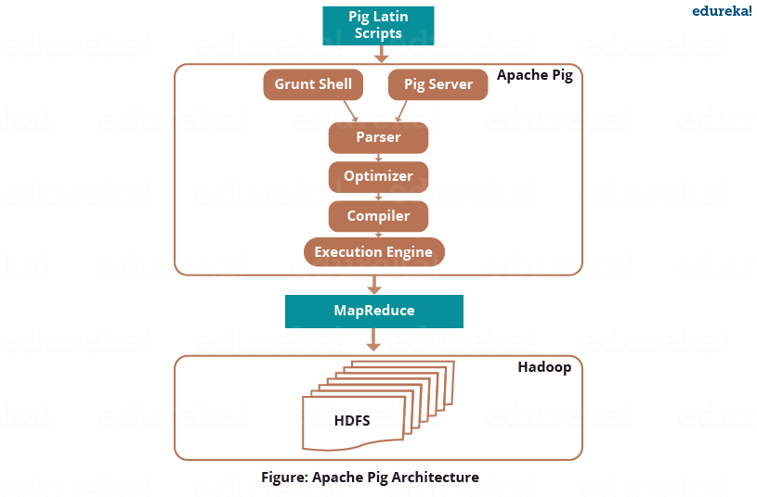

Local vs Mapreduce mode

Local mode: All scripts are run on a single machine without requiring Hadoop MapReduce and HDFS. When you run in Local mode, the Pig program runs in the context of a local Java Virtual Machine, and data access is via the local file system of a single machine. Local mode is actually a local simulation of MapReduce in Hadoop’s LocalJobRunner class. Local mode will build a simulated mapreduce job running off of a local file on disk. In theory equivalent to MapReduce, but it's not a "real" mr job. You shouldn't be able to tell the difference from a user perspective. This can be useful for developing and testing Pig logic. If you’re using a small set of data to develop or test your code, then local mode could be faster than going through the MapReduce infrastructure.

One thing to note is that there is no support for counters in local mode, but that is due to Hadoop Map/Reduce rather than Pig

MapReduce mode (also known as Hadoop mode): Pig is executed on the Hadoop cluster. In this case, the Pig Script gets converted into a series of MapReduce jobs that are then run on the Hadoop Cluster. Input and output are on hdfs.

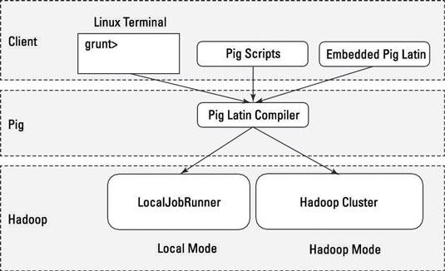

If you have a terabyte of data that you want to perform operations on and you want to interactively develop a program, you may soon find things slowing down considerably, and you may start growing your storage. Local mode allows you to work with a subset of your data in a more interactive manner so that you can figure out the logic (and work out the bugs) of your Pig program.

After you have things set up as you want them and your operations are running smoothly, you can then run the script against the full data set using MapReduce mode.

This example shows how to run Pig in local and mapreduce mode using the pig command.

/* local mode */
$ pig -x local ...
read file from local file system

/* mapreduce mode */
$ pig ...
or
$ pig -x mapreduce ...
read file from hdfs

When to start history server?
Pig in MapReduce mode tries to connect to job history server.
suyog@sks-Inspiron-15-3567:~/hadooop/hadoop-2.6.0-cdh5.13.0/sbin$./mr-jobhistory-daemon.sh start historyserver
starting historyserver, logging to /home/suyog/hadooop/hadoop-2.6.0-cdh5.13.0/logs/mapred-suyog-historyserver-sks-Inspiron-15-3567.out

Reading local file sample.txt into Pig (local mode) and operating on it

pig and sqoop- ncdc dataset sample.txt
find it and run commmands in file

sample.txt
1950 0 1
1950 22 1
1950 -11 1
1949 111 1
1949 78 1

$pig -x local
grunt>

schema on read
records = LOAD '/home/suyog/data/sample.txt' AS (year:chararray, temperature:int, quality:int);

describe records;
## records: {year: chararray,temperature: int,quality: int}

DUMP records;
## ...
## (1950 0 1)
## (1950 22 1)
## (1950 -11 1)
## (1949 111 1)
## (1949 78 1)

filters temp=9999 (type example)
filtered_records = FILTER records BY temperature != 9999 AND quality IN (0, 1, 4, 5, 9);
DUMP filtered_records;

filters temp=0
filtered_records = FILTER records BY temperature != 0 AND quality IN (0, 1, 4, 5, 9);

group b all -> becomes a bag(collection of tuples)
In bag, length of each tuple need not be same. Bag = {}
grouped_records= GROUP filtered_records BY year;
DUMP grouped_records;
## ...
## (1949,{(1949,78,1),(1949,111,1)})
## (1950,{(1950,-11,1),(1950,22,1),(1950,0,1)})

max_temp = FOREACH grouped_records GENERATE group, MAX(filtered_records.temperature);
DUMP max_temp;

filtered_records2 = FILTER records BY temperature != 9999 AND temperature IN (22,78);
DUMP filtered_records2;
## ...
## (1950,22,1)
## (1949,78,1)

grunt> fs -ls /home/suyog/data
Warning: fs.defaultFS is not set when running "ls" command.
Found 16 items
drwxrwxr-x - suyog suyog 4096 2018-02-12 19:48 /home/suyog/data/H2O
drwxr-xr-x - suyog suyog 4096 2018-02-10 22:25 /home/suyog/data/ctr
-rw-rw-r-- 1 suyog suyog 196 2018-01-22 10:59 /home/suyog/data/input_wc.txt
-rw-rw-r-- 1 suyog suyog 286 2018-01-14 15:49 /home/suyog/data/sample_sqoop.txt
...

LOAD -> Four types are there- Pig Storage, TextLoader,...

rec = LOAD '/home/suyog/data/sample_sqoop.txt' USING PigStorage(' ');
dump rec;
## ...
## (1950 0 1)
## (1950 22 1)
## (1950 -11 1)
## (1949 111 1)
## (1949 78 1)

describe rec;
## Schema for rec unknown.

grouped_rec= GROUP rec BY year;
## 2018-02-23 15:42:21,433 [main] ERROR org.apache.pig.tools.grunt.Grunt - ## ERROR 1025: <line 9, column 24> Invalid field projection. Projected ## ## field [year] does not exist.
## Details at logfile: /home/suyog/pig_1519378024446.log

guides:

http://pig.apache.org/docs/r0.7.0/piglatin_ref2.html

http://hadooptutorial.info/pig-functions-examples/

https://www.qubole.com/resources/pig-function-cheat-sheet/

Assignment:

--train_data.txt (total 45 rows, 2 garbage data rows)

fields are separated by pipe “ | ”, and ‘using PigStorage (‘ | ‘) throws error

Yeah, so the issue is that the delimiter can only be one byte character, and you have 3: delimiter - the single byte character that is used to separate fields. I found one hint regarding that: one can always create a new loadfunc and implement his own parsing (perhaps by extending PigStorage and overriding the parsing bits). – Wiktor Stribiżew Mar 6 '16 at 20:06

In train_data.txt- fields separated by 3 chars - <space><pipe><space> -> PigStorage (‘|’) works though

--from docker:
--pig -x mapreduce

--1)Total how many train data is present in input data

records = LOAD '/user/suyog/data/train_data.txt' USING PigStorage('|') AS (trainNo:int, trainTime:int,trainSpeed:int, trainDir:chararray);

--can use regex to validate first 3 columns are numbers and 4th one is char
records2 = FILTER records BY trainNo>0;

records2_group = GROUP records2 ALL;
records2_count = FOREACH records2_group GENERATE COUNT(records2);
--]records2_count = FOREACH records2_group GENERATE COUNT($1);

Dump records2_count;
--(43)
STORE records2_count INTO '/user/pig/output';

--2) How many trains are travelling from this station in each hour

--need to use floor, bcoz 1070 may be getting counted as 11th hour
records3 = FOREACH records2 GENERATE trainNo,trainTime, trainSpeed,trainDir, floor(trainTime/100) AS dummyHour;

describe records3;
--filtered_2_records: {trainNo: int,trainTime: int,trainSpeed: int,Hour: int}

records4 = GROUP records3 by dummyHour;
records4_count= FOREACH records4 GENERATE FLATTEN(group) as (dummyHour), COUNT($1);

Dump records4_count;
--last lines of o/p:
--(9,11)
--(10,17)
--(11,15)
--meaning:
--9th hour,9:00 to 9:59 ,11
--10th hour, 10:00 to 10:59, 17
--11th hour,17

--3) How many trains are travelling in each direction in each hour
records5 = GROUP records3 by (dummyHour,trainDir);
records5_count= FOREACH records5 GENERATE FLATTEN(group) as (dummyHour,trainDir), COUNT($1);

--(9, E,4)
--(9, N,2)
--...

--4) what is the average speed of each train travelling in each direction in each hour

records6 = GROUP records3 by (dummyHour,trainDir,trainNo);

--getting count (not required in task though)
--records7_count= FOREACH records6 GENERATE FLATTEN(group) as (dummyHour,trainDir, trainNo), COUNT($1);

--messy display
--records7_avg = FOREACH records6 GENERATE (records3.dummyHour, records3.trainDir,records3.trainNo), AVG(records3.trainSpeed);

--better display
records7_avg = FOREACH records6 GENERATE FLATTEN(group) as (dummyHour, trainDir,trainNo), AVG(records3.trainSpeed);

Dump records7_avg;

--5)If you receive some data that is incorrect in input file, add additional code to handle that inside your mapper/reducer

--cheap workaround for current file
records2 = FILTER records BY trainNo>0;

--better way--> Regex? Do one regex in Pig
--simpleFilter = FILTER records BY NOT(mystr MATCHES '^unknown.*')

SQOOP

Allows to extract data from RDBMS into Hadoop for further processing
Once the data is processed, it can be pushed back into RDBMS for further
consumption by users

With Sqoop, you can import data from a relational database system into HDFS. The input to the import process is a database table. Sqoop will read the table row-by-row into HDFS. The output of this import process is a set of files containing a copy of the imported table. The import process is performed in parallel. For this reason, the output will be in multiple files. These files may be delimited text files (for example, with commas or tabs separating each field), or binary Avro or SequenceFiles containing serialized record data.

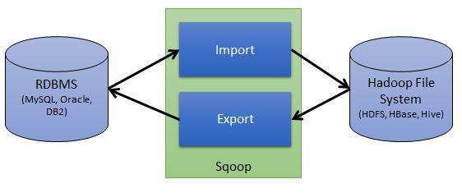

store all JDBC jars in $SQOOP_HOME/lib:
$sudo cp mysql-connector-java-5.1.45-bin.jar $SQOOP_HOME/lib

Sqoop Import / Export internals
- Sqoop connects to DB and verifies the Table schema
- Gets a list of all columns and their SQL types
- SQL types are mapped to Java Data types
- Sqoops codegen will generate the code
- Code gets executed as Mapper / Reducer

http://sqoop.apache.org/docs/1.4.5/SqoopUserGuide.html

https://www.edureka.co/blog/apache-sqoop-tutorial/

IMPORTING DATA FROM TEXT FILE TO MYSQL, THEN MYSQL TO HDFS, THEN EXPORTING IT TO MYSQL:

Basically, we import data to hdfs, perform operations (probably MapReduce), then export data back to database, for user consumption (one of the probable reasons).

creating table in mysql

if we write password in command line (rather than console) then others can see it by command 'ps' or 'history'..
mysql -u root -p
password:root

create database FOR_SQOOP;
use FOR_SQOOP;
## Database changed

create table TAB1 (year VARCHAR(20), temperature INT, quality INT);
show tables;
insert into TAB1 values (1950,0,1),(1950,22,1),(1950,-11,1),(1949,111,1),(1949,78,1);

IMPORTING DATA FROM TEXT FILE TO MYSQL:

creating table since mysql is schema on write (schema must exist beforehand)
create table table2(year varchar(20), temperature int, quality int);
## Query OK, 0 rows affected (0.30 sec)

loading data
LOAD DATA INFILE '/home/suyog/data/sample_sqoop.txt' INTO TABLE FOR_SQOOP.table2 FIELDS TERMINATED BY '/t';
ERROR 1290 (HY000): The MySQL server is running with the --secure-file-priv option so it cannot execute this statement

It's working as intended. Your MySQL server has been started with --secure-file-priv option which basically limits from which directories you can load files using LOAD DATA INFILE.

You may use SHOW VARIABLES LIKE "secure_file_priv"; to see the directory that has been configured.

You have two options:

- Move your file to the directory specified by secure-file-priv.
- Disable secure-file-priv. This must be removed from startup and cannot be modified dynamically. To do this check your MySQL start up parameters (depending on platform) and my.ini.

mysql> SHOW VARIABLES LIKE "secure_file_priv";
+------------------+-----------------------+
| Variable_name | Value |
+------------------+-----------------------+
| secure_file_priv | /var/lib/mysql-files/ |
+------------------+-----------------------+
1 row in set (0.07 sec)

You can import text file in mysql in two ways:
1. Place file on server with running MySQL and call:
LOAD DATA INFILE '/path/file.txt' INTO TABLE table;

File must be located on the server host and is read directly by the server. If path is not specified, the server looks for the file in the database directory of the default database.

2. Import file from any directory on local host:
LOAD DATA LOCAL INFILE 'c:\path\file.txt' INTO TABLE table;

LOAD DATA LOCAL INFILE '/home/suyog/data/sample_sqoop.txt' INTO TABLE TAB2;
## Query OK, 5 rows affected (0.09 sec)
## Records: 5 Deleted: 0 Skipped: 0 Warnings: 0

IMPORTING DATA FROM MYSQL TO HDFS

sqoop help
sqoop help import
sqoop import –help

IMPORT A TABLE
#cloudera vm
$sqoop import --connect "jdbc:mysql://localhost/FOR_SQOOP" --username root --password cloudera --table TAB1 --target-dir /user/cloudera/TAB1 -m 1
# hadoop vanilla
$sqoop import --connect "jdbc:mysql://localhost/FOR_SQOOP" --username root --password root --table TAB1 --target-dir /user/suyog/ETL/TAB1 -m 1;

-m 1: single map task
http://sqoop.apache.org/docs/1.4.5/SqoopUserGuide.html#_connecting_to_a_database_server

$ hdfs dfs -ls /user/sks/ETL
Found 1 items
drwxr-xr-x - suyog supergroup 0 2018-02-23 17:15 /user/sks/ETL/TAB1
$ hdfs dfs -ls /user/sks/ETL/TAB1
Found 2 items
-rw-r--r-- 1 suyog supergroup 0 2018-02-23 17:15 /user/sks/ETL/TAB1/_SUCCESS
-rw-r--r-- 1 suyog supergroup 51 2018-02-23 17:15 /user/sks/ETL/TAB1/part-m-00000
$ hdfs dfs -cat /user/sks/ETL/TAB1/part-m-00000
1950,0,1
1950,22,1
1950,-11,1
1949,111,1
1949,78,1

CODEGEN

Purpose:
The codegen tool generates Java classes which encapsulate and interpret imported records. The Java definition of a record is instantiated as part of the import process, but can also be performed separately. For example, if Java source is lost, it can be recreated. New versions of a class can be created which use different delimiters between fields, and so on.

In object-oriented application, every database table has one Data Access Object class that contains ‘getter’ and ‘setter’ methods to initialize objects. Codegen generates the DAO class automatically. It generates DAO class in Java, based on the Table Schema structure.

sqoop codegen --connect "jdbc:mysql://localhost/FOR_SQOOP" --table TAB1 --class-name TABLE1

where JAVA class is saved?

IMPORT ALL TABLE
#cloudera
sqoop import-all-tables --connect "jdbc:mysql://localhost/FOR_SQOOP" --username root --password cloudera -m 1
#vanilla
sqoop import-all-tables --connect "jdbc:mysql://localhost/FOR_SQOOP" --username root --password root -m 1

$ hdfs dfs -ls /user/suyog
Found 3 items
drwxr-xr-x - suyog supergroup 0 2018-02-23 17:31 /user/suyog/TAB1
drwxr-xr-x - suyog supergroup 0 2018-02-23 17:31 /user/suyog/TAB_empty
drwxr-xr-x - suyog supergroup 0 2018-02-23 17:31 /user/suyog/table2

mysql> use FOR_SQOOP;
mysql> show tables;
+---------------------+
| Tables_in_FOR_SQOOP |
+---------------------+
| TAB1 |
| TAB_empty |
| table2 |
+---------------------+
3 rows in set (0.00 sec)

all tables were imported in hdfs: /user/suyog (dir suyog was created), but why here and not in root position?

Note: In case of import a table, TAB1 is not created in /user/suyog, when i dont mention target dir

IMPORT WITH WHERE CLAUSE

If you are issuing the query wrapped with double quotes ("), you will have to use \$CONDITIONS instead of just $CONDITIONS to disallow your shell from treating it as a shell variable. For example, a double quoted query may look like: "SELECT * FROM x WHERE a='foo' AND \$CONDITIONS"

sqoop import --connect "jdbc:mysql://localhost/FOR_SQOOP" --username root --password cloudera --target-dir /user/cloudera/TAB2 -m 1 --query "select * from TAB1 where temperature=22 AND \$CONDITIONS"

sqoop import --connect "jdbc:mysql://localhost/FOR_SQOOP" --username root --password root --target-dir /user/sks/ETL/TAB2/ -m 1 --query "select * from TAB1 where temperature=22 AND \$CONDITIONS"

$ hdfs dfs -ls /user/sks/ETL
Found 2 items
drwxr-xr-x - suyog supergroup 0 2018-02-23 17:15 /user/sks/ETL/TAB1
drwxr-xr-x - suyog supergroup 0 2018-02-23 19:15 /user/sks/ETL/TAB2
$ hdfs dfs -ls /user/sks/ETL/TAB2
Found 2 items
-rw-r--r-- 1 suyog supergroup 0 2018-02-23 19:15 /user/sks/ETL/TAB2/_SUCCESS
-rw-r--r-- 1 suyog supergroup 10 2018-02-23 19:15 /user/sks/ETL/TAB2/part-m-00000
$ hdfs dfs -cat /user/sks/ETL/TAB2/part-m-00000
1950,22,1

EXPORT DATA TO RDBMS

create table TAB_schema (year VARCHAR(20), temperature INT, quality INT);

sqoop export --connect "jdbc:mysql://localhost/FOR_SQOOP" -m 1 --username root --password cloudera --table TAB_schema --export-dir /user/cloudera/TAB2

$ hdfs dfs -cat /user/sks/ETL/TAB2/part-m-00000
1949,78,1

$sqoop export --connect "jdbc:mysql://localhost/FOR_SQOOP?useSSL=true" -m 1 --username root --password root --table TAB_schema --export-dir /user/sks/ETL/TAB2

mysql> select * from TAB_schema;
+------+-------------+---------+
| year | temperature | quality |
+------+-------------+---------+
| 1949 | 78 | 1 |
+------+-------------+---------+
1 row in set (0.00 sec)

Sqoop-List-Database
Used to list all the database available on RDBMS server. Generic Syntax:
Syntax:
$ sqoop list-databases --connect
sqoop list-databases --connect "jdbc:mysql://localhost" --username root --password root

Sqoop-List-Tables
Used to list all the tables in a specified database. Generic Syntax:
$ sqoop list-tables (generic args) (list tables args)
Syntax:
$ sqoop list-tables –connect
sqoop list-tables --connect "jdbc:mysql://localhost/FOR_SQOOP" --username root --password root

sqoop-Eval
Sqoop-eval command allows users to quickly run simple SQL queries against a database and the results are printed on to the console. Generic Syntax:
$ sqoop eval (generic args) (eval args)
Syntax:
$ sqoop eval --connect --query "SQL query"
Using this, users can be sure that they are importing the data as expected.
sqoop eval --connect "jdbc:mysql://localhost/FOR_SQOOP" --username root --password root --query "select * from TAB1"

RESOLVING WARNINGS:

Warning: /home/suyog/hadooop/sqoop-1.4.6-cdh5.13.0/../hcatalog does not exist! HCatalog jobs will fail.
Please set $HCAT_HOME to the root of your HCatalog installation.
vim ~/.bashrc
export HCAT_HOME=$HIVE_HOME/hcatalog
export PATH=$PATH:$HCAT_HOME/bin

source ~/.bashrc

Warning: /home/suyog/hadooop/sqoop-1.4.6-cdh5.13.0/../accumulo does not exist! Accumulo imports will fail.
Please set $ACCUMULO_HOME to the root of your Accumulo installation.

post1:Set the variable ACCUMULO_HOME to /var/lib/accumulo and export this variable.
This will resolve this warning.
post2: if you are setting ACCUMULO_HOME to a path, you should make sure that the path is actually where accumulo lives. Otherwise you are suppressing the warning without actually resolving it!
Post3:Many systems do not use accumulo, so warning is purely noise
post4: Also, dont forget to make dir: sudo mkdir /var/lib/accumulo

Warning: Establishing SSL connection without server's identity verification is not recommended
$ sqoop codegen --connect "jdbc:mysql://localhost/FOR_SQOOP" --table TAB1 --class-name TABLE1
SLF4J: Class path contains multiple SLF4J bindings.
SLF4J: Found binding in [jar:file:/home/suyog/hadooop/hadoop-2.6.0-cdh5.13.0/share/hadoop/common/lib/slf4j-log4j12-1.7.5.jar!/org/slf4j/impl/StaticLoggerBinder.class]
SLF4J: Found binding in [jar:file:/home/suyog/hadooop/hbase-1.2.6/lib/slf4j-log4j12-1.7.5.jar!/org/slf4j/impl/StaticLoggerBinder.class]
SLF4J: See http://www.slf4j.org/codes.html#multiple_bindings for an explanation.
SLF4J: Actual binding is of type [org.slf4j.impl.Log4jLoggerFactory]
Fri Feb 23 19:30:04 IST 2018 WARN: Establishing SSL connection without server's identity verification is not recommended. According to MySQL 5.5.45+, 5.6.26+ and 5.7.6+ requirements SSL connection must be established by default if explicit option isn't set. For compliance with existing applications not using SSL the verifyServerCertificate property is set to 'false'. You need either to explicitly disable SSL by setting useSSL=false, or set useSSL=true and provide truststore for server certificate verification.

$ sqoop codegen --connect "jdbc:mysql://localhost/FOR_SQOOP?useSSL=true" --table TAB1 --class-name TABLE1
SLF4J: Class path contains multiple SLF4J bindings.
SLF4J: Found binding in [jar:file:/home/suyog/hadooop/hadoop-2.6.0-cdh5.13.0/share/hadoop/common/lib/slf4j-log4j12-1.7.5.jar!/org/slf4j/impl/StaticLoggerBinder.class]
SLF4J: Found binding in [jar:file:/home/suyog/hadooop/hbase-1.2.6/lib/slf4j-log4j12-1.7.5.jar!/org/slf4j/impl/StaticLoggerBinder.class]
SLF4J: See http://www.slf4j.org/codes.html#multiple_bindings for an explanation.
SLF4J: Actual binding is of type [org.slf4j.impl.Log4jLoggerFactory]

Assignment:
train_data.txt -> mySql or/and mongodb or/and hbase ---sqoop--> hdfs ---sqoop--> mySql or/and mongodb or/and hbase

#creating schema, since mysql is schema on wite
mysql>create table TrainData (trainNo INT, trainTIME INT, trainSpeed INT, trainDir VARCHAR(20));

#importing data from text file directly
mysql>LOAD DATA LOCAL INFILE '/home/suyog/data/train_data.txt' INTO TABLE TrainData FIELDS TERMINATED BY ' | ';

#row with trainNo=0 is garbage data. That garbage data got read as 0.
mysql> select * from TrainData;
+---------+-----------+------------+----------+
| trainNo | trainTIME | trainSpeed | trainDir |
+---------+-----------+------------+----------+
| 1000 | 1000 | 60 | E |
| 1001 | 1010 | 80 | W |
...
| 0 | 0 | 0 | D |
...

#deleting those 2 rows
mysql>DELETE from TrainData WHERE trainNo = 0;

#importing in hdfs by sqoop
sqoop import --connect "jdbc:mysql://localhost/FOR_SQOOP" --username root --password root --table TrainData --target-dir /user/suyog/ETL/data/TrainData -m 1;

$ hdfs dfs -cat /user/suyog/data/ETL/TrainData/part-m-00000
1000,1000,60,E
1001,1010,80,W
1002,1015,40,N
...

HIVE

https://cwiki.apache.org/confluence/display/Hive/Tutorial

https://dzone.com/articles/sqoop-import-data-from-mysql-to-hive

Hive is most suitable for following data warehouse applications
- Analyzing the relatively static data
- Less Responsive time
- No rapid changes in data.

SQL over MapReduce (Hiveql)
JDBC Connectivity
Inbuilt SQL Optimisation

$start-dfs.sh
$start-yarn.sh
$hive
error:
SemanticException org.apache.hadoop.hive.ql.metadata.HiveException: java.lang.RuntimeException: Unable to instantiate org.apache.hadoop.hive.ql.metadata.SessionHiveMetaStoreClient

error resolved- solution below (after explanation of metastore)

METASTORE

In Hive, metastore is the central repository to store metadata for hive tables/partitions. Any datastore that has a JDBC driver can be used as a metastore. By default, the metastore service runs in the same JVM as the Hive service and contains an embedded Derby database instance backed by the local disk.

There are 3 different ways to setup the metastore server using different Hive configurations:
- Embedded Metastore
- Local Metastore
- Remote Metastore

Embedded metastore: In Hive by default, metastore service runs in the same JVM as the Hive service. It uses embedded derby database stored on the local file system in this mode. Thus both metastore service and hive service runs in the same JVM by using embedded Derby Database. But, this mode also has limitation that, as only one embedded Derby database can access the database files on disk at any one time, so only one Hive session could be open at a time.
Trying to start a second session gives the error: Failed to start database ‘metastore_db’
So, embedded metastore is not practical solution but can be used for unit tests.

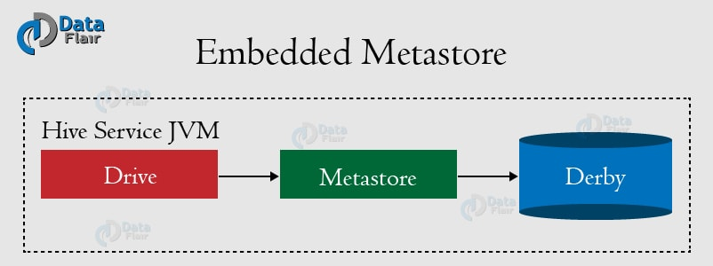

Local Metastore: Hive is the data-warehousing framework, so hive does not prefer single session. To overcome this limitation of Embedded Metastore, Local Metastore was introduced. This mode allows us to have many Hive sessions i.e. many users can use the metastore at the same time. We can achieve by using any JDBC compliant like MySQL which runs in a separate JVM or different machines than that of the Hive service and metastore service which are running in the same JVM. In this mode, multiple users can open connection to metastore and make SQL queries against it.

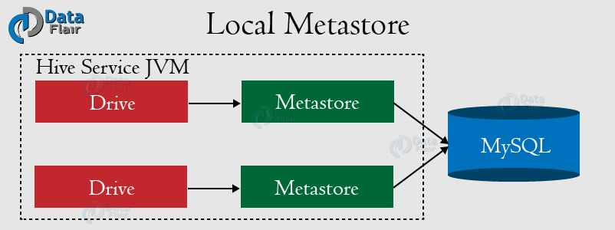

Remote Metastore: In remote metastore, all Hive Clients will make a connection to a metastore server (MySQL or PostgreSQL or Oracle) which in turn queries the datastore. In this mode, metastore runs on its own separate JVM, not in the Hive service JVM. If other processes want to communicate with the metastore server they can communicate using Thrift Network APIs.

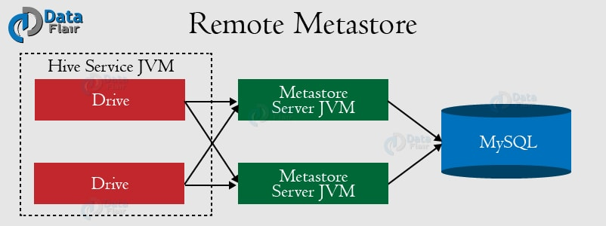

Hive supports 5 backend databases which are as follows:

- Derby
- MySQL
- MS SQL Server
- Oracle
- Postgres

It is said that postgres and mysql are better for cluster environment. Derby is good for pseudo distributed environment (all processes on one node).

metastore_db is in $SPARK_HOME. why?

Configuring Hive

hive-config.sh, added:
export HADOOP_HOME=$HADOOP_HOME # mine

placed mysql-connector-java-5.1.45-bin.jar in hive/lib...probably needed if we set mysql as metastore

$hive --service metastore -> gave error

hive-env.sh -> export HADOOP_HOME=$HADOOP_HOME #mine

created hive-site.xml in $HIVE_HOME/conf. It was empty. $hive wasn't starting CLI "hive>" of hive

create/edit hive-site.xml. We set derby as metastore

<configuration>
<property>
<name>javax.jdo.option.ConnectionURL</name>
<value>jdbc:derby://localhost:1527/metastore_db;create=true </value>
<description>JDBC connect string for a JDBC metastore </description>
</property>
</configuration>

hive>show tables;
Didn’t worked!

<property>
<name>javax.jdo.option.ConnectionURL</name>
<value>jdbc:derby:metastore_db;create=true </value>
<description>JDBC connect string for a JDBC metastore </description>
</property>

hive>show tables;
worked!!

Moreover, we strongly advise users to create the HDFS directories /tmp and /user/hive/warehouse (also known as hive.metastore.warehouse.dir) and set them chmod g+w before tables are created in Hive.

$ hive --service metastore
ls: cannot access '/home/suyog/hadooop/spark-2.2.0-bin-hadoop2.6/lib/spark-assembly-*.jar': No such file or directory
SLF4J: Class path contains multiple SLF4J bindings.
SLF4J: Found binding in [jar:file:/home/suyog/hadooop/hbase-1.2.6/lib/slf4j-log4j12-1.7.5.jar!/org/slf4j/impl/StaticLoggerBinder.class]
SLF4J: Found binding in [jar:file:/home/suyog/hadooop/hadoop-2.6.0-cdh5.13.0/share/hadoop/common/lib/slf4j-log4j12-1.7.5.jar!/org/slf4j/impl/StaticLoggerBinder.class]
SLF4J: See http://www.slf4j.org/codes.html#multiple_bindings for an explanation.
SLF4J: Actual binding is of type [org.slf4j.impl.Log4jLoggerFactory]
2018-02-24 17:06:24,817 WARN [main] util.NativeCodeLoader: Unable to load native-hadoop library for your platform... using builtin-java classes where applicable
Starting Hive Metastore Server
...not moving further

Note:
error: was getting some error even when hive worked couple of days ago.
I deleted metastore_db from ‘/home/suyog/’, hive made new one and now it works. Maybe a issue because of .lck files, lock wasn’t closed or something like that.

HIVE commands (hive is deprecated beeline is recommended)

hive> show tables;
OK
Time taken: 0.11 seconds

hive> show databases;
OK
default
Time taken: 0.079 seconds, Fetched: 1 row(s)

hive>create database if not exists dezyre;
hive>create database myowndb comment "This is just a test database";
hive> describe database myowndb;
OK
myowndb This is just a test database hdfs://localhost:9000/user/hive/warehouse/myowndb.db suyog USER
Time taken: 0.049 seconds, Fetched: 1 row(s)

hive> show databases like 'tez*';
OK
Time taken: 0.067 seconds

hive> show databases like 'my*';
OK
myowndb
Time taken: 0.047 seconds, Fetched: 1 row(s)

hive> use myowndb;
OK
Time taken: 0.028 seconds

hive> create table courses(course_id int,course_name string,students_enrolled int);
OK
Time taken: 0.215 seconds

hive> describe courses;
OK
course_id int
course_name string
students_enrolled int
Time taken: 0.136 seconds, Fetched: 3 row(s)

hive>INSERT INTO TABLE courses VALUES (1,'Hadoop',5500);

hive>INSERT INTO TABLE courses VALUES (2,'spark',3500);

hive>select * from courses;
hive> select * from courses;
OK
1 Hadoop 5500
2 spark 3500
Time taken: 0.139 seconds, Fetched: 2 row(s)

Hive Web Interface
In this instructional post, we will see how to run Hive queries using the Hive Web Interface (HWI). Hive Web Interface (HWI) is a simple graphical user interface (GUI) of the Hive. It is an alternative to using the Hive command line interface.
Features of HWI

$HIVE_HOME/bin/hive --service hwi
browser: http://localhost:9999/hwi

Reading file from local and hdfs:
hive> LOAD DATA LOCAL INPATH './examples/files/kv1.txt' OVERWRITE INTO TABLE pokes;

Loads a file that contains two columns separated by ctrl-a into pokes table. 'LOCAL' signifies that the input file is on the local file system. If 'LOCAL' is omitted then it looks for the file in HDFS.

delimiter
A delimiter is a sequence of one or more characters used to specify the boundary between separate, independent regions in plain text or other data streams. An example of a delimiter is the comma character, which acts as a field delimiter in a sequence of comma-separated values.

hive>use myowndb;

hive>CREATE TABLE records (year STRING, temperature INT, quality INT)
ROW FORMAT DELIMITED
FIELDS TERMINATED BY '\t';

hive>LOAD DATA LOCAL INPATH '/home/suyog/data/sample.txt' OVERWRITE INTO TABLE records;

Checking if table is created in myowndb in /user/hive/warehouse
$ hdfs dfs -ls /user/hive/warehouse
Found 2 items
drwxrw-r-x - suyog supergroup 0 2018-02-24 17:21 /user/hive/warehouse/courses
drwxrw-r-x - suyog supergroup 0 2018-02-24 18:43 /user/hive/warehouse/myowndb.db

$ hdfs dfs -ls /user/hive/warehouse/myowndb.db/records
Found 1 items
-rwxrw-r-x 1 suyog supergroup 51 2018-02-24 18:44 /user/hive/warehouse/myowndb.db/records/sample.txt

$ hdfs dfs -cat /user/hive/warehouse/myowndb.db/records/sample.txt
1950 0 1
1950 22 1
1950 -11 1
1949 111 1
1949 78 1

hive> select year, MAX(temperature)
from records
where temperature != 9999 and quality IN (0,1,4,5,9)
group by year;
...
Stage-Stage-1: Map: 1 Reduce: 1 Cumulative CPU: 4.46 sec HDFS Read: 9001 HDFS Write: 17 SUCCESS
Total MapReduce CPU Time Spent: 4 seconds 460 msec
OK
1949 111
1950 22
Time taken: 18.794 seconds, Fetched: 2 row(s)

Assignment:

https://cwiki.apache.org/confluence/display/Hive/Tutorial

Sample:
1000 | 1000 | 60 | E
1001 | 1010 | 80 | W
1002 | 1015 | 40 | N
1003 | 1020 | 60 | S

hive> create table train_data(trainNo String, trainTime String, trainSpeed String, trainDir String)
row format delimited
fields terminated by '|'
stored as textfile;

hive> load data local inpath '/home/suyog/data/train_data.txt' into table train_data;

create table train_data2 (trainNo int, trainTime int, trainSpeed int, trainDir String)
row format delimited
fields terminated by '|'
stored as textfile;

hive> load data local inpath '/home/suyog/data/train_data.txt' into table train_data2;
All int fields are NULL

Reason for the behaviour (above):

hive is reading field with spaces: “field1 “, “ field2 “, “ field3 “, “field4 “. See below.

hive> describe train_data;
OK
trainno string
traintime string
trainspeed string
traindir string
Time taken: 0.056 seconds, Fetched: 4 row(s)

#doesn’t work
hive> select * from train_data where trainNo="1000";
#works
hive> select * from train_data where trainNo="1000 ";

#doesn’t work
hive> select * from train_data where trainTime="1000";
hive> select * from train_data where trainTime=" 1000";
#works
hive> select * from train_data where trainTime=" 1000 ";w

#doesn’t work
hive> select * from train_data where trainDir="E";
#works
hive> select * from train_data where trainDir like "%E%";
hive> select * from train_data where trainDir like "%E";
hive> select * from train_data where trainDir=" E";

#Improvement
create table train_data3 (trainNo int, trainTime int, trainSpeed int, trainDir String)
row format delimited
fields terminated by ' | '
stored as textfile;

hive> load data local inpath '/home/suyog/data/train_data.txt' into table train_data3;
1000 NULL 1000 |
1001 NULL 1010 |

create table train_data4 (trainNo int, trainTime int, trainSpeed int, trainDir String)
row format delimited
fields terminated by ' |'
stored as textfile;

hive> load data local inpath '/home/suyog/data/train_data.txt' into table train_data4;
1000 NULL 1000 |
1001 NULL 1010 |

create table train_data5 (trainNo int, trainTime int, trainSpeed int, trainDir String)
row format delimited
fields terminated by '| '
stored as textfile;

hive> load data local inpath '/home/suyog/data/train_data.txt' into table train_data5;
NULL NULL NULL E
NULL NULL NULL W

non-elegant solution: it read int as int, String as String!
#read 7 fields, then drop 3 fields from table which has pipe (junk fields)
create table train_data6 (trainNo int, junk1 String, trainTime int, junk2 String, trainSpeed int, junk3 String, trainDir String)
row format delimited
fields terminated by ' '
stored as textfile;

hive> load data local inpath '/home/suyog/data/train_data.txt' into table train_data6;
1000 | 1000 | 60 | E
1001 | 1010 | 80 | W
..
NULL | NULL | NULL | D
..
NULL Am NULL Garb NULL age |
..

It doesn’t remove columns!!
hive> alter table train_data6 replace columns (trainNo int, trainTime int, trainSpeed int, trainDir String);
OK
Time taken: 0.128 seconds
hive> describe train_data6;
OK
trainno int
traintime int
trainspeed int
traindir string
Time taken: 0.059 seconds, Fetched: 4 row(s)
hive>select * from train_data6;
1000 NULL 1000 |
1001 NULL 1010 |
..

or,

create table train_data7 as select trainNo, trainTime, trainSpeed, trainDir from train_data6;
works perfectly!!

Garbage Filtering
hive>insert overwrite table train_data7 select * from train_data7 where trainNo > 20;
hive> select * from train_data6;
## fetched 43 rows, garbage rows gone

Moving to assignemnt:

hive> insert overwrite table train_data select * from train_data where trainNo > 20;
it removed garbage data

1)Total how many train data is present in input data

hive> select count(*) from train_data;
Time taken: 0.2 seconds, Fetched: 43 row(s)

2) How many trains are travelling from this station in each hour

hive> alter table train_data add columns (dummyHour String);
hive> insert overwrite table train_data select trainno,traintime,trainspeed,traindir, floor(traintime/100) as dummyhour from train_data;
hive> select count (*) from train_data group by dummyhour;
17
15
11
Time taken: 20.443 seconds, Fetched: 3 row(s)

Note: even if data type of traintime is string, math worked fine on it.

hive> alter table train_data7 add columns (dummyHour int);
hive> insert overwrite table train_data7 select trainno,traintime,trainspeed,traindir, floor(traintime/100) as dummyhour from train_data7;
hive> select count (*) from train_data group by dummyhour;
17
15
11
Time taken: 20.443 seconds, Fetched: 3 row(s)

hive>select * from train_data7;

3) How many trains are travelling in each direction in each hour

hive> select dummyhour, traindir, count (*) from train_data group by dummyhour,traindir;
10 E 6
10 N 3

hive> select dummyhour, traindir, count (*) from train_data7 group by dummyhour,traindir;

4) what is the average speed of each train travelling in each direction in each hour

hive> select trainno, dummyhour, traindir, avg(trainspeed) from train_data group by trainno, dummyhour, traindir order by trainno,dummyhour;

hive> select trainno, dummyhour, traindir, avg(trainspeed) from train_data7 group by trainno, dummyhour, traindir order by trainno,dummyhour;

5)If you receive some data that is incorrect in input file, add additional code to handle that inside your mapper/reducer

# a cheap workaround for current file’s garbage data
hive> insert overwrite table train_data select * from train_data where trainNo > 20;
it removed garbage data

Try Regex for more sphisticated filtering and pattern matching.

dec 2 tasks

https://github.com/tomwhite/hadoop-book/tree/master/ch03-hdfs/src/main/java

https://github.com/tomwhite/hadoop-book/tree/master/ch06-mr-dev/src/main/java/v1

https://github.com/tomwhite/hadoop-book/tree/master/ch08-mr-types/src/main/sh

https://github.com/tomwhite/hadoop-book/tree/master/ch16-pig/src/main/grunt

https://github.com/tomwhite/hadoop-book/tree/master/ch16-pig/src/main/pig

https://github.com/tomwhite/hadoop-book/tree/master/ch17-hive/src/main/hive

https://github.com/tomwhite/hadoop-book/tree/master/ch03-hdfs/src/main/java

FileSystemCat:
copy pasted and modified hdfs operations:
hadoop jar /home/suyog/eclipse-workspace/hadoop.ch03_hdfs/target/hadoop.ch03_hdfs-0.0.1-SNAPSHOT.jar org.daa.examples.hadoop.ch03_hdfs.FileSystemCat /user/suyog/data/input_wc.txt

maven project -> added dependency in pom -> ...
hadoop jar /home/suyog/eclipse-workspace/hadoop.ch03hdfs/target/hadoop.ch03hdfs-0.0.1-SNAPSHOT.jar org.daa.examples.hadoop.ch03hdfs.FileSystemCat /user/suyog/data/input_wc.txt

Both works in Eclipse, but they can't read file from hdfs. Although, it read file from local filesystem. Is it that eclipse can't reach to hdfs??

FileCopyWithProgress (need to give filename, only /user/suyog/data -> error: dir already exists):
hadoop jar /home/suyog/eclipse-workspace/hadoop.ch03_hdfs/target/hadoop.ch03_hdfs-0.0.1-SNAPSHOT.jar org.daa.examples.hadoop.ch03_hdfs.FileCopyWithProgress /home/suyog/data/1901 /user/suyog/data/1901

FileSystemDoubleCat:
hadoop jar /home/suyog/eclipse-workspace/hadoop.ch03_hdfs/target/hadoop.ch03_hdfs-0.0.1-SNAPSHOT.jar org.daa.examples.hadoop.ch03_hdfs.FileSystemDoubleCat /user/suyog/data/input_wc.txt

ListStatuses:
hadoop jar /home/suyog/eclipse-workspace/hadoop.ch03_hdfs/target/hadoop.ch03_hdfs-0.0.1-SNAPSHOT.jar org.daa.examples.hadoop.ch03_hdfs.ListStatus /user/suyog/data/

FileSystemDoubleCat:
hadoop jar /home/suyog/eclipse-workspace/hadoop.ch03_hdfs/target/hadoop.ch03_hdfs-0.0.1-SNAPSHOT.jar org.daa.examples.hadoop.ch03_hdfs.URLCat /user/suyog/data/input_wc.txt

URLCat:
hadoop jar /home/suyog/eclipse-workspace/hadoop.ch03_hdfs/target/hadoop.ch03_hdfs-0.0.1-SNAPSHOT.jar org.daa.examples.hadoop.ch03_hdfs.URLCat /user/suyog/data/input_wc.txt
erorr!

https://github.com/tomwhite/hadoop-book/tree/master/ch06-mr-dev/src/main/java/v1

https://github.com/tomwhite/hadoop-book/tree/master/ch08-mr-types/src/main/sh
$hadoop jar $HADOOP_HOME/share/hadoop/tools/lib/hadoop-streaming-2.6.0-cdh5.13.0

https://github.com/tomwhite/hadoop-book/tree/master/ch16-pig/src/main/grunt

https://github.com/tomwhite/hadoop-book/tree/master/ch16-pig/src/main/pig

https://github.com/tomwhite/hadoop-book/tree/master/ch17-hive/src/main/hive

APACHE SPARK

https://spark.apache.org/docs/latest/

Apache Spark is a fast and general engine for big data processing with built-in modules for streaming, SQL, machine learning, and graph processing.

Speed
Run programs up to 100x faster than Hadoop MapReduce in memory, or 10x faster on disk

Ease of Use
Write applications quickly in Java, Scala, Python, R.

Spark offers over 80 high-level operators that make it easy to build parallel apps. And you can use it interactively from the Scala, Python and R shells.

Generality
Combine SQL, streaming, and complex analytics.

Spark powers a stack of libraries including SQL and DataFrames, MLlib for machine learning, GraphX, and Spark Streaming. You can combine these libraries seamlessly in the same application.

Apache Spark features:
Runs on jvm
RDD (resilient distributed dataset), immutable
does in-memory computation
100 times faster than MapReduce (100 times in memory, 10 times in disc)
SparkContext
More than Mapreduce:SparkSQL, MLLib, Streaming, GraphX
Transformations (flatmap, filter etc.) -> new RDD is created
Direct Acylic Graph (contains execution flow)
Actions (lazy execution -> holds on operations till action is called)

StandAlone Spark:

modify if needed: spark-env.sh

https://spark.apache.org/docs/latest/spark-standalone.html

In addition to running on the Mesos or YARN cluster managers, Spark also provides a simple standalone deploy mode. You can launch a standalone cluster either manually, by starting a master and workers by hand, or use our provided launch scripts. It is also possible to run these daemons on a single machine for testing.

Starting a Cluster Manually
You can start a standalone master server by executing:

./sbin/start-master.sh
Once started, the master will print out a spark://HOST:PORT URL for itself, which you can use to connect workers to it, or pass as the “master” argument to SparkContext. You can also find this URL on the master’s web UI, which is http://localhost:8080 by default.

master's web ui: http://localhost:8080/
URL: spark://sks-Inspiron-15-3567:7077
your_master_host: sks-Inspiron-15-3567

Similarly, you can start one or more workers and connect them to the master via:

./sbin/start-slave.sh <master-spark-URL>
./sbin/start-slave.sh spark://sks-Inspiron-15-3567:7077
Once you have started a worker, look at the master’s web UI (http://localhost:8080 by default). You should see the new node listed there, along with its number of CPUs and memory (minus one gigabyte left for the OS).

$stop-slave.sh
$stop-master.sh

Test the Standalone Spark :
$spark-shell
scala> sc.parallelize( 2 to 200).count
res0: Long = 199

SparkJobs web ui- http://localhost:4040/jobs/

spark-shell --master yarn
error: need to set HADOOP_CONF_DIR or YARN_CONF_DIR
vim ~/.bashrc
export HADOOP_CONF_DIR=$HADOOP_INSTALL/etc/hadoop
works!!
exit -> System.exit(0)

Interactive Scala Shell
The easiest way to start using Spark is through the Scala shell:
./bin/spark-shell
Try the following command, which should return 1000:
scala> sc.parallelize(1 to 1000).count()

Interactive Python Shell
Alternatively, if you prefer Python, you can use the Python shell:
./bin/pyspark
And run the following command, which should also return 1000:
>>> sc.parallelize(range(1000)).count()

Example Programs
Spark also comes with several sample programs in the `examples` directory.
To run one of them, use `./bin/run-example <class> [params]`. For example:
./bin/run-example SparkPi
will run the Pi example locally.

Spark:
run-example SparkPi

For python and R, use spark-submit:
spark-submit examples/src/main/python/wordcount.py /home/suyog/data/input_wc.txt

Spark-Architecture

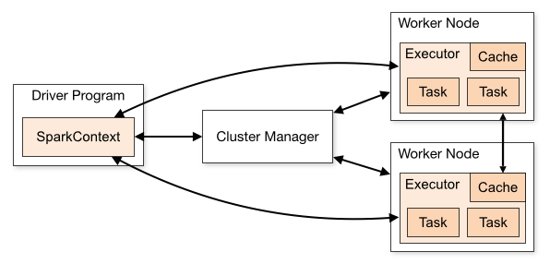

Note that, before Spark 2.0, the main programming interface of Spark was the Resilient Distributed Dataset (RDD). After Spark 2.0, RDDs are replaced by Dataset, which is strongly-typed like an RDD, but with richer optimizations under the hood. The RDD interface is still supported, and you can get a more complete reference at the RDD programming guide. However, we highly recommend you to switch to use Dataset, which has better performance than RDD. See the SQL programming guide to get more information about Dataset.

RDD

-core of spark
-It is resilient distributed datasets, it may be on one machine or multiple machines
-immutable

RDD operations:

Transformations- returns new RDD
lazy evaluation- tranformation not executed until Action is triggered
Action- returns new-RDD. It executes and force earlier tranformations to execute too. Kinda like SQL commit, makes past ops to commit too.

rdd.map(x=>x+1)
x=> x+1 is lambda func

prg:
local[1] 0 run my prg with one thread

Note:
If start-dfs.sh or/and start-yarn.sh not done before then spark-shell throws some error, when we try to use sparkSession and sparContext.

$spark-shell
browser: http://localhost:4040
val is immutable
scala> val v1 = Array(1,2,3,4)
v1: Array[Int] = Array(1, 2, 3, 4)

scala> val v2 = v1.map(x=>x+1)
v2: Array[Int] = Array(2, 3, 4, 5)

scala>v1.count()
error!

RDD programming:

https://spark.apache.org/docs/latest/rdd-programming-guide.html

There are two ways to create an RDD in Spark

- Parallelizing already existing collection in driver program.
- Referencing a dataset in an external storage system (e.g. HDFS, Hbase, shared file system).

Let us learn these in details below:

1.Parallelized collection (parallelizing)

scala> val rdd1 = spark.sparkContext.parallelize(Array(1,2,3,3))
rdd1: org.apache.spark.rdd.RDD[Int] = ParallelCollectionRDD[2] at parallelize at <console>:23

scala> rdd1.foreach(println)
1
3
2
3
scala> rdd1.distinct.foreach(println)
1
2
3

Instead of “spark.sparkContext.” “sc.” Also works! Spark session available as spark. Spark context available as sc.

scala> val rdd3 =sc.parallelize(Array(1,2,3,3))
rdd3: org.apache.spark.rdd.RDD[Int] = ParallelCollectionRDD[8] at parallelize at <console>:24

scala> rdd3.distinct().foreach(println)
1
2
3

scala> rdd3.count()
res19: Long = 4

scala> val rdd2 = rdd1.map(x=>x+1)
rdd2: org.apache.spark.rdd.RDD[Int] = MapPartitionsRDD[3] at map at <console>:25

scala> rdd2.foreach(println)
4
2
4
3

scala> rdd1.count()
res23: Long = 4

scala> rdd1.intersection(rdd2).foreach(println)
3
2

scala> rdd1.intersection(rdd2).foreach(println)
3
2

scala> rdd1.reduce((x,y)=>x+y)
res12: Int = 9

2.External Datasets

scala> val distFile = sc.textFile("/home/suyog/data/input_wc.txt")
distFile: org.apache.spark.rdd.RDD[String] = /home/suyog/data/input_wc.txt MapPartitionsRDD[16] at textFile at <console>:24
scala> distFile.foreach(println)
org.apache.hadoop.mapred.InvalidInputException: Input path does not exist: hdfs://localhost:9000/home/suyog/data/input_wc.txt

#hdfs file location: /user/suyog/..
scala> val distFile = sc.textFile("/user/suyog/data/input_wc.txt")
distFile: org.apache.spark.rdd.RDD[String] = /home/suyog/data/input_wc.txt MapPartitionsRDD[16] at textFile at <console>:24

scala> distFile.map(s => s.length).reduce((a, b) => a + b)
org.apache.hadoop.mapred.InvalidInputException: Input path does not exist: hdfs://localhost:9000/home/suyog/data/input_wc.txt
...

scala> distFile.foreach(println)
suyog apple orange tingle bingle
derry fantastic funtasdic relo nope
nope nope nope well turn
well done Done Derry work
apple tingle tingle derry suyog suyog
apple tingle suyog tingle tingle

Basic RDDs-
rdd1 and rdd2
JavaRDD<String> lines = sc.parallelize(Arrays.asList("pandas", "i like pandas"));

RDDs containing Key-Value pair
Special operations e.g reduceByKey(), join() etc
JavaPairRDD<String, Integer> counts = wordPairRDD.reduceByKey((x, y) -> x + y, 10);

RDD PERSISTENCE
RDDs are evaluated lazily
We can use the same RDD for multiple operations
Spark may recalculate RDD and all its dependencies each time we call an RDD. That may be expensive
We can ask spark to persist the data

RDDs can me removed manually using rdd.unpersist()

DATA LOADING IN SPARK
Following formats are supported
a. Text Filed - SparkContext.textFile(“File_Path”)
b. JSON - JavaRDD.mapPartitions( new MyJSONParser() )
c. CSV - JavaPairRDD.flatMap( new MyCSVParser() )
d. SequenceFiles - SparkContext.sequenceFile(File_Path, classOf[Key],
classOf[Value])
e. Object Files - SparkContext.objectFile(“File_Path”)

EXECUTING SPARK
$./bin/spark-submit \
--master spark://hostname:7077 \
--deploy-mode cluster \
--class com.cdac.myClass \
--name "CDAC DBDA Program" \
--jars dep1.jar,dep2.jar,dep3.jar \
--executor-memory 10g \
myApp.jar "options to your application go here"

ACCUMULATORS & BROADCAST VARIABLES
Broadcast is a read-only global variable, which all nodes of a cluster can read. Think of them more like as a lookup variables. They're variables that we want to share throughout our cluster. They are Immutable, Distributed to the cluster and should Fit in memory

On the other hand think of accumulators as a global counter variable where each node of the cluster can write values in to. These are the variables that you want to keep updating as a part of your operation like for example while reading log lines, one would like to maintain a real time count of number of certain log type records identified.

Spark-Scala

Scala
runs on JVM
based on actor based framework
RDD
datapipeline
lambda(java8) recommended

wordcount program:

$spark-shell
scala> val texFile = sc.textFile("/user/suyog/data/input_wc.txt")
textfile: org.apache.spark.rdd.RDD[String] = /home/suyog/data/input_wc.txt MapPartitionsRDD[1] at textFile at <console>:24

#this works too. Giving location staring from 'data' because in inputfile.collect() system adds '/user/suyog' to hadoop path.
# scala> val texFile = sc.textFile("data/input_wc.txt")
# texFile: org.apache.spark.rdd.RDD[String] = data/input_wc.txt MapPartitionsRDD[1] at textFile at <console>:24 ^

scala> texFile.collect()
res1: Array[String] = Array("suyog apple orange tingle bingle ", "derry fantastic funtasdic relo nope ", "nope nope nope well turn ", "well done Done Derry work ", "apple tingle tingle derry suyog suyog ", apple tingle suyog tingle tingle)

scala> val counts = texFile.flatMap(line => line.split(" "))map(word =>(word,1))reduceByKey(_ + _)
counts: org.apache.spark.rdd.RDD[(String, Int)] = ShuffledRDD[4] at reduceByKey at <console>:26

scala>counts.collect()
scala>System.exit(0)

#can omit if this command dont work
counts.toDebugString
counts.saveAsTextFile("data/outputSpark")
#cache and persist are same. Persist in memory.
counts.cache()

#checking results stored in mentioned dir
$cd outputSpark
$cat part-00000 part-00001
## something like that
(Done,1)
(derry,2)
(orange,1)
(done,1)
(nope,4)
(apple,3)

webui:
http://localhost:4040
If you want to see the storage space that is used for this application, then use above web ui.

what => and () => mean in Scala?
https://stackoverflow.com/questions/6951895/what-does-and-mean-in-scala

=> is syntactic sugar for creating instances of functions. Recall that every function in scala is an instance of a class.
For example, the type Int => String, is equivalent to the type Function1[Int,String] i.e. a function that takes an argument of type Int and returns a String.

scala> val f: Function1[Int,String] = myInt => "my int: "+myInt.toString
f: (Int) => String = <function1>
scala> f(0)
res0: String = my int: 0

scala> val f2: Int => String = myInt => "my int v2: "+myInt.toString
f2: (Int) => String = <function1>
scala> f2(1)
res1: String = my int v2: 1

Here myInt is binded to the argument value passed to f and f2.

() => T is the type of a function that takes no arguments and returns a T. It is equivalent to Function0[T]. () is called a zero parameter list I believe.

scala> val f: () => Unit = () => { println("x")}
f: () => Unit = <function0>
scala> f()
x

scala> val f2: Function0[Unit] = () => println("x2")
f: () => Unit = <function0>
scala> f2()
x2

PySpark

https://www.dezyre.com/apache-spark-tutorial/pyspark-tutorial

PySpark wordcount

$pyspark
>>> text_file = sc.textFile("/home/suyog/data/input_wc.txt")

>>> counts = text_file.flatMap(lambda line : line.split(" ")).map(lambda word: (word,1)).reduceByKey(lambda a,b: a+b)

>>> counts.collect()
[Stage 0:> (0 + [(u'', 5), (u'fantastic', 1), (u'funtasdic', 1), (u'suyog', 4), (u'well', 2), (u'Done', 1), (u'done', 1), (u'orange', 1), (u'relo', 1), (u'nope', 4), (u'apple', 3), (u'Derry', 1), (u'work', 1), (u'bingle', 1), (u'tingle', 6), (u'derry', 2), (u'turn', 1)]

SparkR

SparkR is an R package that provides a lightweight frontend to use Apache Spark from R. In Spark 2.2.0, SparkR provides a distributed data frame implementation that supports operations like selection, filtering, aggregation, etc. — similar to R data frames like dplyr, but on large datasets. SparkR also supports distributed machine learning using Mllib.

$sparkR

SparkSQL

https://spark.apache.org/docs/latest/sql-programming-guide.html

Spark SQL is Apache Spark's module for working with structured data.

Spark’s interface for working with structured Schema
Structured data is any data with a schema
Load data from a variety of structured sources

Integrated
Seamlessly mix SQL queries with Spark programs:
Spark SQL lets you query structured data inside Spark programs, using either SQL or a familiar DataFrame API. Usable in Java, Scala, Python and R.

Uniform Data Access
Connect to any data source the same way:
DataFrames and SQL provide a common way to access a variety of data sources, including Hive, Avro, Parquet, ORC, JSON, and JDBC. You can even join data across these sources.

Hive Integration
Run SQL or HiveQL queries on existing warehouses:
Spark SQL supports the HiveQL syntax as well as Hive SerDes and UDFs, allowing you to access existing Hive warehouses.

Standard Connectivity
Connect through JDBC or ODBC:
A server mode provides industry standard JDBC and ODBC connectivity for business intelligence tools.

Performance & Scalability
Spark SQL includes a cost-based optimizer, columnar storage and code generation to make queries fast. At the same time, it scales to thousands of nodes and multi hour queries using the Spark engine, which provides full mid-query fault tolerance. Don't worry about using a different engine for historical data.

Spark SQL originated as Apache Hive to run on top of Spark and is now integrated with the Spark stack. Apache Hive had certain limitations as mentioned below. Spark SQL was built to overcome these drawbacks and replace Apache Hive.

Limitations With Hive:
Hive launches MapReduce jobs internally for executing the ad-hoc queries. MapReduce lags in the performance when it comes to the analysis of medium sized datasets (10 to 200 GB).
Hive has no resume capability. This means that if the processing dies in the middle of a workflow, you cannot resume from where it got stuck.
Hive cannot drop encrypted databases in cascade when trash is enabled and leads to an execution error. To overcome this, users have to use Purge option to skip trash instead of drop.
These drawbacks gave way to the birth of Spark SQL.

Datasets and DataFrames
SparkSQL uses Datasets and Dataframes ( a.k.a SchemaRDD )

A Dataset is a distributed collection of data. Dataset is a new interface added in Spark 1.6 that provides the benefits of RDDs (strong typing, ability to use powerful lambda functions) with the benefits of Spark SQL’s optimized execution engine. A Dataset can be constructed from JVM objects and then manipulated using functional transformations (map, flatMap, filter, etc.).

A DataFrame is a Dataset organized into named columns. It is conceptually equivalent to a table in a relational database or a data frame in R/Python, but with richer optimizations under the hood.

Dataset is the preferred approach of execution as it provides compile time type-safety

In Scala and Java, a DataFrame is represented by a Dataset of Rows. In the Scala API, DataFrame is simply a type alias of Dataset[Row]. While, in Java API, users need to use Dataset<Row> to represent a DataFrame.

$spark-shell
## Spark session- spark, Spark context- sc

Creating Dataframe

With a SparkSession, applications can create DataFrames from an existing RDD, from a Hive table, or from Spark data sources.
As an example, the following creates a DataFrame based on the content of a JSON file:

scala> val df = spark.read.json("/user/suyog/data/people.json")
df: org.apache.spark.sql.DataFrame = [age: bigint, name: string]

Displays the content of the DataFrame to stdout
scala> df.show()
+---+-------+
|age| name|
+---+-------+
| 40|Michael|
| 30| Andy|
| 19| Justin|
+---+-------+

scala> df.printSchema()
root
|-- age: long (nullable = true)
|-- name: string (nullable = true)

The sql function on a SparkSession enables applications to run SQL queries programmatically and returns the result as a DataFrame.

Register the DataFrame as a SQL temporary view
scala> df.createOrReplaceTempView("people")

scala> val sqlDF = spark.sql("SELECT * FROM people")
sqlDF: org.apache.spark.sql.DataFrame = [age: bigint, name: string]

scala> sqlDF.show()
+---+-------+
|age| name|
+---+-------+
| 40|Michael|
| 30| Andy|
| 19| Justin|
+---+-------+

Creating Dataframe from .csv
scala> val df2 = spark.read.format("csv").option("header", "false").load("/user/suyog/data/people.csv")
df2: org.apache.spark.sql.DataFrame = [_c0: string, _c1: string]

scala> df2.printSchema()
root
|-- _c0: string (nullable = true)
|-- _c1: string (nullable = true)

scala> df2.show()
+-------+---+
| _c0|_c1|
+-------+---+
| Aahaan| 7|
|Lavanya| 30|
| Abhay| 31|
+-------+---+

Creating Dataframe from .txt
scala> val df = spark.read.textFile("/user/suyog/data/input_wc.txt")
df: org.apache.spark.sql.Dataset[String] = [value: string]

scala> df.show()
+--------------------+
| value|
+--------------------+
|suyog apple orang...|
|derry fantastic f...|
|nope nope nope we...|
|well done Done De...|
|apple tingle ting...|
|apple tingle suyo...|
+--------------------+

Creating Dataset
Datasets are similar to RDDs

scala> val path = "/user/suyog/data/people.json"
path: String = /user/suyog/data/people.json

scala> case class Person(name: String, age: Long)
defined class Person

scala> val peopleDS = spark.read.json(path).as[Person]
<console>:25: error: not found: type Person
val peopleDS = spark.read.json(path).as[Person]

DataFrames can be converted to a Dataset by providing a class. Mapping will be done by name
scala> val peopleDS = spark.read.json(path).as[Person]
peopleDS: org.apache.spark.sql.Dataset[Person] = [age: bigint, name: string]

scala> peopleDS.show()
+---+-------+
|age| name|
+---+-------+
| 40|Michael|
| 30| Andy|
| 19| Justin|
+---+-------+

Creating Dataframe from train_data.txt
val df = spark.read.textFile("/user/suyog/data/train_data.txt")
df.show()

The sql function on a SparkSession enables applications to run SQL queries programmatically and returns the result as a DataFrame.

Register the DataFrame as a SQL temporary view
scala> df.createOrReplaceTempView("train")

scala> val sqlDF = spark.sql("SELECT * FROM train")
sqlDF: org.apache.spark.sql.DataFrame = [age: bigint, name: string]

scala> sqlDF.show()
scala> df.show()
+--------------------+
| value|
+--------------------+
|1000 | 1000 | 60 | E|
|1001 | 1010 | 80 | W|
|1002 | 1015 | 40 | N|
|1003 | 1020 | 60 | S|
|1002 | 1015 | 40 | E|

val df2 = spark.read.format("text").option("header", "false").load("/user/suyog/data/train_data.txt")

https://spark.apache.org/docs/2.2.0/sql-programming-guide.html

--- looks like its setting field while converting to DF: .toDF("name","age","city")

--------------- working: default column names present rather than intended

val df = sqlContext.read.format("com.databricks.spark.csv").option("header", "false").option("inferSchema", "false").option("delimiter", "|").load("data/train_data.txt")
scala> df.show()
+-----+------+----+---+
| _c0| _c1| _c2|_c3|
+-----+------+----+---+
|1000 | 1000 | 60 | E|
|1001 | 1010 | 80 | W|

---
df.createOrReplaceTempView("train")

scala> spark.sql("SELECT * FROM train WHERE _c0 = \"2001 \" ").show()
+-----+------+----+---+
| _c0| _c1| _c2|_c3|
+-----+------+----+---+
|2001 | 1011 | 80 | W|
|2001 | 1111 | 80 | S|
+-----+------+----+---+

scala> spark.sql("SELECT * FROM train WHERE _c0 = '2001 ' ").show()
+-----+------+----+---+
| _c0| _c1| _c2|_c3|
+-----+------+----+---+
|2001 | 1011 | 80 | W|
|2001 | 1111 | 80 | S|
+-----+------+----+---+

---
df.createGlobalTempView("train")

// Global temporary view is tied to a system preserved database `global_temp`
spark.sql("SELECT * FROM global_temp.train").show()

scala> spark.sql("SELECT _c0 FROM global_temp.train").show()
+-----+
| _c0|
+-----+
|1000 |
|1001 |

scala> spark.sql("SELECT _c0 FROM global_temp.train WHERE _c0 = '1001 '").show()
+-----+
| _c0|
+-----+
|1001 |
|1001 |
+-----+

-------------- working: columns names are correct too

val rdd = sc.textFile("data/train_data.txt")
val text = rdd.map(lines=>lines.split("|")).map(arrays=>(arrays(0),arrays(1), arrays(2),arrays(3))).toDF("trainNo","trainTime","trainSpeed","trainDir")
text.show()
+-------+---------+----------+--------+
|trainNo|trainTime|trainSpeed|trainDir|
+-------+---------+----------+--------+
| 1| 0| 0| 0|
| 1| 0| 0| 1|

val rdd = sc.textFile("data/train_data.txt")
val text = rdd.map(lines=>lines.split(" | ")).map(arrays=>(arrays(0),arrays(2), arrays(4),arrays(6))).toDF("trainNo","trainTime","trainSpeed","trainDir")
text.show()
+-------+---------+----------+--------+
|trainNo|trainTime|trainSpeed|trainDir|
+-------+---------+----------+--------+
| 1000| 1000| 60| E|
| 1001| 1010| 80| W|

------------------ Programmatically Specifying the Schema:
https://spark.apache.org/docs/2.2.0/sql-programming-guide.html

val trainRDD = spark.sparkContext.textFile("data/train_data.txt")
val schemaString = "trainNo trainTime trainSpeed trainDir"
val fields = schemaString.split(" ").map(fieldName => StructField(fieldName, StringType, nullable = true))
val schema = StructType(fields)
val rowRDD = trainRDD.map(_.split(" | ")).map(attributes => Row(attributes(0), attributes(2), attributes(4), attributes(6)))
val trainDF = spark.createDataFrame(rowRDD, schema)
trainDF.show()

#filter
trainDF.filter("trainNo like '2001'").show()
or
trainDF.filter("trainNo = '2001'").show()

trainDF.filter(trainDF("trainNo")==="2001").show()
+-------+---------+----------+--------+
|trainNo|trainTime|trainSpeed|trainDir|
+-------+---------+----------+--------+
| 2001| 1011| 80| W|
| 2001| 1111| 80| S|
+-------+---------+----------+--------+

trainDF.filter($"trainNo" ==="2001").show()
+-------+---------+----------+--------+
|trainNo|trainTime|trainSpeed|trainDir|
+-------+---------+----------+--------+
| 2001| 1011| 80| W|
| 2001| 1111| 80| S|
+-------+---------+----------+--------+

trainDF.groupBy("trainDir").count().show()
+--------+-----+
|trainDir|count|
+--------+-----+
| E| 16|
| D| 1|
| || 1|
| N| 8|
| W| 11|
| S| 8|
+--------+-----+

.

SparkStreaming

https://spark.apache.org/docs/latest/streaming-programming-guide.html

What is streaming?
- Real time data
- Potentially unlimited data
- Runs 24x7
- Typical operations on streams
  - Filters
  - Aggregates for time-window like count, avg, min, max

Spark Streaming is an extension of the core Spark API that enables scalable, high-throughput, fault-tolerant stream processing of live data streams. Data can be ingested from many sources like Kafka, Flume, Kinesis, or TCP sockets, and can be processed using complex algorithms expressed with high-level functions like map, reduce, join and window. Finally, processed data can be pushed out to filesystems, databases, and live dashboards. In fact, you can apply Spark’s machine learning and graph processing algorithms on data streams.

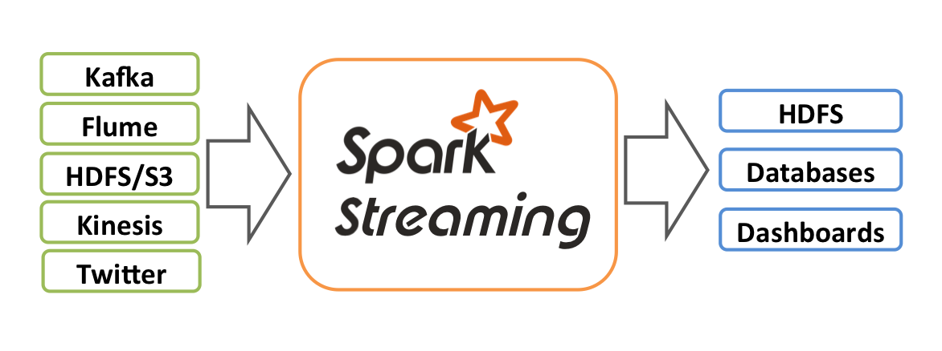

Internally, it works as follows. Spark Streaming receives live input data streams and divides the data into batches, which are then processed by the Spark engine to generate the final stream of results in batches.

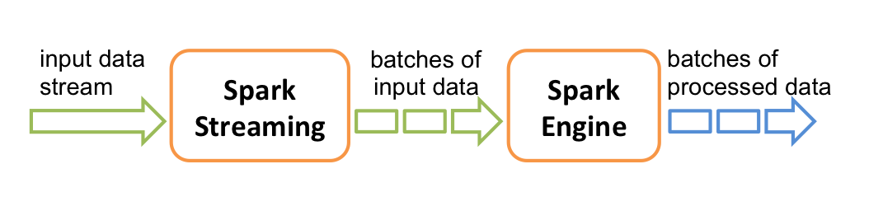

Spark Streaming provides a high-level abstraction called discretized stream or DStream, which represents a continuous stream of data. DStreams can be created either from input data streams from sources such as Kafka, Flume, and Kinesis, or by applying high-level operations on other Dstreams.

Discretized Streams (DStreams)
Discretized Stream or DStream is the basic abstraction provided by Spark Streaming. It represents a continuous stream of data, either the input data stream received from source, or the processed data stream generated by transforming the input stream. Internally, a DStream is represented by a continuous series of RDDs, which is Spark’s abstraction of an immutable, distributed dataset

Example- NetworkWordCount

Let’s say we want to count the number of words in text data received from a data server listening on a TCP socket. All you need to do is as follows.
The complete code can be found in the Spark Streaming example NetworkWordCount.

If you have already downloaded and built Spark, you can run this example as follows. You will first need to run Netcat (a small utility found in most Unix-like systems) as a data server by using

$ nc -lk 9999
Then, in a different terminal, you can start the example by using

# TERMINAL 1:
# Running Netcat

$ nc -lk 9999

hello world

# TERMINAL 2: RUNNING NetworkWordCount
$ ./bin/run-example streaming.NetworkWordCount localhost 9999
...
-------------------------------------------
Time: 1357008430000 ms
-------------------------------------------
(hello,1)
(world,1)
...

Running NetworkWordCount from spark-shell

First, we import the names of the Spark Streaming classes and some implicit conversions from StreamingContext into our environment in order to add useful methods to other classes we need (like DStream). StreamingContext is the main entry point for all streaming functionality. We create a local StreamingContext with two execution threads, and a batch interval of 1 second.

$spark-shell
#import org.apache.spark._ # dont need this. spark-shell already creates Spark session- spark
import org.apache.spark.streaming._ #required in spark-shell

val conf = new SparkConf().setMaster("local[2]").setAppName("NetworkWordCount").set("spark.driver.allowMultipleContexts", "true")
val ssc = new StreamingContext(conf, Seconds(1))

I run into a exception:
org.apache.spark.SparkException: Only one SparkContext may be running in this JVM (see SPARK-2243). To ignore this error, set spark.driver.allowMultipleContexts = true. The currently running SparkContext was created at..

Solution:
If you are running in a spark-shell you already have a SparkSession object as spark. Also SparkContext are already initialized in spark-shell. So the error Multiple running SparkContexts detected in the same JVM is due to multiple SparkContext, one in your code and another in spark-shell

You can have only one SparkContext instance, unless you set spark.driver.allowMultipleContexts = true (but it's not recommended - it's for tests, not production)

When you open the spark-shell, there is already a streaming context created. It is called sc, meaning you do not need to create a configure object. Simply use the existing sc object.

val ssc = new StreamingContext(sc,Seconds(1))

Using this context, we can create a DStream that represents streaming data from a TCP source, specified as hostname (e.g. localhost) and port (e.g. 9999).

// Create a DStream that will connect to hostname:port, like localhost:9999
val lines = ssc.socketTextStream("localhost", 9999)

This 'lines' DStream represents the stream of data that will be received from the data server. Each record in this DStream is a line of text. Next, we want to split the lines by space characters into words.

// Split each line into words
val words = lines.flatMap(_.split(" "))

flatMap is a one-to-many DStream operation that creates a new DStream by generating multiple new records from each record in the source DStream. In this case, each line will be split into multiple words and the stream of words is represented as the words DStream. Next, we want to count these words.

// import org.apache.spark.streaming.StreamingContext._ // not necessary since Spark 1.3
// Count each word in each batch
val pairs = words.map(word => (word, 1))
val wordCounts = pairs.reduceByKey(_ + _)

// Print the first ten elements of each RDD generated in this DStream to the console
wordCounts.print()

The words DStream is further mapped (one-to-one transformation) to a DStream of (word, 1) pairs, which is then reduced to get the frequency of words in each batch of data. Finally, wordCounts.print() will print a few of the counts generated every second.

Note that when these lines are executed, Spark Streaming only sets up the computation it will perform when it is started, and no real processing has started yet. To start the processing after all the transformations have been setup, we finally call

ssc.start() // Start the computation
// it starts from here only in spark-shell

ssc.awaitTermination() // Wait for the computation to terminate

New Terminal:
# Running Netcat
$ nc -lk 9999
the the the sun sun rises in in in in the the east

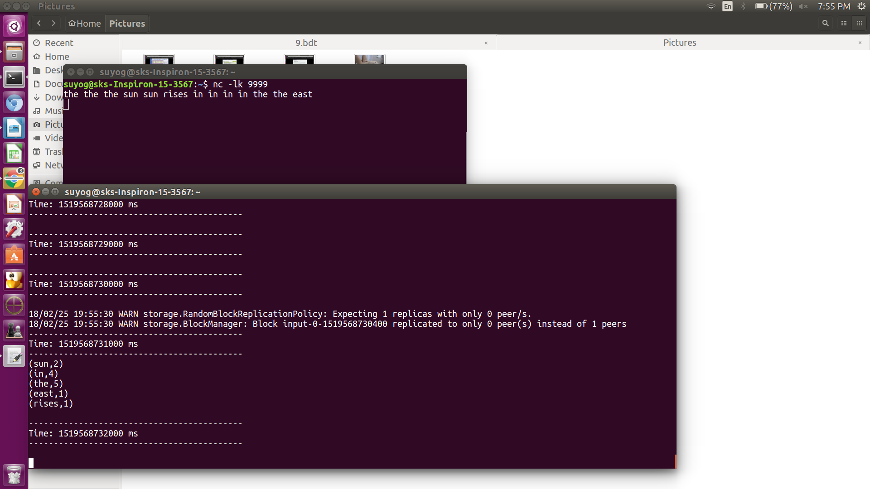

DOCKER

https://www.digitalocean.com/community/tutorials/how-to-install-and-use-docker-on-ubuntu-16-04

Guide to use cloudera docker

INSTALL DOCKER
#works on centOS7, probably on Ubuntu 16.04 too
sudo yum install docker

#Create a group with docker
sudo groupadd docker
usermod -aG docker dbda

#Logout and login again. Then,
sudo service docker start

IMPORTING DOCKER
import from folder which has file (importing once is enough?)
[dbda@localhost ~]$ cd Docker
[dbda@localhost Docker]$ ls
cloudera cloudera-quickstart-vm-5.12.0-0-beta-docker.tar README.txt
[dbda@localhost Docker]$ docker import - cloudera/quickstart:latest < ./cloudera-quickstart-vm-5.12.0-0-beta-docker.tar

docker run --hostname=quickstart.cloudera --privileged=true -t -i cloudera/quickstart:latest /usr/bin/docker-quickstart

done!!

START NTPD
from docker terminal “#”
service ntpd status
service ntpd start

START CLOUDERA-MANAGER
(from docker terminal) start cloudera manager (did it did this in cloudera vm?):
/home/cloudera/cloudera-manager --express --force

SEARCH CONTAINER ID
active containers: docker ps
sleeping containers: docker ps -a

[dbda@localhost Downloads]$ docker inspect 5b (5b is 1st 2 letters of container id)
locate ip
type ip (example-172.17.0.2) in browser
172.17.0.2:7180

done!!

#list of docker commands
$docker

#help regarding command
$docker start --help

#Search container id
docker ps or docker ps -a to get container id

#Start container:
sudo docker start <container Id>
or
sudo docker start -ai 5bbe0d0fd12f
or
sudo docker restart 265d2259eca4 (works for splunk)

#stop a container
sudo docker stop 9753fb7c0b98

stop all containers:
sudo docker stop $(sudo docker ps -a -q)

#remove a container
docker rm <container id>
sudo docker rm 725fb1a6bb99

#stop docker
sudo systemctl stop docker
sudo service docker stop

Error resolving
To solve this error
$docker version (example command)
## error loading config.json, permission denied

Try running
sudo chown "$USER":"$USER" /home/"$USER"/.docker -R
sudo chmod g+rwx "/home/$USER/.docker" -R
$USER is the username of the currently logged in user.

Starting Cloudera docker
$Docker start -ai [container-id]
#ls /home/suyog/data
input_wc.txt sample_sqoop.txt .....

Copying file in docker
The cp command can be used to copy files. One specific file can be copied like:

(docker terminal)#mkdir home/sks

copy to docker:
$docker cp ~/data/train_data.txt 9753fb7c0b98:/home/sks/

copy from docker:
$docker cp 9753fb7c0b98:/home/sks/train_data.txt ~/data/

Multiple files contained by the folder src can be copied into the target folder using:
docker cp src/. mycontainer:/target
docker cp mycontainer:/src/. Target

mysql in cloudera docker
mysql -u root -p
Enter password: cloudera
mysql>exit
#pig -x local
grunt>
records = LOAD '/home/suyog/data/sample.txt' AS (year:chararray, temperature:int, quality:int);
filtered_records = FILTER records BY temperature != 9999 AND quality IN (0, 1, 4, 5, 9);
grouped_records= GROUP filtered_records BY year;
DUMP grouped_records;
max_temp = FOREACH grouped_records GENERATE group, MAX(filtered_records.temperature);
DUMP max_temp;
quit
#

docker import...
docker run...
docker cp /home/suyog/data/sample_sqoop.txt ee83679f76fd:/home/suyog/data/
#docker start -ai ee83679f76fd

#Copy file in Docker
sudo docker cp /home/dbda/sks/sample.txt f82596a9f487:/home/sks

Docker env Vs myMachine env:
docker: cloudera-quickstart-vm-5.12.0-0-beta-docker
Hadoop 2.6.0-cdh5.12.0
Apache Pig version 0.12.0-cdh5.12.0 (rexported)
Sqoop 1.4.6-cdh5.12.0
Hive 1.1.0-cdh5.12.0
HBase 1.2.0-cdh5.12.0

my_machine_ubuntu16.04:
hadoop-2.6.0-cdh5.13.0 (pseudo distributed mode)
pig-0.17.0
sqoop-1.4.6-cdh5.13.0
hive-1.1.0-cdh5.13.0
hbase-1.2.6
spark-2.2.0-bin-hadoop2.6
zookeeper-3.4.6

SPLUNK

dockerhub:
https://hub.docker.com/r/splunk/splunk/
dockerasd123groot@DOCKER#123
docker login

SPLUNK:
pull splunk from docker hub:https://hub.docker.com/r/splunk/splunk/
sudo docker inspect 26
http://localhost:8000 not working on ubuntu machine
127.0.0.1:8000 worked
localhost:8000 now it worked too

major bloat admin groot at SPLUNK hush 1two3 5to6

login splunk-
http://localhost:8000/en-GB/account/logout

You have probably heard of Splunk, but can you describe what it does to a colleague in a few sentences? That is not easy. Splunk does not belong in any traditional category but stands apart from the crowd. That makes it interesting, but also the explaining harder. Here is my attempt.

Google for Logfiles
What do you do when you need information about the state of a machine or software? You look at its log files. They tell you the state it is in and what happened recently. Great.

What do you do when you need information about the state of all devices in your data center? Looking at all log files would be the right answer if it was possible in any practical amount of time. This is where Splunk comes in.

Splunk started out as a kind of “Google for Logfiles”. It does a lot more today but log processing is still at the product’s core. It stores all your logs and provides very fast search capabilities roughly in the same way Google does for the internet.

Search Processing Language
Although you can just use simple search terms, e.g. a username, and see how often that turns up in a given time period Splunk’s Search Processing Language (SPL) offers a lot more. SPL is an extremely powerful tool for sifting through vast amounts of data and performing statistical operations on what is relevant in a specific context. Think SQL on steroids. And then some.

For example, you might want to know which applications are the slowest to start up, making the end user wait the longest. The following search answers that. First, the relevant data is selected by specifying a so-called sourcetype (“ProcessStartup”). The result of this sub-command is piped (“|”) to another command that groups the data by application (“by Name”), calculates the average for each group (“avg(StartupTimeMs)”) and charts the results’ distribution over time (“timechart”):

index=uberagent sourcetype=uberAgent:Process:ProcessStartup | timechart avg(StartupTimeMs) by Name

Splunk is a SIEM (Security Incident and Event Management)
It is being used by a lot of world-wide companies like Coca-cola, IBM, Cisco etc to maintain their security compliances

Apache website:
Bring the power of Splunk Enterprise to Hadoop. Seamlessly search and analyze Hadoop-based data as part of your Splunk Enterprise deployment with Splunk Analytics for Hadoop. Splunk Analytics for Hadoop gives you the power to rapidly detect patterns and find anomalies across petabytes of raw data in Hadoop without the need to move or replicate data.

Interactively query raw data by previewing results and refining searches using the same Splunk Enterprise interface
Quickly create and share charts, graphs and dashboards
Ensure security with role-based access control and HDFS pass-through authentication
Splunk Analytics for Hadoop natively supports Apache Hadoop and Amazon EMR, Cloudera CDH, Hortonworks Data Platform, IBM InfoSphere BigInsights, MapR M-series and Pivotal HD distributions

Schema-on-the-Fly
You don’t have to rely on brittle, predefined schemas. You can ask any question of your data because the schema is automatically created at search time, and can even run against data that’s being ingested in real time. Because the data is always maintained in its raw format, there’s no need for costly ETL or data normalization, and there’s no need to manually recreate a schema when new data types are added or new searches are run.

DATABASES

OLTP (On-line Transaction Processing) is involved in the operation of a particular system. OLTP is characterized by a large number of short on-line transactions (INSERT, UPDATE, DELETE). The main emphasis for OLTP systems is put on very fast query processing, maintaining data integrity in multi-access environments and an effectiveness measured by number of transactions per second. In OLTP database there is detailed and current data, and schema used to store transactional databases is the entity model (usually 3NF). It involves Queries accessing individual record like Update your Email in Company database.

OLAP (On-line Analytical Processing) deals with Historical Data or Archival Data. OLAP is characterized by relatively low volume of transactions. Queries are often very complex and involve aggregations. For OLAP systems a response time is an effectiveness measure. OLAP applications are widely used by Data Mining techniques. In OLAP database there is aggregated, historical data, stored in multi-dimensional schemas (usually star schema). Sometime query need to access large amount of data in Management records like what was the profit of your company in last year.

Most key-value stores (including Cassandra) offer some form of grouping for columns and can be considered "column family" or "big table" as well. Some databases such as HBase were designed as column family stores from the beginning. This is a more advanced form of a key-value pair database. Essentially, the keys and values become composite. Think of this as a hash map crossed with a multidimensional array. Essentially each column contains a row of data.
https://www.infoworld.com/article/2617876/database/database-which-freaking-database-should-i-use.html

NoSQL databases
NoSQL systems are distributed, non-relational databases designed for large-scale data storage and for massively-parallel, high-performance data processing across a large number of commodity servers.

Schema on read Vs schema on write:
For decades now the database world has been oriented towards the schema-on-write approach. First you define your schema, then you write your data, then you read your data and it comes back in the schema you defined up-front. This approach is so deeply ingrained in our thinking that many people would ask, “how else would you do it?” The answer is schema-on-read.

Schema on read follows a different sequence – just load the data as-is and apply your own lens to the data when you read it back out. You might say, “OK, fine. But why would you want to do that?” There are several really compelling reasons. I’ll cover the main ones here.

Columnar Vs row-oriented databases
Columnar data structures provide a number of performance advantages over traditional row-oriented data structures for analytics. These include benefits for data on disk – fewer disk seeks, more effective compression, faster scan rates – as well as more efficient use of CPU for data in memory. Today columnar data is very common and is implemented by most analytical databases, including Teradata, Vertica, Oracle, and others.

In 2012 and 2013 several of us at Twitter and Cloudera created Apache Parquet (originally called Red Elm, an anagram for Google’s Dremel) to bring these ideas to the Hadoop ecosystem. Four years later, Parquet is the standard for columnar data on disk, and a new project called Apache Arrow has emerged to become the standard way of representing columnar data in memory. In this article we’ll take a closer look at why we need two projects, one for storing data on disk and one for processing data in memory, and how they work together.

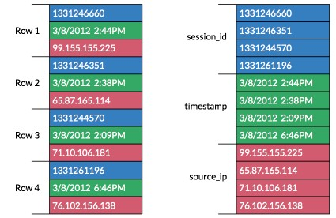

Most systems are engineered to minimize the number of disk seeks and the amount of data scanned, as these operations can add tremendous latency. In transactional workloads, as data is written to a table in a row-oriented database, the columns for a given row are written out to disk contiguously, which is very efficient for writes. Analytical workloads differ in that most queries read a small subset of the columns for large numbers of rows at a time. In a traditional row-oriented database, the system might perform a seek for each row, and most of the columns would be read from disk into memory unnecessarily.

A columnar database organizes the values for a given column contiguously on disk. This has the advantage of significantly reducing the number of seeks for multi-row reads. Furthermore, compression algorithms tend to be much more effective on a single data type rather than the mix of types present in a typical row. The tradeoff is that writes are slower, but this is a good optimization for analytics where reads typically far outnumber writes.

Compression
the sun rises in the east rises rises rises eat east
#assigning numbers/markers
the- 1
sun- 2
rises- 3
in- 4
east- 5
compression will happen on repetitive elements- sun, rises , east
more repetition -> higher compression

HBase

Apache HBase is the Hadoop database, a distributed, scalable, big data store.

Use Apache HBase when you need random, realtime read/write access to your Big Data. This project's goal is the hosting of very large tables -- billions of rows X millions of columns -- atop clusters of commodity hardware. Apache HBase is an open-source, distributed, versioned, non-relational database modeled after Google's Bigtable: A Distributed Storage System for Structured Data by Chang et al. Just as Bigtable leverages the distributed data storage provided by the Google File System, Apache HBase provides Bigtable-like capabilities on top of Hadoop and HDFS.

Features
- Linear and modular scalability.
- Strictly consistent reads and writes.
- Automatic and configurable sharding of tables
- Automatic failover support between RegionServers.
- Convenient base classes for backing Hadoop MapReduce jobs with Apache HBase tables.
- Easy to use Java API for client access.
- Block cache and Bloom Filters for real-time queries.
- Query predicate push down via server side Filters
- Thrift gateway and a REST-ful Web service that supports XML, Protobuf, and binary data encoding option
- Extensible jruby-based (JIRB) shell
- Support for exporting metrics via the Hadoop metrics subsystem to files or Ganglia; or via JMX

HBase is a NoSQL datastore that runs on top of your existing Hadoop cluster(HDFS). It provides you capabilities like random, real-time reads/writes, which HDFS being a FS lacks. Since it is a NoSQL datastore it doesn't follow SQL conventions and terminologies. HBase provides a good set of APIs( includes JAVA and Thrift). Along with this HBase also provides seamless integration with MapReduce framework. But, along with all these advantages of HBase you should keep this in mind that random read-write is quick but always has additional overhead. So think well before ye make any decision.

ZooKeeper is a high-performance coordination service for distributed applications(like HBase). It exposes common services like naming, configuration management, synchronization, and group services, in a simple interface so you don't have to write them from scratch. You can use it off-the-shelf to implement consensus, group management, leader election, and presence protocols. And you can build on it for your own, specific needs.

HBase relies completely on Zookeeper. HBase provides you the option to use its built-in Zookeeper which will get started whenever you start HBAse. But it is not good if you are working on a production cluster. In such scenarios it's always good to have a dedicated Zookeeper cluster and integrate it with your HBase cluster.

Note : You should always have odd number of nodes in your ZK Quorum.

hbase is in stand alone mode:

5.1. Standalone HBase
This is the default mode. Standalone mode is what is described in the quickstart section. In standalone mode, HBase does not use HDFS — it uses the local filesystem instead — and it runs all HBase daemons and a local ZooKeeper all up in the same JVM. ZooKeeper binds to a well known port so clients may talk to HBase.

5.1.1. Standalone HBase over HDFS
A sometimes useful variation on standalone hbase has all daemons running inside the one JVM but rather than persist to the local filesystem, instead they persist to an HDFS instance.

$start-hbase.sh
$hbase shell

hbase(main):001:0> status

h-base webgui- http://localhost:60010/
http://localhost:16010/master-status

$hbase rest start -p 8080
browser: localhost:8080
//shows this in browser (these are tables stored in hbase)
MyTableName
MyTableName2
MyTableName3

$stop-hbase.sh

#$hadoop jar /home/suyog/eclipse-workspace/hadoop.wordcount/target/hadoop.wordcount-0.0.1-SNAPSHOT.jar org.daa.examples.hadoop.wordcount.WordCount /user/sks/wc/input.txt /user/sks/wc/output

$ hadoop jar /home/suyog/eclipse-workspace/hbase/target/hbase-0.0.1-SNAPSHOT.jar org.cdac.examples.hbase.HbaseClient
Exception in thread "main" java.lang.NoClassDefFoundError: org/apache/hadoop/hbase/HBaseConfiguration
at org.cdac.examples.hbase.HbaseClient.main(HbaseClient.java:23)

APACHE PHOENIX

Apache Phoenix enables OLTP and operational analytics in Hadoop for low latency applications by combining the best of both worlds:

the power of standard SQL and JDBC APIs with full ACID transaction capabilities and
the flexibility of late-bound, schema-on-read capabilities from the NoSQL world by leveraging HBase as its backing store
Apache Phoenix is fully integrated with other Hadoop products such as Spark, Hive, Pig, Flume, and Map Reduce.

Apache Phoenix http://phoenix.apache.org/ is a SQL skin over HBase delivered as a client-embedded JDBC driver targeting low latency queries over HBase data. Visit the Apache Phoenix website- http://phoenix.apache.org/

Start phoenix client:
$bin/sqlline.py <your_zookeeper_host>

tried sqlline.py localhost
Setting property: [incremental, false]
Setting property: [isolation, TRANSACTION_READ_COMMITTED]
issuing: !connect jdbc:phoenix:localhost none none org.apache.phoenix.jdbc.PhoenixDriver
Connecting to jdbc:phoenix:localhost
SLF4J: Class path contains multiple SLF4J bindings.
SLF4J: Found binding in [jar:file:/home/suyog/hadooop/apache-phoenix-4.13.1-HBase-1.2-bin/phoenix-4.13.1-HBase-1.2-client.jar!/org/slf4j/impl/StaticLoggerBinder.class]
SLF4J: Found binding in [jar:file:/home/suyog/hadooop/hadoop-2.6.0-cdh5.13.0/share/hadoop/common/lib/slf4j-log4j12-1.7.5.jar!/org/slf4j/impl/StaticLoggerBinder.class]
SLF4J: See http://www.slf4j.org/codes.html#multiple_bindings for an explanation.
18/02/28 20:51:20 WARN util.NativeCodeLoader: Unable to load native-hadoop library for your platform... using builtin-java classes where applicable
18/02/28 20:51:21 WARN client.ClientIdGenerator: Failed to get IP address bytes
java.net.SocketException: Can't get our ip address, interfaces are: java.net.NetworkInterface$2@5939a379
...
Connected to: Phoenix (version 4.13)
Driver: PhoenixEmbeddedDriver (version 4.13)
Autocommit status: true
Transaction isolation: TRANSACTION_READ_COMMITTED
Building list of tables and columns for tab-completion (set fastconnect to true to skip)...
92/92 (100%) Done
Done
sqlline version 1.2.0

0: jdbc:phoenix:localhost> help
0: jdbc:phoenix:localhost> !help

0: jdbc:phoenix:localhost> !list
0: jdbc:phoenix:localhost> !tables

0: jdbc:phoenix:localhost> !exit
Closing: org.apache.phoenix.jdbc.PhoenixConnection

using machine host- sks-Inspiron-15-3567
$ sqlline.py sks-Inspiron-15-3567
Setting property: [incremental, false]
Setting property: [isolation, TRANSACTION_READ_COMMITTED]
issuing: !connect jdbc:phoenix:sks-Inspiron-15-3567 none none org.apache.phoenix.jdbc.PhoenixDriver
Connecting to jdbc:phoenix:sks-Inspiron-15-3567
SLF4J: Class path contains multiple SLF4J bindings.
SLF4J: Found binding in [jar:file:/home/suyog/hadooop/apache-phoenix-4.13.1-HBase-1.2-bin/phoenix-4.13.1-HBase-1.2-client.jar!/org/slf4j/impl/StaticLoggerBinder.class]
SLF4J: Found binding in [jar:file:/home/suyog/hadooop/hadoop-2.6.0-cdh5.13.0/share/hadoop/common/lib/slf4j-log4j12-1.7.5.jar!/org/slf4j/impl/StaticLoggerBinder.class]
SLF4J: See http://www.slf4j.org/codes.html#multiple_bindings for an explanation.
18/03/01 00:15:42 WARN util.NativeCodeLoader: Unable to load native-hadoop library for your platform... using builtin-java classes where applicable
Connected to: Phoenix (version 4.13)
Driver: PhoenixEmbeddedDriver (version 4.13)
Autocommit status: true
Transaction isolation: TRANSACTION_READ_COMMITTED
Building list of tables and columns for tab-completion (set fastconnect to true to skip)...
92/92 (100%) Done
Done
sqlline version 1.2.0
0: jdbc:phoenix:sks-Inspiron-15-3567>

no warnings!!

0: jdbc:phoenix:localhost> !quit
Closing: org.apache.phoenix.jdbc.PhoenixConnection

ZOOKEEPER

HDFS didn't use ZooKeeper (until recently) because it didn't need to. Until recently, Apache Hadoop didn't have a highly available namenode so there was no leader to elect; there was only one possible candidate. Today, the HDFS namenode is highly available and, when configured for automatic failover, the HDFS failover controllers use ZooKeeper to perform leader election. The failover controllers, in turn, effect state changes of their constituent namenode processes. This works mostly the same as HBase's multiple masters, except a separate process (the failover controller) handles issuing state changes rather than it being a function of the namenode, proper.

Hadoop 1.x does not use Zookeeper. HBase does use zookeeper even in Hadoop 1.x installations.

Hadoop adopted Zookeeper as well starting with version 2.0.

The purpose of Zookeeper is cluster management. This fits with the general philosophy of *nix of using smaller specialized components - so components of Hadoop that want clustering capabilities rely on Zookeeper for that rather than develop their own.

Zookeeper is a distributed storage that provides the following guarantees (copied from Zookeeper overview page):

Sequential Consistency - Updates from a client will be applied in the order that they were sent.
Atomicity - Updates either succeed or fail. No partial results.
Single System Image - A client will see the same view of the service regardless of the server that it connects to.
Reliability - Once an update has been applied, it will persist from that time forward until a client overwrites the update.
Timeliness - The clients view of the system is guaranteed to be up-to-date within a certain time bound.

zkServer.sh start
zkServer.sh status

FLUME

Apache Sqoop Tutorial: Flume vs Sqoop
The major difference between Flume and Sqoop is that:

Flume only ingests unstructured data or semi-structured data into HDFS.
While Sqoop can import as well as export structured data from RDBMS or Enterprise data warehouses to HDFS or vice versa.

Now, advancing in our Apache Sqoop Tutorial it is the high time to go through Apache Sqoop commands.

APACHE DataFu

Apache DataFu (incubating) is a collection of libraries for working with large-scale data in Hadoop. The project was inspired by the need for stable, well-tested libraries for data mining and statistics.

It consists of two libraries:

Apache DataFu Pig: a collection of user-defined functions for Apache Pig
Apache DataFu Hourglass: an incremental processing framework for Apache Hadoop in MapReduce

HADOOP MAHOUT

m/c learning software
It offers 3 main techniques- recommendation, classification, clustering

OOZIE

Overview:
Oozie is a workflow scheduler system to manage Apache Hadoop jobs.
Oozie Workflow jobs are Directed Acyclical Graphs (DAGs) of actions.
Oozie Coordinator jobs are recurrent Oozie Workflow jobs triggered by time (frequency) and data availability.
Oozie is integrated with the rest of the Hadoop stack supporting several types of Hadoop jobs out of the box (such as Java map-reduce, Streaming map-reduce, Pig, Hive, Sqoop and Distcp) as well as system specific jobs (such as Java programs and shell scripts).
Oozie is a scalable, reliable and extensible system.

FLINK

Apache Flink is an open-source stream processing framework for distributed, high-performing, always-available, and accurate data streaming applications.

KAFKA

hi, my name is suyog and today I am going to explain kafka with legos..

kafka is publish-subscribe system.
Data gets published to kafka, and consumed by other machines

CASSANDRA

The Apache Cassandra database is the right choice when you need scalability and high availability without compromising performance. Linear scalability and proven fault-tolerance on commodity hardware or cloud infrastructure make it the perfect platform for mission-critical data.Cassandra's support for replicating across multiple datacenters is best-in-class, providing lower latency for your users and the peace of mind of knowing that you can survive regional outages.

CLUSTERING

How do I set up inexpensive Hadoop cluster?

Simplest way - EMR from AWS. A few dollar a hour is by far cheap way.

Cloudera Director - even cheaper, since there is no payment for EMR, only AWS costs.

adding as much RAM as you can on your desktop, and run several VMs and install hadoop inside them, You will learn most of the stuff, but performance will not be realistic.

If your needs are primarily educational, I suggest to create a Free-One month Azure subscription and start Hortonworks Sandbox Virtual Machine or in a VirtualBox

guides:
https://acadgild.com/blog/setting-hadoop-cluster-cloud/

3 parts:
https://techanswersweb.wordpress.com/2017/07/10/cloudera-manager-installation-on-google-cloud-part-2configure-the-server-and-install-cloudera-manager/
https://techanswersweb.wordpress.com/2017/07/22/cloudera-manager-installation-on-google-cloud-part-3assigning-roles-to-different-nodes/
https://techanswersweb.wordpress.com/2017/07/02/cloudera-manager-installation-on-google-cloud-part-1creating-virtual-machines-on-google-cloud/

Spark Cluster:
https://spark.apache.org/docs/latest/cluster-overview.html

Cloud:
https://aws.amazon.com/ec2/
https://cloud.google.com/
https://www.cloudsigma.com/pricing/

AMAZON WEB SERVICES

Amazon Elastic for clustering?

