DROP MENU

<!DOCTYPE html>

<html>

<head>

<style>

ul {

list-style-type: none;

margin: 0;

padding: 0;

overflow: hidden;

background-color: #333;

}

li {

float: left;

}

li a,

.dropbtn {

display: inline-block;

color: white;

text-align: center;

padding: 14px 16px;

text-decoration: none;

}

li a:hover,

.dropdown:hover .dropbtn {

background-color: red;

}

li.dropdown {

display: inline-block;

}

.dropdown-content {

display: none;

position: absolute;

background-color: #f9f9f9;

min-width: 160px;

box-shadow: 0px 8px 16px 0px rgba(0, 0, 0, 0.2);

}

.dropdown-content a {

color: black;

padding: 12px 16px;

text-decoration: none;

display: block;

text-align: left;

}

.dropdown-content a:hover {

background-color: #f1f1f1

}

.dropdown:hover .dropdown-content {

display: block;

}

</style>

</head>

<body>

<ul>

<li><a href="#home">Home</a></li>

<li><a href="#news">News</a></li>

<li class="dropdown">

<a href="javascript:void(0)" class="dropbtn">Dropdown</a>

<div class="dropdown-content">

<a href="#">Link 1</a>

<a href="#">Link 2</a>

<a href="#">Link 3</a>

</div>

</li>

</ul>

<h3>Dropdown Menu inside a Navigation Bar</h3>

<p>Hover over the "Dropdown" link to see the dropdown menu.</p>

</body>

</html>

==============================================================

SLIDE SHOW

<!DOCTYPE html>

<html>

<title>W3.CSS</title>

<meta name="viewport" content="width=device-width, initial-scale=1">

<link rel="stylesheet" href="https://www.w3schools.com/w3css/4/w3.css">

<style>

.mySlides {

display: none;

}

</style>

<body>

<h2 class="w3-center">Manual Slideshow</h2>

<div class="w3-content w3-display-container">

<img class="mySlides" src="img_snowtops.jpg" style="width:100%">

<img class="mySlides" src="img_lights.jpg" style="width:100%">

<img class="mySlides" src="img_mountains.jpg" style="width:100%">

<img class="mySlides" src="img_forest.jpg" style="width:100%">

<button class="w3-button w3-black w3-display-left" onclick="plusDivs(-1)">&#10094;</button>

<button class="w3-button w3-black w3-display-right" onclick="plusDivs(1)">&#10095;</button>

</div>

<script>

var slideIndex = 1;

showDivs(slideIndex);

function plusDivs(n) {

showDivs(slideIndex += n);

}

function showDivs(n) {

var i;

var x = document.getElementsByClassName("mySlides");

if (n > x.length) { slideIndex = 1 }

if (n < 1) { slideIndex = x.length }

for (i = 0; i < x.length; i++) {

x[i].style.display = "none";

}

x[slideIndex - 1].style.display = "block";

}

</script>

</body>

</html>

==============================================================

For auto sideshow

var slideIndex = 0;  
carousel();  
  
function carousel() {  
  var i;  
  var x = document.getElementsByClassName("mySlides");  
  for (i = 0; i < x.length; i++) {  
    x[i].style.display = "none";   
  }  
  slideIndex++;  
  if (slideIndex > x.length) {slideIndex = 1}   
  x[slideIndex-1].style.display = "block";   
  setTimeout(carousel, 2000); // Change image every 2 seconds  
}

=============================================================================

DROPMENU DỌC

<div id="menu">

<ul>

<li><a href="#">Trang chủ</a></li>

<li><a href="#">Tin tức</a>

<ul class="sub-menu">

<li><a href="#">WordPress</a></li>

<li><a href="#">SEO</a></li>

<li><a href="#">Hosting</a></li>

</ul>

</li>

<li><a href="#">Sản phẩm</a></li>

<li><a href="#">Liên hệ</a></li>

</ul>

</div>

#menu ul {

background: #8AD385;

width: 250px;

padding: 0;

list-style-type: none;

text-align: left;

}

#menu li {

width: auto;

height: 40px;

line-height: 40px;

border-bottom: 1px solid #e8e8e8;

padding: 0 1em;

}

#menu li a {

text-decoration: none;

color: #333;

font-weight: bold;

display: block;

}

#menu li:hover {

background: #CDE2CD;

}

/*==Dropdown Menu==*/

#menu ul li {

position: relative;

}

#menu .sub-menu {

position: absolute;

left: 250px;

top: 0;

display: none;

}

#menu li:hover .sub-menu {

display: block;

}

----------------------------------------------------

<select multiple size="6">

<option value="American">American flamingo</option>

<option value="Andean">Andean flamingo</option>

<option value="Chilean">Chilean flamingo</option>

<option value="Greater">Greater flamingo</option>

<option value="James's">James's flamingo</option>

<option value="Lesser">Lesser flamingo</option>

</select>

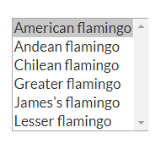

-----------------------------------------------

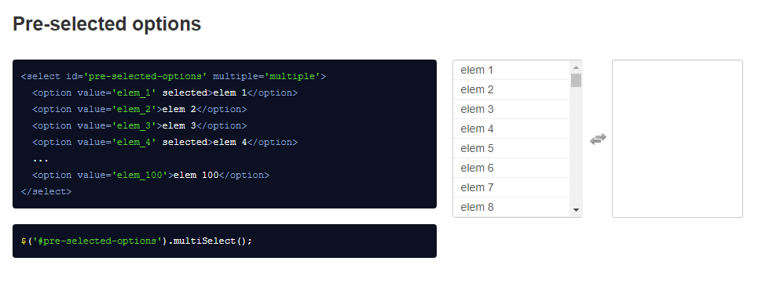

<form>

<fieldset>

<legend>Personalia:</legend>

Name: <input type="text"><br>

Email: <input type="text"><br>

Date of birth: <input type="text">

</fieldset>

</form>

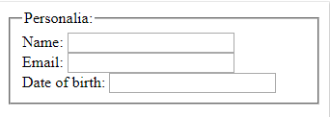

---------------------------------------------------------------------

<select name="loaihoa" id="loaihoa">

<option value="Hoa Hồng">Hoa Hồng</option>

<option value="Hoa Lay Ơn">Hoa Lay Ơn</option>

<option value="Hoa Cúc">Hoa Cúc</option>

<option value="Hoa Tulip">Hoa Tulip</option>

<option value="Hoa Thược Dược">Hoa Thược Dược</option>

<option value="Hoa Vạn Thọ">Hoa Vạn Thọ</option>

<option value="Mai Vàng">Mai Vàng</option>

</select>

var lhoa = document.getElementById("loaihoa").value;

--------------------------------------------------------------

<!DOCTYPE html>

<html>

    <head>

        <title>Select Multiple</title>

        <meta charset="UTF-8">

        <meta name="viewport" content="width=device-width, initial-scale=1.0">

    </head>

    <body>

        <h2>Ví dụ được biên soạn tại freetuts.net</h2>

        <h3>Chọn các chuyên mục từ danh sách dưới đây</h3>

        <select multiple onchange="validateSelectBox(this)">

            <option value="tin công nghệ">Tin công nghệ</option>

            <option value="tin thời sự">Tin thời sự</option>

            <option value="tin quốc tế">Tin quốc tế</option>

            <option value="tin thể thao">Tin thể thao</option>

            <option value="tin nông nghiệp">Tin nông nghiệp</option>

        </select>

        <h3>Danh sách chuyên mục bạn đã chọn:</h3>

        <div id="result">

            Bạn chưa chọn chuyên mục nào

        </div>

        <script language="javascript">

            function validateSelectBox(obj)

            {

                // Lấy danh sách các options

                var options = obj.children;

                // Biến lưu trữ các chuyên mục đa chọn

                var html = '';

                // lặp qua từng option và kiểm tra thuộc tính selected

                for (var i = 0; i < options.length; i++){

                    if (options[i].selected){

                        html += '<li>'+options[i].value+'</li>';

                    }

                }

                // Gán kết quả vào div#result

                document.getElementById('result').innerHTML = html;

            }

        </script>

    </body>

</html>

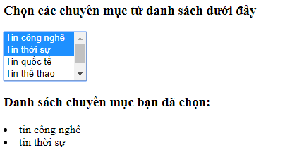

----------------------------------------------------------------

Allow Only One Checkbox to be Checked using jQuery

<input type="checkbox" name="skill" value="male"> Male

<input type="checkbox" name="skill" value="female"> Female

<input type="checkbox" name="skill" value="other"> Other

<script>

$(document).ready(*function*(){

$('input:checkbox').click(*function*() {

$('input:checkbox').not(this).prop('checked', **false**);

});

});

</script>

------------------------------

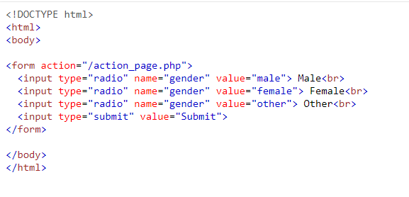

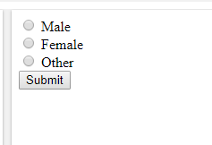

--------------------------------------------------

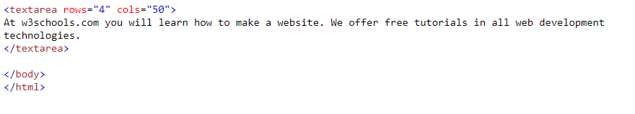

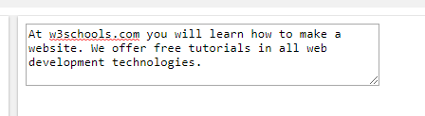

---------------------------------------------------------------

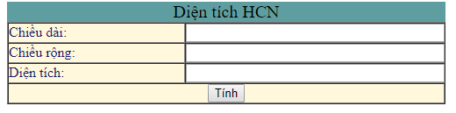

<form action="" method="get">

<table width="500px" align="center" cellpadding="0" cellspacing="0" border="1" style="background-color:cornsilk;color:midnightblue;">

<caption style="background-color:cadetblue; font-size: 20px; color: #000;">Diện tích HCN</caption>

<tr>

<td width="200px">Chiều dài: </td>

<td><input style="width:99%;" type="number" id="txtchieudai" required="required"></td>

</tr>

<tr>

<td width="200px">Chiều rộng: </td>

<td><input style="width:99%;" type="number" name="chieurong" id="txtchieurong"></td>

</tr>

<tr>

<td width="200px">Diện tích: </td>

<td><input style="width:99%;" type="number" name="dientich" id="txtdientich"></td>

</tr>

<tr>

<td colspan="2" align="center">

<input type="button" value="Tính" onclick="tinhDienTich();">

</td>

</tr>

</table>

</form>