Capstone Project Report
  - Ambient Air Quality Anaysis
Ochea Ikpa
2025-12-10
Table of contents

# Load libraries
library(tidyverse)
library(readxl)
library(here)
library(dplyr)
library(readr)
library(ggthemes)
library(ggridges)
library(ggplot2)
library(gt)
library(knitr)
library(stringr)
library(lubridate)
library(broom)
library(scales)
library(sf)
library(janitor)
library(stringr)
library(gt)
library(gtsummary)
library(DT)
# import raw data
ambient_air <- read_excel(here::here("data/raw/who_ambient_air_quality_database_version_2024_(v6.1).xlsx"), sheet = "Update 2024 (V6.1)")
# Process raw data (data transformation)
air_quality <- ambient_air |>
clean_names() |> # cleaning and standardizing name
rename_with(~ gsub("\\s+", "_", .x)) |> # dobulechecking by replacing spaces with "_"
rename(region = who_region,
country = country_name,
pm10 = pm10_concentration,
pm25 = pm25_concentration,
no2 = no2_concentration,
station = type_of_stations) |> # reanmming variable names
mutate(region = recode(region,
`1_Afr` = "AF",
`2_Amr` = "AM",
`3_Sear` = "SEA",
`4_Eur` = "EU",
`5_Emr` = "EM",
`6_Wpr` = "WP",
`7_NonMS` = "NonMS")) |>
mutate(city = str_remove(city, "/[A-Z]{3}$")) |>
mutate(across(c(pm10, pm25, no2, population),
as.numeric), year = as.integer(year), city = factor(city)) |>
filter(!is.na(pm10) &
!is.na(pm25) &
!is.na(no2) & !is.na(year) & !is.na(population)) |>
select(region:year,
pm10:no2, # selcting relevant columns for analysis
station,
population) |>
arrange(region, country, city, year)
# export processed data
write_csv(air_quality,
here::here("data/processed/who_ambient_air_quality_database_version_2024_(v6.1)_processed.csv"))

Note: *****“Create ReadMe & Dictionary files”
# load dataset
air_quality
# A tibble: 6,927 × 10
region iso3 country city year pm10 pm25 no2 station population
<chr> <chr> <chr> <fct> <int> <dbl> <dbl> <dbl> <chr> <dbl>
1 AF BEN Benin Cotonou 2020 9.1 7.7 130. NA 691949
2 AF ZAF South Africa Buffalo 2021 29.0 12.6 10.9 NA 708559
3 AF ZAF South Africa Cape T… 2019 19.8 8.07 24.2 NA 4617560
4 AF ZAF South Africa Cape T… 2020 25.2 8.91 8.22 NA 4617560
5 AF ZAF South Africa Cape T… 2021 36.3 14.9 17.2 NA 4617560
6 AF ZAF South Africa Ethekw… 2015 23.7 15.6 3.7 NA 3158313
7 AF ZAF South Africa Ethekw… 2020 39.1 16.8 36.4 NA 3158313
8 AF ZAF South Africa Ethekw… 2021 39.1 16.7 11.6 NA 3158313
9 AF ZAF South Africa Johann… 2012 57.9 27.0 36.5 NA 5782747
10 AF ZAF South Africa Johann… 2013 41.0 23.1 55.1 NA 5782747
# ℹ 6,917 more rows
# explore dataset
glimpse(air_quality)
Rows: 6,927
Columns: 10
$ region <chr> "AF", "AF", "AF", "AF", "AF", "AF", "AF", "AF", "AF", "AF",…
$ iso3 <chr> "BEN", "ZAF", "ZAF", "ZAF", "ZAF", "ZAF", "ZAF", "ZAF", "ZA…
$ country <chr> "Benin", "South Africa", "South Africa", "South Africa", "S…
$ city <fct> Cotonou, Buffalo, Cape Town, Cape Town, Cape Town, Ethekwin…
$ year <int> 2020, 2021, 2019, 2020, 2021, 2015, 2020, 2021, 2012, 2013,…
$ pm10 <dbl> 9.100, 29.035, 19.816, 25.250, 36.336, 23.737, 39.125, 39.1…
$ pm25 <dbl> 7.700, 12.630, 8.067, 8.915, 14.855, 15.612, 16.834, 16.669…
$ no2 <dbl> 129.635, 10.880, 24.220, 8.220, 17.200, 3.700, 36.350, 11.6…
$ station <chr> "NA", "NA", "NA", "NA", "NA", "NA", "NA", "NA", "NA", "NA",…
$ population <dbl> 691949, 708559, 4617560, 4617560, 4617560, 3158313, 3158313…
head(air_quality)
# A tibble: 6 × 10
region iso3 country city year pm10 pm25 no2 station population
<chr> <chr> <chr> <fct> <int> <dbl> <dbl> <dbl> <chr> <dbl>
1 AF BEN Benin Cotonou 2020 9.1 7.7 130. NA 691949
2 AF ZAF South Africa Buffalo 2021 29.0 12.6 10.9 NA 708559
3 AF ZAF South Africa Cape To… 2019 19.8 8.07 24.2 NA 4617560
4 AF ZAF South Africa Cape To… 2020 25.2 8.91 8.22 NA 4617560
5 AF ZAF South Africa Cape To… 2021 36.3 14.9 17.2 NA 4617560
6 AF ZAF South Africa Ethekwi… 2015 23.7 15.6 3.7 NA 3158313
tail(air_quality)
# A tibble: 6 × 10
region iso3 country city year pm10 pm25 no2 station population
<chr> <chr> <chr> <fct> <int> <dbl> <dbl> <dbl> <chr> <dbl>
1 WP KOR Republic of Ko… Ulsan 2017 42.1 24.1 0.022 NA 910330
2 WP KOR Republic of Ko… Ulsan 2018 39.4 22.9 0.02 NA 910330
3 WP KOR Republic of Ko… Ulsan 2019 36.6 20.3 0.02 NA 910330
4 WP SGP Singapore Sing… 2014 30 18.0 24 NA 5935053
5 WP SGP Singapore Sing… 2018 29 15.0 26 NA 5935053
6 WP SGP Singapore Sing… 2021 28 12 25 Urban 5935053
str(air_quality)
tibble [6,927 × 10] (S3: tbl_df/tbl/data.frame)
$ region : chr [1:6927] "AF" "AF" "AF" "AF" ...
$ iso3 : chr [1:6927] "BEN" "ZAF" "ZAF" "ZAF" ...
$ country : chr [1:6927] "Benin" "South Africa" "South Africa" "South Africa" ...
$ city : Factor w/ 7136 levels "A Coruna","A La Shan Zuo Qi",..: 1394 878 1013 1013 1013 1838 1838 1838 2856 2856 ...
$ year : int [1:6927] 2020 2021 2019 2020 2021 2015 2020 2021 2012 2013 ...
$ pm10 : num [1:6927] 9.1 29 19.8 25.2 36.3 ...
$ pm25 : num [1:6927] 7.7 12.63 8.07 8.91 14.86 ...
$ no2 : num [1:6927] 129.63 10.88 24.22 8.22 17.2 ...
$ station : chr [1:6927] "NA" "NA" "NA" "NA" ...
$ population: num [1:6927] 691949 708559 4617560 4617560 4617560 ...
nrow(air_quality)
[1] 6927
ncol(air_quality)
[1] 10
# analysis of processed data

Analysis
Berlin, Hamburg, Stuttgart, and Munich have been selected because they represent Germany’s largest and most diverse metropolitan regions, with distinct emission profiles, geographical settings, and climatic conditions that influence ambient air quality. They also maintain long-term, high-quality air monitoring networks, making them ideal for robust descriptive statistical analysis, trend analysis and inter-city comparison of PM₂.₅, PM₁₀, and NO₂ levels from 2010 t0 2021
# Filter only German cities of interest
germany_cities <- c("Berlin", "Hamburg", "Munchen", "Stuttgart")
air_quality_deu <- air_quality |>
filter(country == "Germany",
city %in% germany_cities,
year >= 2010 & year <= 2021)

1.0 Descriptive Statistics
desc_stats <- air_quality_deu |>
group_by(city) |>
summarise(
mean_pm25 = mean(pm25),
sd_pm25 = sd(pm25),
median_pm25 = median(pm25),
mean_pm10 = mean(pm10),
sd_pm10 = sd(pm10),
median_pm10 = median(pm10),
mean_no2 = mean(no2),
sd_no2 = sd(no2),
median_no2 = median(no2))
print(desc_stats)
# A tibble: 4 × 10
city mean_pm25 sd_pm25 median_pm25 mean_pm10 sd_pm10 median_pm10 mean_no2
<fct> <dbl> <dbl> <dbl> <dbl> <dbl> <dbl> <dbl>
1 Berlin 15.9 2.99 15.8 23.1 3.25 23.3 31.6
2 Hamburg 13.3 2.32 13.8 19.8 2.36 20.1 29.6
3 Munchen 13.1 2.83 13.5 20.8 3.63 20.4 40.6
4 Stuttgart 14.0 3.45 14.2 24.4 3.98 25.6 52.3
# ℹ 2 more variables: sd_no2 <dbl>, median_no2 <dbl>
desc_stats |>
gt() |> # Using gt() function for table presentation
tab_header(title = "Descriptive Statistical Analysis of Top German Cities' Ambient Air Quality (µg/m³)",
subtitle = "Data from 2010 to 2021") |>
fmt_number(columns = mean_pm25:sd_no2, decimals = 2) |>
cols_label(city = "City",
mean_pm25 = "Mean(PM₂.₅)",
sd_pm25 = "SD(PM₂.₅)",
median_pm25 = "Median(PM₂.₅)",
mean_pm10 = "Mean(PM₁₀)",
sd_pm10 = "SD(PM₁₀)",
median_pm10 = "Median(PM₁₀)",
mean_no2 = "Mean(NO₂)",
sd_no2 = "SD(NO₂)",
median_no2 = "Median(NO₂)")
Table 1: Descriptive Statistical Analysis of Top German Cities' Ambient Air Quality (µg/m³)
Data from 2010 to 2021
City | Mean(PM₂.₅) | SD(PM₂.₅) | Median(PM₂.₅) | Mean(PM₁₀) | SD(PM₁₀) | Median(PM₁₀) | Mean(NO₂) | SD(NO₂) | Median(NO₂)
Berlin | 15.89 | 2.99 | 15.79 | 23.06 | 3.25 | 23.25 | 31.59 | 3.23 | 30.9685
Hamburg | 13.26 | 2.32 | 13.79 | 19.82 | 2.36 | 20.12 | 29.58 | 2.94 | 30.1605
Munchen | 13.06 | 2.83 | 13.48 | 20.78 | 3.63 | 20.45 | 40.58 | 9.29 | 42.5560
Stuttgart | 13.97 | 3.45 | 14.17 | 24.37 | 3.98 | 25.64 | 52.25 | 12.23 | 56.6840
Table 1 below summarises the annual mean concentrations and their variability for PM₂.₅, PM₁₀, and NO₂ across four major German cities from 2010 to 2021 and via 3 descriptive measures: Mean, Standard deviations and Median.
Between 2010 and 2021, Hamburg shows the cleanest air across all pollutants, while Stuttgart exhibits the highest concentrations, especially for NO₂, reflecting severe traffic-related pollution and its valley-basin geography. Berlin has the highest PM₂.₅, whereas Munich shows moderate PM but high NO₂, again linked to traffic intensity. Standard deviations confirm that Stuttgart and Munich experience the largest year-to-year fluctuations, while Berlin and Hamburg remain relatively stable. Overall, Table 1 highlights clear spatial contrasts in air quality, shaped by urban structure, meteorology, and traffic patterns.
desc_stats |>
rename(`City` = city,
`Mean(PM₂.₅)` = mean_pm25,
`SD(PM₂.₅)` = sd_pm25,
`Median(PM₂.₅)` = median_pm25,
`Mean(PM₁₀)` = mean_pm10,
`SD(PM₁₀)` = sd_pm10,
`Median(PM₁₀)` = median_pm10,
`Mean(NO₂)` = mean_no2,
`SD(NO₂)` = sd_no2,
`Median(NO₂)` = median_no2) |>
kable(digits = 2) # Using kable() function table presenation and cross-referencing
Table 1: Descriptive Statistical Analysis of Top German Cities’ Ambient Air Quality (µg/m³). Data from 2010 - 2021
City | Mean(PM₂.₅) | SD(PM₂.₅) | Median(PM₂.₅) | Mean(PM₁₀) | SD(PM₁₀) | Median(PM₁₀) | Mean(NO₂) | SD(NO₂) | Median(NO₂)
Berlin | 15.89 | 2.99 | 15.79 | 23.06 | 3.25 | 23.25 | 31.59 | 3.23 | 30.97
Hamburg | 13.26 | 2.32 | 13.79 | 19.82 | 2.36 | 20.12 | 29.58 | 2.94 | 30.16
Munchen | 13.06 | 2.83 | 13.48 | 20.78 | 3.63 | 20.45 | 40.58 | 9.29 | 42.56
Stuttgart | 13.97 | 3.45 | 14.17 | 24.37 | 3.98 | 25.64 | 52.25 | 12.23 | 56.68

Time Series Plots
ggplot(air_quality_deu,
aes(year,
pm25,
color = city)) +
geom_line(size = 1.1) +
geom_point() +
theme_minimal() +
labs(title = "PM2.5 Trend (2010–2021)", y = "PM2.5 (µg/m³)")
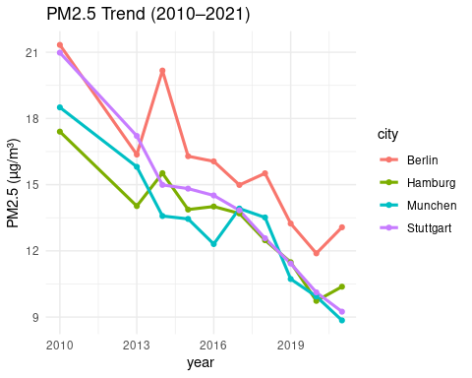
ggplot(air_quality_deu,
aes(year,
pm10,
color = city)) +
geom_line(size = 1.1) +
geom_point() +
theme_minimal() +
labs(title = "PM10 Trend (2010–2021)", y = "PM10 (µg/m³)")
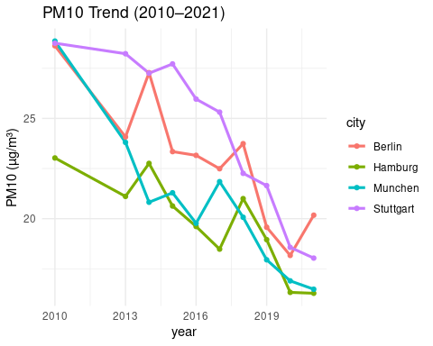
ggplot(air_quality_deu,
aes(year,
no2,
color = city)) +
geom_line(size = 1.1) +
geom_point() +
theme_minimal() +
labs(title = "NO₂ Trend (2010–2021)", y = "NO₂ (µg/m³)")
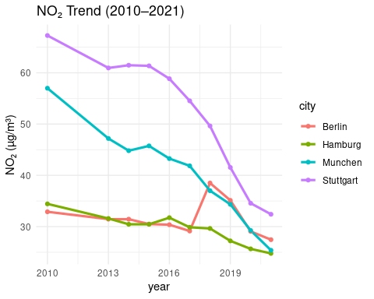
Trend Analysis

Rate of Change per year (using linear regression slope)
compute_slope <- function(air_quality_deu, pollutant) {
model <- lm(air_quality_deu[[pollutant]] ~ air_quality_deu$year)
slope <- coef(model)[2] # yearly rate of change
return(slope)
}
slopes <- air_quality_deu |>
group_by(city) |>
summarise(
slope_pm25 = compute_slope(cur_data(), "pm25"),
slope_pm10 = compute_slope(cur_data(), "pm10"),
slope_no2 = compute_slope(cur_data(), "no2")
)
print(slopes)
# A tibble: 4 × 4
city slope_pm25 slope_pm10 slope_no2
<fct> <dbl> <dbl> <dbl>
1 Berlin -0.795 -0.853 -0.143
2 Hamburg -0.646 -0.606 -0.809
3 Munchen -0.779 -0.999 -2.67
4 Stuttgart -1.00 -1.09 -3.35

Precentage Change (first year vs last year)
percent_change <- air_quality_deu |>
group_by(city) |>
summarise(
pct_pm25 = ((last(pm25) - first(pm25)) / first(pm25)) * 100,
pct_pm10 = ((last(pm10) - first(pm10)) / first(pm10)) * 100,
pct_no2 = ((last(no2) - first(no2)) / first(no2) * 100)
)
print(percent_change)
# A tibble: 4 × 4
city pct_pm25 pct_pm10 pct_no2
<fct> <dbl> <dbl> <dbl>
1 Berlin -38.7 -29.5 -16.5
2 Hamburg -40.4 -29.3 -28.1
3 Munchen -52.2 -42.9 -55.5
4 Stuttgart -55.9 -37.3 -51.8

Correlation Matrix
# Computing correlation matrix
corr_data <- air_quality_deu |>
select(pm25, pm10, no2)
corr_matrix <- cor(corr_data, use = "complete.obs")
print(corr_matrix)
pm25 pm10 no2
pm25 1.0000000 0.8656775 0.3967036
pm10 0.8656775 1.0000000 0.7072060
no2 0.3967036 0.7072060 1.0000000
# Converting matrix to tidy format for ggplot
corr_air_quality_deu <- corr_matrix |>
as.data.frame() |>
rownames_to_column("var1") |>
pivot_longer(cols = -var1, names_to = "var2", values_to = "value")
# Plotting heatmap
ggplot(corr_air_quality_deu,
aes(var1, var2, fill = value)) +
geom_tile() +
geom_text(aes(label = round(value, 2)), size = 5) +
scale_fill_gradient2(low = "blue", high = "red", mid = "white", midpoint = 0) +
theme_minimal() +
labs(title = "Correlation Heatmap", x = "", y = "")
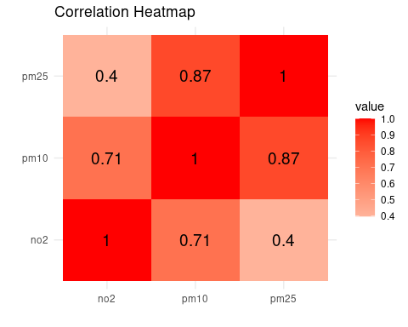

PCA (Principal Component Analysis)
pca_input <- air_quality_deu |>
select(pm25, pm10, no2) |>
scale()
pca <- prcomp(pca_input)
summary(pca)
Importance of components:
PC1 PC2 PC3
Standard deviation 1.527 0.7835 0.23471
Proportion of Variance 0.777 0.2046 0.01836
Cumulative Proportion 0.777 0.9816 1.00000
plot(pca, main = "PCA Scree Plot")
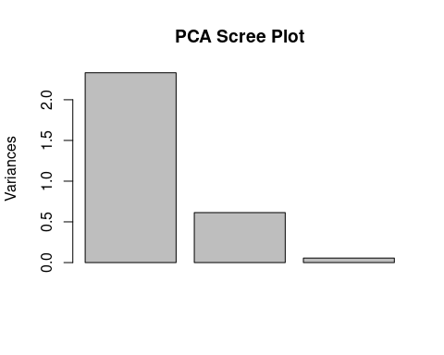
biplot(pca, cex = 0.6, main = "PCA Biplot")
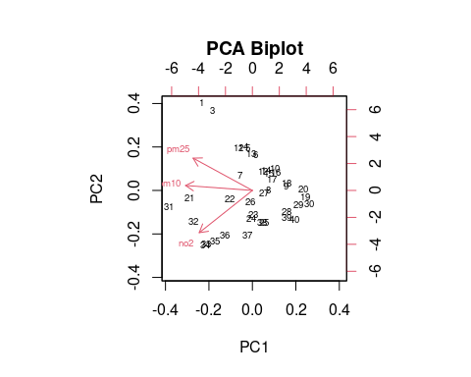
# Plotting PCA without labels
plot(pca$x[,1], pca$x[,2],
xlab = "PC1", ylab = "PC2",
main = "PCA Biplot (clean)",
pch = 19, col = "grey40")
# Adding variable arrows
arrows(0, 0, pca$rotation[,1] * 3, pca$rotation[,2] * 3,
col = "red", lwd = 2)
# Adding variable names with spacing
text(pca$rotation[,1] * 3.2,
pca$rotation[,2] * 3.2,
labels = rownames(pca$rotation),
col = "red", cex = 1)
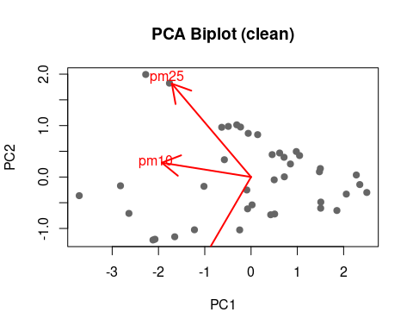

K-Means Clustering
set.seed(123)
k3 <- kmeans(pca_input, centers = 3)
air_quality_deu$cluster <- k3$cluster
ggplot(air_quality_deu,
aes(pm25,
pm10,
color = as.factor(cluster))) +
geom_point(size = 3) +
theme_minimal() +
labs(title = "K-means Clustering (3 clusters)", color = "Cluster")
