AMRITSAR GROUP OF COLLEGES
Autonomous status conferred by UGC under UGC act-1956, (2f), NAAC-A Grade,
(Formerly Known as Amritsar College of Engineering & Technology |
Amritsar Pharmacy College)

Final Report
On
“5 STAR HOTEL MANAGEMENT SYSTEM USING PACKET
TRACER”


Submitted in the Partial fulfilment of the requirement for the Award of Degree of
Bachelor of Technology
In
COMPUTER SCIENCE & ENGINEERING
Batch (2022-26)

Submitted To: Submitted By:
Er. Priyanka Ankit Singh Thapa (2233574)
Aditiya Bhatiya (2233555)
Amit Kumar (2233568)

INDEX PAGE

Sr. No | Content | Page No
1. | Introduction to Computer Network | 3
2. | Introduction to 5-Star Hotel Management Using Cisco Packet Tracer | 5
3. | Tool Used: Packet Tracer | 9
4. | Components Used | 10
5. | Snap-shots Of the Project | 11
6. | References | 13

WHAT IS COMPUTER NETWORK?

1. Definition: A computer network is a collection of interconnected computers and devices that communicate and share resources with one another, enabling data exchange and collaboration.

2. Types of Networks: Computer networks come in various forms, including local area networks (LANs), wide area networks (WANs), and the internet, each serving different purposes and scales.

3. Communication Protocols: Networks rely on communication protocols to govern how data is transmitted and received, such as TCP/IP, HTTP, and FTP.

4. Components: Key components of a network include routers, switches, servers, and client devices, which work together to ensure data flows efficiently.

5. Benefits: Computer networks facilitate efficient data sharing, resource utilization, and enable remote collaboration, making them essential for modern businesses and individuals.

6. Security: Network security is crucial to protect against unauthorized access, data breaches, and cyberattacks. Firewalls, encryption, and access controls help maintain network integrity.

7. Scalability: Networks need to be scalable to accommodate the growth in devices and data traffic, requiring regular upgrades and maintenance.

8. Internet: The internet is a global network of networks, connecting billions of devices worldwide, serving as a vast resource for information, communication, and commerce.

9. Wireless Networks: Wi-Fi and cellular networks have revolutionized connectivity, providing mobility and flexibility in how and where we access the internet.

10. Cloud Computing: Cloud technology leverages computer networks to offer remote storage and computing services, providing businesses and individuals with on-demand resources.

11.IoT (Internet of Things): IoT devices connect to networks to collect and transmit data, enabling smart homes, cities, and industries.

12. Network Troubleshooting: Network administrators are responsible for monitoring, diagnosing, and resolving issues to maintain network performance and reliability.

13. Evolution: Computer networks have evolved over the years, from the early days of ARPANET to today's high-speed, interconnected world, with the promise of even faster, more efficient networks in the future.

14. Challenges: Network management and security challenges continue to grow with the increasing complexity and scale of networks, requiring constant innovation and vigilance.

15. The Future: The future of computer networks is likely to involve innovations such as 5G, edge computing, and increased automation, shaping how we live, work, and connect in the digital age.

INTRODUCTION

Introduction to 5-Star Hotel Management System with Cisco Packet Tracer
The management of a 5-star hotel is a multifaceted and highly demanding endeavour. From providing top-notch guest services to ensuring efficient back-end operations, the role of technology in a luxurious hospitality establishment cannot be overstated. Cisco Packet Tracer, a powerful network simulation tool, plays a pivotal role in designing and optimizing the computer network that underpins a modern 5-star hotel.

A 5-star hotel management system relies on a robust and secure network to orchestrate a wide array of services, including guest reservations, room assignments, billing, security, energy management, and more. Cisco Packet Tracer, renowned for its ability to simulate network configurations, offers an ideal platform to model and optimize the network architecture of such a complex system.

Within the confines of a 5-star hotel, a computer network built with Cisco Packet Tracer facilitates a seamless experience for guests and streamlines hotel operations. It enables real-time communication between various departments, such as front desk, housekeeping, and room service, allowing them to respond promptly to guest requests and preferences. Moreover, the network ensures the security of guest data and the physical premises, from surveillance cameras to access control systems.

This network's significance extends beyond guest services; it also plays a crucial role in energy management. Smart HVAC and lighting systems can be integrated into the network, enabling real-time control and monitoring, thus optimizing energy consumption and reducing costs.

Setting up a Wireless Network using a WAP

Listed below are different types of wireless network setup.
1. Adding a wireless network to an existing wired network
2. Connecting multiple access points together through Wireless Distribution System (WDS)
3. Configuring clustering of Wireless Access Points
4. Configuring Workgroup Bridge
1. Adding a wireless network to an existing wired network
Adding a WAP to your existing wired network is useful to accommodate those devices that are only capable of wireless connection. It is like creating another network only for wireless devices but still be a part of your existing wired network.
Adding a WAP in the existing network is like joining two networks together to form a single network for both wired and wireless devices such as shown in the diagram below.
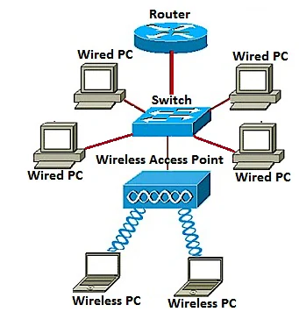

2. Connecting multiple access points together through Wireless Distribution System (WDS)
WDS lets you connect multiple access points together. WDS allows the connected access points to communicate
Page 7
with each other via wireless connection. This feature enables clients who roam to have a seamless experience. This makes it easier to manage multiple wireless networks as well as reduces the amount of cables required to connect the networks.
The WAP can act as a single point-to-point mode access point, point-to-multipoint bridge, or as a repeater. On a repeater mode, a WAP can establish a connection between other access points that are far apart. It will simply act as a wireless extender. Wireless clients can connect to this repeater. A WDS role system can be compared similar to the role of repeater.

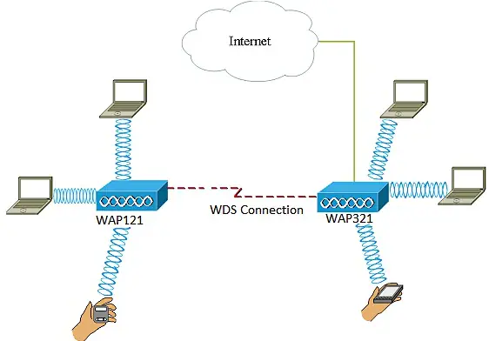

In the example diagram above, a WDS connection is configured between the WAP121 and the WAP321 Access Points.

3. Configuring clustering of Wireless Access Points
Clustering is when multiple WAPs are joined together in the same network. This technology is advanced intelligence that allows them to work together dynamically and simplifies wireless networking. You will be able to configure and manage a clustered wireless network as a single entity, and without having to configure and reconfigure the settings in each access point separately. Up to ten WAPs can be clustered in a wireless network.
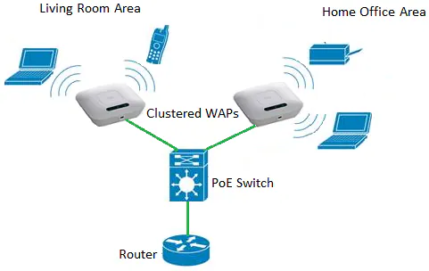
The WAP acts as a transmitter and receiver of Wireless Local Area Network (WLAN) radio signals, providing a larger wireless range as well as the ability to support more clients on a network.

4. Configuring Workgroup Bridge
The Workgroup Bridge feature enables the Wireless Access Point (WAP) to bridge traffic between a remote client and the wireless Local Area Network (LAN) that is connected with the Workgroup Bridge Mode. The WAP device associated with the remote interface is known as an access point interface, while the WAP device associated with the wireless LAN is known as an infrastructure interface. The Workgroup Bridge lets devices that only have wired connections connect to a wireless network. Workgroup Bridge Mode is recommended as an alternative when the Wireless Distribution System (WDS) feature is unavailable.
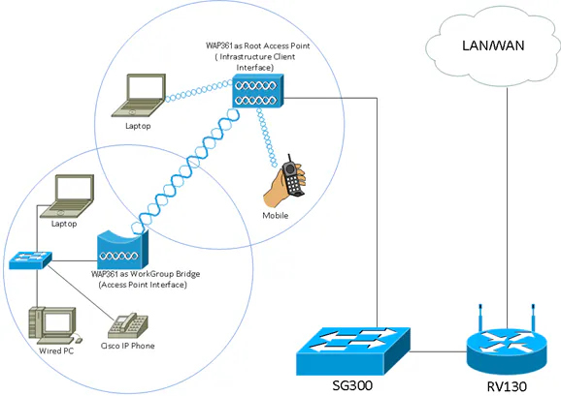

The topology above illustrates a sample WorkGroup Bridge model. Wired devices are tethered to a switch, which connects to the LAN interface of the WAP. The WAP acts as an access point interface, connects to the infrastructure interface.
TOOL USED: PACKET TRACER
Packet Tracer is a cross-platform visual simulation tool designed by Cisco Systems that allows users to create network topologies and imitate modern computer networks. The software allows users to simulate the configuration of Cisco routers and switches using a simulated command line interface. Packet Tracer makes use of a drag and drop user interface, allowing users to add and remove simulated network devices as they see fit. The software is mainly focused towards Cisco Networking Academy students as an educational tool for helping them learn fundamental CCNA concepts. Previously students enrolled in a CCNA Academy program could freely download and use the tool free of charge for educational use.

Packet Tracer can be run on Linux, Microsoft Windows, and macOS. Similar Android and IOS apps are also available. Packet Tracer allows users to create simulated network topologies by dragging and dropping routers, switches and various other types of network devices. A physical connection between devices is represented by a 'cable' item. Packet Tracer supports an array of simulated Application Layer protocols, as well as basic routing with RIP, OSPF, EIGRP, BGP, to the extents required by the current CCNA curriculum. As of version 8.0, Packet Tracer also supports the Border Gateway Protocol.
In addition to simulating certain aspects of computer networks, Packet Tracer can also be used for collaboration. As of Packet Tracer 8.0, Packet Tracer supports a multi-user system that enables multiple users to connect multiple topologies together over a computer network. Packet Tracer also allows instructors to create activities that students have to complete. Packet Tracer is often used in educational settings as a learning aid. Cisco Systems claims that Packet Tracer is useful for network experimentation.

COMPONENTS USED

• Routers:
➢ Used Router: 1941 Router

• Switches:
➢ Used Switch: PT-Switch

• Access Point Name (APN’s):
➢ Used APN: AccessPoint-PT

• Devices:
➢ PC’s

➢ Smartphones

SNAP-SHOTS OF THE PROJECT

Network Design:

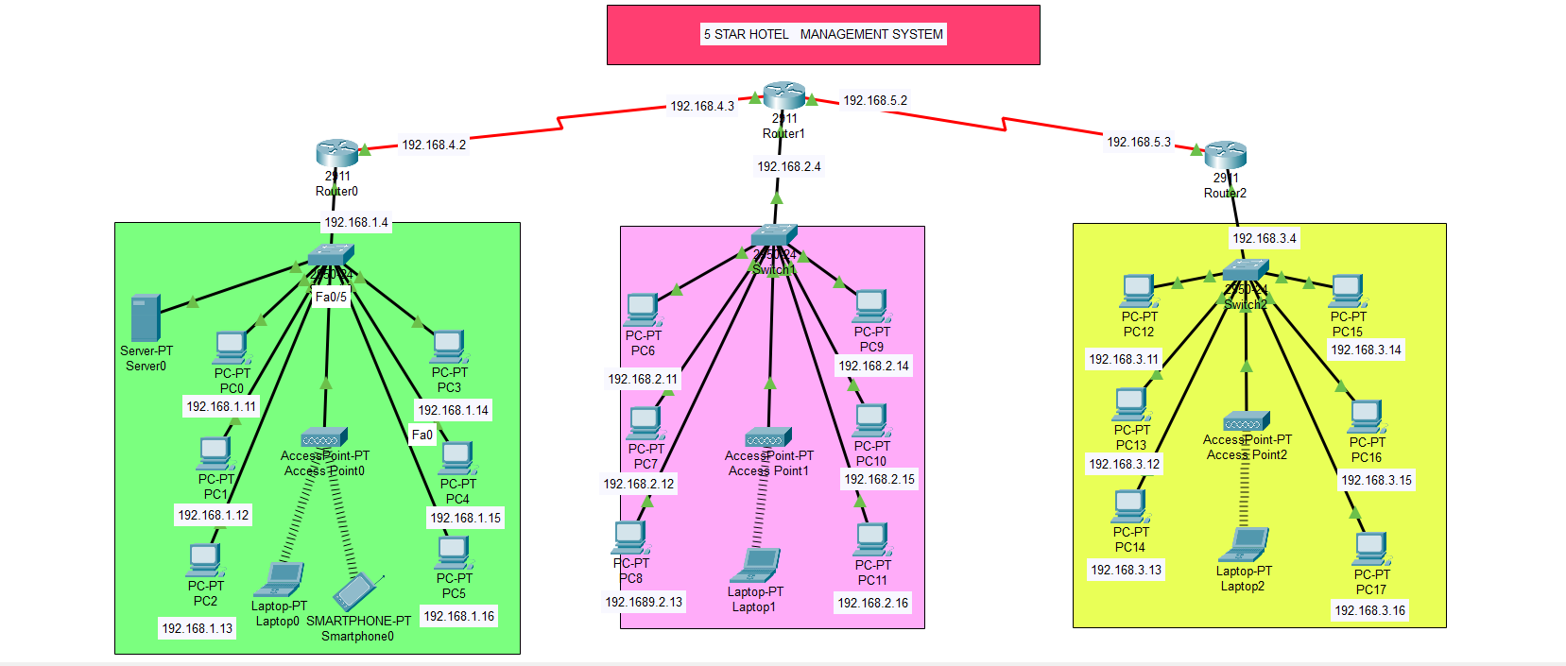

Pinging with Another Device:

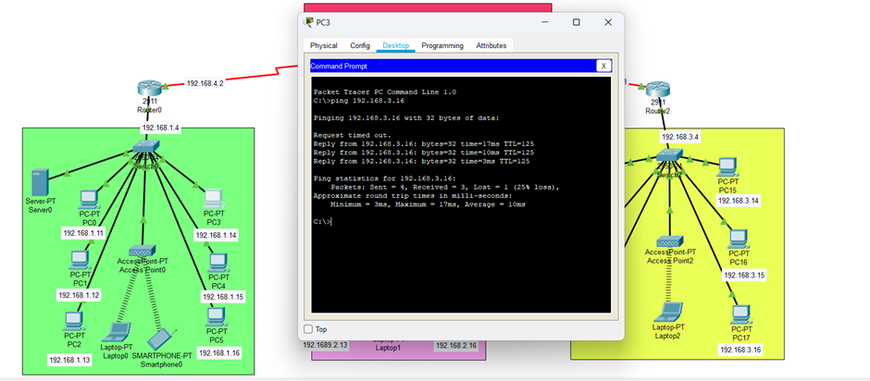

Packet Sent From One Device:

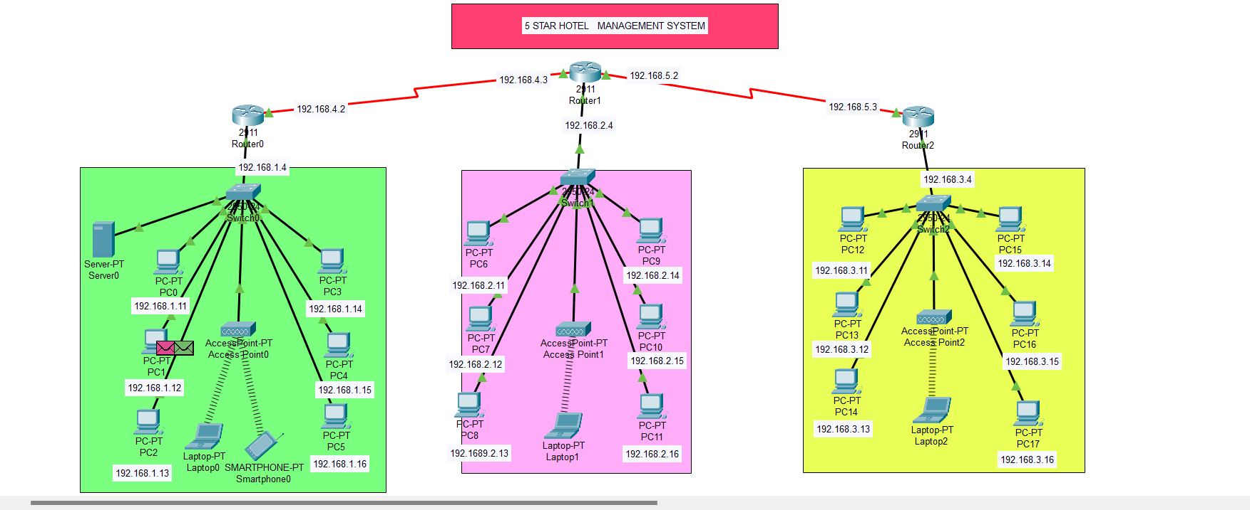

Packet Received:
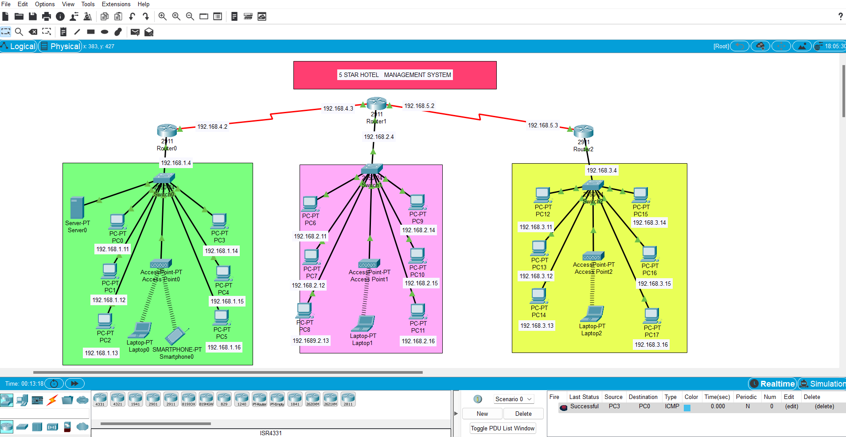

REFERENCE

-Youtube video tutorial - (https://www.youtube.com/watch?v=XIJMPQpYSyw)
- https://en.wikipedia.org/wiki/Access_Point_Name
-www.github.com

