CJ Botlinger, Ryan Fritz, Drew Sadik

IST 311

Group 3

Fantasy Football App

Our application will be a one-stop shop for football fans who would like quick and easy access to interesting and relevant statistics. The application will read in basic stats for the top 20 WRs, RBs, and QBs, and store the data. Based on the basic stats received, it will calculate more complex efficiency-statistics that go a little deeper to show how a player has been performing. The menu will give the user the option to view a list of the top WRs, RBs, and/or QBs, and the player can look further into a single player’s stats by clicking on the player’s name and accessing his profile. If time permits, we would also like the application to take a look at the upcoming week of games, and recommend certain players to start based on matchups.

**.csv files that will be needed:**

1. WR Stats
2. RB Stats
3. QB Stats
4. Defense Rankings*
5. Schedule*

*not till later

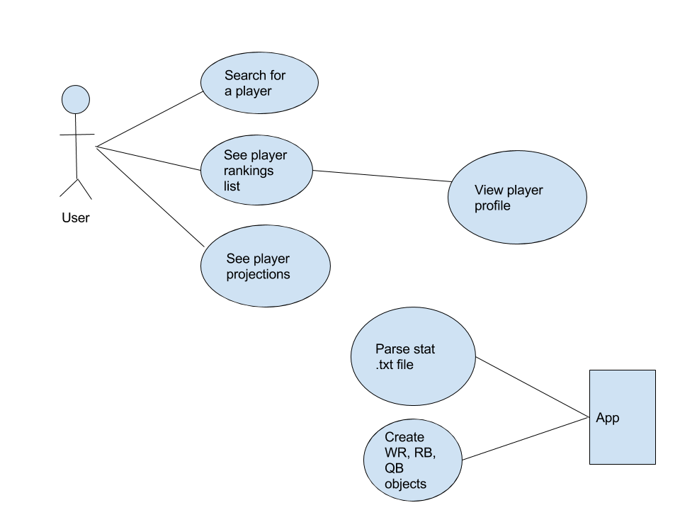

**Info coming from file:**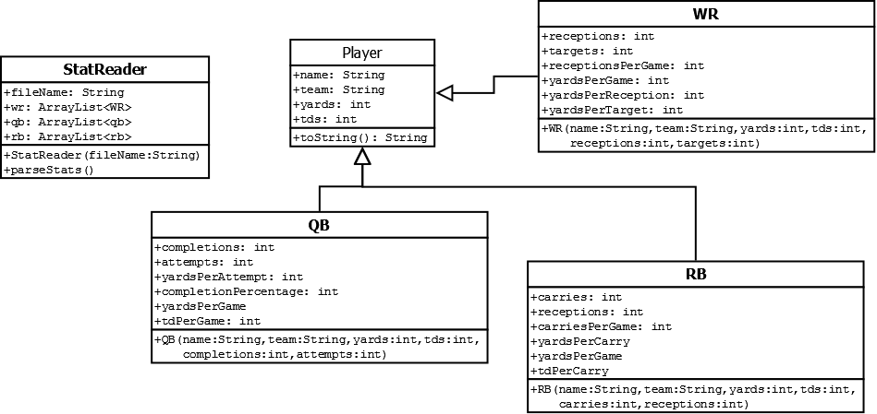

1. Name
2. Team
3. Yards
4. TDs
5. Games Played
6. WR - receptions
7. WR - targets
8. RB - carries
9. RB - receptions
10. QB - completions
11. QB - attempts

**Info being calculated:**

1. WR
   1. Receptions per game
   2. Yards per game
   3. Yards per reception
   4. Yards per target
2. RB
   1. Carries per game
   2. Yards per game
   3. Yards per carry
   4. TDs per carry
3. QB
   1. Yards per attempt
   2. Yards per game
   3. Completion percentage
   4. TDs per game

**Product backlog:**

Create Player class

Create WR class

Create RB class

Create QB class

Create Stats class

Create Projections class and logic

Create Menu (GUI)

**Sprint backlog:**

Create Player class

Create WR class

Create RB class

Create QB class

Create Stats class

**Sprint 1 report:**

Player classes and Stat Parser work as well if not better than initially expected.

A few bugs regarding calculated statistics were not working quite as planned, but do not crash the program at this point in time. We will have to take a look and fix them in Sprint 2.