Lab2: SQL-DDL

### **Objectives**: Study Data Definition Language Commands

**Estimated Time :** 1.5 hour

Summary

SQL divided into 4 categories: DDL, DML, DCL ,and TCL.

* The [**DDL**](https://www.edureka.co/blog/mysql-tutorial/#DDL) (Data Definition Language) consists of those commands which are used to define the database e.g. CREATE, DROP, ALTER command.
* The [**DML**](https://www.edureka.co/blog/mysql-tutorial/#DML) (Data Manipulation Language) commands deal with the manipulation of data present in the database e.g. SELECT, INSERT, UPDATE, DELETE command.
* The [**DCL**](https://www.edureka.co/blog/mysql-tutorial/#DCL) (Data Control Language) commands deal with the rights, permissions and other controls of the database system e.g. GRANT, INVOKE command.
* The [**TCL**](https://www.edureka.co/blog/mysql-tutorial/#TCL) ( Transaction Control Language) consists of those commands which mainly deal with the transaction of the database e.g. COMMIT, ROLLBACK command.

[**DDL**](https://www.edureka.co/blog/mysql-tutorial/#DDL)**- Data Definition Language**

* CREATE DATABASE - create a new SQL database

Syntax

CREATE DATABASE databasename;

Example

CREATE DATABASE SchoolDB;

* DROP DATABASE - drop an existing SQL database.

Syntax

DROP DATABASE databasename;

Example

DROP DATABASE SchoolDB;

* CREATE TABLE - to create a new table in a database.

Syntax

CREATE TABLE table_name (  
    column1 datatype [*constraint]*,  
    column2 datatype [*constraint]*,  
    column3 datatype [*constraint]*,  
    ....  
);

Example

CREATE TABLE Students (  
    StID int,  
    LastName varchar(255),  
    FirstName varchar(255),  
    Address varchar(255),  
    City varchar(255),   
 DateOfBirth varchar(255)  
);

* DROP TABLE - drop an existing table in a database.

Syntax

DROP TABLE table_name;

Example

DROP TABLE Students;

* ALTER TABLE - to add, delete, or modify columns and add and drop constraints on an existing table.
  + ADD Column

Syntax

ALTER TABLE table_name  
ADD column_name datatype;

Example

ALTER TABLE Students  
ADD Email varchar(255);

* + DROP COLUMN

Syntax

ALTER TABLE table_name  
DROP COLUMN column_name;

Example

ALTER TABLE Students  
DROP COLUMN  Email;

* + MODIFY COLUMN

Syntax

ALTER TABLE table_name  
MODIFY COLUMN column_name datatype;

Example

ALTER TABLE Persons  
ALTER COLUMN DateOfBirth date;

* SQL Constraints to specify conditions for the data in a table. Commonly used constraints are :
  + NOT NULL - A column must have value.
  + PRIMARY KEY - Uniquely identifies each row in a table i.e., NOT NULL and UNIQUE.
  + UNIQUE - All values in a column are different
  + FOREIGN KEY - Uniquely identifies a record in another table.
  + CHECK – Specify a specific condition for a column
  + DEFAULT - Sets a default value for a column when no value is specified

Constraints can be specified when the table is created with the CREATE TABLE statement, or after the table is created with the ALTER TABLE statemen. They can be column level or table level. Column level constraints apply to a column, and table level constraints apply to the whole table.

Example

CREATE TABLE Teachers (  
    ID int NOT NULL,  
    LastName varchar(255) NOT NULL,  
    FirstName varchar(255)  
    PRIMARY KEY (ID)  
);

Note: create the constraint for an existing table.

ALTER TABLE Teachers  
ADD PRIMARY KEY (ID);

For more information : https://www.w3schools.com/sql/sql_constraints.asp

* SQL Data Types to specify type of data that will be stored inside each column when creating a table. For more information : https://www.w3schools.com/sql/sql_datatypes.asp

Lab Instruction

1. Write SQL command to drop database named world (if exist).
2. [TASK1] Show SQL editor screen after drop world database.
3. **Create database** named world.

* Type *CREATE DATABASE world;*
  + Do not forgot ';' at end.
  + CREATE DATABASE not case sensitive
  + 'world' is case sensitive
* Type *USE world;*
* execute the commands



Fig. 1 Successful Creating database

The above creates a database named 'world', tells the server to use that database. The image reflects successful completion.

1. **Create tables**: there are three tables in the world database – city, country, and countrylanguage. 4.1 **For country table**, we will Run Script to create and insert data into country.

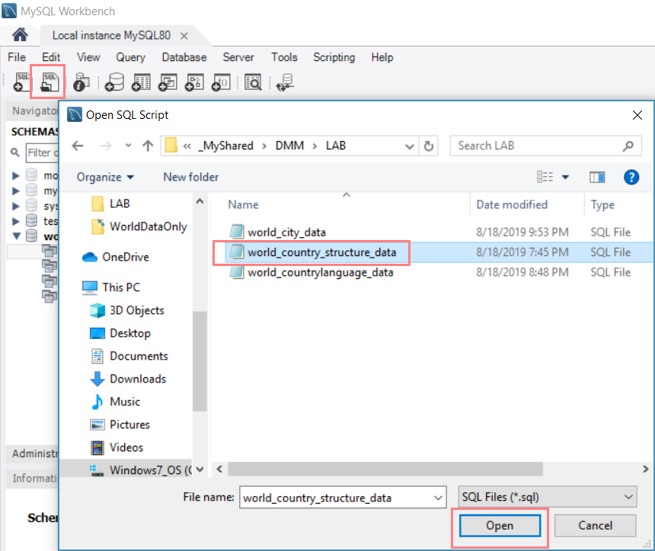

Fig 2. Choose script file to create the country table and insert data

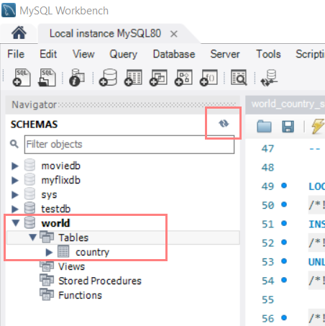

Fig 3. country table is created in world database

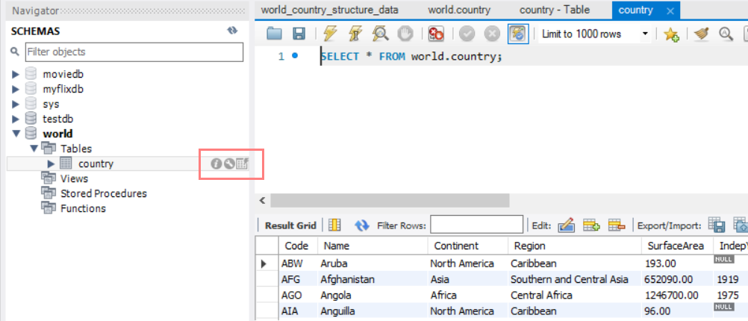

Fig 4. Show records in country table

**4.2 For city table**, we will manually create the table through GUI which has the table structure as Fig 5 and run scripts to insert data into the database.

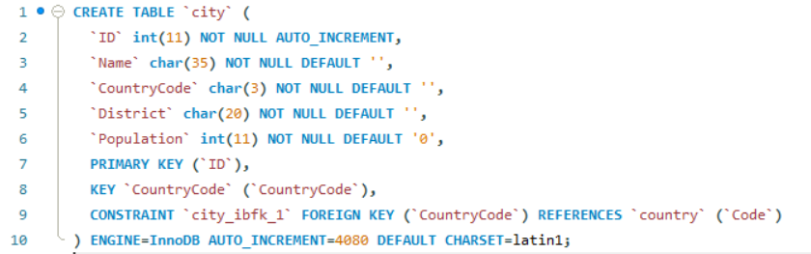

Fig 5. Structure of city table

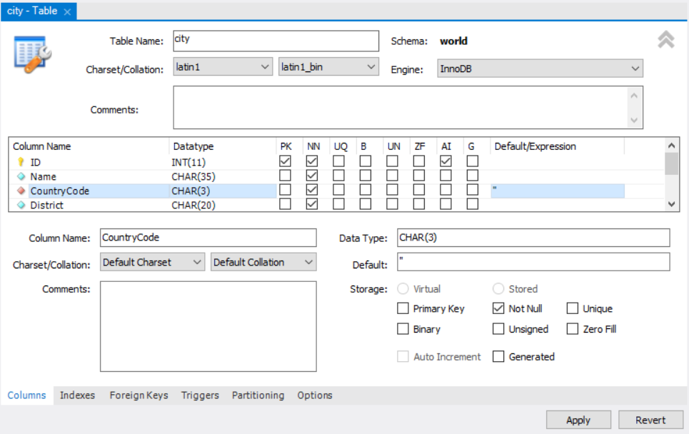

Fig 6. Create the city table and add columns through GUI

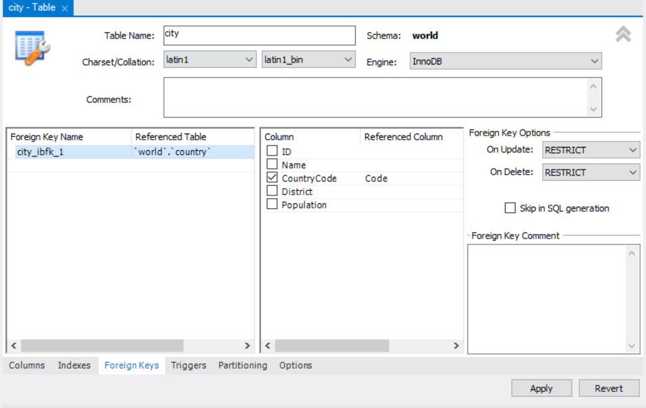Fig 7. Set foreign key of city table

Choose script file ‘world_city_data.sql’ to insert data into city table and run script. The output will show as Fig 9.

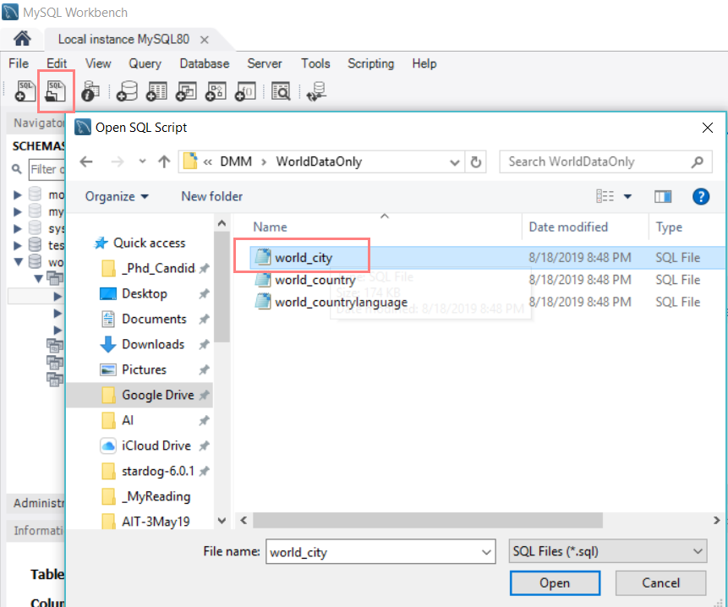

Fig 8. Choose script file to insert data into city table

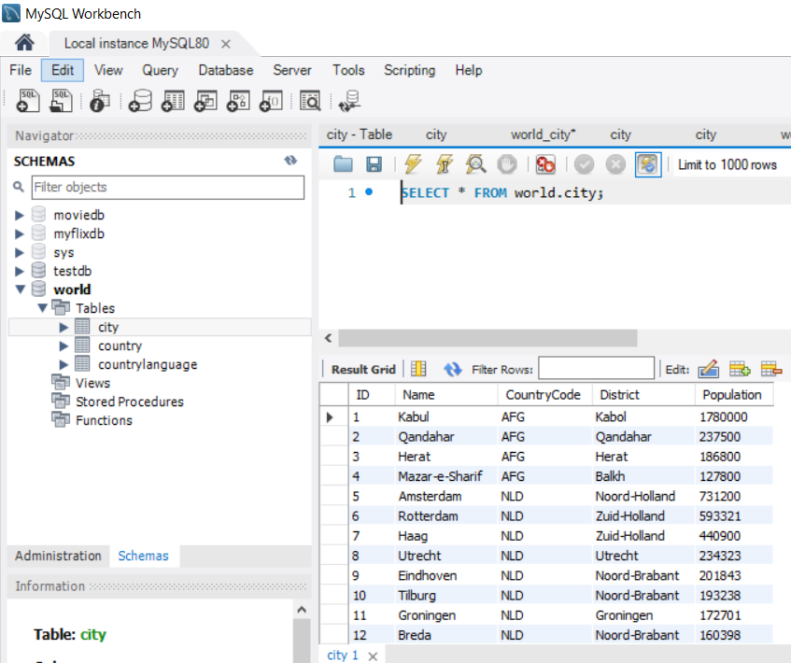

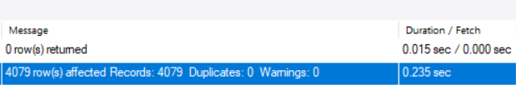

Fig 9. Show records in city table

* 1. **For** **CountryLanguage table**, Write DDL SQL Command to Create CountryLanguage table, then Insert data into countrylanguage table using World_countrylanguage_data.sql.   
       
     **Verify**

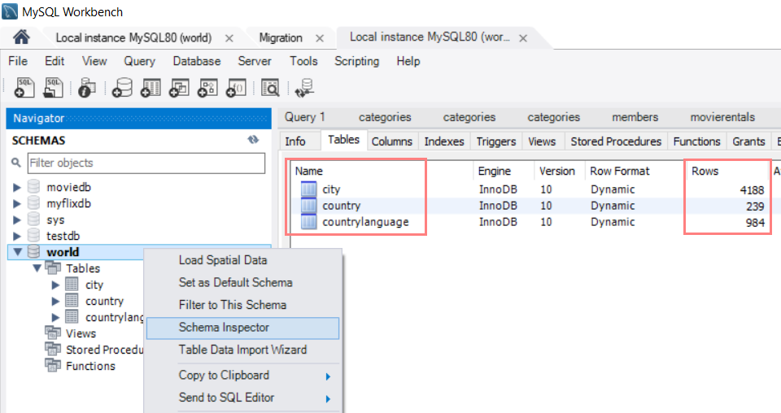

Fig 10. Show all table in world database

[TASK2] Show results of each table including city, country, and countrylanguage.

1. **Create EER Diagram**

Click on the 'Home' icon and select Create EER Model from Existing Database from bottom center of page

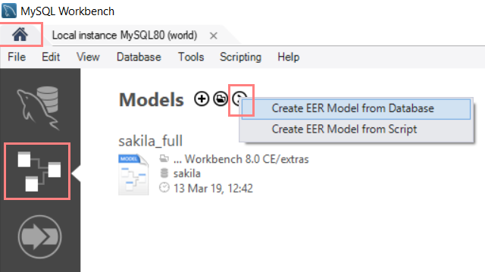

Fig 11. Create EER Model

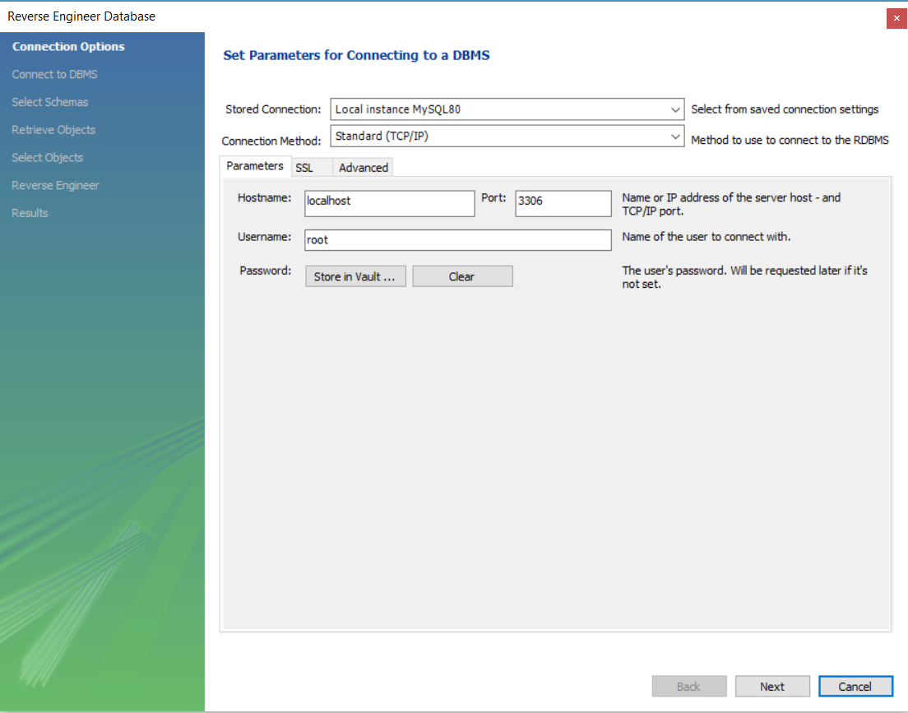

Fig 12. Set parameters for connecting to a database

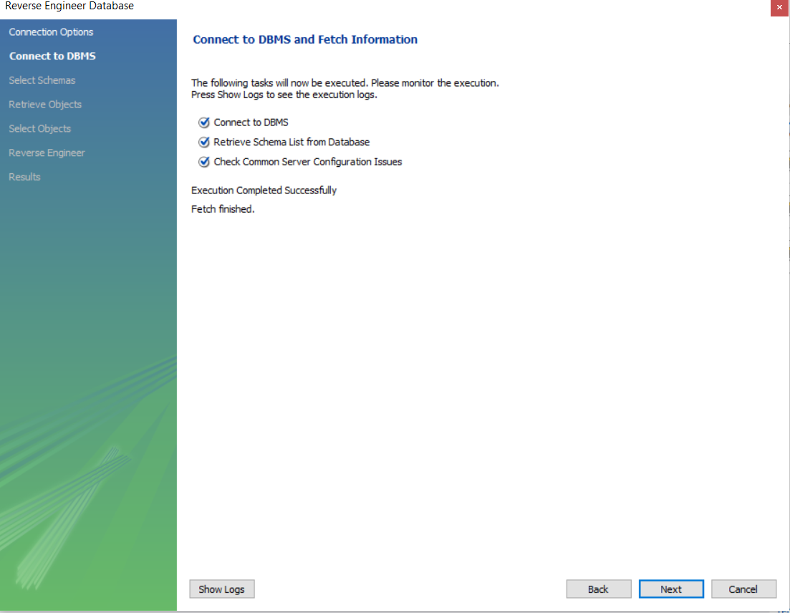

Fig 13. Connect to database and fetch information

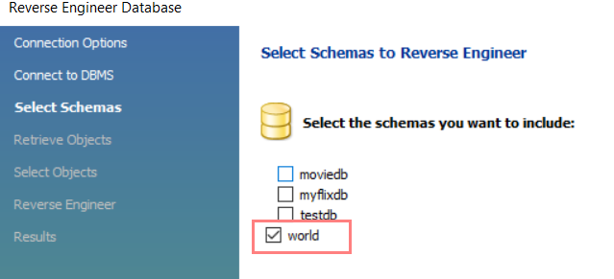

Fig 14. Select database to create EER Model

Select 'world' in the Stored Connection pull-down, then click Next

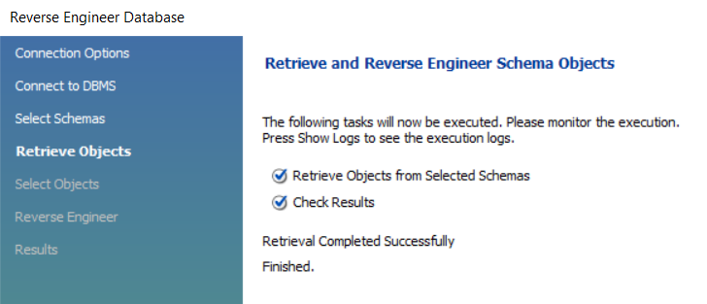

Fig 15. Retrieve and reverse engineer schema objects

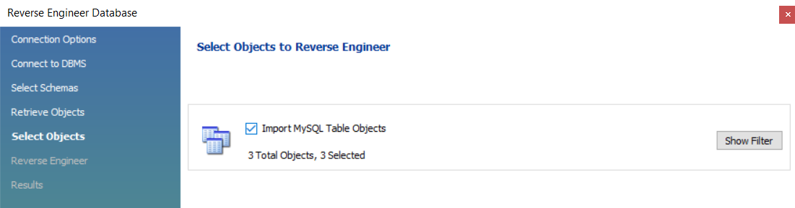

Fig 16. Select objects to reverse engineer

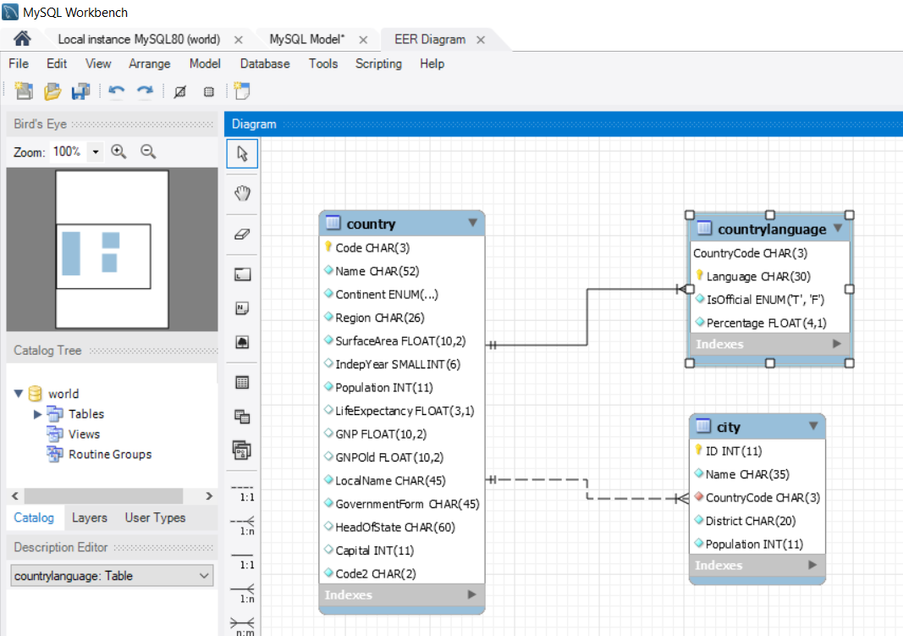

Fig 17. Show EER Model of world database

This is the enhanced entity-relationship (EER) model of the world database. Highlight the connection line to see how the keys correspond between tables.

[TASK 3] Show results after creating EER Model of the world database

1. Using command ALTER TABLE to add column ‘postcode’ which has datatype as varchar(10) for city table.

[TASK4] Show results of city table after adding a postcode column.

Lab Submission

Submission System : Course LMS

Total TASK : 4