Lab6 : MongoDB (Solution)

### **Objectives**: Study NoSQL Document Model using MongoDB

**Estimated Time :** 3 hours

Lab Solution

1. Install Mongo Shell and connect to RDBProject database using the below command

***mongo "mongodb+srv://dmmcluster.f1uoi.gcp.mongodb.net/RDBProject" --username st_dmm***

1. Convert your Peer-review feedback into the below JSON format and insert into feedback collection

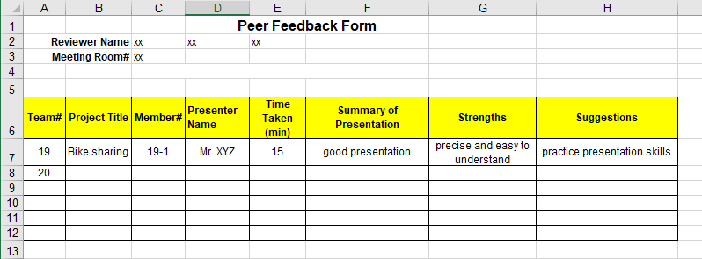

{  
"member_id": "19-1",  
"presenter_name": "Mr. XYZ",  
"project_id" : "19",   
"project_name": "Bike sharing",  
"summary_of_presentation": "the presentation was well prepared and_ ",  
"strengths": [ "precise", "easy to understand" ],  
"suggestions": ["practice presentation skills" ]  
…  
}

… means you can add any other information because NOSQL is schemaless.

1. Insert the peer review into the feedback table in the database.
2. Write MongoDB command to retrieve the following information, capture the running screen and the returned result.

**Answer** The solution is running with the Feedback_Demo Collection.

db.Feedback_Demo.insertOne(

{

"member_id": "19-1",

"presenter_name": "Mr. XYZ",

"project_id" : "19",

"project_name": "Bike sharing",

"summary_of_presentation": "the presentation was well prepared and_ ",

"strengths": [ "precise", "easy to understand" ],

"suggestions": ["practice presentation skills" ]

})

db.Feedback_Demo.insertOne(

{

"member_id": "19-2",

"presenter_name": "Mr. ABC",

"project_id" : "19",

"project_name": "Bike sharing",

"summary_of_presentation": "the presentation was well prepared and_ ",

"strengths": [ "well prepared" ],

"suggestions": ["practice presentation skills", "be confidence" ]

})

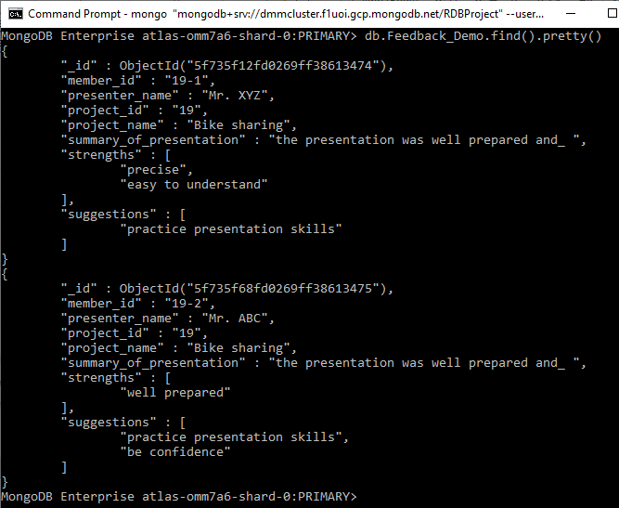

**[TASK1]** List your presentation feedback reviewed by friends (if I am ABC)

db.Feedback_Demo.find({"member_id":"19-2"})

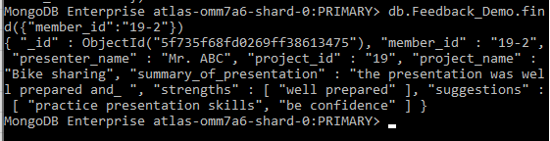

**[TASK2]** How many strengths are provided in total?

db. Feedback_Demo.aggregate({$project:{NumberOfItemsInArray:{$size:"$strengths"}}},{$group: {_id: null,total: {$sum: "$NumberOfItemsInArray"}}})

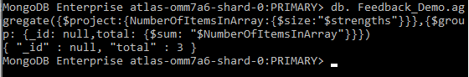

**[TASK3]** What is the average number of suggestion for a reviewer?

db.Feedback_Demo.aggregate({$project:{NumberOfItemsInArray:{$size:"$suggestions"}}},{$group: {_id: null,total: {$avg: "$NumberOfItemsInArray"}}})

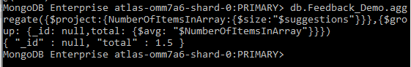

Submission System: Google Classroom

Total TASKS: 3