**Name, Surname:**

You can add print screens. Make answers understandable for me ☺.

#yum install bash* --- why do you need bash-compleation rpm ? **for completing command by using TAB**

1. #history , #man # command –help. Try to not to forget
2. #cd /root
3. List all files include all hiddenls files. 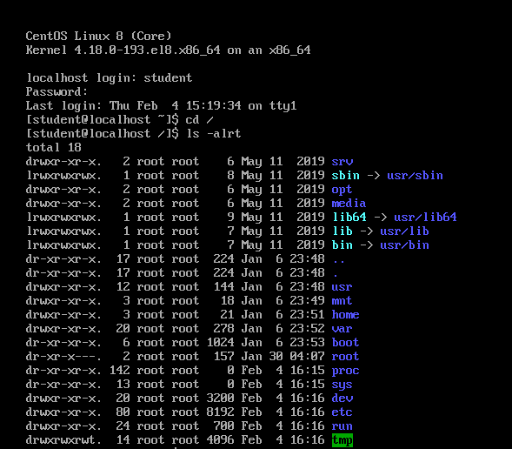
4. What is linux hidden files. Create new hidden file.

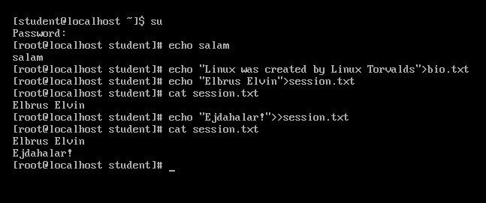

1. Run these commands:

#echo salam.

#echo "Linux was created by Linus Torvalds" > bio.txt

#echo “Elbrus Elvin ” > session.txt

#cat session.txt

#echo “ Bomba oglandilar ” >> session.txt

#cat session.txt



1. Run.

#a=5 **variable-dir**

#color = blue **variable-dir**

#echo $a **a variable qiymətini print edir**

#echo a **a textini** **print edir**

#echo $color **color variable qiymətini print edir**

Try to understand difference.