Open settings in the VS Code
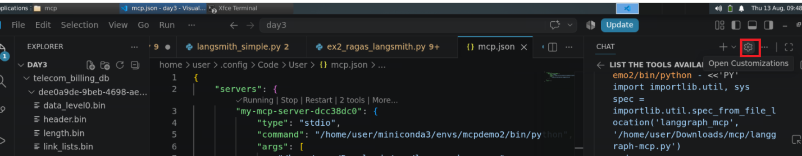
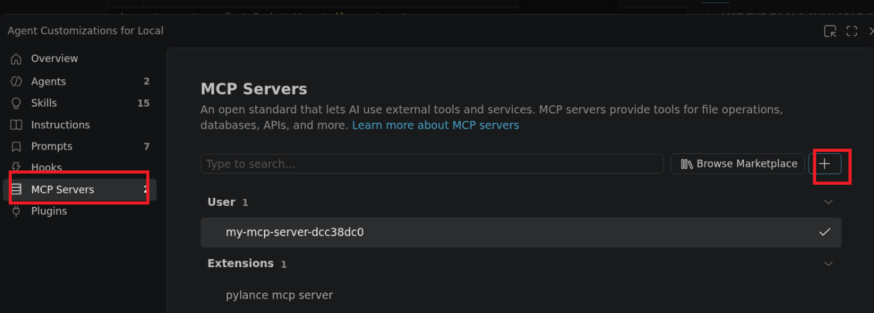
- Get the location of the langgraph-mcp.py code
- Get the python location of the mcpdemo conda environment
- Append the above 2 result like this: python_location code_path/langgraph-mcp.py
Ex. /home/user/miniconda3/envs/mcpdemo2/bin/python /home/user/Downloads/mcp/langgraph-mcp.py
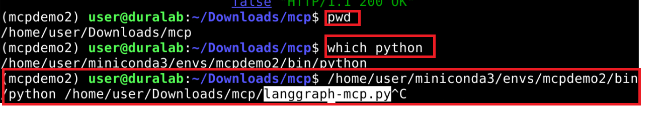
Add the above command to the VS Code in the command option to add the mcp server
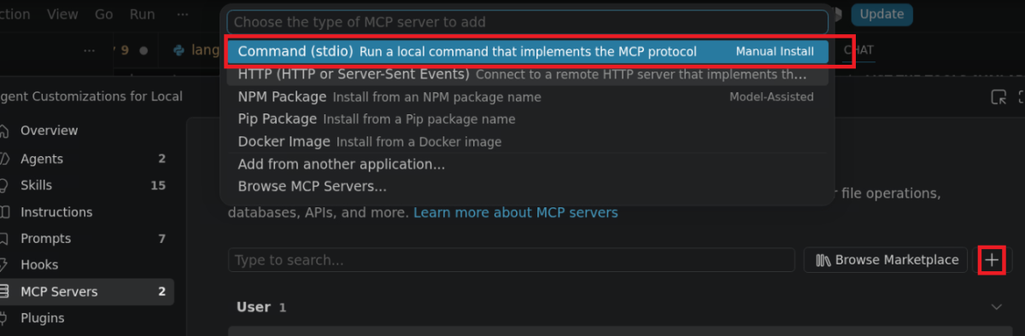
Paste the command and hit enter
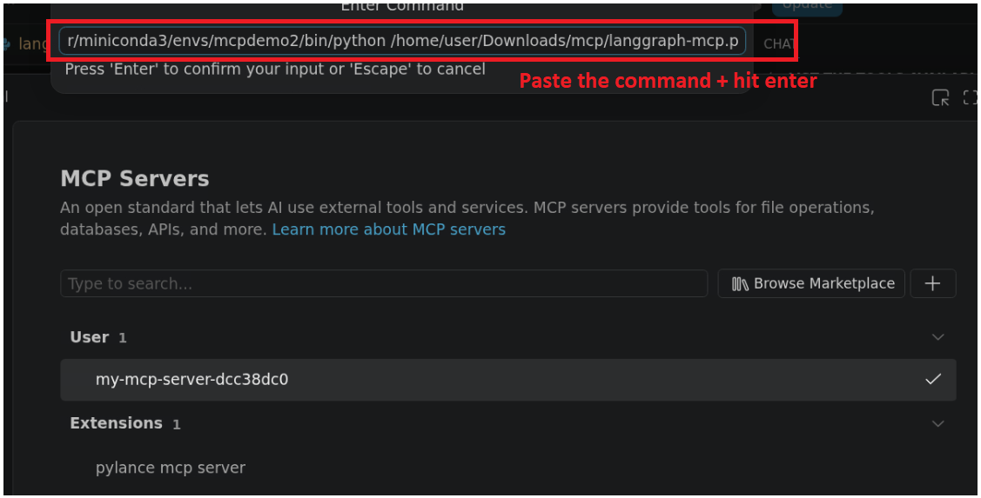
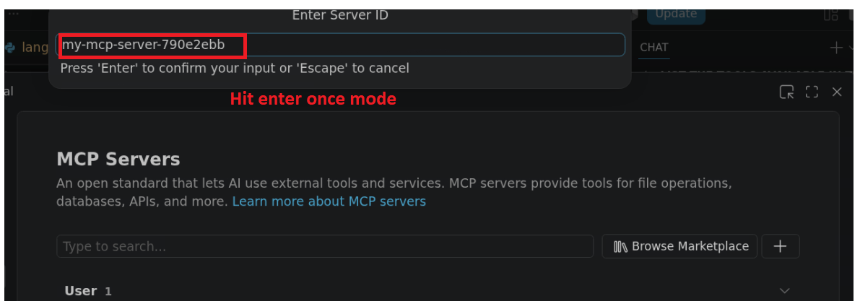
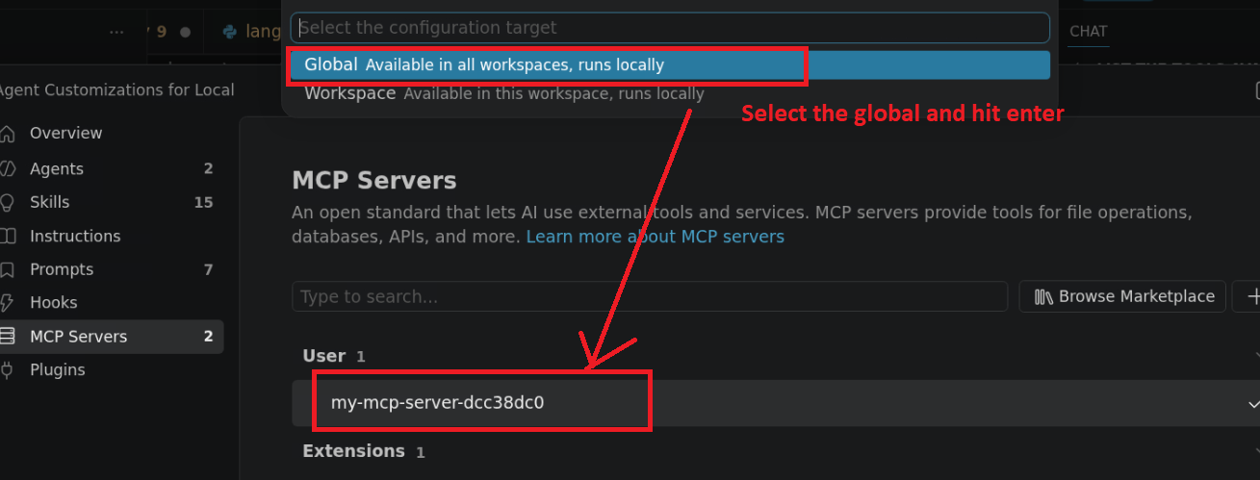
Copilot Chat: Select the GPT-OSS-120b model
Enter the below prompt & execute:
Prompt1:
List the tools available the langgraph mcp server
Prompt2:
Run the demo tool
Prompt3:
What are the resources available in the langgraph mcp server, get the resource and print its contents

