AI Agents vs Agentic AI: What’s the Difference?

What is Agentic AI?
At its core, Agentic AI is a type of AI that’s all about autonomy. This means that it can make decisions, take actions, and even learn on its own to achieve specific goals. It’s kind of like having a virtual assistant that can think, reason, and adapt to changing circumstances without needing constant direction. Agentic AI operates in four key stages:
- Perception: It gathers data from the world around it.
- Reasoning: It processes this data to understand what’s going on.
- Action: It decides what to do based on its understanding.
- Learning: It improves and adapts over time, learning from feedback and experience.
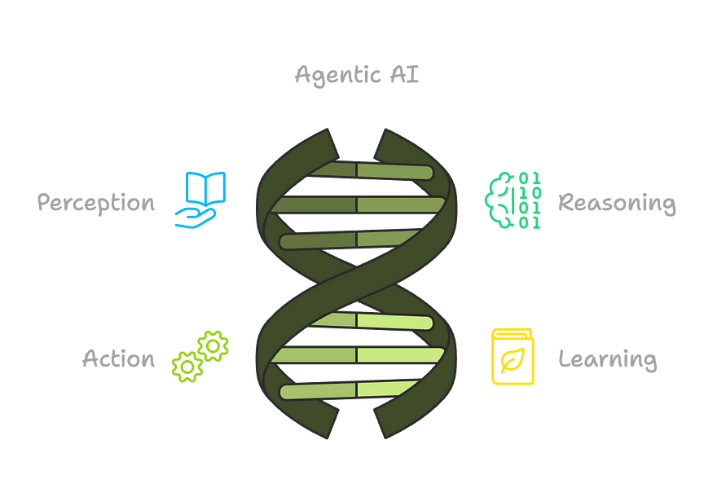
This makes Agentic AI highly autonomous and able to handle complex tasks that require reasoning, problem-solving, and adapting to new situations.

What is an AI Agent?
On the other hand, AI Agents are typically built to do specific tasks. They’re designed to help you with something — like answering questions, organizing your calendar, or even managing your email inbox. AI Agents are great at automating simple, repetitive tasks but don’t have the autonomy or decision-making abilities that Agentic AI does. Think of them as virtual helpers that do exactly what you tell them to do, without thinking for themselves.
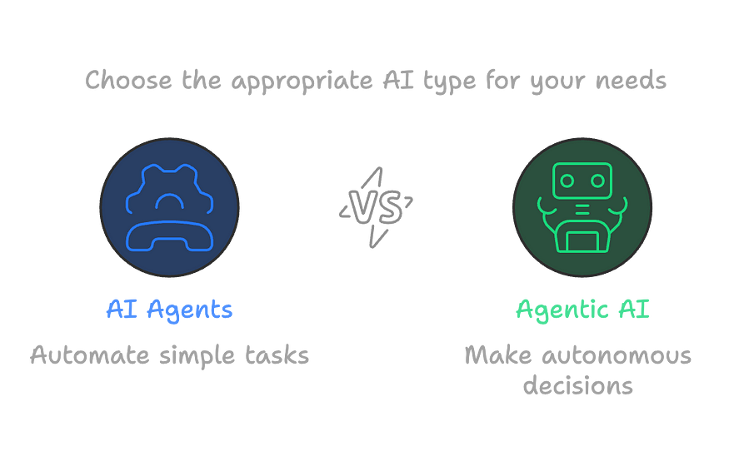

What’s the Difference?
Here’s where things get interesting. Even though AI Agents and Agentic AI are both powered by artificial intelligence, they operate in very different ways.
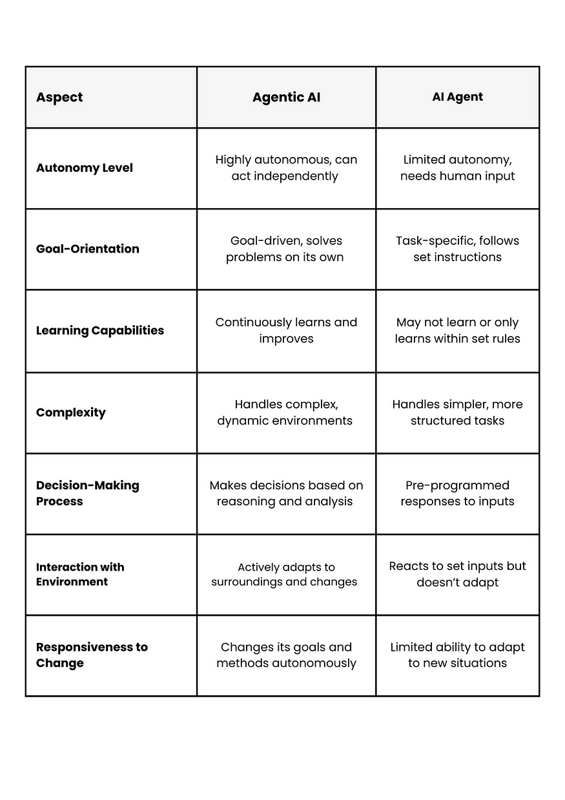

Where Do We See These in the Real World?
Both Agentic AI and AI Agents have started popping up in various industries, and their applications are growing fast.

Agentic AI in Action
- Self-Driving Cars: One of the most exciting uses of Agentic AI is in autonomous vehicles. These AI systems perceive their surroundings, make driving decisions, and learn from every trip. Over time, they get better at navigating and handling new challenges on the road. For example, Tesla’s Full Self-Driving system is an example of Agentic AI that continuously learns from the driving environment and adjusts its behavior to improve safety and efficiency.
- Supply Chain Management: Agentic AI is also helping companies optimize their supply chains. By autonomously managing inventory, predicting demand, and adjusting delivery routes in real-time, AI can ensure smoother, more efficient operations. Amazon’s Warehouse Robots, powered by AI, are an example — these robots navigate complex environments, adapt to different conditions, and autonomously move goods around warehouses.
- Cybersecurity: In the world of cybersecurity, Agentic AI can detect threats and vulnerabilities by analyzing network activity and automatically responding to potential breaches. Darktrace, an AI cybersecurity company, uses Agentic AI to autonomously detect, respond to, and learn from potential cyber threats in real-time.
- Healthcare: AI is playing a big role in healthcare, too. Agentic AI can assist with diagnostics, treatment recommendations, and patient care management. It analyzes medical data, identifies patterns, and helps doctors make more informed decisions. For instance, IBM’s Watson Health uses AI to analyze massive amounts of healthcare data, learning from new information to offer insights that help doctors and healthcare professionals.

AI Agents in Action
- Customer Support: One of the most common uses of AI Agents is in customer service. Chatbots can answer questions, resolve issues, and guide customers through processes — all without needing human intervention. Zendesk’s AI-powered chatbot helps businesses respond to customer queries quickly and efficiently, acting as an AI Agent that handles common issues and frees up human agents for more complex tasks.
- Personal Assistants: You probably already interact with an AI Agent every day if you use voice assistants like Siri or Google Assistant. They can help you set reminders, check the weather, or play your favorite music — tasks that are useful but don’t require much decision-making. These AI Agents rely on predefined commands and are great at handling simple, repetitive tasks.
- Email Management: AI Agents are also great for managing your inbox. They can sort emails, flag important ones, and even provide smart replies to save you time. Google’s Gmail Smart Compose feature is an excellent example of an AI Agent at work, helping users respond to emails faster by suggesting phrases based on context.
- Productivity Tools: Tools like GitHub Copilot are AI Agents that help software developers by suggesting code and helping with debugging. They’re like having a second set of eyes that’s always there to help. By offering code suggestions in real-time, this AI Agent enhances developer productivity, allowing them to focus on more creative aspects of their work.

The Benefits
- Revolutionizing Industries: Both Agentic AI and AI Agents are transforming industries. Whether it’s making self-driving cars a reality or automating customer service, AI is making things more efficient and cost-effective.
- Better Decision-Making: Agentic AI has the potential to process huge amounts of data, recognize patterns, and make decisions that are often more accurate than humans can.
- Personalization: In industries like finance, AI can provide highly personalized services — adjusting financial advice or investment strategies based on real-time data and predictions.

The Risks and Challenges
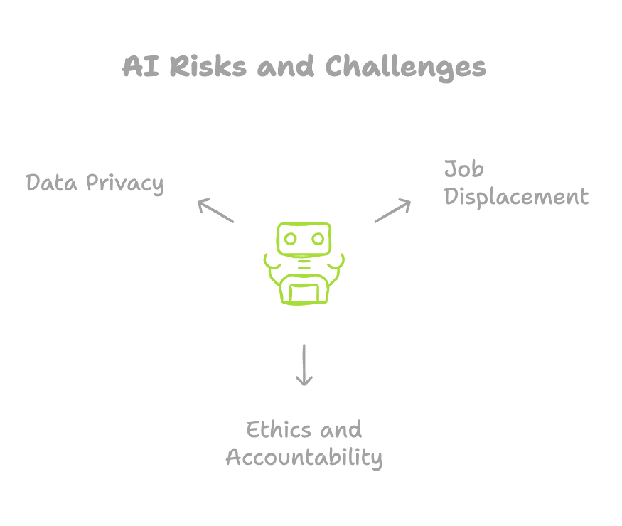
- Job Displacement: As AI takes over more tasks, there’s a fear of job loss in sectors like customer service, driving, and even healthcare. But there’s also the potential for AI to create new jobs and opportunities.
- Ethics and Accountability: As AI systems become more autonomous, questions about accountability arise. If an Agentic AI makes a mistake, who’s responsible? And how transparent should these systems be?
- Data Privacy: With more AI systems handling sensitive data, privacy concerns are growing. How will companies protect user data, and what safeguards are in place?
As AI continues to develop, the line between AI Agents and Agentic AI might blur even further. The potential for these technologies to complement each other is huge — imagine an AI Agent that can learn and adapt like Agentic AI, offering even more power to automate tasks and make decisions.

Final Thoughts
Both AI Agents and Agentic AI are changing the world in different ways. While AI Agents are great for automating repetitive tasks and handling specific actions, Agentic AI is pushing the boundaries of what AI can do by making decisions, learning from experiences, and solving complex problems. Both are valuable tools that are shaping the future of technology and the way we live.
Example (Telco):
- Reactive AI: “What is the current network status in Mumbai?”
- Agentic AI: “Monitor network status for Mumbai and notify when latency exceeds threshold.”

3. Why Do We Need Agentic AI? (Telco Use Cases)

Telecom Industry Applications:
Area | Agent Use Case
Customer Care | Handle full conversations, fetch customer plan details, upgrade plans, raise tickets
Network Monitoring | Autonomous agents query health APIs, analyze KPIs, escalate outages
Billing & CRM | Fetch customer invoices, apply offers, log transactions
Predictive Maintenance | Agents evaluate sensor feeds from towers, predict faults, dispatch field teams
Self-Healing Networks | Agents reroute traffic or restart services on anomaly detection

4. Core Components of AI Agents

a. LLMs – The Reasoning Engine
- GPT-4, Claude, Gemini, etc.
- Interpret goals, break down tasks, decide next actions
- Capable of ReAct (Reason + Act) or Chain-of-Thought logic

b. Tools & APIs – Extending Capabilities
- External tools (search, file I/O, code interpreter)
- Custom plugins for:
  - CRM
  - Network APIs
- Example: get_customer_details(customer_id)

c. Memory & Context Management
- Vector Stores (Pinecone, Weaviate, Chroma) for long-term memory
- Buffer/summary memory for maintaining conversational threads
- Example: Retaining a user’s device preferences over 3 months

d. Multi-Agent Collaboration
- Planner Agent → Task Agent → Verifier Agent
- Example: One agent fetches SIM plan usage, another checks eligibility for upgrade

e. Integration with Telecom Systems
- Telecom APIs: service catalog, customer info
- Integration with:
  - REST APIs for customer data
  - SOAP/XML-based legacy systems
  - SNMP/NetConf for network infrastructure

Agentic AI framework
𝗣𝗵𝗶𝗗𝗮(Agno)
- Multi-modal, simple yet powerful
- Built-in UI and debugging
- Minimal coding required

𝗖𝗿𝗲𝘄𝗔𝗜:
- Beginner-friendly
- Assigns roles to "team members" for sequential tasks
- Needs extra coding for memory management

IBM 𝗕𝗲𝗲𝗔𝗴𝗲𝗻𝘁:
- Lightweight, focused on task automation
- Integrated tools (file ops, web browsing, Python execution)

𝗟𝗮𝗻𝗴𝗚𝗿𝗮𝗽𝗵:
- Advanced, built on LangChain
- Handles complex workflows and non-linear tasks
- Great for developers needing full control

𝗢𝗽𝗲𝗻𝗔𝗜 𝗦𝘄𝗮𝗿𝗺:
- OpenAI's native solution with GPT-4 integration
- Built-in memory and tool management

𝗔𝘂𝘁𝗼𝗚𝗲𝗻 (𝗠𝗶𝗰𝗿𝗼𝘀𝗼𝗳𝘁): Studio
- Strong community support
- Great for parallel processing and group chats
- Steeper learning curve

