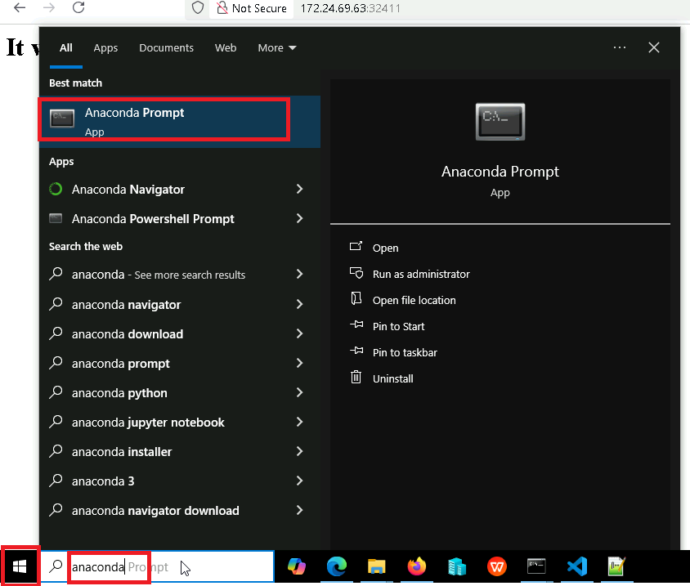

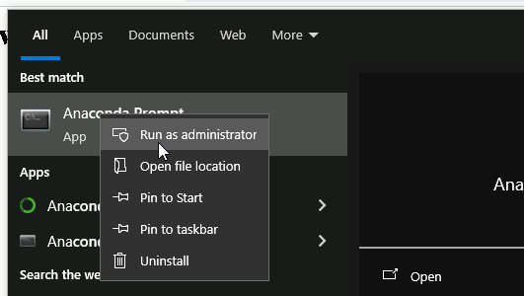

conda create -n devopsdemo --yes

conda activate devopsdemo

pip install kubegpt

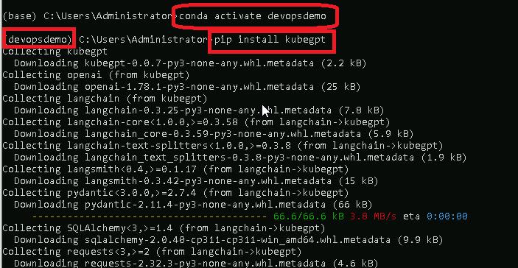

**set OPENAI_API_KEY=REPLACE_YOUR_KEY**

pip install -U langchain-community

pip install langchain-experimental

set allow_dangerous_tools=True

# On notepad++ open the file in the below location:

C:\Program Files\Python311\Lib\site-packages\langchain_community\agent_toolkits\load_tools.py

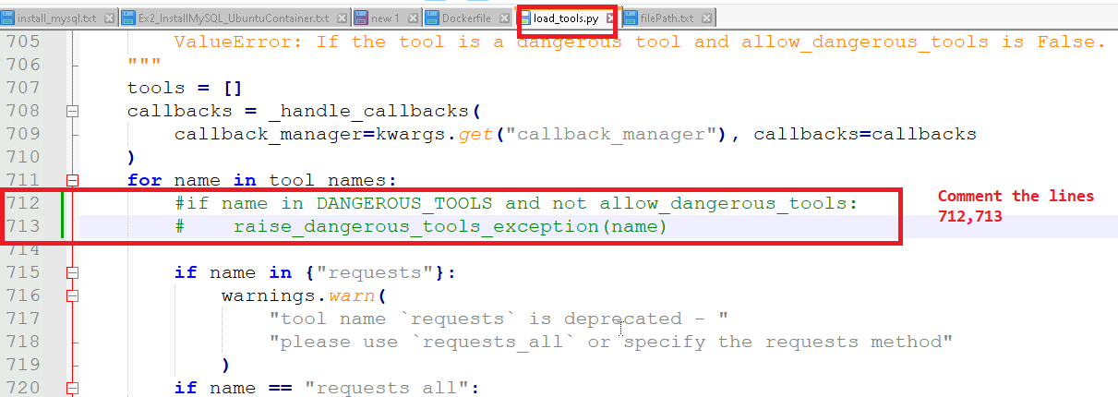

kubegpt "What kubernetes context am I using?"

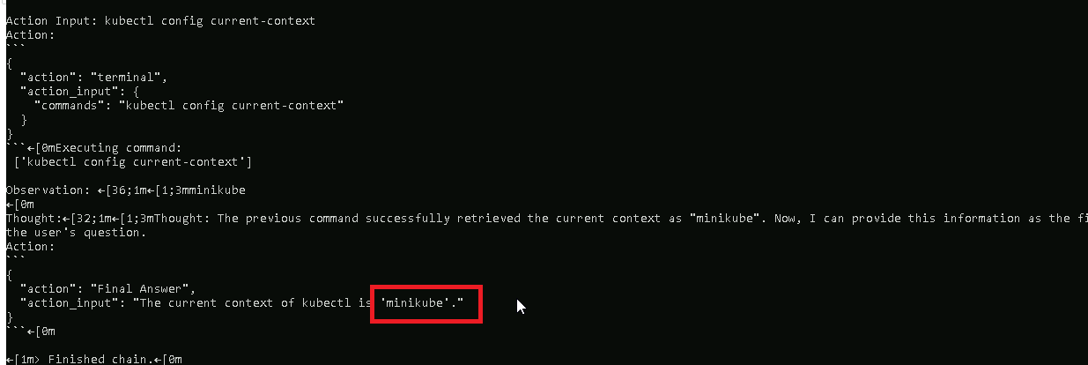

kubegpt "create a deployment named dep1 with httpd image and 2 replicas"

kubectl get pods

kubectl get deployments

kubegpt "create a service exposure for the dep1 deployment with node port type of service"

kubectl get svc

kubegpt "create a 2 gb volume"

# This should give an error, will fail