**The RACEF Framework**

The RACEF Framework provides a structured approach to enhancing AI interactions through five essential components:

* **Rephrase:** Refine the wording of your query to achieve more precise and relevant results.
* **Append:** Add details or constraints to guide the AI towards targeted outputs.
* **Contextualize:** Provide background information or situational details to align the AI's responses with your needs.
* **Examples:** Include sample inputs or desired outputs to clarify expectations.
* **Follow-Up:** Encourage iterative improvement by allowing the AI to ask questions or refine its responses.

By leveraging these components, RACEF empowers users to maximize AI capabilities, ensuring clarity, depth, and adaptability in every prompt.

**RACEF vs CRISPE Framework: Choosing the Right Approach**

Both frameworks are designed to improve AI interactions, but they differ in their focus and application. Here's how they compare:

|  |  |  |
| --- | --- | --- |
| **Aspect** | **RACEF** | **CRISPE** |
| **Focus** | Refining prompts for precision and adaptability | Clarity and iterative refinement for consistent results |
| **Best for** | Iterative and complex problem-solving | Structured and step-by-step tasks |
| **Flexibility** | Highly flexible across domains | Focused on structured use cases |

RACEF is ideal for dynamic, exploratory tasks, while CRISPE excels in scenarios requiring consistent outputs.

**RAFEF Framework Overview**

Rephrase: Adjust the phrasing of your prompt to ensure clarity and relevance.

Append: Add details, specifications, or constraints to focus the AI's response.

Focus: Narrow the scope of the query to avoid broad or irrelevant outputs.

Examples: Provide clear examples to guide the AI towards the desired response format.

Clarify: Enable follow-up questions or clarifications to refine results iteratively.

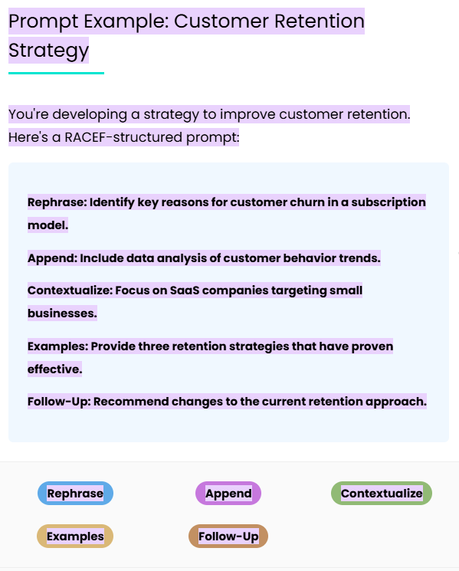

**The CRISPE Framework**

The CRISPE Framework brings clarity and consistency to AI interactions through its six essential components:

* **Clarity:** Clearly define the task or goal to minimize ambiguity.
* **Relevance:** Focus on aligning the prompt with the context or audience for accurate results.
* **Iteration:** Incorporate iterative improvements by refining responses based on feedback.
* **Specificity:** Add precise details or constraints to narrow the AI's focus.
* **Practicality:** Ensure that the output is actionable and feasible for implementation.
* **Examples:** Provide sample inputs or outputs to guide the AI towards the desired outcome.

By combining these elements, CRISPE enables structured, reliable, and goal-oriented prompts for both simple and complex tasks.

**CRISPE vs RACEF Framework: Finding the Perfect Fit**

While both frameworks enhance prompt engineering, CRISPE emphasizes clarity and step-by-step precision, whereas RACEF focuses on iterative refinement and adaptability. Here's a comparison:

|  |  |  |
| --- | --- | --- |
| **Aspect** | **CRISPE** | **RACEF** |
| **Focus** | Clarity and structured precision | Flexibility and iterative improvement |
| **Best for** | Technical and repeatable tasks | Exploratory or evolving challenges |
| **Flexibility** | Great for structured outputs | Better for dynamic, context-driven tasks |

**CRISPE Framework Overview**

Clarity: Eliminate ambiguity to ensure AI understands the task precisely.

Relevance: Align the prompt with the specific objective or context.

Iteration: Allow refinement through feedback and follow-up prompts.

Specificity: Focus on precise details to guide the AI's response.

Parameters: Define constraints to shape the output effectively.

Examples: Demonstrate the desired format or structure of the response.

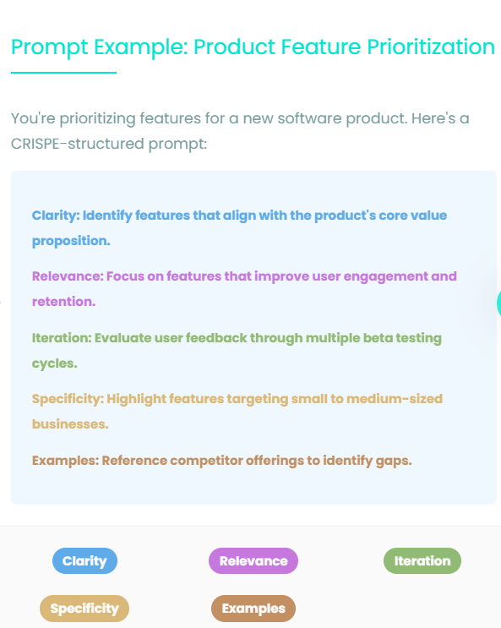

**The BAB Framework**

The BAB Framework (Before, After, Bridge) is a simple yet powerful tool for structuring persuasive prompts and copy. It guides AI interactions by focusing on three core elements:

* **Before:** Highlight the current problem, challenge, or pain point faced by the user or audience.
* **After:** Paint a vivid picture of the ideal outcome or solution, showing the transformation they desire.
* **Bridge:** Connect the problem and solution by introducing your product, service, or idea as the key to achieving that outcome.

With this straightforward structure, BAB excels at creating emotionally compelling narratives, making it ideal for marketing, customer engagement, and persuasive communication.

**BAB vs AIDA Framework: Choosing the Right Approach**

Both frameworks are powerful tools for marketing and prompting, but they cater to different objectives. Here's a comparison:

|  |  |  |
| --- | --- | --- |
| **Aspect** | **BAB** | **AIDA** |
| **Focus** | Emotion-driven storytelling | Attention, interest, desire, and action |
| **Best for** | Persuasion through problem-solution narratives | Structured, step-by-step conversion processes |
| **Flexibility** | Excellent for emotionally charged copy | Great for capturing and converting leads |

**BAB Framework Overview**

* **Before:** Describe the user's problem or challenge in a relatable and engaging way.
* **After:** Present an ideal future state or solution that addresses the problem.
* **Bridge:** Highlight how a specific product, service, or strategy connects the problem to the solution.

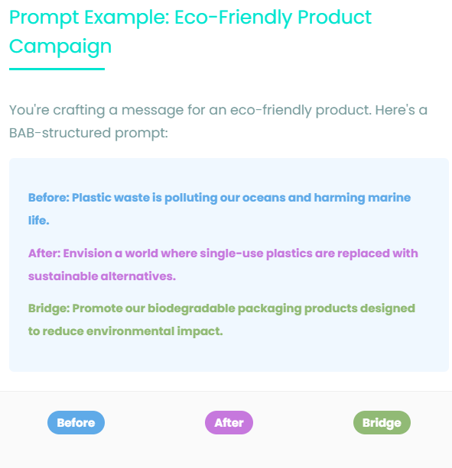

**Best Generative Models for the BAB Framework**

The BAB Framework is highly effective with the following generative AI models, ensuring your prompts deliver maximum impact:

* **OpenAI's GPT-4:** Ideal for crafting emotionally resonant narratives and persuasive content with nuanced language.
* **Google's Bard:** Perfect for creating creative, engaging copy that bridges emotional connections.
* **Anthropic's Claude:** Great for producing detailed, empathetic responses aligned with the BAB structure.
* **Juuzt AI's proprietary tools:** Optimized for marketing applications, leveraging BAB to craft compelling campaigns.
* **Meta’s Llama 2:** Best suited for specialized storytelling tasks and niche audience targeting.

**Where to Use the BAB Framework**

The BAB Framework is ideal for tasks requiring clarity, empathy, and motivation. Use it for:

* Cold email campaigns
* Marketing and branding strategies
* Customer support solutions
* Educational content creation
* Persuasive presentations

**Components, Benefits, and Applications of RELIC**

The RELIC Framework simplifies prompt creation by breaking down a prompt into five key components:

* **Role:** Define ChatGPT’s role in the interaction, such as an advisor, strategist, or creator.
* **Emphasis:** Highlight the most important aspects of your request to guide ChatGPT’s focus.
* **Limitation:** Set boundaries to keep the response concise, relevant, and on-brand.
* **Information:** Provide the necessary background or context to ensure accurate outputs.
* **Challenge:** Define the problem or task, creating clear objectives for ChatGPT to address.

By combining these elements, RELIC ensures your prompts are well-structured and capable of delivering actionable results across diverse applications.

**RELIC Framework Overview**

* **Role:** Specify the role ChatGPT should adopt to tailor its response effectively.
* **Emphasis:** Direct the AI's attention to the most important elements of your request.
* **Limitation:** Set clear boundaries to ensure responses remain concise and focused.
* **Information:** Provide the necessary context for well-informed outputs.
* **Challenge:** Articulate the task or problem, ensuring clear objectives.

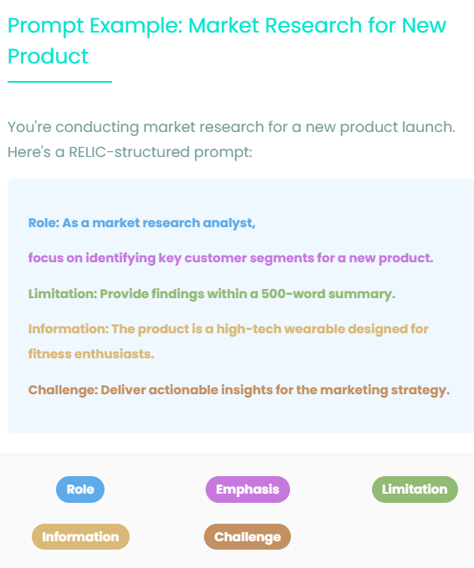

**Why Use RELIC?**

The RELIC Framework enhances ChatGPT interactions by providing structure and clarity. Whether you're drafting social media strategies or planning complex projects, RELIC ensures that your prompts yield precise, impactful, and relevant responses.  
  
**Core Advantages of RELIC:**

* **Clarity:** Eliminates ambiguity, ensuring AI understands the task.
* **Focus:** Guides ChatGPT to prioritize key details.
* **Versatility:** Adapts to a wide range of tasks, from creative content to technical problem-solving.
* **Efficiency:** Saves time by reducing back-and-forth adjustments.

**Generative AI Models Compatible with RELIC**

The RELIC Framework pairs seamlessly with cutting-edge generative AI models, offering precision and adaptability for crafting targeted, impactful prompts. Its structured approach enhances model performance by providing clear instructions and goals.

Whether you're optimizing ChatGPT for strategic planning or leveraging multimodal capabilities, RELIC ensures consistent and relevant results across platforms.

* **ChatGPT-4o and 4o1:** Renowned for advanced reasoning and nuanced responses, ideal for RELIC's structured prompts.
* **Claude Sonnet 3.5:** Excels in generating creative and ethical solutions, aligning with RELIC's focus on targeted problem-solving.
* **Google Gemini Pro:** Handles complex tasks and multimodal inputs with ease, making it perfect for RELIC's diverse applications.
* **OpenAI DALL·E 3:** Complements RELIC's creative elements, enabling visually stunning outputs with clear contextual alignment.

**Ideal applications of the framework**

The RELIC Framework is best suited for scenarios requiring precision, creativity, and structure. Its versatility makes it invaluable across multiple domains, including:

* **Content Creation:** Develop engaging blog posts, social media content, and email campaigns.
* **Strategic Planning:** Optimize marketing strategies, project prioritization, and workflow designs.
* **Educational Tools:** Design interactive learning experiences and curriculum development.
* **Customer Engagement:** Craft personalized interactions to enhance user satisfaction.

**What Is SCAMPER and How Does It Work?**

The SCAMPER Framework offers seven methods to explore and expand ideas:

* **Substitute:** Replace one element of an idea or process with another to improve outcomes.
* **Combine:** Merge multiple concepts to create something new and innovative.
* **Adapt:** Modify an idea to fit different needs, audiences, or environments.
* **Modify:** Alter or magnify elements to enhance value or functionality.
* **Put to Another Use:** Repurpose an idea or tool for a new application or audience.
* **Eliminate:** Remove unnecessary parts to streamline and improve efficiency.
* **Reverse:** Reimagine an idea from an opposite perspective for unique insights.

Using these seven techniques ensures a structured approach to innovation, enabling users to think outside the box and generate actionable solutions.

**SCAMPER Framework Overview**

* **Substitute:** Change parts of an idea or process to find improvements.
* **Combine:** Bring different elements together for innovation.
* **Adapt:** Adjust an idea to new contexts or uses.
* **Modify:** Enhance elements to amplify impact.
* **Put to Another Use:** Find alternative applications for existing ideas.
* **Eliminate:** Simplify by removing unnecessary parts.
* **Reverse:** Flip perspectives to uncover fresh insights.

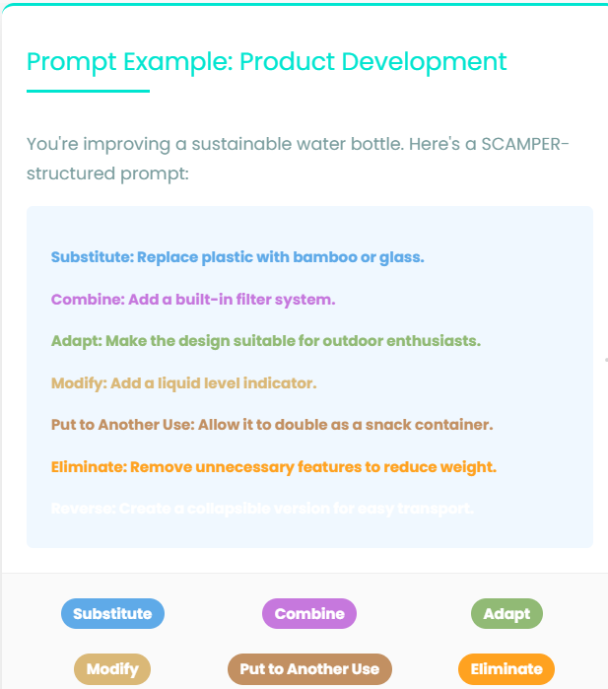

**Why Use SCAMPER?**

The SCAMPER Framework is ideal for anyone seeking to enhance creativity and innovation in their projects. By offering a structured method for generating ideas, it provides clarity and focus across diverse applications.  
  
**Core Advantages of SCAMPER:**

* **Versatility:** Applicable to countless scenarios, from product design to personal development.
* **Clarity:** Encourages clear and actionable thought processes.
* **Creativity:** Promotes unconventional approaches to problem-solving.
* **Accessibility:** Suitable for beginners and experienced innovators alike.

**Generative AI Models Compatible with SCAMPER**

The SCAMPER Framework enhances generative AI interactions by providing a structured approach to creativity. Its compatibility with leading AI tools ensures robust and adaptable outcomes.

SCAMPER's structured strategies enable tools like ChatGPT to generate precise, actionable, and innovative ideas, making it indispensable for brainstorming and problem-solving.

* **ChatGPT-4o:** Exceptional for nuanced and structured idea generation.
* **Claude Sonnet 3.5:** Ideal for creative and ethical brainstorming tasks.
* **Google Gemini:** Handles complex, multimodal inputs with ease.

**Best Applications of SCAMPER**

The SCAMPER Framework excels in scenarios demanding creativity and systematic exploration. Ideal applications include:

* **Product Innovation:** Enhance features, usability, and appeal.
* **Process Optimization:** Streamline workflows for efficiency.
* **Content Creation:** Develop engaging campaigns and materials.
* **Problem-Solving:** Tackle challenges with fresh perspectives.
* **Personal Growth:** Reimagine skills and projects for new opportunities.

**What Is the Six Thinking Hats Framework and How Does It Work?**

Developed by Edward de Bono, the Six Thinking Hats Framework organizes thinking into six distinct perspectives, each represented by a colored hat:

* **White Hat:** Focuses on facts, data, and objective information.
* **Red Hat:** Embraces emotions, gut feelings, and intuitive responses.
* **Black Hat:** Identifies risks, challenges, and potential pitfalls.
* **Yellow Hat:** Explores optimism, benefits, and positive outcomes.
* **Green Hat:** Encourages creativity, innovation, and fresh ideas.
* **Blue Hat:** Manages the thinking process and ensures structure.

By using each 'hat' in turn, you can address problems holistically and strategically.

**Overview of the Six Thinking Hats**

* **White Hat:** Focus on factual data and information gathering.
* **Red Hat:** Allow space for emotional and intuitive insights.
* **Black Hat:** Critically evaluate risks and weaknesses.
* **Yellow Hat:** Highlight benefits and optimistic outcomes.
* **Green Hat:** Foster creative and alternative solutions.
* **Blue Hat:** Maintain control and structure in discussions.

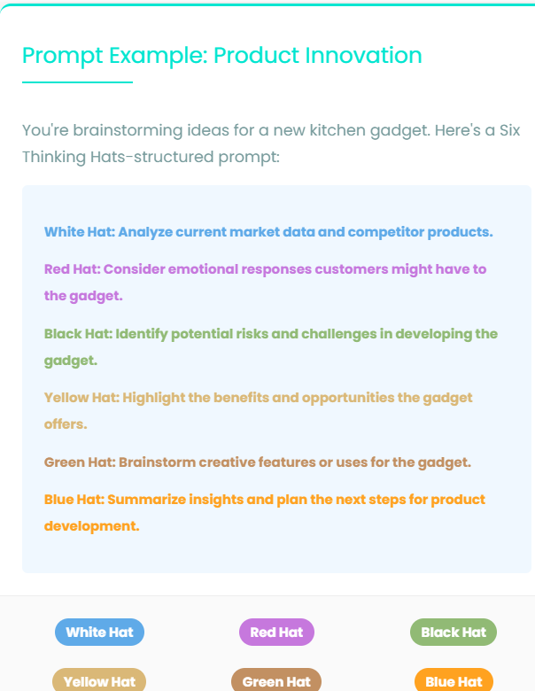

**Why Use the Six Thinking Hats Framework?**

The Six Thinking Hats Framework enhances clarity, creativity, and collaboration by encouraging diverse thinking styles.  
  
**Key Benefits:**

* **Comprehensive Analysis:** Examines issues from multiple angles.
* **Improved Creativity:** Sparks fresh ideas and innovative solutions.
* **Balanced Decisions:** Combines logic, emotion, and practicality for better outcomes.
* **Team Alignment:** Streamlines discussions and reduces conflict.

**Generative AI Models Compatible with Six Thinking Hats**

The Six Thinking Hats Framework leverages AI for structured insights. Generative AI models enhance its utility, providing rapid, diverse perspectives.

* **ChatGPT-4o:** Excels at structured brainstorming and idea generation.
* **Claude Sonnet 3.5:** Perfect for exploring emotional and creative aspects.
* **Google Gemini:** Ideal for combining visual and textual insights.

**Practical Applications**

**Best Uses of the Six Thinking Hats**

The Six Thinking Hats Framework is ideal for:

* **Strategic Planning:** Develop comprehensive and balanced strategies.
* **Problem-Solving:** Address complex challenges with creativity and logic.
* **Team Collaboration:** Foster constructive discussions and consensus.
* **Decision-Making:** Ensure informed, balanced, and confident choices.