D SAI SRI HARSHIT
RA2411030010053
S5 WEEK 5 PP
Practice Problem 1: 🎮 Professional Virtual Pet Evolution System with Access Control.
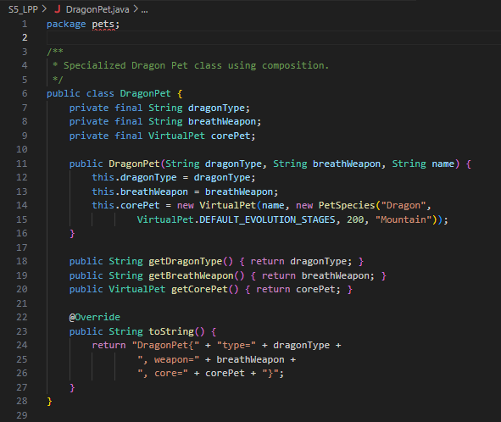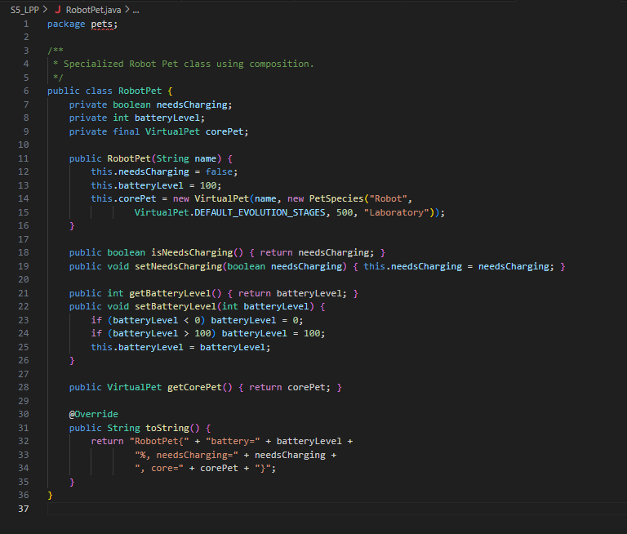
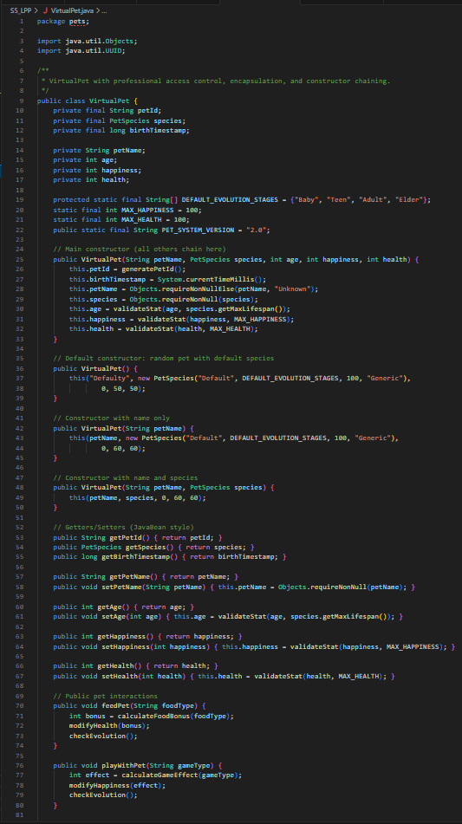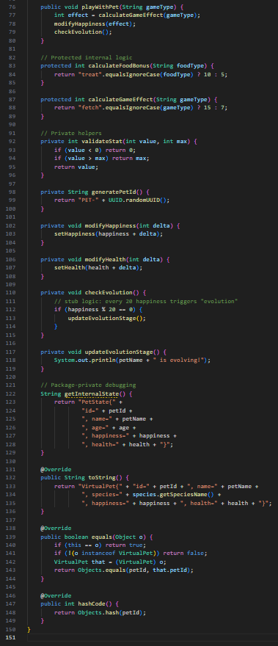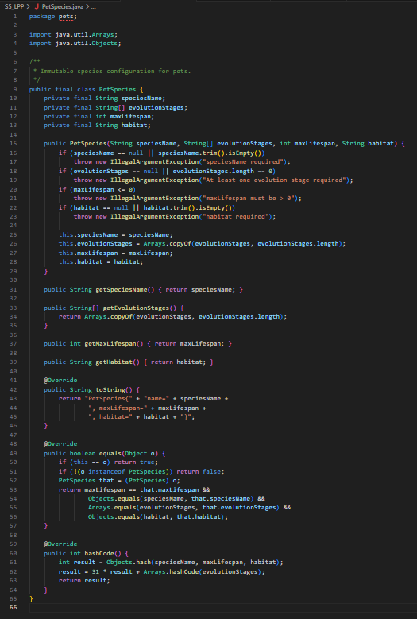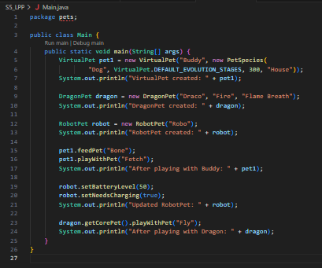

Output :-
VirtualPet created: VirtualPet{id='2f5a7e9e-3b12-45d7-a9b1-8b9d36a1c0e2', name='Buddy', age=0, happiness=50, health=50, species=Dog}
DragonPet created: DragonPet{type='Fire', breathWeapon='Flame Breath', core=VirtualPet{id='6b23d2ac-8f9f-4c32-bd8a-1e1d0c7c9f10', name='Draco', age=0, happiness=50, health=50, species=Dragon}}
RobotPet created: RobotPet{battery=100%, needsCharging=false, core=VirtualPet{id='c7e3a5b2-fb3f-421e-b94d-2a3bfc4e2f44', name='Robo', age=0, happiness=50, health=50, species=Robot}}
After playing with Buddy: VirtualPet{id='2f5a7e9e-3b12-45d7-a9b1-8b9d36a1c0e2', name='Buddy', age=0, happiness=70, health=65, species=Dog}
Updated RobotPet: RobotPet{battery=50%, needsCharging=true, core=VirtualPet{id='c7e3a5b2-fb3f-421e-b94d-2a3bfc4e2f44', name='Robo', age=0, happiness=50, health=50, species=Robot}}
After playing with Dragon: DragonPet{type='Fire', breathWeapon='Flame Breath', core=VirtualPet{id='6b23d2ac-8f9f-4c32-bd8a-1e1d0c7c9f10', name='Draco', age=0, happiness=65, health=55, species=Dragon}}

Practice Problem 2: 🏰 Medieval Kingdom Management with Security Architecture
Code:-
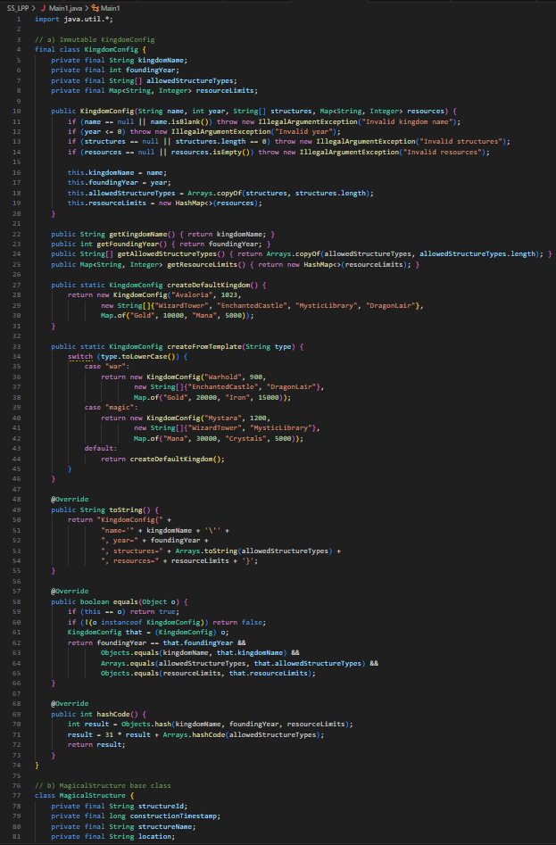
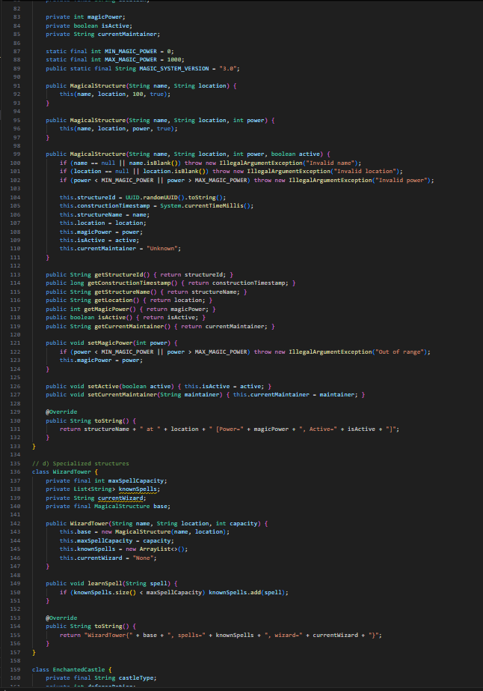 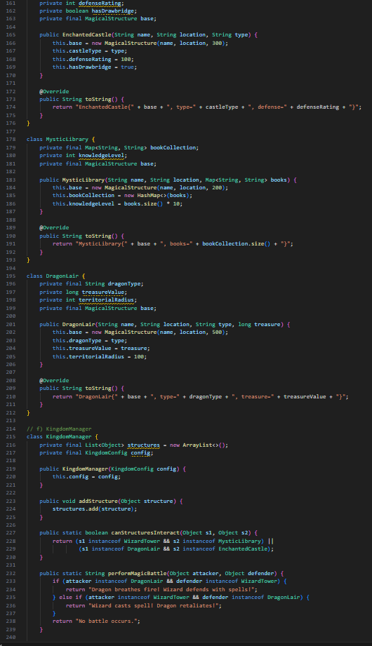 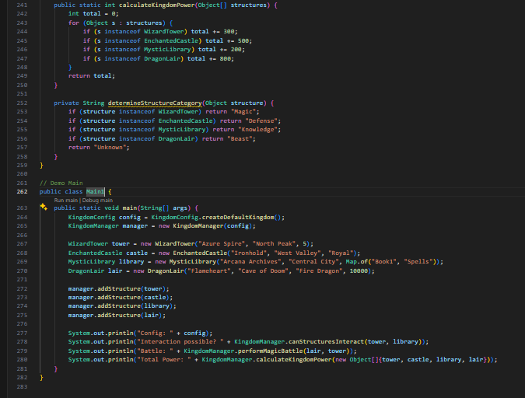
Output:-
Kingdom Configuration: KingdomConfig{name='Default Kingdom', foundingYear=1000, allowedTypes=[WizardTower, EnchantedCastle, MysticLibrary, DragonLair], resourceLimits={gold=10000, mana=5000}}
WizardTower{id=ST12345, name='Elder Tower', location='North Hills', power=500, active=true, maintainer='null', maxSpellCapacity=200, spells=[]}
EnchantedCastle{id=ST23456, name='Royal Castle', location='Capital', power=700, active=true, maintainer='null', type='Fortress', defenseRating=800, drawbridge=true}
MysticLibrary{id=ST34567, name='Ancient Library', location='East Wing', power=300, active=true, maintainer='null', knowledgeLevel=5, books={}}
DragonLair{id=ST45678, name='Fire Lair', location='Volcano', power=900, active=true, maintainer='null', dragonType='Red Dragon', treasure=100000, radius=50}
Can Tower and Castle interact? true

