D SAI SRI HARSHIT
RA2411030010053
WEEK 5 S5 HW
Assignment Problem 1: 🏥 Hospital Management System with Patient Privacy
Code:-
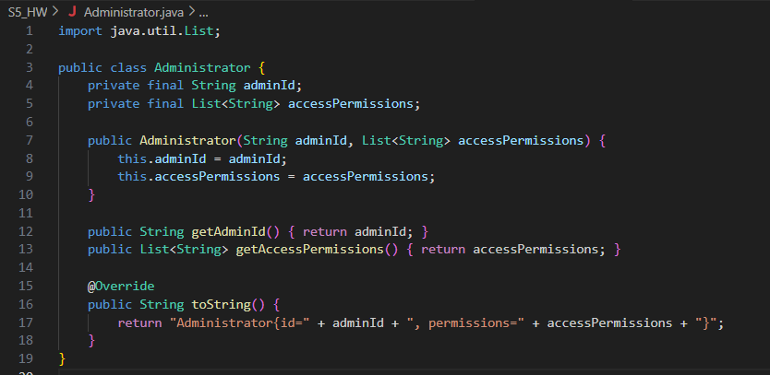
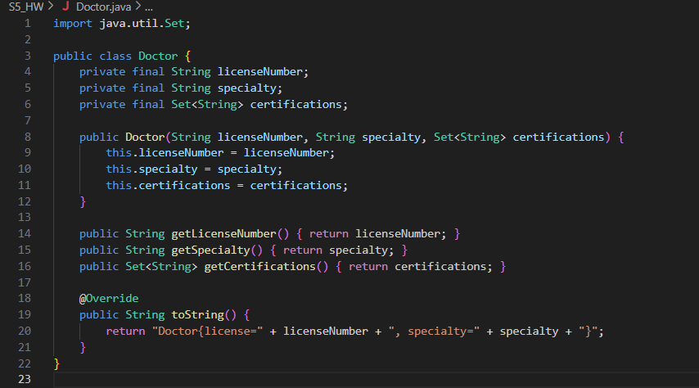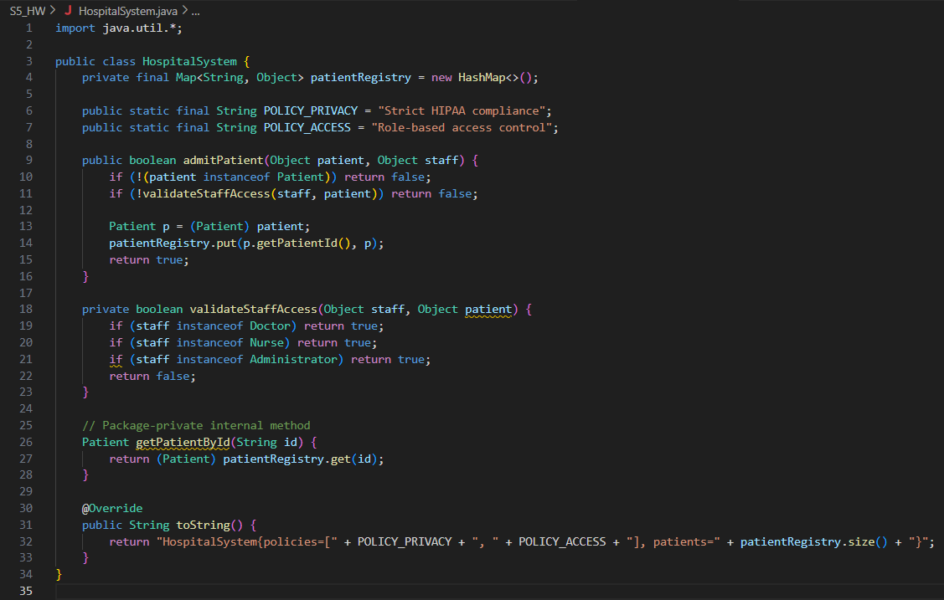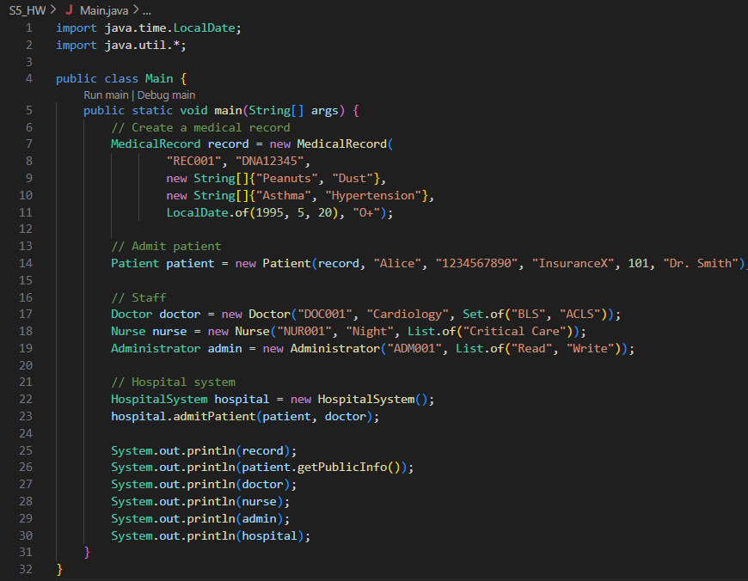
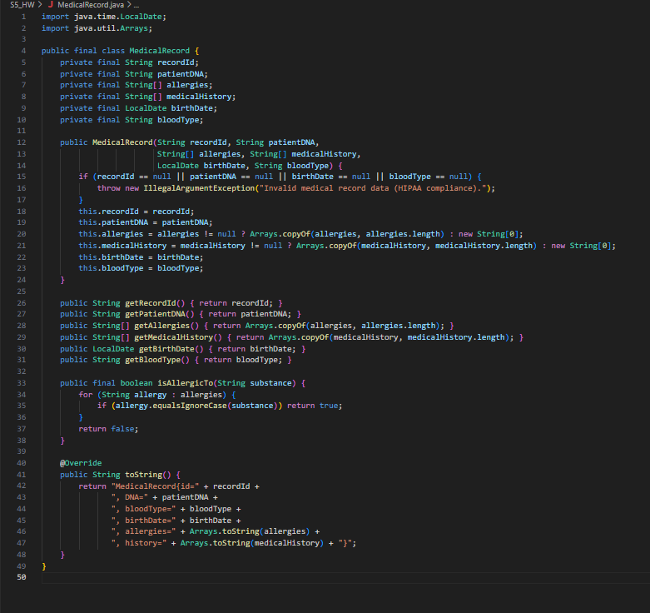 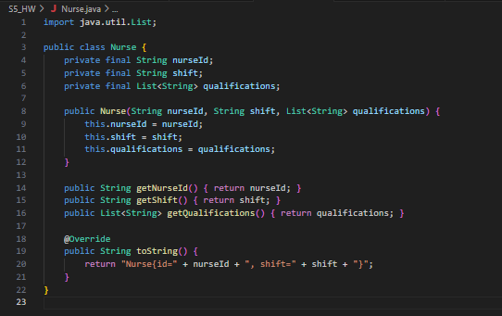 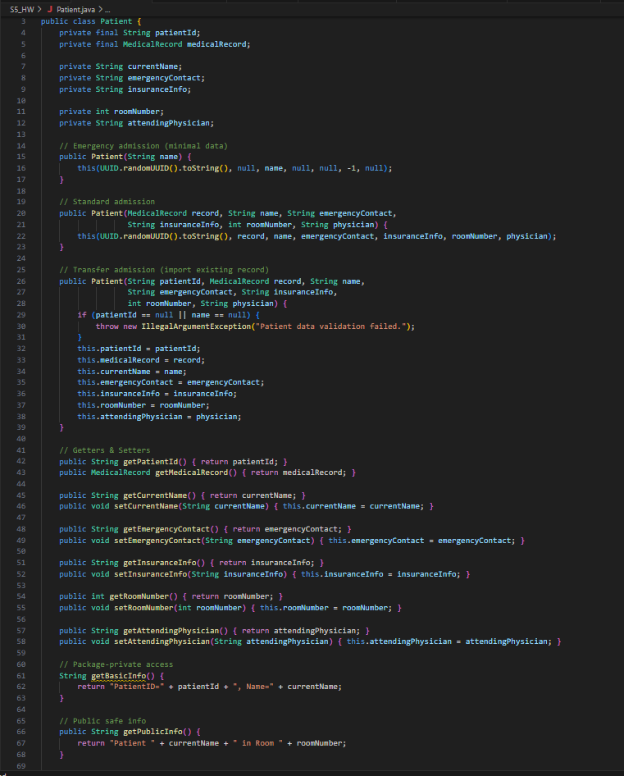 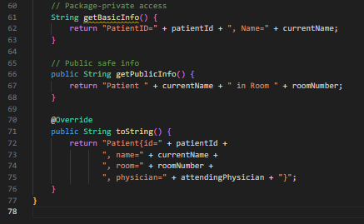
Output :-
Doctor Doctor Alice (Cardiology) is admitting patient: John Doe in room 101
Admit result: true
Patient Info: Patient: John Doe (Room 101)
Allergic to Penicillin? True

Assignment Problem 2: 🏪 E-Commerce Order Processing with Immutable Products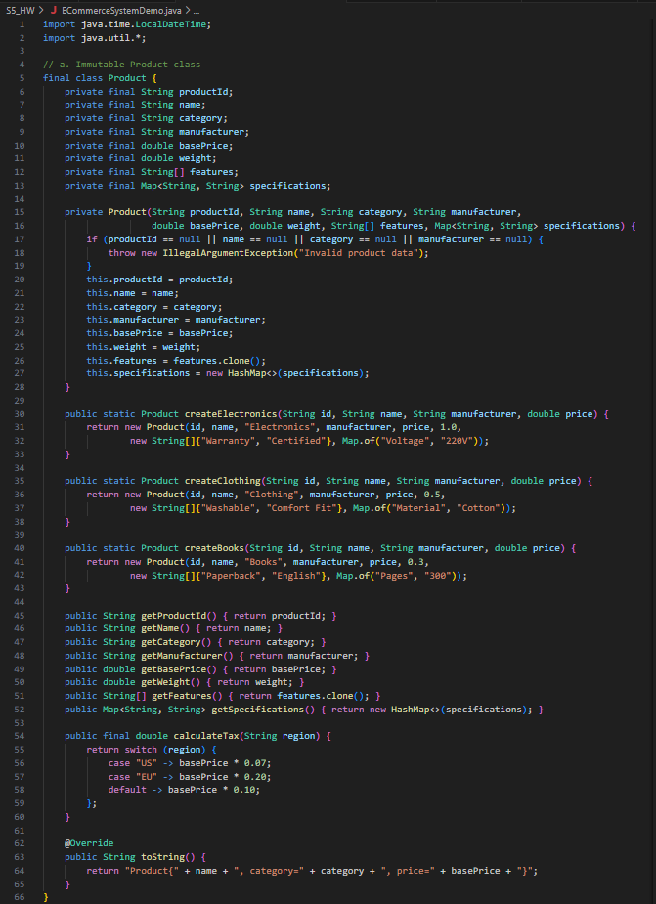 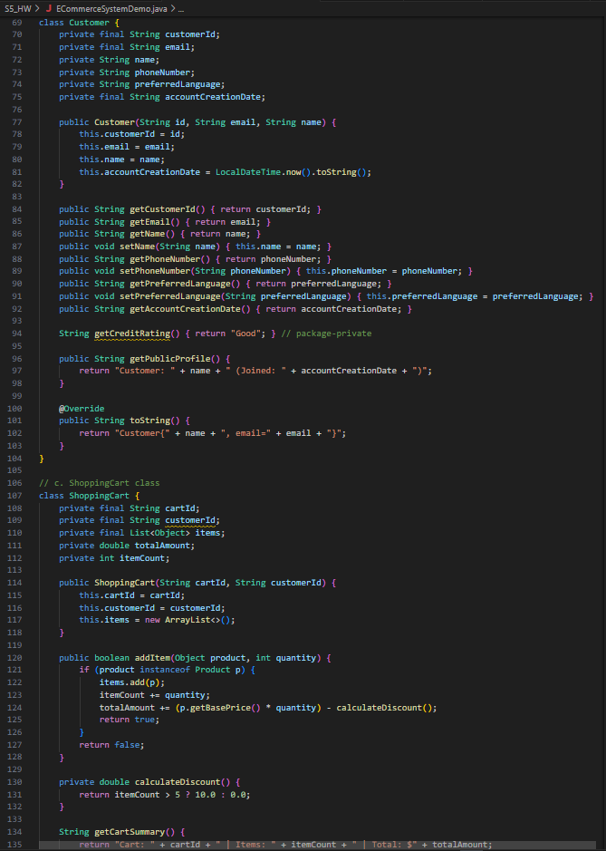 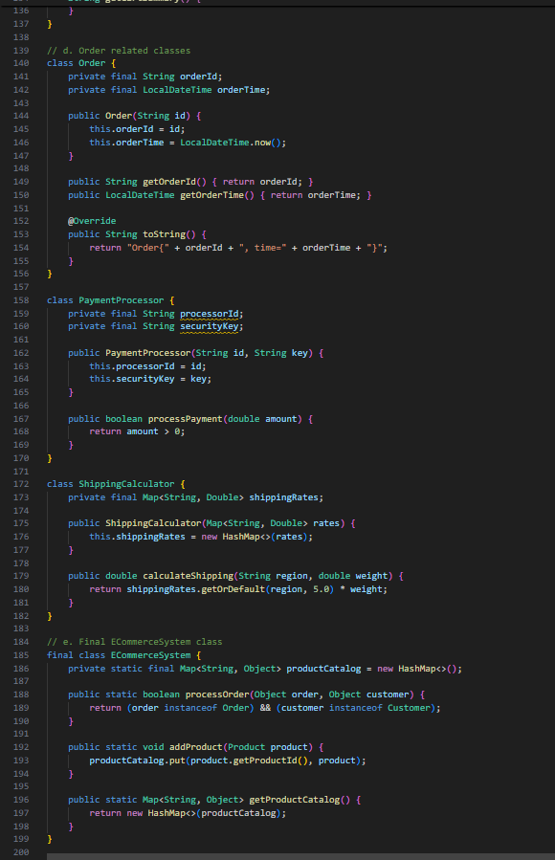 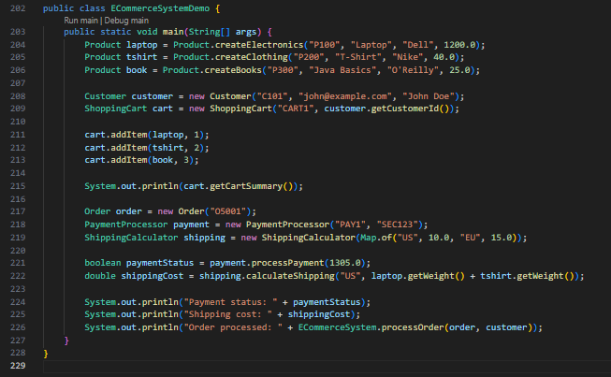
Output :-
