MOVIE TICKET BOOKING SYSTEM
A PROJECT REPORT
Submitted by
D.GURU SAI TEJ REDDY [RA2411056010008]

Under the guidance of
Dr. Mercy Theresa M
Assistant Professor, Department of Data Science and Business Systems
In partial fulfillment of the requirements for the degree of
BACHELOR IN TECHONOLOGY


DEPARTMENT OF DATA SCIENCE AND BUSINESS SYSTEMS
SRM INSTITUTE OF SCIENCE AND TECHNOLOGY
KATTANKULATHUR – 603 203
NOVEMBER 2025



SRM INSTITUTE OF SCIENCE AND TECHNOLOGY KATTANKULATHUR – 603 203

BONAFIDE CERTIFICATE

Certified that this minor project report for the course 21CSC206P ADVANCED OBJECT ORIENTED AND PROGRAMMING entitled in “MOVIE TICKET BOOKING SYSTEM”is the Bonafide work of D.GURU SAI TEJ REDDY [RA2411056010008], [RA2411056010031] and DEEPESH REDDY [RA2411056010057] who carried out the work under my supervision.

SIGNATURE SIGNATURE
Dr. Mercy Theresa M Dr. Kavitha V
SUPERVISOR HEAD OF DEPARTMENT
ASSISTANT PROFESSOR PROFESSOR
DEPARTMENT OF DATA DEPARTMENT OF DATA
SCIENCE AND SCIENCE AND BUSINESS
BUSINESS SYSTEM

ACKNOWLEDGEMENTS

We express our heartfelt thanks to our honourable Vice Chancellor Dr. C.Muthamizhchelvan, for being the beacon in all our endeavours.
We would like to express my warmth of gratitude to our Registrar Dr. S.Ponnusamy, for his encouragement.
We express our profound gratitude to our Dean (College of Engineering and Technology) Dr. Leenus Jesu Martin M, for bringing out novelty in all executions.
We would like to express my heartfelt thanks to Chairperson, School of Computing Dr. Revathi Venkataraman, for imparting confidence to complete my course project.
We extend my gratitude to our HOD Dr. Kavitha V, Professor,
Department of Data Science and Business Systems and my Departmental colleagues for their Support.
We are highly thankful to my Course project Faculty Dr.Mercy Theresa M, Assistant Professor, Department of Data Science and Business Systems for her assistance, timely suggestion and guidance throughout the duration of this course project.
Finally, we thank our parents and friends near and dear ones who directly and indirectly contributed to the successful completion of our project.
Above all, I thank the almighty for showering his blessings on me to
complete my Course project.
D.GURU SAI TEJ REDDY

AUTHORS

ABSTRACT

The Movie Ticket Booking System is a comprehensive software application developed using object-oriented programming concepts to automate and simplify the ticket reservation process in movie theaters. The main objective of this system is to provide an efficient and user-friendly platform for customers to view available movies, check show timings, select seats, and book tickets without the need for manual assistance. Traditional ticket booking systems often involve long queues, limited availability information, and human errors, which lead to customer inconvenience. To overcome these issues, the proposed system introduces an automated solution that enhances accuracy, convenience, and time efficiency. The use of object-oriented programming principles such as encapsulation, inheritance, abstraction, and polymorphism ensures the system is modular, reusable, and easy to maintain. The system also includes features for administrators to manage movie listings, update schedules, track seat availability, and monitor overall ticket sales.
The project is implemented using modern programming tools and database technologies to maintain real-time accuracy and performance. The interface is designed to be simple, intuitive, and accessible, ensuring that users can easily navigate through available options and complete bookings with minimal effort. The system improves operational efficiency for theater administrators while providing a seamless experience for users. In addition, it demonstrates how object-oriented programming can be applied effectively to real-world scenarios involving data management and automation. With further enhancements such as integration of online payment gateways, mobile application support, and QR-code ticket generation, this project can be extended into a full-fledged commercial ticketing platform. Overall, the Movie Ticket Booking System showcases the power of software engineering principles in creating reliable, scalable, and user-centered applications.

TABLE OF CONTENTS

S.NO CONTENTS PAGE NO

- ABSTRACT 4

- INTRODUCTION 6-9

- REQUIREMENT ANALYSIS 10-16

- IMPLEMENTATION 17-22

5. RESULTS 23-25

6. REFERENCES 26

CHAPTER 1 INTRODUCTION

In the modern era of digital transformation, automation has become an essential part of every domain — from education and healthcare to entertainment. The entertainment industry, especially the movie sector, has experienced a significant shift from manual operations to online and computerized systems. One of the most common and necessary changes has been the automation of movie ticket booking. Traditionally, booking movie tickets required visiting the theater, standing in queues, checking seat availability manually, and handling cash transactions. This process was not only time-consuming but also error-prone and inconvenient for both customers and staff.
The Movie Ticket Booking System is developed as a comprehensive software solution that simplifies and automates this process. By integrating Object-Oriented Programming (OOP) principles, the system provides an efficient, modular, and user-friendly platform where users can view movies, select show timings, check seat availability, and confirm bookings. Meanwhile, theater administrators can manage movie information, show schedules, and seat allocations easily. The system eliminates repetitive manual work, minimizes errors, and enhances user experience by allowing quick and reliable ticket reservations. This project also serves as an academic demonstration of applying OOP principles like encapsulation, inheritance, abstraction, and polymorphism in real-world problem solving, showcasing how programming concepts can lead to scalable and maintainable software.

1.1 Motivation
The primary motivation behind developing this project arises from the increasing need for automation in day-to-day activities and the inefficiencies of traditional ticket booking systems. In the past, customers were required to visit theaters physically to buy tickets, often standing in long queues, especially during weekends or blockbuster releases. This process caused delays, confusion, and dissatisfaction among customers. Additionally, managing bookings manually placed a heavy workload on theater staff, leading to mistakes in seat allocation, data entry, and record keeping.
The growing dependency on technology for daily convenience inspired the development of a computerized system that can perform these tasks efficiently. Online ticket booking platforms such as BookMyShow and Paytm Movies have proven that digital solutions can revolutionize entertainment services. However, most small or local theaters still lack affordable and simplified automation systems. This project is motivated by the idea of designing an educational yet practical system that bridges this gap — demonstrating how OOP techniques can be used to create a scalable solution even for smaller operations. The Movie Ticket Booking System aims to enhance convenience, accuracy, and speed while reducing the operational costs and human effort associated with manual ticket management.

1.2 Objectives
The Movie Ticket Booking System has been developed with several clear objectives that focus on both user convenience and system performance. The main objectives include:
- Automation: To eliminate manual work by developing a fully automated software system for movie ticket booking.
- User Accessibility: To create a user-friendly interface that allows customers to easily search for movies, select show timings, and book tickets.
- Administrative Efficiency: To provide administrators with tools to manage movie listings, showtimes, and booking records effectively.
- Database Management: To ensure secure storage and management of booking data, user profiles, and transaction history.
- Reliability and Accuracy: To reduce the occurrence of booking errors, duplicate entries, or mismanagement of seats.
- Demonstration of OOP Concepts: To implement and demonstrate the use of object-oriented programming concepts such as abstraction, encapsulation, inheritance, and polymorphism for modular and reusable code.
- Scalability: To design a system architecture that can easily accommodate new features like payment integration, real-time notifications, and mobile application compatibility in the future.
By achieving these objectives, the system provides an end-to-end solution for both customers and theater management, contributing to operational excellence and user satisfaction.

1.3 Problem Statement
In conventional theaters, the process of booking movie tickets is often carried out manually. Customers have to visit the theater, inquire about the availability of seats, and then purchase tickets at the counter. This manual process leads to several issues — long waiting lines, miscommunication, human errors in recording bookings, and a lack of transparency in seat allocation. During peak times, the system becomes overwhelmed, causing confusion and frustration among customers. Manual record keeping also makes it difficult to track transactions, generate reports, or verify data accuracy. Furthermore, the absence of a centralized system leads to inefficiency in managing multiple shows or screens.
Another significant problem lies in the lack of accessibility. Customers living far from the theater cannot check availability or book tickets remotely. This not only reduces customer convenience but also limits the theater’s business potential. There is also no systematic way to handle cancellations or refunds effectively. As a result, both the users and administrators suffer from inconvenience and data inconsistency.
Therefore, the problem identified is the need for a digital, automated, and reliable movie ticket booking system that allows customers to check availability, book tickets, and view details online while providing administrators with efficient management tools. The system must also ensure accuracy, security, and scalability to accommodate future technological improvements.

1.4 Scope of Work
The Movie Ticket Booking System aims to cover the complete cycle of ticket booking, from movie selection to ticket confirmation. The system provides functionalities for both users and administrators. Users can register, log in, view the list of available movies, check show timings, select desired seats, and confirm their bookings in real-time. Each booking is stored in a database, ensuring data consistency and reliability. Users can also cancel their tickets before showtime, and the system updates the availability automatically.
For administrators, the scope includes the ability to manage movie details such as title, genre, duration, and show timings. The admin can also add or remove movies, allocate seats, and generate booking reports. The system ensures data protection and prevents unauthorized access through secure login credentials. Additionally, the database architecture supports scalability, allowing the integration of new features such as payment gateways, QR-code ticket generation, and email or SMS confirmations in the future.
This project not only serves as a real-world example of OOP implementation but also as a stepping stone toward advanced ticket management platforms. The Movie Ticket Booking System demonstrates the importance of applying object-oriented design for creating reliable, user-friendly, and future-ready applications that can improve both user experience and theater operations.

CHAPTER 2
REQUIREMENT ANALYSIS
Requirement analysis is a crucial stage in the development of any software system. It defines the necessary hardware and software components required to implement, execute, and maintain the system efficiently. This process ensures that the developed software is compatible with its operational environment, meets user needs, and performs reliably.
The Movie Ticket Booking System is designed to automate and simplify the movie ticket reservation process. It enables users to book tickets, view seat availability, and manage bookings digitally. To ensure seamless operation, appropriate hardware and software configurations are required. This chapter discusses in detail the hardware and software requirements essential for the development, testing, and deployment of the Movie Ticket Booking System.

2.1 Hardware Requirements
The Movie Ticket Booking System is designed as a lightweight and scalable application that can be executed on standard computing environments. The hardware requirements ensure that the system functions smoothly, delivers optimal performance, and remains responsive even under heavy usage. These requirements are divided into minimum and recommended configurations.

2.1.1 Minimum Hardware Requirements
The minimum hardware configuration defines the least resources required to run the system without issues. It is suitable for small-scale deployments such as college laboratories, small offices, or single-theater setups.
- Processor: Intel Core i3 or AMD equivalent (2.0 GHz or higher)
This provides sufficient processing speed for executing database queries, logic operations, and user interface tasks efficiently.
- RAM: 4 GB
Adequate for running the integrated development environment (IDE), database, and application concurrently without lag.
- Hard Disk: 500 MB of free storage space
Required for application files, logs, and small-scale database storage.
- Monitor: 1024×768pixelsresolution
Provides clear visualization for both text-based and graphical user interfaces.
- Keyboard and Mouse: Standard input devices for smooth navigation and data entry.
- Printer (Optional): For printing hard copies of ticket receipts and reports.
This configuration supports basic testing, development, and demonstration of the project.

2.1.2 Recommended Hardware Requirements
The recommended configuration enhances performance and is more suitable for large-scale deployment or production environments where multiple users interact with the system simultaneously.
- Processor: Intel Core i5/i7 or AMD Ryzen 5 and above
Ensures faster execution and multitasking capabilities, crucial for handling concurrent bookings.
- RAM: 8 GB or higher
Prevents system slowdowns during data-intensive operations such as accessing large databases.
- Storage: At least 1 GB of free disk space
Provides space for database growth, backups, and system updates.
- Display: Full HD (1920 × 1080 resolution) monitor
Ideal for GUI-based systems with better user interface visualization.
- Network Connection: Reliable internet connection (LAN/Wi-Fi)
Required for online database access and remote bookings.
- Power Backup: Uninterrupted Power Supply (UPS)
Prevents data loss or corruption during unexpected power failures.
This setup ensures a smooth and efficient experience for both users and administrators.

2.1.3 Justification for Hardware Requirements
The chosen hardware specifications provide a perfect balance between performance and cost-effectiveness. The system is designed to run on commonly available hardware without the need for specialized devices. For educational or small-scale use, even minimal hardware ensures proper functionality. However, the recommended setup ensures scalability — allowing for the integration of additional modules like payment gateways, analytics dashboards, or cloud-based services in future versions.

2.2 Software Requirements
The Movie Ticket Booking System utilizes object-oriented programming principles, making it flexible, reusable, and modular. Selecting appropriate software ensures smooth development, easy maintenance, and reliable operation. The following software components form the backbone of the system’s functionality.

2.2.1 Operating System
The operating system acts as the base platform for running both the development tools and the final application.
Supported Operating Systems:
- Microsoft Windows 7/8/10/11
- Linux Distributions (Ubuntu, Fedora, Debian)
- macOS (for cross-platform development)
Justification:
Windows provides a user-friendly environment ideal for development and testing. Linux offers stability and better performance for server-based deployment, while macOS ensures compatibility for developers using Apple hardware.

2.2.2 Programming Language
Preferred Languages: C++ or Java
Both languages support Object-Oriented Programming, enabling the use of key principles like encapsulation, inheritance, and polymorphism.
- C++ is suitable for lightweight console-based systems and offers direct control over hardware and memory.
- Java is preferred for GUI-based or web-integrated systems due to its platform independence and built-in libraries.
Justification:
OOP languages simplify complex system logic into reusable components. This improves maintainability and scalability, making them ideal for large, evolving projects like movie booking systems.

2.2.3 Integrated Development Environment (IDE)
Recommended IDEs:
- Code::Blocks (for C++)
- Eclipse or NetBeans (for Java)
- Visual Studio Code (for multi-language development)
Justification:
An IDE provides essential features like syntax highlighting, debugging, version control, and code organization. These features increase development speed and reduce programming errors, ensuring efficient implementation.

2.2.4 Database Management System (DBMS)
Preferred DBMS: MySQL or SQLite
Justification:
MySQL offers high performance and scalability for multi-user environments. SQLite, being lightweight, is ideal for single-user or local deployments. Both are open-source, reliable, and easy to integrate with Java or C++ applications through JDBC or ODBC connectors.
Database Entities:
- User Table: Stores user credentials and details.
- Movie Table: Contains movie title, duration, genre, and language.
- Show Table: Records showtime, screen, and available seats.
- Booking Table: Maintains transaction details, booked seats, and payment status.

2.2.5 User Interface Tools
For Desktop Applications:
- Java Swing / JavaFX / AWT for GUI
- C++ Console I/O for text-based interaction
For Web Applications (Optional):
- HTML, CSS, JavaScript for frontend
- PHP, JSP, or Servlets for backend integration
Justification:
A well-designed interface improves user experience. Swing and JavaFX provide interactive GUIs, while web technologies enable remote accessibility. For academic implementation, a console-based interface is sufficient to demonstrate OOP principles effectively.

2.2.6 Supporting Software
To ensure a complete development environment, the following supporting software and tools are required:
- Compiler: GCC for C++ or JDK for Java
- Database Connector: MySQL Connector/C++ or JDBC
- Server (Optional): Apache Tomcat for online deployment
- Version Control: Git / GitHub for code management
- Documentation Tools: Microsoft Word / LaTeX for report preparation
- Design Tools: StarUML, Lucidchart, or Draw.io for diagrams
Justification:
Supporting tools simplify code testing, maintain version consistency, and ensure professional documentation and design visualization.

2.2.7 Optional Add-on Software
For future scalability and modernization, additional software tools can be integrated:
- Payment Gateway API: Razorpay, PayPal, or Stripe for secure online payments.
- Cloud Platforms: AWS, Firebase, or Microsoft Azure for database hosting.
- Email/SMS Integration: Twilio or SMTP API for digital ticket confirmation.
- Analytics Tools: Power BI, Tableau for sales and audience analytics.
Justification:
These tools can transform the project from an academic model into a commercially viable online ticketing platform, enhancing functionality without changing the base system design.

2.3 Compatibility and Integration
The system’s design ensures compatibility between all selected tools and technologies. The database and application layers interact through standard interfaces (like JDBC/ODBC). OOP-based modular architecture allows future integration with different databases, GUIs, or payment systems without rewriting the entire program.

2.4 Summary
The hardware and software requirements defined in this chapter establish the foundation for developing a reliable, scalable, and user-friendly Movie Ticket Booking System. The chosen specifications balance performance, cost, and usability.
By employing object-oriented programming languages, a structured database system, and supportive tools, the project achieves modularity, portability, and easy maintainability.

CHAPTER 3 IMPLEMENTATION

import javax.swing.*;
import java.awt.*;
import java.awt.event.ActionEvent;
import java.awt.event.ActionListener;
import java.util.ArrayList;
import java.util.List;
public class MovieBookingGUI extends JFrame {
private JComboBox<String> movieComboBox;
private JTextField nameField;
private JTextField ticketCountField;
private JButton bookButton;
private JPanel seatPanel;
private List<JButton> seatButtons;
private List<String> selectedSeats;
public MovieBookingGUI() {
setTitle("🎬 Movie Ticket Booking System 🎟️");
setSize(700, 550);
setDefaultCloseOperation(JFrame.EXIT_ON_CLOSE);
setLayout(new BorderLayout(15, 15));
getContentPane().setBackground(new Color(240, 248, 255));
setLocationRelativeTo(null);
JPanel topPanel = new JPanel();
topPanel.setBackground(new Color(30, 144, 255));
topPanel.setBorder(BorderFactory.createEmptyBorder(10, 10, 10, 10));
topPanel.add(new JLabel("<html><font color='white' size='4'><b>Select Movie:</b></font></html>"));
String[] movies = {"Avengers: Endgame", "Inception", "The Dark Knight", "Titanic", "Interstellar"};
movieComboBox = new JComboBox<>(movies);
movieComboBox.setFont(new Font("Arial", Font.BOLD, 14));
movieComboBox.setBackground(Color.WHITE);
topPanel.add(movieComboBox);
JPanel middlePanel = new JPanel(new BorderLayout(10, 10));
middlePanel.setBackground(new Color(240, 248, 255));
JPanel userPanel = new JPanel(new GridLayout(2, 2, 10, 10));
userPanel.setBackground(new Color(224, 255, 255));
userPanel.setBorder(BorderFactory.createTitledBorder("User Details"));
userPanel.add(new JLabel("Name:"));
nameField = new JTextField(15);
userPanel.add(nameField);
userPanel.add(new JLabel("Number of Tickets:"));
ticketCountField = new JTextField(5);
userPanel.add(ticketCountField);
seatPanel = new JPanel(new GridLayout(2, 5, 10, 10));
seatPanel.setBackground(new Color(248, 248, 255));
seatPanel.setBorder(BorderFactory.createTitledBorder("Select Your Seats"));
seatButtons = new ArrayList<>();
selectedSeats = new ArrayList<>();
for (int i = 1; i <= 10; i++) {
JButton seatButton = new JButton("Seat " + i);
seatButton.setBackground(new Color(173, 216, 230));
seatButton.setFont(new Font("Arial", Font.BOLD, 12));
seatButton.setFocusPainted(false);
seatButton.addActionListener(new SeatActionListener());
seatButtons.add(seatButton);
seatPanel.add(seatButton);
}
middlePanel.add(userPanel, BorderLayout.NORTH);
middlePanel.add(seatPanel, BorderLayout.CENTER);
JPanel bottomPanel = new JPanel();
bottomPanel.setBackground(new Color(30, 144, 255));
bookButton = new JButton("Book Tickets");
bookButton.setFont(new Font("Arial", Font.BOLD, 16));
bookButton.setBackground(new Color(34, 139, 34));
bookButton.setForeground(Color.WHITE);
bookButton.setFocusPainted(false);
bookButton.setPreferredSize(new Dimension(200, 40));
bookButton.addActionListener(new BookActionListener());
bottomPanel.add(bookButton);
add(topPanel, BorderLayout.NORTH);
add(middlePanel, BorderLayout.CENTER);
add(bottomPanel, BorderLayout.SOUTH);
setVisible(true);
}
private class SeatActionListener implements ActionListener {
@Override
public void actionPerformed(ActionEvent e) {
JButton button = (JButton) e.getSource();
if (selectedSeats.contains(button.getText())) {
selectedSeats.remove(button.getText());
button.setBackground(new Color(173, 216, 230));
} else {
selectedSeats.add(button.getText());
button.setBackground(new Color(144, 238, 144));
}
}
}
private class BookActionListener implements ActionListener {
@Override
public void actionPerformed(ActionEvent e) {
String name = nameField.getText().trim();
String movie = (String) movieComboBox.getSelectedItem();
int ticketCount;
if (name.isEmpty()) {
JOptionPane.showMessageDialog(null, "Please enter your name!");
return;
}
try {
ticketCount = Integer.parseInt(ticketCountField.getText().trim());
} catch (NumberFormatException ex) {
JOptionPane.showMessageDialog(null, "Please enter a valid ticket count!");
return;
}
if (ticketCount <= 0) {
JOptionPane.showMessageDialog(null, "Ticket count must be greater than zero!");
return;
}
if (selectedSeats.size() != ticketCount) {
JOptionPane.showMessageDialog(null, "Selected seats must match ticket count!");
return;
}
String summary = "🎟 Booking Confirmed 🎟\n\n"
+ "Name: " + name
+ "\nMovie: " + movie
+ "\nSeats: " + String.join(", ", selectedSeats)
+ "\n\nEnjoy your movie!";
JOptionPane.showMessageDialog(null, summary, "Booking Successful", JOptionPane.INFORMATION_MESSAGE);
nameField.setText("");
ticketCountField.setText("");
for (JButton seatButton : seatButtons) {
seatButton.setBackground(new Color(173, 216, 230));
}
selectedSeats.clear();
}
}
public static void main(String[] args) {
SwingUtilities.invokeLater(MovieBookingGUI::new);
}
}

CHAPTER 4 RESULTS

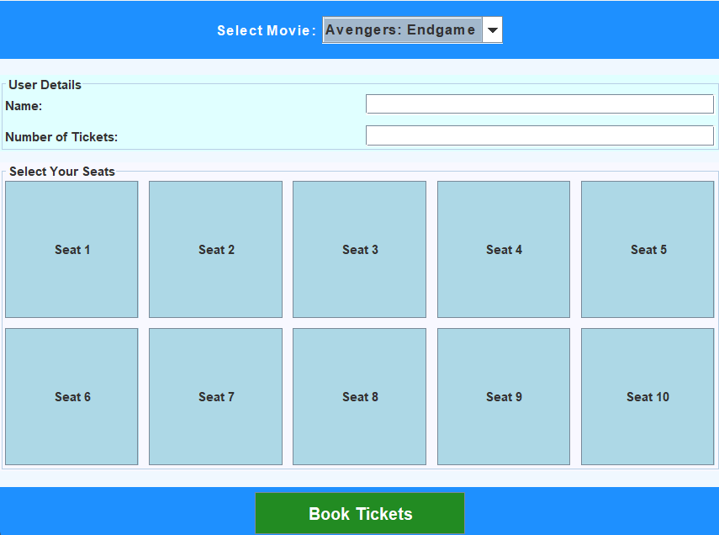

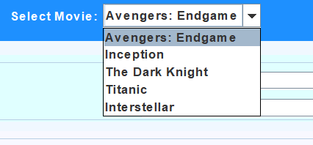

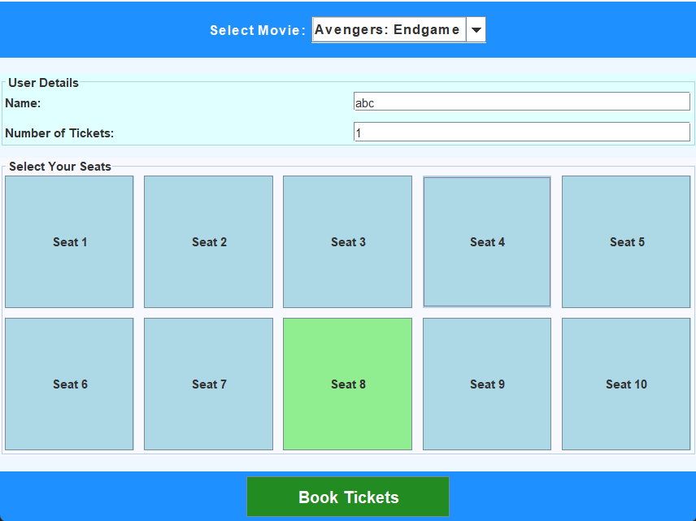

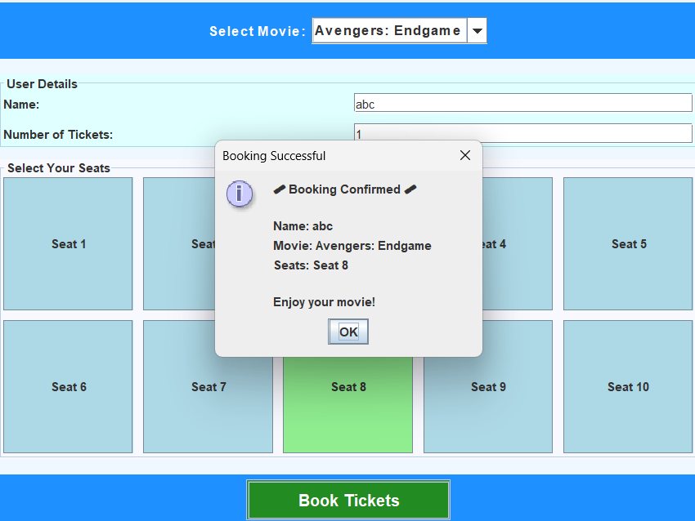

CHAPTER 5 REFERENCES

- Bjarne Stroustrup, https://www.stroustrup.com/4th.html
- https://www.mheducation.com/highered/product/java-complete-reference-schildt/M9781260440232.html
- Grady Booch, Object-Oriented Analysis and Design with Applications, 3rd Edition,PearsonEducation.
https://www.pearson.com/en-us/subject-catalog/p/object-oriented-analysis-and-design-with-applications/P200000003412
- Oracle Corporation, Java Platform, Standard Edition Documentation, Oracle Docs.
https://docs.oracle.com/javase/
- TutorialsPoint, Object-Oriented Programming Concepts, TutorialsPoint EducationalPortal.
https://www.tutorialspoint.com/object_oriented_analysis_design/ooad_object_oriented_paradigm.htm

