Appendix O
X-Axis Controller Circuit

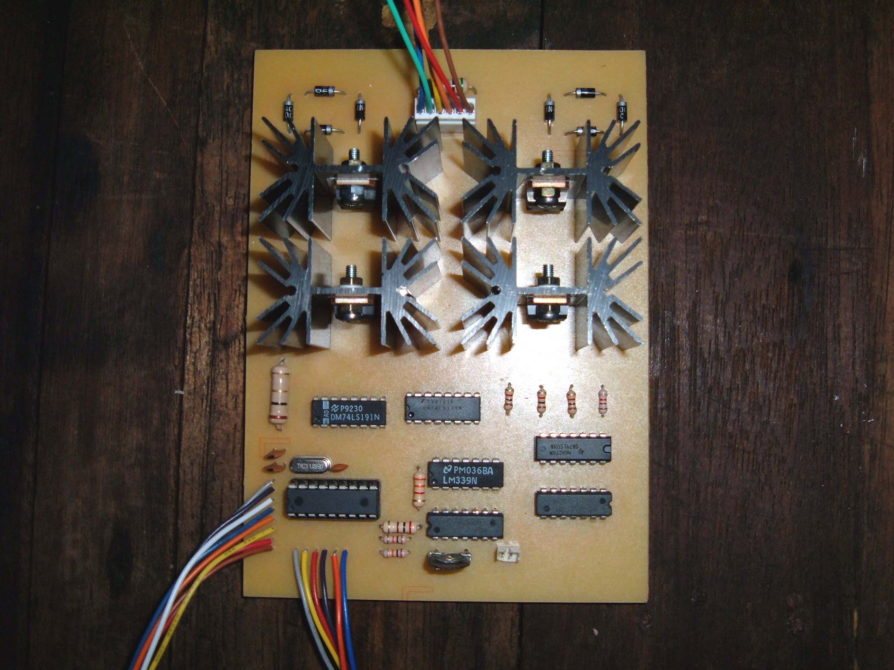
Appendix P
Sensor Board Circuits

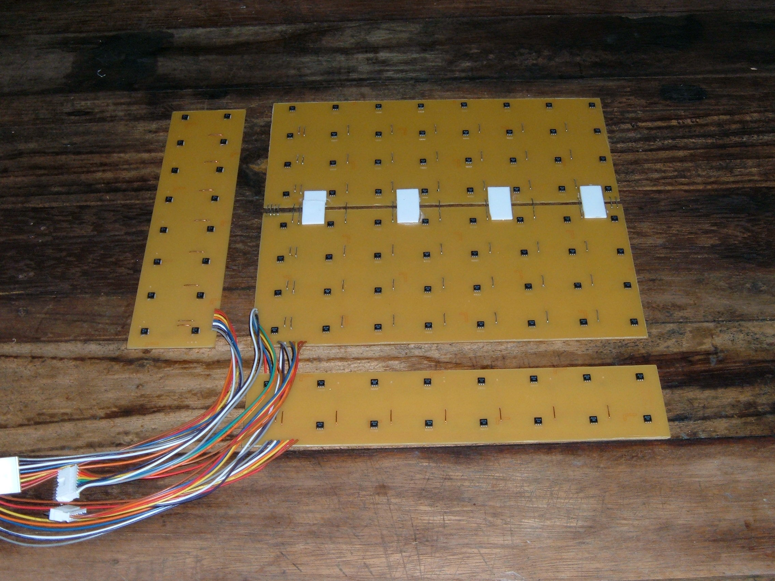
Appendix Q
The Actuators

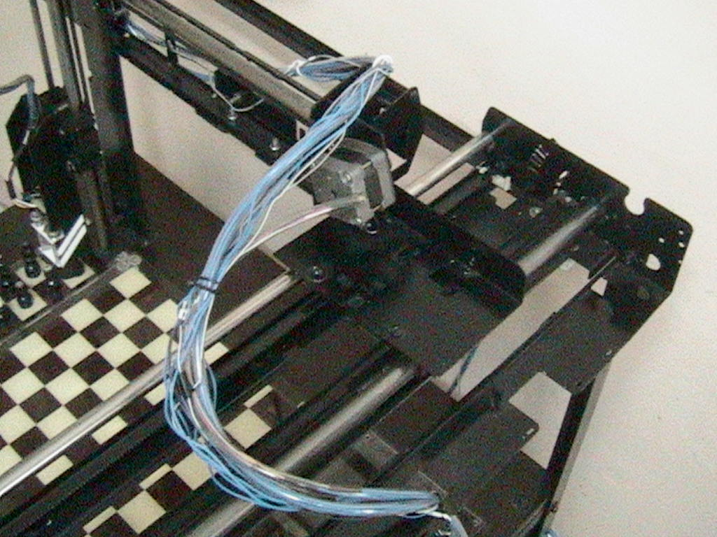
Appendix R
Z-Axis Stepper Motor

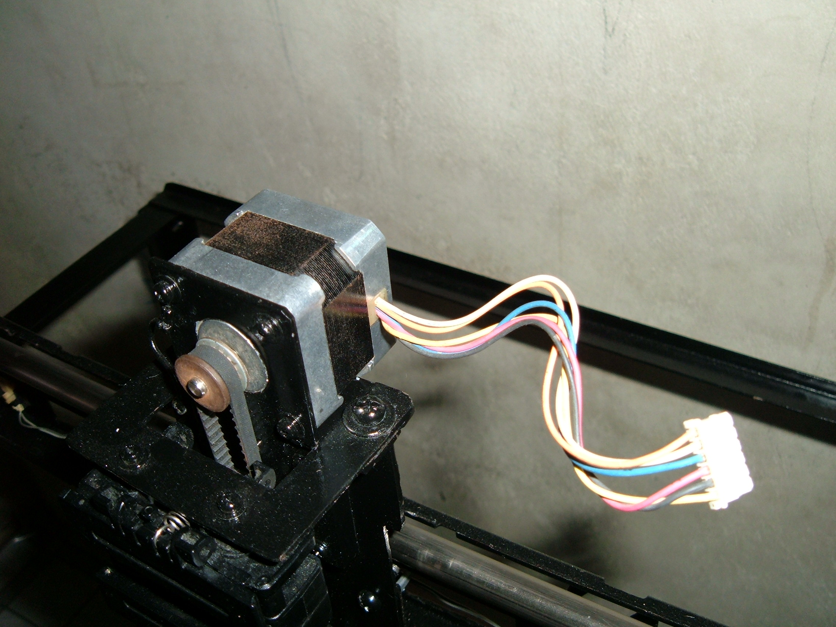
Appendix S
The Chess Set

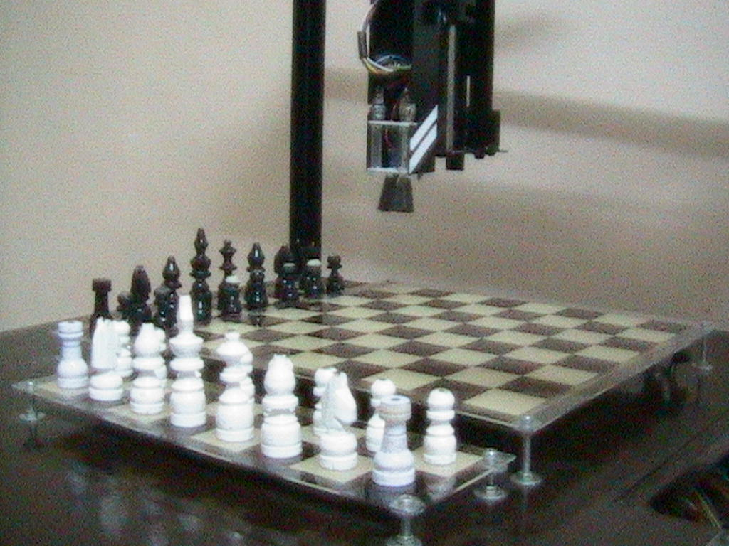
Appendix T
The KS5 Project

