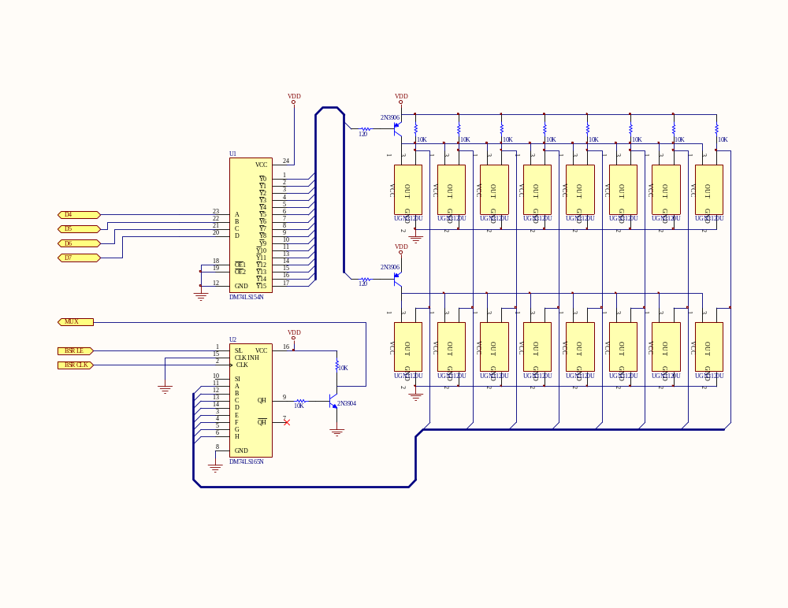
Appendix C
Sensor Board Circuit Schematic Diagram
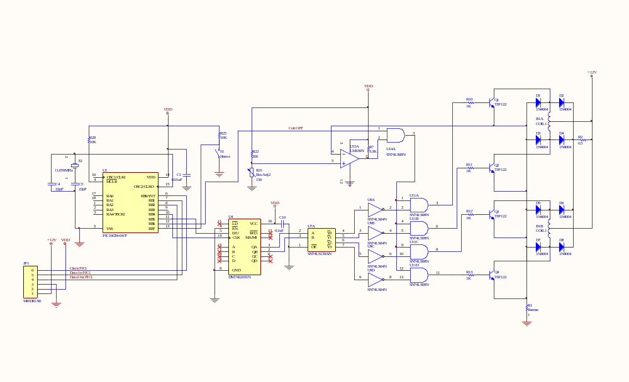
Appendix B
Driving Circuit Schematic Diagram
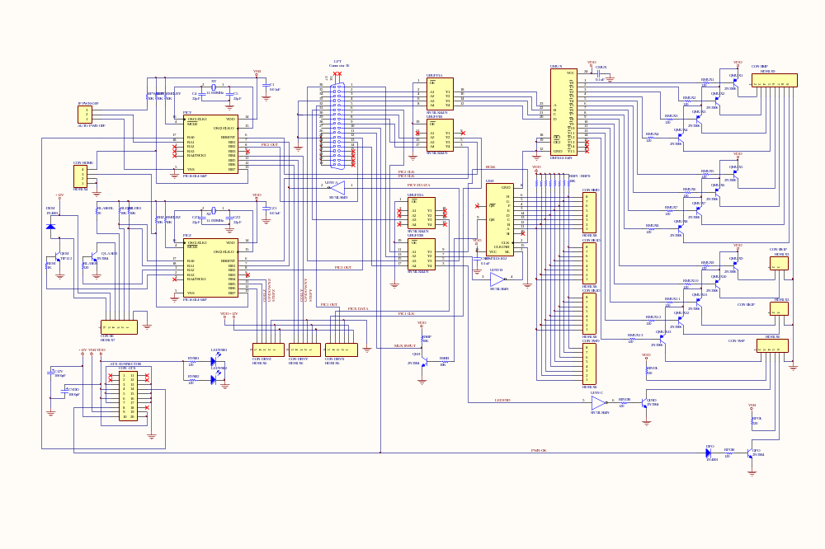
Appendix A
Main Circuit Schematic Diagram

