Appendix K
KS5.KS5Console.exe Screenshot

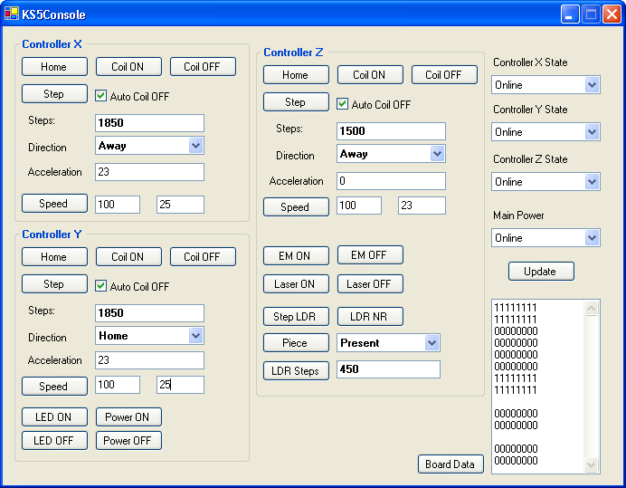

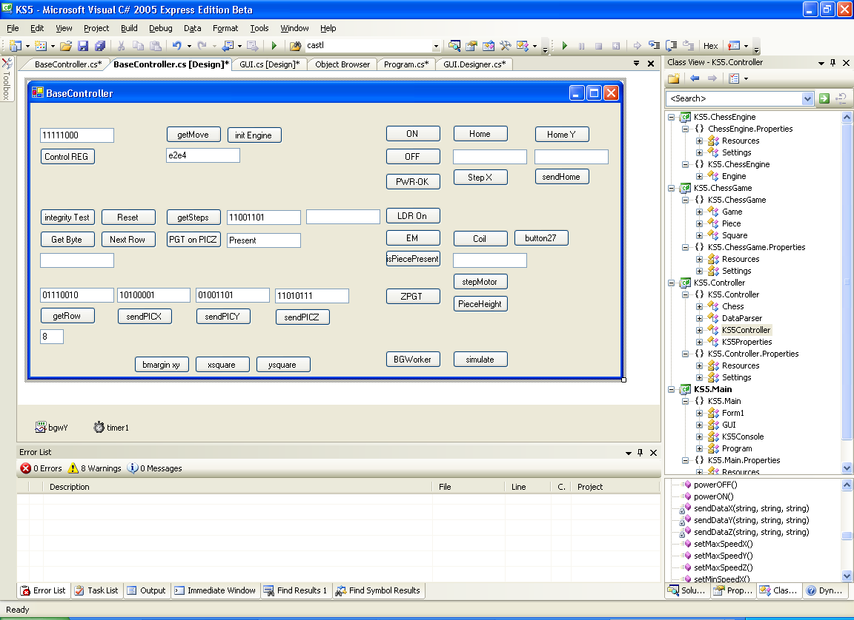
Appendix L
KS5.BaseController.exe Screenshot
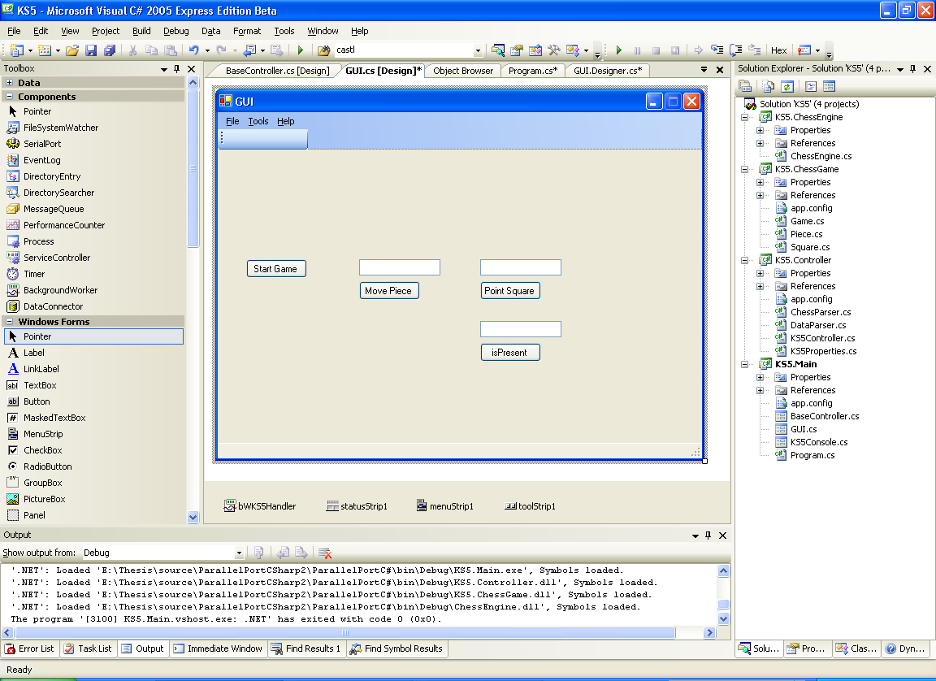
Appendix M
KS5.GUI.exe Screenshot

