Dated: July 3, 2012
Database: Employee data updated on 2012.xls

Database: Access 2010, Database Name: ULCEmpDatabase, HR Folder: July02, 2012
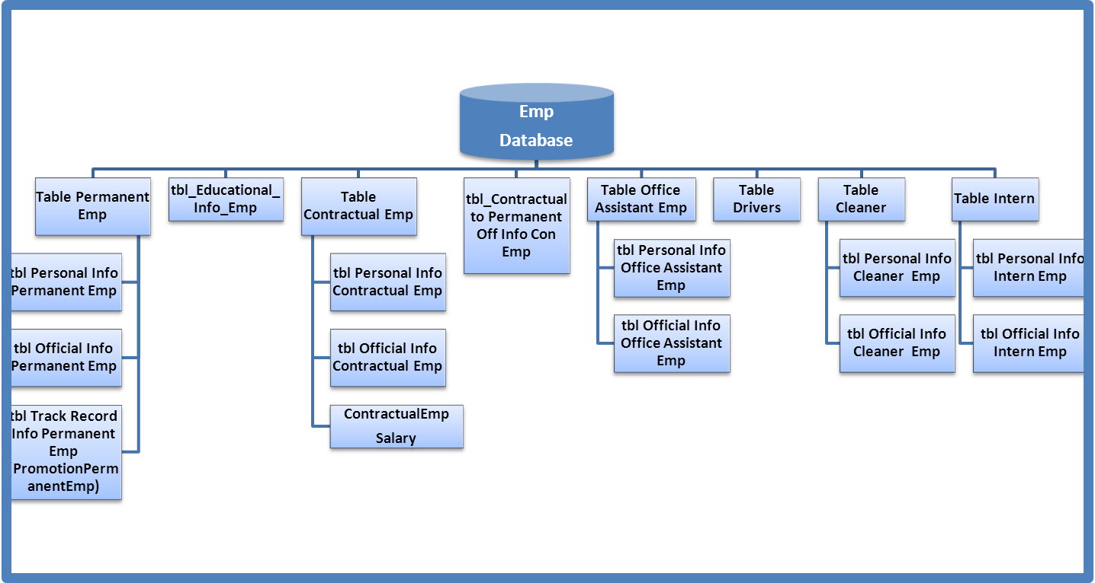
Folder: HR July02, 2012

Table of Contents
Table: tbl Permanent Employee 3
Table: tbl Personal Info Permanent Emp 4
Table: tbl Official Info Permanent Emp 4
Table: tbl Promotional Info Permanent Emp 4
Table: tbl Contractual Employee 4
Table: tbl Office Assistant 4
Table: tbl CONFIRMATION DUE 4
Table: tbl Resignation 4
Table: tbl Driver Previous Salary Structure: 4
Table: tbl Driver Present Salary Structure: 4
Table: tbl Cleaner 4
Table: tbl Intern 4

Table: tbl Permanent Employee
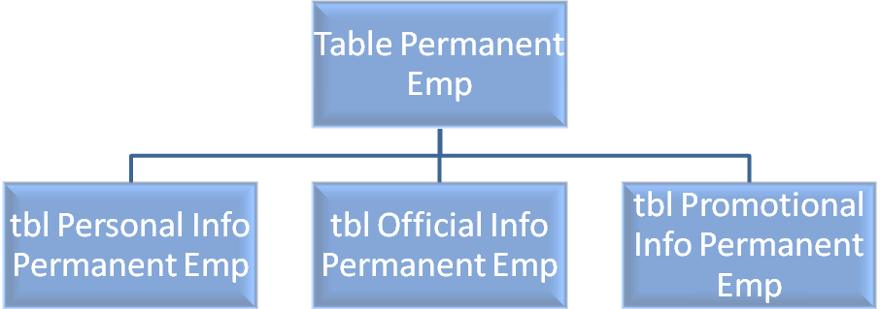
Source: Employee data updated on 2012.xls-Sheet Name- permenant Employee

Table: tbl Personal Info Permanent/CONTRUCTUAL/INTERN /OA/CLEANER/TEA GIRL

Field Name:
Field Name | Data Type | Field Size
SL | Double | 8
EmpID
EmpType
* NAME | Text | 255
* FATHER’S NAME | Text | 255
* MOTHER’S NAME | Text | 255
* GENDER | Text | 255
* DATE OF BIRTH | Date/Time
* AGE – Auto Count
* EDUCATIONAL QUALIFICATION
* SSC
* HSC
HONORS
MASTERS
OTHER
BLOOD GROUP | Text | 255
* PHONE NO | Text | 255
NID NO.
PASSPORT NO.
DRIVING LICENSE NO
* MARITAL STATUS
SPOUSE NAME
SPOUSE OCCUPATION
CHILDREN
* PRESENT ADDRESS
* PERMANENET ADDRESS
NAME OF REFERENCES
Reference CONTATC NO.
OCCUPATION
* EMERGENCY CONTACT
REMARKS

(*) Mandatory Field

Table: tbl Official Info Permanent Emp
Field Name:
Field Name | Data Type | Field Size
SL – Auto Genrated/Changed (When Required) | Double | 8
EmpID
EmpType
* NAME | Text | 255
* DESIGNATION
* DEPARTMENT
* BRANCH
* PHONE NO
PROFESSIONAL
WORKING IN ULC TILL
SERVICE PERIOD IN DAYS – AUTO COUNT
YEARS OF SERVICE IN ULC -– AUTO COUNT
DATE OF PROMOTION
YEARS OF SERVICE AFTER LAST PROMOTION - – AUTO COUNT
Contractual Joining Date
Contractual Employment Tenure in ULC – Auto Count from Contractual joining Date
PREVIOUS EXPERIENCE | Text | 255
 | Text | 255
* RESIGNATION DATE
* Effective DATE
* Resignation Type
REMARKS | Text | 255

(*) Mandatory Field
SL – needs to be changed when a employee resigns & his/her status changes from active to resign
Phone No. – 2 Fields 1. Existing
2. Official
(Mandatory – either personal or official)

Table: tbl Track Record Info Permanent Emp
Field Name:

Field Name | Data Type | Field Size
SL | Double | 8
* NAME | Text | 255
* DESIGNATION | Text | 255
* DEPARTMENT | Text | 255
* BRANCH | Text | 255
* JOINING DATE | Date/Time
* DATE OF CONFIRMATION | Date/Time
* DATE OF PROMOTION | Text | 255
*DESIGNATION From
*DESIGNATION To
*DEPARTMENT From
*DEPARTMENT To
*BRANCH From
*BRANCH To
 | Date/Time | 8
 | Double | 8
 | Double | 8
 | Date/Time | 8
 | Double | 8
* OLD STATUS –Permanent/Contractual/Intern Drop down | Text | 255
Remarks
Table: tbl Contractual Employee
Source: Employee data updated on 2012.xls-Sheet Name- Contractual
Field Name:

Field Name | Data Type | Field Size
SL | Double | 8
Employee ID
* NAME | Text | 255
* DESIGNATION | Text | 255
* DEPARTMENT | Text | 255
* BRANCH | Text | 255
* PHONE NO | Double | 8
Drop Box - TEMPORARY POSTING/In Training | Date/Time
* JOINING DATE | Date/Time
* DURATION/Contract Tenure
* END DATE OF CONTRACT
Defer-Auto Pop-Up
CONTRACT RENEW DATE | Text | 255
* CONFIRMATION DUE DATE (auto Cal End date of contract before one month due) | Date/Time | 8
CONFIRMED ON (DATE) | Double | 8
* Status
Resignation Date
* Total Contract Duration in ULC – Auto Count from contractual joining date (month)
* DATE OF BIRTH | Memo | -
EXPERIENCE | Double | 8
REMARKS
* SALARY | Date/Time | 8

Table: tbl Office Assistant
Source: Employee data updated on 2012.xls-Sheet Name- Office Assistant
Field Name:

Field Name | Data Type | Field Size
SL # | Double | 8
* Employee ID
*EmpType
* NAME | Text | 255
* DESIGNATION | Text | 255
* DEPARTMENT | Text | 255
* BRANCH | Text | 255
* JOINING DATE | Date/Time
*Educational Qualification
* DUE DATE OF CONFIRMATION | Date/Time
CONFIRMATION DATE | Text | 255
* DATE OF BIRTH | Date/Time | 8
* TODAY DATE | Date/Time | 8
* AGE | Double | 8
* LAST DEGREE | Memo | -
EXPERIENCE | Date/Time | 8
* CONTACT NO | Double | 8

Table: tbl CONFIRMATION DUE
Source: Employee data updated on 2012.xls-Sheet Name- CONFIRMATION DUE
Field Name:

Field Name | Data Type | Field Size
* NAME | Double | 8
* Employee ID
* DESIGNATION | Text | 255
* DEPARTMENT | Text | 255
* JOINING DATE | Text | 255
* CONFIRMATION DUE DATE | Text | 255
CONFIRMED ON (DATE) | Date/Time
* Status | Date/Time
Defer-Auto Pop-Up | Text | 255
NAME | Date/Time | 8
DESIGNATION | Date/Time | 8
DEPARTMENT | Double | 8
JOINING DATE | Memo | -
CONFIRMATION DUE DATE | Date/Time | 8
CONFIRMED ON (DATE) | Double | 8
Status
Defer

Table: tbl Resignation
Source: Employee data updated on 2012.xls-Sheet Name- Resignation
Field Name:

Field Name | Data Type | Field Size
SL | Double | 8
* Employee ID
* NAME | Text | 255
* DESIGNATION | Text | 255
* DEPARTMENT | Text | 255
* JOINING DATE | Text | 255
* Date of Confirmation | Date/Time
* RESIGNATION DATE | Date/Time
* Effective DATE | Text | 255
* Resignation Type

Table: tbl Driver Previous Salary Structure:

Source: Employee data updated on 2012.xls-Sheet Name- Driver
Field Name:

Field Name | Data Type | Field Size
SL No. | Double | 8
Name of the Drivers/Guard | Text | 255
Date of Birth | Text | 255
Date of Joining | Text | 255
Today Date | Text | 255
Age | Date/Time
Basic Salary | Date/Time
Total Salary | Text | 255
Overtime (fixed 52 hrs pm)
Salary including overtime

Table: tbl Driver Present Salary Structure:

Source: Employee data updated on 2012.xls-Sheet Name- Driver
Field Name:

Field Name | Data Type | Field Size
SL No. | Double | 8
Name | Text | 255
Basic | Text | 255
House Rent (100% of basic) | Text | 255
Transport (50% of basic) | Text | 255
Medical (50% of basic) | Date/Time
Washing | Date/Time
Overtime | Text | 255
Total salary
10 % PF
Gross

Table: tbl Cleaner
Source: Employee data updated on 2012.xls-Sheet Name- Cleaner
Field Name:

Field Name | Data Type | Field Size
SL | Double | 8
NAME | Text | 255
DESIGNATION | Text | 255
DEPARTMENT | Text | 255
JOINING DATE | Text | 255
Due Date of Confirmation | Date/Time
DATE OF BIRTH | Date/Time
Last Degree | Text | 255

Table: tbl Intern
Source:
Field Name:

Field Name | Data Type | Field Size
SL | Double | 8
NAME | Text | 255
DESIGNATION | Text | 255
DEPARTMENT | Text | 255
JOINING DATE | Text | 255
Due Date of Confirmation | Date/Time
DATE OF BIRTH | Date/Time
Last Degree | Text | 255

