FertMap

(remove the above picture and insert your project logo)

Submission date

The Go-Merries

Albert Casany Vilà

Pau Borja Lasmarias Gil

Daniel Sánchez López

**Table of Contents**

RA1. Introduction and Context 3

1. Bioinformatics Market 3

2. Business opportunities 3

3. Project description 4

4. Occupational Safety and Health 4

RA2. Use Cases, Requirements, Mockups, Resources, Cost Estimation 4

1. Use Cases, Functional Requirements, Non-Functional Requirements 5

2. Mockups and Diagrams 6

3. Resources and Cost Estimation 7

RA3. Planning 8

1. Project Planning 9

2. Risk Mitigation Planning 10

RA4. Tests 10

1. Unit/Integration testing 10

2. Usability/Accessibility testing 11

# RA1. Introduction and Context

## 1. Bioinformatics Market

According to the National Library of Medicine. Bioinformatics is defined as the application of tools of computation and analysis to the capture and interpretation of biological data. It is an interdisciplinary field, which harnesses computer science, mathematics, physics, and biology.

Nowadays, Bioinformatics is essential for management of data in modern biology and medicine.

There are quite a few labs and research centers in Barcelona, such as:

* ISGlobal
* CVC
* IBEC
* IRB
* CRG
* etc.

## 2. Business opportunities

There isn’t a lot of attention for the consequences of fertilizers to our ecosystem. We see this as a great opportunity to make a web app that shows this topic with an easy-to-use interface and a couple of tools to help with research about this topic

## 3. Project description

Our web app shows the amount of fertilizer per hectare per region per year with filters and sliders to customize your research and the possibility to download the filtered data. It will also show how these fertilizers are affecting fauna and flora

## 4. Occupational Safety and Health

* Stress for working under such immense pressure and strict timing
* Eye injuries for sustained exposure to blue light screens
* Accidents that can occur when going to school or coming back home
* Back injuries due to extended periods of time working
* Hand injuries due to extended periods of time working

# RA2. Use Cases, Requirements, Mockups, Resources, Cost Estimation

## 1. Use Cases, Functional Requirements, Non-Functional Requirements

* 1. [Use cases](https://viewer.diagrams.net/?tags=%7B%7D&highlight=0000ff&edit=_blank&layers=1&nav=1#R7Ztdb5s6GMc%2FTS4bGRuDuezSrrvYpGrVzmkvKbiJJcAROE1yPv0xwSQxzttSAk63qKrwgzH4z4%2FnxSEDNEoXD3k4nfzgMU0GEMSLAbobwNVnUP6BeFlZPI9UhnHO4srkbAxP7D%2BqjEBZZyymhdZRcJ4INtWNEc8yGgnNFuY5n%2Bvd3niin3UajqlheIrCxLT%2By2IxqawE%2Bhv7N8rGk%2FrMjhdUe9Kw7qxmUkzCmM%2B3TOh%2BgEY556LaShcjmpTi1bpUx33ds3d9YTnNxCkHTMnI%2FecXeb7%2Fdv8Q0dR7eU5HN2qU9zCZqQnfxinL1BWLZS2DvPhpuTlLk9tI8HyAvrzTXDAp1PfwlSaPvGCC8Ux2eeVC8HSrw23CxuUOwafSOhFpIhuO3OQzkbCMjta3DkijOa36GuVwdLFlUtN8oDylIl%2FKLmrvDVGSK%2BYQwlV7vrmDWHWZaDdPGUMFzXg99EZXuaGk%2FQ2ZoSHzr4Lm162yj3SV3Vq93lRGhso%2F6ZgVguY0%2Flxak76lDky%2FEUW0KMpzSXHScqqVpy4M5eXw0nvLxpf5hAn6NA2jcs9cBhBdzRaEW8eROvyYwjlwh3LkUsLV17Ol3B1NqKDSVvqEfuVqOE63d7XM%2BCRTDPZWXvKsd7VusG1ymXHmOx%2FvCOedPoKerpLT%2FzNoBgopk%2FTd%2Ferk6zqtPXp%2FOrmGTjKyzYpErPLbaZlPlxExkVl7vnL9WVzaEp6HVknp9o8c3h8w5%2FRVphq0X8Uanh%2FvyDA6Vszbr1g4Zb2q5TSzCtS7Wr6h1leWiLLGACx747ksR8tkFgL%2BJv%2FFoQhfw4Ku9lYIWvXAov59HzEENRXK4ttyiUG2oiQsChbpwuR8lsU0VmUAXTDxXG4PsWq9aK27xVbHu%2BVW45HmTM5K3swjBUXBZ3lED82q6ifCfEzFCXkXjbXVEfP%2BHSlAaltOE8nfu76msuueqTM8crYqIPYmWo3bXk1cHbW9BlIP1OSqPrBSwjhwhcx6mh%2Bo%2B81s3xqKJDz5shrKle5DGV7UWVeNzWCr1nK71QOUwC4oXfxBKNfRZOgFyPMgkUM4BCOkjevAYOg5LkHE92BAgtrVd4WwWVPYiDDeBhgcAbgDVr1PyqoLhgAFm4%2Bns4o69q9mJWchnJahia1CEwUfje1qINfdk0N2xaJZ4lnI4hAAovE49CyN9sgqTG9Qw4M2l9ZP9qCBP8Q%2BwgFyICHAh7oHxb439B3sQ%2BJjiBFpXOilGTaLbisZ1vNVybCkxU6KoV0UwwbF8EyKIThMMemV4j%2B6dg%2FsIq4BnHsucPAgcB7oEzh0FWW%2B7jLxEYfZgW%2F07SK1rRoJEjAMPLD5uNq4CJBu4TS%2FQ7UQTjMvRYQcQbSvmO7axW1bmSkMDnPrdMztNSw8OV05VXSV0f%2FTFPeo%2FYWmMxGyIRU9FUbLqh8c6J7Sqauh36URNWg03rO7NI3mixl%2Faby2FaX2aGw4Wdg1je0vfO6h8YRlnnZDfA%2BQ2lUU%2BaABKToT0nXkX1dBHUPa%2Fsrmn%2BAy7Sp1LkajC4KdX2t2Baf59tZH4bziUgdeJ5yt1Tq4kV3i5prppWm0ePl8Q%2BOOLzLhUdfbbkw%2FGVS7Y7rrt%2BRFcdeJp%2FkrJPtABcOAoAaoqOOVzZNBtevVkDZBPbSyaayYXpjb2p%2FbyO35kJ2cU1oGmdfIKV3rvKFsbn4mXnXf%2FNge3f8P)

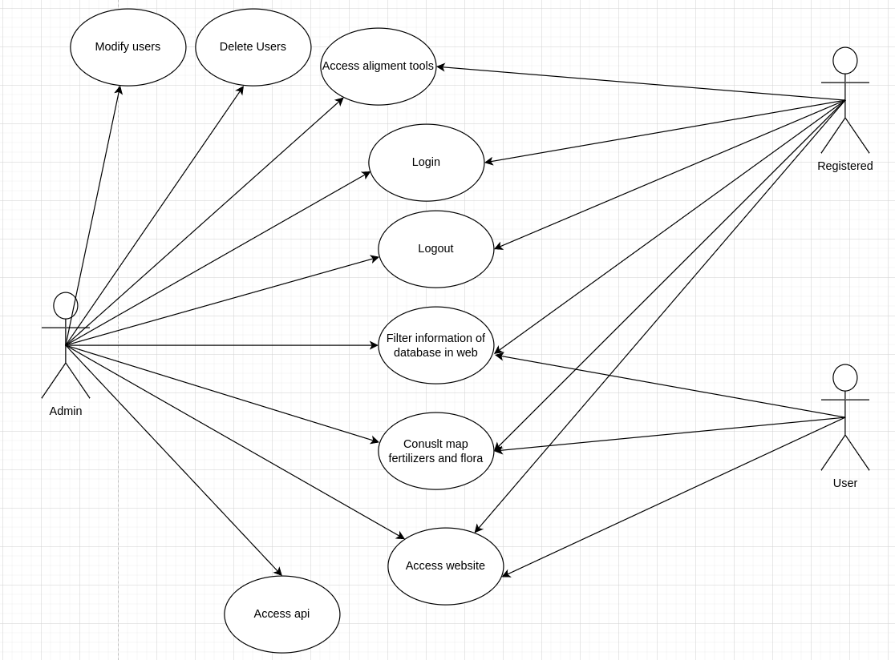

## 

## 

## 2. Mockups and Diagrams

**Mockup of the registration menu of our web application**

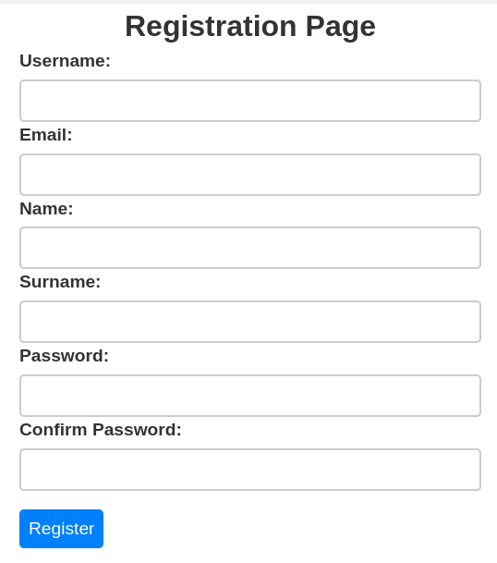

**Mockup of the login menu of our web application**

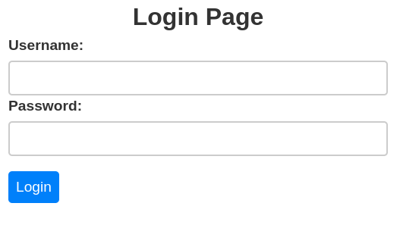

**Mockup of the web application**

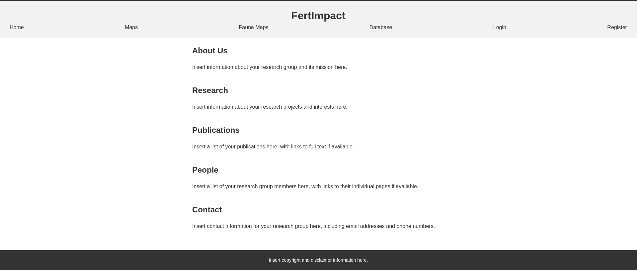

## 

## 

## 3. Resources and Cost Estimation

For this project, we need at least:

* Three computers with at least 8gb of RAM and virtual machine hosting capabilities → For example:

<https://www.pccomponentes.com/acer-aspire-3-a315-56-566l-intel-core-i5-1035g1-8gb-256gb-ssd-156>

* Flask technology
* Angular technology
* MySQL technology
* D3 maps technology
* Data for the fertilizers
* Data for the fauna and flora
* Albert’s salary: €1200
* Pau’s salary: €1200
* Daniel’s salary: €1100

Total price for laptops→ €472.27 x 3 = €1416.81

Total salary →€3500

Total cost → €4.916.81

# RA3. Planning

## 1. Project Planning

<https://dawbi-22-g1.youtrack.cloud/projects/4f24cb55-a596-4980-8a01-5144aeb77c97>

## 2. Risk Mitigation Planning

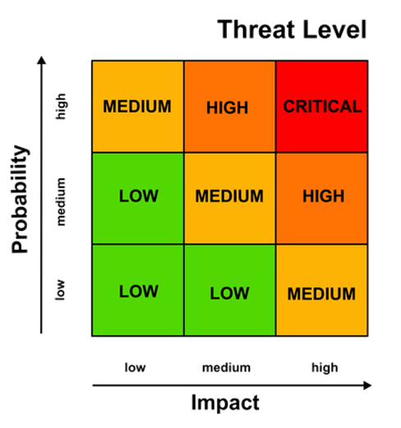

| Probability | Impact | Threat Level | Description | Response |
| --- | --- | --- | --- | --- |
| Low | High | Medium | To not finish the project | Manage time accordingly |
| High | High | Critical | Web difficult to use | Keep it simple, stupid |

# 

| Probability | Impact | Threat Level | Description | Response |
| --- | --- | --- | --- | --- |
| Medium | High | Critical | Incompatibility with server | Document about web services |
| Medium | Low | Low | To not find the information we need | Use placeholder information |

# 

# RA4. Tests

## 1. Unit/Integration testing

## 2. Usability/Accessibility testing