3D Printing of Medical Images

Deekshith Sandesari,
Department Of Computer Science,The University Of Akron
Akron,Ohio-44304, ds168@zips.uakron.edu

Introduction

Medical imaging is the technique used to create images of the human body for clinical purposes especially for analyzing some anatomy related to abnormalities[1]. Conventional 2D imaging such as CT scan, MRI and ultrasound have limitations in quantifying the volume of structures of interest in the body, because only a two dimensional frame is produced at a given time. For years now, medical researchers have also been reproducing human cells in laboratories by hand to create blood vessels, urine tubes, skin tissue and other living body parts. But engineering full organs, with their complicated cell structures, is much more difficult. About 18 people die in United States each day waiting in vain for transplants because of shortage of donated organs. So ,volume quantification is important in assessing the progression of disease , tracking progression of response to treatment, educational purposes and also producing artificial organs for transplants. So, we considered 3D image reconstruction and 3D printing as a solution to this problem.

Approach

Visualization is the process of converting data into graphics. Figure 1 shows the approach considered for the project implementation. The programming is done in C++ with Visualization Toolkit (VTK) toolbox. The Visualization Toolkit (VTK) is an open-source, freely available software system for 3D computer graphics, image processing and visualization. Initially the data is given as input to visualization pipeline [2]. The visualization pipeline processes the input and it produces two outputs, one that can be viewed on the window and second an STL file used to print the physical object using a 3D printer.
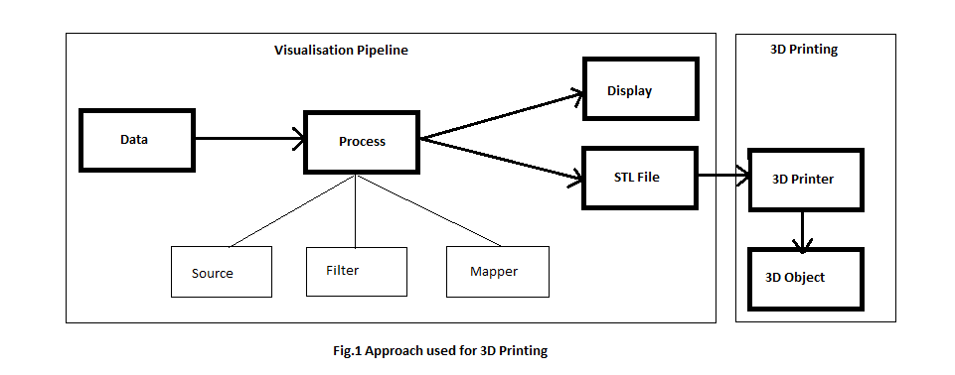
2.1. Visualization Pipeline

Scientific visualization scientific visualization is fundamentally a process of input and output, where the input data is transformed by one or more transformations, and the chain of operations known as a pipeline [3]. Transformations may include attribute changes to alter raw data or geometric manipulations that rotate or scale the data. Output is achieved by a process known as rendering which terminates a visualization pipeline by mapping data onto visual objects. Elaborating the various components of visualization pipeline:
Data: The data considered is medical brain image files in the format of Minc or vtk. The source of data is collected from The McConnell Brain Imaging Centre (BIC) of the Montreal Neurological Institute, McGill University [4][5]. The vtk image data considered is from head.vtk example [6].
Process: The approach used here is initially the head data vtk file or medical image (mnc format) file is given as input to the program. The source, that is the vtkStructuredPointsReader for vtk file or vtkMINCImageReader for mnc format file is used to construct the data object directly. The filter which is vtkContourFilter is used to perform transformation such as extract skin or bone components from the input data file. The mapper, that is vtkPolyDataMapper is used to create the geometry for rendering the output.
Output of VTK Pipeline: The above process in the visualization pipeline generates two outputs. One output is rendered on the vtk render window using vtkRenderer. vtkRenderWindowInteractor is used to interact with the window. The interactor used in the program is KeyPressInteractorStyle. This interactor facilitates the user to view to increase and decrease the contour values of the 3D object by pressing “i” and “d” keys on the keyboard.
Another output is the output written onto a file in STL format using vtkSTLWriter. An STL (Stereo Lithography) file consists of triangulated surfaces of 3D object and facilitates 3D printing of the object by a 3D printer. A chrome browser add-on 3DView can be used to view the object in the STL file.
STL File: An STL is file is a triangular representation of a 3-dimensional surface geometry. The surface of any 3d object is logically represented as series of small triangles known as facets.Figure 2 shows an object represented in series of small triangles known as facets.

Figure 2. Object shows representation of facets

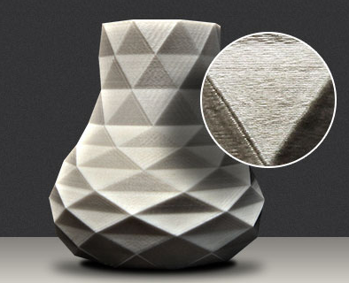
Each facet is uniquely identified by a unit normal and three vertices of the triangle. The orientation of a facet (i.e the surface is either inward or outward) is determined by the direction in which the vertices are specified as shown in Figure 3.

Figure 3. Facet

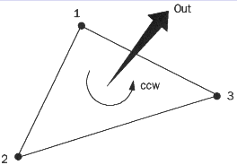

ASCII STL: VTK writes stl files in ascii format by default with .stl extension. The keywords facet normal and vertex in bold and lower case are used to represent the normal and vertices of each facet . The numerical data that represent normal and vertices are single precision floats. A facet normal may have a leading minus sign. The below is the structure representing a sample ascii format STL file.

solid ascii
..
facet normal n_{i} n_{j} n_{k}
outer loop
vertex v1_{x} v1_{y} v1_{z}
vertex v2_{x} v2_{y} v2_{z}
vertex v3_{x} v3_{y} v3_{z}
endloop
endfacet
..
endsolid name

2.2. 3D Printing

3D Printing also known as addictive manufacturing is the process of building 3D objects by adding layer upon layer of material using a 3D printer. The 3D Printer used for printing the model is the MakerBot Replicator 2X shown in Fig 2 [7]. It is an experimental 3D printer that uses dual-extrusion to create solid, three-dimensional objects using MakerBot ABS Filament. It supports STL, OBJ ,THING formats for printing. After the file (STL) is given as input, MakerBot's specifically designed plastic is then heated, and pressed through extruder nozzles onto a heated build platform, layer by layer, to create the 3D object. The plastic is printed in ultra-fine layers (0.0036 in) allowing the MakerBot Replicator 2X to create highly detailed three-dimensional models, with extreme precision.

Figure 4. MakerBot Replicator 2X 3D Printer [7]
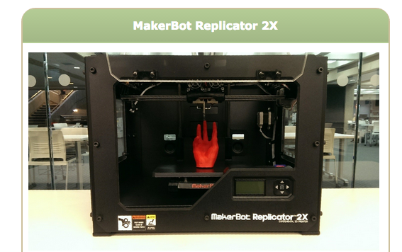

Design/UML Diagrams

3.1. Class Diagram:
The class diagrams show the flow of the visualization pipeline. The pipelines used involved a vtkStructuredPointsReader, vtkMINCImageReader, vtkContourFilter, vtkPolyDataMapper, vtkCamera, vtkActor, vtkRenderer, KeyPressInteractorStyle, vtkRenderWindowInteractor and vtkSTLWriter.

Figure 5. Class Diagram
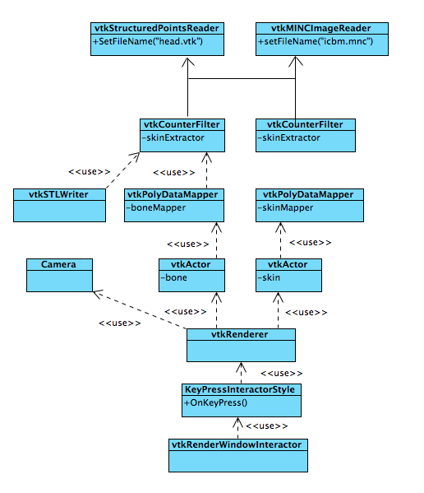

3.2. Use Case:
User is an actor. User operates the application or runs the program to specify the input file. The application or the program reads the input vtk or mnc file. The application process the input file and produces the output STL file. A 3D Printer is used to read the STL file and print the 3D object using the contents of STL file.

Figure 6. Use case Diagram
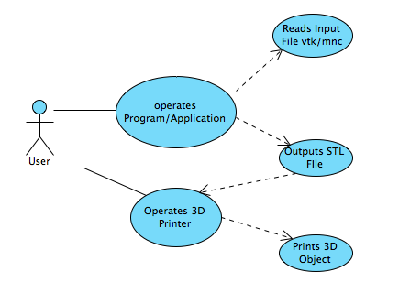
3.3. Sequence Diagram:
The sequence diagram shows the flow sequence of the entire process involving user, application/program and 3D printer.

Figure 7. Sequence Diagram
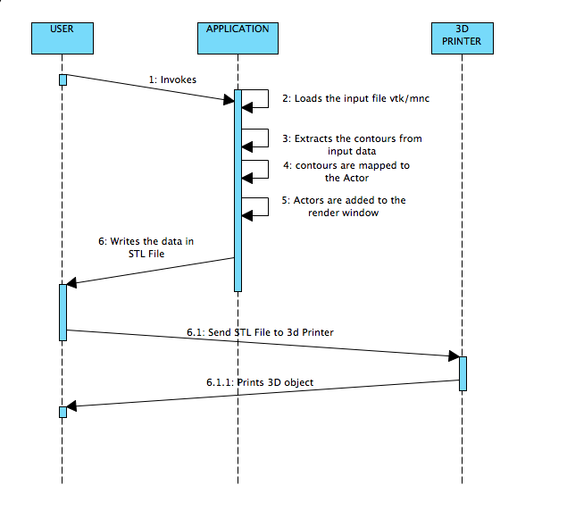

Implementation/Coding

The main implementation is described in the following steps:

1. vtkStructuredPointsReader is used to read the input from vtk file as shown below:

vtkStructuredPointsReader *vminc = vtkStructuredPointsReader::New();
vminc->SetFileName("head.vtk");

OR

vtkMINCImageReader is used to read the input from mnc format file as shown below:

vtkMINCImageReader *vminc=vtkMINCImageReader::New();
vminc->SetFileName("icbm.mnc");

2. Counters are extracted using vtkContourFilter and vtkPolyDataMapper is used to map the contours to an actor. The actors are added to the renderer to display on the render window.

3. The data is written onto the STL file as shown below:

std::string outputSTLFile = "C:\\Users\\ds168.CS\\Desktop\\brainOut.stl";
vtkSTLWriter *stlWriter = vtkSTLWriter::New();
stlWriter->SetFileName(outputSTLFile.c_str());// Sets bone output filename
stlWriter->SetInputConnection(boneExtractor->GetOutputPort());
stlWriter->Write(); // writes onto the file

4. The implementation also enables the user to increase the contour values by pressing “i” key
on the keyboard and decrease the contour value by pressing “d” key.

Results

The results obtained are the vtk outputs on the render window for vtk structured data and mnc format data. STL format files for both the input data and the 3D printed object printed using a 3D printer.

5.1. VTK output on renderer window

Fig 8. VTK output of vtk structured data
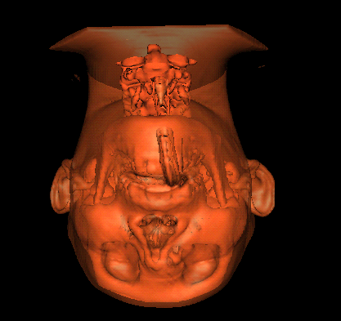

Fig 9. VTK output of MNC format data
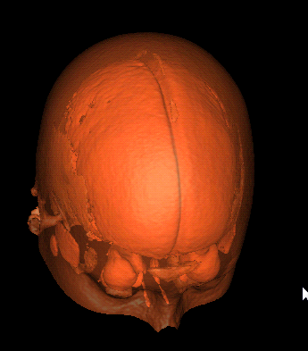

5.2. STL file viewed using 3DView

Fig 10. Output of STL File from MNC Data in a 3Dviewer:
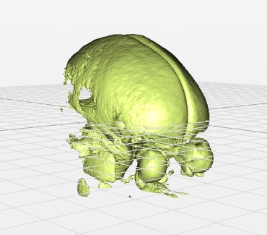
Fig 11. Output of STL File from VTK Data in a 3D viewer:

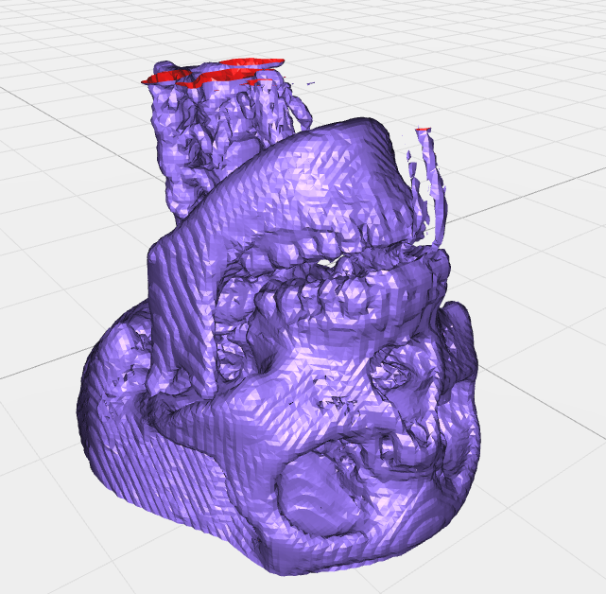

5.3. STL File: The STL file generated shows ascii representation of facets/triangles with vertices and normals.

Fig 12. STL file viewed using an editor

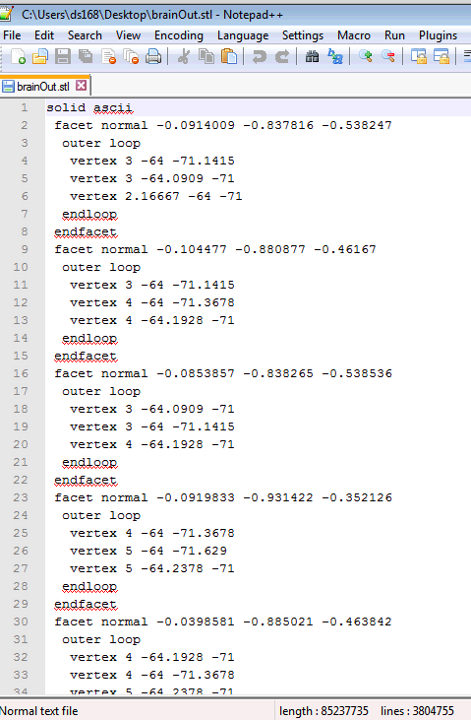

5.4. 3D printed Model:
The figure shows the different views of the 3D printed model printed using MakerBot Replicator 2X.

Figure 13. 3D Printed Model

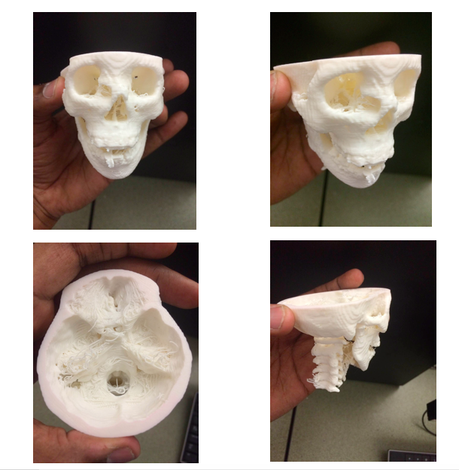

Conclusion and Future Work

3D Printing is still in its infancy but has rapidly growing interest from investors, industry and consumers. It has the potential to shape multiple industries as well as the cost and quality of products to the end user. The data source considered in this project is vtk or minc file, future work can be done on extending the vtk programming to many other medical image formats. The application can be further enhanced so that it can be installed on any system and directly send the file to the 3D printer. In future we will be able to print actual biological living tissues to create actual organs that may eliminate the need of organ donors and save the life of many people. But there are lots of technological challenges and more research is needed in the area.

Acknowledgment

Some of the material in this paper is taken from previous papers [1][2][3]. This project work is carried out with the help of Dr. Yingcai Xiao, Associate Professor, Department of Computer Science, The University of Akron, who helped in printing the 3D model.

References

- Mahani Hafizah, Tan Kok, and Eko Supriyanto, “Development of 3d image reconstruction based on untracked 2d fetal phantom ultrasound images using vtk “, WSEAS transactions on signal processing, issue 4, volume 6, October 2010 .
- Mingchang Zhao, Jie Tian1, Xun Zhu, Jian Xue, Zhanglin Cheng, Hua Zhao , “The Design and Implementation of a C++ Toolkit for Integrated Medical Image Processing and Analyzing” , Medical Image Processing Group, Institute of Automation, The Chinese Academy of Sciences, Beijing 100080, China, Jan 2004.
- Stephen Bathgate, Visualisation of the Forestry Woodchain using VTK, The University of Edinburg, Aug 2007.
- The McConnell Brain Imaging Centre (BIC) of the Montreal Neurological Institute, McGill University, http://www.bic.mni.mcgill.ca/ServicesAtlases/ICBM152Lin
- C.A. Cocosco, V. Kollokian, R.K.-S. Kwan, A.C. Evans : "BrainWeb: Online Interface to a 3D MRI Simulated Brain Database". NeuroImage, vol.5, no.4, part 2/4, S425, 1997 -- Proceedings of 3-rd International Conference on Functional Mapping of the Human Brain, Copenhagen, May 1997.
- Dr.Yingcai Xiao, The University of Akron, http://www.cs.uakron.edu/~xiao/visualization/Head-Example.zip
- 3D Printing, University Libraries, The University of Akron, http://libguides.uakron.edu/content.php?pid=612119
- http://www.willit3dprint.com/

