A WPF Based Data Visualization System

Deekshith Sandesari
Department Of Computer Science, The University Of Akron
E-mail: ds168@zips.uakron.edu

Abstract

Data is being generated in high volumes nowadays. Exploring and analyzing the vast volumes of data becomes increasingly difficult. Information visualization and visual data mining can help to deal with the flood of information. The advantage of visual data exploration is that the user is directly involved in the data mining process and provides leverage over the human visual system to provide insight and understanding of unorganized data. There are large numbers of information visualization techniques that have been developed over the last decade to support the exploration of large data sets. In this paper, we propose a simple Visualization system using Windows Presentation Foundation (WPF).
Keywords – Windows Presentation Foundation (WPF), Extensible Application Markup Language (XAML).

1. Introduction

Data can collected in vast amounts easily but extracting valuable information is a difficult task. Data analysis is an indispensable part of all applied research and problem solving in industry especially in Data Mining. Visual data exploration is needed in data mining processes to extract the valuable information and to give insights into the data to draw conclusions and directly interact with data. There are a large number of visualization techniques that can be used for visualizing the data. One of the standard 3D techniques is using Bubble Charts.
Bubble Chart

A Bubble Chart is a type of Chart that displays three dimensions of data. Each entity with its triplet (V₁, V₂, V₃) of associated data is plotted as a disk that expresses two of the V_{i} values through the disk's (x, y) location and the third through its size. Bubble charts were introduced by Fernanda Viegas and Martin Wattenberg and have since become a popular method of displaying data.
Interactive Filtering

In addition to the visualization technique, for an effective data exploration it is necessary to use some interaction technique. Interaction techniques allow the data analyst to directly interact with the visualizations and dynamically change the visualizations according to the exploration objectives, and they also make it possible to relate and combine multiple independent visualizations. In exploring large data sets, it is important to interactively partition the data set into segments and focus on interesting subsets. This can be done by a direct specification of properties of the desired subset (querying).

Windows Presentation Foundation (WPF) and XAML

Windows Presentation Foundation (WPF) is a next-generation presentation system for building Windows client applications with visually stunning user experiences. With WPF, you can create a wide range of both standalone and browser-hosted applications. One of the biggest changes that WPF introduces for desktop application developers is the extensive use of and support for declarative programming. WPF user interfaces and resources can be declared using Extensible Application Markup Language (XAML), an XML-based markup language.
XAML is a simple declarative programming language for constructing and initializing .NET objects. It separates the front end from the back end and usually the most concise way to represent user interfaces. The main advantage is that it doesn’t need to compile to render the objects.

2. WPF Based Data Visualization System

2.1 Objective
The aim of this project is to visually analyze the impact of Involuntary Migration caused by TGP that affected 1.3 million Chinese people. The dataset consists of 1056 subjects of which 636 are non-migrants and 420 are migrants. Dataset has been collected in two phases: Wave1 i.e. before relocation and Wave2 i.e. after relocation.

2.2 Architecture
The implementation is done using WPF: XAML with code behind using C#. NET and backend as the Microsoft SQL as Database Server. Various modules of the system are implemented with the classic 2-tier architecture as shown in Fig 2.2.1

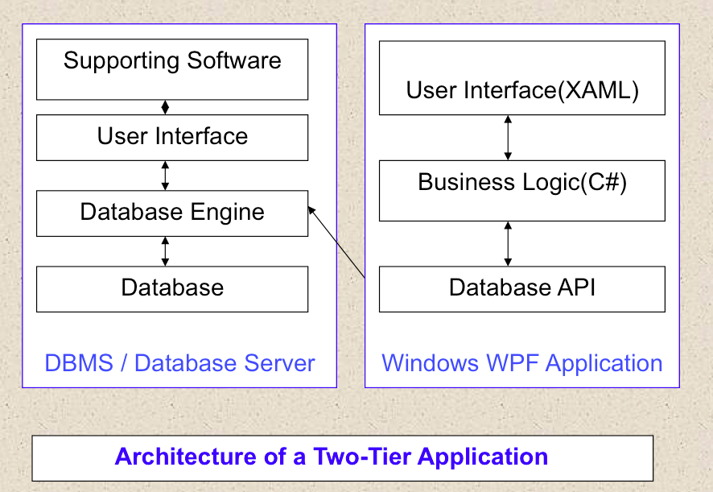
Fig 2.2.1 Two-Tier Architecture
2.3 Class Diagram
The WPF based application has windows, canvas and other event listeners that allow the user to interact with the visualized model and render again when required based on user selection as shown in Fig 2.3.1.
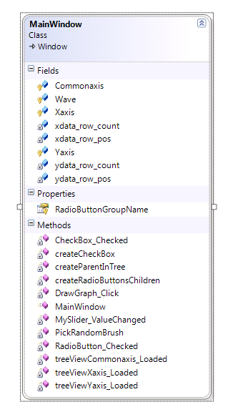
Fig 2.3.1 Class Diagram
2.4 Database Design
The database consists of two tables TGP_WV1 and TGP_WV2 as shown in Fig 2.4.1
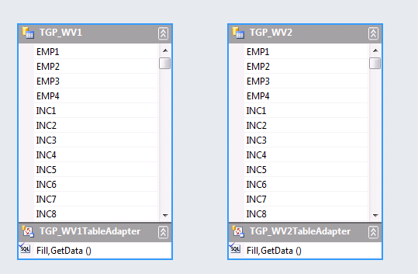

Fig 2.4.1 Two Data Tables in the database

3. Results
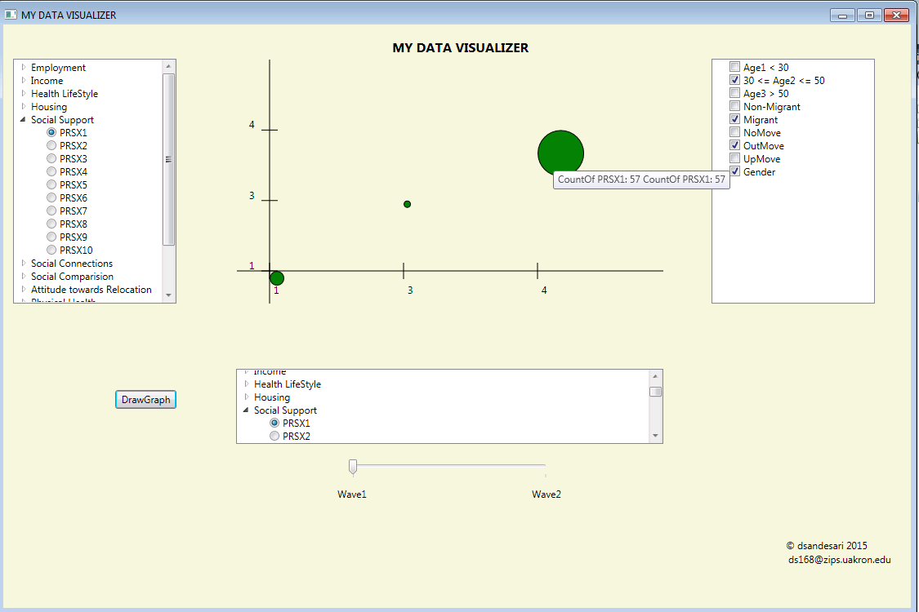
Fig 3.1. Bubble plot visualization shown using data from wave1
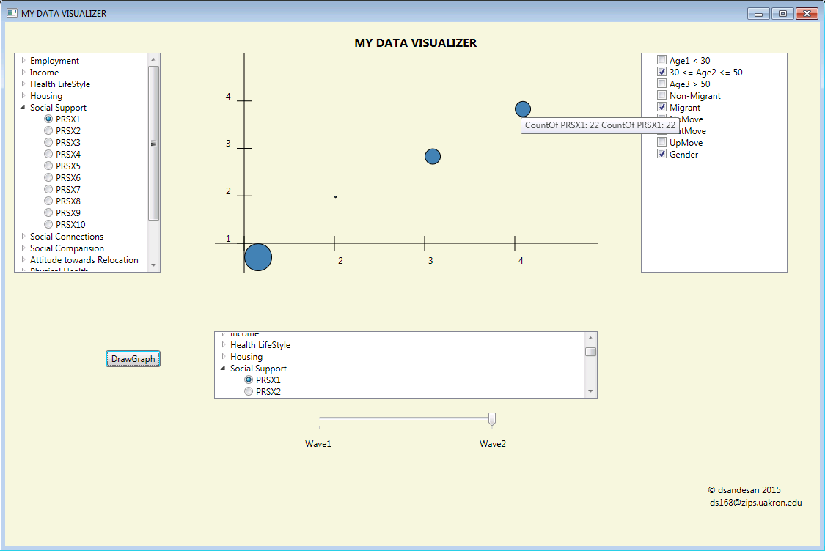

Fig 3.2. Bubble plot visualization shown using data from wave2

4. Acknowledgement
This project work is carried under the guidance of Dr. Yingcai Xiao, Dr. C. Chan and Dr. Joann.

5. Conclusion and Future Work

The exploration of large data sets is an important but difficult problem. Information visualization techniques may help to solve the problem. Visual data exploration has a high potential and many applications such as data mining will use information visualization technology for an improved data analysis.
Future work will involve adding advanced features such as Interactive zooming and multicolored charts. The ultimate goal is to bring the power of visualization technology to every desktop to allow a better, faster and more intuitive exploration of very large data resources. This will not only be valuable in an economic sense but also will also stimulate and delight the user.

6. References

[1]. Keim, D.A., "Information visualization and visual data mining," Visualization and Computer
Graphics, IEEE Transactions on, vol.8, no.1, pp.1, 8, Jan/Mar 2002
[2]. Fabrice Rossi, “Visual Data Mining and Machine Learning”, ESANN'2006, Projet AxIS, INRIA,
Domaine de Voluceau, Rocquencourt, B.P. 105 78153 Le Chesnay Cedex – France,
[3]. http://en.wikipedia.org/wiki/Information_visualization
[4]. Josh Smith, “Customize Data Display with Data Binding and WPF”, MSDN Magazine,
https://msdn.microsoft.com/en-us/magazine/cc700358.aspx , July 2008.
[5]. http://en.wikipedia.org/wiki/Bubble_chart

