**BeaversFirst – University Management System**

Members:

* Divya Sankar – [dsankar000@citymail.cuny.edu](mailto:dsankar000@citymail.cuny.edu)
* Marjan Rezvani – [mrezvan000@citymail.cuny.edu](mailto:mrezvan000@citymail.cuny.edu)
* Deepak Kumar – [dkumar000@citymail.cuny.edu](mailto:dkumar000@citymail.cuny.edu)

Project Proposal:

BeaversFirst is a university management system maintained by an institution that provides services to two different types of users namely, administrators and students. The administrator can manage the courses offered for a particular term. The students can view their personal information, courses offered and access the library.

University management system, although a well-studied problem, presents interesting challenges from a database system design perspective. There are multiple associated views to the same core information with differing levels of privileges. For example, information pertinent to a course is presented differently for a student vs. an admin. We would like to explore different methods to store and retrieve information.

This software has drawn inspiration from the CUNYfirst website at City College.

The main tables that we have included in the database are: Users, Student, Admin, Courses and Library. We have worked to create a simple University Management system where students and admin are users, who can perform basic operations. Following are the schema for the University Management System database:

* User (id, role, password)
* Student (empl_id, firstname, lastname, email, address, phno)
* EnrollsIn (S_id: Student.empl_id , C_id: Courses.course_id)
* Admin (empl_id, firstname, lastname, email)
* Manage (S_id: Admin.empl_id , C_id: Courses.course_id)
* Courses (course_id, course_name, department, instructor, term)
* Reference (C_id: Courses.course_id, ISBN: Library.isbn)
* Library (isbn, author, bookname, dept)

The Entity-Relation (ER) diagram for the above schema has been shown below;

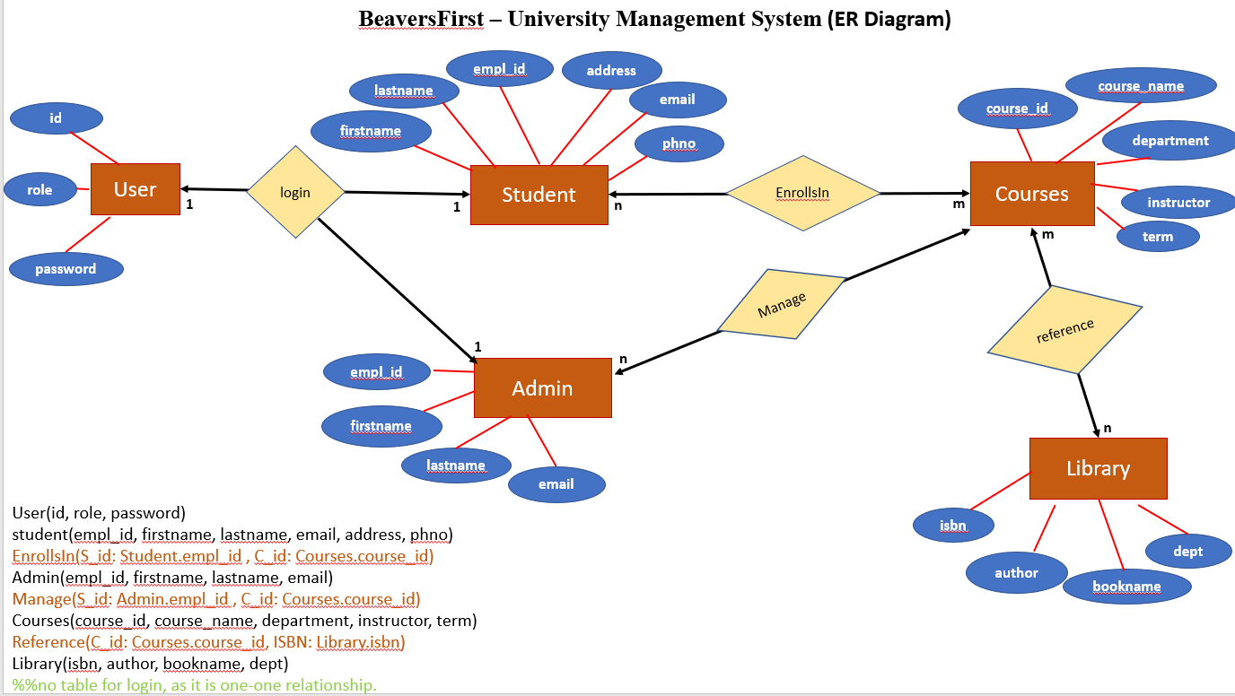

**USER GUIDE - What does the application do?**

1. Login: The user can login with their ID and password. The system will re-render the login page if the username and password does not match the records in the database. The user can be either *student* or *admin*.

(Student login: (id, password) - (ds100, xyz123), (mr200, abc123) , (dk300, password)

admin login: (id, password) - (admin, admin)

1. The application renders different views based on the user who has logged in and they are independent of each other. For example, the student cannot add new courses and the admin cannot view the personal information page of a particular student.
2. *Student* can perform following operations:
   * 1. On logging in, the student can view their personal information. The Home link will help them to navigate to the Student Center.
     2. The Student Center contains the links to the courses and library page. There is also a logout option available in case the student wishes to logout.
     3. In the courses page, the Student can select the term from the drop down option and can enter the department for which they want to view the courses (Departments available in DB - Computer Science, Data Science and Engineering). Based on the option selected and value entered a list of courses will be displayed. The student can return back to the Student Center by clicking on the Home link available in the courses page.
     4. The student can view the library page by clicking on the library hyperlink. In the Library page they can select the department from the drop-down menu. This displays the list of books available in the particular department.
3. *Admin* can perform following operations:
   * 1. Once the admin logs in, they can view the add course page. This page allows them to add a new course. Upon successful addition of the course, Update Successful message is displayed. The admin can use the Add Courses link to add more courses or log out.

**How our User interface looks like:**

**Login Form:**

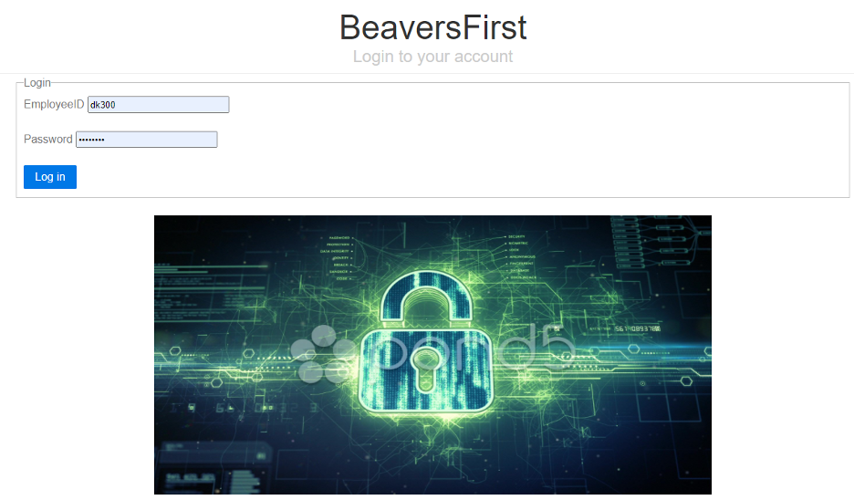

**Student Center (Home page for students):**



**Courses:**



**Library:**

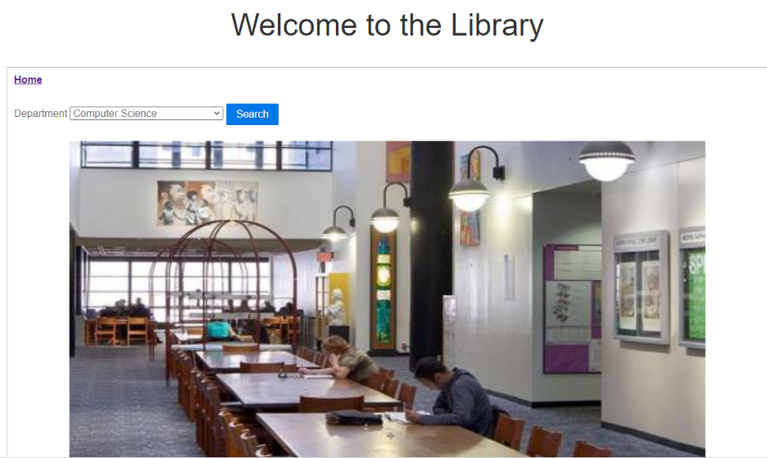

**Add Courses:**

This page can be viewed only by the admin user.

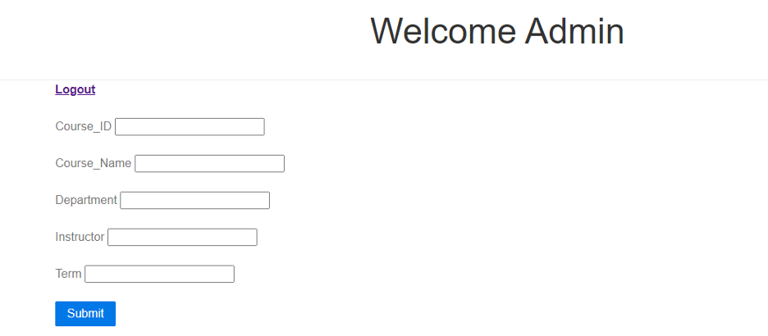

**Summary:**

Thus, the BeaversFirst - University Management System app allows users (students & admin) to login to the application and view/add information based on the usertype.