## **Introduction**

Polars is a high-performance DataFrame library designed for speed and efficiency. It leverages all available cores on your machine, optimizes queries to minimize unnecessary operations, and manages datasets larger than your RAM. With a consistent API and strict schema adherence, Polars ensures predictability and reliability. Written in Rust, it offers C/C++ level performance, fully controlling critical parts of the query engine for optimal results.

## **Key Concepts**

1. Apache Arrow Format:

Polars uses Apache Arrow, an efficient columnar memory format, to enable fast data access and manipulation, ensuring high performance and seamless interoperability with other Arrow-based systems.

2. Lazy vs Eager Execution:

Polars supports lazy execution, deferring operations for optimization, and eager execution, performing operations immediately. Lazy execution optimizes computations, while eager execution provides instant results.

3. Streaming:

Polars can handle streaming data, processing large datasets in chunks. This reduces memory usage and is ideal for real-time data analysis.

4. Contexts:

Contexts in Polars define the scope of data operations, providing structure and consistency in data processing workflows. The main contexts are selection, filtering, and aggregation.

5. Expressions:

Expressions in Polars represent data operations like arithmetic, aggregations, and filtering. They allow for building complex data processing pipelines efficiently.

6. Strict Schema Adherence:

Polars enforces a strict schema, requiring known data types before executing queries. This ensures data integrity and reduces runtime errors.

Now let's use Polars on the data.

## **Polars Expressions**

Install polars with 'pip install polars'

we can read the data and describe it like in Pandas

df = pl.read_csv('iris.csv') df.head() # this will display shape, datatypes of the columns and first 5 rows df.describe() # this will display basic descriptive statistics of columns12345bash

We can select different columns with basic operations

df.select(pl.sum('sepal_length').alias('sum_sepal_length'), pl.mean('sepal_width').alias('mean_sepal_width'), pl.max('species').alias('max_species')) # retuens a data frame with given column names and operations performed on them.12345bash

We can also select using polars.selectors

import polars.selectors as cs df.select(cs.float()) # returns all columns with float data types# we can also search with sub-strings or regex df.select(cs.contains('width')) # returns the columns that have 'width' in the name.123456python

We can use conditionals

df.select(pl.col('sepal_width'), pl.when(pl.col("sepal_width") >2) .then(pl.lit(True)) .otherwise(pl.lit(False)) .alias("conditional")) # This returns an additional columnwithbooleanvalueswithtruewhen sepal_width >21234567sql

Patterns in the strings can be checked, extracted, or replaced.

df_1 = pl.DataFrame({"id": [1, 2], "text": ["123abc", "abc456"]}) df_1.with_columns( pl.col("text").str.replace(r"abc\b", "ABC"), pl.col("text").str.replace_all("a", "-", literal=True).alias("text_replace_all"), ) # replace one match of abc at the end of a word (\b) with ABC and all occurrences of a with -1234567python

Filtering columns

df.filter(pl.col('species') == 'setosa', pl.col('sepal_width') > 2) # returns data with only setosa species and where sepal_width > 21234python

Groupby in polars

df.group_by('species').agg(pl.len(), pl.mean('petal_width'), pl.sum('petal_length')) 1234less

the above returns the number of values by species and mean of petal_width, sum of petal_length by species.

Joins

In addition to typical inner, outer, and left joins polars also has 'semi' and 'anti' joins. Let's look at 'semi' join.

df_cars = pl.DataFrame( { "id": ["a", "b", "c"], "make": ["ford", "toyota", "bmw"], } ) df_repairs = pl.DataFrame( { "id": ["c", "c"], "cost": [100, 200], } ) # now an inner join produces with multiple rows for each car that has had multiple repair jobs df_cars.join(df_repairs, on="id", how="semi") # this produces a single row for each car that has had a repair job carried out123456789101112131415161718makefile

'anti' join produces a DataFrame showing all the cars from df_cars where the id is not present in the df_repairs DataFrame.

We can concat dataframes with simple syntax

df_horizontal_concat = pl.concat( [ df_h1, df_h2, ], how="horizontal", ) # this returns wider dataframe df_horizontal_concat = pl.concat( [ df_h1, df_h2, ], how="vertical", ) # this returns longer dataframe123456789101112131415makefile

## **Lazy API**

The above examples show eager API where the query is executed immediately. In Lazy API, the query is evaluated after various optimizations are applied. This makes lazy API preferred option.

Let's look at an example

q = ( pl.scan_csv("iris.csv") .filter(pl.col("sepal_length") > 5) .group_by("species") .agg(pl.col("sepal_width").mean()) ) # how query graph without optimization - install graphviz q.show_graph(optimized=False)123456789python

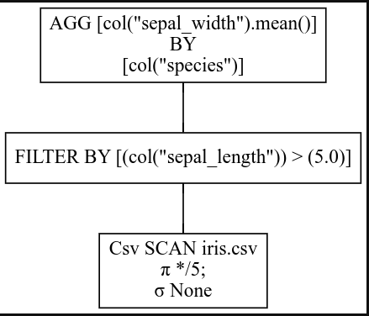

Read from bottom to top. Each box is one stage in query plan. sigma is for SELECTION and indicates selection based on filter conditions. pi is for PROJECTION and indicates choosing a subset of columns.

Here we are choosing all 5 columns and no selections are done while reading the csv file.Then, we filter by the column, and aggregate one after other.

now, look at the optimized query plan with q.show_graph(optimized=True)

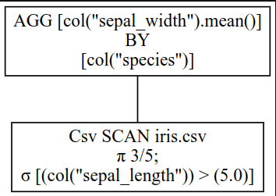

Here, we are choosing only 3 out of 5 columns as subsequent queries are done on only them. Even in them, we are only selecting data based on the filter condition. We are not loading any other data. Now we can do aggregations on the selected data. Thus, this method is much faster and needs lower memory.

We can collect the results now. If whole dataset doesn't fit the memory, we can process the data in batches.

q.collect()# to process in batches q.collect(streaming=True)1234graphql

Polars is growing in popularity and many libraries like scikit-learn, seaborn, plotly and others support Polars.

## **Conclusion**

Polars offers a powerful, high-performance DataFrame library designed for speed, efficiency, and scalability. With features like Apache Arrow integration, lazy and eager execution, streaming data processing, and strict schema adherence, Polars stands out as a versatile tool for data professionals. Its consistent API and use of Rust ensure optimal performance, making it an essential tool in modern data analysis workflows.

## FAQs

1. What is Polars and how does it differ from other DataFrame libraries like Pandas?

Polars is a high-performance DataFrame library designed for speed and efficiency. Unlike Pandas, Polars leverages all available cores on your machine, optimizes queries to minimize unnecessary operations, and can manage datasets larger than your RAM. Additionally, Polars is written in Rust, offering C/C++ level performance.

2. What are the key benefits of using Apache Arrow with Polars?

Polars uses Apache Arrow, an efficient columnar memory format, which enables fast data access and manipulation. This integration ensures high performance and seamless interoperability with other Arrow-based systems, making it ideal for handling large datasets efficiently.

3. What is the difference between lazy and eager execution in Polars?

Lazy execution in Polars defers operations for optimization, allowing the system to optimize the entire query plan before executing it, which can lead to significant performance improvements. Eager execution, on the other hand, performs operations immediately, providing instant results but without the same level of optimization.

4. How does Polars handle streaming data?

Polars can process large datasets in chunks through its streaming capabilities. This approach reduces memory usage and is ideal for real-time data analysis, enabling Polars to efficiently handle data that exceeds the available RAM.

5. What is strict schema adherence in Polars, and why is it important?

Strict schema adherence in Polars requires that data types are known before executing queries. This ensures data integrity, reduces runtime errors, and allows for more predictable and reliable data processing, making it a robust choice for data analysis.